Meta-heuristic Tuning of Fractional-Order Parallel Control System for Increased Robustness

Mridul Dixit
Department of Computer Engineering & Applications
GLA University, Mathura
mridul.dixit@gla.ac.in
Saloni Bansal
Department of Electronics & Communications Engineering
GLA University, Mathura
saloni.bansal@gla.ac.in

Abstract— This paper explores an augmented fractional-order parallel control structure (FOPCS) and its adjustment facets within the context of an industrial control loop that includes a first-order process with dead time, with the goal of improving the loop's durability. The aim of this study is to improve the control loop's resistance to outside disturbances. Enhancing the control loop's resilience to outside disturbances is the main objective of this research. The calculation burden for the parameters of a control loop increases significantly when fractional order calculus is utilized. As a result, tuning is something that needs to be done for things to work correctly. In pursuit of the goal of maximizing the benefits of both the PCS and the FOPCS, four different tuning procedures are taken into account. Performance study has taken into account the overshoot value and the integral of the time-weighted absolute error for servo and regulatory considerations. We took this action to provide a clear picture of efficiency. Both setpoint modifications and differences in the parameters of the process model have been the focus of a great deal of simulation study. Based on these tests, it was discovered that the FOPCS controller performed better than all other controllers evaluated in terms of the performance metrics that were looked into when it was modified with the use of a backtracking search algorithm.
Keywords— Meta-heuristic tuning, FOPCS, PID controllers, power series expansion

Introduction
To get the most profit and productivity out of the facility, efficient management of the industrial systems that power the firm is essential. This problem affects all process-oriented enterprises. The prioritization of human safety and the numerous economic advantages could be crucial for the effective regulation of industry-specific concerns. However, the industrial plant's primary goals cannot be met without first strictly regulating a number of process variables. This is true even if the plant's ultimate goal is something else. These basic control mechanisms are frequently connected to problems with regulation, robustness, and servo. Industry standard practice is to use a single-controller conventional control structure (CCS) in order to accomplish these goals. Nevertheless, these goals are rarely met with optimal efficiency when CCS is used. According to the research [1], the best way to maximize a control approach's servo, regulatory, and robustness performance is to use a parallel control structure (PCS). By building two distinct, specialized controllers, this PCS successfully decouples the disturbance rejection and setpoint tracking functions of the control system. These independent controllers can be adjusted to maximize system performance within their own operating regimes.
Proportional integral derivative (PID) controllers, also referred to as classical PID controllers, are used in standard PCS implementations. This is also true since their basic structure and behavior are not greatly affected by nonlinearities such as integrator windup and actuator saturation. More than 90% of all control loops use the proportional-integral-derivative (PID) controller, which is the most widely used type of controller in industry [2, 3]. Not only that, but only 5–10% of industrial loops are thought to use controllers besides PID [4]. [4] While PID controllers do have some advantages, there are also a number of disadvantages that make them unfeasible as a process variable regulator. Despite being widely utilized, classical linear PID controllers are insufficiently efficient when applied to nonlinear, uncertain, or time-variable systems [5, 6]. for the straightforward reason that these systems' nonlinearity characterizes them. In the corporate world, nonlinearity and unpredictability are also constants. The values of the parameters in a nonlinear structure may change depending on when they are used in the process. PID controllers fail to present a compelling case for their superiority in these circumstances. Devices with preset control structures are also less versatile and resilient. Furthermore, it is simple to demonstrate that a single PID controller can only offer one of the two advantages: improved load regulation or tracking of setpoints. Numerous strategies have been proposed in the literature to deal with the problems caused by parametric uncertainty. However, companies are still evaluating these recently constructed controllers because of tuning challenges, a convoluted structure, and involved goals. Adding fractional order calculus to control algorithms is one method that could be applied to solve these issues. A generalization of the PID controller is the fractional order PID (FOPID) controller. The integration and derivative strengths of these controllers can be changed independently of unity, which sets them apart from traditional PID controllers. Increased durability is one of the benefits that the FOPID controller is supposed to offer over the PID control. This is done without adding any complexity to the already simple PID control.
In several cases reported in the academic literature, fractional order calculus has been demonstrated to offer higher resilience and control performance for uncertain and nonlinear systems [7-9]. You can find these samples. Reports of these incidents have been made on several times. For the control of a distillation column, it is recommended to use a fractional order fuzzy controller; hence, the controller's control performance and resilience to failure are enhanced [6]. Another example of the use of fractional order control is the regulation of an antilock braking system, as demonstrated in [10], which deals with the system's regulation. A wide range of applications are documented in the literature [12–15], which suggests that the use of fractional order control is becoming a more common practice. It is crucial that you understand that a FOPID controller has two more parameters over a standard PID controller. Because of this, the FOPID controller is more flexible than the conventional PID controller.
Based on the results of the conducted literature review, it is possible to conclude that the inclusion of fractional order calculus can provide more robustness and handle parametric uncertainties more effectively. This conclusion can be reached by following the logical implications of the findings. However, industrial control requires the ability to track setpoints, reject disturbances, and have a strong control system. These are the main qualities that comprise industrial control requirements. One option to meet the first two of these objectives is to use a parallel control structure that is intended for the decoupling of regulatory actions and servo actions. A large percentage of control systems in use today have this form. On the other hand, PCS's use of fractional order operators presents an opportunity to improve resilience, fulfilling the third requirement. According to one school of thinking, a proportional-integral-derivative system (PCS) integrated with fractional order calculus can provide enhanced resilience in addition to decoupled servo and load control action. This study examines the consequences of changing a fractional order PCS's (FOPCS) parameters, as the title suggests [23]. Better robustness and decoupling tracking and regulatory actions are provided by the FOPID controllers incorporated into the FOPCS structural design. The performance of the studied control system is quantitatively assessed using the integral of time weighted absolute error (ITAE) for setpoint tracking and disturbance rejection, over-shoot (OS), and integral of absolute rate of controller output. A variable is said to "over-shoot" when it exceeds the desired value. Since most industrial processes can be described using a first order plus dead time (FOPDT) system, its behavior is comparable to that of most other industrial processes, making it an ideal choice for use as a test plant.. Furthermore, the backtracking search technique and the differential evolution (DE) approach are used to optimize the gains of the FOPID controller during the creation of an effective FOPCS. The study employed two established tuning techniques, namely direct synthesis (DS) and the gain margin - phase margin (GM-PM) methodology, to assess the performance of the FOPCS under investigation vs traditional PCS.

SPECIFICATION OF THE FRACTIONAL-ORDER PARALLEL CONTROL STRUCTURE
The dual-loop control structure at the center of the parallel control system is referred to by the abbreviation PCS [1]. The possibility of success is increased since the two control loops enable the setpoint tracking and load regulation to be carried out independently. Nevertheless, in the past, PCS architectures have had difficulty meeting the last robustness condition in a satisfactory manner. Parametric uncertainty is the main driving force behind the requirement for a robust control loop. As an illustration, consider this: This could be brought on by aging, inaccurate plant dynamics forecasts, or deeply rooted process nonlinearities. You can keep control operation performance as near to ideal as possible in the absence of plant-model mismatch by using a reliable controller. You can preserve the integrity of the control procedure by doing this. It is feasible to adjust the controller parameters to increase the resilience of a standard PCS; however, this will result in a decrease in the tracking and regulating performance of the system. While there are a number of methods that can be used to create a dependable controller, it is usually advised to maintain the controller's industrial character wherever feasible. Fractional order controllers are becoming more and more common in manufacturing nowadays, as they represent a logical progression of integer order controllers. They make sense to follow integer order controllers as the following stage. It was not until relatively recently that these controllers became widely used. It is claimed that these provide better performances than their integer order counterpart for fractional order [16], higher order [17], non-minimum phase [18–20], longer time delay [21, 22], and nonlinearity [23] systems [14, 15]. They are said to be able to achieve this by producing better results for higher order [17], non-minimum phase [18–20], and fractional order [16–17] systems. This is true for non-minimal phase systems [16, 17] as well as systems with significant temporal delays [18–20].
Figure 1 shows the structure of the reviewed FOPCS [23]. PID structures are present in both the disturbance rejection GDR (s) controllers and the setpoint tracking GST (s) controllers; however, in both cases, the PID structure has been extended to fractional order. Stated differently, the conventional PCS can now be considered as offering resilience to control the parametric uncertainty since it separates the setpoint tracking and disturbance rejection operations. This is a result of the conventional PCS's rejection of disturbances separate from setpoint tracking. This is because disturbance rejection and setpoint tracking operate independently of one another.
It is possible to infer from Figure 1 that the process variable is represented by the letter y, and the process that needs to be managed is represented by the letter Gp. The process is being impacted by the disturbance, and the variable that represents the process is reflecting this impact. Process: The process creates the control input (represented by the letter u) by merging the FOPID controllers for GST (s) and GDR (s).
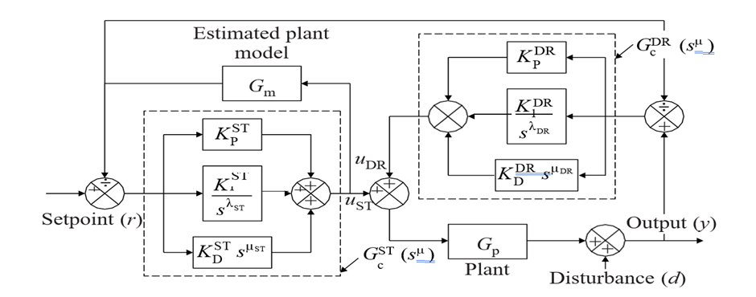
Fig. 1. Fractional order parallel control structure block diagram [23]

(1) and (2) lead to the obvious conclusion that whereas GDR (s) can handle disturbances and parameter uncertainty, GST (s) is in charge of the process variable's setpoint tracking. The gains and fractional order dynamics of these controllers can be individually tweaked to enable decoupling tracking and regulatory actions, but this will only happen nominally, that is, when there is a high degree of agreement between the plant and its estimated mathematical model. In the event of a mismatch, resilience becomes necessary, and fractional order calculus can be useful in determining the proper level of robustness [23]. Various methods have been suggested in academic literature to simulate the functioning of a fractional order operator. This kind of methodology includes techniques such as Oustaloup's recursive approximation (ORA), curve fitting, optimization based on the frequency response of fractional order operators, and power series expansion (PSE). Nonetheless, the popular and widely used ORA approach has been selected for this assignment. This is due to the fact that its design is simple, efficient, and gives a reliable approximation of the fractional order operators needed at a particular frequency. The fractional-order operator's structure can be expressed as follows: the ORA method iteratively calculates the poles and zeros of the higher-order filter.
s^{µ} = H(s) , µ ∈ ℜ .
s^{µ} ≈ K′k Y= N s + ω_{z}k
k=−N s + ωpk
In this work, we examine and estimate the behavior of operators of fractional order with angular frequencies ranging from 0.01 to 100 rad/s. The following range of angular frequencies was taken into account in this analysis: Systems in this range are frequently used for process control. Furthermore, the value of N has a significant impact on the fractional order approximation's performance. Increasing N makes the calculation more complicated but also enables a more precise approximation that smoothes out the magnitude and phase characteristics. Let's assume that N is three for the purposes of this study. This assumption is addressed.
Furthermore, the effectiveness of the standard PCS and the fractional order PCS controllers that have been researched has also been assessed using a FOPDT system. Examining the two systems' respective levels of efficiency was the aim of this evaluation. The FOPDT system has been used for all comparative performance testing since it can be used to simulate almost all industrial environment operations. Additionally, bear in mind that the FOPCS and the conventional PCS both have their own controllers, meaning that different sets of parameters will be required for each implementation. This information is crucial. Tuning techniques, which are used to find the ideal values, are essential to the process since the parameters' values have such a big influence on how the control loop functions. Because of this, tuning procedures play a crucial role in the process. The whole discussion of the aforementioned subject in relation to the PCS and the FOPCS is contained in the next section.

Prepare Your Paper Before Styling
There are many different tuning techniques, but they can be generally classified as "traditional methods" or "smart techniques." These two classes may contain all the different tuning techniques, despite the fact that there are many of them. Conventional tuning methods such as Ziegler-Nichols, Direct Synthesis, Astrom / Haglund, Gain Margin / Phase Margin, and the Quarter Decay Ratio are still often used in the business sector. Another popular tuning method is the Gain Margin - Phase Margin procedure. Nevertheless, these methods cannot be utilized to regulate nonlinear systems, systems exhibiting uncertain behavior, or systems incorporated into non-conventional control frameworks like PCS. Not only that, but the current standard tuning methods are unable to get a performance index to its lowest value. One area of engineering that has grown out of the ubiquity of these kinds of circumstances in recent years is meta-heuristic optimization approaches. These techniques, in conjunction with other relevant frameworks, primarily rely on bio-inspired processes or physical principles to identify a globally optimum solution to a challenging multimodal optimization problem. Moreover, these algorithms are more effective since they can produce globally optimum solutions without using gradient search. Numerous algorithms [24–30] have been created as a result of the in-depth research on global optimization. The genetic algorithm (GA), differential evolution (DE), particle swarm optimization algorithm (PSO), cuckoo search algorithm (CSA), backtracking search algorithm (BSA), harmony search algorithm (HSA), and grey wolf optimizer are a few examples of algorithms that meet this criterion. Not to mention the myriad different algorithms out there. Control engineering is not an exception given the broad use of these algorithms for solving issues in a variety of industries

Performance evaluation index
To adjust the controller settings by using the optimization procedure under study, one must first define a potentially acceptable objective function. This objective function necessitates the required inclusion of an index linked to the intended control performance level. The acronym stands for integral time weighted absolute error for setpoint tracking response. The abbreviation ITAEDR stands for integral time weighted absolute error for disturbance rejection. OS is taken to be at its maximum value in the tracking response. An optimization challenge is presented in this work as an aggregate of three performance measures: the OS, the ITAEDR, and the ITAEST. All three parts add up to the algebraic expression of the goal function, which may be expressed as follows. To the greatest extent that is practical, the value of this function should be reduced.
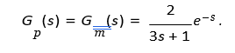
To change the controller parameters, the system is exposed to a unity setpoint at t = 0 s and a 0.5-magnitude step disruption at t = 10 s. These two queries are separated by ten seconds. It should be noted that a saturator was employed to guarantee that the controller's output remained within the designated range [5, 5]. This was carried out since the controller's output required control in order to accurately simulate real-world scenarios.

Tuning of PCS and FOPCS
The objective function vs. iteration curve for DE and BSA is shown in Figure 2. It is clear from the statistics in this figure that the deadlines for DE and BSA targets were fulfilled. Figure 2 displays the larger goal function values that the integer order controllers for both DE and BSA provided. This will be verifiable by observers.
TABLE I: LABELED IMPROVEMENTS REALIZED

Method | KST | KST | KST | KDR | KDR | KDR
Method | KST | KST | d | KDR | KDR | d
GMPM-PID | 1.176 | 0.394 | 0 | 0.787 | 0.26 | 0
DS-PID | 0.751 | 0.253 | 0.376 | 0.753 | 0.251 | 0.374
DE-PID | 0.633 | 0.198 | 0.104 | 0.682 | 0.201 | 0.122
DE-FOPID | 0.795 | 0.292 | 0.145 | 0.772 | 0.287 | 0.154
BSA-PID | 0.847 | 0.24 | 0.126 | 0.788 | 0.23 | 0.02
BSA-FOPID | 0.726 | 0.263 | 0.186 | 0.874 | 0.275 | 0.107

Minimum values of J for DE-PID, BSA-PID, DE-FOPID, and BSA-FOPID are 5.982, 3.680, 3.753, and 3.409, respectively. Tab 1 is labeled "Improvements Realized" and it lists the improvements that were realized across all of the different optimization strategies.
Furthermore, conventional tuning techniques, such as DS and GM- PM [1], can be used to accomplish the controller improvements. The two given are only two illustrations. In this section's Tab. 1, you'll also find a list of the parameter values that may be acquired by employing these methods.

Here, we contrast the effectiveness of conventional PCS with that of GM-PM, DS, DE, and BSA-enhanced FOPCS. Additionally, we compare the two types of systems. The performance of the control structures under different scenarios, namely the nominal case, the nominal case with a modified setpoint, the parameter mismatch case (also called the mismatch in steady state gain), the dead time, and the time constant calculation are all investigated in these simulation studies. Each research, which includes disturbance rejection and setpoint tracking, takes up twenty seconds. After concentrating on servo problems for 10 s, a 0.5-magnitude step interruption is applied at t = 10 s into the investigation.

Nominal case G_{m} = G_{p}

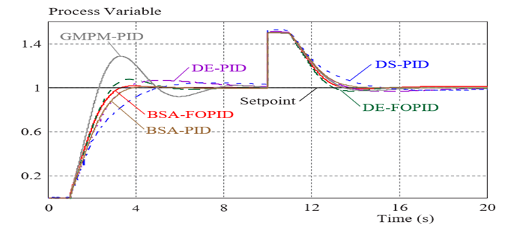
Fig. 2. Objective function vs iteration curve

Since nominal modeling is employed in this investigation, there are no instances of plant model mismatch throughout the analysis. The responses of several control structures to modifications utilizing the assessed approaches for disturbance rejection and setpoint tracking are shown in Figure 3. Ignoring or rejecting disruptive stimuli is one of these reactions. Figure 3 demonstrates how each controller followed the target value while maintaining a steady state and successfully reaching the target setpoint. However, each controller under study has unique properties that are evident in its transient reactions. The PCS with the PID controller tuned using the GM-PM technique is in the most efficient working condition, as Figure 3 clearly shows.

TABLE II. PERFORMANCE COMPARISON OF PCS AND FOPCS IN NOMINAL CASE
Method | ITAEST |  | ITAEDR | OS(%) | IARCO | J
GMPM-PID | 4.113 |  | 1.403 | 28.67 | 2.767 | 5.803
DS-PID | 4.462 |  | 2.33 | 4.545 | 685.3 | 6.838
DE-PID | 3.994 |  | 1.987 | 0.025 | 200 | 5.982
DE-FOPID | 2.486 |  | 1.192 | 7.497 | 2.555 | 3.753
BSA-PID | 2.396 |  | 1.271 | 1.211 | 158.5 | 3.68
BSA-FOPID | 1.973 |  | 1.419 | 1.58 | 4.215 | 3.409

The PID controller that is adjusted for DS, DE, and BSA also exhibits overshoot. Despite this, the BSA-adjusted PID controller performs better than every other PID controller that has been researched. But when calibrated with BSA, FOPCS performs better than the others. It outperforms all other controllers analyzed in terms of servo and regulatory problems. Its OS is the lowest and its settling time is the fastest.
A more thorough quantitative evaluation of the controllers' relative efficacy may be made easier with the help of Table 2, which offers a detailed breakdown of the performance index values. Another performance metric that can be computed is the integral of the absolute rate of controller output, which is shown in Tab. 2.

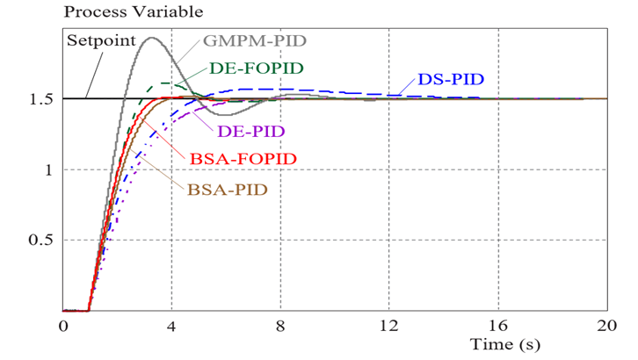
Fig.3. effective in solving the problem in this investigation.

Multiple controllers were shown to be effective in solving the problem in this investigation. Given that it is conceivable for such a system to have proportional kick and that the effect of proportional kick would be amplified by a higher setpoint value, it is likely that a control system that is tuned for better setpoint tracking may have proportional kick. Since this is the case, it is crucial to put the controller through its paces using a setpoint value other than the one employed during tuning. This is crucial in every way. Using a step input of magnitude 1.5 at time t = 0, Figure 4 depicts the subsequent changes in the process variables. No disruptions were introduced into the control loop over the course of this investigation.
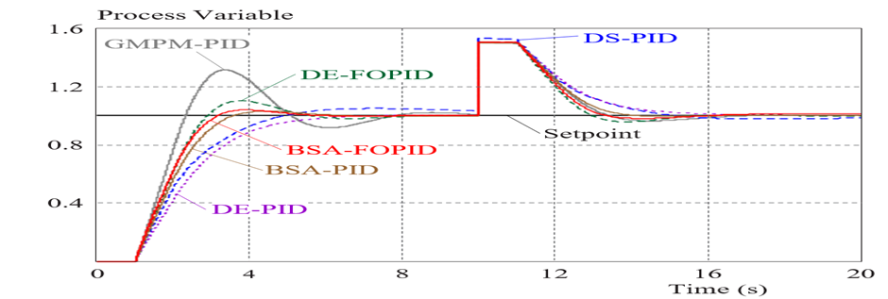

Fig. 7. Process variable variation for 5% change in dead time

The evaluating our capacity for setpoint monitoring and control as part of our study. As Figure 7 illustrates, there were variations in the process variable for the first case. It is demonstrated that the current approach—a PCS controller tuned via GM-PM—is inefficient in addressing dead-time uncertainty while delivering the highest OS. Nonetheless, FOPCS can react appropriately in the regulatory and servo domains. It is noteworthy that the ITAEST value for servo responsiveness is just 2.213, the lowest of all the controllers taken into consideration. Furthermore, with a measurement of 3.813, the BSA-tuned FOPCS has the lowest feasible objective function. The new architecture offers an objective function value of 6.504, while the previous PCS architecture, which was altered using the GM-PM approach [1], yielded a value of 6.371. This discrepancy shows that the FOPCS's response is strengthening the inquiry as well.

CONCLUSION
The overall responsiveness of the system is sacrificed in order to improve a PCS's control performance to the level required by the robustness criterion. This is because it is intrinsically detrimental to increase the control performance's sensitivity to disturbances in order to satisfy the robustness requirements. This study examines a modified parallel control structure that combines fractional order calculus's benefits to improve the system's robustness without compromising control performance in order to address the raised problem. A number of tests were taken into consideration in order to assess and compare the two construction types. These strategies were used because achieving the best results was the ultimate objective. The success metric selected was the index of a composite objective function. The integral of absolute error in disturbance rejection (ITAEDR), the integral of absolute error in setpoint tracking (ITAEST), and the total system value would be the mathematical sum for this index. The findings indicate that the BSA-tuned FOPCS produced the lowest objective function value among the controllers examined and outperformed the GM-PM-tuned PCS by at least 26.28%. The BSA adjusted FOPCS supports this conclusion since it can provide the lowest value of the objective function among the controllers under consideration. By adopting FOPCS. The fact that this functions even at greater control performance levels is a benefit. Conclusion: If all else is equal, a fractionally-order calculus-tuned Particle Filtering Control System (PCS) would provide a higher level of resilience without sacrificing control performance. It is reasonable to expect that the application of fractional order calculus will be beneficial, thus we can draw this conclusion.

References

- Feng X, Ren D, He X, Ouyang M. Mitigating thermal runaway of lithium-ion batteries, Joule. 4 (2020) 743–70.
- Zuo W, Zhang Y, E J, Huang Y, Li Q, Zhou K, Zhang G. Effects of multi-factors on performance of an improved multi-channel cold plate for thermal management of a prismatic LiFePO4 battery, Energy. 261 (2022) 125384.
- Y. Chen, M. Sang, W. Jiang, Y. Wang, Y. Zou, C. Lu, Z. Ma, Fracture predictions based on a coupled chemo-mechanical model with strain gradient plasticity theory for film electrodes of Li-ion batteries, Eng. Fract. Mech. 253 (2021) 107866
- Yang H, Li M, Wang Z, Ma B, A compact and lightweight hybrid liquid cooling system coupling with Z-type cold plates and PCM composite for battery thermal management, Energy. 263 (2023) 126026.
- Badhoutiya, A. and Yadav, A., 2017, May. Boost control for PV applications using impedance source inverter. In 2017 2nd IEEE International Conference on Recent Trends in Electronics, Information & Communication Technology (RTEICT) (pp. 1967-1970). IEEE.
- Chen K, Wu WX, Yuan F, Chen L, Wang SF. Cooling efficiency improvement of air-cooled battery thermal management system through designing the flow pattern, Energy. 167 (2019) 781–90.
- Park S, Jang DS, Lee D, Hong SH, Kim Y. Simulation on cooling performance characteristics of a refrigerant-cooled active thermal management system for lithium ion batteries, Int. J. Heat Mass Transfer. 135 (2019) 131–41.
- Dixit, K.K., Yadav, I., Gupta, G.K. and Maurya, S.K., 2020, February. A review on cooling techniques used for photovoltaic panels. In 2020 International Conference on Power Electronics & IoT Applications in Renewable Energy and its Control (PARC) (pp. 360-364). IEEE.
- Luo W, Li H, Chu T, A numerical study of battery thermal management system with square spiral ring-shaped liquid cooling plate, Thermal Science and Engineering Progress. 45 (2023) 102120.
- Bao Y, Shao S, Numerical study on ultrathin wide straight flow channel cold plate for Li-ion battery thermal management, J. Energy Storage. 64 (2023) 107263.
- Kumar, Y., Enhanced performance of photovoltaic systems with LUO converter and modified P and O tracking algorithm. In Applications of Mathematics in Science and Technology (pp. 852-856). CRC Press.
- A.D. Tuncer, A. Khanlari, A. Sozen, E.Y. Gürbüz, H.I. Variyenli, Upgrading the performance of shell and helically coiled heat exchangers with new flow path by using TiO2/water and CuO–TiO2/water nanofluids, Int. J. Therm. Sci. 183 (2023) 107831.
- Liu S, Liu Y, Gu H, Tian R, Huang H, Yu T, Experimental study of the cooling performance of γ-Al2O3/heat transfer fluid nanofluid for power batteries, J. Energy Storage. 72 (2023) 108476
- Kumar, Y., Goyal, M. and MISHRA, R., 2020, November. Modified PV based hybrid multilevel inverters using multicarrier PWM strategy. In 2020 4th international conference on electronics, communication and aerospace technology (ICECA) (pp. 460-464). IEEE.
- “Treatment episode data set: discharges (TEDS-D): concatenated, 2006 to 2009.” U.S. Department of Health and Human Services, Substance Abuse and Mental Health Services Administration, Office of Applied Studies, August, 2013, DOI:10.3886/ICPSR30122.v2

