The Synergistic Impact of Thermal Energy Storage on Solar Thermal collector efficiency

Puneet Sharma
Department of Computer Engineering & Applications
GLA University, Mathura
puneet.sharma@gla.ac.in
Mridul Dixit
Department of Computer Engineering & Applications
GLA University, Mathura
mridul.dixit@gla.ac.in

Abstract— The necessary thermal energy storage systems are critical to the solar thermal collectors. The efficiency of the storage and retrieval of the solar heat relies on precepts involving the balance of energy and principles of transfer of heat. Some of the factors of influence on heat transfer are the conductivity of heat, the temperature difference, the surface area, the quality of insulation and properties of the medium of storage. The important parameter to be selected in TES systems is storage media. Water, rocks, molten salts and organic liquids comprise sensible storage media. The phase change materials or PCMs are paraffin wax, salt hydrates and organic salts used in latent storage. In thermochemical storage, chemical reaction heat storage and release are used. Some factors guide the selection process in determining an appropriate medium storage, including the energy storage capacity, heat transfer properties, temperature range, cost, environmental impact, durability, safety and compatibility with the collector. The areas to be optimized for such systems as TES include material selection, system design, integration with the solar collector and control strategies. All these factors and principles must be understood to enable engineers to make use of a well-designed TES system for their applications. In this paper, daily improvements in thermal efficiency based on the energy captured and stored by the TES system has been analyzed.
Keywords— Thermal energy storage, solar collector, Phase change materials, thermochemical energy.

Introduction
Due to its immense potential, solar energy—which solar cells may use in a variety of ways—is one of the most important renewable energy sources. A thermal photovoltaic hybrid collector is made possible by the combination of a photovoltaic module with a flat solar collector. This allows the sun's radiation to power transformation and the subsequent recovery of the heat it transports. Because of the thermal cogeneration of energy, it is evidently highly exciting to use such systems for the creation of sophisticated and well-suited solar dryers in a number of industries, especially the farming business. First (1st) generation solar cells, which are based on crystalline silicon technology, make up the majority of solar cells now available on the market. Using relatively thin film materials, second (2nd) generation solar cells were developed as less expensive alternatives to crystalline silicon technologies [1]. Because they have a greater capacity for light reception, they use incredibly thin sheets of materials to capture sunlight.
A solar collector, a specialised energy exchanger used in PV (Photovoltaic) applications, converts solar radiation heat either directly into electric energy or, in the case of solar thermal operations, into the heat energy of the operating fluid. In solar thermal operations, a solar collector transforms solar energy into heat, which is then transferred to the working fluid—which could be water, oil, or air. The heat generated by the working fluid can be used to provide hot water and heating for homes, or it can be used to fill a thermal energy storage container from which heat can be drawn at a later time (during the night or on cloudy days). By attaching recovery tubes filled with the supplied fluids to the PV board, waste heat generated by a photovoltaic module can be recovered for thermoelectric application [2]. In addition to efficiently converting solar radiation into electrical power (often with relatively low efficiency), a photovoltaic module for photovoltaic jobs also produces a significant amount of waste heat. Solar energy is simultaneously converted with hybrid photovoltaic/thermal (PVT) collectors to produce heat and electricity. A photovoltaic module with a peak efficiency between 5% and 20% and an absorber plate attached to the back of the PV module to act as heat-absorbing apparatus comprise a conventional PVT collector. The heat ejection plate lowers the temperature of the PV module to improve electrical performance while simultaneously collecting excess heat that can be used for low-temperature activities like home hot water usage (laundry and bathing) and adsorption air conditioning systems.
The absorber plate is a rectangular plate made of a heat-conductive material, preferably aluminium or copper because of its high thermal conductivity. In order to enhance solar radiation absorption, it is usually sprayed black and covered with absorbent material. This incredibly thin layer is highly vulnerable to short-wave UV light, even if it is relatively permeable to long-wave solar energy. Beneath the coating's surface is a thin layer that is highly reflective in the long wavelength range. With the least amount of heat loss possible, the absorber plate delivers solar heat to the operating fluid. Big-diameter pipes are placed at the top and bottom of the absorber plate to allow fluid to enter and exit. The absorber plate's heat transfer is maximised by using copper header pipes. There are several copper tubes on the absorber plate. The operational fluid flows across the heated tubes. The copper pipes are placed parallel to one another on the absorber plate. The fluid tube is joined at both ends using header tubing with a large diameter [3]. To increase surface contact and promote effective heat exchange between them, these are glued and fastened to the absorber plate. In the current study, a traditional baseline structure of CdTe solar cells showed significantly increased performance when an appropriate BSF was inserted using computational methods. The CdTe thin-film solar cell has demonstrated exceptional efficiency. Cell achievement was reduced by the deterioration of the back contact metal of the CdTe solar cell. This was addressed by employing the BSF strategy, for example, by lowering the barrier height or introducing an extra layer that was extensively p-type infused and used as a BSF layer with sufficient width between the p-CdTe absorber layer and the final back contact metal. From this data, it was possible to improve the cell functionality of CdTe solar cells in an effective and simple way by placing the proper BSF layer above the back contact [4]. Utilising suitable BSF materials behind the absorber layer improved the efficiency of ultra-thin CdTe solar cells.
A PVT collector is created by combining a solar PV cell with a solar thermal energy collector to generate both heat and electricity simultaneously. Whereas solar PV converts the absorbed SE to energy, the STC converts it to heat. Such a configuration maximises the utilisation of SE, making it more efficient and capable of producing more energy per unit area than solar PV or solar heating systems alone.
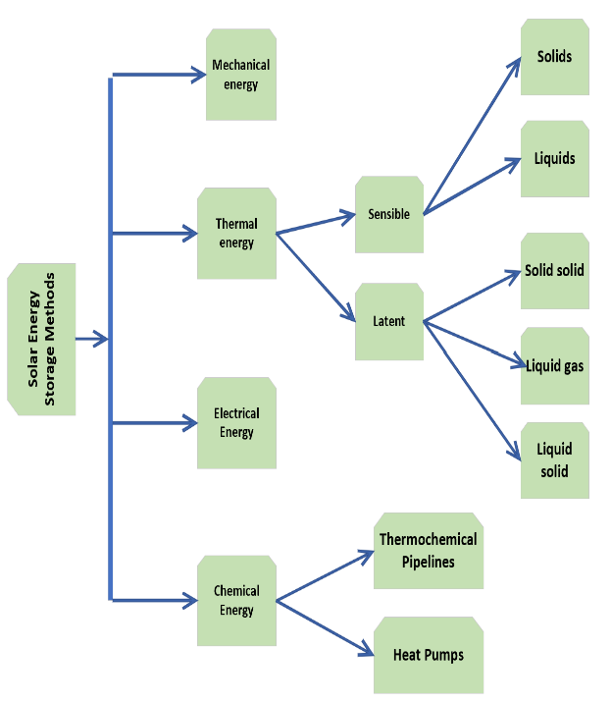
Fig.1. Different methods for storing solar energy

Storage Medium Selection and Optimization in Thermal energy storage systems

The choice of storage medium is a critical factor in the design and performance of thermal energy storage (TES) systems employed in solar thermal collectors. The ideal medium should have high energy storage capacity, low cost, minimal environmental impact and efficient heat transfer properties.

A. Sensible Heat Storage Media

Sensible heat storage involves storing energy by simply raising the temperature of a material by sensible percentage without any phase change. It is popularly used as a storage medium is due to its high specific heat capacity and availability in the liquid state. Whereas it is its relatively low boiling point that makes it unsuitable for use across wide temperature range. Some rocks like granite and basalt have high energy storage density and temperatures enduring capabilities. In packed bed storage systems, they are common [5]. Molten salts have high specific heat capacities and can operate at high temperatures; for example, sodium nitrate or potassium nitrate. This is the type of solar collectors used in central receiver and parabolic trough power plants. Monobasic free organic liquids such as thermal oils have favourable heat transfer properties, therefore these can be used in many applications of TES.

B. Latent Heat Storage Media

Latent heat storage (LHS) is the most efficient according to exergy Loss minimization rules as compare to other methods of storing thermal energy because it occurs at a constant temperature, while all other occur over a range of temperature [6]. This made LHS systems more promising in solar thermal applications, because the specific thermocapillary forces are on a per-unit volume basis or mass very huge. Phase Change Material (PCM) is a latent heat storage media, which change from one phase to another at a certain specific temperature in the form of liquid-solid. This phase change takes place at near constant temperature, which means significant quantities of energy can be both absorbed and released in a little over 10 degrees K.
Common types of PCMs include:
- Paraffin waxes: These are organic compounds derived from petroleum that have a wide range of melting points, making them suitable for various applications.
- Salt hydrates: Inorganic compounds that form hydrates with water. They offer high energy storage capacities and can be used in a variety of temperature ranges.
- Organic salts: Organic compounds that have a high latent heat of fusion and can be used in a wide range of applications.
- Metallic alloys: Alloys of metals that undergo a phase change at a specific temperature, such as eutectic alloys.
In a solar thermal application, PCM requirements not only relate to its latent heat of fusion and chemical stability but also to factors like the melting point and thermal conductivity. The price of PCM used should equal the high solar thermal collector temperature. The higher the latent heat of fusion, the more energy can be stored or released per unit mass at the PCM melting point [7]. The thermal conductivity of a phase change material is quite high that caused by the long distance between the individual metal atoms that are attached to each other in the lattice. The PCM should have only a very small mass stay chemically stable for a long time over repeated phase changes. The cost of the PCM is something significant when it has to be taken into account mainly for large-scale applications. The environmental impact of the PCM is a subject that should be taken under evaluation, especially with the regard of toxicity and flammability. LHS systems can be used in a variety of solar thermal applications, including Space heating and cooling.

C. Thermochemical Storage Media
Thermochemical storage refers to the process of collecting energy by way of chemical reactions. This method is known for the very high energy in confined spaces and long-term storage capacity. Thermochemical storage mediums present within the market are diverse and various and include metal oxide and ammoniated salts. Metallic rocks including iron oxide and copper oxide undergo a chemical reaction with water or carbon dioxide which results in steam formation followed by its re-entry into the original substance [8]. The heat exchange process between ammoniated salts and ammonia occurs because these compounds draw in or release thermal energy when they interact with ammonia. The process of ammonia absorption and desorption leads to the production of ammonia.

D. Optimization of Storage Medium Performance
The selection of an appropriate storage medium demands attention alongside the creation of a TES system which delivers optimal performance results. The process requires choosing storage materials by studying different storage media characteristics to discover the best fit for this particular application. System design optimization requires developers to create storage systems which maximize heat transfer efficiency while reducing thermal losses [9]. The solar collector integration requires proper storage system compatibility with solar power systems during the connection process. The storage system requires functional control strategies to manage its charging and discharging processes.

Factors to Consider in Storage Medium Selection for Thermal Energy Storage Systems

Storage medium functions as a core element within thermal energy storage systems which operate through solar thermal collectors. The ideal medium requires these specific attributes which need to merge into one system. The system requires maximum energy storage and retrieval capabilities along with minimal friction losses [10]. Few elements must be taken into account like stored and release energy, heat transfer properties, temperature range, chemical stability, cost, environmental impact, durability and longevity, safety and compatibility with solar collector. The medium requires a storage system which allows it to store large amounts of energy per unit mass or volume for rapid release. These materials need to have a high specific heat capacity or latent heat of fusion. Phase Change Materials (PCMs) function as substances which store and release large energy amounts through their melting and solidifying processes at specific temperatures because they contain high heat of fusion. Green heat transfer is crucial for speedy charging and discharging of the TES device. The medium needs to possess high thermal conductivity to enable heat transfer operations [11]. The system which manages fluid flow operations faces influence from the medium's viscosity and density properties according to heat switch quote data.
The TES device requires an operating temperature range which matches the storage medium's home values. The molten salt garage system operates at high temperatures which makes it compatible with concentrated solar power plants. The medium needs to maintain chemical stability throughout its entire lifespan especially during exposure to high temperatures and repeated heating and cooling cycles. The system prevents degradation which results in consistent performance. The economic success of the TES system depends on the storage medium expense [12]. High-performance materials tend to have higher costs but their extended value in energy savings and lasting performance needs to be evaluated. The evaluation process needs to determine how the storage medium affects the environment. The environmental impact of some PCMs stems from their toxic and flammable nature. The storage medium needs to possess long-lasting durability with extended lifespan because it reduces maintenance expenses and replacement costs. The evaluation process requires special attention to corrosion resistance and thermal cycling stability and mechanical strength. The storage system needs to maintain secure handling and storage methods because it contains dangerous materials or operates at elevated temperatures. Safety measures must exist alongside containment systems and emergency response plans. The storage medium needs to match the specific solar collector type which operates the system. A packed bed storage system would function better with parabolic trough collectors according to the example but a molten salt tank would serve central receiver systems more effectively [13]. By carefully considering these factors, engineers can select the most appropriate storage medium for their TES system, optimizing its performance, efficiency, and long-term sustainability.

Results and Discussion

The Table.1 below shows the performance improvement of solar thermal collectors through the addition of Thermal Energy Storage (TES) systems during three months of testing. The data shows daily changes in thermal efficiency through the measurement of stored energy by the TES system.

This table data will, therefore, provide an analytical basis for evaluating how the combination of TES systems improves the efficiency of solar thermal collectors and allows better utilization of heat as well as better energy management. Here is the plot of improvement of efficiency by using a TES system on solar thermal collectors over 3 months. All the total system efficiencies with the TES system are illustrated by the blue line and, as it would be expected, have an upward tendency as the system optimizes. The red line depicts the efficiency of the system that does not have TES. It is smooth and very low and has shown no significant fluctuation during this time period. All these improvement trends are shown in Fig. 2, where the green line represents improvements due to the TES system: almost a consistent increase in efficiency from 33% to 41%. These calculations justify the efficiency improvement curve shown in the plot, which steadily increases due to the presence of the TES system.

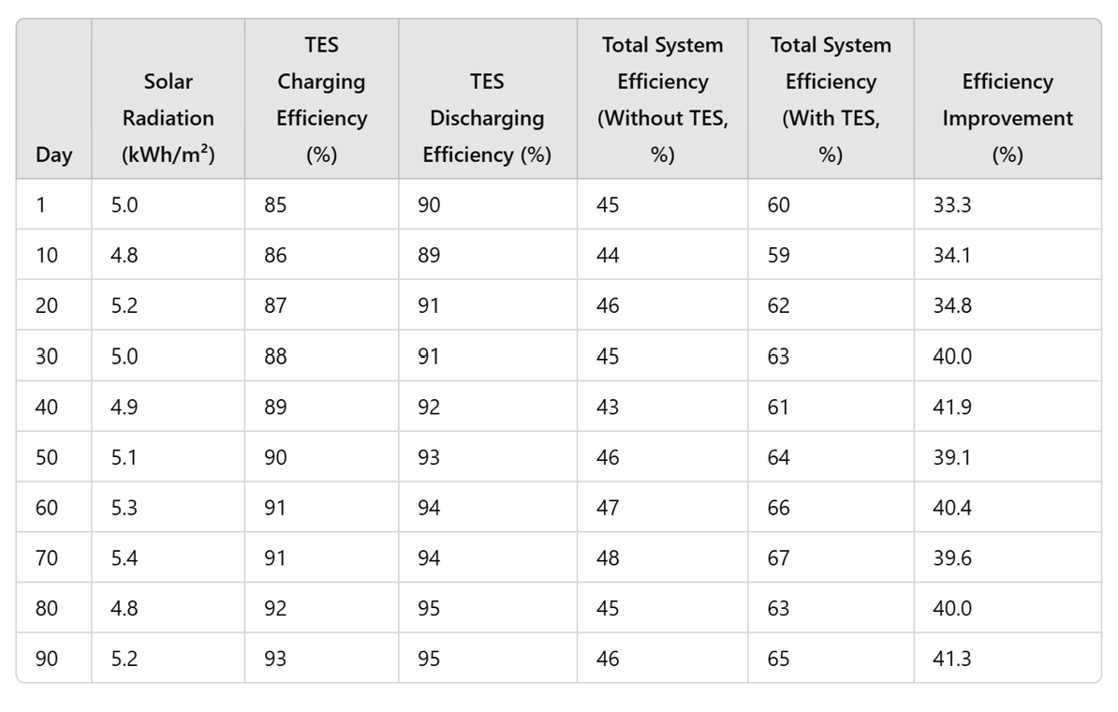
Table.1. 3-months readings of a solar thermal collector system integrated with Thermal Energy Storage

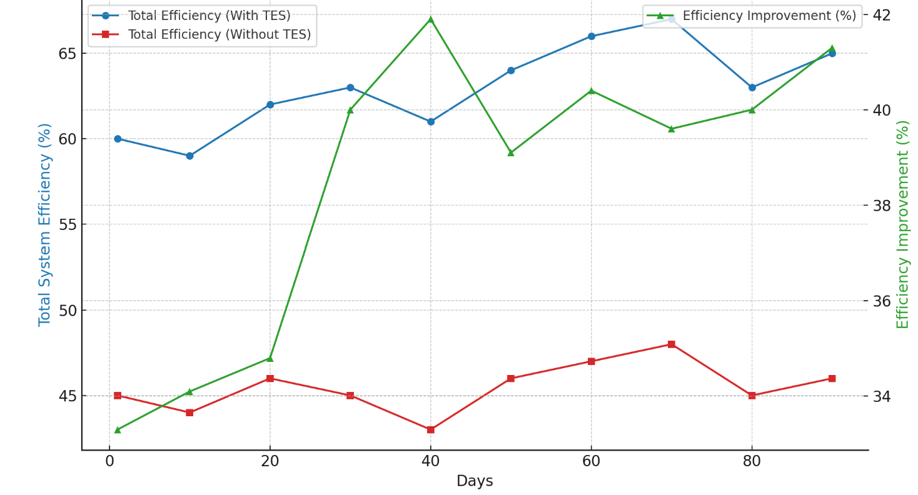
Fig.2. Graphical representation of improvements due to TES system

Table.2. Percentage improvement in the efficiency of the system with and without additional thermal energy storage

Day | Efficiency Without TES (%) | Efficiency With TES (%) | Calculated Efficiency Improvement (%)
1 | 45 | 60 | 33.3
10 | 44 | 59 | 34.1
30 | 45 | 63 | 40.0
50 | 46 | 64 | 39.1
90 | 46 | 65 | 41.3

Conclusion
Thermal Energy Storage (TES) Systems in solar thermal collectors play a crucial role in storing excess solar energy for later use. The system requires knowledge of energy balance and heat transfer principles to achieve effective heat storage and retrieval. The three main methods of energy transfer include conduction, convection and radiation. The system depends on five main factors which are conductivity, temperature difference, surface area, insulation and storage medium characteristics. The selection of storage medium stands as the core element which determines the performance of TES systems. Sensible heat is stored in water and rocks as well as molten salts and organic liquids. The latent heat storage media contains phase change materials (PCMs) which include paraffin wax and salt hydrates with organic salts. The system operates through chemical reactions which maintain heat energy within their chemical bonds. The selection of storage medium requires attention to several main factors which include energy storage capacity, heat transfer properties, temperature range, cost, environmental impact and durability with safety and solar collector compatibility. Material selection, system design, integration with the solar collector and control strategies can all be part of optimization of TES systems. This research allows engineers to develop and create functional TES systems which support solar thermal applications. The study investigates continuous improvements in thermal efficiency which stem from the stored energy within TES systems. The results prove that solar thermal collectors with thermal energy storage systems achieve better performance because their efficiency rises from about 33% to 41%.

References

- Evangelisti, Luca, Roberto De Lieto Vollaro, and Francesco Asdrubali. "Latest advances on solar thermal collectors: A comprehensive review." Renewable and Sustainable Energy Reviews 114 (2019): 109318.
- Kalogirou, S. A., Karellas, S., Braimakis, K., Stanciu, C., & Badescu, V. (2016). Exergy analysis of solar thermal collectors and processes. Progress in Energy and Combustion Science, 56, 106-137.
- Wole-Osho, I., Okonkwo, E. C., Abbasoglu, S., & Kavaz, D. (2020). Nanofluids in solar thermal collectors: review and limitations. International Journal of Thermophysics, 41(11), 157.
- Aissa, A., Qasem, N. A., Mourad, A., Laidoudi, H., Younis, O., Guedri, K., & Alazzam, A. (2023). A review of the enhancement of solar thermal collectors using nanofluids and turbulators. Applied Thermal Engineering, 220, 119663.
- Meena, Seema Bai, Priyanka Rajesh Patil, S. R. Kandharkar, N. Hemalatha, Ashutosh Khade, Krishna Kant Dixit, and Narender Chinthamu. "The evolution of smart grid technologies: Integrating renewable energy sources, energy storage, and demand response systems for efficient energy distribution." Nanotechnology Perceptions (2024): 1098-1109..
- Kaur, Harpreet, Raman Kumar, Pulkit Kumar, Swapandeep Kaur, Krishna Kant Dixit, and Hemant Sharma. "Efficient and cost-effective renewable energy integration of photovoltaic and hydro in rural india using HOMER Pro: a case study of Chupki, Punjab." In International conference on intelligent manufacturing and energy sustainability, pp. 281-291. Singapore: Springer Nature Singapore, 2023..
- Dewangan, A. K., Moinuddin, S. Q., Cheepu, M., Sajjan, S. K., & Kumar, A. (2023). Thermal energy storage: Opportunities, challenges and future scope. Thermal Energy Systems, 17-28.
- Tawalbeh, M., Khan, H. A., Al-Othman, A., Almomani, F., & Ajith, S. (2023). A comprehensive review on the recent advances in materials for thermal energy storage applications. International Journal of Thermofluids, 18, 100326.
- Praveen, R. P., and Kotturu VV Chandra Mouli. "Performance enhancement of parabolic trough collector solar thermal power plants with thermal energy storage capability." Ain Shams Engineering Journal 13.5 (2022): 101716.
- Suresh, Charmala, and Rajeshwer Prasad Saini. "Review on solar thermal energy storage technologies and their geometrical configurations." International Journal of Energy Research 44.6 (2020): 4163-4195.
- Muhammad, Y., Saini, P., Knobloch, K., Frandsen, H. L., & Engelbrecht, K. (2023). Rock bed thermal energy storage coupled with solar thermal collectors in an industrial application: Simulation, experimental and parametric analysis. Journal of Energy Storage, 67, 107349.
- Ahmed, S. F., Khalid, M., Rashmi, W., Chan, A., & Shahbaz, K. (2017). Recent progress in solar thermal energy storage using nanomaterials. Renewable and Sustainable Energy Reviews, 67, 450-460.
- Koçak, Burcu, Ana Ines Fernandez, and Halime Paksoy. "Review on sensible thermal energy storage for industrial solar applications and sustainability aspects." Solar Energy 209 (2020): 135-169.

