Stochastic and Modular Optimization for Superior Microgrid Performance for BAPV System Insights and Future Direction

Puneet Sharma
Department of Computer Engineering & Applications
GLA University
Mathura, India
puneet.sharma@gla.ac.in
Arti Badhoutiya
Department of Electrical Engineering
GLA University
Mathura, India
arti.badhoutiya@gla.ac.in

Abstract— Maintaining constant power supply in developing countries is a tough target to achieve due to deteriorating infrastructure and urbanization. In case of power shortage, using diesel generators as backup is not an economical option. To address the energy requirement, increase and reduce carbon emissions, various renewable energy sources should be added to the conventional energy systems. This research is aimed at assessing the dispatchable options of optimal operation of the hybrid renewable energy systems. The incorporation of intricate charging protocols governing the dynamics of the plug-in hybrid electric vehicle (PHEV) charging is highlighted. Our efforts are optimized on the basis of the main objective of maximization of the earnings of the market. Real-Time Pricing (RTP) tariffs are taken into consideration by the optimization model, which not only optimizes BESS and EV charging and discharging patterns but also makes household appliance scheduling more effective. Significant energy savings are demonstrated by case studies of both single and multiple Smart Homes (SH). When comparing the conditions of multiple SHs to a traditional SH scenario without the integration of a PV, BESS, and EV, a significant 45.46% cost decrease was seen.
Keywords— Photovoltaic, greenhouse gas, efficiency, charging power, final drive ratio, grid stability.

Introduction
Energy crises and a growth in grid operating difficulty are direct results of the increase in worldwide power demand. Apart from the commercial and industrial loads, residential loads account for about 40% of global power consumption and are a significant contributor to greenhouse gas emissions [1]. The bidirectional power flow resulting from DG integration has added to the overall complexity. A grid that is either powerful or underpowered can be caused by even the smallest management mistake. Because of this, more attention must be paid to the power distribution system regulation that gave rise to the SH system. The development of cutting-edge technology present in SHs, like as smart meters, smart gadgets, and HEM systems, is to blame for this. These technologies support peak demand management and power sharing within the system, but they also assist consumers in reducing their electricity usage, which lowers total electricity prices [2]. Along with facilitating power transfer, the SG also makes data possible, which enhances the integration of PVs, BESSs, and EVs and makes DSM easier [3].
The MG is an effective way to fulfill local demand through the creation of loads and small-scale sources of power. Due to the opportunity to work at the highest efficiency, the MG becomes the important player in the constantly evolving landscape of the liberalized energy market. DGs in combination with RERs gain a massive momentum as the demand increases and a potent avenue is created in which heat and electricity can be generated [4]. DGs can have their orchestration carefully prepared to maximize their impact within MGs. Notably, because DGs depend on wind speed and irradiation, respectively, their behavior displays sporadic patterns, as demonstrated by PVs and WTs.
Recent years have seen a substantial increase in the study of optimization in HEV, as a key instrument for putting this approach into practice. The Pareto solution is included into an optimum scheme to maximize the global objective when there are several objectives that must be met in a given scenario. Numerous techniques to improve the precision and effectiveness of algorithms have been put forth in order to provide an appropriate Pareto solution set. Grey wolf optimization and the genetic algorithm are inferior single-objective optimization methods compared to the fire hawk optimization (FHO) approach. Large problems can be divided into discrete subsets by it, and it has a faster rate of convergence and iteration. NSGA Ⅱ is utilized to handle the optimization link between the motor's parameters in order to select the optimal motor. The final fuel economy is what FHO aims to emulate.
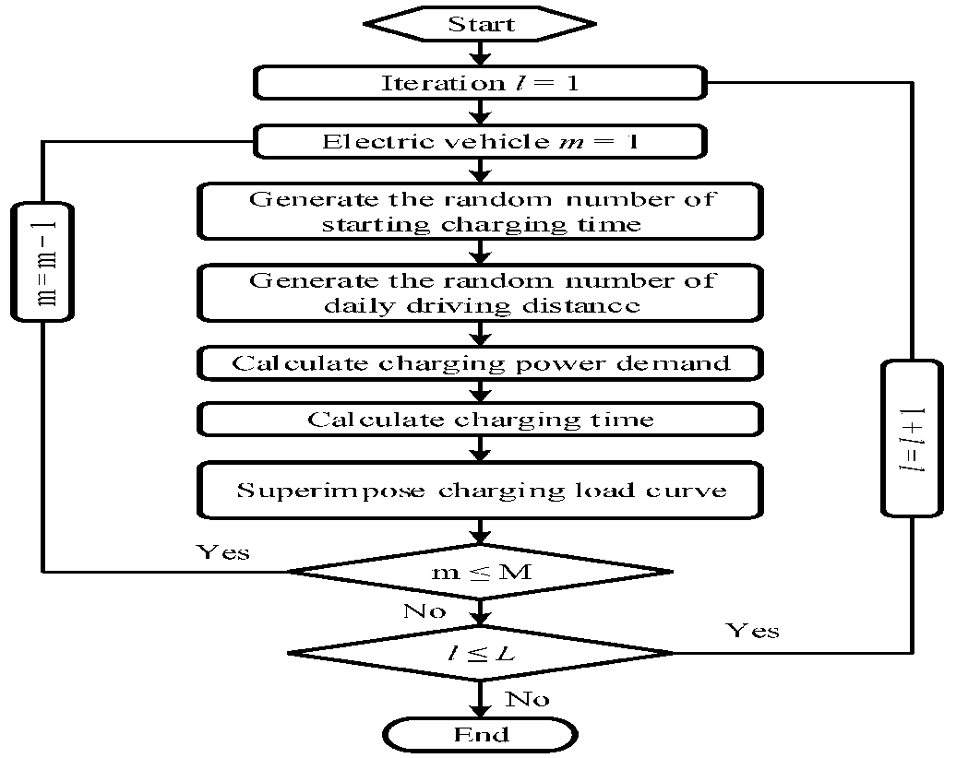
Following is a summary of the primary innovations and contributions of this study. Accurate energy management optimization is hampered by efficiency changes that frequently occur throughout the motor optimization process, which have an impact on system performance. Firstly, the impossibility of optimizing both motor and energy management control at the system level at the same time is tackled by the suggested approach [5]. A particular structure's ideal driving performance may be obtained by theoretically adjusting various structural elements. The control parameters' ability to match the optimal structure is not certain, though. Through system-level optimization, this paper explores the problem of combining energy management with the ideal structure and finds the best samples that accomplish a balanced combination of control and structure. 3) Conventional approaches optimize every parameter across the hybrid electric system, which raises the risk of a dimension catastrophe. On the other hand, nested design separates the optimization problem into tiers, such as engine, motor, and powertrain, and modularizes the hybrid electric system. By using this technique, the system's complexity is broken down into more manageable components that may be independently designed and optimized.

Methodology

Revenue is generated by tariffs and power sales; operating expenses are borne by the generators, storage units, and system. The second term ensures energy resource availability while accounting for reliability. The available power from storage units and generators, accounting for significant fluctuations in unit voltage levels from the previous time step and the dependability factor. Generators that fall short of a predetermined reliability standard will be penalized under the third term. The magnitude of the penalty depends on the distance of the distance between the reliability of the generator and distance between the cut-off that was set [6]. This objective functional offers an overall guideline to facilitate MG operations, which would establish a balance between the reliability of energy supply and economic factors. MCS approach has been utilized in this case to model the uncertainties of such an aspect. The multifaceted and randomness of the system are perfectly described by the MCS approach that gives the opportunity to explore the options of the situation and learn the existing state in detail. It shows at what time PHEV charging is supposed to begin. This formula illuminates the specific element that defines the commencement of PHEV charging, which is an essential element to understanding the dynamics of the infrastructure that underlies the charging. In this paper, Monte Carlo estimation of the PV power and the total charging load of electric vehicles (EVs) is done. The charging load profile of each particular EV is determined by the initial time and distance of the vehicle traveling. The load profiles of each of the participating electric cars are then overlaid to obtain the overall charging load profile.

PARAMETERS SELECTION AND SENSITIVITY ANALYSIS
A continuous variable and discrete variable optimization issue is presented by the interaction of topology, component dimensions, and control method. The dynamic model of the planetary gear is built upon the introduction of the planetary gear's characteristic parameter, K, in this section. K1 and K2, two typical characteristics, are chosen as the design parameters in order to achieve this as shown in Fig. 1. It is thought that an important factor influencing the vehicle's dynamic performance and fuel efficiency is the final drive ratio (FDR) gearbox ratio. Although the acceleration and climbing capabilities are higher, the fuel efficiency decreases with increasing final drive ratio. When the ratio is high, though, the engine won't be able to provide its maximum power to reach the target speed [7]. Additionally, the mode switch torque T, the limit of electric power retention, and the speed threshold at which the vehicle switches to operating mode v1 Additionally, SOC1 are regarded as the powertrain's control parameters. K1, K2, and fd have an impact on topology setup. Additionally, the control algorithm is linked to v1, T, and SOC1. Because these characteristics are interdependent, assessing how these parameters relate to the optimization goal necessitates using a scientific approach [8]. Numerous techniques have been employed to assess the sensitivity; correlation coefficients have been found.
Fig.1. Flowchart of the methodology
Based on the statistical analysis, it appears that all six of the design parameters were chosen to be bigger than the significance threshold. Specifically, each of their f coefficients is greater than 0.1, demonstrating their significance in influencing the objective variation [9]. Among all the characteristics, v1 has the most influence. In MC4 (M4), v1 has a value of 1.9, whereas in M3, it has the lowest value of 0.7. T, on the other hand, typically has minimal effect and exhibits little change between the maximum and minimum levels.

Result and discussions

This decrease not only reflects an immediate reaction to demand limits, but it also has larger implications for sustainable energy management. Comparison between the modified load and the MG's starting load is shown in Fig.2.
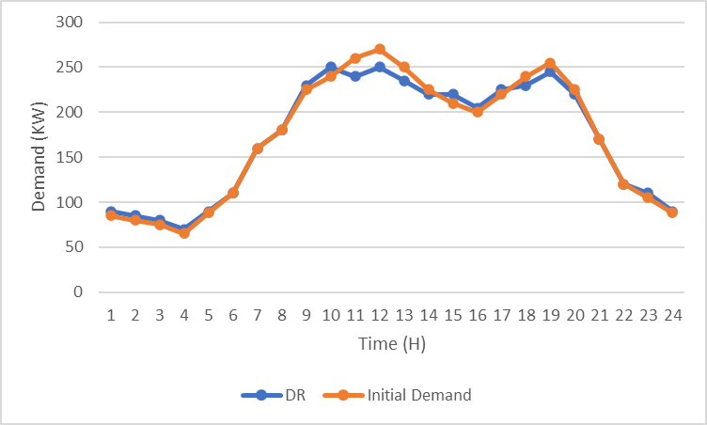
Fig. 2. Comparison between the modified load and the MG's starting load

The complex nature of charging and discharging features of the battery on the MG is shown in Fig. 4 as a visual tour of how the battery works throughout the day. The two axes are set to display the instances of battery drain and battery recharge respectively on the positive and negative axes of the graph respectively. In order to give a more in-depth examination of the subject we will take into consideration the droids of importance that are held in the charging and discharging process of the MG battery [10]. The charging events usually take place because of the overload of the energy or overload on the output of the RER as shown by the negative y-axis of the picture. This strategic charging is in compliance with the larger object of harnessing excess energy when the times are good to ensure good consumption and storing to be utilized in the future. The positive y-axis is, however, the discharging events which occur during high times which will also maximize the use of energy and ensure stability of the grid. These patterns of charge and discharge have to be created in a particular context so that the process of reading becomes more entertaining to the readers. Not everything about quality battery management in the larger sense is the ups and downs of charging and discharging the battery. It immediately maintains a list of benefits, which improve the work of MG.
To make Fig. 5 even more informative, it is impossible not to say that there is a necessity to find the way to derive the correlation between the most desirable power profiles of MTs and PEMFCs and the overall dynamics of energy supply and demand in the MG. It is perhaps with knowledge of how these profiles may be transferred to the overall operating needs of the MG that the reader will be able to understand the relevancy of the figure. This excellent performance of MG in terms of strategic management of energy is marked by the high output of the MTs and the PEMFCs in Figure 5 that shows that high power of the MTs and PEMFCs was generated at peak demand [11]. The load-balancing and responsiveness of such sources also enhance the overall resilience and performance of the MG in times of varying demand of energy. Finally, Figure 5 presents us with an impression of the role that has been played by the MTs and PEMFCs in determining the energy landscape of the MG. The optimal power output curves that have greater output at times of peak demand underline the strategic value of the sources [12]. Their responsiveness and load-balancing role is another testimony to their importance as the keystones of the MG energy policy. Through this thorough investigation, readers are invited to see the dynamic coordination of energy sources within the MG as well as the visual representation, which ensures a stable and flexible energy ecology.
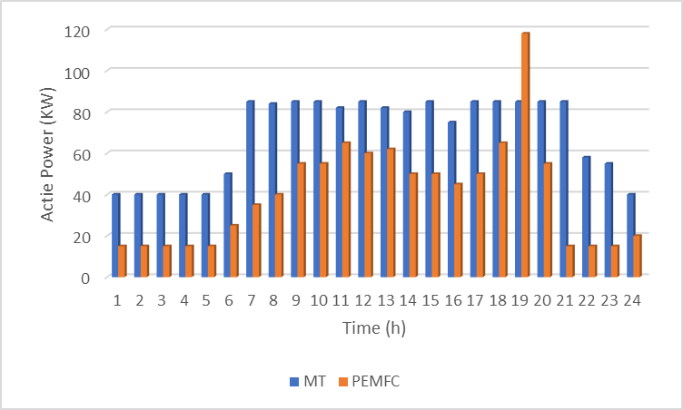

Fig. 3. 24 hours of maximum power for both MT and PEMFC
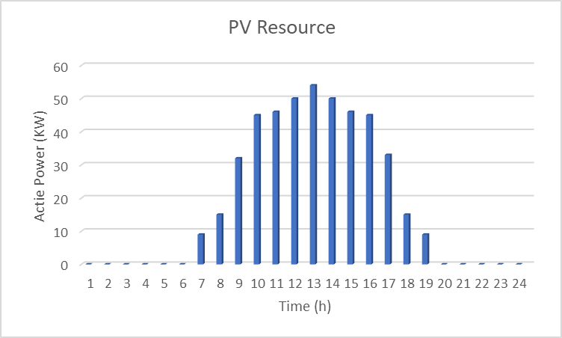
Fig. 4. Active power on PV Resources
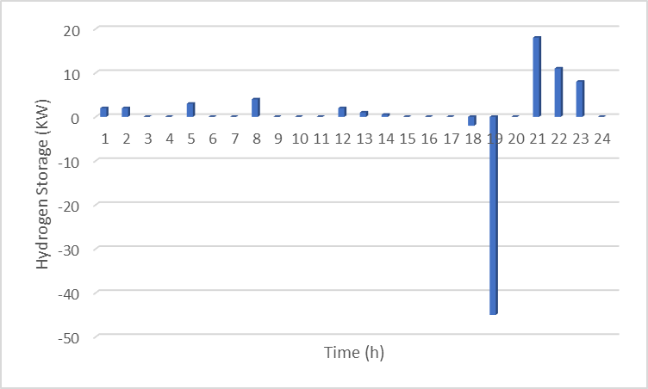
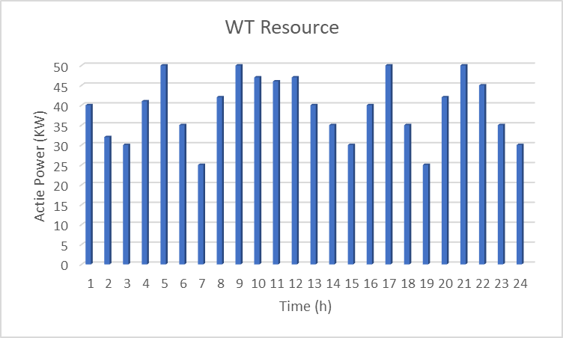
Fig. 5. Graph show the WT resources of energy

Fig. 6. Graph show the hydrogen storage state
Instead of only being graphical representations, the bolded conclusions that are shown in Fig 3, 4, 5 and 6 are visualizations of a synergistic energy management method. The results relate both to the flexibility of the MG to adapt to evolving energy needs as well as to demonstrate the radically new possibilities of holistic and sustainable energy management systems.
V. Conclusion
The study's findings present a novel method for optimizing MGs, tackling the complex issues brought about by the convergence of many parts such as energy storage solutions, CHP systems, RERs, PHEVs, and DRPs. These components are expertly coordinated by the stochastic framework to optimize MG performance. The process divided the engine, motor, and powertrain into discrete, separately developed, and optimized components. The hardware and software layers were continually optimized by utilizing the NSGAII and FHO algorithms to identify the ideal parameter combinations. show that choosing and installing the best battery for a BAPV system may lower costs, boost subscriber earnings, and enhance PS and SC. Although this study is conducted in a fixed location, future research might include variable factors in the calculations, examine how temperature affects battery health, PV deterioration, and investigate the possibility of using batteries for power arbitrage in order to increase the study's thoroughness. The suggested strategy not only provides better optimization outcomes, but it also offers a quicker and more effective solution, which is especially useful for bigger MG applications. To put it succinctly, this research contributes to the progress and efficiency of MG energy management by introducing a comprehensive strategy that not only overcomes complexity but also surpasses current techniques.

References

- Bornapour, M.; Hooshmand, R.A.; Khodabakhshian, A.; Parastegari, M. Optimal stochastic scheduling of CHP-PEMFC, WT, PV units and hydrogen storage in reconfigurable micro grids considering reliability enhancement. Energy Convers. Manag. 2017, 150, 725–741.
- Emrani-Rahaghi, P.; Hashemi-Dezaki, H. Optimal scenario-based operation and scheduling of residential energy hubs including plug-in hybrid electric vehicle and heat storage system considering the uncertainties of electricity price and renewable distributed generations. J. Energy Storage 2021, 33, 102038.
- Shojaeiyan, S.; Dehghani, M.; Siano, P. Microgrids Resiliency Enhancement against Natural Catastrophes Based Multiple Cooperation of Water and Energy Hubs. Smart Cities 2023, 6, 1765–1785.
- Huang, Y.; Xu, J.; Gao, S.; Lee, K.Y.; Wang, D.; Wang, B. Incomplete information oriented optimal scheduling of multi-energy hub systems with thermal energy storage. J. Energy Storage 2021, 42, 103062.
- Gao, C.; Lin, J.; Zeng, J.; Han, F. Wind-photovoltaic co-generation prediction and energy scheduling of low-carbon complex regional integrated energy system with hydrogen industry chain based on copula-MILP. Appl. Energy 2022, 328, 120205.
- Cui, Q.; Du, S.; Liu, C.; Zhang, L.; Wei, G. A stochastic optimal energy management strategy considering battery health for hybrid electric bus. Proc. Inst. Mech. Eng. Part D J. Automob. Eng. 2020, 234, 3112–3127.
- Cheng, T.; Zhu, X.; Gu, X.; Yang, F.; Mohammadi, M. Stochastic energy management and scheduling of microgrids in correlated environment: A deep learning-oriented approach. Sustain. Cities Soc. 2021, 69, 102856.
- Mokaramian, E.; Shayeghi, H.; Sedaghati, F.; Safari, A. Four-objective optimal scheduling of energy hub using a novel energy storage, considering reliability and risk indices. J. Energy Storage 2021, 40, 102731.
- Samimi, A.; Shateri, H. Network constrained optimal performance of DER and CHP based micro-grids within an integrated active-reactive and heat powers scheduling. Ain Shams Eng. J. 2021, 12, 3819–3834.
- Fan, S.; Ai, Q.; Piao, L. Hierarchical energy management of microgrids including storage and demand response. Energies 2018, 11, 1111.
- Bansal, Saloni, Birendra Kr Saraswat, and Vijay Kr Sharma. "Analysis of machine learning: enhancing performance and interpretability through deep neural network." Sustainability in Digital Transformation Era: Driving Innovative & Growth. CRC Press 76-80,
- Yadav, Kanchan, et al. "Digital Dimensions: Unveiling the Potential of E-Design and Virtual Prototyping." E3S Web of Conferences. Vol. 453. EDP Sciences, 2023.

