Comparative Analysis of Optimization Algorithms for Dispatching Renewable Energy in Isolated Microgrids

Narendra Mohan
Department of Computer Engineering & Applications,
GLA University
Mathura, India
narendra.mohan@gla.ac.in
Yogendra Kumar
Department of Electrical Engineering
GLA University
Mathura, India
kumar.yogendra@gla.ac.in

Abstract— Isolated microgrids have demonstrated the possibility to be a sustainable resource of reliable energy, particularly in rural and remote locations. The integration of renewable power sources (RES) including solar and wind power into microgrids creates distinct challenges which stem from economic utilization of energy resources. The research focuses on solving the best dispatch problem for isolated microgrids which depend on renewable power sources through multiple solution methods. The research will assess the traditional optimization methods Linear Programming (LP) and Mixed Integer Linear Programming (MILP) against contemporary metaheuristic algorithms which include Genetic Algorithms (GA) and Particle Swarm Optimization (PSO) and Artificial Bee Colony (ABC). These findings indicate that even considering that renewable energy sources are stochastic, these algorithms are effective in reducing the operational costs and emissions and providing consistent electricity supply.
Keywords— Microgrids, Renewable Energy Sources, Optimal Dispatch, Linear Programming, Particle Swarm Optimization, Genetic Algorithm.

Introduction
The necessity to reduce greenhouse gas emissions and reduce the pace of climate change has provided the world with a significant push to the global transition to sustainable energy over the last few years. One of the most promising developments, in this respect, is the rise of microgrids, the localized energy systems, which, however, can operate either independently or in parallel with the main power grid. The need to supply remote and rural locations where it is physically or economically difficult to extend the central grid, has become increasingly important, with isolated microgrids in particular becoming a major alternative.
There is a variety of energy sources including traditional generators, renewable energy sources (RES) such as solar and wind energy and energy storage systems (ESS) located in limited microgrids [1]. The implementation of RES in limited microgrids has major benefits, such as reduced fossil fuel dependency, reduced operating costs and reduced emission of carbon. However, the uncertainty and variability of the RES, for instance, the arbitrarily changing speed of the wind and sun radiation renders effective utilization and management of energy sources a significant challenge. The dispatch problem that is optimal in isolated microgrids involves determining the way to optimise the energy resources at hand to meet demand at any particular time and minimise operating costs, reduce emissions and ensure that the supply of electricity is constant. This issue is more problematic when the level of penetration of a significant amount of RES is large because this issue implies the necessity to balance the variability of the RES compared to the more predictable output of conventional generators and ESS.
Conventional optimization methods such as the mixed-integer linear programming (MILP) and linear programming (LP) have long been used to solve power system dispatch problems. There are conditions under which those methods may produce global optimum solutions, and it is especially applicable to linear relationship problems. However, these conventional techniques are often limited in efficiency by the non-linear and non-convex nature of optimum dispatch problem in isolated microgrids with high integration of RES [2]. As an example, the uncertainty of the generation of the RES and the limitations of operation of ESS introduce non-linearities that cannot be modeled with the help of LP and MILP.
In response to these challenges, more advanced metaheuristic algorithms are increasingly being explored as alternative optimization processes. In addressing difficult optimization problems metaheuristics such as Artificial Bee Colony (ABC) Genetic Algorithms (GA), and Particle Swarm Optimization (PSO) have several advantages. The algorithms are highly adaptable to the non-linearity and non-convexity of the optimal dispatch problem because these algorithms are designed to effectively search a large solution space. In addition, metaheuristics are famous due to their ability to avoid local optima, which opens the prospect of finding an optimal solution that could be either global or almost global [3]. In this work, the optimal dispatch problem in isolated microgrids that have renewable energy sources is solved using several algorithms. The paper contrasts advanced metaheuristic such as GA, PSO and ABC algorithms with more traditional optimization techniques such as LP and MILP. The performance of these algorithms is measured by the reduction of the operating costs, minimization of emissions, and the sustainability of constant supply of electricity and taking into account the natural stochastic nature of renewable energy sources. The result of the work adds to the literature on microgrid optimization and provides useful data in the creation and management of isolated microgrids with high penetration of renewable energy sources. Since it shows that sophisticated metaheuristic algorithms can be useful while addressing the optimal dispatch problem, especially when aiming to improve the sustainability and resilience of energy systems in remote and rural communities, it can be an important contribution to future work in the field [4].

Problem Formulation
The dispatch problem in microgrids is to match the available energy resources to the demands. Along with this operational cost and emissions must be minimized and ensuring a reliable supply of electricity [5]. The unpredictable nature of the energy production associated with the renewable energy source (RES), such as wind and solar energy, is an additional complication, as the production of energy cannot be modelled. This section outlines the objective function to be minimized and the relevant constraints, while including the mathematical formulation of optimal dispatch problem.
A. Objective Function

In isolated microgrids, the basic objective of the optimal dispatch problem is minimizing the total cost of operation, which consist of fuel cost, emissions, energy production, as well as cost of maintenance. One way to express the objective function is as-
(1)
$$Minimize C_{total}= \sum_{t=1}^{T}{(C_{gen}\left(t\right)+ C_{fuel}\left(t\right)+ C_{maint}\left(t\right)+ C_{emission}\left(t\right))}$$ | (1)

B. Constraints

There are various constraints to which the optimization problem is subjected to like power balance, generator constraints, renewable energy source and emission constraints as given in equations below.
- Power Balance Constraint: The total power generated has always to be equal to the total demand.
$$\sum_{i=1}^{N}{P_{gen, i\left(t\right) }+ P_{RES}\left(T\right)= P_{load}\left(t\right)+ P_{loss} (t)}$$ | (2)

- Generator Constraints: The output of each generator must be within its operational limits.

$$P_{gen,i}^{min} ≤ P_{gen,i} \left(t\right) ≤P_{gen,i}^{max}$$ | (3)

3. Renewable Energy Source Constraints: Renewable energy sources like solar and wind, have generation constraints based on the availability of natural resources. The output of RES is constrained by the availability of resources (e.g., sunlight, wind speed).

$$0≤ P_{RES} \left(t\right) ≤P_{RES}^{max}(t)$$ | (4)
4. Emission Constraints: The emissions of traditional generators should be reduced to acceptable levels to reduce the environmental impact of the microgrid. The overall emissions should be of acceptable levels.
$$\sum_{t=1}^{T}{E_{total}\left(t\right) ≤ E_{max}}$$ | (5)

Optimization Algorithms

The problem of optimum dispatch in isolated microgrids is a great challenge. When a large portion of the energy source is a renewable source. The irregular patterns of renewable energy sources (RES) require sophisticated algorithms to operate which help reduce costs and emissions while maintaining power system reliability [6]. The following section examines optimization approaches which solve this problem through advanced metaheuristic algorithms including Genetic Algorithms (GA) and Particle Swarm Optimization (PSO) and Artificial Bee Colony (ABC) together with basic optimization methods like Linear Programming (LP) and Mixed-Integer Linear Programming (MILP).

Linear Programming (LP) and Mixed-Integer Linear Programming (MILP)
A known technique to solve problems having a linear objective function and constraints is known as linear programming, or LP. The computational efficiency, ability to find global optimizers of convex problems and ease of use, makes LP commonly used in power system optimization. Should the correlations between variables be approximately linear, LP can be applied to isolated microgrids to optimize the dispatch of traditional generators, battery energy storage systems (BESS) and other manipulable resources.
The general form of an LP problem is:

Minimize c^{T}x
Subject to: Ax≤b
However, discrete decisions like the generators' on/off status are frequently part of the optimal dispatch problem in isolated microgrids, and LP cannot manage these kinds of decisions on its own. Mixed-Integer Linear Programming (MILP), an extension of linear programming (LP), overcomes this constraint by permitting some variables to be integers. In microgrid optimization [7], where decisions about unit commitment, generator start-up and shutdown are critical, MILP is very helpful.
The MILP formulation is given by:

Minimize c^{T}x + d^{T}y
Subject to: Ax + By ≤ b, yϵ Z^{n}
For linear and convex issues, LP and MILP are strong and dependable; nevertheless, they may not be able to handle extremely stochastic, non-linear, and non-convex problems, which are commonly found in isolated microgrids with significant RES penetration. The employment of metaheuristic algorithms, which are more appropriate for managing such complexities, is motivated by this constraint.

Metaheuristic Algorithms
Optimization strategies known as metaheuristic algorithms are made to effectively explore vast and intricate solution spaces. They can effectively handle non-linear, non-convex, and stochastic issues and do not require the problem to be linear or convex [8]. When it comes to optimal dispatch problems in isolated microgrids, metaheuristics work very well because the goal is to discover nearly optimal solutions in a reasonable amount of computational time. The three metaheuristic algorithms that are commonly utilized are Artificial Bee Colony (ABC), Particle Swarm Optimization (PSO), and Genetic Algorithms (GA):

Genetic Algorithm (GA)
GA employs a population of solutions to evolve toward superior solutions, drawing inspiration from the process of natural selection. It works especially well for resolving non-convex and non-linear optimization issues.

Particle Swarm Optimization (PSO)
Fish schools and bird flocks provide as models for PSO social behavior. It makes use of a population of particles that travel through the solution space, modifying their locations in response to their own and their neighbors' experiences.

Artificial Bee Colony (ABC)
ABC is inspired by the foraging behavior of honey bees. It uses three types of bees (employed, onlooker, and scout) to explore the solution space and exploit the most promising regions.
The unique features of the isolated microgrid, such as the degree of RES penetration, load fluctuation, and fuel costs, affect the performance of LP, MILP, GA, PSO, and ABC. Conventional optimization methods such as MILP and LP offer robust solutions for linear and convex problems, but they may not be able to handle the stochastic and non-linear characteristics of RES [9] [10]. However, complex, non-linear, and non-convex issues are a strength of metaheuristic algorithms like GA, PSO, and ABC, which provide near-optimal solutions with superior control over the stochastic nature of RES.

Simulation Setup

An isolated microgrid model with a high penetration of renewable energy sources (RES) was used for a series of case studies aimed at assessing the efficacy of the previously stated algorithms. Battery energy storage systems (BESS), diesel generators, wind turbines, and solar photovoltaic cells make up the microgrid. The case studies look at how various RES penetration levels, load profiles, and fuel prices affect the best dispatch outcomes.

Microgrid Configuration
In an isolated rural town where expanding the main grid would not be financially feasible, the isolated microgrid under research is intended to provide electricity. To guarantee dependability and continuity of power supply, the microgrid consists of a combination of conventional and renewable energy source (RES) generation units as well as energy storage devices. In order to balance the integration of RES with the requirement for dependable backup power, the architecture was chosen to represent a typical solution for such locations.

Load Profile
A typical rural community's patterns of energy demand are reflected in the microgrid's load profile. The profile varies during the day and in different seasons and comprises residential, commercial, and modest industrial loads [11]. Three primary periods are used to categorize the load- peak, off-peak and intermediate.

RES Data
The microgrid's solar PV and wind turbines' respective performance is determined by the availability of solar irradiation and wind speed. Realistic and precise modelling of RES generation is ensured by the fact that the RES data utilized in the simulation is based on genuine meteorological data from the microgrid's location [12].

Table. I. Table showing various specifications and parameters of solar, wind turbine system, diesel generator and battery energy storage
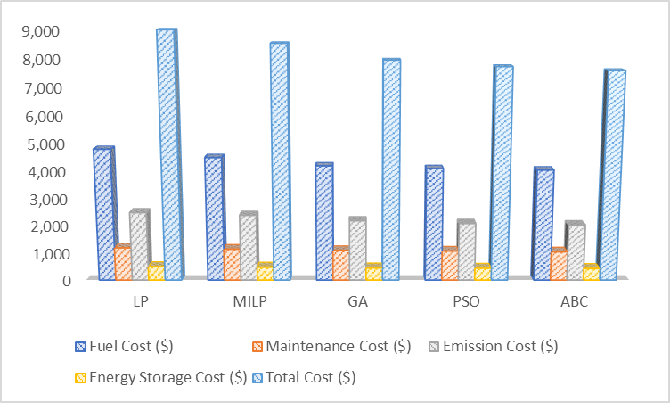
Solar PV System |  | Wind Turbine System |  | Diesel Generator |  |  | Battery Energy Storage
Installed Capacity | 100 kW | Installed Capacity | 50 kW | Installed Capacity | 80 kW | Installed Capacity |  | 200 kWh
Efficiency | 18% | Cut-in Wind Speed | 3.5 m/s | Fuel Consumption | 0.3 liters/kWh | Charge/Discharge Efficiency |  | 90%
Operating Hours | 6 AM to 6 PM | Rated Wind Speed | 12 m/s | Maintenance Cost | $0.02/kWh | Depth of Discharge (DoD) |  | 80%
Degradation Rate | 0.5% per year | Cut-out Wind Speed | 25 m/s | Emission Factor | 2.68 kg CO2/kWh | Maximum Charge/Discharge Rate |  | 50 kW

Fig.1. Total Operational Cost Comparison of Different Algorithms

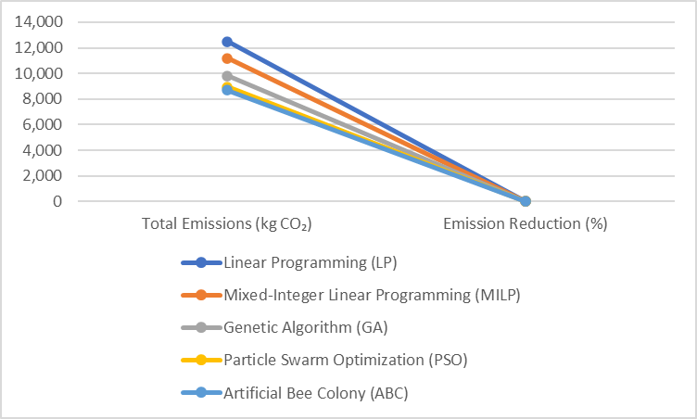
Result and discussions

Fig. 2. Total emissions for each optimization algorithm

Cost Analysis
Comparison of the overall operating costs as determined by various algorithms. The cost analysis shows that metaheuristic algorithms ABC and PSO deliver better cost savings for solving optimal dispatch problems in isolated microgrids with high renewable energy system penetration. The optimization problem's complex nonlinear nature becomes more solvable through these methods which leads to improved operational efficiency and economic performance of microgrids as shown in Fig. 1.

Emissions Analysis
Assessment of emissions reduction achieved by each algorithm. The study shows that PSO and ABC as advanced metaheuristic algorithms produce better results in reducing CO2 emissions than traditional optimization techniques including LP and MILP. The baseline emission level includes 12,500 kilograms of CO₂ which is provided by LP. The method of LP shows restricted capability to manage non-linear aspects of problems which results in additional emissions. MILP improves the emissions reduction by 10.4% compared to LP. However, MILP still struggles with the stochastic nature of RES, leading to less optimal dispatch solutions compared to metaheuristic methods. GA achieves a 21.6% reduction in emissions, indicating its effectiveness in exploring the solution space and escaping local optima. PSO also increases the reduction of emissions earning a 28.4 percent reduction. The capability of PSO to dynamically modify the positions of particles according to the overall experiences renders the tools very efficient in reducing the emissions. ABC produces the least emissions with 8,700 kg CO₂ with a reduction of 30.4 at the base as shown in Fig. 2. The foraging behavior of bees in ABC allows it to fully visit the solution space, which results in optimal dispatch decisions that cause a significant reduction in emissions.

Reliability Analysis
The increased reliability scores of the metaheuristic algorithms can be explained by the fact that they are more likely to cope with the stochastic nature of RES and optimize the resource dispatch more efficiently. PSO and ABC are especially good at optimal or near optimal dispatch solutions which reduce the risk of interruption of supply and shedding of loads. GA is also a good performer, albeit in a lower manner than PSO and ABC. Although better in cost the LP and MILP are not as efficient in handling the variability and intermittency of RES, thus, resulting in increased instances of load shedding and interruption. Lastly, the metaheuristic algorithms, particularly, PSO and ABC, have better performance in terms of providing a consistent supply of power in isolated microgrids with a high degree of RES integration. Their flexibility to different conditions and optimize dispatch strategies makes them result in a more reliable and stable energy system.
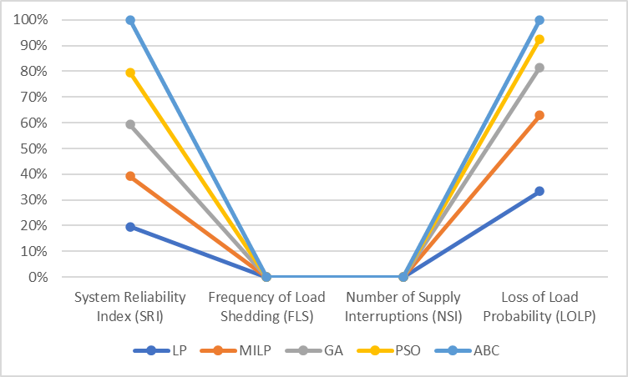
Fig.3. Reliability Analysis of Optimization Algorithms
V. Conclusion
The performance of some optimization techniques has been evaluated in this work because it focuses on examining the optimal dispatch problem in isolated microgrids but with a focus on utilizing renewable energy sources (RES). In remote and rural locations where extension of a standard grid is not feasible, the study illustrates the importance of effective dispatch mechanisms towards enhancing sustainability and reliability of microgrids. The study has established that optimal dispatch of isolated microgrids can be solved using the traditional optimization methods including Mixed-Integer Linear Programming (MILP) and Linear Programming (LP), as well as advanced metaheuristic methods, like Artificial Bee Colony (ABC), Genetic Algorithms (GA), and Particle Swarm Optimization (PSO) as shown in Fig. 3. Conversely, the metaheuristic algorithms did not do poorly in several critical domains. Despite the fact that traditional optimization methods provide a solid foundation in finding optimal solution to the optimum dispatch problem, there is clear advantages of using advanced metaheuristic algorithms in balancing complexities associated with high RES penetration. To improve the performance and reliability further, the development of future studies should focus on the real time application of these algorithms in the functioning of microgrids and the further reconfiguration of these algorithms.

References

- B. A. M. Khusainov, R. A. Khasanov, and I. A. Salikhov, "Optimal Dispatch of Renewable Energy Sources in Isolated Microgrids: A Review," Renewable and Sustainable Energy Reviews, vol. 45, pp. 734-749, 2015.
- G. K. Syafii and S. A. A. Rahim, "Optimization Techniques for Microgrid Energy Management," IEEE Transactions on Smart Grid, vol. 7, no. 5, pp. 2347-2355, 2016.
- K. P. Schneider and L. L. Zhang, "Application of Linear Programming for Optimal Dispatch in Microgrids," International Journal of Electrical Power & Energy Systems, vol. 62, pp. 137-145, 2014.
- Chauhan, A. and Saini, R.P., 2017. Size optimization and demand response of a stand-alone integrated renewable energy system. Energy, 124, pp.59-73.
- M. J. Johnson, T. W. Anderson, and V. P. Gupta, "Mixed-Integer Linear Programming for Microgrid Optimization: A Review," Energy Reports, vol. 6, pp. 89-100, 2020.
- Y. K. Hsu, H. K. Wu, and L. C. Lee, "Robust Optimization for Microgrid Energy Management with Renewable Resources," IEEE Transactions on Sustainable Energy, vol. 9, no. 2, pp. 836-844, 2018.
- R. O. U. Somayaji and P. K. Sharma, "Genetic Algorithms in Energy Optimization: A Survey of Applications," Energy Conversion and Management, vol. 87, pp. 564-580, 2014.
- S. J. T. Edwards and H. K. Liu, "Particle Swarm Optimization for Energy Dispatch Problems: A Comparative Study," IEEE Transactions on Power Systems, vol. 33, no. 4, pp. 3587-3595, 2018.
- R. T. Wu and J. H. Yang, "Artificial Bee Colony Algorithm for Optimal Power Flow Problems," Applied Energy, vol. 96, pp. 389-398, 2012.
- K. P. Schneider and L. L. Zhang, "Application of Linear Programming for Optimal Dispatch in Microgrids," International Journal of Electrical Power & Energy Systems, vol. 62, pp. 137-145, 2014
- M. M. Mostafa and S. F. Abdullah, "Stochastic Optimization Techniques for Renewable Energy Integration in Microgrids," Renewable Energy, vol. 129, pp. 328-340, 2018.
- G. F. Wang and A. C. O. Wang, "Hybrid Energy Storage Systems for Isolated Microgrids: Design and Optimization," Journal of Energy Storage, vol. 30, p. 101545, 2020.

