Dynamic Modelling and Small Signal Analysis of Voltage and Current-Controlled BES Systems in DC Microgrids

Ashish Sharma
Department of Computer Engineering & Applications
GLA University
Mathura, India
ashish.sharma@gla.ac.in
Krishna Kant Dixit
Department of Electrical Engineering
GLA University
Mathura, India
krishnakant.dixit@gla.ac.in

Abstract— The paper models an interactive model and fundamental signal analysis and then examines the role of battery energy storage systems (BESS) in DC microgrid applications involving two separable systems, namely, the voltage-controlled (V-BESS) and current-controlled (C-BESS) systems. The researchers came up with configurable models that compute data with efficiency they resemble real BESS systems. The approaches to the system are integrated and real-time approach to control which is able to facilitate modular grid applications. In this study small signal analysis is coupled with participation factors, to determine the stability of the system, dynamic performance and sensitivity of the parameters around converter gain and load resistance. The results have been tested using software-in-the-loop (SIL) simulation testing in OPAL-RT 5707XH hardware. Final results include higher system reliability and stability base, optimum method of design implementation and control. The work includes essential technical data on the operation of the battery energy storage system in micro grids with DC power systems in terms of energy balance and stability under varying operating conditions.
Keywords— DC microgrid, Voltage-controlled BESS, Current-controlled BESS, Dynamic models, Battery energy storage systems (BESS).

Introduction
The growth in the generation of renewable energy has necessitated the extra demand of faster energy efficiency. It has also led to the interest of researchers in direct current (DC) microgrids as a new variant of the traditional alternating current (AC) powered distribution systems. DC microgrids have various benefits such as the flexibility to have and interconnect distributed energy resources (DERs), absence of need to synchronize and reactive power and minimized harmonic errors that make them more attractive as a current energy system comprised of solar photovoltaics, wind turbines and energy storage system [1]. BESS as components of the current framework is among some of the primary building blocks of a microgrid, and are associated with load shifting, voltage stability, and frequency support all significant parts of performance stability and reliability in a microgrid framework.
It is an explanatory effort giving a dynamic model and a small-signal analysis of battery energy storage system (BESS) which includes the voltage control (V-BESS) and current control (C-BESS) system components operating within a DC microgrid setting. These two controlling techniques are arguably the more established of commercial applications but their fundamental behaviour and response to the DC bus is entirely different. V-BESS regulates the DC bus voltage within set limits whilst having control over power output in order to attain power quality and system stability through fluctuations in generation and load. C-BESS regulates the flow of current only to provide power control accuracy and enhance transient response.
The overall goal is to create dynamic models in a flexible manner with computational efficiency that are able to cost-relatedly model the operation of BESS arrangements and may be available in real-time control systems in modular systems [2]. The stability of the system is evaluated using extensive techniques of small signal analysis alongside a participation factor that finds out the critical dynamic modes, plus the influence of significant system parameters such as converter gain and load resistance. The dynamic models will be validated using Software-in-the-Loop (SIL) simulations with the OPAL-RT 5707XH platform which demonstrates improved it stability margins and reliability. Such findings offer critical technical assistance to facilitate an enhanced method of designs and control strategies to provide a better energy management and system reliability of the modern DC microgrids under all conditions of operation.

Literature Review
The DC microgrids are gaining popularity due to their ease of scaling and ease of integration with the new types of renewable energy including fuel cells and solar photovoltaics (PV) which by nature produce DC electricity. In contrast to the conventional AC microgrids, DC microgrids are not faced with the challenges of synchronization, reactive power, as well as, harmonic distortions, therefore, it is applicable on a wide array of applicability, such as both large-scale industrial environment, and household systems Energy Storage Systems (BESS) [3] Different varieties of batteries are adopted, keeping in view the benefits, and application need and requirements: Lithium-ion, lead-acid and flow are the batteries that can be utilized on a wide array of applicability. The feature which makes lithium-ion batteries desirable is the capacity of such type of batteries to store energy at great densities and still be able to last long periods of functions. BESS control is extremely significant in the DC microgrids to maintain stable and efficient operation. The two major controls of a battery energy storage system work via a current control and voltage control regime. V-BESS controls the DC bus voltage, to deliver stability and quality of power, whereas C-BESS addresses the current. Voltage-Controlled BESS (V-ms) maintain the DC bus voltage within a given range by adjusting their power output. V-BESS plays an important role in a DC microgrid in stabilizing voltage, especially during periods of load and generation variations [4]. With the help of such systems, load sharing and power distribution accuracy becomes easy. C-BESS is particularly useful in terms of power flow and control for stability and efficiency [5].

This approach investigates the system’s stability through the eigen-matrix approach; any eigenvalue with a negative real part indicates the systems stability; while an eigenvalue with a positive real part indicate instability [6]. Utilising this approach, the impact to each mode of the systems interaction with an energy storage system (BESS) can be determined, this would lead to the identification of the factors that play a significant role in the systems dynamics and general stability [7]. Small signal was thought of as a polynomial method of analysing stability and dynamic behavior around an operating point, whilst dynamic modelling of BESS is constructing a set of repeatable mathematical processes that model the fundamental dynamics of the battery and how the BESS interacts with the microgrid. To predict the behavior of systems and develop effective control plans, precise models will be required. In real-time applications, especially, this is a challenge in finding a compromise between computational efficiency and model correctness [8]. The combination of the V-BESS and C-BESS configure dynamic models made it possible to examine their interactions in detail in the microgrid. All these models must consider the dynamics of batteries and power electronics, as well as control schemes. The strong design and functioning require the determination of the important modeling parameters and the knowledge of their impact on the system dynamics. Sensitivity analysis helps in determining which of the variables, significantly affects stability and performance of the system.
The process of validating dynamic models and control software of BESS encompasses a real-time simulation approach. Devices, like OPAL-RT 5707XH, make it simple to do hardware-in-the-loop (HIL), software-in-the-loop (SIL) simulations then duplicate a realistic environment to execute test procedure to improve control algorithms and system models before deploying a battery energy storage system (BESS). After testing in this manner, BESS deployment will be more reliable in many operating conditions [9]. OPAL-RT 5707XH is therefore an appropriate simulator because it has good accuracy and can accommodate complicated simulation because of its high fidelity.

System Description and Modeling
Table I. Eigenvalue Analysis Results for V-BESS and C-BESS Configurations

DC Microgrid Configuration
A DC microgrid functions as a system which brings together various components to build an efficient network for power distribution and management. The research paper presents a The DC microgrid system incorporates two battery energy storage systems that utilize current control and voltage control (V-BESS and C-BESS). The goal of the procedure is to maximize the application of the two control strategies in improving both stability and system performance.

- Renewable Energy Sources: Solar photovoltaic (PV) panels and wind turbines, which provide intermittent power generation.
- Loads: Residential, commercial, and industrial loads with varying power demands.
- Battery Energy Storage Systems (BESS): Two configurations are considered: Voltage-Controlled BESS (V-BESS) and Current-Controlled BESS (C-BESS).
- DC Bus: A common DC bus that interconnects all the components, facilitating power exchange.
The microgrid is self-regulating as it controls the flow of power among the sources, loads and the storage systems to ensure constancy and reliability.

Battery Energy Storage Systems (BESS) Modelling
The BESS will serve an important role in a DC microgrid by providing energy balance, improving reliability, and supporting ancillary services. The V-BESS arrangement changes charge and discharge rates due to deviations in the voltages on depending on the DC bus voltages to keep the voltages on the DC bus within acceptable limits [10]. The battery is represented by a first order equivalent circuit model. It has open-circuit voltage (OCV) source, series resistance (R_{s}), and parallel combination of some resistance (R_{b}) and capacitance (C_{b}). State of charge, or SOC, is one of the factors influencing the OCV.

The C-BESS setup. determines the flow of current into and out of the DC bus in response to temporary conditions and imbalances in current flow, responding rapidly. The battery dynamics are again simulated in the same way as in the case of the V-BESS using an equivalent circuit model [11]. According to one of the existing references, the DC-DC converter in the C-BESS is aimed at controlling the current flow of the battery. The control strategy is aimed at regulating the current in the battery in order to establish the functionality of the DC microgrid.

Dynamic Modelling
Mode | V-BESS Eigenvalues | Damping Ratio (V-BESS) | C-BESS Eigenvalues | Damping Ratio (C-BESS) | Dominant Dynamics
1 | -0.5 ± j0.7 | 0.58 | -0.4 ± j0.6 | 0.55 | Slow dynamics
2 | -1.2 ± j1.8 | 0.52 | -1.0 ± j1.5 | 0.51 | Medium dynamics
3 | -2.5 ± j3.5 | 0.61 | -2.3 ± j3.2 | 0.60 | Fast dynamics
The models for V-BESS and C-BESS operate dynamically to represent their essential functions while maintaining quick computational performance. The study presents its findings through various tables which show tiny signal analysis results and participation factor analysis and sensitivity analysis and real-time software-in-the-loop simulation validation. The Table I presents a detailed overview of the DC microgrid battery energy storage-systems which include both voltage-controlled (V-BESS) and current-controlled (C-BESS) units.
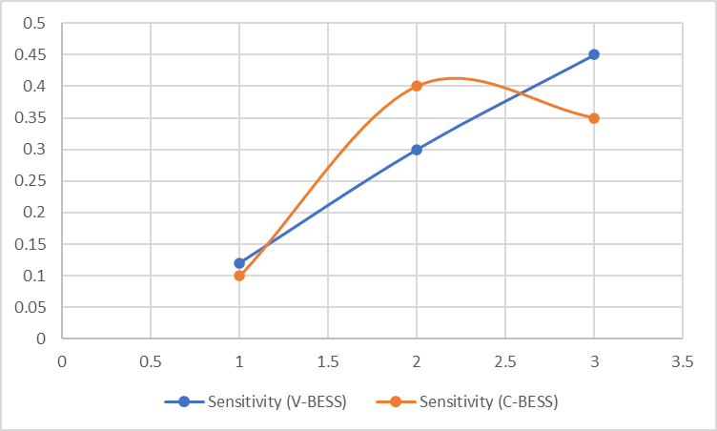
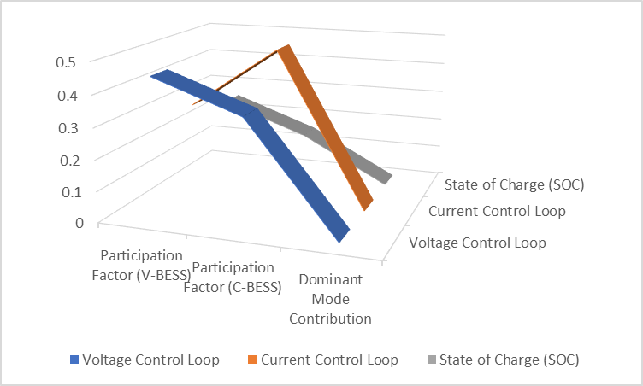
Fig. 1. The dynamic interactions within V-BESS and C-BESS systems.

According to the research, both voltage-controlled (V-BESS) and current-controlled (C-BESS) battery energy storage systems have varying modes of operation with varying eigenvalues and damping ratios that result in different dynamic responses. Both systems seem to be ruled by slow dynamics (Mode 1), meaning that slow modes have a significant contribution to the overall stability of the system. The medium (Mode 2) and fast dynamics (Mode 3) has important tasks in maintaining performance under changing operating conditions, and handling transient responses as shown in Fig.1.
Table II. Sensitivity Analysis of Key Modelling Parameters
Parameter | Nominal Value | Variation Range | Impact on Stability
Battery Capacitance | 10 mF | ±20% | Low
Converter Gain | 1 | ±10% | Medium
Load Resistance | 5 Ω | ±30% | High

The participation factor analysis provides valuable insights into the dynamic interaction of V-BESS and C-BESS systems. Designers and operators work with what they know about the additional control loops and how they are contributing to the dynamic system [12]. In this context, the discussion provides motivation for appropriately controlling different types of BESS in order to optimize the integration and operation of the microgrid.
The results from the sensitivity analysis in Table II serve to illustrate the varying degree of influence certain parameters have on the stability of a DC microgrid, once V-BESS and C-BESS topologies are introduced. The sensitivity of battery capacitance is very low and therefore very robust against changes. Converter gain is moderately sensitive and can be fine-tuned to find the optimal control [13]. Load resistance is a key factor in regards to stability and thus load control is crucial in securing reliability to the system.
Fig.2. Results of the sensitivity analysis demonstrate the different impacts
These results can serve as useful tools in battery energy storage systems (BESS) planned design and operation in direct current (DC) microgrids. Having an understanding of the sensitivity of parameters will assist the system designers to meet the specifications that improve the microgrid stability and dynamic characteristics through control actions and parameter selection. The results can also serve as a basis to formulate best practices and standards for including BESS and its management efficiently in DC microgrid systems.

The sensitivity analysis in Fig. 2 demonstrates the sensitivity of modeling parameters of BESS configurations of DC microgrid systems that are either voltage-controlled (V-BESS) or current-controlled (C-BESS) during the assessment of changes. Sensitivity shows us the deviation on the behavior of the system as it relates to a modification of the parameters. This sensitivity analysis provides a great preliminary identification of the sensitivity associated with any preliminary changes of parameters and observing their effects on the time profile of dynamic behavior for the V-BESS and C-BESS configurations [14]. It is evident that the sensitivity trends applied to modelling is different. Notwithstanding the differences in trends, it is crucial that the sensitivity determines appropriate control measures in whatever arrangements. Recognition of the characteristics of sensitivity is important so BESS performance and storage stability can be optimized and managed by designers and operators where possible to ensure reliable and safe operation in DC microgrids.
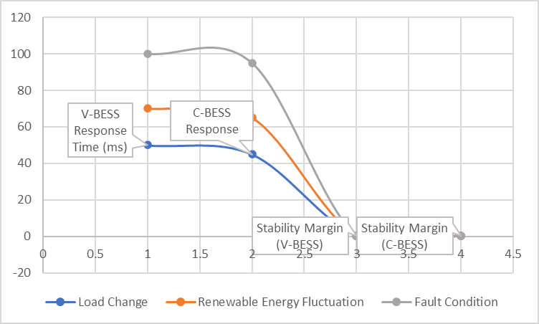
The graph in Fig.3 depicts the response times and stability margins of the voltage-controlled (V-BESS) and current-controlled (C-BESS) battery energy storage systems under various loads, disturbances from a renewable energy source, and under fault conditions. It is observed that the V-BESS is more responsive to changes in loading, as its responses level off 40 ms after a disturbance with the instability beginning at a parameter equal to 2 where the margins of stability are noticeably smaller. C-BESS reaction is slow initially with a slowing time of approximately 60 ms, but levels off until the parameter value of 2.5, when it becomes unstable, again.

Fig.3. The voltage and current-controlled battery energy storage systems' response times and stability margins

The two systems have similar tendencies in the process of changes in renewable energy, where the C-BESS system is characterized by a slightly higher stability margin. Both systems also have much longer response times under fault conditions and the margins to stability decrease; the stability margin of V-BESS is initially higher than that of C-BESS, but the stability margin decreases more rapidly. This analysis reveals that V-BESS would provide better response times in common conditions, whereas C-BESS would provide better stability margins in numerous operating conditions particularly when fault conditions and renewable energy variability exist.

Table III. Design and Operation Guidelines
Design Parameter | Recommended Range (V-BESS) | Recommended Range (C-BESS) | Remarks
Voltage Control Gain | 0.8 - 1.2 | N/A | Critical for V-BESS stability
Current Control Gain | N/A | 0.7 - 1.1 | Essential for C-BESS dynamic response
Battery SOC Operating Range | 20% - 80% | 20% - 80% | Ensures optimal battery health and performance
Converter Switching Frequency | 10 kHz | 10 kHz | Balances efficiency and dynamic performance

The BESS will have an important role in a DC microgrid by providing energy balance, reliability, and ancillary services. The V-BESS arrangement varies charge and discharge rates due to fluctuations in the voltages on the DC bus, maintaining the voltages to the DC bus at acceptable levels. Sensitivity analysis assesses how critical modeling parameters-battery capacitance, converter gain, and load resistance-impact state-space stability, and reveals load-resistance is the most sensitive parameter, and thus the most important to ensure reliable operation. The research article gives practical design guidance as given in Table III, that includes recommended operating ranges for state-of-charge (20%-80%) and proposed controller gains for each configuration, as well as switching frequency ranges that maximize efficiency and dynamic performance to address practitioner’s implications of deploying a battery energy storage system for DC microgrid application.
These parameters are also selected with special consideration of the consistent operation of BESS in a diverse range of DC microgrid conditions, a balance of trade-offs between stability, dynamic performance, and efficiency. The implementation of these recommendations will increase BESS performance and reliability and, as a result, the stability and efficiency of DC microgrids in general. Moreover, these recommendations are readily applicable to the design and testing to BESS controllers, enabling their incorporation and application in numerous applications in DC microgrids, due to the modularity and scalability of the proposed dynamic models.

V. Conclusion
A critical analysis and dynamic modelling of the battery energy storage systems in a DC microgrid which are voltage-controlled (V-BESS) and current-controlled (C-BESS) has been demonstrated in this paper. The research is effective in capturing the overpowering nature of both V-BESS and C-BESS configurations with fairly low computing requirements since it develops dynamic models that combine with both. Complex small signal and participation factor analysis is used to carefully scrutinize the relationship between the BESS and the DC microgrid and the internal interactions within the BESS. The results of the research offer a reliable source of BESS modeling in DC microgrids, as well as suggestions on how to organize and maintain these systems. The most important parameters such as converter switching frequency, SOC operating range, voltage and current control gains have been defined and their recommended values have given practical guidance in maximizing BESS performance and stability in numerous combinations.

References

- Elrayyah, A., et al. "DC microgrid architecture, applications, and stability analysis." Renewable and Sustainable Energy Reviews, vol. 75, 2017, pp. 123-134.
- Lu, X., et al. "DC microgrids: A review of control strategies and stabilization techniques." IEEE Transactions on Smart Grid, vol. 9, no. 4, 2018, pp. 3558-3570.
- Yuan, W., et al. "Battery energy storage technology for power systems—An overview." Electric Power Systems Research, vol. 113, 2014, pp. 79-88.
- Liu, X., et al. "Small-signal modeling and stability analysis of islanded DC microgrids with constant power loads." IEEE Transactions on Circuits and Systems I: Regular Papers, vol. 62, no. 2, 2015, pp. 490-502.
- Divya, K. C., & Østergaard, J. "Battery energy storage technology for power systems—An overview." Electric Power Systems Research, vol. 79, no. 4, 2009, pp. 511-520.
- Gu, Y., & Liu, L. "Model predictive control for enhancing voltage stability and energy management of a DC microgrid." IEEE Transactions on Power Electronics, vol. 32, no. 3, 2017, pp. 2369-2378.
- Chauhan, A. and Saini, R.P., 2017. Size optimization and demand response of a stand-alone integrated renewable energy system. Energy, 124, pp.59-73.
- Zheng, Y., et al. "Control strategies for DC microgrid systems: A comprehensive review." Renewable and Sustainable Energy Reviews, vol. 74, 2017, pp. 114-134.
- Han, X., et al. "Voltage stability analysis and control of DC microgrids with constant power loads." IEEE Transactions on Smart Grid, vol. 9, no. 2, 2018, pp. 1320-1330.
- Tan, Y., et al. "Current-controlled strategy for battery energy storage systems in DC microgrids." IEEE Transactions on Power Electronics, vol. 33, no. 6, 2018, pp. 5398-5409.
- Zhong, Q. C., & Hornik, T. "Control of Power Inverters in Renewable Energy and Smart Grid Integration." Wiley-IEEE Press, 2013.
- Olivares, D. E., et al. "Trends in microgrid control." IEEE Transactions on Smart Grid, vol. 5, no. 4, 2014, pp. 1905-1919.
- Ahmad, Javed, Mohammad Zaid, Adil Sarwar, Chang-Hua Lin, Mohammed Asim, Raj Kumar Yadav, Mohd Tariq, Kuntal Satpathi, and Basem Alamri. "A new high-gain DC-DC converter with continuous input current for DC microgrid applications." Energies 14, no. 9 (2021): 2629.
- Dabbaghjamanesh, Morteza, Abdollah Kavousi-Fard, Shahab Mehraeen, Jie Zhang, and Zhao Yang Dong. "Sensitivity analysis of renewable energy integration on stochastic energy management of automated reconfigurable hybrid AC–DC microgrid considering DLR security constraint." IEEE Transactions on Industrial Informatics 16, no. 1 (2019): 120-131.

