Collaborative Manipulator Adaptive Path Planning with Human Presence and Comfort Zone Consideration
Mohammad Hamdan  Depertment of Cyber Security,  College of software engineering  Amman Arab University  Amman, Jordan  m.hamdan@aau.edu.jo | Jafar Ababneh  Cyber Security department,  Faculty of Information Technology  Zarqa University  Zarqa, Jordan  jababneh@zu.edu.jo | Mohamed Hafez  Faculty of Engineering FEQS,  INTI-IU-University  Nilai, Malaysia  mohdahmed.hafez@newinti.edu.my
Amer Abu-Jassar  Department of Computer Science,  College of Information Technology  Amman Arab University  Amman, Jordan  A.abujassar@aau.edu.jo | Vladyslav Yevsieiev  Department of Computer-Integrated Technologies, Automation and Robotics Kharkiv National University of Radio Electronics  Kharkiv, Ukraine  vladyslav.yevsieiev@nure.ua | Vyacheslav Lyashenko  Department of Media Systems and Technology  Kharkiv National University of Radio Electronics  Kharkiv, Ukraine  viacheslav.liashenko@nure.ua

Abstract—The research examines the potential for adaptive planning in the trajectory construction of a collaborative manipulator in the presence of humans, such as public health service or crowded workplaces . Mathematical models are proposed that integrate the gradient field of potential functions, adaptive weighting of social repulsion, and the change of the motion vector through fuzzy logic. The models provide safe and effective trajectories considering the operator's proximity, obstructions, and the target. The proposed models are examined through their software implementation in the Python environment. These techniques facilitated the simulation of effector motion, the construction of a gradient field, and the assessment of system behavior under varying environmental configurations. The results indicate successful evasion of physical objects and the human comfort zone while achieving the intended objectives. The developed models possess the capability for incorporation into collaborative robotics systems in alignment with the specifications of Industry 5.0. Subsequent study may focus on incorporating reinforcement learning, extending to three-dimensional space, and conducting real hardware testing.
Keywords—adaptability, collaborative robot, comfort zone, fuzzy logic, Industry 5.0, potential field, safety, trajectory planning

Introduction
In the current context of swift advancements in integrated technologies and the shift towards the industry 5.0 paradigm, there is an increasing demand for the creation of intelligent robotic systems that can adaptively engage with humans in a collaborative workspace [1], [2]. Collaborative manipulator robots that execute precise movements near the operator garner significant attention [3]-[5]. Under such circumstances, it is imperative to guarantee both the precision of work execution and the respect for an individual's personal space, which constitutes the so-called comfort zone; hence, neglecting this component may result in psychological distress, diminished faith in the robotic system, and potentially traumatic experiences. Consequently, the development of adaptive methods for planning the trajectory of the manipulator's movement is of paramount importance. Consequently, numerous strategies and approaches may be employed [6]-[10]; in this instance, the pertinent developments must consider both the target coordinates of the action and the fluctuating position of the individual within the workspace. Specifically, using the comfort zone in trajectory planning facilitates not only a heightened level of safety but also establishes the conditions for sustained effective interaction between humans and intelligent systems. The aligned interaction with the fundamental principles of Industry 5.0, emphasizing a human-centric methodology, customization of manufacturing, and the advancement of future adaptive technology.
The research conducted by A. Noormohammadi-Asl, S. L. Smith, and K. Dautenhahn examined adaptive task planning in human-robot interaction systems [11]. The study concentrates on tackling the dilemma of leading or following. The robot adaptively alters its role in collaboration based on work context and human behavior, hence enhancing the flexibility and efficiency of Human-Robot Collaboration (HRC) scenarios [11]. Nonetheless, from the perspective study, it is important to keep in mind the spatio-temporal interaction involving an individual, rather than solely the alteration of roles. The paper [12] proposes a modular architecture for task and trajectory planning, which facilitates secure human-robot interaction by establishing a distinct separation of components at the control level. The design facilitates the seamless adaptation of the system to various production processes [12]; where architecture fails to consider real-time dynamic adaptation to human presence. The research conducted by C. Cai, E. D. Saraiva, Y. J. Pan, and S. Liu presents a "coarse-to-fine" motion planning approach utilizing Model Predictive Control (MPC) for robotic object transportation in intricate environments [13]. Hierarchical control is employed to diminish computational complexity, which is unsuitable for adaptation to human-centric parameters or comfort zones. The study of [14] demonstrates the personalization of trajectories in Human-Robot Collaboration (HRC) via dynamic motion primitives and velocity scaling, which enables adaptable customization for a particular operator and facilitates adjustments at the micro-motion level [14]; hence in this instance, there is an absence of spatial consideration about the safety zone. Y. Kawawaki, K. Murakami, and Y. Yamakawa utilize skeletal tracking techniques and geometrically based potential fields to prevent collisions in a dynamic environment [15], which facilitates rapid route optimization in intricate scenarios. Consequently, the decisions rendered are advantageous for delineating the comfort zone. Nevertheless, these systems prioritize crash safety over behavioral comfort. J. Oh advocates for a cognitive framework for human-robot collaboration that incorporates a semantic control layer, wherein the robot's decision-making process is elucidated to the user [16]; whereas this method enhances the transparency of HRC, although it is not intended for adaptive spatial design. A strategy for building near-optimal trajectories, considering ISO criteria for joint tissue movement, was devised in [17]; whereas this approach ensures adherence to technical and ergonomic standards; however, this technique lacks genuine flexibility for accommodating a person's shifting position in space. A. Shrivastava conducts a comprehensive examination of diverse trajectory planning algorithms for manipulators in the article [18]. The review enables a comparison of the efficacy of optimization methods, including Rapidly-exploring Random Tree (RRT), Probabilistic Roadmap Method (PRM), and Model Predictive Control (MPC), among others [18]. Nonetheless, despite the review's merit, the work fails to consider the context of collaboration with an individual or their safety zone. The paper [9] proposes a transformer architecture for planning the trajectories of single and paired manipulators in a dynamic environment; mainly because this method enables to consider intricate sequences of activities and adjust to evolving impediments [19]; whereas system is interesting for modeling but needs the incorporation of psychological interaction zones. The research conducted by Y. Cao, X. Wang, Z. Wu, and Q. Xu presents a solution for a mobile manipulator utilizing a hierarchical control technique [20], where the manipulator possesses multipurpose grasping capabilities enables the flexibility in executing intricate operations; nevertheless, the methodology proposed in [20] fails to address the matter of behavioral adaptation in the context of collaborative efforts with an individual. A reactive approach for path replanning with a focus on safety is introduced in [21] that enables the mitigation of risks when altering the placement of objects or individuals within the workstation. The proposed method is somewhat pertinent about the comfort zone; however, it lacks mechanisms for sustained adaptation to a particular operator. W. Ma, A. Duan, H. Y. Lee, P. Zheng, and D. Navarro-Alarcon examine task planning that is responsive to an individual's presence within the framework of sequential manipulations [22], which allows the formulation of responsive actions to alterations in the operator's conduct. The methodology suggested in [22] is beneficial for integrating zones of effect; nonetheless, it necessitates further mathematical formalization to address spatial variations.
Consequently, current articles substantially advance the domains of cognitive planning, reactive security, and adaptive design of human-robot collaboration (HRC); nonetheless, the majority of this research only partially considers the notion of an individual's comfort zone as a spatial-behavioral attribute that affirms the significance and necessity of research focused on creating mathematical models for the adaptive planning of manipulator trajectories in the presence of a human, considering their individual comfort zones within the context of human-centric principles of Industry 5.0.
The development of a suitable trajectory for the movements of a collaborative manipulator is equally significant.

Mathematical Model of Adaptive Planning of the Trajectory of the Collaborative Manipulator
To ensure the safe and effective interaction of a collaborative manipulator with an individual in a shared workspace, it is essential to develop a mathematical model that facilitates adaptive trajectory planning, considering the person's spatial position and comfort zone [23-25]. A model must consider not only the target coordinates and dynamics of the manipulator but also changing spatial limitations related to safety, predictability, and the unique properties of interaction. In the context of the Industry 5.0 paradigm, the emphasis lies not merely on preventing collisions but on configuring the robot's behavior to consider the psychological comfort of the operator [26-28], which necessitates the implementation of specialized repulsion functions, adaptive weights, and objective functions that facilitate a balance between goal attainment and the preservation of a comfortable distance. To this end, the following fundamental mathematical model of the manipulator's motion trajectory is suggested, which underpins the complete adaptive motion trajectory planning system:
$x\left(t\right)=\left[\begin{matrix}x(t) \\ y(t) \\ z(t)\end{matrix}\right]=x_{0}+\int_{0}^{t}{v(τ)dτ}$, | (1)
where: $x\left(t\right)$ denotes the position vector of the manipulator's end at time $t$, encompassing the coordinates: $x(t)$ represents the position along the $X$-axis; $y(t)$ signifies the position along the $Y$-axis; $z(t)$ indicates the position along the $Z$-axis, where the vector delineates the precise trajectory of the manipulator's movement within the operational space; $x_{0}$ represents the beginning position of the end effector at time $t=0$, whereas the coordinate system marks the initial point of the trajectory, serving as the foundation for further calculations of movement; $v(τ)$ represents the vector of instantaneous linear velocity of the end effector at time $τ$ (where $τ∈[0,t]$, and dictates the positional change of the manipulator at each moment; The integral $\int_{0}^{t}{v(τ)dτ}$ represents the accumulation of velocity over time, yielding the change in position (displacement) from the beginning point over the interval up to $t$.
Model 1 enables the computation of the manipulator's present position at any specified moment, predicated on its velocity profile, which makes this serves to be the foundation for the subsequent development of adaptive motion algorithms that consider environmental parameters, specifically the presence of individuals and comfort zones within the workspace.
To delineate an individual's comfort zones, it is suggested to illustrate the model as a repulsive force field that influences the trajectory of the manipulator's movement [29-32]. As the manipulator nears the individual, the potential escalates swiftly, compelling the adaptive planning system to seek alternatives to avoid breaching the safe distance threshold. Consequently, the mathematical representation of an individual's comfort zone, predicated on the potential repulsion function, is articulated as follows:

$U_{rep}\left(x\right)=\left\{\begin{matrix}\frac{1}{2}η\left(\frac{1}{\left\|x-x_{h}\right\|}-\frac{1}{d_{0}}\right),if \left\|x-x_{h}\right\|≤d_{0} \\ 0, otherwise\end{matrix}\right.$, | (2)

where: $U_{rep}\left(x\right)$ is the potential repulsion function, which quantifies the degree of "discomfort energy" that the robot must mitigate by refraining from approaching an individual. The function's value escalates as the proximity to the individual diminishes and equals zero when the robot is beyond the comfort zone; $x$ is the current position of the manipulator's end effector in three-dimensional space, which is the reference point for calculating the distance to the operator; $x_{h}$ is the spatial position of the operator, which defines the center of the comfort zone. The point around which the repulsion zone is established; $\left\|x-x_{h}\right\|$ represents the Euclidean distance between the manipulator and the individual. Establishes the proximity of the robot to the operator; $d_{0}$ is the radius of the comfort zone, which is the maximum distance within which the manipulator must not approach the individual. Standard values range from approximately 0.5 to 1.2 meters, contingent upon the work and individual parameters; $h$ denotes the repulsion coefficient (stiffness of the comfort zone). Establishes the extent to which the manipulator will endeavor to evade entering the zone. The greater the value of $h$, the more intense the repulsion and the more rigid the behavior.
Model 2 enables the integration of a human safety zone into the planning system as a mathematical constraint. It not only prevents physical contact but also influences the manipulator's behavior, which is intuitively comfortable for the operator. Consequently, model 2 serves as the foundation for the execution of human-centric interaction within the context of collaborative robots, adhering to the tenets of Industry 5.0 [33].
It is essential to create a function that adjusts the impact of the potential field based on the operator's proximity inside the working area. The proximity of the manipulator to the individual significantly enhances the impact of the comfort zone on trajectory planning. Consequently, the function representing weight variation from the technique will assume the following form:

$w_{c}\left(t\right)=exp⁡(-α∙\left\|x\left(t\right)-x_{h}(t)\right\|)$, | (3)

where: $w_{c}\left(t\right)$ represents the adaptive weight of the comfort zone at time $t$ to evaluate the degree of negative influence exerted by an individual on the overall trajectory. The value spans from 0, indicating a lack of comfort influence at a distance, to 1, representing the maximum comfort influence at close proximity. The parameter $α$ denotes the sensitivity coefficient, reflecting the rate of increase in the impact of the comfort zone as distance diminishes. Elevated values of $α$ signify a pronounced increase in weight with minimal intervention, while reduced values indicate a more gradual adaptation. Standard values: 0.5 is less than or equal to $α$, which is less than or equal to 2.0; $\left\|x\left(t\right)-x_{h}(t)\right\|$ represents the Euclidean distance between the manipulator and the individual at time $t$; whereas this parameter delineates the spatial proximity of the objects, which directly affects the weight computation; $x\left(t\right)$ represents the position of the manipulator's end effector at time $t$; consequently, this moment involves assessing the proximity of the robot to the individual, denoted as $x_{h}(t)$, which represents the position of the operator at that instant. The individual's mobility within the workspace may cause dynamic fluctuations.
Model 3 is utilized to dynamically adjust the influence of the human comfort zone on the trajectory planning of the collaborative manipulator. A weight coefficient is established that varies according to the spatial distance between the manipulator and the human. The closeness of the robot to the human elevates the weight $w_{c}\left(t\right)$, thereby enhancing the influence of the repulsive potential in the overall navigation function, allowing for real-time adjustments to the manipulator's behavior in response to the dynamic environment, thereby ensuring safe and comfortable interactions across different operator positions; accordingly, this function acts as a mechanism to balance goal achievement with the maintenance of human psychological boundaries.
Accurate formulation of a collaborative manipulator's trajectory in a shared environment with a human requires consideration of both the target position and spatial constraints, hence the equilibrium is achieved by integrating the attractive element directed towards the target with the repulsive element to ensure the avoidance of the human comfort zone. The generalization of these influences allows for the establishment of the overarching trajectory function:

$U\left(x\right)=w_{t}∙U_{att}\left(x\right)+w_{c}(t)∙U_{rep}(x)$, | (4)

where: $U\left(x\right)$ represents the generalized potential function of the trajectory at point $x$, integrating two components: the pursuit of the goal and the avoidance of the discomfort zone where motion planning involves the minimization of this function, where $w_{t}$ represents the target weight, which indicates the system's propensity to converge on the target point. An increased value of $w_{t}$ indicates a more aggressive pursuit of the goal. The attractive potential function, $U_{att}\left(x\right)$, is typically represented quadratically: as the manipulator moves further from the goal, the potential increases correspondingly. The system directs the manipulator to the target position; $w_{c}(t)$ represents the adaptive comfort weight, which varies over time based on the proximity to the individual. The value increases as the manipulator approaches the operator and decreases as the manipulator moves away; $U_{rep}(x)$ represents the repulsive potential function [34], [35], whereas the function establishes an "energy barrier" surrounding the individual, compelling the manipulator to refrain from approaching them.
Function 4 delineates the total potential of the environment, incorporating both the manipulator's attraction to the target point and the repulsion from the human comfort zone. The model facilitates trajectory planning for the manipulator to effectively reach its goal while avoiding the human safety zone, dynamically adjusting its path in response to changes in the operator's position.
An adaptation model utilizing a gradient field is proposed to facilitate smooth and safe movement toward the target while avoiding the comfort zone, similar to the behavior of a particle in a potential field:

$v\left(t\right)=-∇U(x(t))$, | (5)

where: $v\left(t\right)$ is the velocity vector of the manipulator at time $t$. This is the precise movement command that specifies the direction and velocity at which the end effector should move. The gradient of the potential function $U\left(x\right)$ at the current position of the manipulator is denoted as $∇U(x(t))$. It denotes the direction of the most significant potential for growth. That is, the point at which the comfort zone or the distance from the objective becomes more significant. The movement is in the direction of potential diminution, as indicated by the symbol $∇$. That is, the manipulator "descends" along the energy landscape to the minimum point, where the objective and comfort are optimally balanced. The current position of the manipulator end effector in space at time $t$ is denoted by $x(t)$ and the gradient's value and direction are established at this juncture.
Model 5 delineates the motion dynamics of the manipulator's end effector in space, predicated on the gradient of the generalized potential function $U\left(x\right)$. The core principle is that the manipulator progresses in the direction of the most rapid potential reduction, specifically where the overall "energy" of the intended movement is at its lowest, which enables the manipulator to autonomously adjust its trajectory in response to alterations in the target's position, the individual, and the comfort zone; whereas this methodology underpins the execution of adaptive, behavioral navigation, integrating goal attainment with the maintenance of a comfortable distance in real time [36].
The adaptive trajectory modification model relies on a fuzzy decision-making system (Fuzzy Inference System, FIS) [37-39] that enables real-time adaptive alteration of the trajectory of the collaborative manipulator. The system considers the individual's closeness, the velocity of approach, the trajectory of movement, and contextual comfort variables. Since several elements of acceptable interaction between humans and robots are subjective and elude precise characterization by traditional mathematical models, fuzzy logic offers a flexible, intuitive, and interpretable adaptation mechanism based on the following primary elements:
1. Input variables (fuzzy inputs) [40], [41]: Distance to human ($d_{h}$) – the spatial separation between the robot's end effector and the operator; linguistic values: close, medium, far; Speed approaching human ($v_{h}$) – velocity of approach to the human; classifications: slow, moderate, fast; Zone type ($z_{h}$) – zone in relation to the human: anterior to the face, lateral, posterior; Task urgency ($u_{t}$) refers to the priority level of the current task, which can be categorized as low, medium, or high.
2. Fuzzy sets (membership functions) [42], [43]. Triangular or Gaussian membership functions are established for each input variable, which facilitates a seamless transition between language values. For instance:
$μ\left(d_{h}\right)=\left\{\begin{matrix}0<d_{h1}≤0.5, if Near \\ 0.3≤d_{h2}≤1,if Medium \\ 0.8≤d_{h3}≤2.0, if Far\end{matrix}\right.$. | (6)
3. Rule base [44], [45]. The system comprises a collection of fuzzy “if–then” rules: if the distance is close and the speed is high, then reduce speed and bypass; if the area in front of the face and the task is not critical, then minimize speed; if the distance is far and the task is of high priority, then maintain normal speed.
4. Output Variables [40], [41]. Correction speed ($v_{mod}$) refers to the extent of adjustment of the current speed, ranging from 0 to 1. Deviation angle ($θ_{mod}$) indicates the degree of trajectory displacement necessary to navigate around the comfort zone.
The procedure for trajectory modification consists of the following steps:
1. Situation assessment: The current values of $d_{h}(t)$, $v_{h}(t)$, $z_{h}(t)$, and $u_{t}(t)$ are established at each planning step.
2. Fuzzy inference: The pertinent fuzzy base rules are activated, and the influence on speed and direction is quantified accordingly.
3. Defuzzification: the process of transforming fuzzy outcomes into precise values, such as through the center of gravity method.
4. Motion adaptation: The current velocity $v(t)$ and the direction of motion of the manipulator are modified in accordance with the established formulas:
$v_{new}\left(t\right)=v_{mod}(t)∙v(t)$, | (7)
where: $v_{new}\left(t\right)$ – the adjusted speed of the manipulator at time $t$, which is the precise velocity that will be employed to update the robot's position, considering the circumstances. A vector quantity that maintains the direction $v(t)$, but may have a diminished or augmented norm (magnitude); $v_{mod}\left(t\right)$– a scaling coefficient for velocity adjustment, derived, for instance, from fuzzy logic where the scalar ranges from 0 to 1, indicating that the manipulator should operate swiftly at this time. Principles: If $v_{mod}(t)≈1$, the situation is secure, allowing movement at the maximum intended speed; if $v_{mod}(t)≪1$, the manipulator is nearing the individual or the boundary of the comfort zone, resulting in a reduction of speed; if $v_{mod}\left(t\right)=0$, movement ceases entirely (for instance, when critically approaching the individual); $v(t)$ represents the initial speed of movement, computed, for example, via the gradient method (expression 5), without considering adaptation to the comfort zone as the speed characterizes the intended movement solely from the perspective of the objective, devoid of constraints;

$x_{new}\left(t+1\right)=x\left(t\right)+∆t∙R(θ_{mod})∙v_{new}(t)$, | (8)

where: $x_{new}\left(t+1\right)$ – the new position of the manipulator end effector at time $t+1$, after adaptation, is the result of the predicted movement taking into account the correction of speed and direction; $x\left(t\right)$ – the current position of the end effector at time $t$, from which the update is performed, which is the point at which the manipulator is located before calculating the movement step; $∆t$ – the duration of one discrete planning step (time step). Determines how far in advance the movement is calculated. Usually it is a constant (for example, 0.01–0.1 s); $R(θ_{mod})$ – the rotation matrix by the angle $θ_{mod}$, which specifies the change in the direction of movement. It is used to adapt the trajectory in the horizontal plane (for example, to bypass an obstacle or a comfort zone), as shown in the example of 2D that is given in (9) below:
$R\left(θ_{mod}\right)=\left[\begin{matrix}cosθ_{mod} & -sinθ_{mod} \\ sinθ_{mod} & cosθ_{mod}\end{matrix}\right]$, | (9)

$θ_{mod}$ – the corrective angle for the direction of movement, determined by fuzzy logic or an alternative adaptive method. It delineates the extent to which the manipulator must alter its trajectory to prevent discomfort for the individual; $v_{new}(t)$ – the adjusted velocity of the manipulator, which incorporates the proximity to the individual and dictates the speed and direction of the manipulator's movement.

Model 7 facilitates real-time adaptation to dynamic environmental changes, specifically the individual's location, without necessitating intricate reconfiguration of the entire trajectory. Model 8 facilitates localized adaptive adjustments of the manipulator's position at every step; accordingly, this concept enables the manipulator to decelerate in proximity to an individual and to dynamically alter its trajectory to facilitate the behaviorally adaptive navigation, essential for human-centered collaboration within the Industry 5.0 framework.

The constructed models 1-9 provide flexible and adaptable trajectory planning for the collaborative manipulator, considering both goal efficiency and the spatial comfort of the operator. Utilizing gradient algorithms, potential functions, and fuzzy logic, the system may dynamically adapt to environmental changes and the individual's location without necessitating comprehensive replanning to facilitate the attainment of elevated safety, movement predictability, and interaction naturalness, which are crucial in the realm of human-centric technologies within Industry 5.0.

Results and Discussion
To do experimental research on the trajectory planning of the collaborative manipulator in the presence of a human, while considering the comfort zone, the developed models were programmed and analyzed using the Python programming language. The language facilitates the swift execution of intricate mathematical models, encompassing gradient fields, potential functions, adaptive weighting coefficients, and real-time obstacle processing, so ensuring the effective evaluation of hypotheses and experimental scenarios. Consequently, several tests were performed in two distinct directions, which are elaborated upon further below.

Study of the influence of the comfort zone on the trajectory of the effector
This proposed study seeks to examine the influence of the spatiotemporal dynamics of the human comfort zone on the trajectory of the manipulator effector. Accordingly, the proposed study investigates the influence of altering the adaptive weight ($α$) and the radius of the zone ($d_{0}$) on the configuration, deviation, and length of the trajectory of the collaborative manipulator, whereas the simulation assesses the system's ability to consistently avoid the human comfort zone at different sensitivity levels of approach. Figures 1 through 3 illustrate the simulation outcomes.
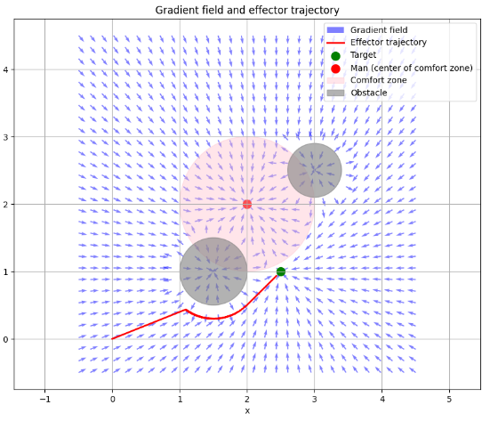
Fig. 1. Simulation results obtained at different values of the comfort zone radius for $α=2.0,d_{0}=1.0$

The analysis of the results from modeling the trajectory of the collaborative manipulator effector at varying values of parameters $α$ and $d_{0}$ enables to derive some significant conclusions about the impact of these parameters on the behavior of the adaptive planning system.

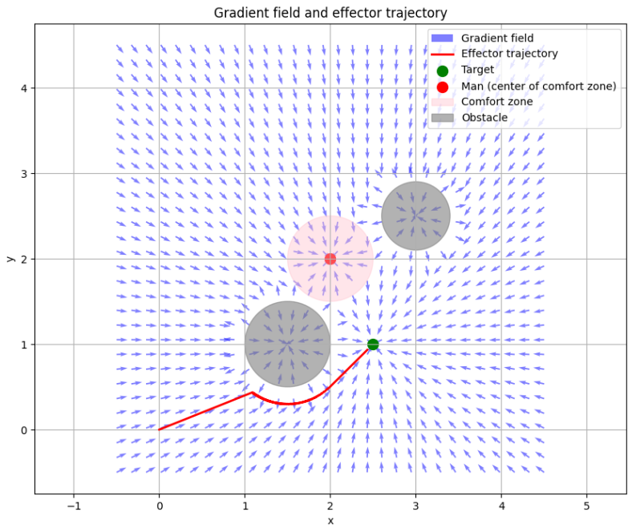
Fig. 2. Simulation results obtained at different values of the comfort zone radius for $α=1.0,d_{0}=0.5$

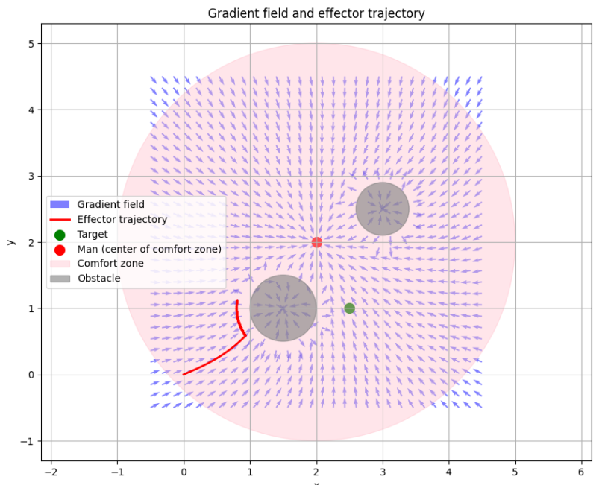
Fig. 3. Simulation results obtained at different values of the comfort zone radius for $α=0.5,d_{0}=3$

At α = 2.0 and $d_{0}$ = 1.0, the manipulator exhibits its most aggressive response to an individual's presence, with a pronounced alteration in trajectory prior to entering the comfort zone to reduce the risk of breaching the safe distance, but it concurrently results in a longer and more energy-intensive trajectory (Fig. 1).
At α = 1.0 and $d_{0}$ = 0.5, the effector chooses a more concise route, just partially circumventing the comfort zone. The latter value signifies a reduction in the priority of comfort distance to prioritize goal attainment (Fig. 2).
The most seamless and effective trajectory occurs at α = 0.5 and $d_{0}$ = 3.0, where the comfort zone is expansive yet its impact is dispersed (Fig. 3) as the setting enables the manipulator to adaptively circumvent the individual at a secure distance without sudden directional alterations.
Logical analysis indicates that the parameter α governs the system's sensitivity to the distance between the effector and the individual. Higher values of α provide more pronounced repulsion gradients, whereas $d_{0}$ establishes the geometric limits of the targeted region. Quantitatively, bigger values of α correlate with an increase in the number of directional changes (up to 12–15 maneuvers), but smaller values do not surpass 6–8. Consequently, the appropriate adjustment of these parameters facilitates a balance of safety, fluidity of motion, and goal attainment efficiency, which is of paramount importance for collaborative robotics systems within the framework of Industry 5.0.

Study of trajectory adaptation with different configurational arrangement of obstacles
The objective of the second study is to evaluate the efficacy of the trajectory planning model in response to alterations in the spatial arrangement of static impediments along the effector's route. The efficacy research examines the modeling system's response to variations in the radii and coordinates of barriers to specifically alters the bypass technique, movement direction, trajectory smoothness, and safety. Indeed, the efficacy work enables the evaluation of the adaptive model's stability in a complex environment resembling production settings with spatial constraints and facilitates the assessment of its compatibility for further integration with actual sensor systems under the HRC safe collaboration framework. The acquired modeling results are illustrated in Figures 4 and 5.

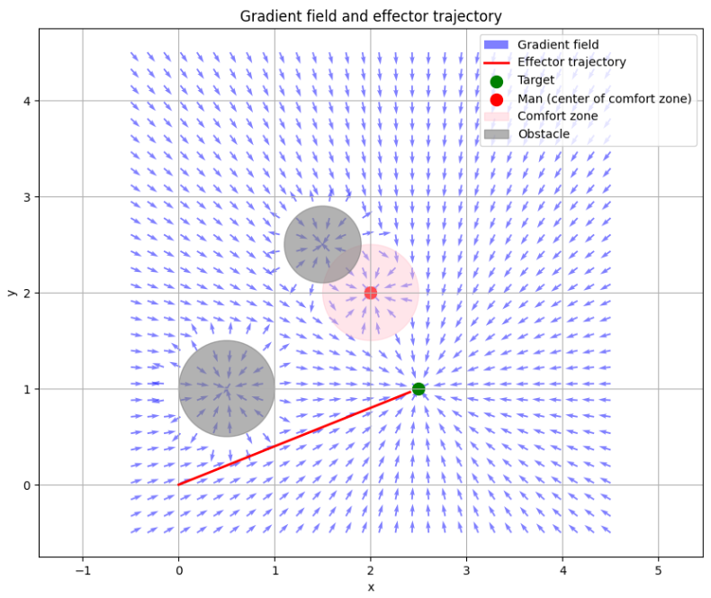
Fig. 4. Modeling of trajectory adaptation with different configurational arrangement of obstacles: Obstacles1{center:0.5, 1; radius:0.5}; Obstacles2{center:1.5, 2.5; radius:0.4}

The analysis of adaptive trajectory planning modeling for a collaborative manipulator revealed a substantial impact of environmental topology on effector behavior while considering various obstacle configurations.
In the initial simulation, with the first obstacle positioned at (0.5, 1.0) and the second at (1.5, 2.5), the manipulator trajectory is constructed with reasonable smoothness, exhibiting little deviation to the right (Fig. 4). The primary adaptation transpires after overcoming the initial obstacle, as it partially intersects the ideal pathway while permitting a deviation without a substantial extension of the path length.
In the second simulation, when the obstacles are near the beginning trajectory (0.5, 0.4) and (1.0, 1.5), the manipulator's motion demonstrates significantly more intricate behavior, characterized by an increased frequency of local directional shifts, particularly during the initial 30–50 steps (Fig. 5), which is because of the restricted maneuvering space present from an early stage, compelling the manipulator to choose a more intricate path with a greater deviation amplitude.

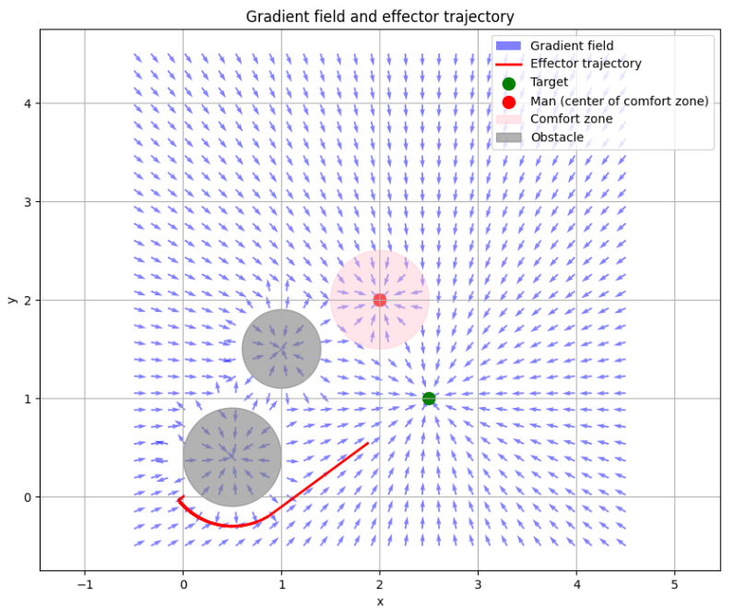
Fig. 5. Simulation of trajectory adaptation with different configurational arrangement of obstacles: Obstacles1{center:0.5, 0.4; radius:0.5}; Obstacles2{center:1.0, 1.5; radius:0.4}

Consequently, it is reasonable to infer that the proximity of impediments to the beginning site substantially elevates the planner's adaptability needs and amplifies the calculations necessary for making a detour option. The trajectory length in the second scenario increases by approximately 20–30%, and the total number of motion corrections doubles. The results demonstrate that minor alterations in obstacle layout can substantially affect adaptation dynamics, making the careful consideration of their spatial arrangement essential for precise and secure manipulator trajectory planning in a genuine collaborative setting.

Conclusion
The work delineates and formulates mathematical models to ascertain adaptive trajectory planning for a collaborative manipulator, considering the presence of an individual and the spatially dynamic comfort zone of that individual. The trajectory of movement is constructed using a combined potential field function, incorporating an attractive component toward the target point, a repulsive component from the comfort zone, and an adaptive weight function that adjusts based on the individual's distance. The model also considered the impact of static impediments by a dynamic gradient calculation of the repulsion force, facilitating realistic and secure path planning. The outcomes of numerical modeling proved the efficacy of the proposed models. The effector's capacity to independently adjust to the spatial arrangement of the environment while maintaining the individual's safety and comfort zone. It was confirmed through a series of experiments that altering the adaptive weight or the radius of the comfort zone considerably influences the trajectory's characteristics. Consequently, The specifically dictates the smoothness, length, and complexity of operating the collaborative manipulator. The graphical depiction of the gradient field facilitated the visualization of the dynamics of force effects in space and the interactions among barriers, the manipulator, and the individual. Particular emphasis was placed on preventing conflicts between the designated route and the individual's comfort zone, a crucial element in a collaborative setting. The research has shown that including adaptive parameters into the potential fields function enhances the manipulator's behavioral flexibility in challenging settings. The acquired trajectories exhibit stability and align with the principles of secure interaction between the robot and the human. The results demonstrate that, despite various impediments and an altered goal location, the system can identify an efficient and safe route. The acquired methodology demonstrates strong generalizability and can be adapted for more intricate situations in production or collaborative service settings. Future research opportunities involve expanding the models to encompass dynamic objects, including the operator's psychophysiological condition, and incorporating machine learning modules for real-time predictive analysis of human behavior.

References
M., Soori, R., Dastres, B., Arezoo, and F. K. G., Jough, "Intelligent robotic systems in Industry 4.0: A review," Journal of Advanced Manufacturing Science and Technology, pp. 2024007-0, 2024. doi: 10.51393/j.jamst.2024007.
Y., Tian, C., Chen, K., Sagoe-Crentsil, J., Zhang, and W., Duan, "Intelligent robotic systems for structural health monitoring: Applications and future trends," Automation in construction, vo. 139, pp. 104273, 2022. doi: 10.1016/j.autcon.2022.104273.
Y., Al-Sharo, A., Abu-Jassar, V., Lyashenko, V., Yevsieiev, and S., Maksymova, "A Robo-hand prototype design gripping device within the framework of sustainable development," Indian Journal of Engineering, vol. 20, pp. e37ije1673, 2023. doi: 10.54905/disssi.v20i54.e37ije1673.
- J. H., Baker, F., Laariedh, M. A., Ahmad, V., Lyashenko, S., Sotnik, and S. K., Mustafa, "Some interesting features of semantic model in Robotic Science," SSRG International Journal of Engineering Trends and Technology, vol. 69, no. 7, pp. 38-44, 2021. doi: 10.14445/22315381/IJETT-V69I7P205.
V., Lyashenko, A. T., Abu-Jassar, V., Yevsieiev and S., Maksymova, "Automated Monitoring and Visualization System in Production," International Research Journal of Multidisciplinary Technovation, vol. 5, no. 6, pp. 9-18, 2023. doi: 10.54392/irjmt2362.
H., Sukri, A. F, Ibadillah, R., Thinakaran, F., Umam, A., Dafid, A., Kurniawan, M., Morshed, and D., Kurniawan, "Enhanced Precision Control of a 4-DOF Robotic Arm Using Numerical Code Recognition for Automated Object Handling," Journal of Robotics and Control (JRC), vol. 6, no. 1, pp. 315-335, doi: 10.18196/jrc.v6i1.24349.
S. F., Saramago, and V. S., Junior, "Optimal trajectory planning of robot manipulators in the presence of moving obstacles," Mechanism and Machine Theory, vol. 35, no. 8, pp. 1079-1094, 2000. doi: 10.1016/S0094-114X(99)00062-2.
R., Matarneh, S., Maksymova, Z., Deineko, and V., Lyashenko, "Building robot voice control training methodology using artificial neural net," International Journal of Civil Engineering and Technology, vol. 8, no. 10, pp. 523-532, 2017.
- Z. E., Dawahdeh, M. A., Almaiah, T., Alkhdour, A., Lutfi, T. H., Aldhyani, and Q., Bsoul, "A new modified grayscale image encryption technique using elliptic curve cryptosystem," Journal of Theoretical and Applied Information Technology, vol. 102, no. 7, pp. 3225-3239, 2024.
- S. M. H., Mousavi, V., Lyashenko, and S., Prasath, "Analysis of a robust edge detection system in different color spaces using color and depth images," Comput. Opt., vol. 43, no. 4, pp. 632-646, 2019. doi: 10.18287/2412-6179-2019-43-4-632-646.
A., Noormohammadi-Asl, S. L., Smith, and K., Dautenhahn, "To lead or to follow? Adaptive robot task planning in human-robot collaboration," IEEE Transactions on Robotics, vol. 41, pp. 4215 - 4235 , 2025. doi: 10.1109/TRO.2025.3582816.
A., Pupa, S., Comari, M., Arrfou, G., Andreoni, A., Carapia, M., Carricato, and C., Secchi, "Enhancing Performance in Human-Robot Collaboration: A Modular Architecture for Task Scheduling and Safe Trajectory Planning," IEEE Transactions on Automation Science and Engineering, vol. 22, pp. 17535 -17551, 2025. doi: 10.1109/TASE.2025.3574627.
C., Cai, E. D., Saraiva, Y. J., Pan, and S. Liu, "MPC-based Coarse-to-Fine Motion Planning for Robotic Object Transportation in Cluttered Environments," arXiv preprint, arXiv:2507.11211, 2025. doi: 10.48550/arXiv.2507.11211.
P., Franceschi, A., Bussolan, V., Pomponi, O., Avram, S., Baraldo, and A., Valente, "Human-robot collaborative transport personalization via Dynamic Movement Primitives and velocity scaling," arXiv preprint, arXiv:2506.09697, 2025. doi: 10.48550/arXiv.2506.09697.
Y., Kawawaki, K., Murakami, and Y., Yamakawa, "Collision-Free Path Planning in Dynamic Environment Using High-Speed Skeleton Tracking and Geometry-Informed Potential Field Method," Robotics, vol. 14, no. 5, pp. 65, 2025. doi: 10.3390/robotics14050065.
J., Oh, "Towards Cognitive Collaborative Robots: Semantic-Level Integration and Explainable Control for Human-Centric Cooperation," arXiv preprint, arXiv:2505.03815, 2025. doi: 10.48550/arXiv.2505.03815.
R., Kermenov, A., Di Biase, I., Pellicani, S., Longhi, and A., Bonci, "Near Time-Optimal Trajectories with ISO Standard Constraints for Human–Robot Collaboration in Fabric Co-Transportation," Robotics, vol. 14. No. 2, pp. 10, 2025. doi: 10.3390/robotics14020010.
A., Shrivastava, "Exploring optimal motion strategies: a comprehensive study of various trajectory planning schemes for trajectory selection of robotic manipulator," Journal of The Institution of Engineers (India): Series C, vol. 106,no. 2, pp. 691-710, 2025. doi: 10.1007/s40032-025-01171-2.
P., Wang, M., Ghergherehchi, J., Kim, M., Zhang, and J., Song, "Transformer-based path planning for single-arm and dual-arm robots in dynamic environments," The International Journal of Advanced Manufacturing Technology, vol. 139, pp. 3801–3819, 2025. doi: 10.1007/s00170-025-16144-z.
Y., Cao, X., Wang, Z., Wu, and Q., Xu, "Development of a Multifunctional Mobile Manipulation Robot Based on Hierarchical Motion Planning Strategy and Hybrid Grasping," Robotics, vol. 14, no. 7, pp. 96, 2025. doi: 10.3390/robotics14070096.
C., Tonola, M., Faroni, S., Abdolshah, M., Hamad, S., Haddadin, N., Pedrocchi, and M., Beschi, "Reactive and safety-aware path replanning for collaborative applications," arXiv preprint, arXiv:2503.07192, 2025. doi: 10.48550/arXiv.2503.07192.
W., Ma, A., Duan, H. Y., Lee, P., Zheng, and D., Navarro-Alarcon, "Human-aware reactive task planning of sequential robotic manipulation tasks," IEEE Transactions on Industrial Informatics, vol. 21, no. 4, pp. 2898 -2907, 2025. doi: 10.1109/TII.2024.3514130.
Qin, Y., and et al., "Robofactory: Exploring embodied agent collaboration with compositional constraints," arXiv preprint, arXiv:2503.16408, 2025. doi: 10.48550/arXiv.2503.16408.
L. N., Faraj, and B. M., Albaker, "Comprehensive review and a new conceptual framework for collision detection and avoidance system in human-robot collaboration environment," In AIP Conference Proceedings, vol. 3211, no. 1, pp. 020008, 2025. doi: 10.1063/5.0257505.
Z., Saleem, F., Gustafsson, E., Furey, M., McAfee, and S., Huq, "A review of external sensors for human detection in a human robot collaborative environment," Journal of Intelligent Manufacturing, vol. 36, no. 4, pp. 2255-2279, 2025. doi: 10.1007/s10845-024-02341-2.
A., Tóth, L., Nagy, R., Kennedy, B., Bohuš, J., Abonyi, and T., Ruppert, "The human-centric Industry 5.0 collaboration architecture," MethodsX, vol. 11, pp. 102260, 2023. doi: 10.1016/j.mex.2023.102260.
J., Alves, T. M., Lima, and P.D. Gaspar, "Is industry 5.0 a human-centred approach? A systematic review," Processes, vol. 11, no. 1, pp. 193, 2023. doi: 10.3390/pr11010193.
C., Turner, and J., Oyekan, "Manufacturing in the age of human-centric and sustainable industry 5.0: application to holonic, flexible, reconfigurable and smart manufacturing systems," Sustainability, vol. 15, no. 13, pp. 10169, 2023. doi: 10.3390/su151310169.
H., Zhou, S., Zhou, J., Yu, Z., Zhang, and Z., Liu, "Trajectory optimization of pickup manipulator in obstacle environment based on improved artificial potential field method," Applied sciences, vol. 10, no. 3, pp. 935, 2020. doi: 10.3390/app10030935.
Z., Zhou, X., Wang, Z., Xie, J., Gao, F., Li, and X., Gu, "A Collision-free path planning approach based on rule guided lazy-PRM with repulsion field for gantry welding robots," Robotics and Autonomous Systems, vol. 174, pp. 104633, 2024. doi: 10.1016/j.robot.2024.104633.
X., Wang, Q., Wu, T., Wang, and Y., Cui, "A path-planning method to significantly reduce local oscillation of manipulators based on velocity potential field," Sensors, vol. 23, no. 23, pp. 9617, 2023. doi: 10.3390/s23239617.
A., Adel, "Future of industry 5.0 in society: human-centric solutions, challenges and prospective research areas," Journal of Cloud Computing, vol. 11, no. 1, pp. 40, 2022. doi: 10.1186/s13677-022-00314-5.
M. T., Islam, K., Sepanloo, S., Woo, S. H., Woo, and Y. I., Son, "A review of the industry 4.0 to 5.0 transition: exploring the intersection, challenges, and opportunities of technology and human–machine collaboration," Machines, vol. 13, no. 4, pp. 267, 2025. doi: 10.3390/machines13040267.
F., Di Stefano, A., Giambertone, L., Salamina, M., Melchiorre, and S., Mauro, "Collaborative Robot Control Based on Human Gaze Tracking," Sensors, vol. 25, no. 10, pp. 3103, 2025. doi: 10.3390/s25103103.
Z., Huang, Y. J., Mun, F. C., Pouria, and K., Driggs-Campbell, "Hierarchical Intention Tracking with Switching Trees for Real-Time Adaptation to Dynamic Human Intentions during Collaboration," arXiv preprint, arXiv:2506.07004, 2025. doi: 10.48550/arXiv.2506.07004.
M., Elnoor, K., Weerakoon, G., Seneviratne, J., Liang, V., Rajagopal, and D., Manocha, "Vi-LAD: Vision-Language Attention Distillation for Socially-Aware Robot Navigation in Dynamic Environments," arXiv preprint, arXiv:2503.09820, 2025. doi: 10.48550/arXiv.2503.09820.
S. Shirgir, and S. Farahmand-Tabar, "An enhanced optimum design of a Takagi-Sugeno-Kang fuzzy inference system for seismic response prediction of bridges," Expert Systems with Applications, vol. 266, pp. 126096, 2025, doi: 10.1016/j.eswa.2024.126096.
F., Wang, S., Rehman, M. H., Shah, M. A., El Yamani, S., Farooq, and A., Farooq, "Numerical computation of cross nanofluid model using neural network and Adaptive Neuro-Fuzzy Inference system with statistical insights for enhanced flow optimization," Expert Systems with Applications, vol. 263, pp. 125721, 2025. doi: 10.1016/j.eswa.2024.125721.
E. Y. Rineh, and R. L., Cheu, "Fuzzy inference systems for discretionary lane changing decisions: model improvements and research challenges," International Journal of Transportation Science and Technology, vol. 17, pp. 312-327, 2025. doi: 10.1016/j.ijtst.2024.05.001.
K. Ghaziyani, F. H., Lotfi, S., Kordrostami, and A., Amirteimoori, "Efficiency analysis in bi-level on fuzzy input and output," Information sciences, vol. 690, pp. 121551, 2025. doi: 10.1016/j.ins.2024.121551.
T., Salameh, M. M., Farag, A. K., Hamid, and M., Hussein, "Adaptive neuro-fuzzy inference system for accurate power forecasting for on-grid photovoltaic systems: A case study in Sharjah, UAE," Energy Conversion and Management: X, vol. 26, pp. 100958, 2025. doi: 10.1016/j.ecmx.2025.100958.
S. M., Kekshar, and S. A. Aminifar, "Uncertainty Avoider Defuzzification of General Type-2 Multi-Layer Fuzzy Membership Functions for Image Segmentation," IEEE Access, vol. 13, pp. 58120-58135, 2025. doi: 10.1109/ACCESS.2025.3556139.
B. M. Al-Hadithi, and J. Gómez, "Fuzzy Control and Modeling Techniques Based on Multidimensional Membership Functions Defined by Fuzzy Clustering Algorithms," Applied Sciences, vol. 15, no. 8, pp. 4479, 2025. doi: 10.3390/app15084479.
- J., Ababneh, "Application of Naive Bayes, Decision Tree, and K-Nearest Neighbors for Automated Text Classification," Modern Applied Science, vol. 13, no. 11, pp. 1-31, 2019. doi:10.5539/mas.v13n11p31.
M. J. Hao, and Y. X. Zheng, "Highway Travel-Time Forecasting with Greenshields Model-Based Cascaded Fuzzy Logic Systems," Applied Sciences, vol. 15, no. 14, pp. 7729, 2025. doi: 10.3390/app15147729.

