Effect of Wavelet Type on Edge Detection in Megaloblastic Anemia Cells Image with Changed Contrast in RGB and HSV Color Spaces
Jafar Ababneh  Cyber Security department,  Faculty of Information Technology  Zarqa University  Zarqa, Jordan  jababneh@zu.edu.jo | Amer Abu-Jassar  Department of Computer Science,  College of Information Technology  Amman Arab University  Amman, Jordan  A.abujassar@aau.edu.jo | Ling Shing Wong  Faculty of Health and Life Sciences  INTI-IU-University /  Shinawatra University, Pathum  Nilai, Malaysia / Thani, Thailand  lingshing.wong@newinti.edu.my
Mohammad Hamdan  Depertment of Cyber Security,  College of software engineering  Amman Arab University  Amman, Jordan  m.hamdan@aau.edu.jo | Valentyn Liubchenko  Department of Informatics  Kharkiv National University of Radio Electronics  Kharkiv, Ukraine  valentyn.liubchenko@nure.ua | Vyacheslav Lyashenko  Department of Media Systems and Technology  Kharkiv National University of Radio Electronics  Kharkiv, Ukraine  viacheslav.liashenko@nure.ua

Abstract—Medical image analysis is an important task in diagnosing various diseases, among which the study of megaloblastic anemia stands out resulting in improving the publish health. The peculiarity of processing the corresponding images is the selection of the edge for all objects of interest, including the details of the structure of megaloblastic anemia cells. It is shown that for these purposes it is advisable to use the ideology of wavelets. Based on this, the paper considers the issues of the influence of the wavelet type on the selection of the edge in images with megaloblastic anemia cells with changed contrast in the RGB and HSV color spaces. The wavelets considered in this paper include gaus1, haar, db2, and bior1.1. For the purpose of comparing the results, such quality assessments as niqe, brisque, and entropy are used, as well as a visual comparison of the obtained results. It is shown that for selecting the edge and potential areas of interest in images with megaloblastic anemia cells, it is advisable to use the RGB space. It is also noted that the gaus1 wavelet allows for efficient allocation of potential areas of interest, while the haar and bior1.1 wavelets allow for allocation of the edges of objects of interest. The results are presented in the form of various figures and tables.
Keywords— color space, disease diagnostics, edge detection, medical imaging, wavelet analysis, wavelet types

Introduction
Digital image processing and analysis is one of the key areas in real-world research [1] because digital images allow to record current events and conduct detailed analysis, as investigated in [2-6] for various approaches and methods. The proposed approach in this research is based on digital image research methods proposed in [7]-[12], which highlight the most characteristic aspects of the real world in digital images representation, taking into account the specific researches directed to study the microworld, such as microscopic medical images. Examination of such images enables to identify and determine hidden processes of various diseases and the effectiveness of their treatment. One such example, allowing early diagnostics based on digital images, is the study of microscopic images with megaloblastic anemia cells. Such research allows to prevent the development of heart failure and the occurrence of oncological diseases [13], [14].
For the purposes of diagnosing possible diseases from digital images, it is advisable to identify potential areas of interest, which is the main objective of the relevant studies. For example, in the work [15], anemia-based diseases are diagnosed by counting the corresponding specific blood cells. The method for assessing and counting such cells is based on the analysis of the area, perimeter, and diameter of blood cells. This, in turn, presupposes the preliminary identification of potential areas of interest, for which a classifier based on support vectors is used. However, this approach is used as an auxiliary tool for early diagnosis, which necessitates further research for a final conclusion about the disease. It should also be noted that the question of using a specific method for identifying the edge of objects for subsequent calculation of their area is open.
To highlight potential areas of interest in the work [16], first of all, segmentation of potential areas of cells and background is carried out; whereas in this work, the threshold method of Otsu segmentation and edge detection is used, which allows achieving high-quality selection of potential areas of interest. At the same time, questions arise regarding the accuracy of edge detection and the choice of a specific operator for these purposes.
To improve the accuracy and efficiency of anemia detection in blood smear images, the authors [17] use a convolutional neural network; whereas the use of this approach requires an extensive database, which is difficult for rapid diagnostics. At the same time, the question of the accuracy of identifying potential areas of interest remains open in comparison with classical approaches.
K. T. Navya, S. Verma, K. Prasad, and B. M. Kumar Singh use machine learning techniques to identify relevant cells as potential areas of interest [18]; however, as in the previous example, this approach requires some customization of the identification model and an appropriate database to train the models used. Therefore, it is important to consider different approaches that can lead to faster decisions for conducting relevant diagnostic studies. Y. Li also considers the possibility of using machine learning to diagnose diseases based on the analysis of anemia cells [19], whereas special attention is also paid to the issue of constructing a decision tree based on simple edge detection methods for the purpose of identifying potential areas of interest.
Thus, it should be noted that there is a significant diversity of works devoted to the analysis of the selection of potential areas of interest in medical microscopic images, including those with megaloblastic anemia cells. At the same time, the issues of using wavelet ideology to solve the problem have not been sufficiently considered though it is promising, as confirmed by a number of research works, such as in [20]-[23]. However, it should be noted that there are virtually no studies comparing different types of wavelets for edge detection in image objects. This is especially true for the specific processing and analysis of medical images.
The key aspects of such consideration are also the choice of an appropriate color space; which is considered in studies for such scenarios. Y. Shen, Y. Luo, D. Shen, and J. Ke emphasize that color variations sometimes reduce the ability of individual algorithms to obtain more accurate results [24]. The study [25] also notes that due to different types and scales of objects, complex backgrounds, and similarities in the appearance of tissues in medical images, extracting valuable information from different medical images can be difficult, which leads to the need to consider a specific color space; in this case, the RGB and HSV spaces are often indicated as such color spaces [26]-[28].
To improve the efficiency of edge detection, the input image contrast enhancement technique is used [26], which is an acceptable approach, since contrast enhancement plays a decisive role among the methods of image preprocessing, in comparison, in particular, with filtering methods. Based on this, an important aspect is also the choice of the wavelet type for the purpose of edge detection for objects in medical images; however, this point has also not been sufficiently considered in the relevant studies.
Thus, the main goal of this work is to study the effect of the wavelet type on edge detection in an image with megaloblastic anemia cells with altered contrast in color spaces such as RGB and HSV, which allows to evaluate the wavelet ideology as a procedure for identifying potential areas of interest for a certain type of image and to understand the feasibility of conducting such an analysis in general.

Methods and Materials

Wavelets as a tool for edge detection and potential areas of interest detection
Among the many approaches, as a procedure for selecting edges and potential areas of interest, the wavelet ideology should be highlighted [29], [30]. The feasibility of such an analysis is based on the fact that additional information is extracted from the original image, based on the analysis of brightness differences between individual neighboring points of the image, which permits to determine the special specific characteristics of the analyzed image, which allows to more efficiently select areas of potential interest [31], [32]. Transitions between brightness levels are carried out on the basis of the wavelet transform by calculating the wavelet spectrogram matrix [33]:
, (1)
where: is the mother wavelet satisfying the condition . The choice of a certain wavelet type allows to emphasize various features of the brightness differences of the original image , specified as a matrix of brightness level readings on a square grid () in the range from 0 to 255. The indices determine the current coordinates of individual brightness levels of the original image in a two-dimensional coordinate system;
, – the scale and center of temporal localization, which determine the scale and offset of the function () in accordance with the scaling conditions . These parameters are determined by the type of wavelet used and the correspondence between the linear dimensions of the wavelet spectrogram matrix and the dimensions of the original image resulting in emphasizing the characteristic details in the image under study.
As a rule, the construction of the wavelet spectrogram matrix is carried out to determine the break points on the original image in the horizontal and vertical directions achieving the invariance of the approach used to determine potential areas of interest located on the image under study.
In many ways, the quality and efficiency of edge and potential interest zone selection are determined by the type of wavelet used to construct the wavelet spectrogram matrix. It is important to distinguish between three types of wavelets: orthogonal, semi-orthogonal, and bi-orthogonal [34], [35]. The choice of wavelet in each specific case is determined by the task and the features of the presented image. The simplest orthogonal wavelet is the Haar wavelet [36]. Daubechies wavelets are orthogonal wavelets with a compact carrier [37]. At the same time, the Gaussian wavelet is the so-called "rough" wavelet [38]. Among the biorthogonal wavelets, the Bior type wavelets should be distinguished [39]. At the same time, wavelets of the same type also form certain families, the representatives of which are characterized by the time and frequency of the attenuation level that helps to emphasize individual breakpoints in the image under study. The proposed study in this research examines the following types of wavelets and their capabilities in identifying potential areas of interest in medical images of megaloblastic anemia cells:.

Components in assessing the influence of wavelet type when identifying potential areas of interest in an image
Thus, in the proposed study, different types of wavelets from the set will be considered ().
At the same time, attention is also paid to the color space of the original image representation. As a rule, color medical images are presented in RGB format.
However, the researchers also emphasize the importance of considering the analysis results for color medical images in HSV format [40].
The RGB color space is based on an additive color model that describes a way of encoding color for color reproduction using three colors: red (R), green (G), and blue (B) [41].
The HSV color space is based on a color model that combines hue (H), saturation (S), and the brightness value at a certain point in the input image (V) [42], which is a nonlinear transformation of the RGB model that expands the algorithmic capabilities of color image processing.
Thus, the following set of color spaces will be discussed below: .
To compare the results of processing the input image, a standard set of estimates is used [43]-[45]:
niqe – characterizes the quality of the naturalness of the image;
brisque – characterizes the spatial quality of the image;
entropy – shows the change in uncertainty.
The lower the value of the niqe or brisque indicator, the better the quality of perception. A higher value of the entropy indicator indicates the presence of a large number of details in the image.

General strategy for conducting the study
The general strategy of the proposed study is that wavelet processing is performed on typical images of megaloblastic anemia cells to isolate the edge and potential areas of interest. Such processing is performed for individual parent wavelets from the set defined above. The results of such processing in RGB and HSV color spaces are also considered. In order to improve the results of wavelet processing, contrasting of the original images in the corresponding color spaces is performed. Such processing allows to enhance the existing minor brightness differences in the original image, which will increase the efficiency of highlighting potential areas of interest. For contrasting purposes, one of the simplest methods of changing the contrast is used, which is based on histogram equalization. This approach is applied to source images represented in RGB and HSV color spaces, respectively. No other pre-treatment methods were used. Ultimately, the niqe, brisque, and entropy estimates are calculated, on the basis of which the obtained results are compared.
Fig. 1 and Fig. 2 show typical examples of images with megaloblastic anemia cells (these images are in the public domain and were used in our earlier work). It can be seen that there are various blood elements, which is important when conducting the corresponding diagnostics. Therefore, it is advisable not only to select the edge but also to select potential areas of interest, which represents the final result of applying wavelet theory to process the relevant medical images.

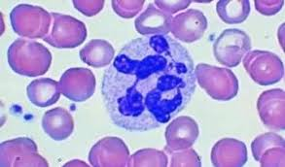
Fig. 1. Medical image with megaloblastic anemia cells (Example 1)
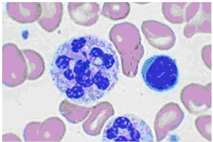
Fig. 2. Medical image with megaloblastic anemia cells (Example 2)
It should be emphasized that wavelet processing is performed for images presented in gray format. Then the sequence of processing the original image is represented by the following sequence:
1. The formation of the original image () occurs from the point of view of their formation in separate color spaces (), then the contrast in separate color spaces changes, and such images are converted to gray format. Thus, for a separate original image, two images are obtained in gray format for the RGB and HSV color spaces.
. (2)
2. Wavelet processing from the set () is applied to each image presented in gray format for the RGB and HSV color spaces. Then, using simple thresholder, individual points are removed; accordingly, this procedure is the same for all images, taking into account their contrast in different spaces; the threshold value is also the same in all cases. The obtained result is superimposed on the original image, and the final result is obtained – the selection of potential areas of interest in each specific case.
. (3)
3. For the set of final images (), the niqe, brisque and entropy estimates are calculated. Based on these estimates, the obtained results are analyzed and compared.

Results and Discussion
Based on the general concept of the ideology of conducting the proposed study, Fig. 3 and Fig. 4 show the results of contrasting the original typical images (Fig. 1, Fig. 2) in the RGB and HSV color spaces. These results are displayed as color images.
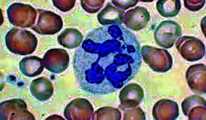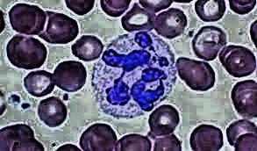
a) RGB b) HSV
Fig. 3. The result of contrasting the image Example 1 in the RGB (a) and HSV (b) color spaces
It should be noted that the various effects of individual color spaces on the results of contrasting the original images are multifaceted, which ultimately affects the efficiency of their corresponding processing—selection of edges and potential areas of interest based on wavelet ideology.
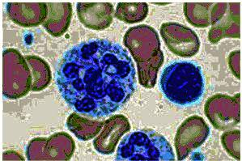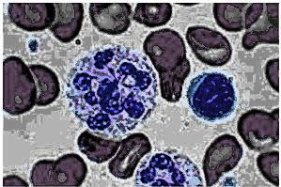
a) RGB b) HSV
Fig. 4. The result of contrasting the image Example 2 in the RGB (a) and HSV (b) color spaces
Further, in Fig. 5 – Fig. 8, in accordance with formulas 1–3, the results of edge detection and potential zones of interest are presented in accordance with the ideology of wavelets (and the set of used mother wavelets – ) for individual RGB and HSV color spaces.
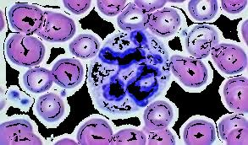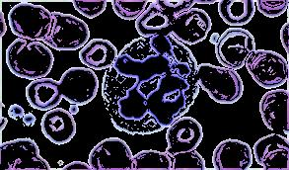
a) gaus1 b) haar
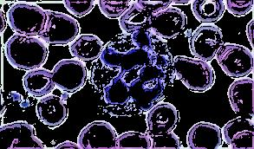
с) db2 d) bior1.1
Fig. 5. Results of wavelet processing of the image Example 1 with different types of wavelets (a – gaus1, b – haar. c – db2, d – bior1.1) in the RGB color space

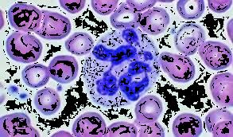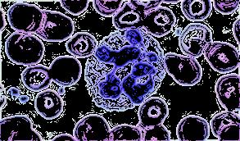
a) gaus1 b) haar
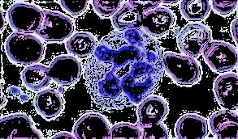
с) db2 d) bior1.1
Fig. 6. Results of wavelet processing of the image Example 1 with different types of wavelets (a – gaus1, b – haar. c – db2, d – bior1.1) in the HSV color space
Based on the visual analysis of the data in Fig. 5 and Fig. 6, it is necessary to talk about significant differences in the results that were obtained based on the wavelet ideology for individual color spaces. First of all, the use of the gaus1 mother wavelet, in comparison with such mother wavelets as haar, db2, and bior1.1, allows one to completely isolate areas of potential interest. In fact, the gaus1 mother wavelet allows to completely cut off the background, which can also have certain brightness differences. At the same time, in the RGB color space, the gaus1 mother wavelet gives a better result than in the HSV color space. In the HSV color space, the gaus1 mother wavelet identifies many false background points.
The mother wavelets haar, db2, and bior1.1 generally cope well with the task of edge detection. The best result is observed for the wavelets haar and bior1.1, since the smallest number of false points are detected. In general, the obtained result is the best for the RGB space, in comparison with the result for the HSV space. At the same time, the best detail in edge detection, namely for the megaloblastic anemia cell, is observed in the HSV color space, which suggests the need to use additional procedures to improve the quality of the obtained results in terms of the HSV color space. It is also worth mentioning the advisability of combining the edge detection results for individual mother wavelets that helps to increase the efficiency of detecting potential areas of interest in the studied class of images. It should also be noted that the choice of using a certain type of wavelet depends on the task of the medical study. This is due to the fact that each type of wavelet allows, first of all, to highlight certain points, which explains the differences in the results obtained.
Table 1 presents the quality assessments of the images presented in Fig. 5 and Fig. 6. The presented assessment values fully confirm the conclusions that were discussed above.
TABLE 1. Quality Assessments of Images Processed Based on Wavelet Ideology for the Original Image Example 1
Color spaces | Quality assessment
Color spaces | niqe | brisque | entropy
gaus1
RGB | 10.51 | 34.87 | 7.31
HSV | 12.58 | 41.89 | 7.48
haar
RGB | 18.79 | 42.73 | 5.47
HSV | 21.48 | 43.41 | 5.99
db2
RGB | 21.34 | 40.86 | 5.64
HSV | 25.49 | 42.02 | 6.39
bior1.1
RGB | 18.79 | 42.73 | 5.47
HSV | 21.52 | 43.38 | 5.95

It is also evident from the data in Table 1 that the processing results generally differ little from each other; therefore, in this case, it is necessary to pay attention to the entropy indicator, which can be used to minimize false points in the processed images.
Fig. 7 and Fig. 8 show the results of potential zone selection based on wavelet ideology for the original image, Example 2.
In general, the obtained results presented in Fig. 7 and Fig. 8 are similar to those shown in Fig. 5 and Fig. 6. Consequently, the reliability of the images study processing results can be discussed based on the wavelet ideology. The mother wavelet gaus1 provides the most complete selection of potential areas of interest in the RGB color space.
In the HSV color space, as a result of applying the mother wavelet gaus1, many false background points appear on the processed image.

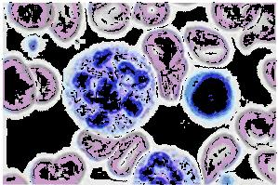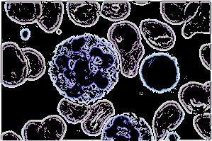
a) gaus1 b) haar
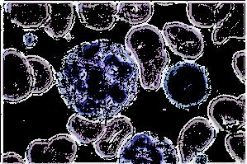
с) db2 d) bior1.1
Fig. 7. Results of wavelet processing of the image Example 2 with different types of wavelets (a – gaus1, b – haar. c – db2, d – bior1.1) in the RGB color space

Mother wavelets of the haar, db2, and bior1.1 types will also effectively highlight the edge on the original image (Example 2). As for the previous example, the most effective are the haar and bior1.1 wavelets. As a result of using such mother wavelets (haar and bior1.1), there are practically no false points in terms of the RGB color space. When using all types of wavelets in the HSV color space, the appearance of false background points is characteristic, which confirms the previously made conclusion about the need to develop additional procedures to eliminate the drawback in terms of the HSV color space.

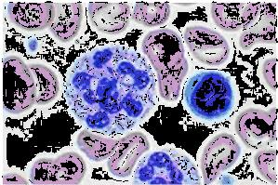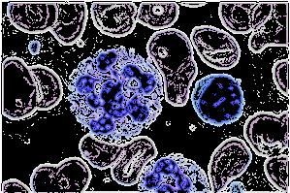
a) gaus1 b) haar
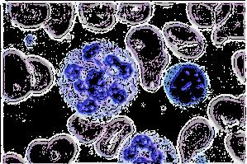
с) db2 d) bior1.1
Fig. 8. Results of wavelet processing of the image Example 2 with different types of wavelets (a – gaus1, b – haar. c – db2, d – bior1.1) in the HSV color space
In Table 2 presents the image quality ratings shown in Fig. 7 and Fig. 8. These ratings confirm the conclusions formulated above.
TABLE 2. Quality Assessments of Images Processed Based on Wavelet Ideology for the Original Image Example 2
Color spaces | Quality assessment
Color spaces | niqe | brisque | entropy
gaus1
RGB | 12.17 | 18.53 | 6.82
HSV | 12.31 | 37.98 | 7.12
haar
RGB | 21.32 | 42.52 | 5.10
HSV | 22.89 | 43.06 | 5.87
db2
RGB | 20.97 | 43.10 | 5.24
HSV | 21.24 | 43.11 | 6.19
bior1.1
RGB | 21.28 | 42.37 | 5.09
HSV | 21.89 | 43.06 | 5.87

Therefore, in general, it is possible to discuss the expediency of using different types of wavelets for detection and identification of areas of interest in medical images with megaloblastic anemia cells; in this context, using the RGB color space is the most effective approach; in this case, the use of the wavelet type or their specific combination for image processing is determined by the conditions of the medical task.

Сonclusion
The study examines individual aspects of the influence of the wavelet type on the selection of edges and potential areas of interest in images with megaloblastic anemia cells. For the purposes of analysis, contrasting of the original images in RGB and HSV color spaces is performed, but with the same parameters for applying such a procedure. The following parent wavelets are considered as the influence of individual wavelet types on solving the problem: gaus1, haar, db2, and bior1.1. To compare the results, various quality assessments (niqe, brisque, entropy) and visual comparisons of the results obtained are used.
The study substantiated the feasibility of considering the RGB space as a basic color space for highlighting the edge and potential areas of interest in images with megaloblastic anemia cells. It was shown that individual types of wavelets can be used to solve various problems faced by medical workers. While the haar and bior1.1 wavelets highlight the edges of objects of interest, the gaus1 wavelet effectively highlights potential areas of interest. The results are supported by a number of experiments and characteristics for assessing the quality of the resulting images. Ultimately, the presented approach can be a tool in solving various practical medical problems and assist in making appropriate decisions.
The conducted experiments and the obtained results demonstrated the need to develop a combined use of mother wavelets for processing the original images. In particular, the combined use of mother wavelets can be the basis for processing an automated diagnostic system based on medical image analysis, which may be one of the directions of further research. At the same time, the considered demonstrated its efficiency and expediency of use for solving research and applied problems in medical visualization.

References
E. Y., Hidayat, K., Hastuti, and A. K., Muda, "Artificial intelligence in digital image processing: A bibliometric analysis," Intelligent Systems with Applications, vol. 25, pp. 200466, 2025. doi: 10.1016/j.iswa.2024.200466.
H., Sukri, A. F, Ibadillah, R., Thinakaran, F., Umam, A., Dafid, A., Kurniawan, M., Morshed, and D., Kurniawan, "Enhanced Precision Control of a 4-DOF Robotic Arm Using Numerical Code Recognition for Automated Object Handling," Journal of Robotics and Control (JRC), vol. 6, no. 1, pp. 315-335, doi: 10.18196/jrc.v6i1.24349.
P., Orobinskyi, D., Petrenko, and V., Lyashenko, "Novel Approach to Computer-Aided Detection of Lung Nodules of Difficult Location with Use of Multifactorial Models and Deep Neural Networks," In 2019 IEEE 15th International Conference on the Experience of Designing and Application of CAD Systems (CADSM), pp. 1-5. doi: 10.1109/CADSM.2019.8779340.
H., Attar, A. T., Abu-Jassar, V., Yevsieiev, V., Lyashenko, I., Nevliudov, and A. K. Luhach, "Zoomorphic mobile robot development for vertical movement based on the geometrical family caterpillar," Computational intelligence and neuroscience, vol. 2022, no. 1, pp. 3046116, 2022. doi: 10.1155/2022/3046116.
J. Atwan, M. Wedyan, Q. Bsoul, A. Hamadeen, R. Alturki, and M. Ikram, "The effect of using light stemming for Arabic text classification," International Journal of Advanced Computer Science and Applications, vol. 12, no. 5, pp. 768-773, 2021.
I., Nevliudov, V., Yevsieiev, J. H., Baker, M. A., Ahmad, and V., Lyashenko, "Development of a cyber design modeling declarative language for cyber-physical production systems," J. Math. Comput. Sci., vol. 11, no. 1, pp. 520-542, 2021. doi: 10.28919/jmcs/5152.
J., Li, P., Jiang, Q., An, G. G., Wang, and H. F. Kong, "Medical image identification methods: A review," Computers in Biology and Medicine, vol. 169, pp. 107777, 2024. doi: 10.1016/j.compbiomed.2023.107777.
C., Albuquerque, R., Henriques, and M., Castelli, "Deep learning-based object detection algorithms in medical imaging: Systematic review," Heliyon, vol. 11, no. 1, pp. e41137, 2025. doi: 10.1016/j.heliyon.2024.e41137.
S. M. H., Mousavi, V., Lyashenko, and S., Prasath, "Analysis of a robust edge detection system in different color spaces using color and depth images," Comput. Opt., vol. 43, no. 4, pp. 632-646, 2019. doi: 10.18287/2412-6179-2019-43-4-632-646.
I. R., Santelices, S., Cano, F., Moreira, and A. P. Fritz, "Artificial Vision Systems for Fruit Inspection and Classification: Systematic Literature Review," Sensors (Basel, Switzerland), vol. 25, no. 5, pp. 1524, 2025. doi: 10.3390/s25051524.
A. M., Babker, R. S., Suliman, R. H., Elshaikh, S., Boboyorov, and V. Lyashenko, "Sequence of Simple Digital Technologies for Detection of Platelets in Medical Images," Biomedical and Pharmacology Journal, vol. 17, no. 1, pp. 141-152, 2024. doi: 10.13005/bpj/2842.
J. Ababneh, A. Abu-Jassar, S. Abuowaida, V. Liubchenko, and V. Lyashenko, "Evaluation of Three Different Operators for Object Highlighting in Medical RGB Images: Canny, Roberts, and LoG in Independent Color Spaces," In 2024 25th International Arab Conference on Information Technology (ACIT), pp. 1-7. doi: 10.1109/ACIT62805.2024.10876948.
A., Gupta, "Megaloblastic Anemia," In Decision Making Through Problem-Based Learning in Hematology: A Step-by-Step Approach in Patients with Anemia, pp. 17-34, 2024. doi: 10.1007/978-981-99-8933-1_2.
O., Nano, M., Muminovic, A., Bonano-Rios, and F. V. Madueno, "Megaloblastic Anemia," in Non-Neoplastic Hematologic Disorders: A Quick Review of Modern Diagnostic and Therapeutic Approaches, pp. 137-146, 2024. doi: 10.1007/978-3-031-62373-8_10.
C. C., Hortinela, J. R., Balbin, J. C., Fausto, P. D. C., Divina, and J. P. T., Felices, "Identification of abnormal red blood cells and diagnosing specific types of anemia using image processing and support vector machine," In 2019 IEEE 11th International Conference on Humanoid, Nanotechnology, Information Technology, Communication and Control, Environment, and Management (HNICEM), pp. 1-6. doi: 10.1109/HNICEM48295.2019.9072904.
Y., Zhao, T., Huang, X., Wang, Q., Chen, H., Shen, and B., Xiong, "Measurement for the area of red blood cells from microscopic images based on image processing technology and its applications in aplastic anemia, megaloblastic anemia, and myelodysplastic syndrome," Frontiers in Medicine, vol. 8, pp. 796920, 2022. doi: 10.3389/fmed.2021.796920.
M. D., Pabiania, K. J. P., Ortiz, D. E. W., Abdel Bari, P. C. A., Marilag, and P. A. A. Nisperos, "CNN-Based Anemia Detection in Blood Smear Images," In Proceedings of the 2024 14th International Conference on Biomedical Engineering and Technology, pp. 133-139. doi: 10.1145/3678935.3678970.
K. T., Navya, S., Verma, K., Prasad, and B. M. Kumar Singh, "Efficient diagnostic model for iron deficiency anaemia detection: a comparison of CNN and object detection algorithms in peripheral blood smear images," Automatika, vol. 66, no. 1, pp. 1-15, 2025. doi: 10.1080/00051144.2024.2433868.
Y. Li, "Analyzing the Application of Machine Learning in Anemia Prediction," In ITM Web of Conferences, vol. 70, pp. 04006, 2025. EDP Sciences. doi: 10.1051/itmconf/20257004006.
S., Yunhong, Y., Shilei, Z., Xiaojing, and Y., Jinhua, "Edge detection algorithm of MRI medical image based on artificial neural network," Procedia Computer Science, vol. 208, pp. 136-144, 2022. doi: 10.1016/j.procs.2022.10.021.
R. Bagaria, S. Wadhwani, and A. K. Wadhwani, "A wavelet-based segmentation technique for medical images," In Artificial Intelligence and Sustainable Computing: Proceedings of ICSISCET 2020, pp. 65-77, 2021. doi: 10.1007/978-981-16-1220-6_6.
S. A., Agnes, A. A., Solomon, and K. J. B. S. P. Karthick, "Wavelet U-Net++ for accurate lung nodule segmentation in CT scans: Improving early detection and diagnosis of lung cancer," Biomedical Signal Processing and Control, vol. 87, pp. 105509, 2024. doi: 10.1016/j.bspc.2023.105509.
H., Li, and K., Xu, "Innovative adaptive edge detection for noisy images using wavelet and Gaussian method," Scientific Reports, vol. 15, no. 1, pp. 5838, 2025. doi: 10.1038/s41598-025-86860-9.
Y., Shen, Y., Luo, D., Shen, and J., Ke, "Randstainna: Learning stain-agnostic features from histology slides by bridging stain augmentation and normalization," In International Conference on Medical Image Computing and Computer-Assisted Intervention, pp. 212-221, 2022. DOI: 10.1007/978-3-031-16434-7_21.
X. Xie, W., Zhang, X., Pan, L., Xie, F., Shao, W., Zhao, and J., An, "Canet: Context aware network with dual-stream pyramid for medical image segmentation," Biomedical Signal Processing and Control, vol. 81, pp. 104437, 2023. 10.1016/j.bspc.2022.104437.
J. P., Gu, L., Hua, X., Wu, H., Yang, and Z. T., Zhou, "Color medical image enhancement based on adaptive equalization of intensity numbers matrix histogram," International Journal of Automation and Computing, vol. 12, no. 5, pp. 551-558, 2015. doi: 10.1007/s11633-014-0871-9.
M., Zhou, K., Jin, S., Wang, J., Ye, and D., Qian, "Color retinal image enhancement based on luminosity and contrast adjustment," IEEE Transactions on Biomedical Engineering, vol. 65, no. 3, pp. 521-527, 2017. doi: 10.1109/TBME.2017.2700627.
E. Goceri, "Medical image data augmentation: techniques, comparisons and interpretations," Artificial intelligence review, vol. 56, no. 11, pp. 12561-12605, 2023. doi: 10.1007/s10462-023-10453-z.
Y., Su, W., Tan, Y., Dong, W., Xu, P., Huang, J., Zhang, and D. Zhang, "Enhancing concealed object detection in Active Millimeter Wave Images using wavelet transform," Signal Processing, vol. 216, pp. 109303, 2024. doi: 10.1016/j.sigpro.2023.109303.
G., Wang, W., Zhao, P., Zou, J., Wang, H., Yin, and Y., Yu, "Quantum image edge detection based on Haar wavelet transform," Quantum Information Processing, vol. 23, no. 8, pp. 302, 2024. doi: 10.1007/s11128-024-04513-8.
N. Kingsbury, "Image processing with complex wavelets," Philosophical Transactions of the Royal Society of London. Series A: Mathematical, Physical and Engineering Sciences, vol. 357, no. 1760, pp. 2543–2560, 1999. doi: 10.1098/rsta.1999.0447.
C. E., Heil, and D. F., Walnut, "Continuous and discrete wavelet transforms," SIAM review, vol. 31, no. 4, pp. 628-666, 1989. doi: 10.1137/103112.
S. Badiezadegan, S., and R. C. Rose, "A wavelet-based thresholding approach to reconstructing unreliable spectrogram components," Speech Communication, vol. 67, pp. 129-142, 2015. doi: 10.1016/j.specom.2014.11.005.
M. K. Saini, R. Kapoor, A. K. Singh, and M. Manisha, "Performance Comparison between Orthogonal, Bi-Orthogonal and Semi-Orthogonal Wavelets," Advanced Materials Research, vol. 433, pp. 6521-6526, 2012. doi: 10.4028/www.scientific.net/AMR.433-440.6521.
M., Bayjja, G., Alsharahi, L., Amhaimar, N., Amar Touhami, and M., Aghoutane, "Applying biorthogonal and orthogonal wavelet basis functions to the method of moments for modeling the helix antenna," Journal of Electromagnetic Waves and Applications, vol. 35, no. 6, pp. 822-832, 2021. doi: 10.1080/09205071.2020.1856006.
K. T., Poumai, N., Khanna, and S. K., Kaushik, "Analysis of finite Haar wavelet transform and its implementation," Mathematical Methods in the Applied Sciences, vol. 47, no. 18, pp. 14431-14445, 2024. doi: 10.1002/mma.10282.
C., Vonesch, T., Blu, and M., Unser, "Generalized Daubechies wavelet families," IEEE transactions on signal processing, vol. 55, no. 9, pp. 4415-4429, 2007. doi: 10.1109/TSP.2007.896255.
T., Guo, T., Zhang, E., Lim, M., Lopez-Benitez, F., Ma, and L., Yu, "A review of wavelet analysis and its applications: Challenges and opportunities," IEEE Access, vol. 10, pp. 58869-58903, 2022. doi: 10.1109/ACCESS.2022.3179517.
M., Saadatmorad, and B., Khatir, B. "Crack detection in concrete structures using the standard deviation of discrete wavelet transform," HCMCOU Journal of Science–Advances in Computational Structures, vol. 15, no. 1, pp. 14-28, 2025. doi: 10.46223/HCMCOUJS.acs.en.15.1.68.2025.
K. D. N., Khiruddin, W. A., Mustafa, K. S., Ab Rahman, H., Alquran, and S. Junaini, "Improved Colour Visualization in Pap Smear Images Based on HSV Channel Analysis," Journal of Advanced Research Design, vol. 126, no. 1, pp. 99-120, 2025. doi: 10.37934/ard.126.1.99120.
T. Azetsu, A. Fujita, and N. Suetake, "Image enhancement for dichromatic vision by geometric approach in RGB color space," Color Research & Application, vol. 50, no. 2, pp. 125-131, 2025. doi: 10.1002/col.22956.
A. K., Chinchanikar, and M. P. Dale, "Analyzing RGB and HSV Color Spaces for Non-Invasive Blood Glucose Level Estimation Using Fingertip Imaging," International Journal of Advanced Computer Science & Applications, vol. 16, no. 4, pp. 173, 2025. doi: 10.14569/ijacsa.2025.0160419.
K. Ding, K. Ma, S. Wang, and E. P. Simoncelli, "Image quality assessment: Unifying structure and texture similarity," IEEE transactions on pattern analysis and machine intelligence, vol. 44, no. 5, pp. 2567-2581, 2020. doi:10.1109/TPAMI.2020.3045810.
A., Mittal, R. Soundararajan, and A. C. Bovik, "Making a Completely Blind Image Quality Analyzer," IEEE Signal Processing Letters, vol. 22, no. 3, pp. 209–212, 2013, doi:10.1109/LSP.2012.2227726.
A., Mittal, A. K. Moorthy, and A. C. Bovik, "No-Reference Image Quality Assessment in the Spatial Domain," IEEE Transactions on Image Processing, vol. 21, no. 12, pp. 4695–4708, 2012, doi: 10.1109/TIP.2012.2214050.

