Fine Tuning BERT For Fake News Detection

Kshitij Kumarª, Aryan Agnihotri^{b}, Dr. Kavita Arora^{c}
ªStudent, SCA, MRIIRS. (Kshitijray028@gmail.com)
^{b}Student, SCA, MRIIRS. (aryan2agnihotri1@gmail.com)
^{c}Associate Professor, SCA, MRIIRS. (Kavita.sca@mriu.edu.in)
Abstract — The augmentation of fake news across online platforms has come forth as a challenge to society and threat to democracy. Fake news gnaws confidence in reliable news sources and threatens social cohesion and belief in democracy. Fake news comes from different sources and spreads like a wildfire. It becomes difficult to distinguish the authenticity of real news from fake news. While numerous studies have addressed fake news detection using machine learning algorithms, many conventional approaches are limited by their reliance on manual feature engineering or an incomplete understanding of linguistic context. This paper works on a more advanced approach using a fine-tuned Bidirectional Encoder Representations from Transformers (BERT) model to overcome this limitation. This research work puts emphasis on fine-tuning a pre-trained BERT model on a task-specific news dataset. Fine tuning can significantly improve detection accuracy. An extensive study has been carried out on the ISOT dataset taken from the University of Victoria that consists of thousands of real and fake news articles. The model used in the research achieved an accuracy of 99.97%, precision of 100%, F-1 score of 99.97% and recall of 99.94%, validating its superiority over previously reported methods.
Keywords— Fake news, BERT, Fine Tuning, Pre-processing, Natural Language Processing, Machine Learning Algorithms.

- Introduction
The growth of online media platforms has reshaped the scope of information. On the other side, it has also become the ground for the rapid augmentation of misinformation [1]. Misinformation also called as “fake news”, poses a threat to social and political stability. As we all know “half knowledge is worse than ignorance”, distorted information can lead to serious real-world outcomes [2]. To tackle with this problem various machine learning and deep learning models like Support Vector Machines (SVM), decision tree, logistic regression and Long Short-Term Memory (LSTM) networks have been put in [3]. These models employ Natural Language Processing (NLP) for the segregation of fake news articles from the real one [4].
To resolve this challenge, this paper brings out a deep learning approach concentrated on the Bidirectional Encoder Representation from Transformers (BERT) model [5]. BERT is a transformer-based model which is trained on a vast body of text [6]. BERT processes entire body of text at once. BERT consists of two unsupervised pre-training methodologies: Masked Language Modelling (MLM) and Next Sentence Prediction (NSP) [7]. MLM trains the model to predict the randomly masked word based on the context given by the known-masked word. The NSP model is fed with pairs of sentences, and the model is trained to predict if the second sentence logically follows the first one or not [8]. These pre-training tasks of BERT improves the effectiveness of Natural Language Processing (NLP). This feature of BERT makes it an appropriate model for the fake news detection.
To harness this exceptional capability of BERT, this paper employs a learning technique where BERT is suited to a specific task: differentiation between Real news and Fake news. This step adjusts the model’s intrinsic parameters to specialize its knowledge within a specific domain, significantly enhancing its performance on the target task. This study aims to evaluate the performance of a fine-tuned BERT model for fake news detection. The subsequent sections are organized as follows: Section II reviews previous literature in the field. Section III describes the dataset and the proposed methodology. Section IV presents the results and a comparative analysis, and Section V consists of conclusion and the future work.
- Literature Review
Sudhakar and Kaliyamurthie [9] analyzed the performance of four distinct traditional machine learning algorithms for fake news detection, concluding that the Decision Tree Algorithm achieved the highest mean accuracy of 99.6990%. Other algorithms i.e. Logistic Regression achieved 98.7080%, Random Forest achieved 98.6380%, and Naïve Bayes achieved 94.8490%. Research of this paper relied on a confidential Dataset; no details were provided on the data sourcing or preprocessing. While the Performance is measured solely by mean accuracy.
Pogul et al. [10] evaluated four distinct machine learning models for fake news detection by using title, author and body text of news articles. They preprocessed the dataset using Stemming and Stop-Word. Subsequently, TF-IDF vectorizer was used for feature extraction. Comprehensive evaluation includes accuracy, precision, recall and F1-Score, these results revealed that Logistic Regression was the most effective with an accuracy of 98.12%, outperformed Random Forest (94.89%), LSTM (85.01%) and XGBoost (79.02%). They suggested that for specific datasets, fine-tuned traditional models can be more effective than Deep Learning approaches.
Almarashy et al. [11] introduced a novel hybrid deep learning model for fake news detection, achieving peak accuracies of 99.94% on ISOT dataset and 99% on the FA-KES dataset. They used TF-IDF to capture global test statistics, CNN for spatial features, and a BiLSTM for temporal features, which are then classified by a Fast-Learning Network (FLN). The sgdm optimizer was used for training of CNN with a maximum of 200 epochs and an initial learning rate of 0.1 and the BiLSTM was trained using adam optimizer, with a maximum of 25 epochs and an initial learning rate of 0.1.
Essa and Alqahtani [12] presented a hybrid approach that combines a fine-tuned BERT for feature extraction with a LightGBM classifier for fake news detection. Authors used a standard linear classification head on top of BERT for feature extraction to produce rich semantic embeddings. After this, these embeddings were fed into a LightGBM model for the final classification. Evaluation or Classification were done on three different dataset ISOT, TI-CNN, and FNC datasets, the model achieved the accuracies of 99.88%, 96.94%, and 99.06%, respectively, outperforming traditional models.
Sathvik et al. [13] with a comprehensive evaluation of machine learning and deep learning models for fake news detection. Three distinct dataset Politifact, CoAID and GossipCop are preprocessed and used for training of the models. The BERT model with fine tuning demonstrated best results, achieving F1-Score of 92.06% on Poltificat, 93.38% on CoAID, and 82.40% on GossipCop. This performance outperformed other deep learning models LSTM, Ni-LSTM, and a suite of ten classical classifiers such as SVM and Naive Bayes.
To address the specific problem of garlic-related CoVID-19 misinformation, Kim et al. [14] fine-tuned Five BERT models. After that, they conducted comparison on a general CoVID-19 rumors dataset and a garlic-specific dataset. They evaluated that the models which were fine-tuned on a topic-specific dataset outperforms the models which were tuned on a general CoVID-19 rumors dataset. BERTweet-large, achieved the highest accuracy among all the five models, it achieved the accuracy of 91.1% and a F1-Score of 0.894. They demonstrate the necessity of domain specific data for effective classifications.
Datta et al. [15] presented a comparative evaluation of seven fake news detection models, that includes both machine learning and deep learning models. This research included traditional classifiers like Naive Bayes, SVM and Random Forest as well as deep learning models such as BiLSTM and BERT. Authors used an unspecified dataset, on which the BERT model achieved the highest accuracy of 99.8%, and the SVM emerged as the best machine learning classifier with the accuracy of 99.6%. Other models and algorithms like Bidirectional LSTM, Decision Tree, Random Forest, Logistic Regression and Naive Bayes achieved the accuracy of 99.05%, 99.55%, 99.2%, 98.83% and 95.33%, respectively.
Mina Schützl et. al [16] addressed cross-lingual fake news detection for the ChecThat! 2022 lab by applying pre-trained multilingual XLM-ROBERTa Transformer mode. This model was first pre-trained on a large external corpus which is not publicly available and then fine-tuned for classification using the original English training data combined with its German translations. The adopted approach yielded F1-Score of 15.48% on the English test set and 19.46% for the German test set. A significant degree of overfitting was observed in the model due to the high number of training epochs (30), which consequently led to poor performance.
In the research paper Thangamani et. al [17], highlights the application of Deep Learning especially transformer-based model to detect the fake news. In this paper BERT has shown 92%, RoBERTa has shown 97%, ALBERT has shown 98%, DistilBERT has shown 97% and XLNet has shown 96% accuracy on the dataset. It explores the limitations posed by the spread of misinformation in the digital era and explains a strong solution using advanced natural language processing techniques.
In the research paper by Anju R et. al [18], highlights CredBERT, a framework design to enhance fake news detection on social media platforms. It explains challenge of differentiating credible sources from unreliable sources. The BERT model in this paper has shown 98%, Convolutional Neural Network (CNN) has 98% accuracy on the dataset model. However, the major drawback is that the paper lacks real time fake news detection capabilities. Its predictions depend on pre-existing data and cannot provide immediate analysis as new information comes in.
Table I
COMPARATIVE ANALYSIS (Source: Self-created)
S. No. | Title of the paper | Authors name  &  Year of publishing | Findings | Limitations
1. | Effective prediction of fake news using two machine learning algorithms | M. Sudhakar, K.P. Kaliyamurthie  (2022) | Study concluded that the Logistic Regression algorithm provided better performance when compared to the  Naïve Bayes algorithm. It also concluded that the Decision Tree classifier outperformed the Random  Forest classifier. | The limitation of the study is that the models used in this have drawbacks in natural language processing, as they ignore grammar and semantic context, which are important for identifying fake news.
2. | Ensemble approach for fake news classification using machine learning | Gopi Pogul, Sanket Rohokhale, Priya  More, and Pallavi Chavan  (2022) | For certain datasets, well-tuned traditional models can be more effective than deep learning approaches. | This study uses TF-IDF vectorization scheme, which operates on a bag-of-words principle. It is limited to capturing lexical frequency and fails to account for the semantic context, syntactic structure within the text.
3. | Enhancing Fake News Detection by Multi-Feature Classification | Ahmed Hashim Jawad Almarashy, Mohammad-Reza Feizi-Derakhshi, and Pedram Salehpour  (2023) | Achieved an accuracy of 99.4% and an F1-score of 99% on ISOT and achieved an accuracy of 99% and an F1-score of  99% on FA-KES dataset | This research obtained results using 80:20 (train: test) split without a different validation set for hyperparameter optimization. This approach risks overfitting of the hyperparameter, potentially inflating the final performance metrics.
4. | Fake news detection based on a hybrid BERT and LightGBM models | Ehab Essa and Karima Omar Ali Alqahtani  (2023) | The model achieves excellent results that are superior to or competitive with other state-of-the-art methods, clearly demonstrating the effectiveness of the proposed architecture. | A major drawback of this research is that the model was trained for only one epoch despite using a large dataset. For larger datasets, training the model for just one epoch is not sufficient.
5. | Fake News Detection by Fine Tuning of Bidirectional Encoder Representations from Transformers | MSVPJ Sathvik, Mukesh Kumar Mishra, Sibasankar Padhy, Boddu Moses Vijay Kumar, Prashant Kumar Singh, Kanishk Bajpai  (2023) | BERT's accuracy was approximately 7% higher on PolitiFact and 5% higher on CoAID. It also significantly surpassed the best-performing  machine learning models, such as Passive Aggressive Classifier and SVM, on each dataset. | In this research, Key hyperparameters like learning rate, number of training epochs, choice of optimizer are entirely omitted.
6. | Fine-Tuning BERT Models to Classify Misinformation on Garlic and COVID-19 on Twitter | Myeong Gyu Kim, Minjung Kim, Jae Hyun Kim, and Kyungim Kim  (2022) | The top-performing model was BERTweet-large, which achieved a maximum accuracy of 0.911 and an F1-score of 0.894.  They demonstrate the necessity of domain specific data for effective classifications. | Limitation of this paper is that it follows the approach which forces the model to learn or train from a poorly defined and noisy data class.
7. | Enhancing Veracity: Empirical Evaluation of Fake News Detection Techniques | KS Sreekar Datta, G Narasimha Naidu,  S Abhishek, Anjali T  (2024) | The paper highlights that BERT's superior performance is due to its ability to capture deep contextualized word embeddings and its use of transfer learning. | In Loss Curves of Bidirectional LSTM, the validation loss shows an upward trend in the later epochs while the training loss continues to decrease. This divergence occurs because of overfitting.
8. | Cross-Lingual Fake News Detection with a Large Pre-Trained Transformer | Mina Schütz, Jaqueline Böck, Medina Andresel, Armin Kirchknopf, Daria Liakhovets, Djordje Slijepčević,  and Alexander Schindler  (2022) | The authors noted that their model  performed better on the cross-lingual  task than the monolingual one.  The T5 models performed poorly. | The major limitation of this paper is the extremely low performance of their models, with the F1 – Score of 15.48% and 19.46%.
9. | Fake News Detection using Deep Learning A Transformer Model Approach | Thangamani R, Vimladevi M, Ramyasri M M, Sasvath K R, Mohammad Aadhil A, Varshini S H  (2025) | The study of this research paper highlights the usage of deep learning by using different types of Transformers with diferent accuracy like BERT with 92%, Roberta with 97%, DistilBERT shows 97%, XLNET shows 96%. | The Primary drawback highlighted in this research paper is that the transformer model used in this research paper demands high computational resources which pose challenge for real time detection.
10. | CredBERT: Credibility-Aware BERT Model for Fake News Detection | Anju R, Nargis Pervin  (2024) | This research showcases CredBERT design to enhance fake news detection on social media. On the dataset model BERT shows 98% and CNN also shows 98% accuracy on the dataset model. | The major drawback is that the paper lacks real time fake news detection capabilities. The model’s predictions does not provide immediate analysis as the fresh information comes in.

- Methodology
The dataset (ISOT) [19] used in this study is from the University of Victoria. It encompasses a substantial collection of 44,898 news articles which is divided into two distinct files Figure 1 (Class Distribution of the ISOT Dataset): True.csv (21,417 articles) and Fake.csv (23,481 articles). The data sourced for these two files is unambiguous and evident. Real news articles are sourced from Reuters, whereas fake news articles are gathered from organisations like Wikipedia. The humungous dataset and the text rich nature of this article are perfect for BERT.
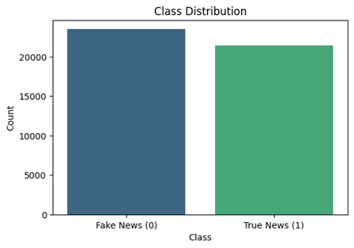
The preprocessing of data starts with loading and joins the file of fake and real news article. The binary values were assigned to each and every record “0” represents fake news whereas “1” represents real news. Rows with missing values were dropped. Further "Title” and” Text “were coupled into a single field name” Content”.
To standardise the data and reduce the series of text normalisation operations were performed. To eliminate case sensitivity, text was converted to lower case. All URL’s and hyperlinks were removed.
Figure 1. Class Distribution of the ISOT Dataset
After cleaning, the dataset was segmented into three sets Training, Testing and Validation in a ratio of 70:15:15. A uniform random state was used to ensure that our results are reproduceable.

Study Design of Research:
1.) Data Collection and Preparation: The Dataset consists of two CSV files: Figure 2. “Fake.csv” (contains fake news articles) and Figure 3. “True.csv” (contains true news articles). Labels are assigned “0” for fake news and 1 for True. The datasets are merged into one data frame and cleaned by removing missing values.
Figure 2. Fake Dataset
Figure 3. True Dataset


2.) Data Analysis: Class distribution is plotted to check balance between fake and real news. Dataset is split into Train (70%), Validation (15%) and Test (15%) sets. The two datasets fake.csv and true.csv gets merged into one dataset on which the model runs.
3.) Preprocessing: Unnecessary elements like uppercase, lowercase inconsistency, URL’s and numbers don’t add meaningful information for the model. Dataset requires less preprocessing time as the dataset is already cleaned before passing it to BERT.
3.1) NLTK (Natural Language Tool Kit): Resources like stopwords and wordnet are used from NLTK.
3.2) Cleaning Pipeline: The clean_text function ignores lowercasing, removes URLs and special characters from special text.
3.3) Lemmatization: Stopwords like “is, was, the”, may be removed and lemmatized words like (better -> good) are used. This process may be skipped because BERT has a powerful tokenizer and internal language understanding.
3.4) Final Output: The cleaned text is stored in a new column: clean_text. This column is then used for train, validation & test splits and further tokenization by BERT.
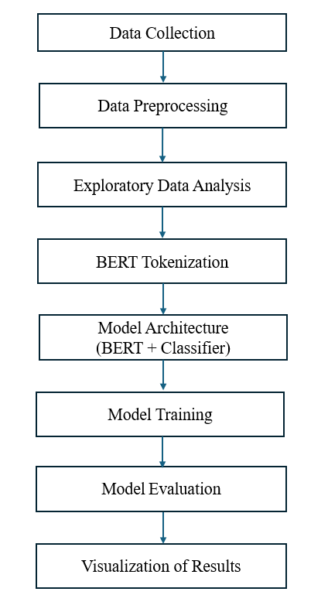
4.) Text Representation using BERT Tokenizer: BERT tokenizer converts each news article into numerical representation that the model can understand. The maximum length of each text is limited to 128 tokens—Shorter texts are padded, and longer ones are truncated. After Tokenization the data is organized into PyTorch dataset and data loaders. It runs the model efficiently during training, validation and testing.
Figure 4. Workflow of the study
5.) Model Architecture: For model architecture, a pre-trained BERT based model is used and then fine-tuned on fake news dataset. The parameters of the model are optimized using the Adam W Optimiser with a learning rate of 2e-5 which is effective during fine tuning BERT. Training and evaluation tasks are carried out on a GPU making the process faster and efficient as compared to only using a CPU.
6.) Model Training: The training model passes three complete stages through the dataset known as epoch. Training process involves several stages like forward pass and backward pass to keep the training stable and prevent large updates, gradient clipping is applied at the end of each epoch, the model’s performance is checked on the validation set. Loss and accuracy for training and validation are recorded.
7.) Model Evaluation: After training, the model’s performance is tested on preprocessed dataset. Model’s performance is measured on several metrics like accuracy, precision and recall. The ROC AUC score is used to evaluate the model’s ability. Predictions made by the model are stored and then compared with the actual labels. It gives the clear picture of where the model performed well and where did it struggle.
Results & Metrics are calculated using:
- Training & Validation Accuracy
The curves in Training & Validation Accuracy are based on this formula:

$Accuracy=\frac{TP+TN}{TP+TN+FP+FN} = \frac{3210+3523}{3210+3523+0+2} ≈0.9997​$
Equation 1
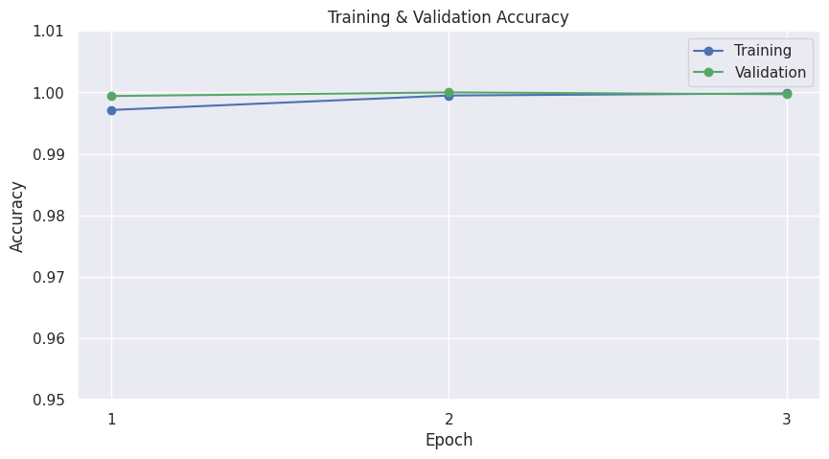
Figure 5. Training & Validation Accuracy

At each epoch e:
$$Accuracy {train }^{(e)}=\frac{Correct predictions on training set}{Total training samples}​$$

- Training & Validation Loss
This graph corresponds to the Binary Cross-Entropy Loss function, as the task performed in the study is
Binary classification (Real vs Fake):
Equation 2
Figure 6. Training & Validation Loss
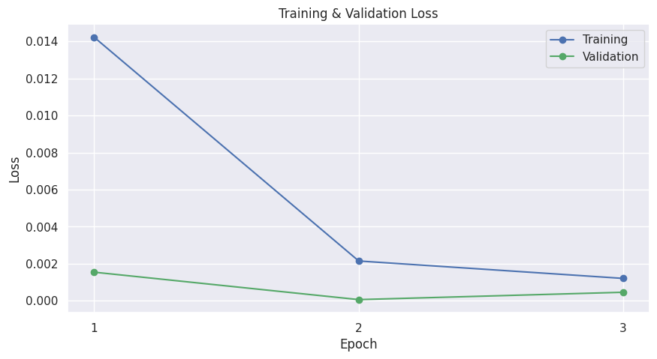
$$L= -\frac{1}{N}\sum_{i=1}^{N}{[y_{i}∙ \log\left(\hat{y_{i}}\right)+\left(1- y_{i}\right) ∙ \log{(1- \hat{y_{i}})}]}$$

- Confusion Matrix – Test Set
Confusion Matrix is derived from:
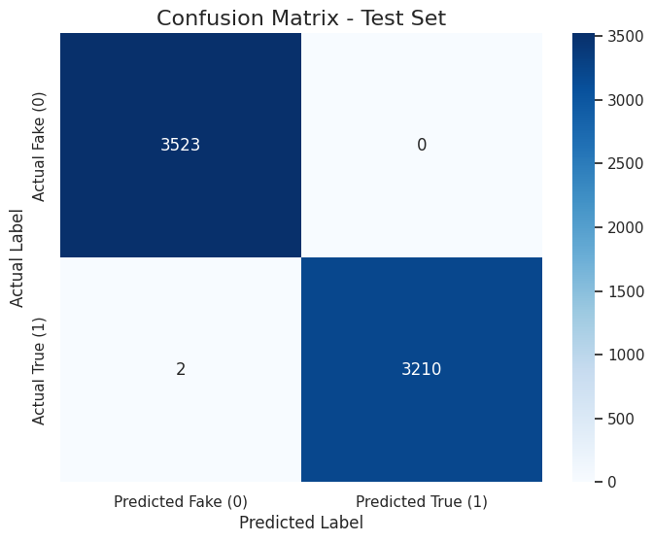
Figure 7. Confusion Matrix - Test Set
$$Confusion Matrix=\left[\begin{matrix}TP & FP \\ FN & TN\end{matrix}\right]= \left[\begin{matrix}3210 & 0 \\ 2 & 3523\end{matrix}\right]$$

Derived metrics:
- Precision
Equation 3
$$Precision= \frac{TP}{TP+FP}= \frac{3210}{3210+0}=1.000$$

- Recall
Equation 4
$$Recall= \frac{TP}{TP+FN} = \frac{3210}{3210+2} ≈ 0.9994$$

- F1 – Score
Equation 5
$$F1= \frac{2 ∙Precision ∙Recall}{Precision+Recall} = \frac{2 ∙1.0 ∙0.9994}{1.0+0.9994}= \frac{1.9988}{1.9994} ≈0.9997$$

- Receiver Operation Characteristic (ROC) Curve
The ROC curve is based on:
- True Positive Rate
Equation 6
$$TPR= \frac{TP}{TP+FN}= \frac{3210}{3210+2} ≈ 0.9994$$

- False Positive Rate
Equation 7
$$FPR= \frac{FP}{FP+TN}= \frac{0}{0+3523}=0$$

- The Area Under Curve (AUC):
Equation 8
$$AUC= \int_{0}^{1}{TPR\left(FPR\right)d(FPR)} ≈1.0$$

- Precision – Recall Curve
The PR curve is plotted using:
Table II
Model Performance Metrics

Metric | Score
Accuracy | 0.9997
Precision | 1.0000
Recall | 0.9994
F1 – Score | 0.9997
ROC AUC | 1.0000

Figure 9. Precision-Recall Curve
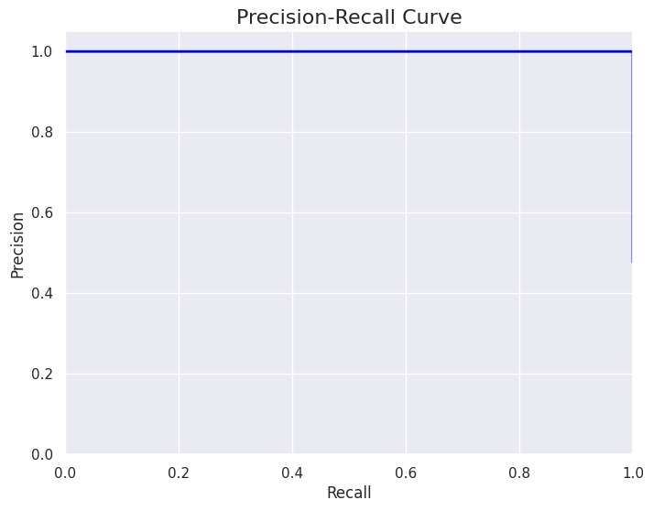
Equation 9
$$PRC= \int_{0}^{1}{Precision \left(Recall\right) d \left(Recall\right) ≈1.0}$$
8.) Visualization of Results: After training different visualizations are created to make the results easier to understand. The changes in training and validation loss and accuracy across epochs (refer to figure 5 & 6) are plotted. A confusion metrics (refer to figure 7.) is also generated which shows whether the model is correctly working or not. To check its ability, a ROC curve along with the AUC curve (refer to figure 8 & 9) is also plotted. Evaluation metrics like accuracy, precision, recall, F1 score and ROC AUC are clearly presented in a table format (Table II).

- Results
This section consists of performance evaluation of the proposed model. Dataset divided into training set (31,428), validation set (6,735) and testing set. Training of BERT includes 3 epochs, each epoch consists of 983 batches and 211 validations.
During training there was a sharp convergence of training and validation accuracy i.e., approximately 1.00 by the 2nd epoch, which is depicted in Figure 5 (Training & Validation Accuracy). After 1st epoch there is a visible decline in the training loss, whereas validation loss remains near 0, Figure 6 (Training & Validation Loss). This analysis indicates effective generalization, absence of overfitting and show both training and validation metrics reached to optimal levels by 2nd epoch.
This model gained an accuracy of 0.9997 and F1 - Score of 0.9997. It is exceptionally high accuracy and robustness which surpasses many traditional methods or other specialized BERT implementations. There is an intact identification of the negative class ('Fake (0)'), which contains 3,523 true negative and zero false positives shown in figure 7 (Confusion Matrix - Test Set). This model also gains the perfect precision of 1.000 and performed strongly on the positive class ('True (1)'), where it correctly identified 3,210 out of 3,212 instances i.e., recall of 0.9994.
In Figure 8 (Receiver Operating Characteristic Curve), there is a ROC curve which visualizes that the model achieved a perfect Area Under the Curve (AUC) of 1.000 and Figure 9 (Precision-Recall Curve) depicts the maintained precision of 1.0 across all recall values, which shows model's reliability. This performance level marks a significant improvement over earlier methodologies like Decision Trees and Logistic Regression, highlighting the paradigm shift driven by Transformer architectures in achieving natural language understanding for complex classification tasks.

- Conclusion & Future work
The aim of this research is to dispense an effective, robust and inclusive evaluation of a fine-tuned Bidirectional Encoder Representations from Transformers (BERT) model to inscribe the scathing problem of fake news. This research used the effective methodology that stratified data split, comprehensive pre-processing and fine tuning of the model for specific number of epochs that ensured the integrity and reproducibility of the findings. It demonstrates that a fine-tuned model performs better in discerning between real and fake news articles. This performance indicates an advancement of this model over many traditional models like Decision Tree, Logistic Regression, CNN etc.
For future study, Researchers can work on cross-lingual detection of fake news to identify misinformation in various languages. Another aspect is to explore the integration of other data modalities, like metadata, that could provide additional contextual clues to improve detection accuracy.
- References
- S. S. Kiran Thotakura, S. Budankayala, A. S. Chandana Pallapothu, D. K. Kata and V. P. Kumar S, "Ant-BERT Based Optimized Fake News Detection," 2024 International Conference on Artificial Intelligence and Emerging Technology (Global AI Summit), Greater Noida, India, 2024, pp.167-172, doi:10.1109/GlobalAISummit62156.2024.10947992.

- Farokhian, M., Rafe, V. & Veisi, H. Fake news detection using dual BERT deep neural networks. Multimed Tools Appl 83, 43831–43848 (2024). https://doi.org/10.1007/s11042-023-17115-w

- S. Pathak, S. J. Quraishi, A. Singh, M. Singh, K. Arora and D. Ather, "A Comparative Analysis of Machine Learning Models: SVM, Naïve Bayes, Random Forest, and LSTM in Predictive Analytics," 2023 3rd International Conference on Technological Advancements in Computational Sciences (ICTACS), Tashkent, Uzbekistan, 2023, pp. 790-795, doi: 10.1109/ICTACS59847.2023.10390255.

- Adeyemi, Adedoyin S., Sunday O. Asakpa, Kehinde H. Bello, Olajide N. Saliu, Olabisi M. Olaoye, and Nike T. Toye. "Fake News Detection using Ensemble Methods: an Empirical Evaluation of Bagging and Boosting Algorithms." vol 6: 317-325.

- Gardazi, N.M., Daud, A., Malik, M.K. et al. BERT applications in natural language processing: a review. Artif Intell Rev 58, 166 (2025). https://doi.org/10.1007/s10462-025-11162-5

- K. Arora, N. Gupta and S. Pathak, "Sentimental Analysis on IMDb Movies Review using BERT," 2023 4th International Conference on Electronics and Sustainable Communication Systems (ICESC), Coimbatore, India, 2023, pp. 866-871, doi: 10.1109/ICESC57686.2023.10193688.

- J. Davis, R. K R, S. D, S. A S and R. Jose, "Fake News Detection using BERT Model," 2025 2nd International Conference on Trends in Engineering Systems and Technologies (ICTEST), Ernakulam, India, 2025, pp. 1-5, doi: 10.1109/ICTEST64710.2025.11042689.

- Zhou, C., Li, Q., Li, C. et al. A comprehensive survey on pretrained foundation models: a history from BERT to ChatGPT. Int. J. Mach. Learn. & Cyber. (2024). https://doi.org/10.1007/s13042-024-02443-6

- M. Sudhakar, K.P. Kaliyamurthie, Effective prediction of fake news using two machine learning algorithms, Measurement: Sensors, Volume 24, 2022, 100495, ISSN 2665-9174, https://doi.org/10.1016/j.measen.2022.100495.

- Gopi Pogul, Sankei Rohokhale, Priya More, Pallavi Chavan, Ensemble approach for fake news classification using machine learning, ITM Web Conf. 44 03017 (2022), DOI: 10.1051/itmconf/20224403017

- A. H. J. Almarashy, M. -R. Feizi-Derakhshi and P. Salehpour, "Enhancing Fake News Detection by Multi-Feature Classification," in IEEE Access, vol. 11, pp. 139601-139613, 2023, doi: 10.1109/ACCESS.2023.3339621.

- Essa, Ehab & Omar, Karima & Alqahtani, Ali. (2023). Fake news detection based on a hybrid BERT and LightGBM models. Complex & Intelligent Systems. 9. 10.1007/s40747-023-01098-0.

- SATHVIK, MSVPJ & Mishra, Mukesh & Padhy, Sibasankar. (2023). Fake News Detection by Fine Tuning of Bidirectional Encoder Representations from Transformers. 10.36227/techrxiv.22215403.v1.

- Kim MG, Kim M, Kim JH, Kim K. Fine-Tuning BERT Models to Classify Misinformation on Garlic and COVID-19 on Twitter. Int J Environ Res Public Health. 2022 Apr 22;19(9):5126. doi: 10.3390/ijerph19095126. PMID: 35564518; PMCID: PMC9103576.

- KS Sreekar Datta, G Narasimha Naidu, S Abhishek, Anjali T, Enhancing Veracity: Empirical Evaluation of Fake News Detection Techniques, Procedia Computer Science, Volume 233, 2024, Pages 97-107, ISSN 1877-0509, https://doi.org/10.1016/j.procs.2024.03.199.

- Schütz, M, Böck, J, Andresel, M-P, Kirchknopf, A, Liakhovets, D, Slijepcevic, D & Schindler, A 2022, Cross-Lingual Fake News Detection with a Large Pre-Trained Transformer. in G Faggioli, N Ferro, A Hanbury & M Potthast (eds), Proceedings of the Working Notes of CLEF 2022 - Conference and Labs of the Evaluation Forum. vol. 3180, 53, pp. 660-670, CheckThat! 2022, 5/09/22.

- Thangamani R, Vimladevi M, Ramyasri M M, Sasvath K R, Mohammad Aadil A, Varshini S H, Fake News Detection using Deep Learning A Transfer Model Approach”, 2025 International Conference on Inventive Research in Computing Applications (ICIRCA) in IEEE | DOI: 10.1109 | ICIRCA65293.20205.11089890

- R, Anju and Pervin, Nargis, Credbert:Credibility-Aware Bert Model for Fake News Detection. Available at SSRN: https://ssrn.com/abstract=5097587 or http://dx.doi.org/10.2139/ssrn.5097587

- Ahmed H, Traore I, Saad S. (2017) “Detection of Online Fake News Using N-Gram Analysis and Machine Learning Techniques. In: Traore I., Woungang I., Awad A. (eds) Intelligent, Secure, and Dependable Systems in Distributed and Cloud Environments. ISDDC 2017. Lecture Notes in Computer Science, vol 10618. Springer, Cham (pp. 127- 138).

- https://colab.research.google.com/drive/14uJhi66jdxT4UZhmrtfbjPhLWM-lbrDi?usp=sharing

