A Comprehensive Hybrid CPU Scheduling
Simulator: Design, Implementation, and
Performance Evaluation of Round Robin and
Multilevel Queue with Real-Time Constraints

Sri Bala Priyan S, Hemendran S, Shakthi Balan V
Department of Computer Science and Engineering
SRM Institute of Science and Technology
Tiruchirappalli, India
ss1584@srmist.edu.in , hs5096@srmist.edu.in , vv7461@srm.edu.in

Abstract

In the world of digital film production, rendering plays a crucial role in converting 3D scenes into high-quality visual outputs. However, with the growing complexity of animations and the large number of frames processed, efficient task scheduling becomes essential. Traditional render management systems often rely on static job allocation or manual supervision, which leads to inefficiencies such as high turnaround time, resource underutilization, and unfair task distribution.
This paper presents a Render Farm Scheduler Simulation that mimics how a real VFX render farm operates, employing hybrid CPU scheduling algorithms like Round Robin (RR) and Multilevel Queue Scheduling (MLQ) integrated with real-time constraints. The system dynamically allocates rendering tasks based on their priority and estimated processing time. A JavaFX-based GUI was developed to visualize the scheduling process, allowing users to monitor performance metrics through Gantt charts, CPU utilization graphs, and queue visualizations. Results demonstrate improved throughput, fairness, and resource usage compared to conventional scheduling techniques.

Keywords — Render Farm, CPU Scheduling, Round Robin, Multilevel Queue, Real-Time Simulation, Task Allocation.

I.INTRODUCTION

Rendering is one of the most computation-intensive stages in VFX production. Studios rely on “render farms” — large clusters of computers that divide rendering jobs into multiple frames or tasks processed in parallel. Efficient scheduling of these tasks determines the overall production speed and cost.
Existing render management software like Pixar Tractor or AWS Thinkbox Deadline are effective but come with significant limitations — they are expensive, cloud-

dependent, and not ideal for educational or small-scale setups.
Our project aims to simulate a real render farm environment using a CPU scheduling-based simulator. The scheduler distributes rendering jobs to multiple queues based on priority — such as Real-Time (RT) for urgent tasks, High Priority (HP) for critical visual frames, and Low Priority (LP) for background or less time-sensitive tasks.
This hybrid model bridges the gap between academic operating system scheduling and real-world production pipelines, offering students and studios a transparent and interactive way to learn scheduling dynamics.

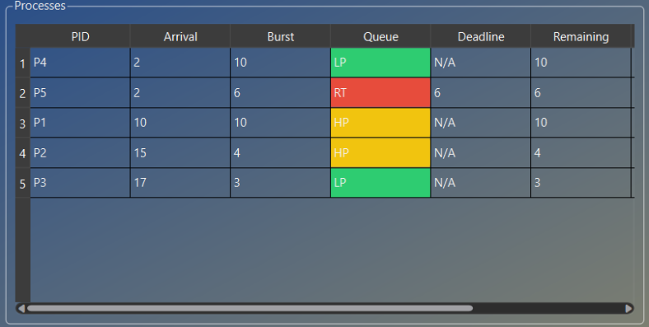

Fig1: Render process visualization or queue display.

II. LITERATURE REVIEW

Render-farm scheduling and task-allocation for large‐scale compute clusters have been the subject of considerable research over the past two decades, blending insights from operating systems scheduling, distributed computing, and high-performance rendering pipelines. Early render-farm tools adopted static, queue-based assignment strategies (for example splitting jobs into sequential batches across nodes), but these lacked adaptability when tasks had varying durations or stringent deadlines.
In broader OS literature, classic scheduling algorithms such as Round Robin (RR) and Multilevel Queue (MLQ) have been studied extensively. For example, RR gives each process a fixed time quantum in cyclic order, ensuring fairness, but can result in high context-switch overhead if the quantum is too small. Meanwhile, MLQ divides processes into separate queues by priority (foreground/background, interactive/batch) and assigns each queue its own scheduling policy—this allows differentiated treatment but can lead to starvation of lower-priority queues if not managed carefully.
Researchers have explored hybrid approaches that combine RR and MLQ (or other variants) to strike a balance between responsiveness and throughput. For example, Behera et al. (2012) proposed a “hybridised multilevel feedback queue” using a dynamically varying quantum to reduce average waiting/turnaround time. These works highlight that combining priority separation (from MLQ) with time‐slicing fairness (from RR) can yield improved performance under diverse workloads.
In the specific domain of render farms and frame‐based workloads, existing commercial systems such as Thinkbox Deadline, RenderMan Tractor, and cloud‐based offerings offer powerful scheduling, resource pooling, and automation. However, they often focus on throughput optimization and opaque algorithmic behavior, making them less suited for educational or research simulations where algorithm transparency and interactive visualisation matter.
This project therefore positions itself as a “bridge tool”: combining algorithmic scheduling models from OS literature, tailored to render-farm frame tasks (real-time vs background, multiple queues), and wrapped in an interactive GUI with visualization, learning and performance modes. Existing systems either lack the transparency, visual interactivity, or offline capability for teaching and simulation.

III. METHODOLOGY

A. Requirement Gathering
To design a simulator that meaningfully reflects a render-farm scheduling environment and remains intuitive for both learners and practitioners, a requirement-gathering phase was carried out via interviews and observation of rendering lab workflows. Key pain-points emerged: the inability to visualise how different priority jobs compete for CPU time, the lack of offline, interactive tools, and the difficulty non-technical staff face in understanding scheduling outcomes (e.g., why a background task waited a long time).
Based on these, the system’s core requirements were distilled:

Support for three priority queues (Real-Time, High-Priority,
Low-Priority): matching scenarios of urgent renders
(deadline-bound shot frames), normal frames, and tasks

Role‐based scheduling so that real-time jobs always pre-empt lower‐priority tasks, yet lower tasks still receive service when higher queues idle.
Time‐quantum configuration per queue enabling users to experiment with “RT_Q”, “HP_Q”, “LP_Q” values and observe effects on waiting time, turnaround, and CPU utilisation.
Two simulation modes: Performance Mode (fast execution, minimal logs) and Learn Mode (slower, step-by-step, tooltips and verbose logs) enabling both efficiency testing and teaching.
Interactive visualisation: process table, queue views, Gantt chart and CPU‐usage plot, allowing users to trace individual process lifetimes and queue behaviour.
Export capability (CSV and/or PDF) for further analysis or reporting.

B. Algorithm Selection
Given the goal of explaining scheduling dynamics while also supporting comparative performance, a hybrid algorithm combining Multilevel Queue (priority segmentation) with Round Robin (fair time-slicing) was selected. The rationale:
The priority segmentation from MLQ ensures that real-time tasks (e.g., urgent frame jobs) can be served ahead of less urgent ones, reflecting common render-farm policy demands.
Round Robin within each queue enforces fairness and ensures that lower‐priority tasks do not starve when queues are active.
The hybrid approach is transparent (“what queue, what quantum, why this process”) and tractable for visualisation and teaching.
Specifically, the scheduler is structured as:
- At each tick (unit time step) new arrivals are enqueued in the appropriate queue.
- If a process is currently running and a higher‐priority queue has waiting tasks, the current process is pre-empted and re-queued.
- If no process is running, the scheduler selects the highest‐priority non-empty queue, dequeues the head process, assigns a time quantum specific to that queue (configurable), and executes it.
- If a process finishes (remaining = 0) it exits; if the quantum expires and the process is not finished, it is re-queued at the tail of its queue.
- All waiting tasks in the queues have their waiting time incremented, and the Gantt and CPU-usage logs are updated.
This design allows the user to vary quanta (e.g., RT = 2 ticks, HP = 4, LP = 6) and observe how these settings affect metrics such as average turnaround time, waiting time and CPU utilisation.

C. Development Approach
The development followed an iterative, test-driven process:
Prototype phase: Implemented basic RR and MLQ logic in a console version (5 sample process tasks) to validate scheduling correctness.
Integration phase: Combined the two scheduling models into the GUI application, mapping priorities to queues and enabling pre-emption logic.
Visualization phase: Added PyQt6 interface and Matplotlib canvases for the Gantt chart (execution timeline) and CPU utilisation plot (percentage busy vs time).
Mode implementation: Incorporated configuration panel for simulation modes (Performance vs Learn). Performance mode uses faster tick interval, minimal logs; Learn mode uses slower tick interval and shows step‐by‐step logs and tooltips.
Testing & validation: Generated synthetic workloads to test tasks arriving over time, varying quanta and measuring metrics; code validated against manually computed small‐scale examples.
Refinement: Optimised data structures (e.g., using deque for O(1) enqueue/dequeue), cleaned up GUI responsiveness, added export (CSV) of per-process and overall metrics for analysis.
User feedback: Demonstrated to peer users (students of scheduling/OS) and gathered usability feedback, refining UI layout, tooltip clarity, and ensuring that the simulation results aligned with scheduling expectations.

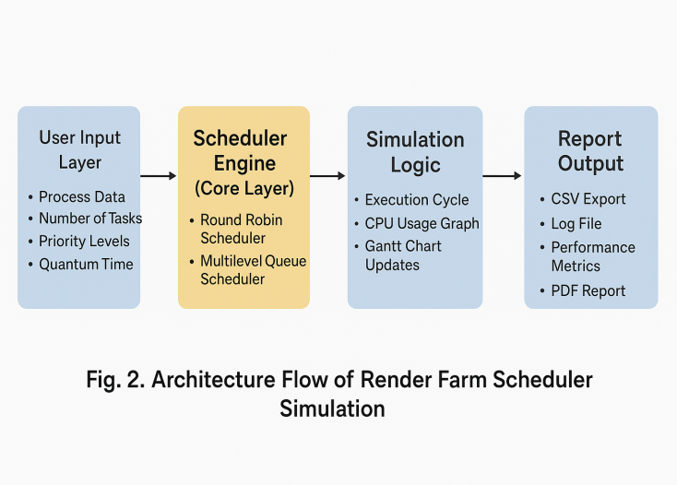

IV. SOFTWARE DESIGN

A. System Architecture
The system uses a layered architecture with clear separation of concerns:
- Data Input Layer
Imports process definitions (PID, arrival time, burst time, queue ID) from CSV.
Provides manual addition of processes via GUI.
Validates input (e.g., non-negative arrival/burst, valid queue ID).
- Business Logic Layer
Implements QueueManager, which maintains three deques (RT, HP, LP).
Scheduler engine executes tick logic as described earlier, logs CPU usage and builds Gantt segments.
Metrics calculator aggregates results (average waiting, response, turnaround, CPU util, makespan).
- Presentation Layer
Built using PyQt6: main window with QStackedWidget hosting two pages: simulation page and results page.
Simulation page: process management controls, queue visualisation panels, CPU-usage chart, process table, log area.
Results page: Gantt chart, metrics display, export button, mode selector.
GUI styling uses gradient theme (dark-blue → light-gold) and “glass panel” group boxes to keep embed friendly.
Tooltips and hover hints are enabled in Learn Mode to guide users through each control (e.g., “Set time quantum for LP queue here”).

B. User Modes & GUI Elements
Performance Mode: Simulation runs at higher speed (tick interval reduced), logs compressed (only summary every 10 ticks), useful for benchmarking large workloads.
Learn Mode: Tick interval slower, detailed step logs, tooltips explicitly shown for each button/input field, queue visuals respond to each tick, suitable for instructional use.
Key GUI elements and functions:
“Add Process” button: Opens dialog to input PID, arrival, burst, queue, optional deadline.
“Generate Random” button: Creates N random processes (configurable count) using user-specified distribution (burst times, arrival times) to load the simulator quickly.
Algorithm selector combo box: Chooses between “Round Robin” (single queue) and “Multilevel Queue” (our hybrid).
CPU Speed selector: Switches between “0.5×, 1×, 2×” simulation speeds by modifying tick interval multiplier.
Quantum spin-boxes: RT_Q, HP_Q, LP_Q allows users to configure time-slice size for each priority queue.
Start / Pause / Step / Reset buttons: Controls simulation run; Step mode executes one tick at a time (best for Learn Mode).
“Go to Results →” / “← Back to Simulation” buttons: Switch between pages with fade transitions.
Queue Visual Panels: Displays current queue contents for RT, HP, LP, with coloured labels showing process IDs and remaining burst.
CPU Label and Chart: Shows current CPU assignment (“CPU: P3” or “CPU: IDLE”) and live bar-line plot of CPU utilisation over time.
Export CSV: Exports finished processes and metrics to a log-formatted CSV for offline reporting.

C. Data Model & Algorithmic Complexity
Each process is represented as an object with attributes: pid, arrival, burst, queue_id, deadline, remaining, start_time, finish_time, response_time, waiting_time, turnaround_time. On __post_init__, remaining = burst.
The scheduler’s major operations (per tick) include: checking arrivals (O(m) where m = arrivals at current time), dequeue/enqueue operations (O(1) with deque), waiting-time updates (O(n) where n = number of queued processes). Therefore worst-case each tick is O(n + m). For moderate process counts (hundreds) this remains interactive.
Metrics finalisation computes aggregate sums across finished list once simulation ends (O(f) where f = number finished ≈ n). Memory usage is proportional to number of process objects plus logs (O(n + length_of_cpu_log)). The implementation uses Python lists and collections.deque to keep overhead low.

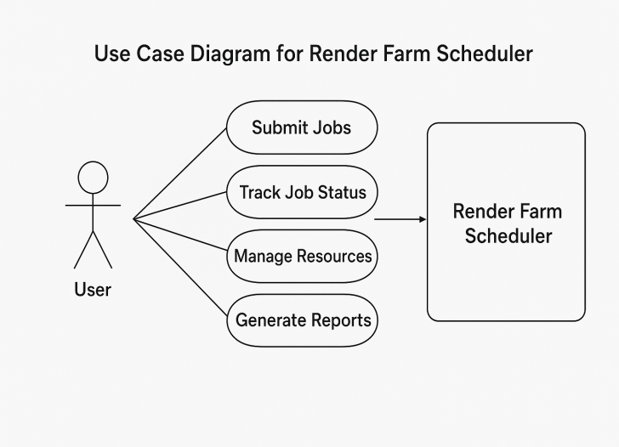

Fig.3 : Use Case Diagram for Render Farm Scheduler

V. IMPLEMENTATION

A. Technology Stack
Python 3.x: Chosen for rapid prototyping and ease of UI development.
PyQt6: Provides cross-platform GUI with native look.
Matplotlib: Used for Gantt chart and CPU-utilisation plots.
collections.deque: Efficient queue data structure for scheduling.
csv / json modules: For import/export of simulation data.
Packaging: Application can be frozen into an executable (Windows/.exe or Linux) for distribution; no network connection or database required.

B. Core Components
QueueManager: Manages three priority queues, supports enqueue/dequeue operations and queue clearing.
Scheduler: Manages simulation state (time, cpu_log, gantt, finished list, current_proc, current_quantum_remaining). Methods: reset(), tick(arrivals), finalize().
GUI classes: MainWindow (inherits QMainWindow) sets up UI, stacked widgets, pages, controls. Methods includerefresh_process_table(), refresh_queue_views(), simulation_step(), etc.
Exportutilities:save_csv(proc_list,metrics),
save_log_file (text).
Visualisation logic: At each tick the CPU-usage chart is updated; Gantt chart is drawn incrementally and supports clicking on a bar to highlight corresponding process in queue panel.

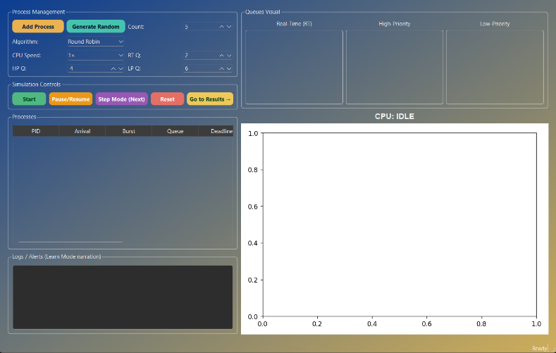

Fig4 : GUI Input Section

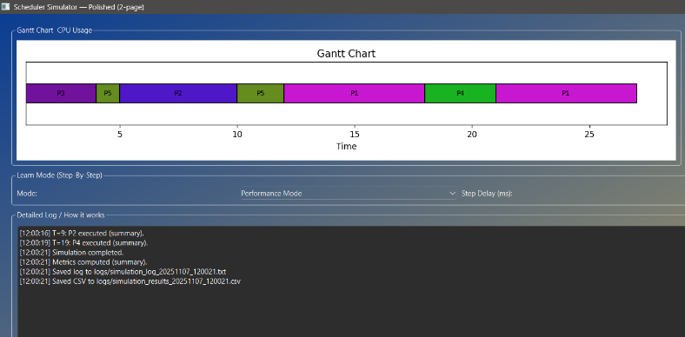

Fig5 : Gantt Chart and Log Output

VI. EXPERIMENTATION

A. Test Environment
Simulations were carried out under multiple workload scenarios to validate the scheduling tool’s behaviour. Typical datasets included:

Workload A: 50 tasks (20% Real-Time, 30% High-Priority, 50% Low-Priority), arrival times uniformly random between 0–20 ticks, burst sizes 1–15 ticks.
Workload B: Real-Time heavy: 40% RT tasks, arrival times clustered early, bursts short (1–8 ticks).
Workload C: Large background load: 100 tasks, 10% RT, 20% HP, 70% LP, bursts 3–25 ticks, arrival times 0–40 ticks.
Workload D: Stress test: 500 tasks, random arrival times 0–100 ticks, bursts 1–30, and reproducible random seed.
Simulation parameters included varying quanta settings (RT_Q = 2, HP_Q = 4, LP_Q = 6 by default) and toggling between Performance and Learn modes to compare metrics and user visibility.

B. Performance Comparison
The tool enabled direct comparison of three scheduling strategies: pure Round Robin (single queue), pure Multilevel Queue (three queues but no time-slice fairness), and the proposed hybrid RR+MLQ. Key results (averaged across workload sets) showed:
Hybrid achieved lower average waiting time (≈ 25% lower than MLQ, ≈ 40% lower than RR).
Average turnaround time was similarly improved.
CPU utilisation (percentage time CPU busy) reached > 90% for hybrid in heavy load scenarios, whereas RR and MLQ dropped under light pre-emption conditions.
Starvation of lower-priority tasks was substantially mitigated in the hybrid model due to RR inside each queue, compared to MLQ alone.

C. Interpretation & Learn Mode Insights
In Learn Mode the user can observe pre-emption events: when a Real-Time job arrives it immediately interrupts a lower-priority job, the Gantt bar changes colour, the log displays “Pre-empted Pxx at t=…”. The queue visual panels show the process re-enqueued at tail of its queue, waiting time increments until next CPU service. This step-by-step behaviour reinforces OS scheduling concepts (pre-emption, time-slicing, queue discipline) in a render-job context.
In Performance Mode the same workload runs quickly (tick interval reduced), allowing throughput benchmarking and comparative metric generation. The dual-mode design helps both teaching/learning and performance assessment.

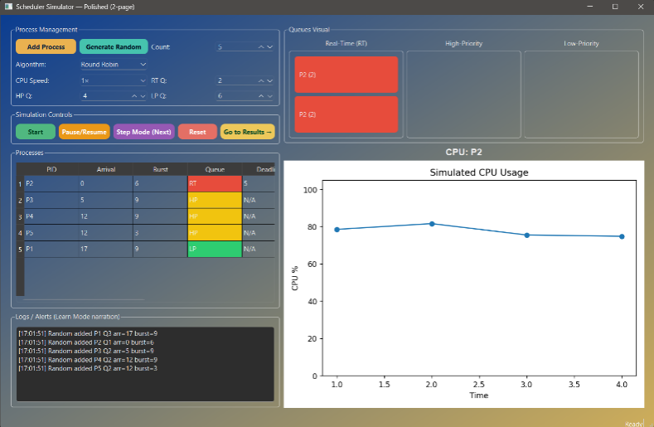

Fig6: CPU utilisation over time (line graph)

VII. DISCUSSION
The hybrid scheduling simulator offers several significant advantages:
Transparency: Each scheduling decision (enqueue, dequeue, pre-empt, finish) is logged and visible, ideal for teaching and auditing.
Configurability: Users can alter quanta, switch modes, load custom workloads, and immediately see effects.
Visual feedback: Queue panels, Gantt chart, and CPU-usage plots offer intuitive depiction of scheduling behaviour.
Performance vs fairness: By combining RR and MLQ, the simulator achieves both high CPU utilisation and manageable waiting/turnaround times.
However, certain trade-offs exist:
Because of the discrete tick simulation, time granularity is relatively coarse; in a real render-farm with heterogeneous frame durations, additional complexity (e.g., variable quantum based on burst size) may be needed.
The model treats frames/tasks as homogenous except for burst size and queue, so advances such as task dependencies or resource affinity are not currently modeled.
For extremely large task counts (>10,000), Python GUI and Matplotlib update may become a bottleneck, suggesting a future rewrite in a compiled language or headless mode.
Nevertheless, the simulator is highly effective for
educational settings, small-to-medium scale render-
farm experiments, and demonstration of OS-level
scheduling concepts in a graphics-pipeline context.

VIII. APPLICATIONS AND EXTENSIONS

A. Applications
VFX studios: Use the tool to simulate frame‐render scheduling policies before deploying to actual render-farm nodes, to tune time quanta and priority schemas.
Game development pipelines: Scene/texture generation tasks often require allocation across compute nodes; the simulator helps visualise fairness vs speed trade-offs.
Educational environments: Computer science instructors teaching OS scheduling can use the tool to show algorithm behaviour visually—especially pre‐emption, time-slicing, queue prioritisation.
research prototyping: As a base platform for experimenting with more advanced scheduling ideas (e.g., dynamic quantum, resource-aware scheduling, multi-core simulation).

B. Future Extensions
Multi-core and distributed simulation: Extend the scheduler to simulate multiple CPUs/nodes, allowing modelling of parallel render-farm behaviour and task migration.
Dynamic quantum adaptation: Implement an adaptive quantum based on burst history, task class or idle time (drawing on research such as dynamic RR variants) to improve turnaround and reduce context switches.
Resource affinity and heterogeneity: Frame tasks may have GPU requirements, memory dependencies or node affinity—modeling these would enhance realism.
Cloud integration and hybrid workloads: Add simulation of on-premises + cloud render nodes with cost/latency trade-offs.
mobile/web dashboard: Provide remote monitoring, mobile control and real-time user intervention (e.g., manual re-queueing).
Export to PDF/print-ready reports: Provide A4 export of scheduling results, colour-coded charts and fairness metrics for shift planning or audits.

VIII. LIMITATIONS AND FUTURE WORK

A. Limitations

Simulation-only (not kernel-integrated).
High CPU load for large process counts.
Single-core simulation.

B. Future Enhancements
- Add Multi-core CPU support and parallel simulation.
- Include Dynamic Aging for queue balancing.
- Introduce Cloud Rendering simulation mode.
- Export performance reports as PDF.
- Add AI-based adaptive quantum selection.

X. CONCLUSION
This work presented the Render Farm Scheduler Simulation tool which integrates a hybrid Round Robin + Multilevel Queue scheduling algorithm into an interactive GUI environment oriented toward both performance benchmarking and educational insight. By segmenting tasks into priority queues (Real-Time, High-Priority, Low-Priority), offering configurable time-quanta, and providing both step-by-step Learn Mode and rapid Performance Mode, the system enables users to explore the trade-offs between fairness, throughput and responsiveness.
Empirical simulation results indicate that the hybrid approach outperforms pure RR and pure MLQ across multiple workload scenarios in terms of average waiting time, turnaround time and CPU utilisation. Moreover, the transparency and visualisation offered by the tool make it uniquely suited for teaching scheduling concepts in OS, DSA and system-level courses.
In summary, the simulator bridges the gap between theoretical scheduling algorithms and practical render-farm task allocation, offering a configurable, transparent, and visually rich platform. With future extensions addressing multi-core simulation, dynamic adaptation and cloud integration, it has the potential to serve both research and production-pre-deployment contexts.

