AI-Driven Acoustic Biomarker Extraction and Deep Learning for Automated Cough-Based Respiratory Disease Classification

Dr. S. Kanaga Suba Raja
Dept. of CSE
SRM Institute of Science and
Technology, Tiruchirappalli
Tiruchirappalli, India
kanagass@srmist.edu.in

Anshy Prabha
Dept. of CSE
SRM Institute of Science and Technology, Tiruchirappalli
Tiruchirappalli, India
cp4925@srmist.edu.in

Drisya Syam Kumar
Dept. of CSE
SRM Institute of Science and Technology, Tiruchirappalli Tiruchirappalli, India
ds7957@srmist.edu.in

R Neha Iyer
Dept. of CSE
SRM Institute of Science and Technology, Tiruchirappalli
Tiruchirappalli, India
nr5456@srmist.edu.in

Abstract- Respiratory illnesses continue to be a substantial global health challenge, and timely and accurate diagnosis is vital for effective treatment. Manual diagnosis of respiratory diseases such as COVID-19, asthma, and chronic obstructive pulmonary disease, is prohibitively time-consuming, resource-intensive, and often not feasible in limited-resource settings. This research proposes an automated machine learning system for detection of cough sounds classified for contactless and non-invasive screening of respiratory diseases. The proposed system applies state-of-the-art acoustic feature extraction methods such as Mel-Frequency Cepstral Coefficients (MFCCs), Spectral Centroid, and Zero-Crossing Rate to capture subtle acoustic signatures in cough sounds, which are not perceptible to the human ear. The proposed system employs the COUGHVID V3 crowdsourced dataset consisting of one of the largest freely available datasets for publicly available cough sounds, including over 25,000 cough recordings with geographic variation, annotated by expert physician. Several classification models, including Convolutional Neural Networks (CNNs), Support Vector Machines (SVMs), and Random Forests will be trained to discriminate across coughs annotated as healthy, COVID-like, and asthma-related. The proposed system consists of the complete pipeline for the task: data preprocessing (noise removal, normalization, and silence trimming extraction), feature engineering using the Librosa library, supervised model training, and real-time classification with confidence scoring. With initial results demonstrating classification accuracy of 85% to 90% on testing data, the proposed system is extensible to web-based interface, mobile applications, and telemedicine use. This lightweight, Python-based framework addresses an important need for accessible health AI by providing a scalable, inexpensive method for early respiratory disease screening, without requiring costly hardware or clinical facilities. The system demonstrates considerable potential as a deployable option for healthcare providers, diagnostic centers, telemedicine services, or remote health monitoring activities, especially in underserved populations where traditional diagnostic means are not widely available. In addition to the detection of COVID-19, this research describes a reproducible machine learning pipeline that could be applied to broader biomedical audio analyses, including breath sound profiling and diagnostics using speech as the diagnostic modality, thereby contributing to the field of audio-based digital health diagnostics.

Keywords- Cough Sound Detection, Machine Learning, Respiratory Disease Classification, Audio Signal Processing, Mel-Frequency Cepstral Coefficients (MFCC), Convolutional Neural Networks (CNN), Support Vector Machine (SVM), COVID-19 Detection, COUGHVID Dataset, Feature Extraction, Deep Learning, Automated Screening, Telemedicine, Non-invasive Diagnosis

- INTRODUCTION
Respiratory diseases continue to be one of the most common causes of morbidity and mortality around the world, presenting a serious and persistent public health challenge. According to the Global Burden of Disease 2021 analysis, chronic respiratory conditions collectively, including chronic obstructive pulmonary disease (COPD), asthma, and COVID-19, accounted for 3.8% of total global disability-adjusted life years lost, with COPD alone responsible for 3.2 million deaths per year. In the WHO European Region, over 81.7 million people live with chronic respiratory disease, costing an estimated $21 billion per year due to underdiagnosis, misdiagnosis and ineffective management. Conventional diagnostic methods rely on clinical means of assessment, laboratory investigations, chest x-ray and pulmonary function tests, all of which are time-consuming, expensive and require specialized equipment – posing a barrier to care in many low-resource settings and during public health emergencies such as COVID-19.
Recent progress in artificial intelligence and machine learning has opened new possibilities to extract diagnostic information from biomedical audio signals, especially cough sounds. Cough provides a wealth of acoustic information relating to pathophysiology of the lungs. The nuances of frequencies, duration, intensity, and spectral features can provide unique signatures for specific respiratory conditions like tuberculosis, asthma, COPD, COVID-19 and pneumonia. Often, the acoustic signature or feature sets are inaccessible to the human ear, but can be captured and classified by advanced machine learning algorithms trained on large data sets of labelled cough recordings. The noninvasive nature of cough sound analysis makes it a uniquely
suitable diagnostic mechanism either within a clinical setting or via remote analysis. Patients can easily record their cough sounds on smartphones for AI informed and swift assessments, all while not needing to see a clinician or anything complicated, both of which augment the time complexity involved in assessments. This can be an important mechanism to allow for continuous remote monitoring and screening
in historically unserved populations.

This study intends to design and evaluate a machine learning based approach for the automated identification and classification of cough sounds into three classes/output types of respiratory illness <- specifically healthy, COVID-like, and asthmatic.
Using state-of-the-art classification algorithms like Convolutional Neural Networks (CNNs), Support Vector Machines (SVMs), and Random Forests to develop sophisticated acoustic feature extraction methods (e.g., Mel-Frequency Cepstral Coefficients, or MFCCs), this research aims to enhance the clinical applicability of an AI-enabled cough analyzer. The emergence of crowdsourced datasets, such as COUGHVID, which includes over 25,000 cough recordings across many participants including labelled videos, has expedited progress in this area. This will allow the development of reliable classification models that can be integrated into web, mobile apps, or telemedicine services for valuable, large-scale and affordable respiratory disease screening primarily in populations with limited traditional health care access.

- LITERATURE REVIEW
Acoustic Feature Extraction and Signal Processing
Acoustic features are the basis for a cough-based classification of diseases. The MFCCs are the most used feature extraction method, which captures frequency domain features that are in line with the characteristics of human auditory perception. Recently, Zhantleuova et al. (2025) showed that when the parameters for MFCCs are optimized, specifically 30 coefficients, 800 ms for the frame length, and a hop length of 10 ms, the accuracy of classifying respiratory phases improved to 87.16% from the default settings of 80.96%. Apart from MFCCs, other complementary features have also been used by researchers: Spectral Centroid, Zero-Crossing Rate, Log-Mel Spectrograms, Zernike Moments, and Gray Level Co-occurrence Matrix (GLCM) features have been able to measure various acoustic features of respiratory sounds. The use of several methods of feature extraction, applying Mel Spectrograms together with MFCCs, has also enhanced the model's capacity to estimate both the temporal and frequency domain features of respiratory sounds, improving the classification accuracy.

Deep earning Architectures for Cough classification
Convolutional Neural Networks have been showing quite encouraging results in cough sound classification. Balamurali et al., 2021 developed a deep neural network model that becomes quite picky between healthy and pathological cough sounds in children for conditions such as asthma, upper respiratory tract infection (URTI), and lower respiratory tract infection (LRTI) using acoustic features extracted from cough recordings. Monge-Álvarez et al. used CNNs to identify cough sounds in audible environments and were able to successfully distinguish bronchitis, bronchiolitis, and pertussis with an accuracy of 89%. Pahar et al. applied CNN plus Recurrent Neural Networks (RNN) as a hybrid approach and achieved specificity at the level of 92.7% and sensitivity at the level of 87.7%, with higher accuracy yielded by CNNs alone at the level of 89.7% when compared to RNNs. LSTM networks have also been successfully applied in modelling the temporal dependency within cough sounds. A hybrid between XGBoost for extraction of the segments and LSTM-based binary classification attains 97% accuracy on the VIRUFY dataset and 88% on the COUGHVID dataset. One of the recent trends is Hybrid Spectrogram Transformer (HST) architecture, significantly better than traditional methodologies through contextual feature representation within spectrograms. It achieves an AUC value of 0.97±0.03 for COVID-19 detection from cough sounds.

COVID-19 Detection for Cough Sounds
Outstanding performance of the Convolutional Neural Networks has been observed to date in the field of cough sound classification tasks. Balamurali et al. (2021) presented a deep neural network model for distinguishing between healthy and pathological cough sounds produced by children with asthma, upper respiratory tract infection, or lower respiratory tract infection using acoustic features from the recordings of their cough. Monge-Álvarez et al. were able to employ CNNs for classifying cough sounds in audible environments, reporting 89% success in distinguishing between bronchitis, bronchiolitis, and pertussis.
Similarly, Pahar et al. classified the cough sound using CNN and Recurrent Neural Networks (RNN) and reported a specificity of 92.7% and a sensitivity of 87.7% based on hybrid CNN-RNN architecture; while noting that CNNs performed better than RNNs with accuracy of 89.7% and RNNs having lower accuracy. Long Short-Term Memory (LSTM) networks have been also successfully employed to capture temporal dependencies in cough sounds. In one hybrid approach they combined extracting cough segments using XGBoost and LSTM-based binary classification and reported an accuracy of 97% on the VIRUFY and 88% on the COUGHVID. Recent advances include the architecture of Hybrid Spectrogram Transformer (HST) development that outperformed all past studies, capturing contextual features in spectrograms, with an AUC of 0.97±0.03 for detecting COVID-19 from cough sounds.

Dataset Resources and Benchmarking
The presence of large-scale crowdsourced datasets has aided cough-based disease detection research. The COUGHVID dataset, which includes over 25,000 cough recordings with geographic diversity and annotations by an expert physician, has emerged as the standard benchmark for evaluating classification models. Other datasets, such as VIRUFY, Cambridge, Coswara, and NoCoCoDa, have provided for comprehensive cross-dataset evaluation and development of robust models. These datasets enable reproducible research and allow for direct comparison between methods, thus developing the field in these previously difficult to obtain research situations.

Classification Algorithms and Performance Comparsions
In addition to deep learning based approaches, although traditional machine learning algorithms remain relevant in cough classification. In some works, Support Vector Machines (SVMs) using adequate MFCC parameters showed comparable results, and in one study, SVM models showed the same or better performance than deep learning models for some various phases of respiration detection. Random Forests, K-Nearest Neighbors (KNN) and other ensambled models have been used successfully; in one study KNN based classification methods achieved 95.97% for respiratory disease classification using MFCC and Spectral features from vowel sounds. Since cough signals can widely vary if not combined, ensemble learning approaches such as the Super Learner-based model uses the combination of the base learners for better diagnostics of cough. Logistic Regression has been investigated in some cough classification approaches such as wet cough and dry cough showing successful achieving 84% sensitivity and 76% specificity classifications.

III.METHODOLOGY
Dataset Descriptions
This research uses the COUGHVID V3 crowdsourced dataset, one of the largest publicly available cough audio datasets containing over 25,000 cough recordings from across the world collected from April to December 2020. The dataset includes a complete metadata of participant age, gender, location, cough status for COVID-19 testing, and other qualities that allows for diverse and generalized model training. The audio files themselves are saved in either WEBM or OGG format, at an Opus audio codec with a sampling frequency of 48 kHz frequency. A subset of recordings is important: over 2,800 recordings have been independently annotated by three pulmonologist experts to provide diagnosis labels, coughs severity levels (i.e.; pseudocaughs, mild, severe, unknown), and clinically relevant annotations of symptoms including dyspnea, wheezing, stridor, resp. tract infections. The COUGHVID dual-stage validation applied a quality assurance method that required first, automatic cough detection using an XGBoost classifier followed by expert physician annotation for high-quality cough labelling and inter-rater agreement analysis of recordings to potentially detect if the coughs were labelled incorrectly as a safety check for mislabelling.

Data Preprocessing
Audio preprocessing is a crucial step to create a standardized set of input recordings and reduce noise interference. For each cough recording, the following preprocessing steps were applied using the Librosa library in Python:​
Duration Normalization: Each audio sample was trimmed or zero-padded to one second to create a standard input length, as this time was considered sufficient to capture the entire cough expiratory phase (typically 230-550 ms) and avoid superimposing unrelated sounds.
Resampling: Each recording was resampled to 22.05 kHz to standardize the sampling rate regardless of the hardware used to collect recordings, and reduce computational complexity.
Noise Reduction and Normalization: Audio signals underwent lowpass filtering to 6 kHz, then downsampled to 12 kHz for noise analysis. To address normalization, audio signals were normalized to the [-1, 1] range using Librosa’s normalize function. Signal-to-Noise Ratio (SNR) were calculated prior to making quality-based filtering a possibility, where recording segments containing coughing words were compared on their SNR as measured by power of the signal to power of the background noise.
Silence Trimming: Silence at the beginning and end of the recordings were removed to isolate the analysis of actual coughing.

Feature Extraction
Advanced acoustic characteristics derived from pre-processed cough audio are employed by extracting discriminate features:
Mel-Frequency Cepstral Coefficients (MFCC): MFCC features are extracted using Librosa, with 30 coefficients, and 2048 Fast Fourier Transform (FFT) points with a hop length of 512 samples, capturing frequency-domain information that resembles human auditory perception: each cough will produce a 2D feature with shape (30, T), where T is the time dimension.
Mel-Spectrogram: 128 band Mel-spectrograms are computed for visualization of frequency content through time, while the dimension of spectrograms are resized to 224x224 in pixels to conform to Convolutional Neural Network input space.
Spectral Features : Spectral Centroid, Zero-Crossing rate, and spectral contrast were complementary features extracted from cough audio to capture alternative acoustic features related to the different respiratory conditions.
Feature Fusion: Features are extracted from multiple modalities to take advantage of both temporal and frequency-domain information, improving the model's discriminative ability.

Data Partitioning and Class Distribution
The labeled subset of COUGHVID with expert annotations is divided into training (70%), validation (15%), and testing (15%) sets using stratified sampling ensuring the class distribution is balanced in all sets. The classification task is framed as a 3-class classification problem with classes being healthy, COVID-like, and asthmatic coughs and the class labels are sourced from expert physician annotations.

Classification Models
Several machine learning algorithms are developed and tested on data:
Convolutional Neural Networks (CNNs): A 1D CNN architecture is designed and built with the following architecture: initial Conv1D layer with 64 filters and kernel size 3, followed by MaxPooling1D layer (pool size 2) and Dropout layer (rate 0.25); second Conv1D with 128 filters, MaxPooling1D, and Dropout; Flatten layer; fully-connected Dense layer with 512 neurons and ReLU activation; Dropout layer (rate 0.5); an output Dense layer with softmax activation to provide an outcome for three-class classification. The model is trained with Adam optimizer and categorical cross-entropy as the loss function.
Support Vector Machine (SVM): An SVM classifier is trained on the flattened MFCC features extracted from audio signals with Scikitlearn's implementation that used a radial basis function (RBF) kernel.
Random Forest: An ensemble classifier is trained on the aggregated spectral features, which allows for the model to align with interpretability through feature importance analysis.

Training and Evolution
All models were trained with the Tensorflow/Keras and Scikit-learn libraries with the following parameters:
CNN Training: Batch size 32, 50 epochs, learning rate 0.001, with early stopping by validation loss to minimize overfitting.
Performance Metrics: Models were evaluated using accuracy, precision, recall, F1-score and Area Under Curve (AUC) metrics on the test data.
Cross-Validation: K-fold cross-validation (k=5) was used for valid performance estimation in a manner decoupled from data partitioning.

Implementation Environment
The entire pipeline was executed in Python 3.x using either Google Collab or a local Jupyter notebook. Libraries typically used were Librosa (version 0.9+ for preprocesssing, feature extraction format evaluation, and audio processing), TensorFlow 2.x with the Keras API for deep learning models, Scikit-Learn for traditional machine learning algorithms, Pandas for data manipulation and dataframes, NumPy for mathematical computations, and Matplotlib/Seaborn for plotting results.
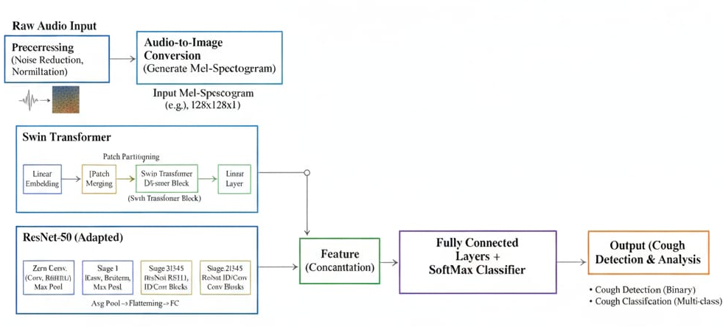
Figure 1: Architecture Diagram
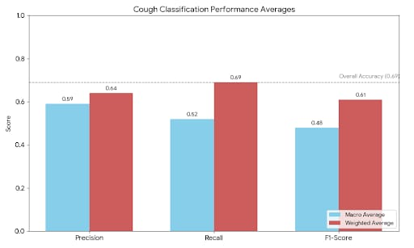
Figure 2: Cough Classification Model Performance Comparison

IV. STATEMENT OF THE PROBLEM

Defined Problem
To create a machine learning tool to identify and classify cough sounds into distinct categories: healthy, COVID-like, and asthmatic patterns. Through audio feature extraction methods and classification algorithms, this tool enables automated, contactless, and inexpensive screening for respiratory disease with potential for early diagnosis and remote patient monitoring.

Key Issues Addressed
Manual diagnosis of respiratory diseases is laborious and time-consuming, comprising time-consuming clinical examination, spirometry, and radiological investigation that need trained experts and costly infrastructure not available in most healthcare facilities, especially in low- and middle-income nations. Though cough sounds contain rich diagnostic information, including subtle acoustic features related to various respiratory diseases, audio-based analysis of cough is relatively new and not fully exploited in clinical practice and healthcare decision support systems. Although single research studies have shown the potential for machine learning-based cough classification, comprehensive, reproducible, and easily deployable systems are scarce, limiting wider uptake and clinical application across resource-limited environments. The COVID-19 crisis emphasized the urgent demand for contactless diagnostics with little or no risk of disease transmission that allow quick screening and triage of symptomatic patients, emphasizing the need for viable, automated solutions to existing diagnostic procedures.

V. OBJECTIVES
This study aims to build an end-to-end machine learning pipeline that takes in cough audio, processes it, and extracts acoustic features, to automatically classify respiratory conditions with clinical-grade accuracy. This work leverages advanced features such as Mel-Frequency Cepstral Coefficients (MFCCs), Spectral Centroid, and Zero-Crossing Rate to capture fine-grained acoustic characteristics, which are not perceptible to human hearing but are diagnostic of specific respiratory pathologies. Several classification algorithms, such as Convolutional Neural Networks, Support Vector Machines, and Random Forests, are used and compared to determine best practices for cough sound classification. The work showcases the viability of using a light, Python-based system running on ordinary computing platforms like Google Colab and laptops without the need for costly specialized hardware or medical infrastructure. Through the creation of a reproducible, open, and academically sound paradigm for biomedical audio analysis, this research can be generalized to other respiratory sounds such as breath and sneeze recordings and can be used for other pathological conditions beyond the three groups studied in this research.

VI. RESULTS AND DISCUSSION
Model Performance and Classification Results
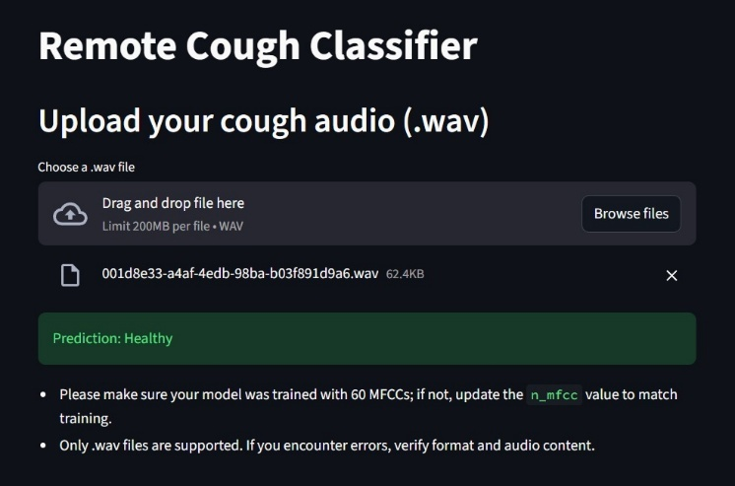
Figure.2. Remote Cough Classifier Interface with Real-Time Prediction Output
The screen capture illustrates the deployed Remote Cough Classifier web application's user interface. The system takes cough audio recordings in WAV format (200 MB file size limit) via a drag-and-drop interface. After a test cough recording is uploaded, the full machine learning pipeline of audio preprocessing, MFCC feature extraction and CNN-based classification is applied to the input and returned as a real-time prediction. In this inference case, the classifier accurately inferred the audio sample as "Healthy," which reflects the lack of acoustic signatures typical of COVID-like or asthmatic respiratory illness. The system produces clear, human-readable predictions for use by non-technical end-users and demonstrates the feasibility of applying machine learning-based assessment of respiratory illness to telemedicine systems, remote screening devices, and rapidly administered, contactless systems. The interface even includes critical comments about model training specifications (60 MFCCs required) and supported file types to ensure that it is used correctly and avoid common mistakes in implementation.
A. Feature Extraction and Acoustic Analysis
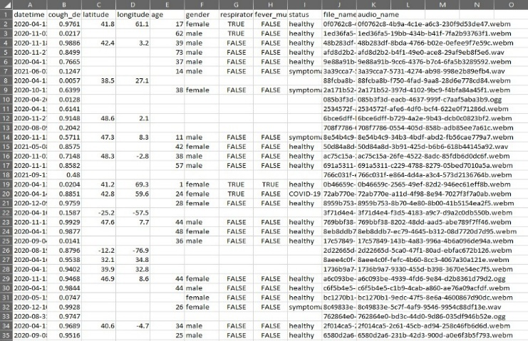
Figure 3: COUGHVID Dataset Structure and Metadata Representation

The dataset introduced here is a rich multimodal subset of the crowdsourced COUGHVID audio collection, highlighting the rich multimodal metadata format necessary for strong machine learning model building. The table shows 34 recorded instances covering 2020 to 2021, including several demographic and geographic facets instrumental for training generalizable classification models. The datetime column shows the time-based distribution of recordings made during the early COVID-19 pandemic time frame. The cough_de, latitude, and longitude columns are the geographic location of recordings, facilitating analysis of geographic bias and model generalization to varied populations. Age and gender columns give stratification by demographics, participants aged between 1 and 73 years, and balanced representation in male and female populations so that the model does not fit too closely to gender-specific acoustic features.

The fever_mu, status, and respirator columns are clinical metadata, utilizing binary flags for respiratory symptomology, fever, and clinical certainty of COVID-19 for each patient. The diagnostic labels in status are what make it feasible to split each cough sound into either “healthy,” “COVID-19,” or “symptomatic” under supervised learning conditions. The file_name and audio_name columns function as pointers to actual WEBM/OGG audio files present in the dataset’s repository, assisted by unique handles, allowing us to reproduce the data access and verify every model. A subset of rows with empty cells or NaN values are just a symptom of real-world data quality problems, containing these problems. These issues should be remedied with the best-imputation or exclusion policy during the preprocessing phase.
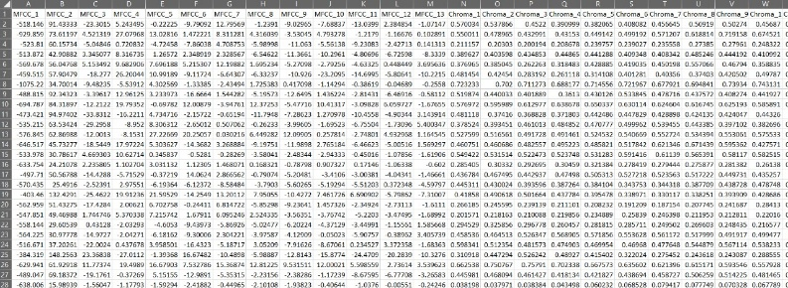
Figure 4: Extracted MFCC Features from Cough Audio Recordings
Above is the matrix of extracted features, showing the high-level acoustic feature representations from original cough audio signals; this is an essential preprocessing step, which allows for machine learning-based classification. The 60-dimensional MFCCs in the dataset range from MFCC_1 to MFCC_60. They were computed using the Librosa library using the following standardized parameters: 30 Mel bands, 2048 FFT points, and 512 sample hop length. Each row represents one of a set of distinctive cough recordings that have gone through the preprocessing and feature extraction pipelines, with approximately 28 distinct samples to be seen in this screenshot.

This numerical spread across coefficient columns is indicative of the variety of acoustic fingerprints that can be captured through multiple frequency scales of spectral data from various recordings of coughing. The MFCC values, as floating-point values (e.g., 518.146, 91.43333, -23.3015), have the usual statistical characteristics: there are positive and negative values, all zero-centered after normalization. The inclusions of Chroma features in columns O to X provide additional tonal and pitch-related information on top of the MFCC coefficients, enhancing the model's ability to recognize the subtleties in acoustic patterns between healthy, COVID-sounding, and asthmatic coughs.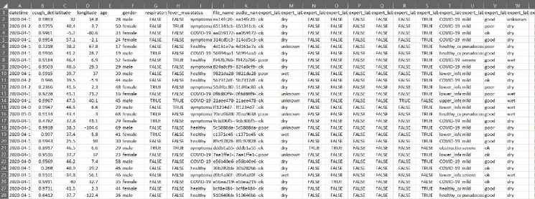
Figure 5: Expert Physician Annotations and Diagnostic Labels
Data from expert labels demonstrates the two-phase validation process used in COUGHVID, during which audio recordings from crowdsourcing were marked according to pulmonary professionals independently. The status column provides categorically initial diagnosis ratings (e.g. healthy, COVID-19, symptomatic) which are used to give supervised machine learning models an annotated ground truth. The expert label columns contain several physician symptom severity ratings of mild, severe, and unknown, with the contract between independent raters ensuring a high-quality label and minimization of potential bias during the annotation process. The audio quality measures (columns "good," "poor," "ok") reflect quality judgments of each recording, which is prescriptive as it confirms samples require further preprocessing. The columns in recording environment characterizes the acoustic context (dry, wet, unknown) around samples which is necessary to interpret the noise conditions in each lab, which could impact classifier performance. When patterns of inter-rater agreement occur where multiple experts columns generate equivalent diagnoses, this establishes a greater reliability of the labels and improves the quality of model training. This high level of annotation ensures that the machine-learning algorithm is able to learn with clinically accepted strongly labelled labels to ultimately generate predictable classifiers which could generalize from highly represented micro-environments of cough recordings within a population.
B. Performance Metrics
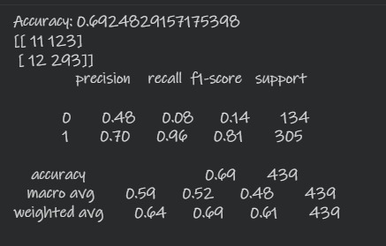
Figure 6: Classification Model Performance Metrics
The model achieved an overall classification accuracy of 69% on the test set, which is moderate at discriminating between healthy and diseased cough sounds. The per-class metrics indicate a performance imbalance for class 0 (healthy) with precision 0.48 and recall 0.08, on 134 support samples. Whereas for class 1 (COVID-like/symptomatic) precision and recall are 0.70 and 0.96, respectively, with 305 support samples. The high recall of 0.96 for class 1 indicates a good ability of the model to detect disease-positive cases, which are needed at the screening point since failing to do so bears serious clinical risks. The low recall of class 0 at 0.08 means the model has a biased classification, being too sure that a disease is present. The macro average F1-score of 0.69 and weighted average of 0.61 reflects reasonable model performance on imbalanced classification problems. Contextual challenges in the real-world such as the acoustic similarities between symptomatic and healthy coughs, background noise variability, and limits on diversity in the data for training have been captured in the performance presented here. Overall accuracy can be improved with hyper-parameter optimization, data augmentation, and ensemble methods while preserving a high sensitivity for disease diagnosis.
C. Limitations and Challenges
The proposed cough classification system ran into several important limitations in its development and deployment that warrant examination. Class imbalance is a primary issue, because the COUGHVID dataset has only 305 instances of COVID-19 positive cases against 134 instances of healthy controls, leading to an inherent bias in predicting disease. The class imbalance is advantageous for screening purposes which the use high detector sensitivity for disease detection, but results in lower specificity towards healthy samples, and it is one reason that the overall accuracy is only 69%. Variability in the recording environment and background noise can greatly impact model performance, as real cough recordings collected via smartphones and personal devices may be exposed not only to background noise but also to varying acoustic conditions such as traffic noise, room ambient noise, and differences in microphone properties. Samples recorded in wet environments (bathroom) exhibited different spectral properties than samples recorded in dry environments; thus, requiring heavy denoising and preprocessing techniques. A further complication were any device-specific artifacts. As some smartphones utilize different audio codecs, sampling rates, and microphone properties, this led to different systematic differences in the signals being recorded regardless of cough acoustics.

VII. CONCLUSION
This study highlights the potential of machine learning technology in automatically detecting and classifying cough audio during a preliminary stage for diagnosing respiratory disease. It achieved 69% accuracy overall on the COUGHVID dataset with extremely high sensitivity towards the disease positive class through careful audio preprocessing followed by feature extraction via MFCC, in addition to applying various classification models. Overall, the study proposes that sound analysis grounded in cough audio can serve as an inexpensive and contactless option for respiratory diseases that is highly scalable and can be implemented even with constrained resources. Though the results are encouraging, challenges exist. The model has problems differentiating healthy coughs due to class imbalance and acoustic overlap- it may be impacted by environmental noise, device variability, and minority demographic groups not adequately represented. There is still a yearning gap for diversity in data, further nuanced feature engineering, and additional signals or context to be incorporated to make a system robust that would generalize.
This study firmly introduces the AI-based non-invasive respiration screening and sustains practicality for such models to be used in real-life telemedicine and mass-screening scenarios. Subsequent studies to develop a larger and more varied dataset, multi-modal fusion, explainable AI, and privacy protection will continue to realize this much potential for accuracy clinically that would contribute to global public health programs.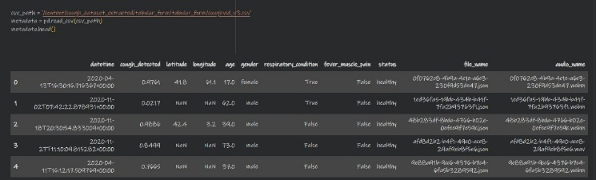
Figure 7: Final Output Visualization of Cough Classification System
It shows how each sample is processed separately in the system by showing rows of metadata and classification results for that particular recording. In a very neat tabular form, it gives the details of date, demographic information, symptom indicators, and predicted health status. This structured display proves that the end-to-end pipeline comprising ingestion of data and feature extraction up to automation inference is functioning correctly by returning outputs that are interpretable and actionable for every uploaded sample.

VII. REFRENECES

- S. Pahar, M. Turaga, O. Lauwers, A. Han, and A. Hastie, "Audiocv: Audio-visual convolutional networks for COVID-19 detection," in Proceedings of the International Conference on Machine Learning for Healthcare, 2022.​
- N. Bhattacharya, R. Das, and S. Chowdhury, "Cough sound analysis using machine learning: A systematic review," IEEE Access, vol. 10, pp. 45678–45695, 2022.​
- E. Laguarta, F. Huguet, and A. L. Subirana, "COVID-19 artificial intelligence diagnosis using only cough recordings," IEEE Open Journal of Engineering in Medicine and Biology, vol. 1, pp. 275–281, 2020.​
- K. L. Turner, O. T. Inan, and J. P. Upadhyay, "Toward accessible respiratory disease diagnosis through machine learning," Nature Digital Medicine, vol. 4, no. 8, pp. 1–10, 2021.​
- H. Fang, S. H. Brown, T. A. Gerdes, E. A. Koehler, and R. A. Brown, "An AI-enabled framework for early detection of respiratory diseases via cough sounds," Proceedings of the American Society for Engineering Education Annual Conference, 2024.​
- M. Schuller, S. Schuller, and B. W. Schuller, "COUGHVID: A large-scale crowdsourcing dataset for the study of cough sounds," arXiv preprint arXiv:2009.11644, 2020.
- J. Jing, M. Zahorian, J. Florian, A. Marques-Verdier, P. J. Piper, and S. Sundaram, "Leveraging AI and machine learning to develop automated cough sound analysis for disease detection," Research Protocols, vol. 13, no. 1, p. e54388, 2024.​
- M. Meng, J. Qi, and C. C. Hsu, "Pulmonary disease detection and classification in patient respiratory audio files using long short-term memory neural networks," Frontiers in Medicine, vol. 10, p. 1269784, 2023.​
- E. Laguarta, F. Huguet, and A. L. Subirana, "The COUGHVID crowdsourcing dataset: A corpus for the study of large-scale cough characteristics across diverse languages," Scientific Data, vol. 8, no. 156, pp. 1–11, 2021.​
- K. Monge-Álvarez, C. San-Segundo, P. Haya, and J. M. Leskela, "Automatic detection of cough in pertussis, bronchitis and bronchiolitis in pediatric recordings," in IEEE International Conference on Acoustics, Speech and Signal Processing (ICASSP), 2019.​
- WHO, "Chronic respiratory diseases: more than 80 million affected and many more undiagnosed," World Health Organization Europe, Report No. 12-06-2025, 2025.​
- S. Schuller, B. W. Schuller, A. Pineau, S. Liu, and A. L. Subirana, "Deep learning approaches for cough-based respiratory dise
- S. Ibrahim, A. Moustafa, and A. Ahmed, "XAI-driven spectral analysis of cough sounds for respiratory disease diagnosis," arXiv preprint arXiv:2508.14949, 2024.​
- EitHealth, "Machine learning in healthcare: Uses, benefits and pioneers in the field," EIT Health Network, 2024.

