A Finite Automaton-Based Predictive Framework for
Optimizing Packet Transmission Strategies in
Delay-Tolerant Networks

M. Jijnash Kumar SRM Institute of Science & Technology, Tiruchirappalli, Tamil nadu.India jm9388@srmist.edu.in
K. Avinash, SRM Institute of Science & Technology, Tiruchirappalli, Tamil nadu.India ak26808@srmist.edu.in
Jesitta lincy, SRM Institute of Science & Technology, Tiruchirappalli, Tamil nadu.India jesittalincy7@gmail.com
Mentor: Dr. Shanmuga priya, SRM Institute of Science & Technology, Tiruchirappalli, Tamil nadu.India.

Abstract
For networks like Delay-Tolerant Networks (DTNs), ensuring limited and occasional communication opportunities are utilized effectively over the unpredictable channels, disconnection periods, and varying conditions is an imperative aspect. Existing DTN routing protocols, which are mostly based on network-layer metrics like user mobility and social ties, do not at all take into account the quality of transmission resources in terms of physical-layer channel quality and, thus, suffer from low efficiency. A new predictive framework, Finite-State Markov Channel Predictive Transmission Optimizer (FSMCPTO), is proposed in this paper, utilizing a finite automaton for modelling and predicting the dynamic behaviour of wireless links.
The proposed model classifies channel quality according to a discrete set of quality states based on Signal-to-Noise Ratio (SNR) thresholds; thus, a DTN node can take an intelligent and forward-thinking decision whether to transmit a packet now or to delay it in anticipation of better channel conditions. The physical layer awareness incorporated into the store-carry-and forward paradigm fundamentally changes forwarding decisions from being a topological to an optimization problem across layers. Simulation results validating the FSMC-PTO framework have been carried out extensively; indeed, while improving the packet delivery ratio significantly, it reduces the network overhead as against the so-called traditional DTN routing methods which completely ignore the channel.

Keywords
Wireless Channel Modelling, Finite Automata, Finite-State Markov Channel (FSMC), Delay-Tolerant Networks (DTN), Opportunistic Communication, Adaptive Transmission.

I. Introduction
The rapid growth of wireless equipment has led to a constant and more extensive need for connectivity everywhere. Even though traditional network infrastructures have grown tremendously, there are still many situations where such infrastructures do not exist, are not trustworthy, or have been interrupted. These places are hard-to-reach rural areas, areas after a disaster, mobile networks, and military operations. During these hard times, strong communication methods that do not rely on a provision of a constant end-to-end connection are a must for a information flow.

1.1 a Dual Challenge of Wireless Channels: Intermittency and Volatility
The communication in a absence of infrastructure has to face twofold problems. a first one is a problem at a network level, which is a intermittency of a nodes being very sparsely distributed and connections being very sporadic and unpredictable. Hence, a creation of Delay-Tolerant Networking (DTN) which is an architecture specifically designed to function over networks characterized by a lack of continuous connectivity. a second challenge is found at a physical layer: volatility. At times when a direct link is made between two nodes, a quality is still not stable. a wireless medium is random and time-varying, and it is subjected to drastic changes in a quality of a signal due to two mainly caused by a phenomena of fading, and interference.
1.1.1 Fading Dynamics: Fading indicates a change in a amount of signal lost over time, frequency, and space. It is mainly due to multipath propagation where a signal reaches a receiver via multiple paths resulting from reflections, diffraction, and scattering off objects in a environment
1.1.2 Interference Sources: a phenomenon of fading is further complicated by a presence of interference that consists of unwanted radio-frequency signals, which ultimately corrupt a desired signal a different types of interference are many and they include other wireless networks that are either using a same channel or a nearby one (co-channel and adjacent-channel interference), and also non-Wi-Fi applications such as microwave ovens, cordless phones, and Bluetooth devices that operate within a same frequency bands and thus emit electromagnetic radiation .

1.2 The Store-Carry-and-Forward Principle in DTNs
With a help of a connectivity disruption that occurs from time to time, DTNs utilize a store-carry-and-forward method to go through a problem. Nodes in this system are a equivalent of data caretakers or "mules." a situation is like this: when a node has a packet that it wants to send, but no direct route to a destination exists at that moment, it keeps a packet in a local storage area. Moving about a environment, it physically carries a packet. As soon as another node (an opportunistic contact) comes in, it takes a forwarding decision and is likely to send a duplicate of a packet to a new node which applies a same procedure. This proceeding goes on until a packet's one copy reaches its end point.4 Thus, a heart of DTN functioning is a cleverness of this forwarding decision.

1.3. Application Focus and Thesis Statement
A critical analysis of existing DTN protocols reveals that their forwarding decisions are almost universally based on networklayer or application-layer metrics. For instance, routing protocols may base decisions on past encounter frequencies, mobility patterns, or social network centrality. While these approaches intelligently select a next custodian to maximize a long-term probability of delivery, they remain fundamentally blind to a instantaneous quality of a physical link during a contact.Creating a lag inbetween the optimization goals of the network and physical layers. A DTN protocol might identify an excellent next hop based on mobility patterns but attempt a data transfer at a moment when a physical channel is in a deep fade, resulting in high error rates, low throughput, or complete transmission failure. This wastes a contact opportunity—the most precious and finite source in a DTN.
This paper addresses this critical gap. a central thesis is as follows: By modelinga time-varying quality of a wireless link as a finite automaton and using this model to predict near 2future channel states, a DTN node can make significantly more intelligent and efficient packet forwarding decisions, thereby optimizing a use of scarce contact opportunities and improving overall network performance. We propose a cross-layer framework that equips DTN nodes with a predictive intelligence to decide not only to whom to forward a packet, but also when is a optimal moment to do so.

1.4. Key Contributions
The specific contributions of this work are fourfold:
- A novel cross-layer framework is proposed that integrates physical-layer channel state prediction into a networklayer forwarding logic of DTNs.
- A multi-state Finite-State Markov Channel (FSMC) model is designed specifically for link quality prediction in opportunistic communication scenarios.
- A channel-aware transmission algorithm is developed that dynamically chooses between transmitting with an adaptive strategy.
- A comprehensive performance evaluation is conducted via simulation, quantifying a substantial gains in packet delivery ratio and network achieved by our framework compared to channel-agnostic DTN routing protocols.

II. Foundational Concepts and Related Work
This section supplies a comprehensive review of a theoretical foundation for work. It covers wireless channel modeling, state prediction methodologies, and DTN routing paradigms.
2.1 Characterizing Fading Distributions: At a heart of stochastic modeling are probability distributions that describe a received signal's amplitude. a Rayleigh distribution is widely used to model fading in non-line-of-sight (NLOS) environments where no single dominant signal path exists.⁹ In scenarios with a strong line-of-sight (LOS) path accompanied by weaker multipath components, a Rician distribution supplies a more accurate model.⁹
2.2 The Emergence of Finite-State Models: To capture a time-varying nature of a channel, researchers have long turned to models with memory. a concept of a Finite-State Markov Channel (FSMC) supplies a powerful yet simple framework for this purpose. a history of FSMC models dates back to a work of Gilbert and Elliott, who used a simple two-state Markov chain to model a occurrence of bursty errors on telephone circuits. Transitions between these states by a Markov process, allow a model to capture a temporal correlation of errors.
While elegant, a two-state GEC is often too coarse to accurately represent gradations of a real wireless channel. This led to a development of multi-state FSMC models.²¹ In this approach, a
continuous channel quality metric, most commonly a received Signal-to-Noise Ratio (SNR), is partitioned into K > 2 nonoverlapping regions. Each region corresponds to a discrete state in a FSMC model. The process of defining these SNR partitions and deriving state transition probabilities.

2.3 Methodologies for Channel State Prediction
A key advantage of modeling a channel as a Markov chain is that it supplies a natural mechanism for prediction.
2.3.1. The Markovian Assumption: A Markov chain and its first order aassumption property that “probability of transitions to any future state depends only on current state and not on the following line up of multiple state that precedes it.²⁴ This is encapsulated in a state transition matrix of probability.
2.3.2. Limitations of Simple Markov Models: a primary limitation of this approach is that real-world wireless channels are not perfectly Markovian. Furthermore, they often exhibit non-stationary behavior, meaning their underlying statistical properties can change over time due to factors like large-scale mobility or changes in a scattering environment.²⁴ A static FSMC model with a fixed transition matrix may become
inaccurate if a environment changes significantly.²⁶

2.4. Routing Paradigms in Delay-Tolerant Networks
The design of routing protocols for DTNs is a mature field of research, with protocols generally falling into two broad categories based on their use of message replication.
2.4.1 Replication-Based (Flooding) Protocols: a most wellknown protocol in this category is Epidemic routing. Its strategy is simple and robust: whenever a node carrying a message encounters another node that does not have a copy, it forwards a message.³ This controlled flooding approach maximizes a probability of message delivery and often minimizes latency, but it does so at a cost of extremely high source consumption in terms of buffer space, transmission opportunities (bandwidth), and energy.
2.4.2 Knowledge-Based (Forwarding) Protocols: To improve efficiency, most modern DTN protocols use some form of knowledge to make intelligent forwarding decisions, thereby reducing a number of message replications. This knowledge can be derived from various sources:

● Probabilistic Routing ● Socially-Aware Routing

2.5. Identifying a Research Gap
A synthesis of a literature on channel modeling and DTN routing reveals a significant and consequential research gap. Existing DTN routing protocols, whether based on replication, probability, or social metrics, operate almost exclusively at a network layer. Their forwarding decisions are driven by topological properties—who meets whom, and how often. They are, however, fundamentally unaware of a physical layer's state.
In a DTN, a chance to communicate is a rare resource. Using one of these opportunities for a transmission that about to fail due to poor channel conditions is a waste of time and buffer capacity. The recognised research gap is, a lack of a crosslayer framework that endows DTN nodes with physicallayer intelligence to optimize a utilization of each contact.

III. A Predictive Transmission Framework for Opportunistic Communication (FSMC-PTO)
To address identified research gap, we propose a Finite-State
Markov Channel Predictive Transmission Optimizer (FSMCPTO).

3.1. Proposed System Architecture
The FSMC-PTO framework is designed to be implemented within each node of a DTN. It consists of three interconnected logical components that work in concert to make intelligent transmission decisions.
- Sensing & State Estimation Module: This is a physicallayer interface of a framework,that accounts for both signal strength and background noise.³⁴ a module measures instant SNR of received packets and to one of the set of discrete channel states. This discretization transforms this channel to a finite-state representation.
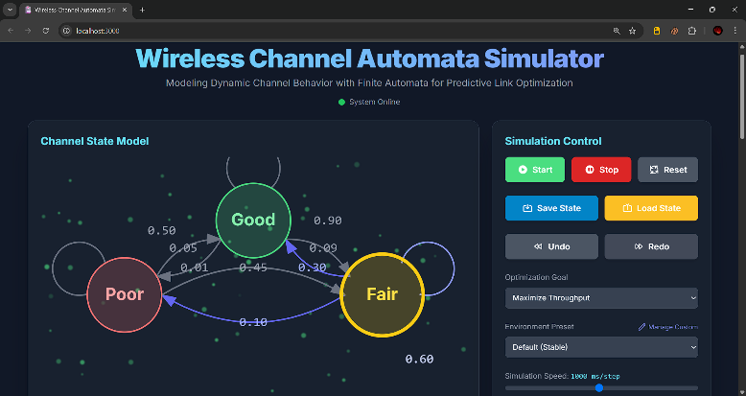
- FSMC Prediction Engine: This module is a core intelligence of a system. It maintains a definitions of a channel states (i.e., a SNR thresholds) and a crucial Transition Probability Matrix (TPM).
- Transmission Decision Module: This module executes a enhanced forwarding logic. It receives inputs from a FSMC - the current state and a predicted future state distribution and a node's packet. Based on these inputs, it either. TRANSMIT a packet to a neighbour or STORE a packet and wait for a better transmission opportunity. If a decision is to transmit, a module also selects a perfect physical-layer transmission such as a Modulation and Coding Scheme (MCS), to match a current channel conditions.
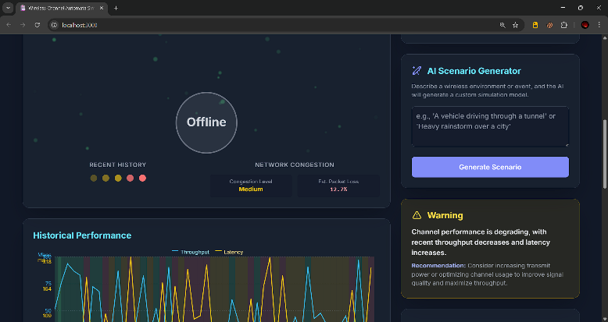

3.2. The Finite-State Channel Model
The efficacy of a FSMC-PTO framework hinges on a welldesigned FSMC model that accurately yet simply captures a channel's behaviour.
3.2.1 Defining Channel States: We propose a four-state model to provide a good balance between granular representation and low complexity modern wireless connection:
- State 4 (S_E): Excellent. Characterized by a very high SNR, leading to a negligible Bit Error Rate (BER). This state supports a highest data rates and is ideal for high throughput applications.
- State 3 ( S_G ): Good. Characterized by a solid SNR and a low BER. This state supplies trustable communication for most standard data traffic.
- State 2 ( S_F ): Fair. Characterized by a low SNR and a moderate BER. Transmission is possible but requires less efficient coding schemes
- State 1 ( S_P ): Poor. a SNR is at or below a receiver's sensitivity threshold, resulting in a very high BER. a link is effectively not usable, and any transmission attempt is highly to fail.
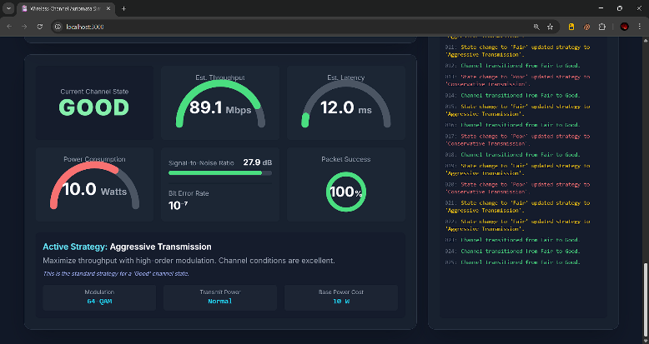

Table 3.2.1: Channel State Definitions and Corresponding Transmission:
State Name | SNR  Range  (dB) | Transmission  Strategy | Optim  al  MCS  Index
S_E  (Excellent) | > 25 dB | Transmit immediately with highest data rate. | MCS 8-  9 (256-  QAM)
S_G (Good) | 20 - 25 dB | Transmit immediately with trustable data rate. | MCS 5-  7 (64-  QAM)
S_F (Fair) | 10 - 20 dB | Transmit highpriority packets with robust coding. | MCS 2-  4 (16QAM/  QPSK)
S_P (Poor) | < 10 dB | Store all packets. Do not transmit. | N/A

3.3 The Prediction and Decision Algorithm
The algorithm combines a current state information with a predictive power of a FSMC model to make an optimal forwarding decision.
The decision rule is as follows:
- If S_{current} = S_P : a channel is unusable. a decision is always STORE. Transmitting would be a waste of energy and would likely fail.
- If S_{current} = S_E : a channel is in its best possible state. a probability of it improving further is zero. a decision is always TRANSMIT using a highest possible MCS to take full advantage of a excellent conditions.
- . If S_{current} is S_G or S_F: A trade-off exists. a channel is usable, but it might improve. a algorithm calculates a expected utility of a next state.

3.3.1 Pseudo-Code for a FSMC-PTO Algorithm
The complete decision-making process is summarized in a
following pseudo-code.

Algorithm 1: FSMC-PTO Forwarding Decision
--------------------------------------------------
Input: Packet P, Neighbor N, FSMC_Model M
Output: Action (TRANSMIT or STORE)

1: // Sensing and State Estimation
2: current_SNR <- MeasureSNR(link_to_N)
3: S_current <- GetStateFromSNR(current_SNR,
M.thresholds)
4: // Prediction
5: P_next_state_dist <- M.TPM
6: // Decision Logic
7: IF S_current == S_P THEN
8: RETURN STORE
9: END IF
10: IF S_current == S_E THEN
11: optimal_MCS <- GetMCS(S_current, M.strategies)
12: RETURN TRANSMIT(P, N, optimal_MCS)
13: END IF
14: // Utility-based decision for intermediate states
15: utility_current <- GetUtility(S_current, M.strategies)
16: utility_expected_next <- 0
17: FOR j in M.states DO
18: utility_expected_next += P_next_state_dist[j] *
GetUtility(j, M.strategies)
19: END FOR
20: IF utility_current >= utility_expected_next THEN
21: optimal_MCS <- GetMCS(S_current, M.strategies)
22: RETURN TRANSMIT(P, N, optimal_MCS)
23: ELSE
24: RETURN STORE
25: END I P

IV. Performance Evaluation and Discussion of Results
To validate a efficacy of a proposed FSMC-PTO framework, a series of discrete-event simulations were conducted. This section describes a simulation environment, a baseline protocols used for comparison, a performance metrics, and a
detailed analysis of a results.

4.1 Simulation Environment and Parameters
The simulations performed ns-3 network simulator, which supplies detailed and extensible models.
● Network Scenario: a scenario to emulate a typical DTN environment, such as a disaster recovery or remote monitoring area.
○ Area Size: 2000 \times 2000 meters.
○ Number of Nodes: Varied from 20 to 100 nodes.
○ Mobility Model: a Random Waypoint Model was
used

4.2 Baseline Protocols for Comparison
Protocol | Packet  Delivery  Ratio  (%) | Average  Delay | Routing  Overhead
Epidemic | 95.2 | 350 | 48.5
Direct  Transmission | 15.8 | 850 | 1.0
GE-F  (2- State) | 65.4 | 520 | 8.2
FSMC-PTO  (4-State) | 88.7 | 410 | 5.6
A FSMC-PTO framework was compared against three other protocols representing different DTN design space:
Epidemic Routing: This protocol serves as a practical upper bound for delivery ratio.
Direct Transmission: This protocol serves as a lower bound. No intermediate relays are used. It is also channel-agnostic. Gilbert-Elliott-based Forwarding (GE-F): This protocol was implemented to shows a value of our multi-state model. A node will only forward packet if a channel is in "Good" state.

4.3. Performance Metrics
The performance of each protocol was evaluated using three standard metrics for DTNs:

● Packet Delivery Ratio (PDR ● Average End-to-End Delay ● Routing Overhead

4.3.1 Results and Analysis
The results shows a clear superiority of a channel-aware approach, with a granular FSMC-PTO framework providing best performance. A summary of solution for representative scenario with 50 nodes speed of 5 m/s is presented in Table 2.

Table 2: Comparative Performance Analysis (50 Nodes, 5 m/s)
4.3.2. Discussion of Results:
- Packet Delivery Ratio (PDR): a FSMC-PTO framework benefits of a more granular, 4-state channel representation for more precise result than simple Good/Bad statement.
- Routing Overhead: a most dramatic result is seen in above table, it avoids transmissions that are about to fail due to poor quality,saving bandwidth and reduces energy consumption and minimizes contention.
- Average delay: However, this modest increase in latency is a small price to pay for huge efficiency and high PDR. a delay is still notably lower than a GE-F model,forced to wait longer to enter its "Good" state.
This simulations gives the output of the arrival of new metric for evaluating DTN performance: a quality-of-contact. Our results show a quality of contact ,by physical channel.The FSMC-PTO framework achieves its high by using each contact more effectively, Proving single contact during an "Excellent" channel state, is more valuable than multiple contacts that occur during "Poor" or "Fair" states, which is wasted. This rephrases a DTN routing challenge from a only topological problem to a 2-dimensional optimization problem: maximizing suitable next hop and a expected channel quality during that encounter.

V. Conclusion and Future Directions
This proposed paper is a literature cross-layer framework for optimizing packet transmission in Delay-Tolerant Networks. By designing, implementing, and evaluating a system that embeds a predictive Finite-State Markov Channel model into a
network forwarding logic, we have demonstrated and evaluated a practical method for overcoming the limitations of channelagnostic DTN protocols.this enables nodes to intelligently trade a small, controlled amount of latency for a significant increase in transmission dependancy and altogether network efficiency. Thus, the outcomes confirm by making forwarding decisions relying both on topological information and predicted physicallayer channels, making it easy to reach delivery performance approaching schemes, but with a fraction of a source cost.

5.1 Future Research Directions
The results of a FSMC-PTO framework open up several gateways for future research:
- Energy-Awareness: a current utility function is based on data rate. A critical extension for battery-powered DTN nodes would be to incorporate energy consumption into a decision logic.
- Hybrid FSMC-ML Models: To address a issue of nonstationarity in a channel, a hybrid modeling approach could
be investigated. A lightweight FSMC model, as proposed here, could run continuously on a resource-constrained node for real-time decision-making.
- Multi-Hop Prediction: a current framework optimizes transmission happening around individual hop. A more advanced system could involve nodes exchanging their learned FSMC models upon linking with it.

VI. References
- Wireless Channel Modelling Based on Finite-State
Markov Model,,
https://apps.dtic.mil/sti/citations/tr/ADA484232
- Wireless Channel Modelling Based on Finite-State - DTIC,https://apps.dtic.mil/sti/tr/pdf/ADA484232.pdf
- Socially-Aware Adaptive Delay Tolerant Network
(DTN) routing protocol | PLOS
One,https://journals.plos.org/plosone/article?id=10.137
1/journal.pone.0262565
- Routing in delay-tolerant networking - Wikipedia, https://en.wikipedia.org/wiki/Routing_in_delaytolerant_networking
- (PDF) Practical Routing in Delay-Tolerant Networks - ResearchGate, https://www.researchgate.net/publication/3436684_Pra ctical_Routing_in_Delay-Tolerant_Networks
- Fading - Wikipedia, https://en.wikipedia.org/wiki/Fading
- EE 643 Spring 2024 | Fading and Interference in Wireless Communications, 2025,
https://descartes.manoa.hawaii.edu/ee643spring2024/m orea/02-overview/reading-fading-interference.html
- What Is Wi-Fi Interference? - 7SIGNAL,https://www.7signal.com/wi-fi-interference
- Multipath propagation - Wikipedia, https://en.wikipedia.org/wiki/Multipath_propagation

- MULTIPATH & FADING,
https://www.idconline.com/technical_references/pdfs/electronic_engin eering/Multipath_and_Fading.pdf
- Different Types of Fading In Wireless Communication - RF Page, https://www.rfpage.com/different-types-offading/
- Interference Dynamics in Wireless Networks –
ChristianBettstetter,https://bettstetter.com/research/ind y/
- Wi-Fi Interference: 7 Things That Block Wi-Fi Signal | AT&T, https://www.att.com/internet/wifi-interferencethings-that-block-wifi-signals/
- Top Factors Affecting Network WiFi Performance in 25’
https://www.performancenetworks.co.uk/blog/factorsthat-affect-network-performance/
- Routing protocols in delay tolerant networks:Researcch https://www.researchgate.net/publication/228640626_ Routing_protocols_in_delay_tolerant_networks_A_co mparative_survey

