Model of Spatial Localization and Identification Objects in the Working Area Collaborative Robot
Hani Attar  Faculty of Engineering  Zarqa University /  Faculty of Engineering  University of Business and Technology  Zarqa, Jordan / Jeddah, Saudi Arabia  hattar@zu.edu.jo | Amer Abu-Jassar  Department of Computer Science,  College of Information Technology  Amman Arab University  Amman, Jordan  A.abujassar@aau.edu.jo | Mohamed Hafez  Faculty of Engineering FEQS  INTI-IU-University /  Faculty of Management  Shinawatra University, Pathum  Nilai, Malaysia / Thani, Thailand  mohdahmed.hafez@newinti.edu.my
Yasser Mohammad Al-Sharo  Cybersecurity and Cloud Computing Department,  Faculty of Information Technology  Ajloun National University  Ajloun, Jordan  yaser.shrah@anu.edu.jo | Vladyslav Yevsieiev  Department of Computer-Integrated Technologies, Automation and Robotics Kharkiv National University of Radio Electronics  Kharkiv, Ukraine  vladyslav.yevsieiev@nure.ua | Vyacheslav Lyashenko  Department of Media Systems and Technology  Kharkiv National University of Radio Electronics  Kharkiv, Ukraine  viacheslav.liashenko@nure.ua

Abstract—This study examines a deep learning model for spatial localization and identification of objects within the collaborative robot workspace through the integration of computer vision, such as in public health and crowed workplaces. A method utilizing the YOLOv8 paradigm is proposed, incorporating depth assessment for each identified object. The approach facilitates the representation of the spatial co-ordinates of objects in the format (X, Y, Z). The simulation outcomes illustrate the efficacy of neuronal identification and dynamic localization under various experimental environmental situations. The generated graphs evaluate the algorithm's stability and its suitability for implementation in adaptive control systems by showing the variation in object quantity over time and their spatial distribution. The proposed implementation utilizes Python within the PyCharm environment, ensuring the flexibility and scalability of the analyzed systems. The potential of the created model is contingent upon its compatibility with the Industry 5.0 framework and its capacity for cognitive perception in collaborative human-robot interactions.
Keywords—computer vision, collaborative robot, deep learning, Industry 5.0., object identification, spatial localization, YOLOv8

Introduction
The escalating demands for safety, adaptability, and efficient interaction between robotic systems and individuals or objects in dynamic environments need the implementation of advanced models for spatial localization and object recognition within collaborative robot workspaces [1-5]. In contemporary industrial and service settings, it is essential for robots to accurately identify both the position and type of items in order to respond promptly to changes in their environment [6], [7]. Consequently, it is prudent to employ diverse methods and approaches [8-11]. The simultaneous application of integrated computer vision and deep learning techniques enhances recognition accuracy and facilitates contextual scene interpretation, which underpins intelligent behavior, which creates new possibilities for the execution of adaptive visual servo control, collision avoidance, and secure human-robot collaboration in real time.
Y. Cohen, A. Biton, and S. Shoval investigate the integration of computer vision and artificial intelligence in collaborative robotics [12]. The authors examine essential methodologies for integrating visual perception to enhance human-robot interaction [12], which facilitates the development of adaptable, intelligent, collaborative systems. The research conducted by E. Mendez et al. focused on the amalgamation of deep learning with collaborative robotics for information acquisition tasks, prioritizing positioning precision and trajectory modification to enable adaptable control in dynamic environments [13]. M. Andronie et al. examine the integration of big data processing methods, deep learning for object detection, and geographic environment simulations [14]. Their work offers a sophisticated multi-tier integration of robotic Internet of Things systems. Y. Xiao proposes an approach that integrates convolutional neural networks with the RANSAC algorithm [15]. The technique enhances the reliability of item detection in industrial environments, particularly among noisy or dynamic image distortions. The study [16] integrates computer vision with tool transfer and gesture control tasks in human-robot interaction situations, facilitating the development of an intuitive interaction environment. The publication by Z. Mei, Y. Li, R. Zhu, and S. Wang [17] presents a strategy for fruit location and capture utilizing the YOLO VX model and 3D vision. It exhibits exceptional precision under uneven lighting and natural interference settings. R. Raj and A. Kos, in their review, examine many applications of convolutional neural networks in computer vision, highlighting their contribution to enhancing visual perception in robotics [18]. A. Wang, H. Wu, and Y. Iwahori introduce contemporary methodologies for integrating computer vision and deep learning, focusing on their use in autonomous and semi-autonomous systems, facilitating the development of efficient adaptive computing architectures [19]. A real-world experiment involving a robotic dog equipped with an integrated computer vision system is proposed in [20], enabling real-time 3D environmental modeling and facilitating interaction with individuals via a network of cameras. In the study, X. Li, J. Ma, S. Yao, G. Chi, and G. Zhang devised a bimodal methodology for trajectory creation in a welding robot utilizing stereo vision and deep learning, enabling the robot to adjust its movements in response to alterations in the shape and position of objects [21]. A review in [22] examined approaches for item recognition and tracking in aquatic environments utilizing deep learning, revealing considerable potential for intricate visual situations, although exhibiting restricted applicability in standard manufacturing settings. E. F. Langås, M. H. Zafar, and F. Sanfilippo [23] examine human-robot interaction in the context of Industry 5.0. Digital twins and machine learning are employed for such reasons [23]. The proposed research’s findings are applicable solely to the integration of visual systems with decision-making systems utilizing neural networks. Nonetheless, several efforts exhibit limited specialization, such as those pertaining to agriculture or underwater systems, which cannot be immediately applied to collaborative industrial robots without modification. The overarching conclusion is that current research substantiates significant interest in the convergence of computer vision and deep learning within robotics; however, challenges pertaining to the universality and generalization of localization models and their integration with dynamic human-robot interaction tasks remain unresolved, which aggravates the necessity and significance of more research on the given subject.

Components of the Overall Research Design

Basic models of spatial localization and identification of objects in the Collaborative Robot workspace
To convert the 3D coordinates of objects in the robot workspace to the 2D coordinates of pixels where image detection is performed, the Pinhole projection model will be used [24-26]. The projection of a 3D point $P={(X,Y,Z)}^{Т}$ onto the image plane looks like this:

$\left[\begin{matrix}u \\ v \\ 1\end{matrix}\right]=\frac{1}{Z}\left[\begin{matrix}f_{x} & 0 & c_{x} \\ 0 & f_{y} & c_{y} \\ 0 & 0 & 1\end{matrix}\right]\left[\begin{matrix}X \\ Y \\ Z\end{matrix}\right]$, | (1)

where: $f_{x},f_{y}$ – focal length in pixels along the x and y axes (affects the scale); $c_{x},c_{y}$ – coordinates of the projection center (optical center); $u,v$ – coordinates of a pixel in the image; $X,Y,Z$ – spatial coordinates of a point in the camera coordinate system.
The model for spatial localization of objects, known as depth reconstruction, when utilizing a depth map ([27]) or stereo vision, is represented in the following form ([28]):

$$P_{i}=D\left(u_{i},v_{i}\right)∙K^{-1}∙\left[\begin{matrix}u_{i} \\ v_{i} \\ 1\end{matrix}\right],$$ | (2)

$$Z=\frac{f∙B}{d}, X=\frac{(u-c_{x})∙Z}{f}, Y=\frac{(v-c_{y})∙Z}{f},$$ | (3)
where: $D(u_{i},v_{i})$ – depth at the image point; $K^{-1}$ – inverse matrix of internal camera parameters; $f$ – focal length; $B$ – base distance between stereo cameras; $d$ – disparity (distance between corresponding pixels in the left and right images); $(u,v)$ – coordinates of the pixel where the depth is determined.
Models 2 and 3 enable the transformation of pixels, where objects were detected, into precise 3D coordinates inside the robot's environment, which is essential for motion planning, obstacle evasion, and physical engagement.
The object identification model, a neural classification model, is executed as a neural network function [29-31], which delineates the procedure for ascertaining the most probable class for a specified image or its segment:

$$\hat{y}=arg\max_{j}{{\left[Softmax(W∙ϕ\left(X\right)+b)\right]}_{j},}$$ | (4)
where: $X$ represents the input data, typically an image or a bounding box that encloses the object. $ϕ\left(X\right)$ represents the feature vector derived from the processing of $X$ through convolutional layers in a convolutional neural network (CNN). The weight matrix of the fully connected classification layer is denoted as $W$. The matrix quantifies the influence of each feature from the vector $ϕ\left(X\right)$ on the probability of class membership across all possible classes. It has dimensions $C×N$, where $C$ represents the number of classes and $N$ denotes the dimension of the feature vector. Additionally, $b$ is the bias vector that is incorporated into the outcome of the linear transformation, which enables the model to more effectively adjust to biased or asymmetric data, thereby enhancing the generalization capacity of the neural network. The expression $W∙ϕ\left(X\right)+b)$ represents a vector of logits, which are nonlinearly normalized values, which provides an estimate of the "raw" probability for each class [32-34]; whereas this quantity refers to the degree of similarity between the input image and the samples belonging to the class. The $Softmax(∙)$ function transforms logits into probabilities, ensuring that their sum equals 1 [35-37], which enables the interpretation of model output as a probability distribution over classes; ${\left[∙\right]}_{j}$ represents the probability that the object belongs to the $j$-th class; $arg\max_{j}$ denotes the operation of selecting the index $j$ corresponding to the highest probability value, indicating the class with the maximum predicted probability. The predicted class of the object is denoted as $\hat{y}$.
Model 4 enables the identification of the specific preset class to which an object in a frame is assigned, which is an essential element of the collaborative robot's intelligent vision, enabling the detection of an object as well as its classification – such as a tool, an operator's hand, or an obstacle.
The subsequent mathematical representation articulates the framework for planning or adapting motion to an object (integration of position with dynamics). The objective function (5) or (6) incorporates the robot's current position $q(t)$,, its velocity $\dot{q}(t)$ , and the object's position $p_{0}$ [38-40]:

$$\min_{u}{{\left\|p_{r}\left(t-∆t\right)-p_{0}\right\|}^{2}+λ∙{\left\|u\right\|}^{2}},$$ | (5)

where: $u$ is the vector of control inputs or speeds of movement (linear and/or angular) of the robot’s actuators. The optimization seeks a control that will bring the robot’s position closer to the target; $p_{r}\left(t-∆t\right)$ is the position of the robot’s working body (end-effector) at time $t-∆t$, which reflects the previous position and is the basis for calculating the displacement; $p_{0}$ is the current position of the object, which was determined using a computer vision system. The goal is to minimize the distance between the robot and the object; ${\left\|p_{r}-p_{0}\right\|}^{2}$ is the square of the Euclidean distance between the robot and the object, whereas minimizing the expression signifies the objective of attaining the target; $λ$ represents the regularization weight that governs the equilibrium between positioning precision and the extent of control influence. A substantial $λ$ diminishes the control amplitude, preventing abrupt or energy-intensive movements; ${\left\|u\right\|}^{2}$ represents the control standard that defines the intensity or force of the action. It is reduced to prevent undue exertion and facilitate fluid motions.

$$u\left(t\right)=-λ∙J^{⊺}∙\left(s\left(t\right)-s^{*}\right),$$ | (6)

where: the control vector $u\left(t\right)$, established at time $t$, dictates the precise alterations in the state of the actuators (robot movement), while the gain constant $λ$ determines the velocity of the system's response to a visual discrepancy. Elevated numbers result in a rapid response, yet may induce instability; $J^{⊺}$ denotes the Jacobi transposed matrix (either pseudo-inverse or complete), which illustrates the correlation between variations in picture parameters (pixel coordinates) and alterations in robot coordinates. Employed to convert the visible error into the control domain; $s\left(t\right)$ represents a vector of present visual attributes or coordinates within the image, such as the object's position within the frame or the characteristics of its shape (center, size, orientation); $s^{*}$ represents the reference vector of visual features that dictates the expected appearance of the scene upon the robot's attainment of the goal; $s\left(t\right)-s^{*}$ denotes the visual error, indicating the extent of deviation between the current visual state and the intended state, whereas the disparity propels the control system.
Models 5 and 6 employ adaptive control to direct the robot's movement toward the object using data from the vision system. The optimization model reduces positioning inaccuracy and energy consumption, while the visual servo controller delivers continuous control updates informed by real-time visual feedback.

Generalization of the modeling procedure and its implementation
The generalized modeling technique comprises the following steps:
1. Initializing the model and surroundings. The pre-trained YOLOv8 kernel is loaded, and the camera for image acquisition is engaged for processing.
2. Acquiring a frame from a video stream. Each frame from the camera is transmitted to the input of the neural network: $X∈R^{H×W×3}$ – the picture represented as a three-dimensional tensor of RGB channels.
3. Identification of things within an image. YOLOv8 concurrently identifies object boundaries (bounding boxes) and categorizes them in accordance with formula (4).
4. Determining the center of the object. The center of the detected object is defined as: $X_{c}=\frac{x_{1}+x_{2}}{2}$, $Y_{c}=\frac{y_{1}+y_{2}}{2}.$
5. The depth (Z-coordinate) is calculated. Depth is determined by the object's height in pixels and the actual camera model, represented graphically by the $Z$ coordinate.
6. Constructing a spatial position vector. The location of an object in space is given as a point: $p_{r}\left(t\right)=\left[\begin{matrix}X_{c} \\ Y_{c} \\ Z\end{matrix}\right]$, which is a three-dimensional estimate of the object's position in the frame.
7. Adjustment of robotic motion in line with equations (5) and (6). The process involves devising or correcting the robot's path towards a target based on its spatial coordinates.
8. Graph construction and analysis.
The models employed for experimental purposes were constructed using the Python programming language, because of Python popularity in computer vision, the plethora of deep learning packages (e.g., OpenCV, PyTorch, Ultralytics YOLO), and its appropriateness for rapid algorithm creation and evaluation [41-43].
The PyCharm 2025.1.1.1 programming environment was chosen for its exceptional integration with machine learning libraries, effective debugging system, code autocompletion, and support for virtual environments, which are crucial for steady performance in modeling complex robotics jobs, whereas the combination of methodologies ensures rapid creation and enhanced visualization of object localization and identification results.

Results and Discussion

Modeling the dynamics of object detection in the working area of a collaborative robot based on time fixation
The proposed study enables the evaluation of variations in the quantity of objects within the camera's field of view over time, facilitating the detection of abnormal occurrences, activities, or alterations in environmental circumstances. It is beneficial for modifying the robot's behavior in response to alterations in the work environment, including task modifications and the presence of others or objects, and for assessing the robustness of the computer vision model. Figure 1 illustrates a segment of a streaming video depicting static item identifications, henceforth referred to as Simulation 1.

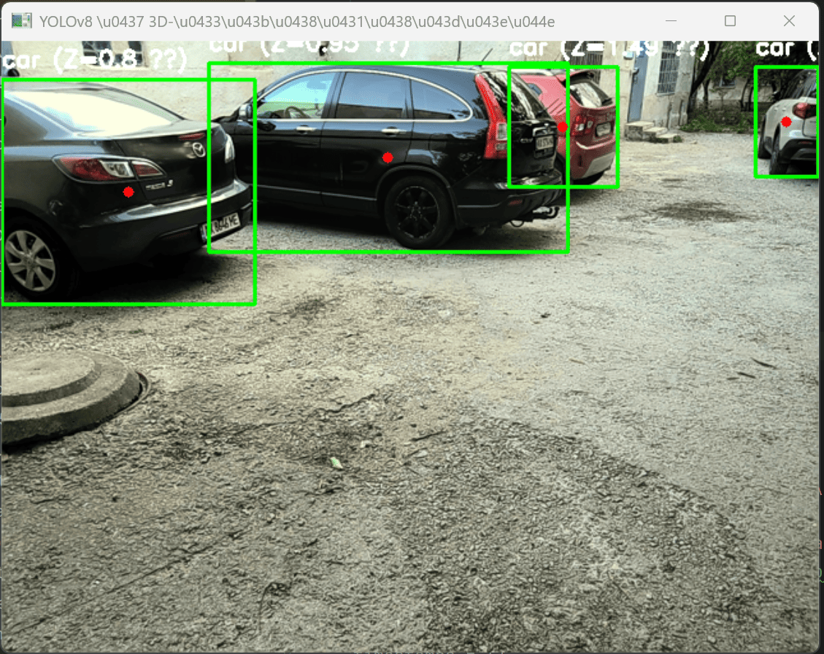
Fig. 1. Fragment of streaming video from static object identifications (Simulation 1)

The resulting graph of object detection dynamics based on time fixation for simulation 1 (Fig. 1) is presented in Fig. 2.

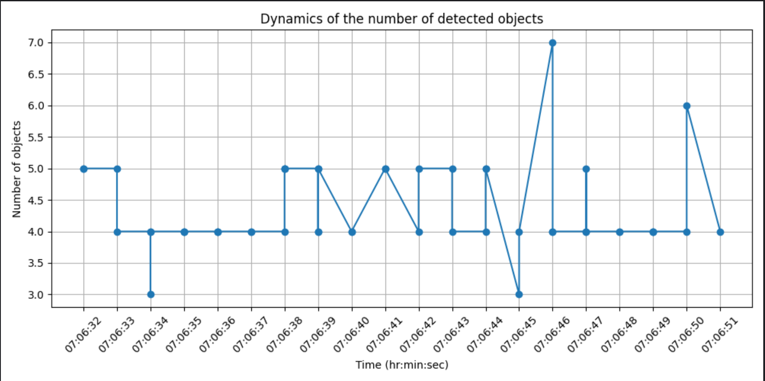
Fig. 2. Graph of object detection dynamics (Simulation 1)

The graph presented (Fig. 2) illustrates the dynamics of object detection, reflecting the variation in the count of recognized elements within the operational area of the collaborative robot in real time. Relative stability is noted among 4–5 objects; however, short-term fluctuations to 6 and 7 objects (at approximately 07:06:45) and a decrease to 3 objects (at 07:06:44) were documented, which may suggest a modification in the scene, displacement of objects, or constraints of the model when stabilizing objects under specific conditions. The results illustrate the variability of conditions in the workplace and highlight the necessity of an adaptive approach to identification. The graph validates the model's functionality in a real-world context and facilitates the analysis of events through quantitative changes.
Modeling the dynamics of object detection in dynamic space is shown in Fig. 3 (hereinafter referred to as Simulation 2).

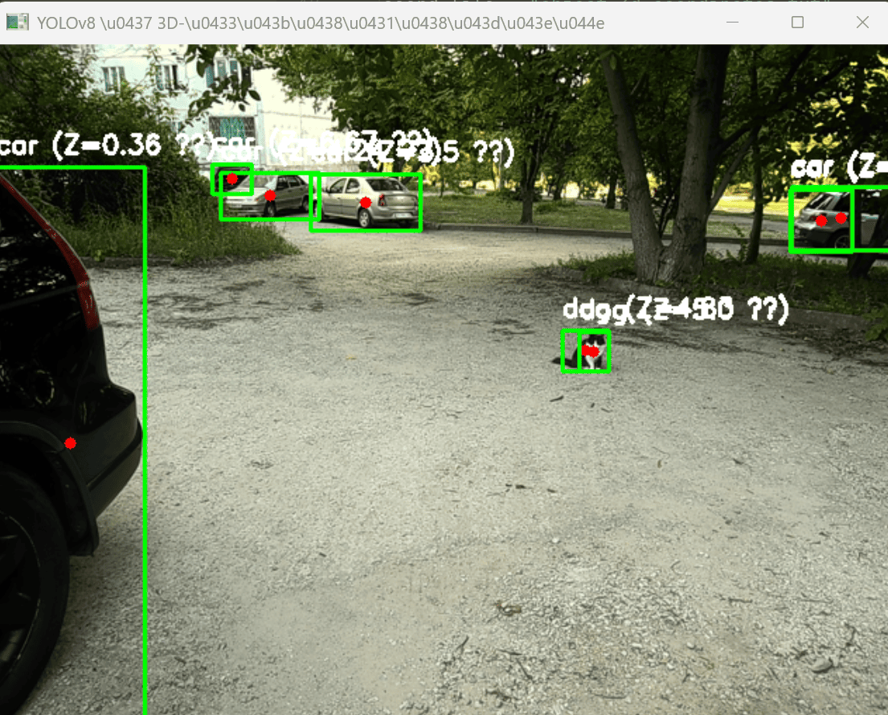
Fig. 3. Fragment of streaming video from dynamic object identification (Simulation 2)
Figure 4 shows the graph that represents how object detection changes over time in a moving space for simulation 2 (Fig. 3).
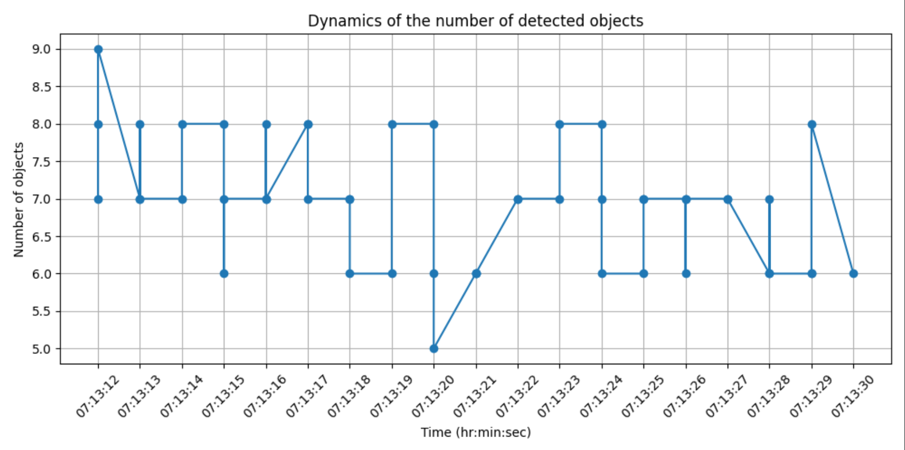
Fig. 4. Graph of object detection dynamics in dynamic space (Simulation 2)

The graph depicting the dynamics of object detection in dynamic space reveals an initial high of 9 items, followed by oscillations ranging from 5 to 8 for the entire observation period. Such oscillations signify dynamic movement or alteration in the location of objects inside the operational region, resulting in a modification of visibility for the computer vision system. A reduction to 5 at specific intervals suggests a potential short-term loss of objects resulting from partial overlap or constraints of the camera angle. The findings of the investigation illustrate the model's capacity to detect real-time fluctuations in object quantity, which is essential for accurate spatial localization under varying settings. The result validates the efficacy of the selected method for adaptively addressing situational alterations in the operational domain of the collaborative robot.

Research on spatial reconstruction and localization of objects in 3D space based on combined visual identification methods
The proposed study enables the construction of a model representing the spatial positioning of objects in X, Y, and Z coordinates. It offers insight into the arrangement of the workspace, enables the identification of safe or hazardous zones for operation, and serves as the foundation for developing a motion planning system or visual servo. 3D graphs depicting the spatial locations of objects were constructed based on simulations 1 and 2. The findings are illustrated in Figures 5 and 6.
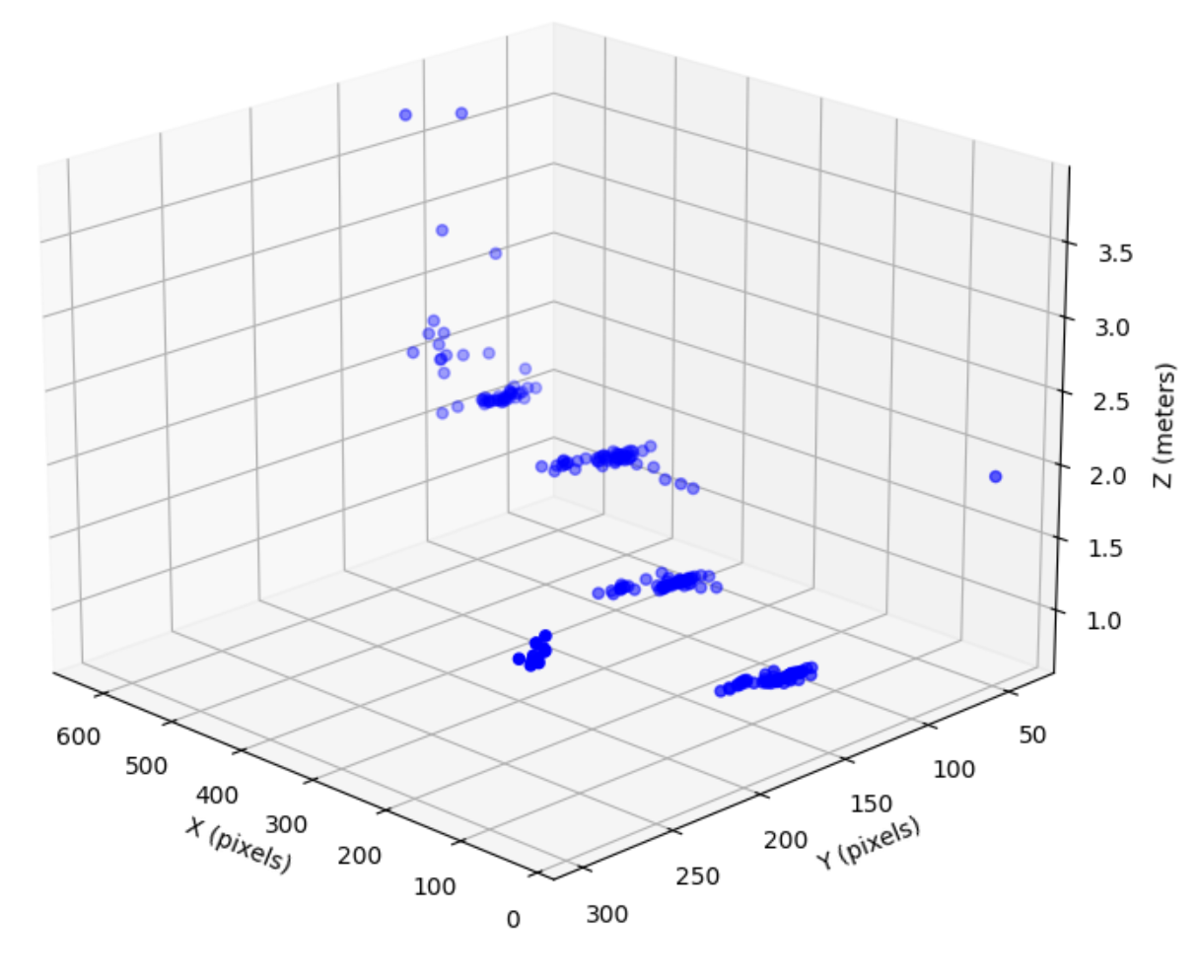
Fig. 5. Spatial reconstruction and localization of objects in 3D space based on combined visual identification methods (Simulation 1)

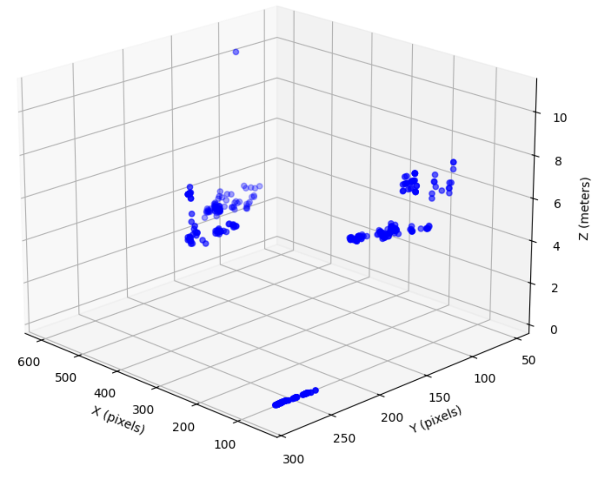
Fig. 6. Spatial reconstruction and localization of objects in 3D space based on combined visual identification methods (Simulation 2)
The results of spatial reconstruction and object localization in 3D space, derived from combined visual identification methods (see Fig. 5 and Fig. 6), demonstrate the adequacy of the developed models; consequently, capability enables real-time localization of objects in 3D space (depth) within dynamic environments, which is essential for contemporary collaborative human-robot interactions in workspaces.
The results indicate the potential for employing integrated approaches to computer vision and deep learning to enhance the model for spatial localization and object identification within the operational domain of a collaborative robot; in this instance, it is crucial to consider the specific dynamics of object detection and adjust the model to align with actual operating conditions. The modeling conducted facilitated the recording of quantitative and spatial characteristics of the identified objects, as evidenced by the generated graphs of localization and temporal dynamics.
The implementation of depth calculation enables a three-dimensional assessment of object positioning, thereby enhancing the efficiency of the robot's navigation and interaction with its environment. The study identified the significance of optimizing processing and identification parameters, particularly regarding the selection of depth and coordinates, to ensure accurate object identification within the operational area of the collaborative robot. In conclusion, the implemented model enhances the quality of autonomous interaction among robotic systems and is pertinent to the advancement of Industry 5.0 technologies.

Conclusion
The research resulted in the proposal and implementation of an enhanced model for spatial localization and object recognition within the operational domain of a collaborative robot, utilizing a synthesis of computer vision, deep learning, and the YOLOv8 neural architecture. The Python software facilitates real-time object detection, coordinates (X, Y) identification, and depth (Z) estimation based on the item's dimensions within the frame. The findings are represented through two graphs: the trends in the quantity of identified objects and their spatial positioning in three-dimensional space. Graph analysis demonstrated the efficacy of the suggested approach in both static and dynamic contexts. Simultaneously, logging and data logging facilitate enhanced understanding of object activity. Developing localization logic through a hybrid method facilitates flexibility to intricate production settings. The potential of the created model is contingent upon its compatibility with Industry 5.0 systems, which emphasize a human-centric approach, flexible robotics, and adaptive interactions between humans and robots.

References
- F., Vicentini, "Collaborative robotics: a survey," Journal of Mechanical Design, vol. 143, no. 4, pp. 040802, 2021. doi: 10.1115/1.4046238.
- Y. J., Pan, S., Buchanan, Q., Chen, L., Wan, N., Chen, S., Forbrigger, and S. Smith, "Survey on recent advances in planning and control for collaborative robotics," IEEJ Journal of Industry Applications, vol. 14, no. 2, pp. 139-151, 2025. doi: 10.1541/ieejjia.24005652.
- H., Attar, A. T., Abu-Jassar, V., Yevsieiev, V., Lyashenko, I., Nevliudov, and A. K. Luhach, "Zoomorphic mobile robot development for vertical movement based on the geometrical family caterpillar," Computational intelligence and neuroscience, vol. 2022, no. 1, pp. 3046116, 2022. doi: 10.1155/2022/3046116.
- R., Matarneh, S., Maksymova, Z., Deineko, and V., Lyashenko, "Building robot voice control training methodology using artificial neural net," International Journal of Civil Engineering and Technology, vol. 8, no. 10, pp. 523-532, 2017.
- H., Attar, A. T., Abu-Jassar, A., Amer, V., Lyashenko, V., Yevsieiev, and M. R. Khosravi, "Control system development and implementation of a CNC laser engraver for environmental use with remote imaging," Computational intelligence and neuroscience, vol. 2022, no. 1, pp. 9140156, 2022. doi: 10.1155/2022/9140156.
- C., Palanisamy, L., Perumal, and C. W., Chin, "A comprehensive review of collaborative robotics in manufacturing," Engineering, Technology & Applied Science Research, vol. 15, no. 2, pp. 21970-21975, 2025. doi: 10.48084/etasr.9709.
- I., Nevliudov, V., Yevsieiev, J. H., Baker, M. A., Ahmad, and V., Lyashenko, "Development of a cyber design modeling declarative language for cyber-physical production systems," J. Math. Comput. Sci., 11(1), 520-542, 2020. doi: 10.28919/jmcs/5152.
- O., Kuzomin, V., Lyashenko, M., Tkachenko, M. A., Ahmad, and H., Kots, "Preventing of technogenic risks in the functioning of an industrial enterprise," International Journal of Civil Engineering and Technology, 7(3), 262-270, 2016.
- S., Alzoubi, M., Jawarneh, Q., Bsoul, I., Keshta, M., Soni, and M. A., Khan, "An advanced approach for fig leaf disease detection and classification: Leveraging image processing and enhanced support vector machine methodology," Open Life Sciences, vol. 18, no. 1, pp. 20220764, 2023. doi: 10.1515/biol-2022-0764.
- H., Sukri, A. F, Ibadillah, R., Thinakaran, F., Umam, A., Dafid, A., Kurniawan, M., Morshed, and D., Kurniawan, "Enhanced Precision Control of a 4-DOF Robotic Arm Using Numerical Code Recognition for Automated Object Handling," Journal of Robotics and Control (JRC), vol. 6, no. 1, pp. 315-335, doi: 10.18196/jrc.v6i1.24349.
- S. M. H., Mousavi, V., Lyashenko, S., and Prasath, "Analysis of a robust edge detection system in different color spaces using color and depth images," Comput. Opt., vol. 43, no. 4, pp. 632-646, 2019. doi: 10.18287/2412-6179-2019-43-4-632-646.
- Y., Cohen, A., Biton, and S., Shoval, "Fusion of Computer Vision and AI in Collaborative Robotics: A Review and Future Prospects," Applied Sciences, vol. 15, no. 14, pp. 7905, 2025. doi: 10.3390/app15147905.
- E. Mendez, O., et al., "Integration of deep learning and collaborative robot for assembly tasks. Applied Sciences," vol. 14, no. 2, pp. 839, 2024. doi: 10.3390/app14020839.
- M., Andronie, G., Lăzăroiu, M., Iatagan, I., Hurloiu, R., Ștefănescu, A., Dijmărescu, and I., Dijmărescu, "Big data management algorithms, deep learning-based object detection technologies, and geospatial simulation and sensor fusion tools in the internet of robotic things," ISPRS International Journal of Geo-Information, vol. 12, no. 2, pp. 35, 2023. doi: 10.3390/ijgi12020035.
- Y., Xiao, "Integrating CNN and RANSAC for improved object recognition in industrial robotics," Systems and Soft Computing, vol. 7, pp. 200240, 2025. doi: 10.1016/j.sasc.2025.200240.
- B., Malobický, M., Hruboš, J., Kafková, J., Krško, M., Michálik, R., Pirník, and P., Kuchár, "Towards Seamless Human–Robot Interaction: Integrating Computer Vision for Tool Handover and Gesture-Based Control," Applied Sciences, vol. 15, no. 7, pp. 3575, 2025. doi: 10.3390/app15073575.
- Z., Mei, Y., Li, R., Zhu, and S., Wang, "Intelligent Fruit Localization and Grasping Method Based on YOLO VX Model and 3D Vision," Agriculture, vol. 15, no. 14, pp. 1508, 2025. doi: 10.3390/agriculture15141508.
- R., Raj, and A., Kos, "An extensive study of convolutional neural networks: applications in computer vision for improved robotics perceptions," Sensors, vol. 25, no. 4, pp. 1033, 2025. doi: 10.3390/s25041033.
- A., Wang, H., Wu, and Y., Iwahori, "Advances in Computer Vision and Deep Learning and Its Applications," Electronics, 14(8), 1551, 2025. doi: 10.3390/electronics14081551.
- Z., Zhu, et al., "Real-time computer vision and deep learning for 3D environment modeling, camera network calibration, and human-robot interaction using a robot dog," In Real-Time Image Processing and Deep Learning 2025, vol. 13458, pp. 76-91, 2025. doi: 10.1117/12.3052817.
- X., Li, J., Ma, S., Yao, G., Chi, and G., Zhang, "A Dual-Modal Robot Welding Trajectory Generation Scheme for Motion Based on Stereo Vision and Deep Learning," Materials, vol. 18, no. 11, pp. 2593, 2025. doi: 10.3390/ma18112593.
- M., Elmezain, L. S., Saoud, A., Sultan, M., Heshmat, L., Seneviratne, and I., Hussain, "Advancing underwater vision: a survey of deep learning models for underwater object recognition and tracking," IEEE Access, vol. 13, pp. 17830-17867, 2025. doi: 10.1109/ACCESS.2025.3534098.
- E. F. Langås, M. H., Zafar, and F. Sanfilippo, "Exploring the synergy of human-robot teaming, digital twins, and machine learning in industry 5.0: A step towards sustainable manufacturing," Journal of Intelligent Manufacturing, pp. 1-24, 2025. doi: 10.1007/s10845-025-02580-x.
- T. T. Han, M. T. Duc, and H. D. Tan, "A lightweight distance estimation method using pinhole camera geometry model," Measurement Science and Technology, vol. 36, no. 4, pp. 045406, 2025. doi: 10.1088/1361-6501/adbf3b.
- Han, J., et al., "CaLiSa-NeRF: Neural Radiance Field with Pinhole Camera Images, LiDAR Point Clouds, and Satellite Imagery for Urban Scene Representation," In Proceedings of the Winter Conference on Applications of Computer Vision, pp. 442-450, 2025.
- Y., Li, S., Ji, D., Gong, D., Fan, J., Song, and D., Gao, "Optimization Method for DSM Reconstruction of Equivalent Pinhole Model Based on Iterative Resampling and Chunking Process," IEEE Journal of Selected Topics in Applied Earth Observations and Remote Sensing, vol. 18, pp. 6870-6883, 2025. doi: 10.1109/JSTARS.2025.3528029.
- X., Wang, C., Wang, S., Wang, X., Wang, Z., Zhao, L., Zhu, and B., Jiang, "Mambaevt: Event stream based visual object tracking using state space model," IEEE Transactions on Circuits and Systems for Video Technology, 2025. doi: 10.1109/TCSVT.2025.3588533.
- W., Duan, C., Chen, and R., Zhang, "An Improved YOLOv8 Algorithm for Apple Object Recognition and Localization in Complex," In Proceedings of the First International Conference on Advanced Robotics, Control, and Artificial Intelligence: ICARCAI 2024, 9–12 December, Perth, Australia, vol. 1376, no. 0010, pp. 436, 2025. Springer Nature. doi: 10.1007/978-981-96-5373-7_37.
- N., Alam, S., Hasan, G. A., Mashud, and S., Bhujel, "Neural Network for Enhancing Robot-Assisted Rehabilitation: A Systematic Review," In Actuators, vol. 14, no. 1, pp. 16, 2025. doi: 10.3390/act14010016.
- M. A. Ahmad, J. H., Baker, I., Tvoroshenko, and V., Lyashenko, "Computational complexity of the accessory function setting mechanism in fuzzy intellectual systems," International Journal of Advanced Trends in Computer Science and Engineering, vol. 8, no. 5, pp. 2370-2377, 2019. doi: 10.30534/ijatcse/2019/77852019.
- A., Calzada-Garcia, J. G., Victores, F. J., Naranjo-Campos, and C., Balaguer, "A review on inverse kinematics, control and planning for robotic manipulators with and without obstacles via deep neural networks," Algorithms, vol. 18, no. 1, pp. 23, 2025. doi: 10.3390/a18010023.
- D., Bossér, G., Hendeby, M. L., Nordenvaad, and I., Skog, "Broadband passive sonar track-before-detect using raw acoustic data," IEEE Journal of Oceanic Engineering, pp. 1-11, 2025. doi: 10.1109/JOE.2025.3573066.
- C., Yin, H. Y., Chen, W. L., Chao, and P., Zhang, "Federated inverse probability treatment weighting for individual treatment effect estimation," arXiv preprint arXiv:2503.04946, 2025. doi: 10.48550/arXiv.2503.04946.
- A., Kaufman, J., Corona, Z., Ozzello, B., Senseman, M., Asaduzzaman, and Y., Meurice, "Exploring near critical lattice gauge simulators with Rydberg atoms facilities," arXiv preprint arXiv:2507.14128, 2025. doi: 10.48550/arXiv.2507.14128.
- [35] A. E., Aby, S., Salaji, K. K., Anilkumar, and T., Rajan, "Classification of acute myeloid leukemia by pre-trained deep neural networks: A comparison with different activation functions," Medical Engineering & Physics, vol. 135, pp. 104277, 2025. doi: 10.1016/j.medengphy.2024.104277.
- J., Zhang, and C., Ding, "Simple yet effective adaptive activation functions for physics-informed neural networks," Computer Physics Communications, vol. 307, pp. 109428, 2025. doi: 10.1016/j.cpc.2024.109428.
- X., Li, Z., Xia, and H., Zhang, "Cauchy activation function and XNet," Neural Networks, vol. 188, pp. 107375, 2025. doi: 10.1016/j.neunet.2025.107375.
- M., Cao, L., Xiao, Q., Zuo, X., Yan, L., Li, and X., Gao, "Uncalibrated Model-Free Visual Servo Control for Robotic Endoscopic with RCM Constraint Using Neural Networks," IEEE Transactions on Cybernetics, pp. 1-13, 2025. doi: 10.1109/TCYB.2025.3582866.
- D. He, Y. Lin, Z. Dai, and S. X. Yang, "Neurodynamics-Based Visual Servo Predictive Control for Improving Smooth Movement of Logistics Omnidirectional Robots," IEEE Transactions on Industrial Electronics, pp. 1-10, 2025. doi: 10.1109/TIE.2025.3585028.
- Z., Li, Y., Zhou, L., Wang, X., Zhang, A., Li, M., Zhu, and Q., Wu, "An end-to-end controller with image-based visual servoing of industrial manipulators with soft-actor-critic algorithm," Knowledge-Based Systems, vol. 311, pp. 112980, 2025. doi: 10.1016/j.knosys.2025.112980.
- L., Twist, J. M., Zhang, M., Harman, D., Syme, J., Noppen, and D., Nauck, "LLMs Love Python: A Study of LLMs' Bias for Programming Languages and Libraries," arXiv preprint arXiv:2503.17181, 2025. doi: 10.48550/arXiv.2503.17181
- P. R. Sekhar and S. Goud, "Collaborative learning techniques in Python programming: A case study with CSE students at Anurag University," Journal of Engineering Education Transformations, vol. 38, pp. 243-249, 2024.
- V., Van Der Werf, A., Swidan, F., Hermans, M., Specht, and E., Aivaloglou, "Teachers' beliefs and practices on the naming of variables in introductory Python programming courses," In Proceedings of the 46th International Conference on Software Engineering: Software Engineering Education and Training, pp. 368-379, 2024. doi: 10.1145/3639474.3640069.

