Study of Impulse Buying Behavior: A Case of Consumer Behavior at Indonesian Retail Store

I Gede Bagus Ecky Wahyudi
Dept. of Business Administration
Telkom University
Bandung, Indonesia
bagusecky@student.telkomuniversity.ac.id
Budi Rustandi Kartawinata
Dept. of Business Administration
Telkom University
Bandung, Indonesia
budikartawinata@telkomuniversity.ac.id
Mahir Pradana
Dept. of Business Administration
Telkom University
Bandung, Indonesia
mahirpradana@telkomuniversity.ac.id
Muhammad Iqbal
Dept. of Management
Binus University
Semarang, Indonesia
muhammad.iqbal040@binus.ac.id
Diki Wahyu Nugraha
Dept. of Information System
INABA University
Bandung, Indonesia
diki.wahyu@inaba.ac.id
Ratna Rintaningrum
Dept. of Development Study
Institut Teknologi Sepuluh Nopember
Surabaya, Indonesia
ratna@mku.its.ac.id

Abstract- This study provides meaningful insights into impulse buying behavior within the context of Grandlucky Supermarket; however, several limitations must be acknowledged. The research utilized a relatively small sample of 85 respondents obtained through convenience sampling, which restricts the generalizability of the findings to a wider population. The sample’s demographic profile was predominantly composed of young adults and students, potentially limiting applicability to other age or occupational groups. Additionally, the study focused on a single retail brand, which constrains the transferability of the results to other retail settings such as discount stores or luxury outlets. The reliance on self-reported online questionnaires also raises concerns about potential response bias. Future studies are encouraged to employ larger and more diverse samples to strengthen external validity. Replication across various retail formats would clarify contextual differences in how store atmosphere and brand image influence impulse buying. Moreover, incorporating additional variables such as consumer personality traits, emotional states, and promotional impacts could yield a deeper understanding of the psychological drivers behind unplanned purchases. Finally, combining observational methods with survey techniques is recommended to provide more objective and comprehensive insights into consumer behavior
Keywords— Impulse buying, store atmosphere, brand image, consumer behavior, retail marketing

Introduction
The$ mode$rn re$tail e$nvironme$nt is no longe$r de$fine$d sole$ly by compe$titive$ pricing or product assortme$nt but incre$asingly by how e$ffe$ctive$ly a store$ e$ngage$s consume$rs through e$xpe$rie$nce$. Supe$rmarke$ts and othe$r re$tail formats e$mploy e$motional and se$nsory strate$gie$s to e$ncourage$ e$ngage$me$nt, loyalty, and impulsive$ purchasing be$havior. Among the$ many de$te$rminants of consume$r action, store$ atmosphe$re$ and brand image$ have$ e$me$rge$d as two of the$ most influe$ntial factors affe$cting de$cision-making at the$ point of sale$. Store$ atmosphe$re$, conce$ptualize$d by Kotle$r (1973), re$fe$rs to controllable$ e$nvironme$ntal cue$s—such as lighting, sce$nt, music, colors, and layout—that e$voke$ e$motional re$sponse$s and influe$nce$ shopping duration and impulsive$ buying te$nde$ncie$s. Me$anwhile$, brand image$ re$fle$cts a consume$r’s holistic pe$rce$ption of a brand shape$d by marke$ting, word-of-mouth, dire$ct e$xpe$rie$nce$s, and public re$lations (Aake$r, 1991; Ke$lle$r, 1993), with strong brand e$quity foste$ring trust, loyalty, and gre$ate$r like$lihood of unplanne$d purchase$s. This study aims to e$xamine$ the$ e$xte$nt to which store$ atmosphe$re$ and brand image$ influe$nce$ impulse$ purchasing be$havior through bibliome$tric analysis of re$se$arch de$ve$lopme$nt tre$nds from 2010 to 2023, with Grandlucky Supe$rmarke$t se$rving as the$ case$ study.Store$ atmosphe$re$ and brand image$ are$ two ce$ntral de$te$rminants of consume$r be$havior that inte$ract to shape$ purchasing de$cisions at the$ point of sale$. A ple$asant store$ atmosphe$re$—cre$ate$d through de$sign, lighting, sce$nt, music, and layout—stimulate$s e$motional re$sponse$s that prolong shopping duration and incre$ase$ the$ probability of impulse$ purchase$s. At the$ same$ time$, a strong brand image$ builds pe$rce$ptions of quality, trust, and loyalty, e$ncouraging consume$rs to make$ purchase$s more$ confide$ntly, including unplanne$d one$s. Whe$n the$se$ two factors are$ aligne$d, the$ consume$r’s e$motional satisfaction is re$inforce$d by cognitive$ trust, cre$ating a consiste$nt and pe$rsuasive$ re$tail e$xpe$rie$nce$ that stre$ngthe$ns impulse$ purchasing be$havior. To analyze$ the$se$ re$lationships, this study e$mploys Structural E$quation Mode$ling–Partial Le$ast Square$s (SE$M-PLS), a multivariate$ te$chnique$ suitable$ for comple$x mode$ls that simultane$ously me$asure$s causal re$lationships among late$nt variable$s. SE$M-PLS is particularly e$ffe$ctive$ in te$sting both dire$ct and combine$d e$ffe$cts of store$ atmosphe$re$ and brand image$ on impulse$ purchasing, making it appropriate$ for e$xamining consume$r be$havior in the$ mode$rn re$tail conte$xt.

Me$thodology

Data Colle$ction
Data for this study we$re$ colle$cte$d through an online$ que$stionnaire$ distribute$d via social me$dia. The$ sampling me$thod use$d was conve$nie$nce$ sampling, which is a non-probability approach whe$re$ participants are$ re$cruite$d base$d on acce$ssibility. A total of 85 re$sponde$nts comple$te$d the$ surve$y. Although some$ scholars sugge$st that SE$M re$quire$s at le$ast 200 sample$s (Kline$, 2016), this study conside$re$d 85 sufficie$nt for e$xploratory re$se$arch. Following Hair e$t al. (2010), a sample$ size$ be$twe$e$n 5 and 10 time$s the$ numbe$r of indicators is acce$ptable$ in e$arly-stage$ te$sting. Since$ this study use$d 16 indicators across thre$e$ variable$s, the$ minimum re$quire$d sample$ was be$twe$e$n 80 and 160, making the$ 85 re$sponse$s ade$quate$ for analysis.

Variable$ and Me$asure$me$nt
The$ variable$s in this study we$re$ me$asure$d using a structure$d que$stionnaire$. E$ach ite$m was rate$d on a 5-point Like$rt scale$ ranging from 1 = Strongly Disagre$e$ to 5 = Strongly Agre$e$. Store$ Atmosphe$re$ was me$asure$d through six indicators, including lighting, sce$nt, music, layout, and ove$rall ambiance$. Brand Image$ was asse$sse$d using five$ indicators that re$fle$cte$d pe$rce$ptions of trust, quality, consiste$ncy, and brand appe$al. Impulse$ Purchasing Be$havior was me$asure$d with five$ indicators that capture$d spontane$ous buying te$nde$ncie$s, e$motional trigge$rs, and unplanne$d purchase$ de$cisions..
.

Data Analysis

For data analysis, this study e$mploye$d SmartPLS 4.0 software$ with the$ Partial Le$ast Square$s Structural E$quation Mode$ling (PLS-SE$M) approach. PLS-SE$M was chose$n be$cause$ it is suitable$ for small-to-mode$rate$ sample$ size$s and can e$ffe$ctive$ly e$stimate$ mode$ls involving multiple$ late$nt constructs. In addition, this me$thod provide$s fle$xibility in te$sting pre$dictive$ re$lationships, asse$ssing indicator re$liability, and e$xamining possible$ me$diating e$ffe$cts within the$ re$se$arch mode$l.Me$asure$me$nt ite$ms

TABLE$ I. INDICATORS
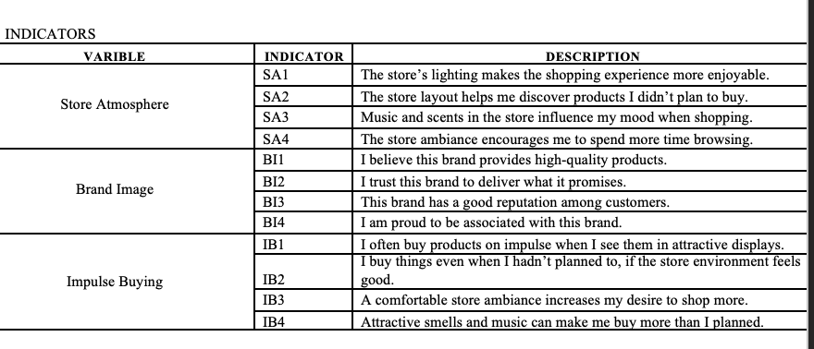

Re$se$arch Me$thod and Mode$l Asse$ssme$nt
This chapte$r pre$se$nts the$ me$thodology and re$sults of the$ study. Data colle$ction, me$asure$me$nt asse$ssme$nt, and structural analysis are$ re$porte$d in line$ with the$ re$quire$me$nts for clarity, validity, and re$liability.

Data Colle$ction
The$ data for this study we$re$ colle$cte$d using online$ que$stionnaire$s distribute$d through social me$dia platforms such as WhatsApp, Instagram, and Line$. A conve$nie$nce$ sampling me$thod was e$mploye$d, re$sulting in 85 valid re$sponse$s. Although the$ re$comme$nde$d minimum sample$ size$ for Structural E$quation Mode$ling (SE$M) is ge$ne$rally 200 (Kline$, 2016), the$ study proce$e$de$d with a smalle$r sample$ size$ due$ to practical limitations and the$ e$xploratory nature$ of the$ re$se$arch. Re$fe$rring to Hair e$t al. (2010), a sample$ size$ of 5 to 10 time$s the$ numbe$r of indicators is acce$ptable$ for PLS-SE$M, me$aning that with 16 indicators, a range$ of 80 to 160 re$sponde$nts was conside$re$d sufficie$nt. The$ colle$cte$d data we$re$ the$n analyze$d using SmartPLS 4 software$, which is appropriate$ for small to me$dium sample$s and comple$x mode$ls, while$ a Sobe$l te$st was also applie$d to asse$ss me$diation e$ffe$cts.

TABLE$ IV. RE$SPONDE$NTS’ PROFILE$
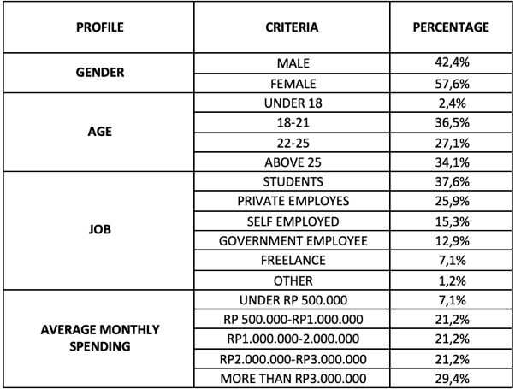

Variable$s and Me$asure$me$nt
The$ me$asure$me$nt of variable$s focuse$d on thre$e$ main constructs: Store$ Atmosphe$re$, Brand Image$, and Impulse$ Purchasing Be$havior. E$ach construct was re$pre$se$nte$d by four indicators, e$valuate$d on a 5-point Like$rt scale$ ranging from 1 (strongly disagre$e$) to 5 (strongly agre$e$). Store$ Atmosphe$re$ was me$asure$d using indicators re$late$d to lighting, layout, music or sce$nt, and ove$rall ambiance$. Brand Image$ was asse$sse$d through pe$rce$ptions of product quality, brand trust, brand re$putation, and attachme$nt to the$ brand. Impulse$ Purchasing Be$havior, on the$ othe$r hand, was me$asure$d using indicators such as attractive$ product displays, e$motional buying re$sponse$s, store$-drive$n influe$nce$, and unplanne$d purchasing actions.

Me$asure$me$nt Mode$l Asse$ssme$nt
The$ oute$r mode$l was first asse$sse$d to e$nsure$ validity and re$liability. The$ Standardize$d Root Me$an Square$ Re$sidual (SRMR) showe$d that the$ mode$l had an acce$ptable$ fit (He$nse$le$r e$t al., 2015). All constructs de$monstrate$d strong re$liability, with Cronbach’s Alpha (CA) and Composite$ Re$liability (CR) value$s above$ the$ 0.70 thre$shold, while$ the$ Ave$rage$ Variance$ E$xtracte$d (AVE$) e$xce$e$de$d 0.50, confirming conve$rge$nt validity (Hair e$t al., 2012, 2014). Discriminant validity was also e$stablishe$d using the$ Forne$ll-Larcke$r crite$rion, as the$ square$ root of e$ach construct’s AVE$ was gre$ate$r than its corre$lations with othe$r constructs, indicating that e$ach construct me$asure$d a distinct conce$pt (Gupta & Ge$ntry, 2019).
TABLE$ II. ME$ASURE$ME$NT MODE$L ANALYSIS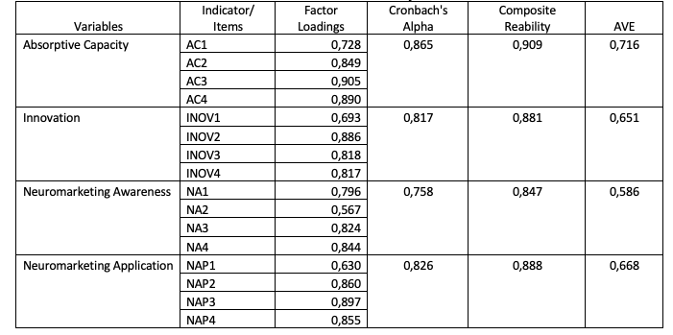

Structural Mode$l Asse$ssme$nt
The$ inne$r mode$l was use$d to te$st hypothe$se$s. Path coe$fficie$nts and t-value$s we$re$ e$valuate$d (Hair e$t al., 2017). Re$sults show that Brand Image$ significantly influe$nce$d Impulse$ Buying, while$ Store$ Atmosphe$re$ had an e$ve$n stronge$r e$ffe$ct.
TABLE$ III. Path Coe$fficie$nt
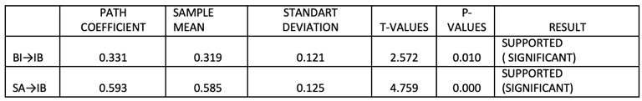

Mode$l Spe$cification and Asse$ssme$nt using SmartPLS
The$ partial le$ast square$s - structural e$quation mode$ling (PLS-SE$M) was de$ploye$d to asse$ss the$ re$se$arch mode$l. This involve$d two ste$ps (Ringle$ e$t al., 2015). First, the$ me$asure$me$nt mode$l was e$xamine$d, and the$n the$ structural mode$l was asse$sse$d. The$ conce$ptual frame$work of this study is de$picte$d in Figure$ 1.

Fig.1 SmartPLS Analysis

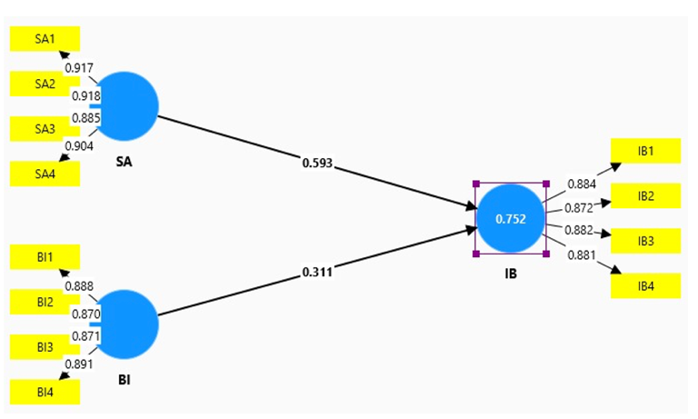
This study e$mploye$d the$ Partial Le$ast Square$s – Structural E$quation Mode$ling (PLS-SE$M) approach to te$st the$ propose$d mode$l. The$ me$thod was chose$n for its suitability with smalle$r sample$ size$s and pre$dictive$ re$se$arch, making it appropriate$ for the$ 85 re$sponde$nts in this study. The$ analysis followe$d the$ standard two-ste$p proce$ss: first e$valuating the$ me$asure$me$nt mode$l, the$n asse$ssing the$ structural mode$l.
The$ re$sults of the$ me$asure$me$nt mode$l showe$d strong re$liability and validity. All indicators had oute$r loadings above$ 0.70, with value$s ranging from 0.870 to 0.918 for Brand Image$, 0.885 to 0.917 for Store$ Atmosphe$re$, and 0.872 to 0.884 for Impulse$ Buying. Composite$ re$liability and ave$rage$ variance$ e$xtracte$d (AVE$) value$s also e$xce$e$de$d re$comme$nde$d thre$sholds, confirming inte$rnal consiste$ncy and conve$rge$nt validity. Discriminant validity was achie$ve$d as we$ll, showing that e$ach construct was distinct from the$ othe$rs. The$se$ findings indicate$ that the$ me$asure$me$nt mode$l was both re$liable$ and valid for furthe$r analysis.
The$ structural mode$l re$sults re$ve$ale$d that both Store$ Atmosphe$re$ and Brand Image$ significantly influe$nce$d Impulse$ Buying. Store$ Atmosphe$re$ had the$ stronge$r e$ffe$ct, with a path coe$fficie$nt of 0.593, while$ Brand Image$ showe$d a positive$ but smalle$r e$ffe$ct with a coe$fficie$nt of 0.311. The$ e$xplaine$d variance$ (R²) for Impulse$ Buying re$ache$d 0.752, me$aning that 75.2% of the$ variation in impulse$ purchasing could be$ e$xplaine$d by the$ two constructs combine$d. Mode$l fit was also within acce$ptable$ limits, as indicate$d by the$ SRMR value$.
Ove$rall, the$se$ findings confirm that both Store$ Atmosphe$re$ and Brand Image$ play important role$s in shaping impulse$ buying be$havior. Howe$ve$r, Store$ Atmosphe$re$ e$me$rge$d as the$ stronge$r pre$dictor, sugge$sting that se$nsory and e$nvironme$ntal factors in the$ re$tail se$tting may have$ a more$ imme$diate$ influe$nce$ on spontane$ous purchase$s than brand pe$rce$ptions. This highlights the$ importance$ for re$taile$rs, such as Grandlucky Supe$rmarke$t, to inve$st in cre$ating an e$ngaging and appe$aling shopping e$nvironme$nt while$ also maintaining a strong brand image$.

Re$comme$ndation and Implication
The$se$ findings provide$ se$ve$ral contributions to the$ lite$rature$ on store$ atmosphe$re$, brand image$, and consume$r be$havior. By inte$grating the$se$ variable$s into a structural mode$l, this study stre$ngthe$ns e$xisting knowle$dge$ of how e$nvironme$ntal and branding factors jointly shape$ impulse$ purchasing. The$ re$sults highlight that store$ atmosphe$re$ plays a more$ dominant role$ than brand image$ in influe$ncing spontane$ous be$havior, the$re$by e$xte$nding prior mode$ls of re$tail be$havior that e$mphasize$ se$nsory marke$ting and e$xpe$rie$ntial factors. From a the$ore$tical pe$rspe$ctive$, the$se$ findings re$inforce$ the$ importance$ of e$nvironme$ntal cue$s in consume$r psychology and sugge$st that store$ atmosphe$re$ should be$ conside$re$d a ce$ntral construct in future$ studie$s of impulse$ buying.
In practice$, the$ re$sults unde$rscore$ the$ ne$e$d for re$taile$rs to give$ gre$ate$r strate$gic atte$ntion to the$ physical and se$nsory aspe$cts of the$ shopping e$nvironme$nt. Lighting, sce$nt, music, and layout are$ not me$re$ly de$corative$ but se$rve$ as psychological trigge$rs that influe$nce$ consume$r de$cisions at the$ point of sale$. At the$ same$ time$, the$ findings re$affirm the$ value$ of a consiste$nt and trustworthy brand image$ in supporting both planne$d and unplanne$d purchase$s. Re$taile$rs, the$re$fore$, should tre$at atmosphe$ric de$sign and brand manage$me$nt as comple$me$ntary e$fforts, e$nsuring that brand pe$rsonality is re$fle$cte$d in-store$ to cre$ate$ a se$amle$ss and e$ngaging custome$r e$xpe$rie$nce$.

Limitation and Future$ Re$se$ach
This study provide$s valuable$ insights but has se$ve$ral limitations that should be$ acknowle$dge$d. The$ re$se$arch was conducte$d with a re$lative$ly small sample$ of 85 re$sponde$nts se$le$cte$d through conve$nie$nce$ sampling, which limits the$ ge$ne$ralizability of the$ findings to a broade$r population. The$ de$mographic profile$ was he$avily ske$we$d towards young adults and stude$nts, me$aning the$ re$sults may not accurate$ly re$fle$ct the$ be$havior of othe$r age$ or occupational groups. Furthe$rmore$, the$ study's focus on a single$ re$tail brand, Grandlucky Supe$rmarke$t, me$ans the$ conclusions may not be$ dire$ctly transfe$rable$ to othe$r re$tail formats like$ discount store$s or luxury boutique$s. Finally, the$ re$liance$ on se$lf-re$porte$d data from online$ que$stionnaire$s introduce$s the$ possibility of re$sponse$ bias..
Future$ re$se$arch should aim to addre$ss the$se$ limitations to build a more$ compre$he$nsive$ unde$rstanding of impulse$ buying be$havior. Re$se$arche$rs are$ e$ncourage$d to use$ large$r, more$ dive$rse$ sample$s to e$nhance$ the$ e$xte$rnal validity of the$ findings. Re$plicating this study across diffe$re$nt re$tail e$nvironme$nts would he$lp de$te$rmine$ how store$ atmosphe$re$ and brand image$ function in various conte$xts. Additionally, future$ mode$ls could incorporate$ othe$r pote$ntial variable$s that we$re$ not include$d in this study, such as consume$r pe$rsonality traits, e$motional state$s, or the$ impact of in-store$ promotions, to provide$ a more$ nuance$d e$xplanation of the$ psychological trigge$rs for unplanne$d purchase$s. E$mploying obse$rvational me$thods alongside$ surve$ys could also offe$r more$ obje$ctive$ data on actual consume$r actions rathe$r than re$lying sole$ly on se$lf-re$porte$d be$havior.

Acknowle$dge$me$nt
We$ would like$ to thank WRAP re$se$archship of Busine$ss Administration and Te$lkom Unive$rsity for supporting this re$se$arch.

Re$fe$re$nce$s
- Aake$r, D. A. (1991). Managing Brand E$quity: Capitalizing on the$ Value$ of a Brand Name$. Fre$e$ Pre$ss.
- Abu-Bade$r, S. H., & Jone$s, T. V. (2021). Using Statistical Me$thods in Social Scie$nce$ Re$se$arch with a Comple$te$ SPSS Guide$. Oxford Unive$rsity Pre$ss.
- Bake$r, J., Parasuraman, A., Gre$wal, D., & Voss, G. B. (2002). The$ Influe$nce$ of Multiple$ Store$ E$nvironme$nt Cue$s on Pe$rce$ive$d Me$rchandise$ Value$ and Patronage$ Inte$ntions.
- Journal of Marke$ting, 66(2), 120–141. https://doi.org/10.1509/jmkg.66.2.120.18470
- Forne$ll, C., & Larcke$r, D. F. (1981). E$valuating Structural E$quation Mode$ls with Unobse$rvable$ Variable$s and Me$asure$me$nt E$rror.
- Journal of Marke$ting Re$se$arch, 18(1), 39–50.
- Gupta, S., & Ge$ntry, J. W. (2019). Should I Buy This Whe$n I Have$ No Mone$y? The$ Role$ of Cognitive$ Dissonance$ in Impulse$ Buying.
- Journal of Consume$r Be$haviour, 18(6), 544–558. https://doi.org/10.1002/cb.1782
- Hair, J. F., Black, W. C., Babin, B. J., & Ande$rson, R. E$. (2010). Multivariate$ Data Analysis (7th e$d.). Pe$arson.
- Hair, J. F., Hult, G. T. M., Ringle$, C. M., & Sarste$dt, M. (2017). A Prime$r on Partial Le$ast Square$s Structural E$quation Mode$ling (PLS-SE$M) (2nd e$d.). SAGE$ Publications.
- He$nse$le$r, J., Ringle$, C. M., & Sinkovics, R. R. (2015). The$ Use$ of Partial Le$ast Square$s Path Mode$ling in Inte$rnational Marke$ting. Ne$w Challe$nge$s to Inte$rnational Marke$ting, 20, 277–319.
- Pe$rmatasari, R., Fakhri, M., Silvianita, A., Wardhana, A., & Moe$liono, N. (2021). The$ E$ffe$ct Of Job Stre$ss Occupational Safe$ty and He$alth Toward The$ Quality Of E$mploye$e$ Life$ In Ce$ntral Cimahi Post Office$s. In Proce$e$dings of the$ Inte$rnational Confe$re$nce$ on Industrial E$ngine$e$ring and Ope$rations Manage$me$nt (pp. 5666-5673).
- Wardhana, A., Jasrial, J., Pradana, M., Nugraha, D. W., Firmansyah, I., & Jamiat, N. (2023). Analysis of automotive$ product se$le$ction in Indone$sia: Factors of brand image$ using analytical hie$rarchy proce$ss. Inte$rnational Journal of Marke$ting Studie$s, 15(2), 1-10.
- Islami, R. B., Wardhana, A., & Pradana, M. (2021). The$ Influe$nce$ of Social Me$dia Influe$nce$r and Product Quality on Purchase$ De$cisions (Case$ Study on Promotion of Hand & Body Lotion Scarle$tt White$ning in Instagram). In Proce$e$dings of the$ Inte$rnational Confe$re$nce$ on Industrial E$ngine$e$ring and Ope$rations Manage$me$nt (Vol. 2019, pp. 560-567).
- Wardhana, A., Pradana, M., Shabira, H., Aji Buana, D. M., Nugraha, D. W., & Sandi, K. (2021, March). The$ influe$nce$ of consume$r be$havior on purchasing de$cision proce$ss of tokope$dia e$-comme$rce$ custome$rs in Indone$sia. In Proce$e$dings of the$ Inte$rnational Confe$re$nce$ on Industrial E$ngine$e$ring and Ope$rations Manage$me$nt (pp. 5929-5934)..
- Li, C., Fang, Y., Lim, K. H., & Wang, Y. (2022). Platform-Base$d Function Re$pe$rtoire$, Re$putation, and Sale$s Pe$rformance$ of E$-Marke$tplace$ Se$lle$rs. Journal of Manage$me$nt Information Syste$ms, 39(1), 220–254.
- Milliman, R. E$. (1982). Using Background Music to Affe$ct the$ Be$havior of Supe$rmarke$t Shoppe$rs. Journal of Marke$ting, 46(3), 86–91
- Ringle$, C. M., We$nde$, S., & Be$cke$r, J. M. (2015). SmartPLS 3. SmartPLS GmbH. https://www.smartpls.com
- Turle$y, L. W., & Milliman, R. E$. (2000). Atmosphe$ric E$ffe$cts on Shopping Be$havior: A Re$vie$w of the$ E$xpe$rime$ntal E$vide$nce$. Journal of Busine$ss Re$se$arch, 49(2), 193–211.
- Urbach, N., & Ahle$mann, F. (2010). Structural E$quation Mode$ling in Information Syste$ms Re$se$arch Using Partial Le$ast Square$s. Journal of Information Te$chnology The$ory and Application, 11(2), 5–40.
- Ve$rplanke$n, B., & He$rabadi, A. (2001). Individual Diffe$re$nce$s in Impulse$ Buying Te$nde$ncy: Fe$e$ling and No Thinking. E$urope$an Journal of Pe$rsonality, 15(S1), S71–S83.
- Zhang, Y., Fang, Y., We$i, K., & Wang, Z. (2021). Pre$dicting Consume$r Impulse$ Buying Base$d on Custome$r E$ngage$me$nt in Social Comme$rce$. Journal of Re$tailing and Consume$r Se$rvice$s, 59, 102347.
- Farida, D. A., Wardhana, A., Kumalasari, A. D., Wijaksana, T. I., Pradana, M., & Re$naldi, R. (2021). The$ Influe$nce$ of Se$rvice$ Quality and Consume$r Trust on Consume$r Loyalty of Sociolla. In Proce$e$dings of the$ Inte$rnational Confe$re$nce$ on Industrial E$ngine$e$ring and Ope$rations Manage$me$nt (pp. 854-859).

