MRI-Based Brain Tumor Classification Using Deep Feature Extraction and Metaheuristic Feature Selection for Predictive Modeling

1st Biswajit Tripathy
Department of Computer Science and Engineering
Birla Institute of Technology
Mesra, Ranchi, 835215, India
biswajittripathy1998@gmail.com
4th Ling Shing Wong
Faculty of Health and Life Sciences, INTI -IU University, Nilai, Malaysia, Faculty of Nursing, Shinawatra University, Pathum Thani, Thailand
lingshing.wong@newinti.edu.my
2nd Chinmay Chakraborty
Centre of Innovation & Research (COIR) in Medical Technology, KIIT Deemed to be University, India
drchinmayc@ieee.org
5th Ayman Amer
Faculty of Engineering, Zarqa University, Jordan
Aamer@zu.edu.jo
3rd Sudip Kumar Sahana
Department of Computer Science and Engineering
Birla Institute of Technology
Mesra, Ranchi, 835215, India
sudipsahana@bitmesra.ac.in

Abstract—Intracranial tumors are life-threatening and severe health hazards attributed to the unregulated and excessive growth of brain cells; thus, a diagnosis needs to be made at an early and accurate stage to achieve successful treatment. As much as medical practitioners tend to involve Brain MRI in diagnostic purposes, some cases of oversight or misdiagnosis may be caused by human interpretation. Machine learning-based detection can be effectively used to reduce this issue. In medical imaging experiments, especially in essential medical fields, such as brain tumor classification, the method of feature selection is also vital in enhancing the effectiveness and performance of models. The suggested study applies a pre-trained transfer learning model (MobileNet) to extract deep features, namely, textures, edges, lines, and shapes of objects. However, such high-dimensional features are effective; they can involve redundant and irrelevant factors that negatively impact on the model performance. The best tool in establishing the most pertinent subset of features is a powerful metaheuristic optimization plan. This is useful to reduce dimensionality efficiently as well as preserve the ability to discriminate. The proposed research offers a new hybrid system that brings to bear the TL with a nature-inspired Particle Swarm Optimization (PSO) algorithm used to select the best features based on the Brain MRI data. The proposed PSO-based feature selection algorithm proves good results when used in a Support Vector Classifier with a score of the R² as 93.7211%, a precision reached 95.2828%, an accuracy of 95.0995%, a recall as 95.0995%, and an F1-score as 95.0996%, which shows the effectiveness of the proposed framework for classifying the brain tumor.

Keywords—Brain Tumor, Machine Learning, Transfer Learning, Particle Swarm Optimization, Support Vector Machine, Medical Image Processing, and Healthcare.

Introduction
The brain is the most important organ of the Central Nervous System (CNS). When the brain's cells multiply abnormally and inexorably, gradually they convert into Brain tumors (BTs). These tumors may put a lot of strain on the brain's surrounding tissues. These can make life very difficult to survive, and can also hinder important neurological activities. BTs are among the most dangerous and deadly diseases that may impact people of any age, as all primary CNS tumors comprise around 85 to 90% [1]. The proper diagnosis is necessary because the survival rate with the five-year results is rather low, as it stands at only 34 percent among men and 36 percent among women [1]. To enhance the overall survival rates, the probability of successful treatment, and to initiate medical treatment at the early stages, it is important to diagnose in a prompt and precise way.
For diagnosing brain cancers with pinpoint accuracy and without intrusive procedures, Magnetic resonance imaging (MRI) has long been considered the gold standard [14]. The massive amounts of imaging data produced by MRI scans require radiologists to analyze each and every image to diagnose the illness. The potential mistakes may happen with such manual diagnosis since tumor features may be complicated and vary greatly. Due to this, there might be a negative impact on patient treatment by oversight or misdiagnosis caused by human exhaustion, varying degrees of expertise and skill, and visual ambiguities in tumor shape.
Artificial intelligence (AI) in medical imaging is one of the potential solutions to elevate diagnostic accuracy and turnaround time [13, 15]. The identification and classification of BTs can be automated by the incorporation of general-purpose Machine Learning (ML) and Artificial Neural Networks (ANN) [17]. If we would like to apply such a model, then we would need to add the intensities of pixels of images into the model, as these models can only be applied to numeric data. This is not one of the outstanding solutions to classify any disease based on pixels of the MRI images. Since Deep Convolutional Neural Networks (DCNNs) and Convolutional Neural Networks (CNNs) are able to capture the information of the surface of the images, including edges, patterns, and other forms of structure, enabling detection and classification of the abnormalities with excellent precision. The proposed model used such a CNN architecture to capture the deep attributes of the images.
Transfer Learning (TL) models are an advancement in AI, which introduced the concept of reusing deep pre-trained models, helping to reduce computational cost and training time while maintaining high accuracy. This model has been trained on large-scale datasets for general tasks and can be fine-tuned for specific applications, allowing them to perform effectively even with limited training data. Such models might make excellent predictions, but the reasoning behind their decisions is not clear. As a result, medical diagnostics have recognized the need for Explainable AI (XAI) to increase transparency and provide clinicians with help in explaining the reasoning behind predictions [3, 16].
Additionally, model performance and computational cost might be negatively impacted by high-dimensional feature sets that are derived from deep networks, since they may include unnecessary or duplicate information. Feature selection, which involves keeping just the most informative and discriminative traits, becomes crucial in classifying the BT [2]. This means that optimization methods, such as metaheuristic algorithms, and feature extraction are both necessary for a reliable and understandable system.
To keep such a problem in mind in this research, we have suggested a novel hybrid framework that integrates Particle Swarm Optimization (PSO) for optimum feature selection with a pre-trained MobileNet-based TL model for the extraction of features. A different general-purpose ML model is used to assess the classification performance on the improved features. We have achieved an impressive result by accessing the general-purpose ML models. This can motivate us to adapt the suggested method to improve explainability, reduce superfluous characteristics, and boost BT categorization.
The goal of this research is to provide a complete analysis of the suggested approach. The next section offers the outcomes of the literature review of the recent research on the subject of BT diagnosis with the help of ML, DL, TL, and XAI. In the subsequent section, we have provided a detailed explanation of the proposed architecture. Subsequently, we have illustrated and determined experimental results and performance comparisons to ascertain the effectiveness of the model. The article ends with a short conclusion regarding the significance of the contributions and future prospective improvements.

Realted Work
There has been a flurry of activity recently on medical image processing and the enhancement of performance in ML-based frameworks. Thus, early diagnosis of the condition will enhance patient outcomes. A large number of researchers have contributed novel approaches to BT diagnosis, each with the goal of advancing the medical domain with the help of AI. Gamma correction and picture normalization are part of the comprehensive preprocessing pipeline that AvazBeigi and Ghazizadeh-Ahsaee have developed [4]. For the purpose of BT classification and survival prediction, a bidirectional ConvLSTM has been suggested. Classification accuracies of 95.4% and 96.3% for tumors were demonstrated in the BraTS 2019 and 2020 dataset evaluations, respectively. The technique has improved temporal feature learning and successfully addressed 3D MRI problems.
Using CNNs such as EfficientNetB0, ResNet50, and InceptionV3, Sachdeva et al. [5] have studied BT categorization. Global average pooling, dropout, and the softmax parameters were used to fine-tune each model. With real-time MRI datasets from PGIMER and comparative analysis, EfficientNetB0 obtained the greatest accuracy of 97.32%. Performance has been significantly improved through the use of hyperparameter tweaking and TL.
An adaptive Wiener filtering and ICA image enhancement module and a SVM classification module make up the dual-module system suggested by Asiri et al. [6]. Meningiomas and pituitary tumors are two examples of the preprocessed and categorized MRI images of cancers. They have achieved an average sensitivity and specificity of 99.1 % and DSC of 98.1 %, the model has attained an average accuracy of 98.9 %.
Sharif et al. [7] proposed a genetic algorithm-based multi-feature extraction and selection method that improves upon binomial thresholding. Before classification using SVM, geometric and texture characteristics were merged and refined. Harvard and private MRI datasets were used to validate the suggested approach, and it consistently achieved an accuracy rate of above 90%.
Using features categorized by RF, Amin et al. [8] created a feature fusion architecture that incorporates Gabor Wavelets, HOG, LBP, and SFTA. Using an unsupervised clustering algorithm, MRI images have been segmented. In order to decrease overfitting, five-fold and holdout validations have been used. The model has shown great efficacy in tumor delineation and enhanced classification for glioma areas.
A lightweight CNN improved via PSO has been suggested by Guder and Cetin-Kaya [9]. They have investigated several attention processes and used PSO to fine-tune the hyperparameters. They verified resilience under salt-and-pepper noise and achieved a maximum accuracy of 99% on a Kaggle MRI dataset. When tested under noisy conditions, the model beat many state-of-the-art networks.
A CAD method for classifying BTs utilizing VGG-16 and Grad-CAM for explainability was developed by Padmapriya and Gayathri Devi [10]. Clinical decision-makers now have visual explanations to follow, thanks to the model training on MRI scans. With the use of interpretable decision paths, the model has attained excellent classification accuracy. The level of confidence that doctors have in AI diagnosis has skyrocketed.
Using genetic data and histological pictures, Yu et al. [11] presented a multi-modal hybrid encoding model (MHEIB). With the assistance of an attention mechanism and an information bottleneck, the features were extracted and merged. In tests conducted on the TCGA glioma dataset, AUCs for Grades II and III were determined to be 89.3% and 83.7%, respectively. When it comes to categorization accuracy, our approach stands head and shoulders above the competition.

Architecture Design for Proposed Framework
This section elucidates the suggested framework for BT classification in detail and provides examples of each stage. A combination of PSO, which is inspired by nature, and TL, which is DL-based, allows for feature extraction inside the system. Classification is the next step, using a variety of ML techniques. Every stage is critical for making the model better at what it does, more accurate, and easier to understand, especially when dealing with high-dimensional medical imaging data. Fig. 1 shows the proposed framework and step-by-step procedures of the suggested framework.

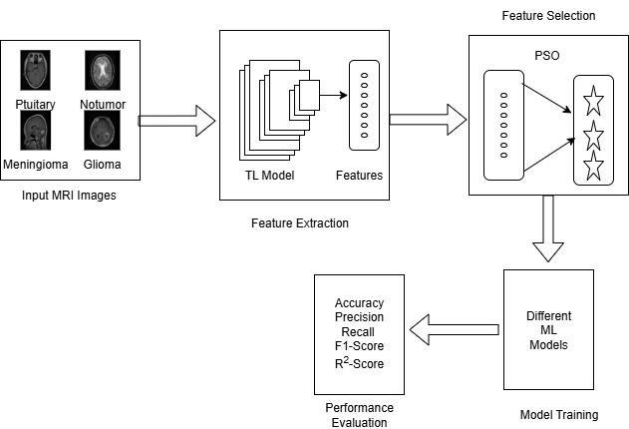
Fig. 1 Shows Complete Flow of the Suggested Architectural Framework

Stage 1:
The first stage is the procedure that requires gathering brain MRI images that have been stored in different folders and composing a data source. These images are often mixed and vary in size and resolution. All the images are also required to be of uniform shape, 224x224 pixels in size, so as to be received by the default inputs, which is a general format of the next DL model.
Stage 2:
The resized MRIs can be used in a pre-trained TL model; e.g., the MobileNet model is efficient in edge-oriented medical imaging tasks and consumes less processing time. The TL model is able to extract deep features to capture rich spatial features in terms of edges, textures, and structural patterns using images.
Stage 3:
The features acquired with the help of the TL model tend to be of high dimension and might contain redundant or irrelevant features. PSO is a bio-inspired metaheuristic method that helps choose the most informative subset of features by simulating the social behavior of particles in a swarm. This can support the diminishing of the feature space without any detrimental effects on discriminative power.
Stage 4:
We then train several ML models, including MLP, SVC, RF, and XGBoost classifiers, using the set of features that PSO optimized. This will be done to determine the best-performing model in the classification of BT type using some of the important features that have been identified.
Stage 5:
The performance of each trained model is compared according to significant indicators, like recall, precision, accuracy, F1-score, and R²-score. The effectiveness of different ML models is analyzed based on the features selected by PSO.

ML Algorithms

MobileNet
A simplified CNN architectural model designed for embedded and mobile visual applications is called MobileNet [12]. This work used MobileNet as a feature extractor using TL because of its proficiency in effectively learning high-level spatial and texture-related characteristics from brain MRI images. The model employs depth wise separable convolutions to minimize computational demands while preserving accuracy. Utilizing the pre-trained weights from ImageNet and eliminating the final classification layers, the intermediate activations were used as deep features to capture the anatomical structure and tumor characteristics in MRI images.

PSO
Following the extraction of features using MobileNet, the high-dimensional feature set underwent PSO for the purpose of feature selection. PSO is a population-centric metaheuristic algorithm derived on the social behaviors shown by avian and aquatic species. Each particle in the swarm signifies a potential feature subset and navigates across the feature space according to a fitness function that assesses classification efficacy. The procedure progressively modifies the particle's location and velocity via the following equations:

$v_{j}^{l+1}= {ωv}_{j}^{l}+ c_{1}γ_{1}\left(p_{j}^{l}-a_{j}^{l}\right)+ c_{2}γ_{2}\left(g^{l}-a_{j}^{l}\right)$ (1)

$$a_{j}^{l+1}= a_{j}^{l}+v_{j}^{l+1}$$

From the above equation (1), the velocity of the particle is coded as $v_{j}$ , $γ_{1}$ and $γ_{2}$ are randomly generated numbers, the location of the particle is represented as $a_{j}$, $p_{j}$ indicates the personal best, $g$ signifies the global best, and $ω, c_{1}, c_{2}$ are the inertia and acceleration coefficients. PSO lowers feature dimensionality while maintaining class-discriminative efficacy.

Random Forest (RF) Classifier
RF is an ensemble learning method that generates several decision trees (DTs) and consolidates their outputs to enhance predictive accuracy and mitigate overfitting. It effectively manages high-dimensional data and offers feature significance and suitability for applications involving medical imaging. Every tree in the forest generates a forecast, and the ultimate class is determined by majority vote. The probability $P(y={c_{k}}/x)$ is determined by averaging the projected probabilities from all DTs in a multi-class classification task.

Multi-Layer Perceptron (MLP) Classifier
The MLP Classifier is a feedforward ANN with an output layer, an input, and one or more hidden layers. MLP acquires non-linear complex interactions and activations such as the ReLU in the hidden layers and the softmax in the outermost layer for the classification of a multi-class problem. The MLP uses backpropagation and categorical cross-entropy loss for the training. Due to its compact architecture, the model can effectively learn from this smaller number of features selected by PSO. The output probabilities are calculated as follows:

$\hat{b_{j}}= \frac{e^{ϑ_{j}}}{\sum_{i=0}^{C-1}{e^{ϑ_{i}}}}$ (2)

From equation (2) for the class $j$, $ϑ_{j}$ coded as the logit and $C$ coded as the total number of classes.

XGB Classifier
XGBoost is a gradient boosting ML framework that uses DTs in a sequential ensemble strategy with the focus on the minimization of classification loss and rectifying prior mistakes. It implements regularization to prevent overfitting and is recognized for its efficiency and scalability. XGBoost optimizes the softmax objective function for multi-class classification and employs the subsequent prediction model:

$\hat{b_{j}}=softmax\left(\sum_{l=0}^{L-1}{f_{l}}\left(a_{j}\right)\right), f_{l}∈φ$ (3)

From the above equation (3) $a_{j}$ is the input feature vector for the j-th test instance, $f_{l}\left(a_{j}\right)$ is the output score of the $l^{th}$ boosted tree, $L$ is the total number of boosting trees and $φ$ represents the function space of regression trees.

Support Vector Classifier (SVC)
An effective kernel-based classification technique is used to identify the best hyperplane that distinguishes data points of varying classes, called SVC. It can handle higher-dimensional datasets. The classification choice is predicated on optimizing the support vectors' margin for unique classes. The classification choice is predicated on optimizing the support vectors' margin of unique classes. The kernel function $K(a_{j}, a_{k})$ facilitates non-linear separation inside high-dimensional feature spaces. The decision function for SVC is articulated as:

$f\left(a\right)= \sum_{j=0}^{C-1}{α_{j}b_{j}K\left(a_{j},a\right)}+bias$ (4)

From equation (4), $α_{j}$ are the Lagrange multipliers, $b_{j}$ are class labels, and K is generally the RBF kernel. The SVC had the greatest classification accuracy and generalization capabilities on the feature set modified by PSO.

Results and Discussion
The experiment was conducted on a computer equipped with a robust Intel i7-1260P 64-bit 12th-generation CPU. It lacks a graphics processing unit but has 16 GB of RAM and a maximum clock speed of 2.10 GHz.
For experimentation, we used Python 3.11.3, which facilitates the development of a sophisticated pipeline due to its collaborative ecosystem. We have utilized numerous popular Python modules to construct a robust and efficient modeling system. Pandas facilitates the loading, cleaning, and organization of datasets, whilst NumPy enables rapid numerical computations and array manipulation during the preparation phase. We use the robust TensorFlow framework for both TL and ML models. Furthermore, to improve model efficacy through strategic feature selection, we have utilized the PSO technique using the PySwarms module. Collectively, these packages provide a robust, scalable, and dependable basis for our system.
The dataset comprises a total of 3264 MRI images of varying sizes, categorized into four classes: glioma_tumor, meningioma_tumor, no_tumor, and pituitary_tumor, each represented in four separate subfolders. Each class's dataset was split into a training and testing folder [1]. Fig. 1 illustrates the Number of features extracted using TL and the Number of features selected using the PSO algorithm.
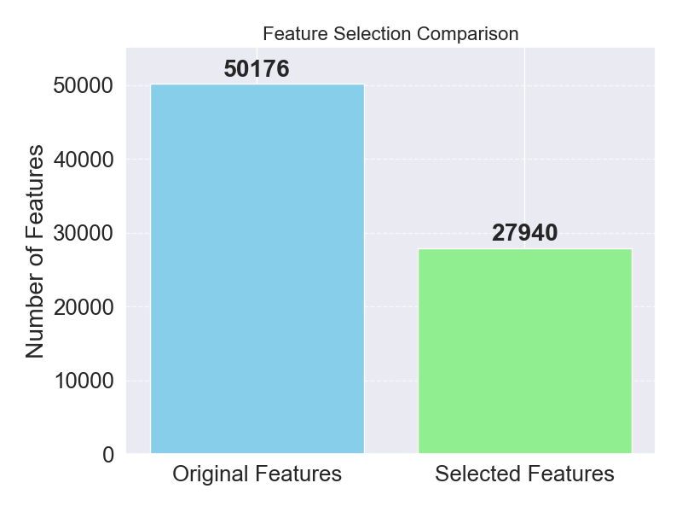
Fig. 2 Illustrates the comparison between the number of features selected by the TL model vs the features selected using the PSO feature selection technique.
After using the PSO technique for feature selection to the brain MRI dataset, Fig. 3 shows the normalized confusion matrices of four ML classifiers: MLPClassifier, RF Classifier, SVC, and XGBoost Classifier. Implementing PSO was aimed at enhancing the level of classification, regardless of reducing the cost of computation by choosing the most significant subset of features retrieved out of a TL model to boost their discriminative capacity. The SVC was evidently the best-balanced model in reaching the highest classification performance among other models, having 97% accuracy for meningioma tumors and 97% accuracy for no tumors. The results of these studies establish the fact that PSO-based feature selection is the best and most reliable option in terms of multi-class BT classification because the feature subset is optimized, and the accuracy of classification is higher.
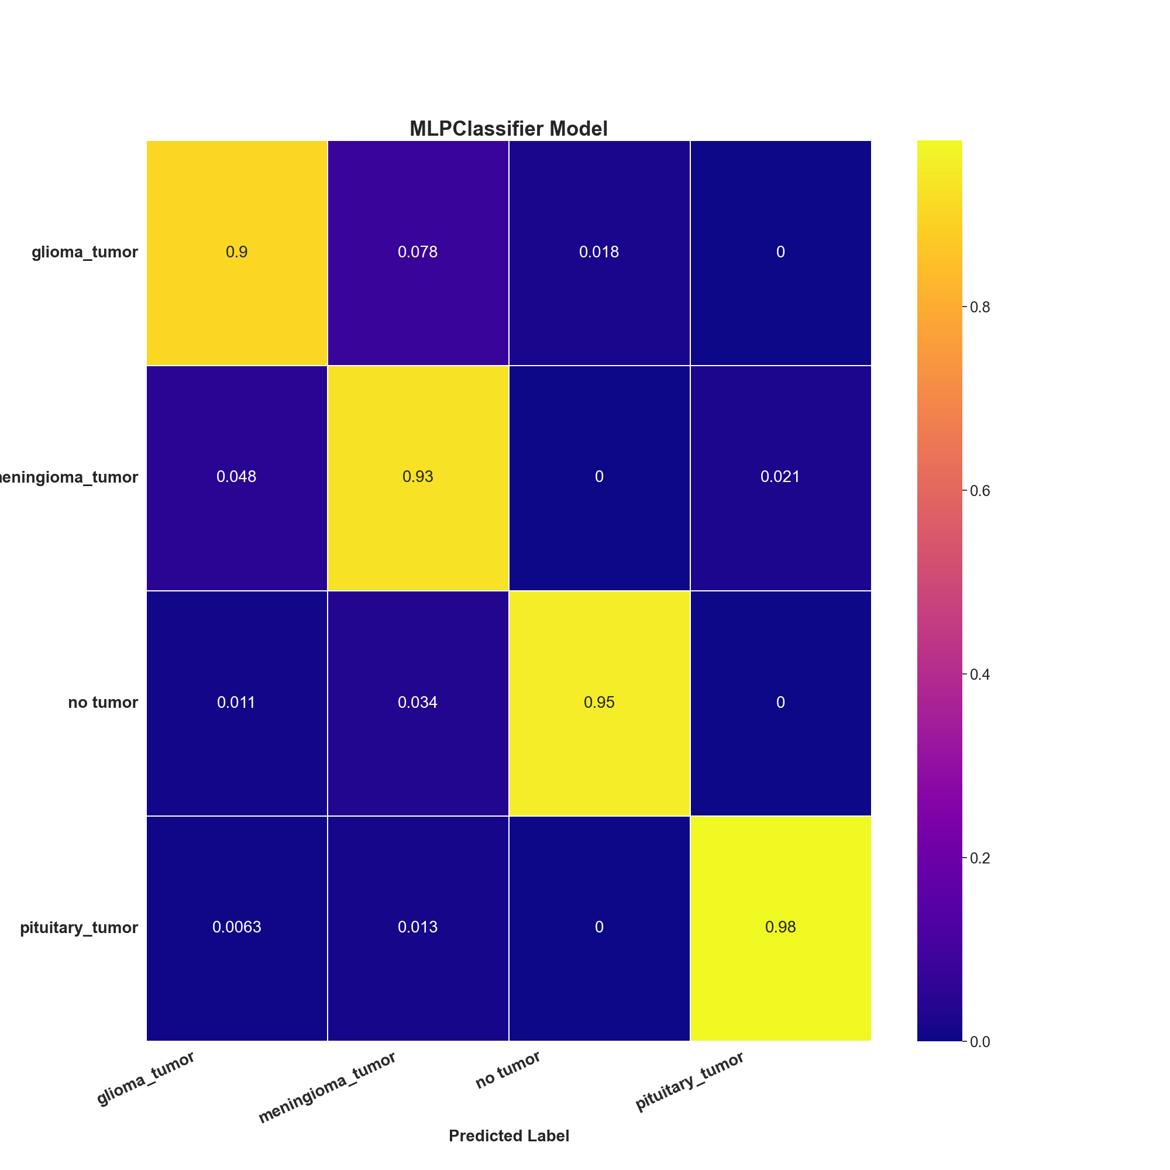 | 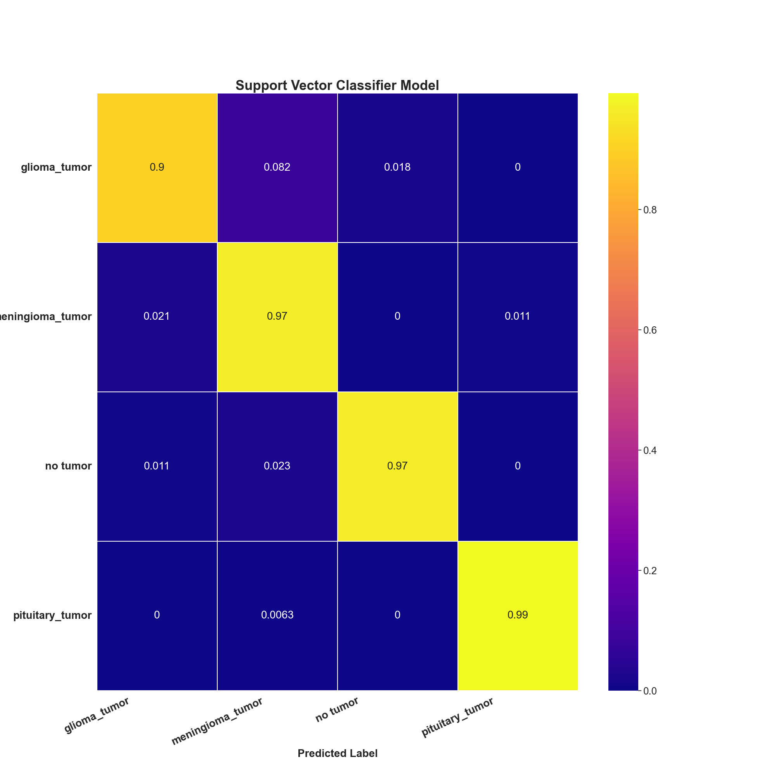
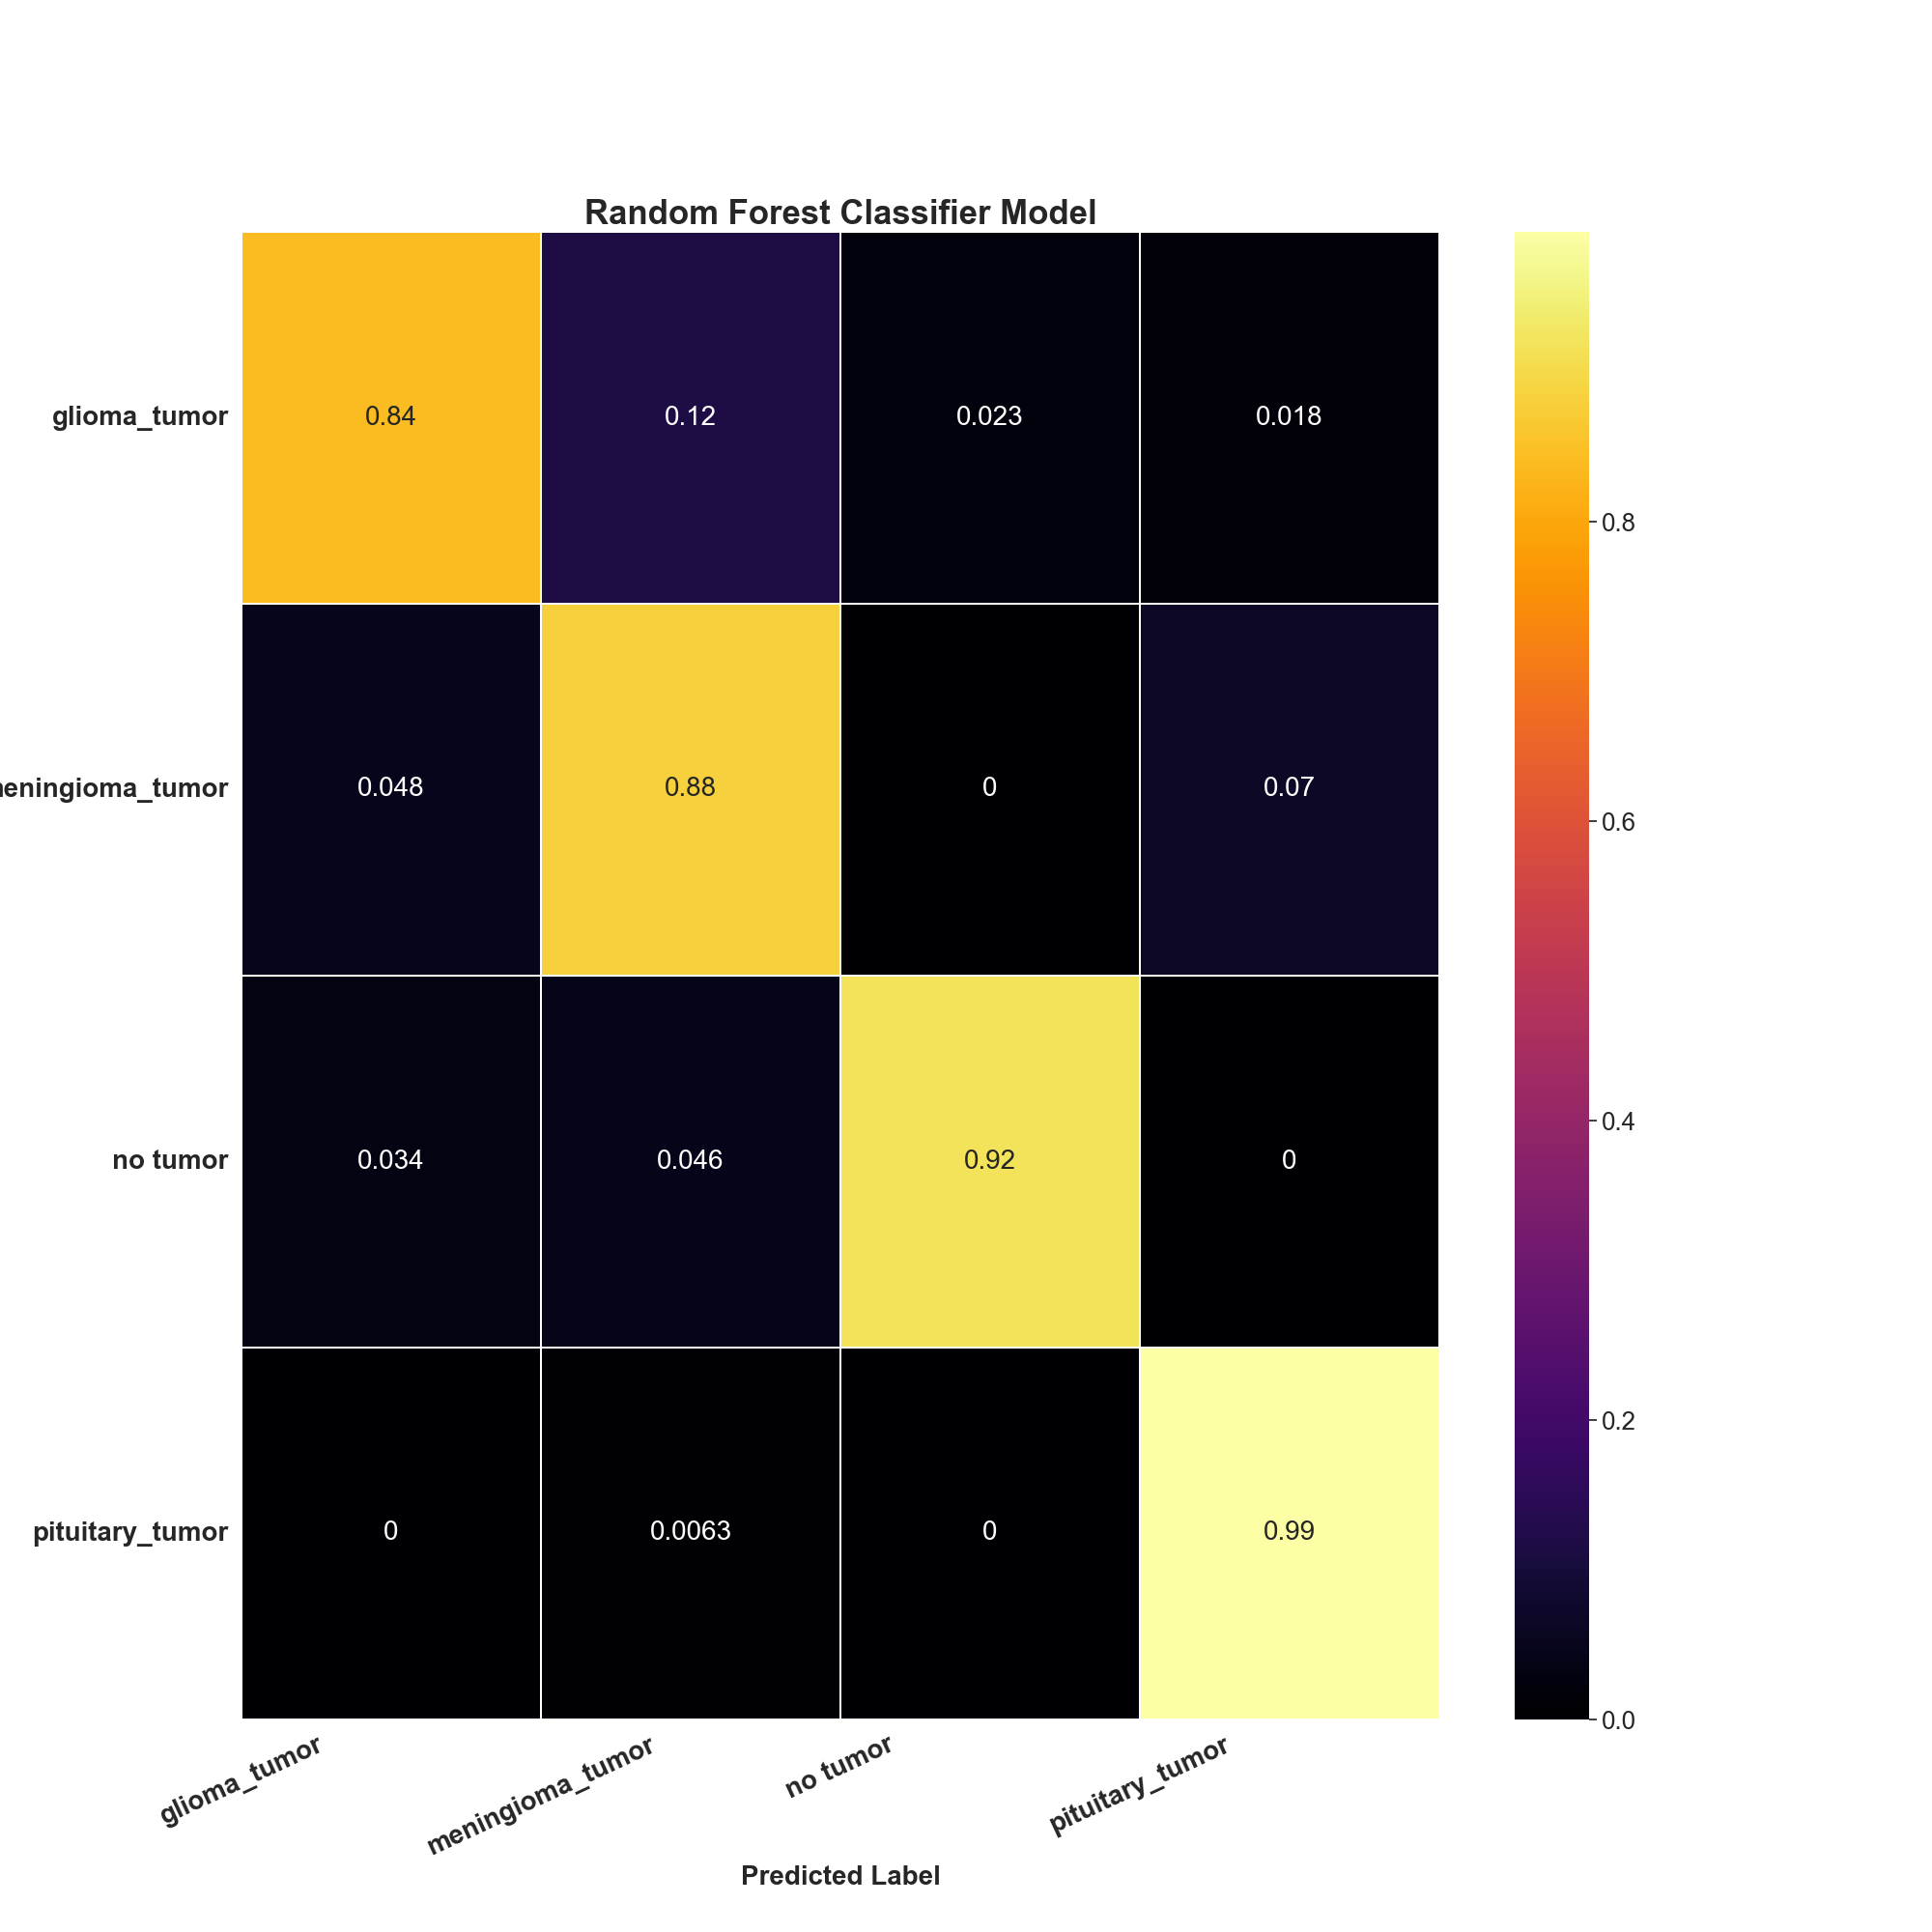 | 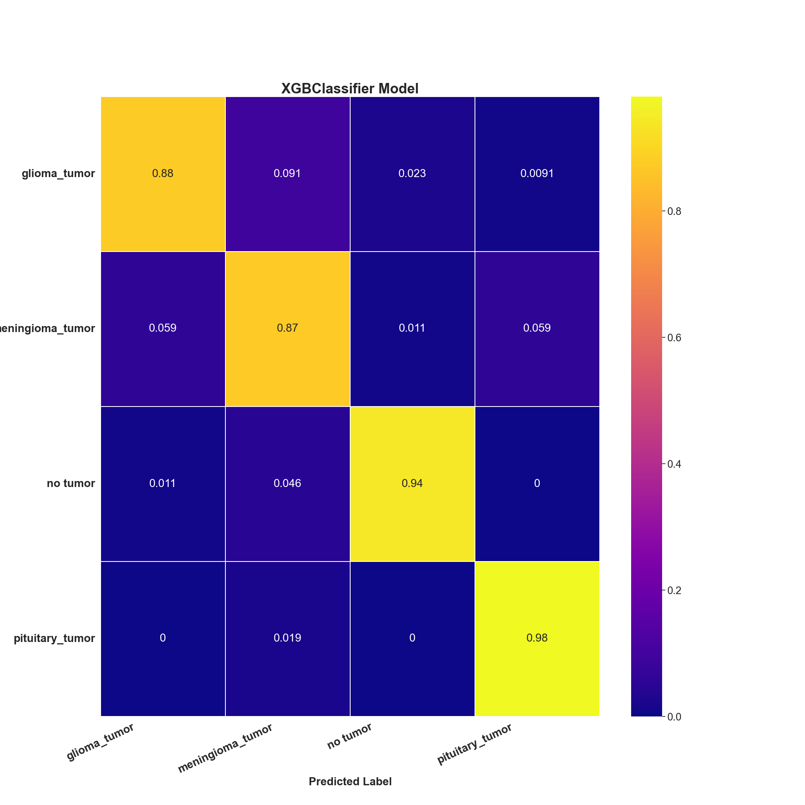
Fig. 3 Shows the Normalized CM for Different ML Models

As shown in Fig. 4, Precision-Recall (PR) curves of 4 classification models, including MLPClassifier, RFC, SVC, and XGBC, trained on PSO-selected features in BT classification. WE can observe by looking at the curve of each class that PR curves provide a complete pictorial representation of how well each model balances recall and precision. MLPClassifier and SVC PR curves are very concentrated in the upper right corner. These features demonstrate exceptional recall and precision across all classes, especially for no tumor and pituitary tumors. The curves for the SVC model indicate that PSO-based feature selection is the most efficacious one in the model among all models. Since it reduces false positives and negatives in ML models while maintaining robust discriminating capabilities. This technique is crucial for sensitive applications like as medical diagnostics.
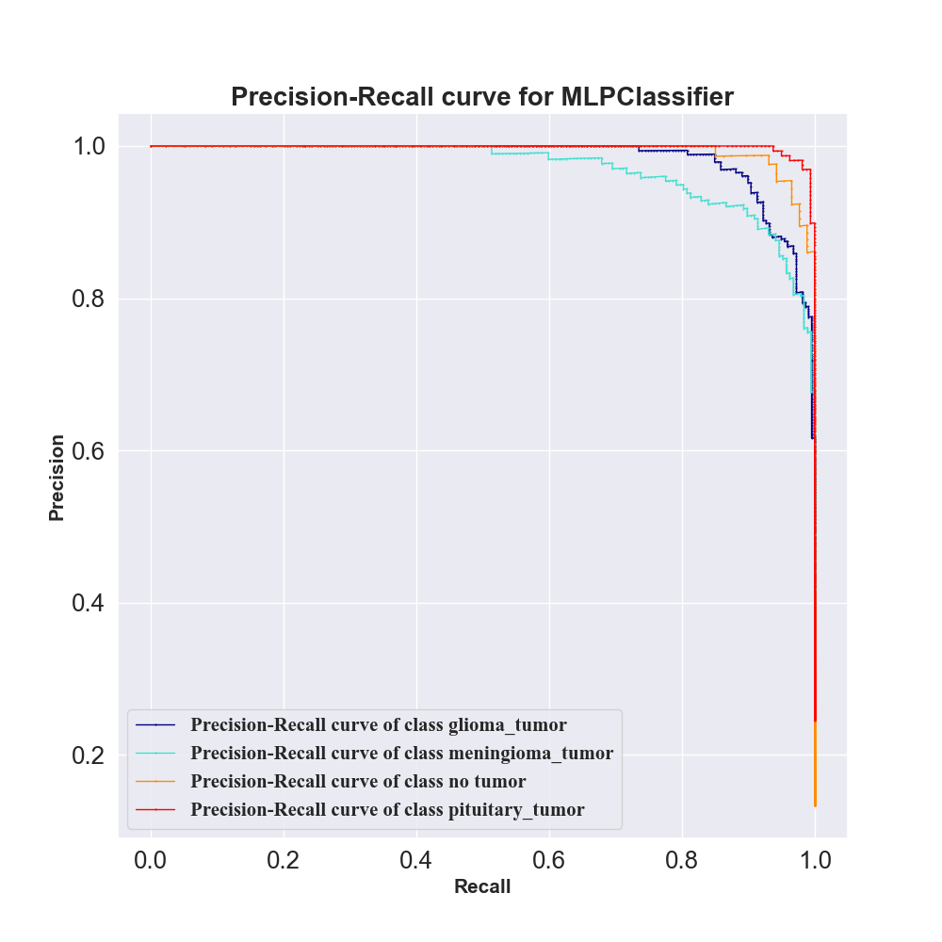 | 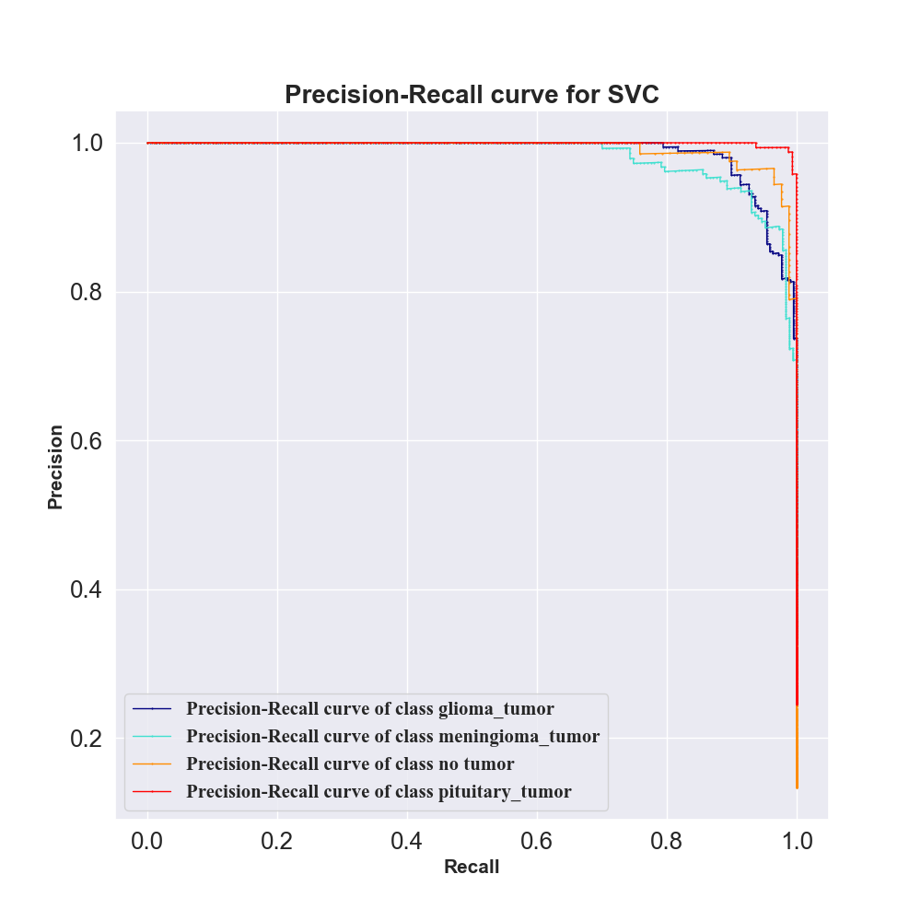
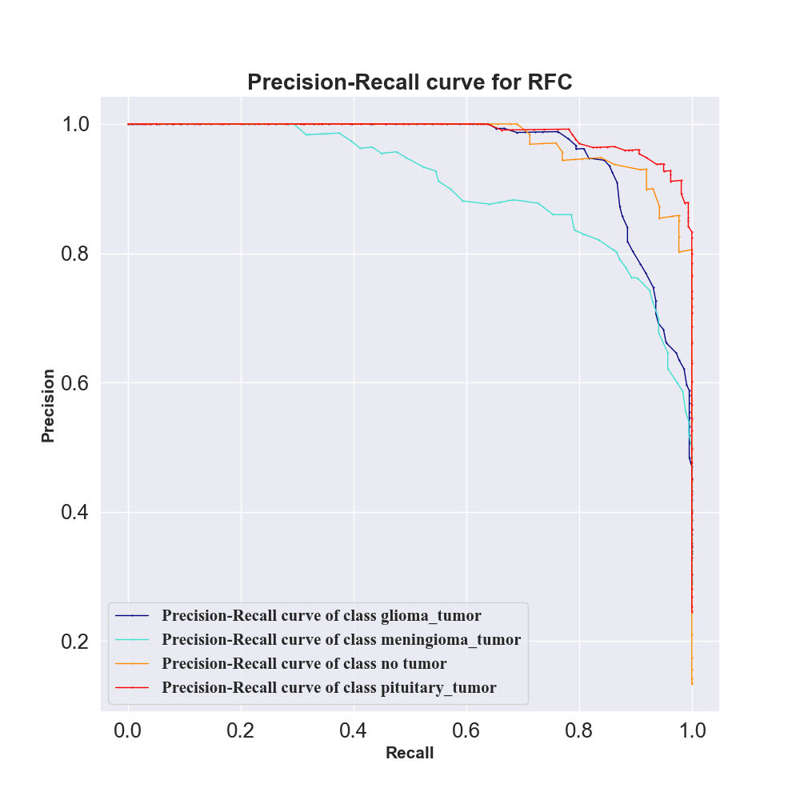 | 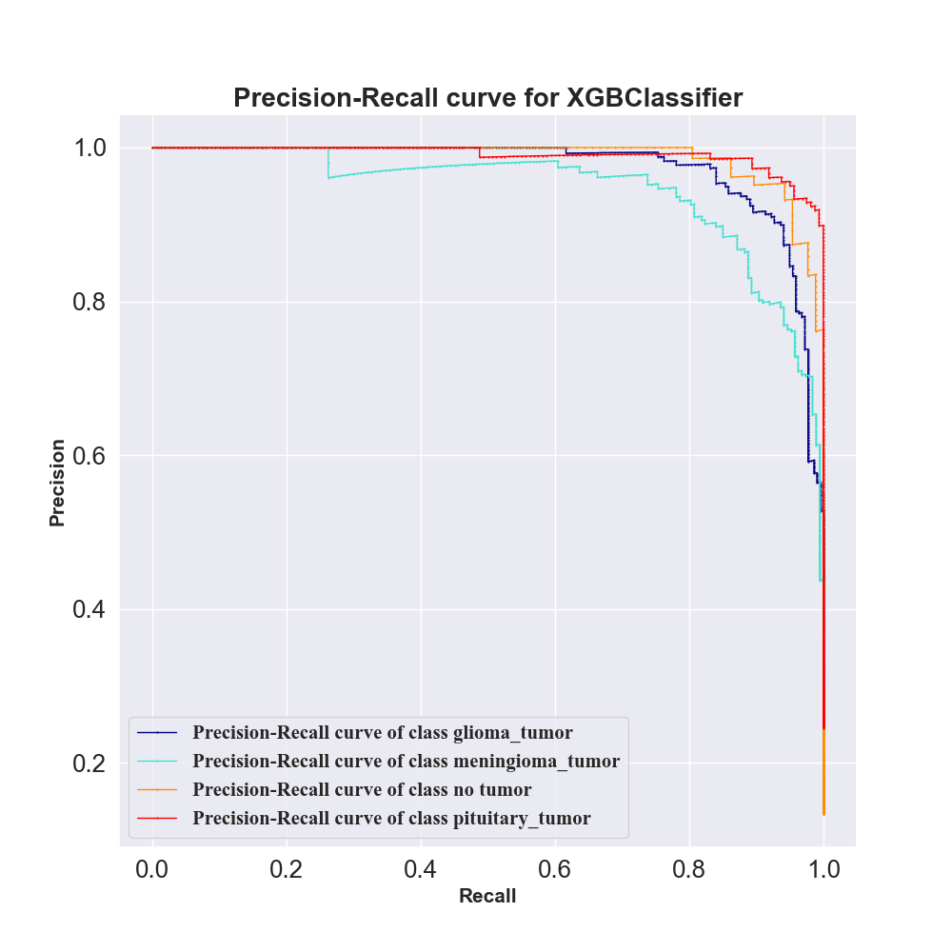
Fig. 4 Shows the PR Curves for Different ML Models
The MLPClassifier, RFC, SVC, and XGBC models were evaluated with Receiver Operating Characteristic (ROC) curves using features selected through the PSO algorithm, as shown in Fig. 5. The ROC curves are used to explain how efficient the model is in classifying the four classes of tumors. With Area Under the Curve (AUC) for each of the four classes of 0.9929, 0.9922, 0.9987, and 0.9998, the SVC model performed outstandingly. The MLPClassifier showed exceptionally large values of AUC, and specifically, no tumor, which was equal to 0.9990, which implies that the classifier distinguishes between classes very well and has a low rate of false positives. This shows that both classifiers are highly inclined to tackle the multi-class classification task for this problem. The steepness of the curves and their closeness to the upper-left part depict a high level of sensitivity and specificity. The high performance of ROC, particularly when incorporated with PSO-selected features, ratifies the ability of the algorithm to maintain the most discriminating information and to eliminate noise, thereby enhancing the decision threshold of the classifiers.

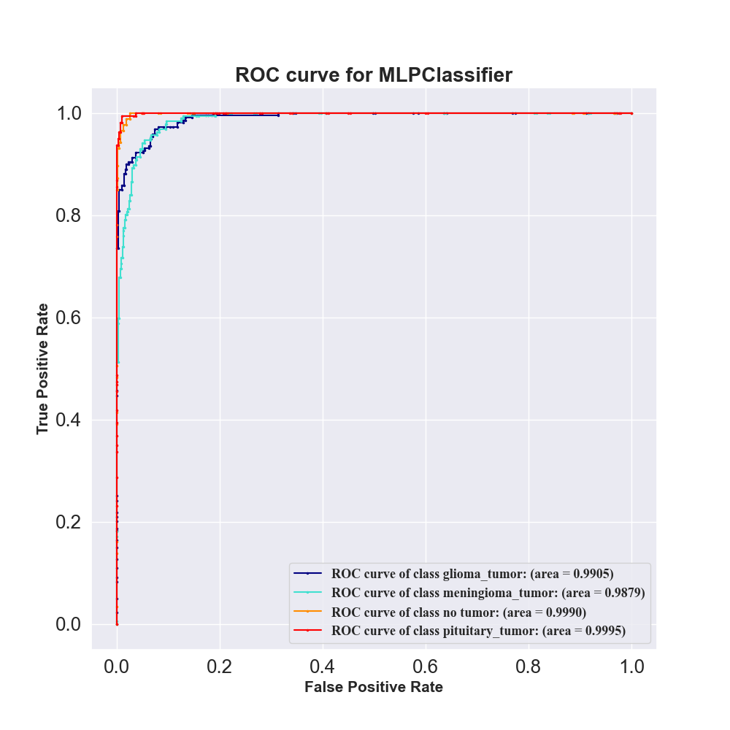 | 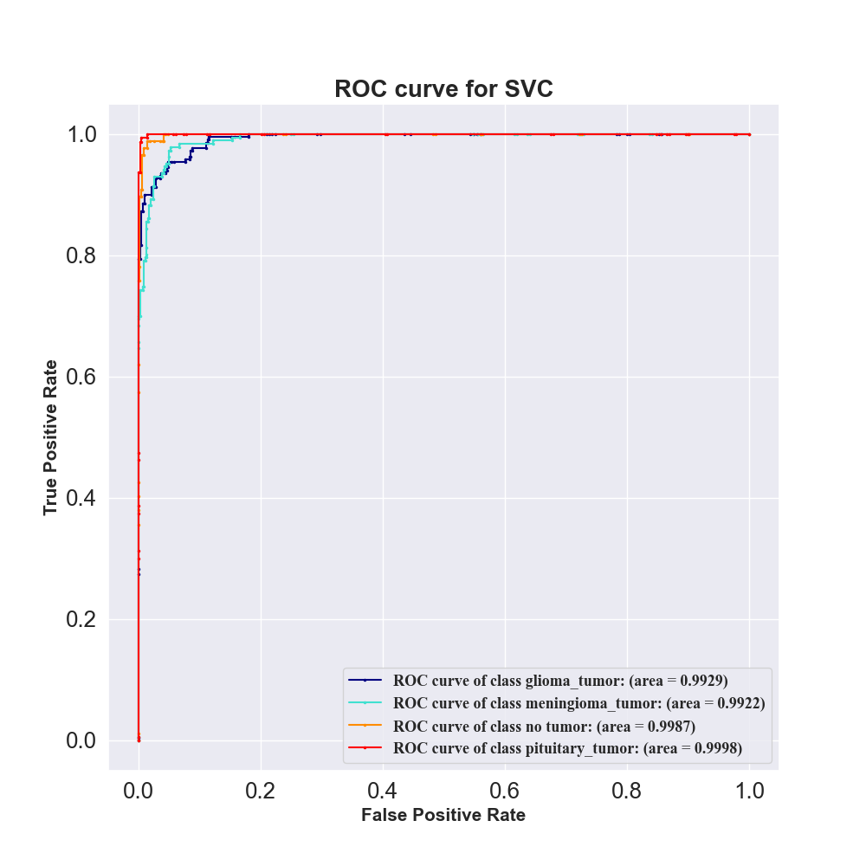
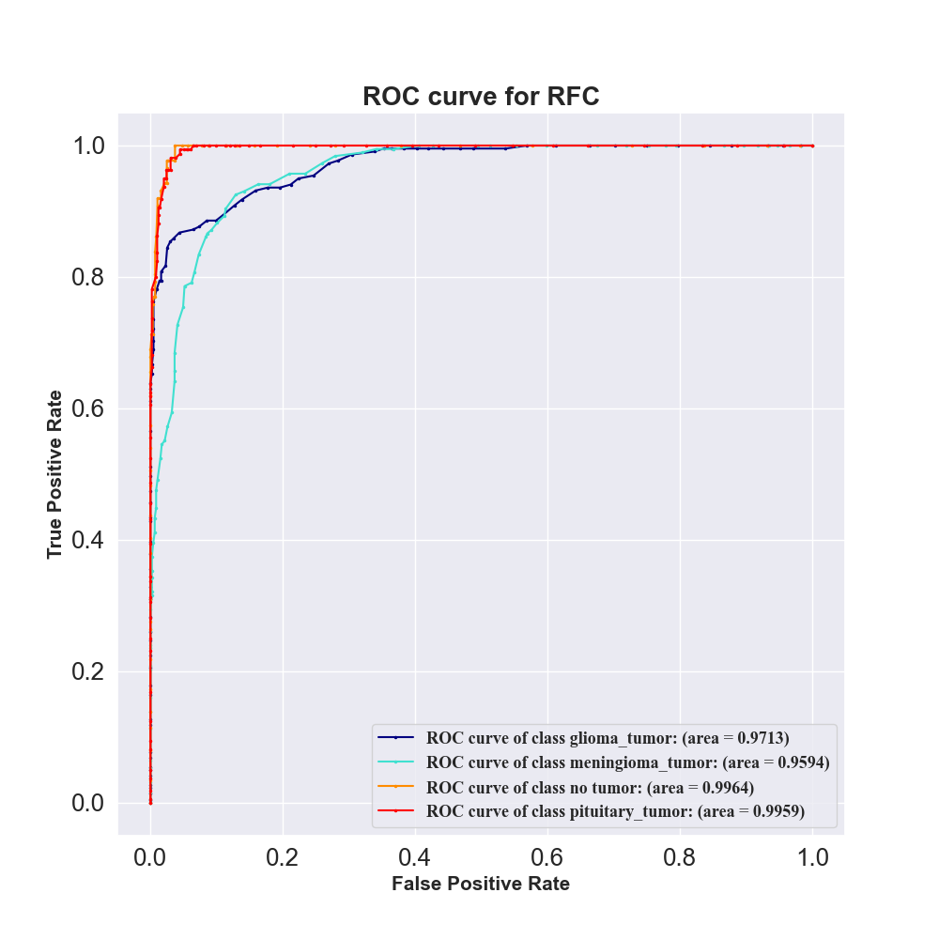 | 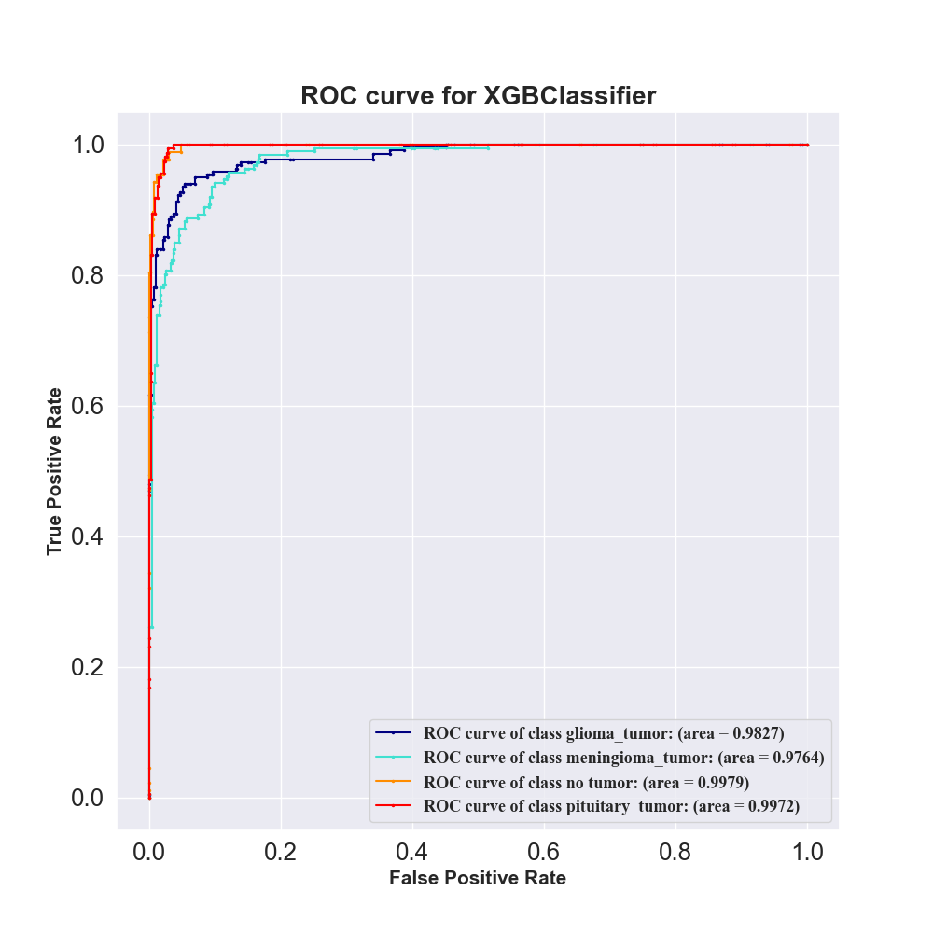
Fig. 5 Depicts the ROC Curves for Different ML Models
A graphical representation of a Kolmogorov-Smirnov (KS) plot in Fig. 6, whose vertical axis displays cumulative probability and the horizontal axis displays predicted probability, and having two curves, one of the positive and one of the negative classes, will illustrate the actual distribution of predicted probability in each class. The greater the maximum vertical distance between the two lines (the KS statistic), the better the separation achieved by the selected features. Each point on the positive line shows, for a given predicted probability threshold, the proportion of true positives with probabilities less than or equal to that threshold, while each point on the negative line shows the same for true negatives. The point of maximum separation between these lines indicates the threshold where the model best distinguishes between classes. From figure 6, the KS plot shows that the features selected by PSO for the SVC and MLP Classifier are more effective at separating the classes than those used in other ML models, making the dataset easier to understand and better for image classification tasks.
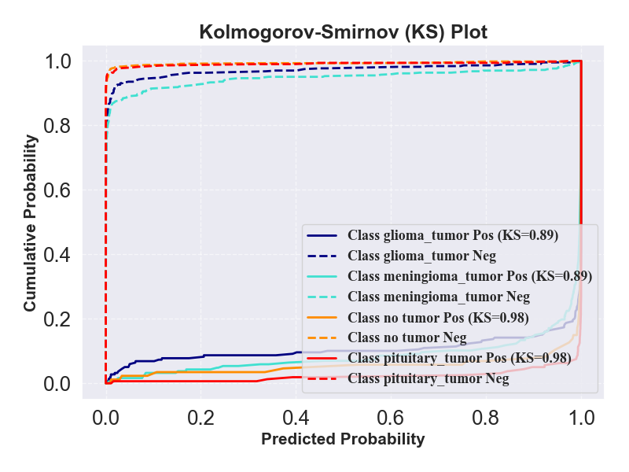 | 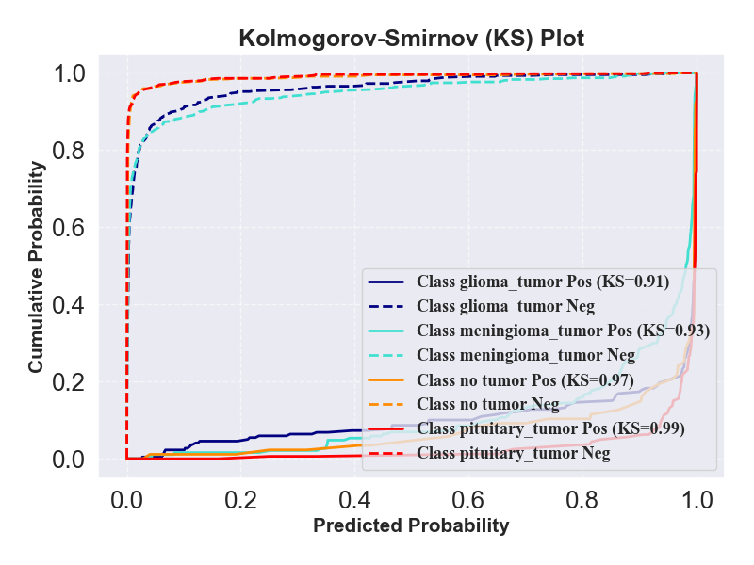
Fig. 6(a) KS Plot for MLP | Fig. 6(b) KS Plot for SVC
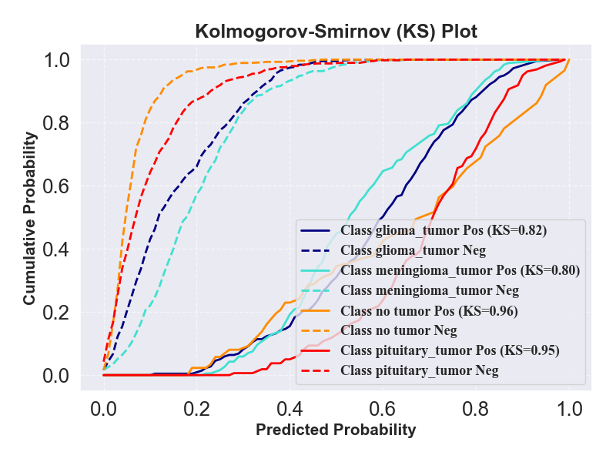 | 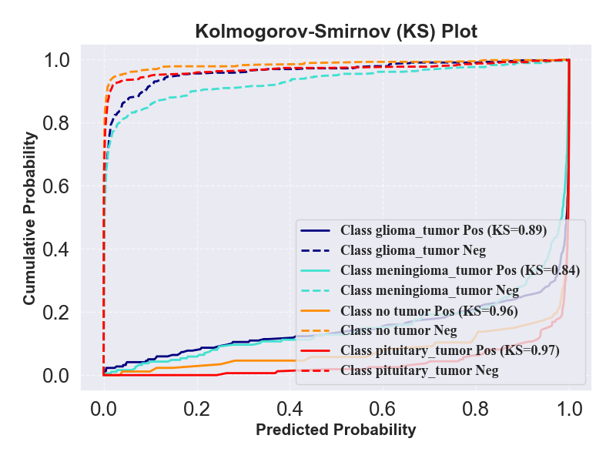
Fig. 6(c) KS Plot for RF | Fig. 6(d) KS Plot for XGB
Fig. 6 Depicts the KS Plot for Different ML Models

The performance measurement matrices for several ML models are presented in Table 1. The results of all the performance assessment matrices show that SVM is the best model.
TABLE I Shows the comparison between different performance evaluation matrices in percentage.
 | RF | XGB | LightGBM | MLP | SVC
Precision | 90.27% | 91.04% | 91.18% | 93.80% | 95.28%
F1-Score | 90.00% | 90.94% | 90.98% | 93.73% | 95.10%
Recall | 90.05% | 90.97% | 90.97% | 93.72% | 95.10%
Accuracy | 90.05% | 90.97% | 90.97% | 93.72% | 95.10%
R²-Score | 81.72% | 84.86% | 86.10% | 90.81% | 93.72%

Conclusions and Future Work
This study presents a novel approach to feature selection for MRI-based BT classification by integrating TL and PSO. This study utilizes the detailed feature representations obtained from a MobileNet model and applies PSO to identify the most significant feature subset. The proposed framework was able to decrease the number of feature dimensions while maintaining important discriminative data. An outstanding classification performance was achieved when trained and tested with several ML classifiers for the selected features. Remarkably, the SVC attained a 95.0995% accuracy, 95.0996% F1-score, 95.2828% precision, 95.0995% recall, and 93.7211% R² score, demonstrating that the PSO-enhanced TL pipeline is effective in reliably and computationally efficiently diagnosing BTs.
While PSO does a great job of reducing computing complexity by doing away with aspects that aren't necessary or provide useful information, there could be some drawbacks. Some modest but crucial traits that might improve categorization could be accidentally discarded by the aggressive dimensionality reduction approach. Despite improvements in execution speed and model simplicity, this may cause a small drop in model accuracy in some cases. Hence, although PSO improves the features' discriminative power and speeds up learning, it is crucial to calibrate it carefully so that clinically significant information is not lost when features are optimized.
By exploring a wider range of values for its parameters, including swarm size, inertia weight, cognitive and social coefficients, future research might investigate more adaptable and resilient PSO variations that optimize feature selection. To reduce the likelihood of losing important patterns, the PSO mechanism could benefit from dynamic or self-adaptive techniques that enable a more context-aware feature selection. To further obtain a more balanced trade-off between feature relevance and completeness, hybrid optimization strategies that combine PSO with other metaheuristics optimization methods should be explored. Clinicians may better comprehend model choices and have more faith in AI-assisted diagnostics if explainable AI (XAI) methods are included into the pipeline to render the chosen features interpretable. Ultimately, the framework may be made more generalizable and useful in the real world by incorporating temporal imaging data or by extending it to multimodal datasets.

References
[1] Bhuvaji S, Kadam A, Bhumkar P, Dedge S, Kanchan S. Brain tumor classification (MRI). Kaggle. 2020 May;10.
[2] Tahosin MS, Sheakh MA, Islam T, Lima RJ, Begum M. Optimizing brain tumor classification through feature selection and hyperparameter tuning in machine learning models. Informatics in medicine unlocked. 2023 Jan 1;43:101414.
[3] Kukreja V. Enhancing Brain Tumor Detection with Convolutional Neural Networks and Explainable Artificial Intelligence Techniques. In2025 International Conference on Electronics and Renewable Systems (ICEARS) 2025 Feb 11 (pp. 1511-1516). IEEE.
[4] AvazBeigi M, Ghazizadeh-Ahsaee M. A Complete Preprocessing Pipeline for Brain Tumor Classification and Overall Survival Prediction Using Bidirectional Convolutional LSTM. SN Computer Science. 2025 Jan;6(1):1-3.
[5] Sachdeva J, Sharma D, Ahuja CK. Comparative analysis of different deep convolutional neural network architectures for classification of brain tumor on magnetic resonance images. Archives of Computational Methods in Engineering. 2024 May;31(4):1959-78.
[6] Asiri AA, Soomro TA, Shah AA, Pogrebna G, Irfan M, Alqahtani S. Optimized brain tumor detection: a dual-module approach for mri image enhancement and tumor classification. IEEE Access. 2024 Mar 20;12:42868-87.
[7] Sharif M, Tanvir U, Munir EU, Khan MA, Yasmin M. SVC segmentation and classification by improved binomial thresholding and multi-features selection. Journal of ambient intelligence and humanized computing. 2024 Jan:1-20.
[8] Amin J, Sharif M, Raza M, Yasmin M. Detection of brain tumor based on features fusion and machine learning. Journal of Ambient Intelligence and Humanized Computing. 2024 Jan:1-7.
[9] Guder O, Cetin-Kaya Y. Optimized attention-based lightweight CNN using particle swarm optimization for brain tumor classification. Biomedical Signal Processing and Control. 2025 Feb 1;100:107126.
[10] Padmapriya ST, Devi MG. Computer-aided diagnostic system for brain tumor classification using explainable ai. In2024 IEEE International Conference on Interdisciplinary Approaches in Technology and Management for Social Innovation (IATMSI) 2024 Mar 14 (Vol. 2, pp. 1-6). IEEE.
[11] Yu L, Liu C, Qu A, Wu Q, Liu J. Multi-Modal Hybrid Encoding Approach Based on Information Bottleneck for Brain Tumor Grading. IEEE Signal Processing Letters. 2025 Jan 13.
[12] Howard AG, Zhu M, Chen B, Kalenichenko D, Wang W, Weyand T, Andreetto M, Adam H. Mobilenets: Efficient convolutional neural networks for mobile vision applications. arXiv preprint arXiv:1704.04861. 2017 Apr 17.
[13] Alomoush W, Khashan OA, Alrosan A, Damseh R, Attar HH, Alshinwan M, Abd-Alrazaq AA. MRI brain segmentation based on improved global best-guided artificial bee colony.
[14] Batumalay M. Automated Brain Tumor Analysis with Multimodal Fusion and Augmented Intelligence. Journal of Applied Data Sciences. 2025 Apr 15;6(2):1277-90.
[15] Attar H, Ahmed T, Rabie R, Amer A, Khosravi MR, Solyman A, Deif MA. Modeling and computational fluid dynamics simulation of blood flow behavior based on MRI and CT for Atherosclerosis in Carotid Artery. Multimedia Tools and Applications. 2024 Jun;83(19):56369-90.
[16] Mukhopadhyay S, Haider N, Chakraborty C, Mitra P, Ghosh SK. CerviSpectraDiag: An Explainable Privacy-Preserved Federated Framework for Early Detection of Cervical Cancer. IEEE Transactions on Computational Social Systems. 2025 Jun 3.
[17] Sharma R, Mahanti GK, Chakraborty C, Panda G, Rath A. An IoT and deep learning-based smart healthcare framework for thyroid cancer detection. ACM Transactions on Internet Technology. 2023 Dec.

