Genetic Algorithm with Weight Coefficients for Multi-Criteria Optimization in Automated Timetabling

Fatme Rashidova
Department of Automation, Information and Control Systems
Technical University of Gabrovo
Gabrovo, Bulgaria
https://orcid.org/0009-0005-2600-2578
Aldeniz Rashidov
Department of Automation, Information and Control Systems
Technical University of Gabrovo
Gabrovo, Bulgaria
https://orcid.org/0000-0003-4946-890X

Abstract—The creation of timetables is a complex combinatorial problem involving numerous hard and soft constraints. Traditional methods often prove ineffective when the number of subjects, teachers and student groups increases. This paper proposes a genetic algorithm with weight coefficients for multi-criteria optimization, which creates timetables by balancing preferences for time, days, halls and workload distribution. The approach uses a multi-criteria fitness function in which the weights are extracted through surveys, allowing for a balanced satisfaction of preferences for time, days, halls, workload distribution and minimization of “free windows”. The experiments conducted show that the algorithm ensures a high percentage of satisfaction of the criteria, no violations of hard constraints, and practical applicability in medium-sized higher education institutions. A block diagram of the algorithm is presented, and the results are discussed in terms of its efficiency, flexibility, and potential for future extensions, including dynamic weight adjustment and integration with machine learning.
Keywords—genetic algorithm, multi-criteria optimization, timetabling, weight coefficients, constraint satisfaction.

Introduction
The creation of timetables is a classic example of a task with high combinatorial complexity, which belongs to the group of NP-hard problems. This process requires simultaneous consideration of many hard constraints - availability of teachers, capacity and occupancy of lecture halls, avoidance of time conflicts - as well as several soft constraints related to the preferences of teachers and students. Traditional approaches (greedy algorithms, backtracking, linear programming) for solving such problems often prove ineffective as the input data increases, since the number of possible combinations grows exponentially.
Modern optimization methods based on evolutionary and metaheuristic algorithms offer more flexible and adaptive solutions. One of the most successful approaches in this area is the use of genetic algorithm (GA), which, through mechanisms inspired by evolution-selection, crossover, and mutation-find solutions close to optimal for tasks with many variables and constraints [1-3].
This paper proposes a GA with weight coefficients (W-GA) for multi-criteria optimization in automated timetabling. The use of weighting coefficients, determined through a survey of teachers and students, allows real preferences and priorities to be reflected. Thus, the proposed approach not only satisfies the hard constraints but also provides more balanced and practical timetables.

Analysis of existing approaches
The task of automated timetable creation has been studied for decades and is the subject of various optimization approaches. Initially, classical methods such as greedy algorithms, backtracking and linear programming were used [3-5]. Although these methods can provide correct solutions for small-scale tasks, their computational complexity increases rapidly as the number of subjects, groups, and time slots increases. This makes them difficult to apply in real-world large-scale conditions.
To overcome these limitations, metaheuristic methods have been actively applied in recent decades. Among them, GA, particle swarm algorithms, tabu search and simulated annealing receive particular attention [6-10]. These approaches have the advantage of working with a population of possible solutions and, through iterative improvements, avoiding falling into local optima.
GA stands out as particularly suitable for tasks such as scheduling, as it allows the integration of multiple objectives and constraints into a single combined fitness function. Various options for defining this function have been proposed in the scientific literature, including those based on penalty coefficients for violations of constraints or reward coefficients for fulfilling certain conditions.
Existing research shows that adding weight coefficients to the evaluation function allows for multi-criteria optimization, which achieves a balance between different interests - for example, distribution of the workload of teachers, use of preferred days and hours, and minimization of “free slots” in the schedules. This is the idea behind the present study, which combines the classic GA with a mechanism for adjusting weights extracted from questionnaire surveys.

Methodology
This section presents the methodology for developing and applying a GA with weight coefficients for creating university timetables. The approach begins with formulating the task and defining the input data and constraints (hard and soft). Then, a multi-criteria model is introduced, in which the fitness function combines different criteria through weight coefficients determined based on a survey. The specific values of the coefficients and their role in adapting the algorithm to the requirements of the higher education institution (HEI) are considered. The stages of the algorithm are described – from the generation of individuals to the operations of evaluation, crossover and mutation – as well as their integration into a comprehensive evolutionary process. Finally, the methodology is supplemented with an experimental part, which validates the effectiveness of the proposed approach on data simulating real conditions in a HEI.

Formulation of the task
The creation of academic schedules can be viewed as a combinatorial optimization problem, in which it is necessary to allocate subjects, lecturers, student groups and lecture halls within time intervals, while satisfying several constraints. Formally, the problem includes:

Input data:
- List of subjects;
- Teachers and their workloads;
- Student groups;
- Lecture halls with capacity and availability;
- Time slots.

Hard constraints (mandatory):
- Two different subjects cannot be scheduled in the same lecture hall at the same time;
- The same subject cannot be taught simultaneously in two different lecture halls;
- A lecturer cannot have two different classes or exams at the same time, a course (group of students) cannot have two exercises or exams at the same time, or the same lecture hall cannot be used for different classes or exams at the same time;
- The halls are designed for specific subjects (depending on the equipment – laboratories, multimedia, etc.) and have a specific capacity;
- There must be sufficient resources available (halls, teachers, equipment, etc.) for the planned period;
- The timetable should be arranged so that each student has only one class or exam at the same time.

Soft constraints (recommended):
- Determining the type of schedule – weekly or by days and dates;
- Considering work commitments (faculty, rector's or academic councils) that prevent classes from being held;
- Compliance with already planned schedules, as during the semester, regular students take exams for the part-time form, which requires careful allocation of resources (halls, lecturers, etc.);
- Availability of guest lecturers who can only teach on certain days (rather than weekly);
- Lecturers' preferences for specific halls for conducting classes/exams;
- The timetable should be distributed by a certain deadline during the day;
- Optimal distribution of the class schedule to avoid empty intervals between classes.

Multi-criteria approach
The task is multi-criteria due to the existence of different goals that may conflict. To combine these criteria, a fitness function with weighting coefficients is introduced, which allows for a balanced consideration of preferences.
The fitness function F is defined by (1).
$$F=\sum_{i=1}^{k}{W_{i} . f_{i}}$$ | (1)
where:
- f_{i} is a partial assessment of the fulfilment of criterion i;
- W_{i} is the weight coefficient determined by a survey;
- k is the number of criteria.
Each partial function f_{i} returns a binary or normalized score in the range [0,1], indicating the degree to which the corresponding criterion is satisfied (e.g., f_{break} = 1 if a lunch break is provided, otherwise 0).

Weight coefficients
A key element in the proposed methodology are the weighting coefficients, determined based on a survey among students and lecturers, which ensures that real priorities and preferences are reflected. The weighting coefficients were derived from an internal survey conducted within the Technical University of Gabrovo, Bulgaria. The study involved lecturers and students from different faculties who are well acquainted with the subject area and were deliberately selected rather than chosen at random. They evaluated the relative importance of the main timetable criteria, and the aggregated results were used to calculate normalized weight values, ensuring that the total sum of all coefficients equals 1. The following weighting coefficients are used in this study:
- W_break - need for lunch break;
- W_compact - maximum compact schedule in the timetable;
- W_free_day - availability of a free day;
- W_subjects - even distribution of “heavy” and “light” subjects in the timetable;
- W_workload - even daily workload;
- W_rel - cause and effect relationship of classes;
- W_period - periodicity (Classes in a discipline should be distributed at equal intervals of time from the beginning to the end of the semester).
The criterion “relationship of classes” (W_rel) ensures that lectures and exercises for the same subject follow a logical order within the week, avoiding reversed or inconsistent sequencing. The “periodicity” criterion (W_period) aims to distribute classes evenly across the semester, maintaining regularity in weekly sessions.
The values of the coefficients can be adapted according to the specific HEI and the results of the surveys. In this way, the algorithm is flexible and allows for the creation of personalized solutions.
- Sample data for weighting coefficients
Coefficient | Value | Explanation/ Purpose
W_break | 0.217 | Need for lunch break.
W_compact | 0.209 | Maximum compact schedule in the timetable.
W_free_day | 0.170 | Availability of a free day.
W_subjects | 0.159 | Even distribution of “heavy” and “light” subjects in the timetable.
W_workload | 0.140 | Even daily workload.
W_rel | 0.062 | Cause and effect relationship of classes.
W_period | 0.043 | Periodicity.

All coefficients are normalized so that their total sum equals 1, ensuring proportional influence of each criterion in the fitness function.

Algorithm
The proposed method uses GA with weight coefficients (Fig. 1), which includes the standard stages of initialization, evaluation, selection, crossover and mutation. The main idea is to integrate a multi-criteria fitness function in which the weights are determined by a survey questionnaire.

Generation of a random individual
Everyone represents a complete schedule. When generating it, a valid time interval and hall are selected for each discipline, subject to the following strict constraints:
Function Generate_Random_Individual():
individual = empty schedule
for each discipline:
select a valid time slot and hall
write to the individual
return individual

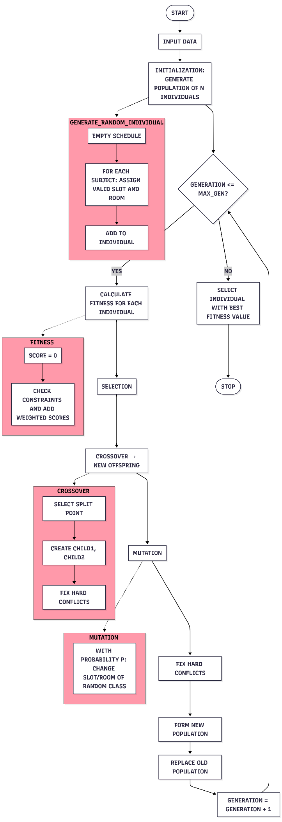
Fig.1. Block diagram of GA with weighting coefficients

Fitness function
Individuals are assessed by combining several criteria through weighting coefficients. The criteria listed in Table I are applied consistently throughout the fitness evaluation. Violations of hard constraints result in significant penalties:
Fitness function (individual):
score = 0
for each activity:
if there is a violation of a hard constraint:
score –= 1000 // penalty value
if the lunch break matches the preferences:
score += W_break
if the compact schedule is preferred:
score += W_compact
if the free_day is preferred:
score += W_free_day
if the distribution of heavy and light subjects is balanced:
score += W_subjects
if the daily workload is even:
score += W_workload
if the cause and effect relationship is preferred:
score += W_rel
if the periodicity is preferred:
score += W_period
return score

Crossover
Two parents exchange parts of their schedules. The resulting children undergo a correction to eliminate hard constraint violations:
Function Crossover(parent1, parent2):
select split point
child1 = first part of parent1 + second part of parent2
child2 = first part of parent2 + second part of parent1
correct if there are hard constraint
return child1, child2
After the crossover operation, each child timetable is checked for potential hard constraint violations such as overlapping classes for the same lecturer, group, or hall. When a conflict is detected, the repair procedure reassigns the conflicting class to the nearest available time slot and suitable hall that meet all hard constraints. This correction ensures the feasibility of all generated offspring before proceeding to the next generation.

Mutation
With a small probability, the time interval or the hall for a random activity is changed:
Function Mutation(individual):
with probability p:
change the time slot or hall of a random class
return individual

Main algorithm
The main algorithm combines all stages into a sequential evolutionary process that controls the development of the population across generations and ensures gradual approximation to the optimal solution.
Algorithm Genetic_Algorithm():
initialize a population of N individuals (random schedules)

for generation = 1 to MAX_GEN:
calculate fitness for each individual
select the best individuals (e.g. tournament selection)

create a new population by:
- crossing selected individuals
- mutation with probability p

correct individuals if necessary
replace the old population with the new one

select the individual with the best fitness value
return it as an optimal schedule

This structure provides a balance between hard and soft constraints, as the use of weight coefficients allows for flexible adaptation of criteria according to specific needs.

Experimental part
To validate the effectiveness of the proposed GA with weighting coefficients, an experiment was conducted with data simulating real conditions in a HEI. The experiment comprised the following stages:

Definition of input data
- Subjects: 120 academic subjects, divided into specializations and courses;
- Teachers: 45 teachers with different workloads and preferences;
- Groups: 60 student groups, each with a different number of hours and requirements;
- Lecture halls: 25 lecture halls with different capacities and technical equipment;
- Time slots: 10 slots per day for a period of 5 academic days.

Algorithm settings
- Population size: N = 100;
- Number of generations: MAX_GEN = 500;
- Probability of mutation: p = 0.1.
The weight coefficients are extracted from a survey among teachers and students:
- W_break = 0.217;
- W_compact = 0.209;
- W_free_day =0.170;
- W_subjects = 0.159;
- W_workload = 0.140;
- W_rel = 0.062;
- W_period = 0.043.

Conducting the experiment
- The experimental tests were carried out on a computer with an Intel® Core™ i7 processor and 16 GB RAM. The algorithm was implemented in Python 3.10 and executed under Windows 11 Pro. All runs were performed under identical conditions to ensure reproducibility.
- An initial population of random timetables was generated;
- The algorithm was run for 500 generations, considering the dynamics of the average and best fitness values. The number of generations (350) was selected empirically as a balance between solution quality and computation time. Preliminary tests showed no significant improvement beyond this limit;
- The population size was set to 100 individuals, with crossover and mutation probabilities of 0.8 and 0.05, respectively, as commonly used in GA implementations.
- The resulting timetables were compared according to the following indicators:
- Degree of satisfaction from the questionnaire (percentage of preferences covered);
- Evenness of the workload of teachers and groups;
- Number of violated hard constraints (must be zero in the final decision);
- Algorithm calculation time.
For validation purposes, the algorithm was executed multiple times under identical input conditions.
The results obtained showed minor variations in fitness values (below 3%), confirming the stability and repeatability of the proposed approach. The reported results in the following section correspond to the average performance across all runs.

Results
The algorithm reaches a stable solution after about 350 generations, with minimal improvements thereafter. The optimal schedule satisfies over 85% of preferences, with no violations of hard constraints. The average computation time for one execution is approximately 4 minutes on a standard workstation (Intel i7, 16GB RAM).

Comparative analysis
To evaluate the effectiveness of the proposed approach, a comparison was made between the GA with weight coefficients (W-GA) and the standard GA without weights (S-GA). Both algorithms were tested on the same dataset consisting of 120 disciplines, 45 lecturers, and 60 student groups.
The standard GA (S-GA) employs the same chromosome representation and uses identical selection, crossover, and mutation operators as the proposed W-GA. However, its fitness function evaluates only the satisfaction of hard constraints, assigning equal importance to all criteria (W_{i} = 1). Thus, S-GA serves as a baseline for assessing the impact of introducing weight coefficients in the optimization process.
Comparison metrics:
- Percentage of preference satisfaction (time, day, hall);
- Number of “free slots”;
- Violations of hard constraints;
- Convergence time.
The results are presented in Table 2.
- Experimental comparative data
Metric | Standard GA (S-GA) | Weight GA (W-GA)
Preference satisfaction | ~65% | ~85%
Average number of  “free windows” | 6.2 | 2
Violations of hard constraints | 3 | 0
Time for convergence | 320 generations | 350 generations
The results shown in Figure 2 illustrate that the standard GA (S-GA) achieves correct schedules without major disruptions, but does not take individual preferences into account, which leads to significantly more “free slots” and lower satisfaction.
In addition, the S-GA method occasionally breaches several hard constraints, confirming its weaker constraint-handling capability compared to the proposed approach. The standard GA (S-GA) produces up to three hard constraint violations, whereas the weight GA (W-GA) eliminates them. The W-GA achieves more balanced schedules, albeit with a slightly increased number of generations to convergence, which indicates that the introduction of weight coefficients improves the quality of solutions at the expense of marginally longer computation time.
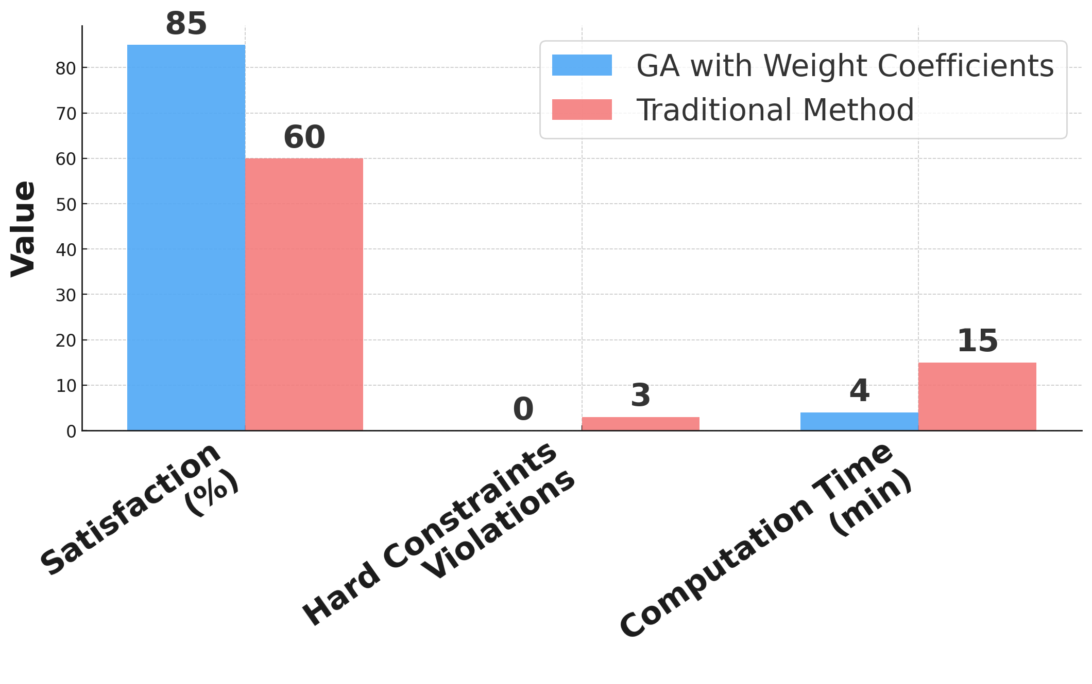
Fig. 2. Comparative analysis between GA (W-GA) and standard GA (S-GA).

Discussion
The results obtained demonstrate and discuss the effectiveness of the proposed strategy with GA and weight coefficients in solving the multi-criteria optimization problem of timetabling.

Key results
- High degree of satisfaction - over 85% of the preferences of teachers and students are considered, which is a significant improvement over traditional manual planning methods;
- Compliance with hard constraints - the algorithm successfully ensures that there are no conflicts in the occupancy of halls, teachers or student groups;
- Balance between criteria - the use of weighting coefficients achieves flexible optimization, allowing for simultaneous consideration of different objectives: even workload distribution, preferences for days and halls, minimization of “windows”;
- Convergence - stabilization of results after about 350 generations shows that the algorithm reaches sufficiently good solutions in a reasonable number of iterations.

Advantages of the approach
- Flexibility - handling multiple diverse criteria;
- Adaptability to the specific needs of different HEI;
- Sustainability - reduction of the risk of local optima thanks to the population approach.

Limitations and challenges
- Computational complexity - with many disciplines and time slots, the time required can increase significantly;
- Need for corrections - solutions generated through crossover and mutation often violate hard constraints and require subsequent validation;
- Sensitivity to parameters - the choice of weight coefficients and algorithm parameters (population size, mutation probability, number of generations) has a significant impact on the result.
Although some challenges remain, the proposed methodology shows good potential for practical application and provides a solid basis for further refinement.

Conclusion
This paper presents a GA with weight coefficients for multi-criteria optimization in automated timetable generation. The study shows that the use of a multi-criteria fitness function with weight coefficients allows for a balanced satisfaction of preferences, ensuring high efficiency and applicability in academic environments.
Despite the results achieved, the proposed methodology also reveals several opportunities for further development and improvement. Guidelines for future research include:
- Dynamic adjustment of weights through machine learning or adaptive strategies;
- Integration of the algorithm into large learning management systems with multiple campuses;
- Extension of the method to include additional criteria such as student and teacher satisfaction, resources, and teacher effectiveness.
In conclusion, the proposed methodology represents a practical, reliable, and flexible solution for automated timetable generation that can be applied in various academic environments with many disciplines, teachers, and student groups.
Future work will focus on expanding the set of optimization criteria and integrating adaptive or machine learning components to enhance convergence speed and decision quality. The proposed approach can also be adapted to other scheduling domains beyond university timetabling.

References
- J. Shi, Y. D. Su and M. Xie, “Research on application of IGA (immune genetic algorithm) to the solution of Course-Timetabling Problem,” 2009 4th International Conference on Computer Science & Education, Nanning, China, 2009, pp. 1105-1109, doi: 10.1109/ICCSE.2009.5228553
- R. D. Capua, A. P. Albina, T. D. Shukla et al., “Implementing Genetic Algorithms for Curriculum Scheduling and Optimization in Higher Education,” 2024 International Conference on Intelligent Systems and Advanced Applications (ICISAA), Pune, India, 2024, pp. 1-6, doi: 10.1109/ICISAA62385.2024.10829023
- S. Chen, Q. -k. Pan, X. Hu and M. F. Tasgetiren, “An Iterated Greedy Algorithm for Distributed Blocking Flowshop Problems with Makespan Minimization,” 2020 39th Chinese Control Conference (CCC), Shenyang, China, 2020, pp. 1536-1541, doi: 10.23919/CCC50068.2020.9188884
- Hong-Bo Li, Zhan-Shan Li, et al., “On research of optimization strategy for dynamic backtracking,” Proc. Int. Conf. Machine Learning and Cybernetics, Hebei, China, 2009, pp. 266–271. doi: 10.1109/ICMLC.2009.5212518
- O. Harrabi and J. C. Siala, “A New Sum Coloring-based Integer Linear Programming for Solving the University Course Timetabling Problem,” 2020 International Multi-Conference on: “Organization of Knowledge and Advanced Technologies” (OCTA), Tunis, Tunisia, 2020, pp. 1-2, doi: 10.1109/OCTA49274.2020.9151838
- W. Jian, X. Tang and C. Yong, “The research of parallel multi-objective particle swarm optimization algorithm,” 2014 IEEE 5th International Conference on Software Engineering and Service Science, Beijing, China, 2014, pp. 300-304, doi: 10.1109/ICSESS.2014.6933568
- S. Jaengchuea and D. Lohpetch, “A hybrid genetic algorithm with local search and tabu search approaches for solving the post enrolment based course timetabling problem: Outperforming guided search genetic algorithm,” 2015 7th International Conference on Information Technology and Electrical Engineering (ICITEE), Chiang Mai, Thailand, 2015, pp. 29-34, doi: 10.1109/ICITEED.2015.7408907
- T. A. Dewa Prakasa, A. Muklason and I. Gusti Agung Premananda, “Automating School Timetabling: An Intelligent System Application Using Simulated Annealing”,2024 International Seminar on Intelligent Technology and Its Applications (ISITIA), Mataram, Indonesia, 2024, pp. 214-219, doi: 10.1109/ISITIA63062.2024.10668040
- D. Kusumawardani, A. Muklason and V. A. Supoyo, “Examination Timetabling Automation and Optimization using Greedy-Simulated Annealing Hyper-heuristics Algorithm,” 2019 12th International Conference on Information & Communication Technology and System (ICTS), Surabaya, Indonesia, 2019, pp. 1-6, doi: 10.1109/ICTS.2019.8850932
- Psarra and D. Apostolou, “A Combination of Genetic Algorithms and Local Search to Solve a Real Data University Timetable Scheduling Problem,” 2023 14th International Conference on Information, Intelligence, Systems & Applications (IISA), Volos, Greece, 2023, pp. 1-8, doi: 10.1109/IISA59645.2023.1034584

