Reconfigurable microstrip antenna design using geometric slot techniques

B. Perumal
Department of Electronics and Communication Engineering Kalasalingam Academy of Research & Education
Krishnankoil,Virudhunagar, India. perumal@klu.ac.in

M.Srujana
Department of Electronics and Communication Engineering Kalasalingam Academy of Research & Education
Krishnan koil,Virudhnagar,India
srujanamallipeddi3@gmail.com

M. Venkata Ramana Department of Electronics and Communication Engineering Kalasalingam Academy of Research &Education Krishnan koil, Virudhunagar, India mallipeddivenkataramana9@gmail.com
M. Vighnesh
Department of Electronics and Communication Engineering Kalasalingam Academy of Research & Education
Krishnan koil,Virudhnagar,India vighneshmaddikuntla2406@gmail.com

Rajesh V Department of Electronics and Communication Engineering, SRM Institute of Science and Technology
Tiruchirappalli,Tamilnadu,India. rajeshatco@gmail.com
Krishna Priya R
Head of Research and Consultancy Department, University of Technology and Applied Sciences, Musandam, Sultanate of Oman. krishna.priya@utas.edu.om

Abstract - An antenna is an essential element of wireless communication systems, used to send and receive electromagnetic waves. Out of several types of antennas, reconfigurable antennas are particularly interesting. They can change their operating parameters based on changing needs. An antenna that can be reconfigured can alter its operating parameters dynamically applying external control signals. This flexibility minimizes the use of multiple antennas in one system, thereby conserving space, cost, and complexity. A bow-tie-shaped microstrip patch antenna with frequency reconfiguration is suggested in this research. It aims to provide wide frequency coverage while keeping compact dimensions and efficient operation. The antenna is made on an FR4 epoxy substrate, which is chosen for its low cost and good electrical properties. The structure is simulated using HFSS software to study and improve its electromagnetic performance. The antenna uses a coplanar waveguide (CPW) feed and includes two PIN diodes along with a shorting pin for frequency switching. Varactor diodes are also added for continuous tuning of the resonant frequency. The antenna can operate at different frequencies—4.55 gigahertz, 7.45 gigahertz, 4.51 gigahertz, and 6.88 gigahertz —demonstrating its reconfigurability with respect to frequency. Additionally, using varactor diodes expands the antenna's tuning range from 3.04 GHz to 5.89 GHz.
Keywords - Frequency Reconfigurable Antenna, Bow-Tie Antenna, Coplanar Waveguide (CPW) Feed, HFSS Simulation. SDG Goals: SDG 9 Multiband Wireless Communication, Wireless Innovation, SDG 12 Advanced Antenna Design, Reconfigurable Electronics.

Introduction
Electromagnetic spectrum is one of the most critical natural resources of mankind, and antennas are crucial in tapping it for contemporary communication. Humans initially used sound and optical signals like drums, smoke, and flags, which employed just the visible spectrum; in recent times, employing radio and other frequencies that are not visible has transformed information exchange over long distances. An antenna, a transducer in nature, transfers electrical energy into electromagnetic waves and vice versa, making it a crucial component in RF, telecommunication, and wireless systems such as radio, television, mobile networks, radar, and satellite communication. Its design— ranging from geometry and size to radiation pattern, polarization, gain, and directivity—has a direct effect on how well it works, how much it covers, and how it performs. the bow-tie antenna, which Heinrich Hertz showed off back in 1886, is kind a big deal for its wide range of frequencies, simple flat design, and flexibility. Computational modelling and reconfigurable technology have made it possible for contemporary bow-tie antennas to change frequency, polarization, and radiation pattern dynamically through PIN diodes, varactors, or MEMS switches and provide multi-band and multi-standard operation. This ability enables a single compact device to substitute for many fixed-frequency antennas, minimizing cost, weight, and complexity while providing high performance in a wide range of communication environments.

Literature Review
A compact CPW slotted patch antenna is built on the low-cost Rogers 5880 substrate for multi-band wireless communication. A single PIN-diode switch allows for frequency changes across WLAN, C-UWB, sub-6 GHz, and X-band. [1] A microstrip-fed antenna that can change frequencies has been designed to operate at 5.6 gigahertz, 3.55 gigahertz, 3.67 gigahertz, and 1.87 gigahertz. PIN diodes adjust the antenna’s electrical length, which lets it switch between these resonant bands. [2] A simple A microstrip antenna that can be reconfigured is suggested. It has six modes of operation.: narrow-beam, wide-beam, and four directional beams. This is achieved by controlling six PIN diodes. [3] First, the holes in the spectrum are examined. This makes it possible for the SUs to take advantage of the opportunities and send or receive their signals without interfering with the main users. [4] The dual-band, 4-port frequency-reconfigurable mimo antenna using varactor diodes in the feedline. It covers a wide tuning range of 1.3–2.6 ghz, with good isolation (>12 db), low profile, compact size (120×60 mm²), and no biasing interference. [5] An antenna is lengthened with stubs to toggle polarization over three frequency bands. The prototype meets LHCP, and RHCP in all bands and is appropriate for present and future wireless communications [6] The strain-involved design method offers a practical, reliable, and accurate solution for building frequency-reconfigurable antennas on flexible substrates. This approach significantly improves performance and adaptability in next-generation soft electronics and wearable wireless systems. [7] Integrating the filter directly with the antenna cuts down on RF interference while keeping strong radiation features. Comparing various designs shows their advantages and drawbacks. [8] The pattern and polarization reconfigurable microstrip antenna that operates from 3.1–3.45 GHz. Using four switches (DMWs), it supports 6 radiation patterns and 3 polarization modes (LP & CP). [9] The liquid-metal-based patch antenna with pattern reconfiguration for reshaping the ground plane. It operates at 5.9 GHz and has five directions of beams with up to ±40° beam steering and merely 0.5 dB scan loss. [10] Integrating the filter directly with the antenna creates a compact, reconfigurable microstrip antenna. This antenna uses three PIN diodes for switchable multiband operation. It covers Bluetooth (2.3 to 2.51 GHz), WiMAX (3.35 to 3.75 GHz), and WLAN (4.95 to 5.53 GHz). [11] A microstrip patch antenna using four shapes (h, e, s, u) and four substrates (fr-4, ro4003, gml1000, rt/duroid5880). It found that rt/duroid5880 gives better bandwidth, while fr-4 provides better gain. [12] A low-loss transformer oil-based patch antenna allows for frequency reconfigurability by changing the oil height in a 3-D printed two-layer air-oil substrate. This design provides a range from 1.42 to 1.96 GHz. [13] A software-controlled, pic microcontroller-based reconfigurable antenna that tunes across discrete frequencies using rf switches. It requires no matching network, and measurements confirm reliable performance with minimal interference from the biasing network, making it suitable for low-cost cognitive radio systems. [14] A frequency-reconfigurable microstrip patch that can change into a slot antenna has been introduced. This antenna can switch among Between 1.98 and 3.59 gigahertz, there are nine distinct frequency bands. By varying the p-i-n diodes, the frequency ratio equal to 1.8:1 is achieved. This suggests that the antenna possesses a strong prospect for cognitive radio application. [15] Dual-polarized, pattern-reconfigurable monopole antenna operating at 2.45 GHz. By using pin diodes, it achieves eight modes with three narrow beams and one wide beam for both x- and y-polarizations. [16] The stub feedline square shaped microstrip antenna demonstrate a good broader bandwidth of 500 mhz. It also possesses a high value of reflection coefficient of -24 db with the height of the substrate 1.57 mm. [17] The pattern and polarization reconfigurable microstrip antenna that supports 6 radiation patterns and 3 polarization modes (lp, lhcp, rhcp) using 4 switches (dmws). It operates over 3.1–3.45 ghz and offers beam steering. [18]A semi-circular patch microstrip antenna with inverted-L stubs on a 60 × 45 × 1.6 mm³ substrate is designed to operate in the 3–6 ghz range. [19] A micromachined is built with a plastic-deformation magnetic assembly (PDMA). This tiny reconfigurable structure can change its operating frequency and radiation pattern. This ability makes it useful for improving the performance of planar antenna arrays. [20].

Proposed Methodology
The patch is a bowtie structure of an isosceles triangle that is created using a 6 mm by 6 mm square metal sheet. With dielectric constant of 4.4, the patch is mounted over 1.59 mm thick substrate made of FR4. To exciting different current modes, asymmetry is achieved through a displacement of the feed point positions. For matching to 50 ohms, a conductor backed coplanar waveguide (CPW) feed is extended on the back side. Reconfigurability is provided by PIN diodes, which allow dynamically rerouting currents directed to the triangular patches. Tuning shunt inductance is provided by connecting the CPW ground plane to a bottom ground layer through a shorting pin. Ground plane offset and pin positions are swept in parametric HFSS simulations in order to maximize impedance matching. Eigenmode solvers and adaptive meshing are used to obtain significant antenna parameters like S11, beamwidth, gain, patterns, and resonance. Comparisons with previous frequency reconfigurable designs confirm enhanced miniaturization and performance.
Multi-band reconfigurable response at a small area involves greater impedance bandwidths, which the triangular bowtie geometry provides. Asymmetrical cases arise with the cutting of a square metal sheet, as compared to traditional rectangular or circular patch antenna configurations. Dual band resonances are enabled through the elimination of degeneracies that allow various current modes to be excited. Asymmetry for diversity in scattering is also supplemented by the offsets of CPW feeds on each triangular element. The nominal CPW impedance of 100–150ohm is significantly attenuated by conductor backing to about 50 ohms to improve antenna matching. Each phase of multiband satellite communication and FRMBA development is crucial attaining optimal performance within system limitations.
Prototypes are made based on the optimized designs as the process proceeds towards deployment. By using extensive validation through HFSS simulations, the antenna designs are validated and tuned for the prototypes. For strict technical compliance, thorough performance testing is conducted on the polarization purity, transmission efficiency, radiation structure, gain, and resonance bandwidth. Once verified, antennas are smoothly integrated into the satellite communication system, ensuring efficiency and compatibility.
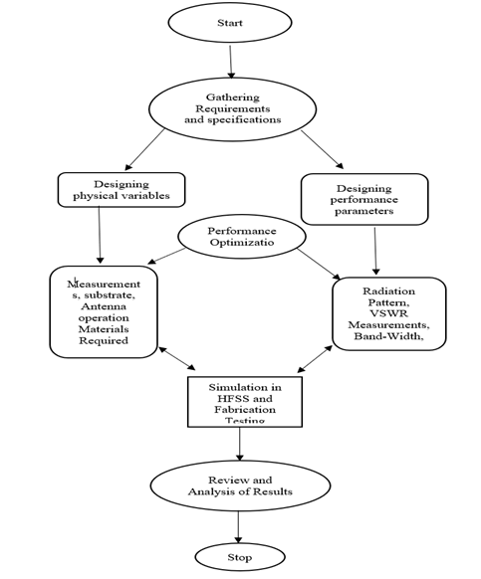
Fig. 1. Block Diagram for Reconfigurable microstrip antenna
The general design and optimization procedure for the suggested microstrip antenna is depicted in Figure 1. First, requirements and specifications are gathered, and then the physical factors and performance parameters are designed. Performance optimization, HFSS simulation, fabrication testing, and result review and analysis are all steps in the process.

Working Princple
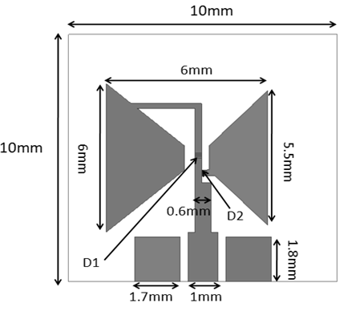
Fig. 2. Proposed Microstrip Bow-tie antenna
Figure 2 depicts the geometric configuration of the suggested bow-tie antenna. The antenna measures 10 × 10 mm² overall with a 6 mm flare width and a 6 mm arm length on the left and 5.5 mm on the right. The feed gap is 0.6 mm, and the lower rectangular sections measure 1.7 mm and 1 mm, respectively. This compact design helps achieve wideband performance in a small form factor.
The suggested antenna is designed on the concept of frequency reconfigurability based on a bow-tie microstrip patch geometry. The bow-tie shape, obtained by bisecting an equilateral square radiating sheet, ensures broad impedance bandwidth and compactness. A coplanar waveguide (CPW) feed with a full ground plane provides effective impedance matching to 50 Ω. Reconfigurability is facilitated by using PIN diodes located along the triangular sides of the bow-tie patch, which alter the effective current path when in ON and OFF states.
The antenna also has a metallic shorting pin, which adds shunt inductance to facilitate control of resonant frequencies in the range 2.4–4.8 GHz. Through modification of current distribution, the antenna dynamically accommodates multiple frequency bands while having stable radiation properties. HFSS simulations validate that the design meets satisfactory return loss (S11 < –10 dB), reasonable VSWR (< 2), and directional radiation patterns throughout the preferred frequency range. The overall process of the proposed antenna is a systematic process that starts from the identification of specifications and requirements like operating frequency range, compactness, and multi-band operation. Depending on these requirements, the physical parameters like substrate material, antenna shape, and feed configuration are chosen, while performance parameters like S11, VSWR, bandwidth, gain, and radiation pattern are set. These inputs are iteratively optimized with parametric sweeps to meet the required performance.

Result And Discussion

S(11)Parameter

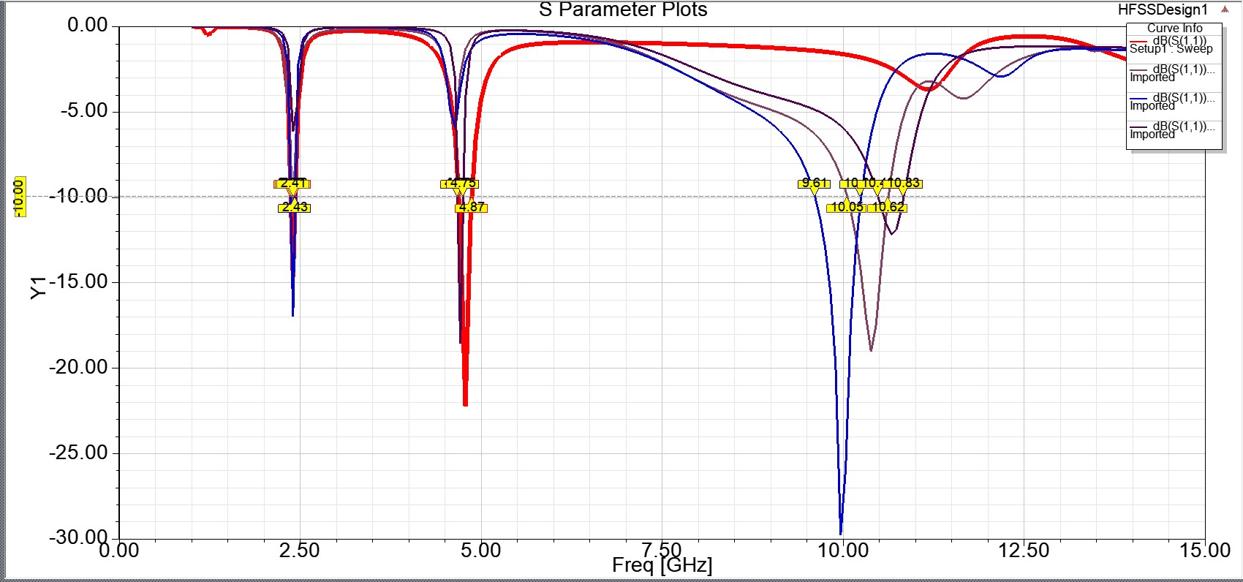
Fig. 3. Output of S11 parameter for 4 Cases Return Loss
Fig. 3 depicts S11 is a Return Loss, how much power is reflected back in the input port in S parameter. It is plotted in DB. If S11 less than10 dB ,it is good matching. Peaks indicate resonant frequencies of your antenna. First Dip around 2.40 GHz is the strong resonance. Second Dip around 4.8–5.0 GHz another resonance At 2 resonant frequencies, 2.41 GHz and 10.62 GHz, the loss of return falls below -10 dB. These frequencies show effective power transfer and good impedance matching13.Good impedance matching is indicated by the antenna's two resonant frequencies, which are approximately 2.43 GHz and 10.24 GHz, where S₁₁ falls below −10 dB. Since the amount of return loss is lowest at 2.3 gigahertz, 5.0 gigahertz, and 10.3 gigahertz, three resonance dips show up, indicating improved impedance matching and more effective transmission of signals at those frequencies.
Case 1 : s1 ‘ON ‘ and s2 ‘ON’
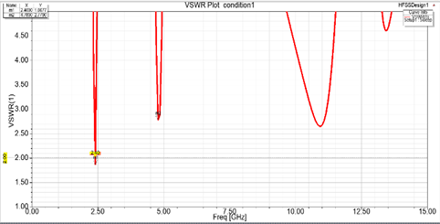
Fig. 4. Output for VSWR in Case1

Figure 4 displays the antenna design's VSWR parameters under condition 1. The plot shows resonance points at roughly 2.40 GHz and 4.96 GHz with VSWR values less than 2, indicating excellent impedance matching at these frequencies.

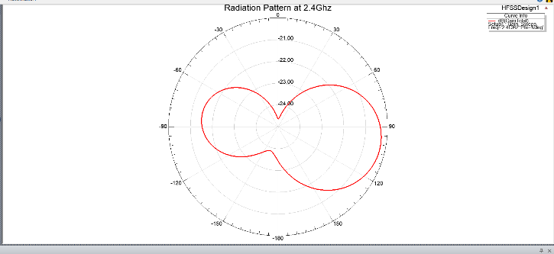
Fig. 5. Radiation Distribution in Case 1 at the 2.4 GHz
The antenna's radiation distribution at 2.4 GHz is depicted in Figure 5, which also displays the gain distribution and directional properties in the system of polar coordinates. The plot you see is a polar plot of the antenna’s far-field at At 2.4 GHz, antenna radiates in a bi-directional / figure-5 shaped pattern.
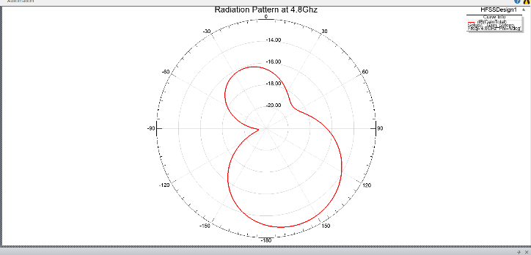
Fig.6: Output of Radiation Distribution in Case1 at 4.8 GHz in Case1

Figure 6 displays the antenna's radiation distribution at 4.8 GHz, emphasizing the change in gain and directed reaction at this higher frequency. This is a polar plot of the antenna’s far-field, At 4.8 GHz. Shape is slightly directional radiation is stronger in one main direction (towards ~180°) with weaker radiation on the opposite side. here the pattern becomes more directional.
Case2: s1 ‘ON ’ and s2 ‘OFF’

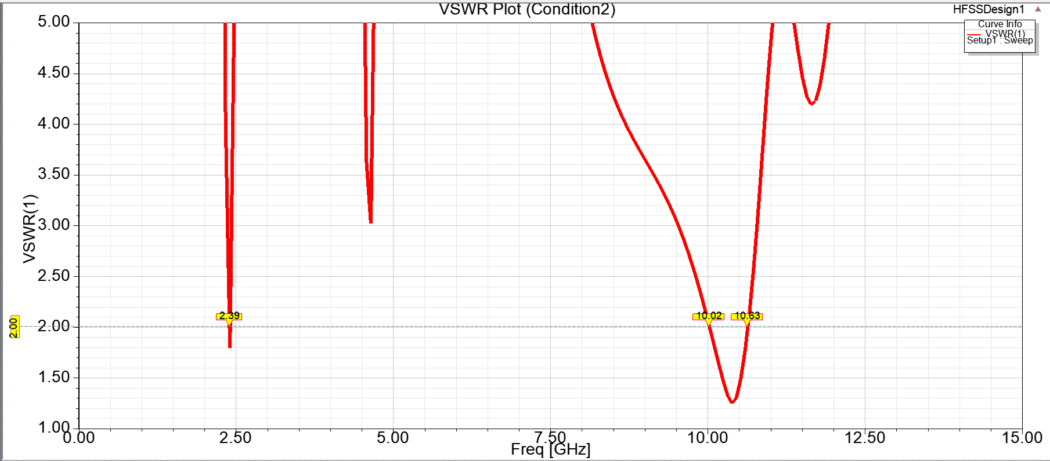
Fig.7: Output for VSWR in Case2
The antenna's VSWR response under Case 2 is shown in Figure 7. Good impedance matching is indicated by VSWR values below 2 at 2.41 GHz and 10.62 GHz.
Efficient radiation and less reflection of signals are associated with lower VSWR. These findings support dual-band resonance and are consistent with the S11 reaction.
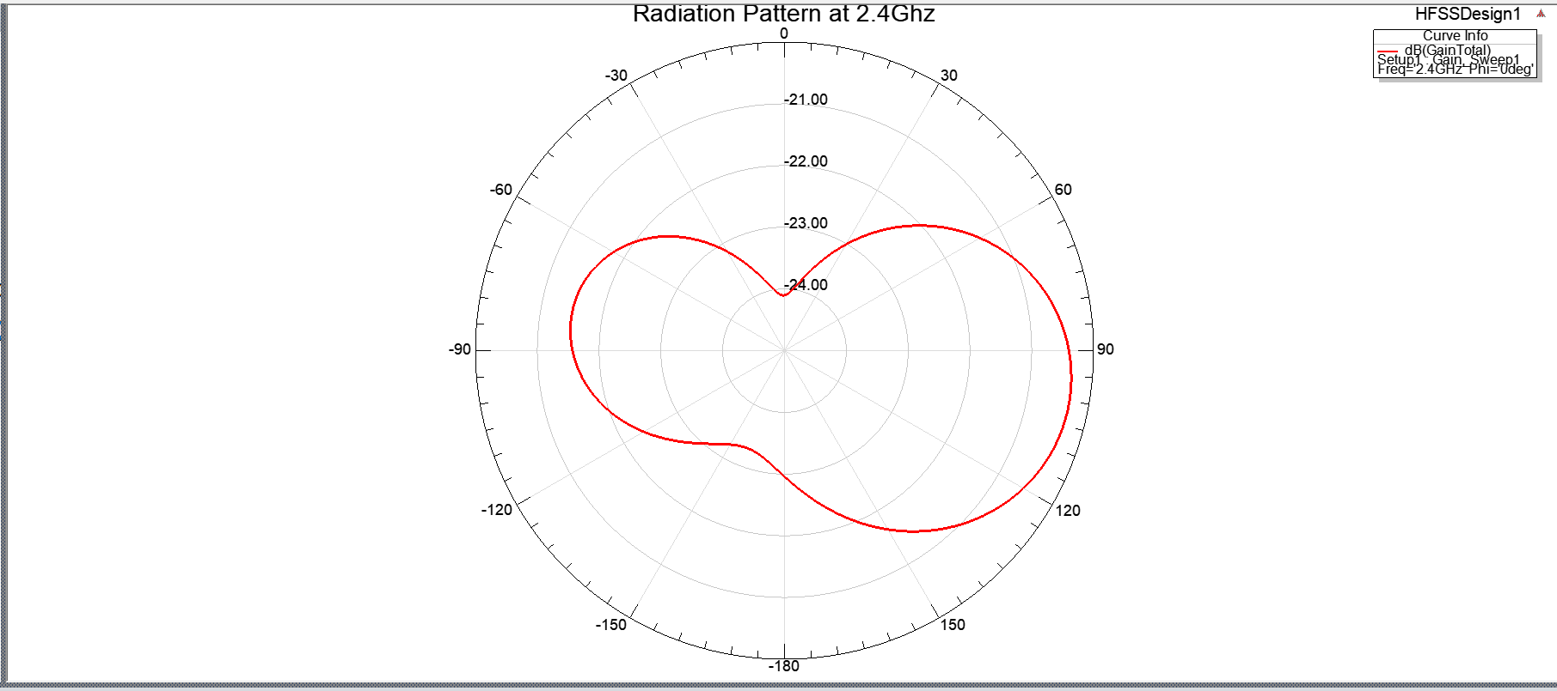
Fig. 8. Radiation Distribution in Case2 at 2.4GHz
Figure 8 illustrates the radiation Distribution of the antenna at 2.4 GHz. The pattern shows a bidirectional shape, indicating directional radiation characteristics. This type of radiation is suitable for short-range point-to-point communication. The gain level is around -23 dB, consistent with typical microstrip performance.
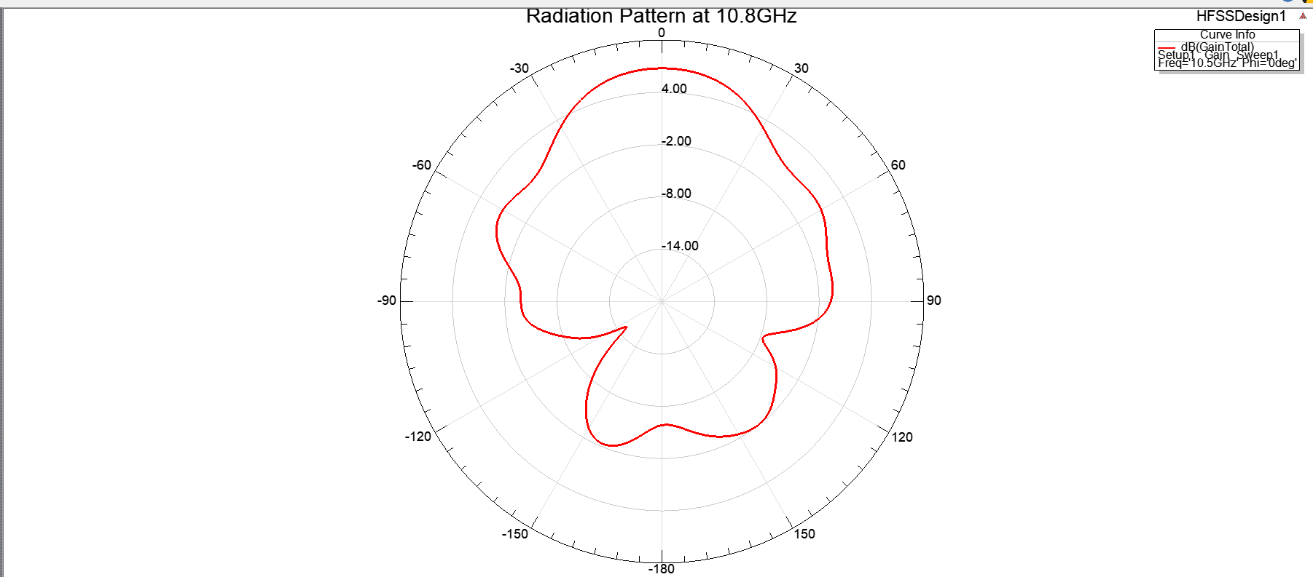
Fig. 9. Radiation Distribution in Case2 at 10.8 GHz
The antenna's 10.8 GHz radiation distribution appears in polar form in Figure 9. The transmitted field's strength in dB against angle is shown by the red curve. With a pronounced primary lobe and smaller side lobes, the pattern is directional. This suggests that energy is mostly focused in one direction by the antenna.
Case3: s1 ‘OFF’ and s2 ‘ON’

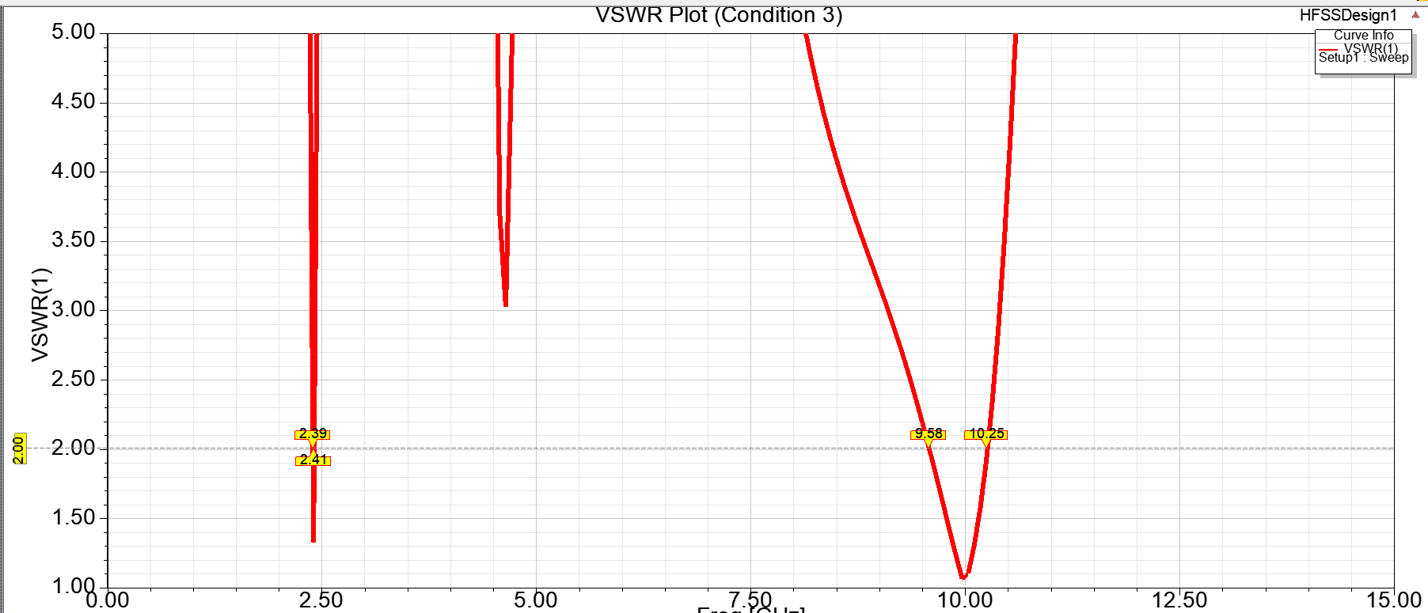
Fig. 10. Output for VSWR in Case3

The antenna's S₁₁ parameter, which shows how well it corresponds to the input transmission across frequencies, is depicted in Figure 10. Strong resonance and little reflection are indicated by the two large peaks at 2.43 GHz and 10.24 GHz.

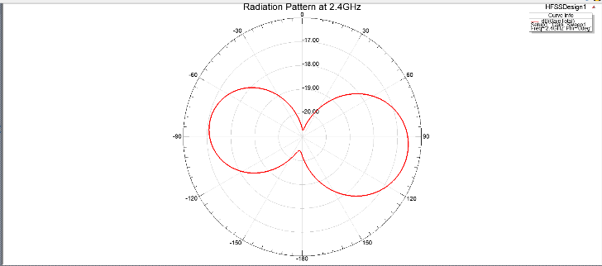
Fig. 11. Radiation Distribution in Case3 at 2.4GHz

The antenna's 2.4 GHz radiation distribution appears in polar form in Figure 11. bi-directional radiation characteristic is indicated by the pattern's figure-eight shape. This indicates that the antenna minimizes radiation in other directions while radiating effectively in two opposite directions.

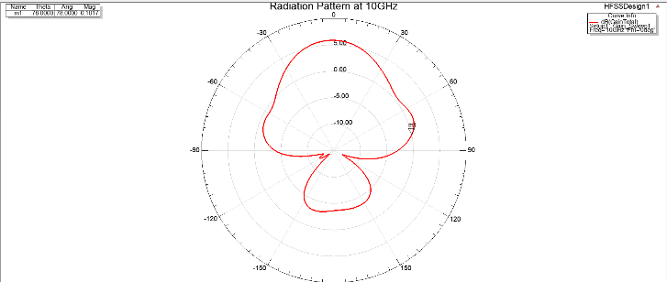

Fig. 12. Output of Radiation Distribution at 10 ghZ in Case3
An antenna's radiation Distribution at 10 GHz can be seen in polar form in Figure 12. The direction of the strongest radiation is indicated by the main lobe, which points close to 0° with an increase above 5 dB. Particularly around ±90°.
Case 4: s1 ‘OFF’ and s2 ‘OFF’

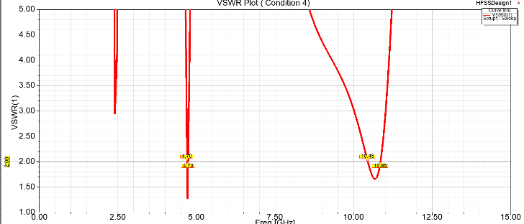

Fig. 13. Output for VSWR in Case4

The figure 13 VSWR plot illustrates the way the antenna and transmission line match across frequencies. Better matching is indicated by lower VSWR values; values near 1 are ideal. Effective power transfer and low reflection of signals at these frequencies are suggested by the dips close to 2.3GHz, 5.0 GHz, and 10.3 GHz.

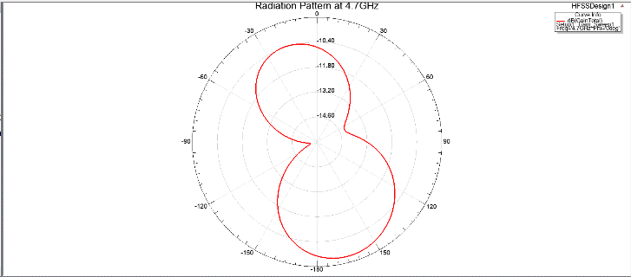
Fig. 14. Output of Radiation Distribution at 4.7 ghZ in Case4

The bidirectional or eight-point shape of the radiation Distribution at 4.7 gigahertz (see Figure 14) suggests that the antenna primarily radiates energy in two opposing directions. Higher radiation intensity is associated with stronger lobes, whereas weaker regions are represented by nulls.
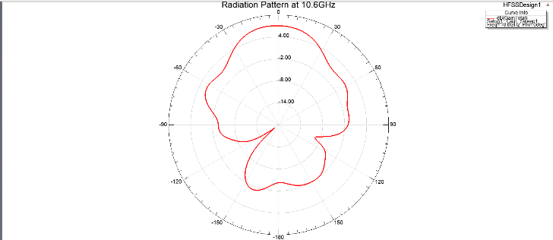
Fig. 15. Output of Radiation Distribution at 10.6 ghZ in Case 4
The antenna radiates energy in multiple directions with different intensities, as shown by the multi-lobed structure of the radiation Distribution at 10.6 gigahertz (see Figure 15).

Conclusion
A compact size frequency-reconfigurable bowtie antenna was enabled using a shorting pin and PIN diodes. It functioned in several bands with a range of operation from 2.4 GHz to 10.65 GHz. It exhibited stable directional radiation patterns for all the states of operation. Efficient impedance matching by a Coplanar Waveguide (CPW) feed was facilitated through optimized ground plane offsets and shorting pin position. The design resulted in a 14.8% size reduction with respect to previous bowtie antennas, with wide impedance bandwidths of a VSWR and reflection coefficients below 10 dB of 1 to 2. It also featured a radiation efficiency of more than 90% and a maximum realized gain of 3.2 to 5.4dB. HFSS simulation proved to effectively validate and optimize these values for consistent performance. Recent distribution analysis validated the reconfigurability mechanism by changing resonant modes when switching diodes. The results demonstrate that the antenna satisfies the design goals and performance specifications indicated in past research and its appropriateness for application in contemporary multiband wireless communication network.

References

- Ahmad, A.; Lee, G.O.; Choi, D.-y. Design and Performance Evaluation of a Compact Frequency Reconfigurable Coplanar Waveguide-Fed Slotted Patch Antenna for Multi-Band Wireless Communication. Electronics 2023, 12, 3889.J. Clerk Maxwell, A Treatise on Electricity and Magnetism, 3rd ed., vol. 2. Oxford: Clarendon, 1892, pp.68–73.
- Isra Nazir, Inam Elahi Rana, Noor ul Ain Mir, and Kanwal Afreen, Design and Analysis of a Frequency Reconfigurable Microstrip Patch Antenna switching between Four Frequency Band, ProgressIn Electromagnetics Research C, Vol. 68, 179–191, 2016K. Elissa, “Title of paper if known,” unpublished.
- Guangwei yang, jianying li, dujuan wei, shi-gang zhou, and ruixu, Pattern reconfigurable microstrip antenna with multidirectional beam for wireless communication, ieee transactions on antennas and propagation, vol. 67, no. 3, march 2019.
- Manjunatha Kurugodu Hanumanthappa1, Shilpa Mehta2. Frequency reconfigurable rectangular patch antenna for cognitive radio applications, International Journal of Electrical and Computer Engineering (IJECE) ρ 579 Vol. 13, No. 1, February 2023.
- Xiongwen zhao and sharjeel riaz, A Dual-Band Frequency Reconfigurable MIMO Patch-Slot Antenna Based on Reconfigurable Microstrip Feedline,2018.
- Rajesh kumar singh and shiban kishen koul , ananjan basu, reconfigurable microstrip patch antenna with polarization switching in three switchable frequency bands, received june 15, 2020
- Lei Sang, Shuaitao Li, Bin Hu Mark Kraman, Kehan Dai, Hong Yang, and Wen Huang, Reconfigurable Microstrip Patch Antennas on Flexible Substrates, ieee antennas & propagation magazine, October 2023
- yuxiang Tu,Yasir I.A,Ahmed L Abdhulkhaleq, A Survey on Reconfigurable Microstrip Filter–Antenna Integration: Recent Developments and Challenges, 5 June 2020.
- Guang-wei yang, jianying li, bao cao, dujuan wei, shi-gang zhou , and jingya deng, acompact reconfigurable microstrip antenna with multidirectional beam and multipolarization, ieee transactions on antennas and propagation, vol. 67, no. 2, february 2019.
- zhishu qu, james r. kelly shaker alkaraki , zhengpeng wang, and yuegao, A configurable microstrip patch antenna with switchable liquid-metal ground plane, ieee antennas and wireless propagation letters, vol.22,no.5,may2023.
- M. Borhani, p. Rezaei, and a. Valizade, Design of a reconfigurable miniaturized microstrip antenna for switchable multiband systems, ieee antennas and wireless propagation letters, vol.15, 2016.
- M. Meena1 and p. Kannan2, Analysis of microstrip patch antenna for four different shapes and substrates, ictact journal on microelectronics, april 2018.
- Shiyan wang, lei zhu, and wen wu, anovel frequency-reconfigurable patch antenna using low-loss transformer oil, december 2017.
- Simone Genovesi, Agostino Monorchio, Michele Borgese Borgese, Sara Pisu, and Fabio Michele Valeri, Frequency-Reconfigurable Microstrip Antenna With Biasing Network Driven by a PIC Microcontroller, 11 nov,2012.
- Huda A. Majid, Mohamad Kamal Abdul Rahim, Mohamad Rijal Hamid, Noor Asniza Murad, and Mohd Faizal Ismail, Frequency-Reconfigurable Microstrip Patch-Slot Antenna, 12 June, 2013.
- Thanhtungphung khackiemnguyen, son xuat ta and nghia nguyen-trong, adesign of dual-polarized composite patch-monopole antenna with reconfigurable radiation pattern, 4 february2024.
- Ranjan Mishra Raj Gaurav Mishra, Design and Analysis of Microstrip Patch Antenna for Wireless Communication, May 2019
- Guang-Wei Yang, Jianying Li, Bao Cao, Dujuan Wei Shi-Gang Zhou, and Jingya Deng, ACompact Reconfigurable Microstrip Antenna With Multidirectional Beam and Multipolarization , FEBRUARY 2019.
- Rudra Umesh Kolwalkar1, Hassanali Virani2, Design and Analysis of Microstrip Antenna for Wireless Applications using Metamaterial, 07 July 2024.
- J.-C. Langer, J. Zou, C. Liu, and J. T. Bernhard, Micromachined Reconfigurable Out-of-Plane Microstrip Patch Antenna Using Plastic Deformation Magnetic Actuation, O. 3, March 2009.

