Breathing sound analysis based on deep learning for diagnosis of respiratory diseases
Ayman Dhafer Abdulnafa Fatima Wasfi Mustafa Yahya salim Ahmed
College of Dentistry College of Health and medical technology College of medicine
Mosul University Al-Noor university Mosul University

Abstract: Asthma, COPD, pneumonia, lung fibrosis and other respiratory diseases represent a significant global health issue, and early diagnosis is the key to successful management. Other conventional diagnostic methods in the clinical practice, such as spirometry, chest X, CT, and arterial blood gas tests have disadvantages of invasiveness, exposure to radiations, dependence on subjective analysis, and limited availability. To address these challenges, this research explores how the automatic classification of respiratory sounds can be reached with the help of deep learning models. The dataset of 112 participants (both healthy and ill) were subjected to preprocessing by resampling, normalization and segmentation into one-second audio segments. Sequential model mel-spectrograms and spectrograms (STFT/CQT) in image models CNN-based models were considered complementing feature representation. There were four architectures including MobileNetV2, ResNet50, a hybrid CNN+BiLSTM, and a baseline CNN. The models were verified using augmented data and then optimized using Adam or RMSProp. Some of the evaluation criteria included accuracy, precision, recall, F1-score, and confusion matrices. Based on the findings, CNN model was better than CNN+BiLSTM (95.8%), ResNet50 (89.5%), and MobileNet (87.5%) in overall accuracy with a score of 97.9. According to the class-wise accuracy analysis, CNN has always fared well in nearly all the categories of diseases. These findings demonstrate that lung sound analysis with deep learning is a potentially promising, non-invasive, and accurate diagnostic instrument that can either supplement or even replace traditional ones in clinical practice.Keyword: Respiratory Sound Classification, Deep Learning, Convolutional Neural Network (CNN), Lung Disease Diagnosis, Non-Invasive Detection
- Introduction
The noises your healthcare provider can hear in your airways, or passages in your lungs, when you breathe in and out are known as lung sounds or respiratory sounds. A stethoscope is frequently used by healthcare professionals to listen to and assess (also known as auscultate) your lungs during an examination[1]. Various conventional methods of diagnosis are commonly used in the clinical assessment of long-term respiratory disorders like Chronic Obstructive Pulmonary Disease (COPD). Spirometry is the most popular and it involves recording the amount of air exhaled by the patient to establish airflow limits. Other methods involve computed tomography (CT) scans, where more complex cases are provided to provide comprehensive imaging and guide surgical decision-making, and chest x-rays, which may detect emphysema and structural lung issues. Also, arterial blood gas (ABG) analysis can be used to determine the level of blood oxygen and carbon dioxide[2]. These traditional approaches have their major drawbacks in spite of the therapeutic advantages. Spirometry is not safe in patients with certain cardiovascular diseases and can be accompanied by such discomfort as nausea, dizziness, or dyspnea. Although CT imaging is expensive and not commonly used in ordinary practice, both chest X-rays and CT scans subject patients to harmful ionizing radiation. In a broader sense, conventional diagnostic methods occasionally depend on the subjective meanings of medical experts and this brings in uncertainty and the risk of diagnostic mistakes. Invasive procedures such as lung biopsies and bronchoscopies though helpful can be dangerous and painful to the patients, restricting their application as a regular screening procedure. Also, these techniques are costly and not easily available in low assets settings because they require specialized equipment and personnel. Widely used diagnostic tools, like the chest X-rays, might fail to distinguish between different respiratory diseases that can lead to a delayed or wrong diagnosis. Finally, due to the numerous procedures that these tests entail, they may be time-consuming which, in turn, may have an impact on patient outcomes by causing a delay in diagnosis and treatment[3].Together, these disadvantages demonstrate the urgency with which non-invasive, cost-effective, and objective diagnostic methods are required. One of the possible solutions that can potentially enable the resolution of most of the problems associated with the old methods is the new invention of machine learning (ML)-driven respiratory sound analysis[4]. Software tools for the automatic analysis of respiratory sounds have been developed in recent years thanks in large part to developments in machine learning (ML). Incorporating the specific patterns obtained after processing and interpretation of acoustic data generated by the human respiratory system with the help of sophisticated algorithms, these instruments provide opportunities to determine the presence of specific pulmonary anomalies.Such systems are a promising addition to conventional diagnostic techniques since they automate this diagnostic procedure, improving respiratory sound analysis's accuracy and dependability while also cutting down on the time and skill needed in clinical settings[5].
- Related work
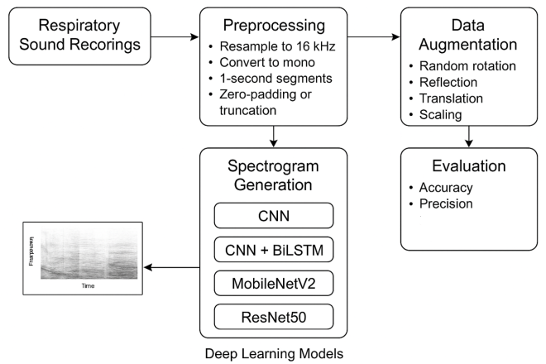
Dainat et-al proposed a system for classifying pulmonary sound from 98 subjects (24 male and 74 female) at median age of 68 years. The study depend on various convolution neural network to classify the lungs sound that result diagnostic accuracy of 91-93%[6]. K.suma et-al classify lung sound and disease by using four model of deep learning which is 2D CNN, ResNet50, MobileNet and Densenet to extract the feature from 920 audio recording. The ICBHI 2017 Respiratory Sound Database was used in this paper. Six kind of lung disease that Bronchiectasis, COPD, Bronchiolitis, Pneumonia, URTI, and a healthy class. The Mobilenet achieved the best accuracy for about 91% but the random forest perform the better with accuracy of about 92%[7]. 1D Convolutional Neural Network (CNN) is an approached presented to detect the respiratory disorder. The study depends on dataset take from ICBHI 2017 for 126 subject with different ages and medical issues. Six classes of disease are searched in the paper which are: bronchiectasis, pneumonia, asthma, COPD, URTI, and healthy. The author get 96% of validation accuracy[8].
Shehab et-al studied of detecting lung disorder by extracting the features of a large scale dataset that converted to spectrogram image then classified by using CNN pretrained model which combine five well known network that include Dens Net201, InceptionResNetV2, ResNet101, and EfficientNetb. Asthma, BRON, COPD, Heart failure, Lung fibrosis, Normal, Plueral, Pneumonia, are the six classes that classified with accuracy about 96%[9]. Anther researched suggest intensive CNN model to classify large dataset are taken from 126 subject to classify COPD, Asthma, lower and upper respiratory tract infection (LRTI, URTI). The accuracy that obtained is 93%[2]. In a study that conducted by Y,Kumari compare four deep learning families—1D CNNs, 2D CNNs, LSTMs, and GRUs—in order to identify various lung disorders from human speech and respiratory data. 6,898 audio samples from both healthy people and patients with illnesses such bronchiolitis, COPD, pneumonia, URTI, LRTI, and asthma made up the dataset. 6,898 audio samples from both healthy people and patients with diseases such bronchiolitis, COPD, pneumonia, URTI, LRTI, and asthma made up the dataset[10].
- Methodology
The procedure of the study is depend on using deep learning method to train the data of breathing sound as show in figure below.

Fig1: Block diagram for breathing sound classification

A. data set
The dataset are taken from kaggle website[11] One hundred and twelve subjects' respiratory sounds(35 healthy and 77 unhealthy)are included in the dataset. There were 69 men and 43 women among the subjects, ages 21 to 90. The dataset comprises sounds from seven diseases (asthma, heart failure, pneumonia, bronchitis, pleural effusion, lung fibrosis, and chronic obstructive pulmonary disease (COPD), as well as normal breathing sounds. The collection comprises audio recordings of chest wall examinations from various perspective points. The specialized physician who performed the diagnostic selected where to place the stethoscope on the subject.The dataset was divided into three subsets in order to guarantee reliable model development:
•70% of the training set is utilized to optimize the model's parameters.
•15% validation set: Used for early stopping and hyperparameter adjustment.
•Test set (15%): Saved for the last assessment to guarantee objective performance reporting.
B.PreprocessingAudio.
To guarantee uniformity and compatibility with deep learning models, every respiratory audio recording was put through a common preparation pipeline. Initially, every signal was resampled to a consistent sampling rate of 16 kHz in order to remove recording equipment fluctuation and maintain clinically significant frequency components. Then, by averaging across channels, stereo signals were transformed into mono channels, lowering redundancy without sacrificing signal integrity.
Because every input sample had the same dimensions, batch training was made more efficient and model bias from varying input lengths was avoided. A consistent dataset of breathing sounds, each generated in a uniform manner for dependable feature extraction and deep neural network training, was the end result of this approach. All audio segments were set to a 1-second duration, with longer signals being trimmed and shorter signals being zero-padded, in order to guarantee consistent input length. The breathing sounds were all prepared in a uniform format for dependable feature extraction and deep neural network training thanks to this normalizing phase.

C. Feature extraction
For feature representation, two complimentary approaches were used:
i.Images with Time-Frequency Spectral Features:
calculated with 512 FFT points, a 25 ms window, and a 10 ms hop length using the Short-Time Fourier Transform (STFT). transformed into Constant-Q Transform (CQT) representations or log-scaled spectrograms. Spectrograms were stored as 224x224 RGB pictures that could be used with CNN-based models.
ii.Mel-spectrograms (acoustic sequential features)
Mel spectrograms for consecutive deep learning models were extracted, containing 98 frequency bins. Prior to model training, features were normalized per-sample.
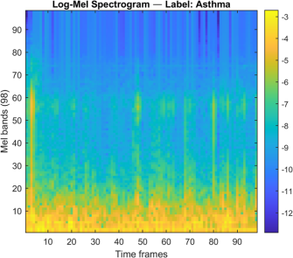
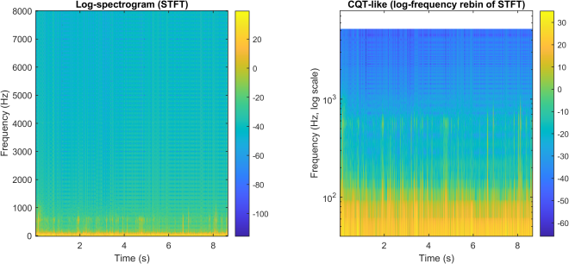

Fig2:features representation of (a) Time-Frequency Spectral Features and (b) Mel-spectrograms

D. Architecture of deep learning model.
Four kinds model of neural network are used in this study:
a) CNN, or convolutional neural network. 2D Mel-spectrogram characteristics are the input.
The architecture includes batch normalization, ReLU activation, max pooling, global average pooling, dropout (0.3), and stacked convolutional layers (64–256 filters, 3×3 kernels), and the Output: Softmax classifier + fully connected.

(b) Hybrid CNN + BiLSTM, combines bidirectional LSTM (100 hidden units) with CNN feature extraction to capture spectral and temporal relationships. improved capacity to simulate the breathing pattern's cycles.

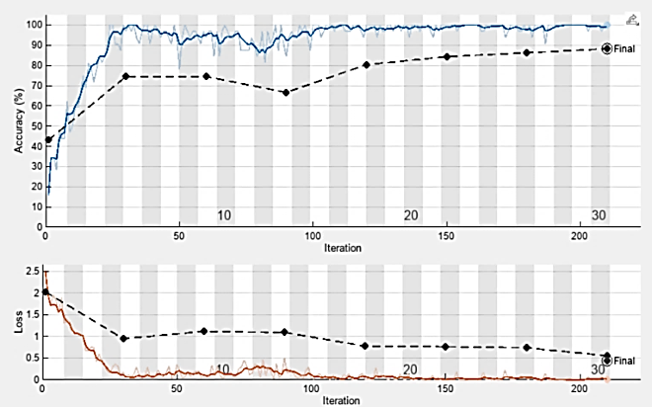
(c) Transfer Learning with MobileNetV2,Final layers are changed to correspond with the amount of breathing classes after being pre-trained on ImageNet, and the Images entered were scaled to 224 x 224 x 3. Real-time applications can benefit from a lightweight architecture.
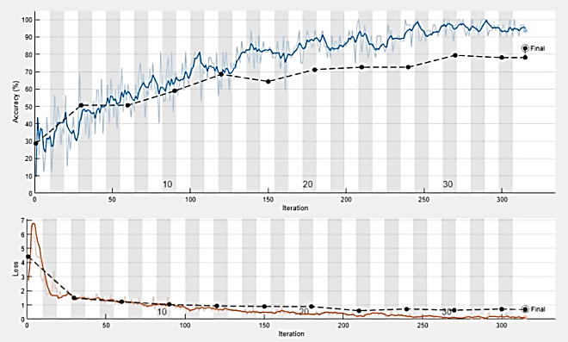
(d) Transfer Learning ResNet50, 50-layer deep residual network. The first 150 classification layers were frozen to preserve broad features, then the final layers were replaced. Rotation, translation, reflection, and scaling are examples of the extensive data augmentation used.
E. strategy of the training
With a learning rate of 0.001, the models were trained in MATLAB using either the Adam optimizer or the RMSProp optimizer. Depending on convergence, the number of epochs varied from 20 to 35, while the batch size ranged from 32 to 64. Every 30 iterations, validation monitoring was carried out to document accuracy and loss. Only CNN-based picture models were subjected to data augmentation techniques such as translations, flips, rotations, and scaling. Depending on the resources available, either a CPU or a GPU was used for training. the following figure representation training accuracy and lose curve for each neural network.
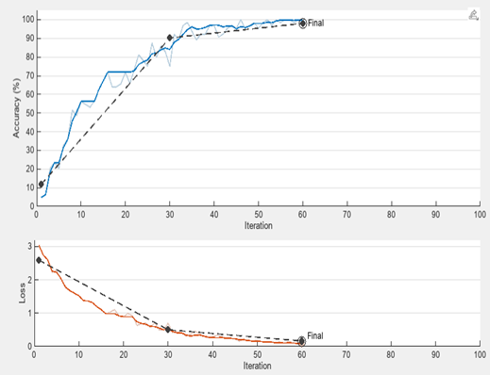
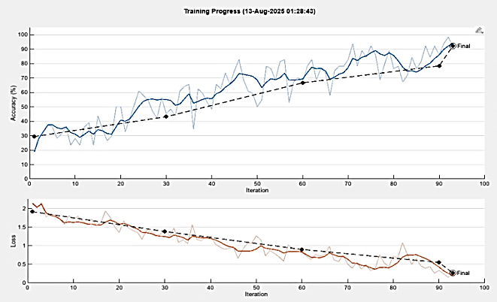
Fig3: Training and loss curves for: (a) CNN network, (b) CNN+BiLTSM , (c) MobileNet and (d) ResNet50
F. Evaluation metric
To ensure a thorough evaluation, multiple measures were used to analyze the model's
performance on the independent test set. Although, the misclassifications by class provided in the confusion matrix, accuracy was used to measure the overall percentage of correct predictions. Also, precision, recall and the F1-score were calculated in order to evaluate per-class performance, which is the key performance measure when using imbalanced datasets. The primary criterion used in evaluation was the macro-averaged F1-score to offer a comparable and fair comparison between models.

- Results
In the evaluation of the classification of respiratory sounds, four deep learning architectures were evaluated, namely CNN, CNN+BiLSTM, MobileNet, and ResNet50. Their performances were assessed using class-wise precision measures, final accuracies and confusion matrices.

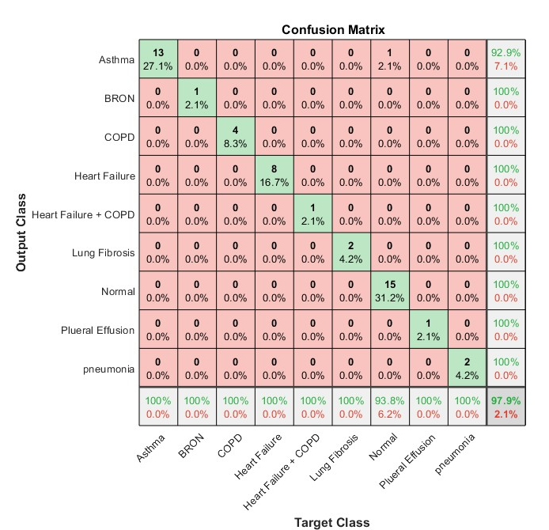
Table2:Overall Accuracy per Network
Network | Final Accuracy (%)
CNN | 97.9
CNN + BiLSTM | 95.8
MobileNet | 87.5
ResNet50 | 89.5

Table3: Class-wise Precision Across Models
Class | CNN | CNN + BiLSTM | MobileNet | ResNet50
Asthma | 100.0 | 100.0 | 85.7 | 85.7
BRON | 100.0 | 100.0 | 100.0 | 75.0
COPD | 100.0 | 100.0 | 75.0 | 100.0
Heart Failure | 100.0 | 100.0 | 75.0 | 100.0
Heart Failure + COPD | 100.0 | 100.0 | 100.0 | 100.0
Lung Fibrosis |  | 100.0 | 100.0 | 50.0 | 75.0
Normal |  | 93.8 | 93.8 | 93.8 | 88.9
Pleural Effusion |  | 100.0 | 66.7 | 100.0 | 100.0
Pneumonia |  | 100.0 | 100.0 | 87.5 | 80.0

The precision table is used to indicate the differences between models at the level of classes. CNN is also fairly accurate with a slight drop in accuracy to Normal (93.8%). They both perform similarly except that CNN +BiLSTM performs poorly in Pleural Effusion (66.7%). While ResNet50 continues to do well overall but falters for BRON (75.0%) and Pneumonia (80.0%), MobileNet performs poorly, especially for Lung Fibrosis (50.0%) and COPD (75.0%).
after all, CNN had the best accuracy (97.9%) with outstanding class-wise precision. Due to residual connections, ResNet50 (89.5%) produced findings that were balanced; yet, it performed poorly in BRON and pneumonia. While CNN+BiLSTM (95.8%) performed well in the majority of courses, it struggled with pleural diffusion. In COPD and lung fibrosis, MobileNet (87.5%) was effective but less effective. In real-world applications, MobileNet performs best in environments with limited resources, CNN delivers good baseline accuracy, and ResNet50 offers powerful generalization.

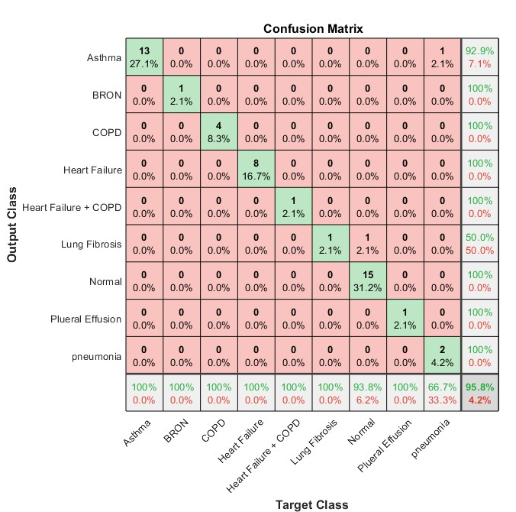

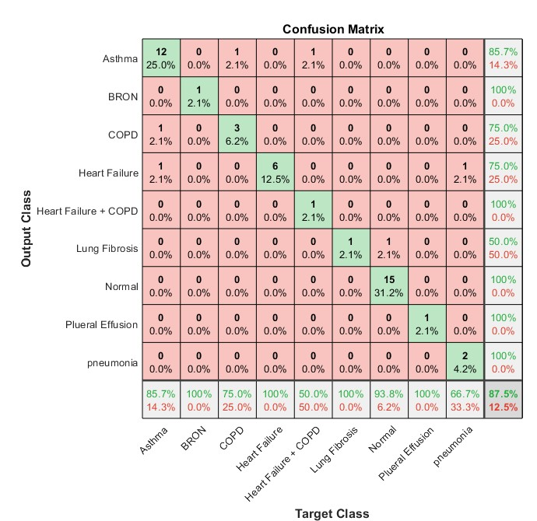
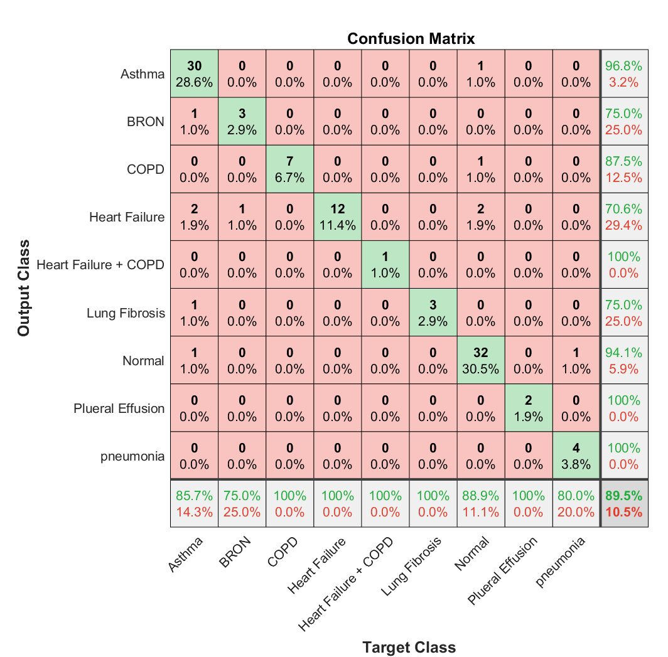
Fig4: confusion matrix for classifying breathing sound for (a) CNN (b) CNN+BiLTSM (c) MobileNet (d) ResNet50
- Conclusion
This study used audio recordings of lung sounds to show how well deep learning algorithms work for automatically classifying respiratory disorders. The study demonstrated that CNN-based models, particularly the baseline CNN, outperformed more intricate hybrid and transfer learning models in terms of accuracy and class-level precision by utilizing complimentary feature representations and evaluating several architectures. In situations when resources were limited or generalization was the main goal, MobileNet and ResNet50 provided benefits, but their accuracy was worse. The findings highlight the promise of non-invasive, audio-based diagnostics as a competitive substitute for traditional techniques, which frequently struggle with issues of subjectivity, invasiveness, expense, and accessibility. However, to increase generalizability and clinical usefulness, future research should investigate bigger, more varied datasets, sophisticated self-supervised or multimodal techniques, and real-time deployment situations. All things considered, respiratory sound analysis based on deep learning offers a promising route to a more approachable, effective, and impartial diagnosis of respiratory conditions.

- Reference
[1] D. Skalicky, V. Koucky, D. Hadraba, M. Viteznik, M. Dub, and F. Lopot, “Detection of respiratory phases in a breath sound and their subsequent utilization in a diagnosis,” Appl. Sci., vol. 11, no. 14, 2021.
[2] A. Srivastava, S. Jain, R. Miranda, S. Patil, S. Pandya, and K. Kotecha, “Deep learning based respiratory sound analysis for detection of chronic obstructive pulmonary disease,” PeerJ Comput. Sci., vol. 7, no. February, pp. 1–22, 2021.
[3] S. O. Zaben, W. M. N. W. Zainon, and A. H. Sabry, “Machine learning-based methods for detecting respiratory abnormalities using audio and visual analysis: A review,” Results Eng., vol. 26, no. May 2024, p. 104744, 2025.
[4] D. M. Huang, J. Huang, K. Qiao, N. S. Zhong, H. Z. Lu, and W. J. Wang, “Deep learning-based lung sound analysis for intelligent stethoscope,” Mil. Med. Res., vol. 10, no. 1, pp. 1–23, 2023.
[5] P. Kapetanidis et al., “Respiratory Diseases Diagnosis Using Audio Analysis and Artificial Intelligence: A Systematic Review,” Sensors, vol. 24, no. 4, pp. 1–37, 2024.
[6] B. Dianat et al., “Classification of pulmonary sounds through deep learning for the diagnosis of interstitial lung diseases secondary to connective tissue diseases,” Comput. Biol. Med., vol. 160, no. june, p. 106928, 2023.
[7] K. V. Suma, D. Koppad, P. Kumar, N. A. Kantikar, and S. Ramesh, “Multi-task Learning for Lung Sound and Lung Disease Classification,” SN Comput. Sci., vol. 6, no. 1, pp. 1–22, 2025.
[8] R. Sreejith, R. K. Ramasamy, and J. Abdullah, “Enhanced Lung Disease Detection Using Double Denoising and 1D Convolutional Neural Networks on Respiratory Sound Analysis †,” in Computer Sciences & Mathematics Forum, 2025, pp. 1–8.
[9] S. A. Shehab, K. K. Mohammed, A. Darwish, and A. E. Hassanien, “Deep learning and feature fusion-based lung sound recognition model to diagnoses the respiratory diseases,” Soft Comput., vol. 28, no. 19, pp. 11667–11683, 2024.
[10] Y. S. Kumari, “Deep Learning Approaches For Lung Disease Detection Through Voice Analysis,” vol. 12, no. 10, pp. 546–556, 2024.
[11] Möbius, “A Dataset of Lung Sounds.” 2021.

