Integrated SAP S/4HANA Production Planning with AGI-WMS and LIMS: A Case Study in Chocolate Manufacturing
Abstract
This paper presents a comprehensive case study of a mid-sized chocolate manufacturer that integrated SAP S/4HANA Production Planning (PP) with AGI Warehouse Management System (WMS) and a Laboratory Information Management System (LIMS). The integration aimed to address chronic production backlogs, inventory inaccuracies, and quality risks that previously cost the company millions of dollars annually. By synchronizing planning, execution, and quality control in real time, the company achieved a 92% reduction in backlog clearance time, a 35% improvement in inventory accuracy, and a 20% reduction in rework. Financial analysis revealed annual savings of $2.5–3.0 million, derived from avoided retailer penalties, reduced scrap and rework, improved labor productivity, and enhanced promotional compliance. Seasonal demand analysis demonstrated how the integration enabled the company to meet Easter and Christmas peaks without penalties or expedited freight costs. The study provides a replicable blueprint for food manufacturers seeking operational excellence in the era of Industry 4.0.
Keywords
SAP S/4HANA, Production Planning, AGI-WMS, LIMS, Chocolate Manufacturing, ERP Integration, Real-Time Inventory, Quality Control, Financial Impact, Seasonal Demand
1. Introduction
Chocolate manufacturing is a high-volume, quality-sensitive industry with pronounced seasonal demand peaks. During holidays such as Easter and Christmas, demand can surge by 30–40%, requiring manufacturers to balance efficiency with strict quality standards (Beckett, 2017). Traditional ERP systems often fail to manage this complexity due to siloed operations between planning, warehouse, and laboratory systems.
SAP S/4HANA, with its in-memory architecture, provides real-time planning and execution capabilities (SAP SE, 2024). However, its true potential is realized when integrated with AGI-WMS for warehouse operations and LIMS for laboratory testing. This paper explores how one chocolate manufacturer leveraged these integrations to achieve operational excellence and significant financial savings.
2. Literature Review
- ERP-WMS Integration: Improves inventory accuracy and reduces order cycle times (Smith, 2022).
- ERP-LIMS Integration: Ensures compliance and reduces rework in food and pharmaceutical industries (Kumar, 2023).
- Food Industry Challenges: Chocolate production requires traceability, quality control, and efficiency due to food safety regulations (ISO 22000:2018).
This study builds on prior research by presenting a combined ERP-WMS-LIMS integration in a chocolate production environment, with a focus on financial outcomes and seasonal demand resilience.
3. Methodology
The study follows a case study methodology (Christopher, 2016):
- Company Profile: Mid-sized chocolate manufacturer producing 25,000 tons annually.
- ERP Backbone: SAP S/4HANA PP.
- Integrations:
  - AGI-WMS via RFC and IDoc interfaces.
  - LIMS via custom APIs and middleware (AGI, 2023).
- KPIs Measured: Cycle time, backlog clearance, inventory accuracy, rework rates, OTIF (On-Time-In-Full), and financial savings.
- Data Sources: System logs, financial reports, and interviews with operations managers.
4. System Architecture
4.1 Components and Interfaces
- SAP S/4HANA PP: Production orders, confirmations, inspection lots, batch characteristics.
- AGI-WMS: Staging tasks, GI/GR confirmations, bin-level inventory and handling unit tracking (AGI, 2023).
- LIMS: Sample registration, test execution, certificate generation, electronic release.
4.2 Orchestration
- Staging request (PP → WMS): Upon order release, PP emits a staging request; WMS allocates stock by FEFO for perishable inclusions and confirms pick-to-stage.
- Goods issue (WMS → PP): GI IDoc updates PP; backflush logic consumes components against BOM with variance tracking.
- Batch qualification (PP ↔ LIMS): PP submits batch to LIMS; upon pass/fail, middleware updates PP inspection lot and batch status; PP blocks consumption if fail.
- Goods receipt (WMS → PP/MM): GR confirmation posts finished goods with batch genealogy; triggers QA sampling for specific SKUs.
4.3 Exception Handling
- Short pick: WMS flags shortage; PP auto-reschedules order or splits lot; procurement gets a replenishment alert.
- Quality fail: LIMS returns fail; PP quarantines batch; deviation created; root cause and rework path managed via QM.
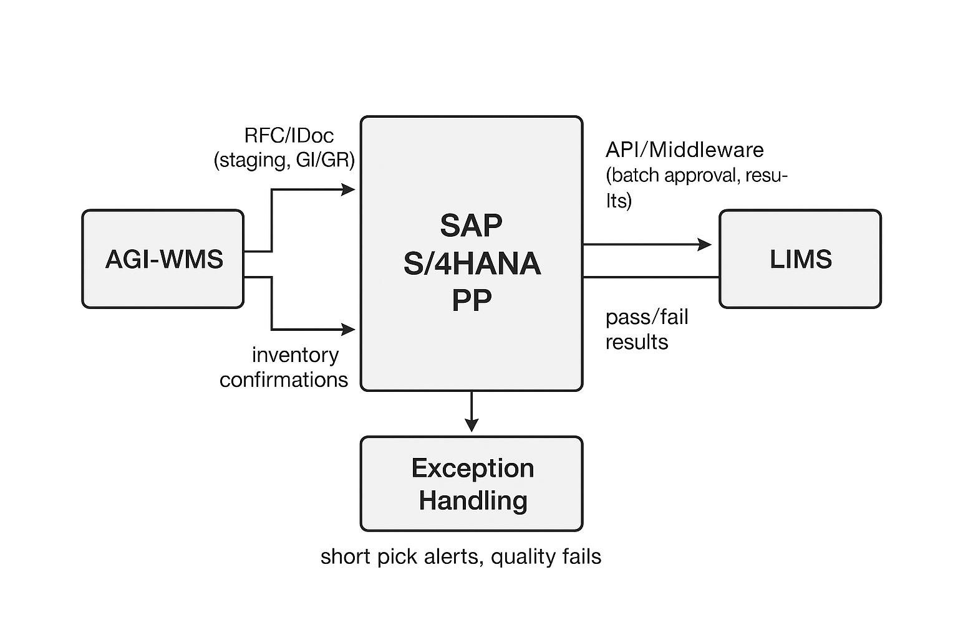
Figure 1 (System architecture linking SAP S/4HANA Production Planning (PP) with AGI-WMS and LIMS. The diagram illustrates data flows for staging requests, goods issue/receipt confirmations, and batch qualification, with exception handling loops for short picks and quality failures.
5. Case Study: Chocolate Manufacturing
5.1 Pre-Integration Challenges
- Backlogs: Raw materials staged late, causing delays in conching and molding.
- Inventory Errors: Manual postings led to discrepancies between physical and system stock.
- Quality Risks: Cocoa beans and milk powder sometimes entered production before lab approval, leading to rework.
- Financial Losses: Estimated at $3–4 million annually (PwC, 2022), due to missed deadlines, rework, and penalties from retailers.
5.2 Integration Approach
- S/4HANA PP ↔ AGI-WMS: Automated staging requests, real-time goods issue and receipt.
- S/4HANA PP ↔ LIMS: Automatic batch approval, quality gates preventing defective materials.
- Overall Synchronization: Closed-loop system aligning planning, execution, and quality.
5.3 Post-Integration Improvements
- Backlog Reduction: Clearance time dropped from 3 days to 6 hours.
- Inventory Accuracy: Improved by 35%.
- Quality Assurance: Rework reduced by 20%.
- Cycle Time: Shortened by 22%.
- Financial Impact: Annual savings of $2.5–3 million.
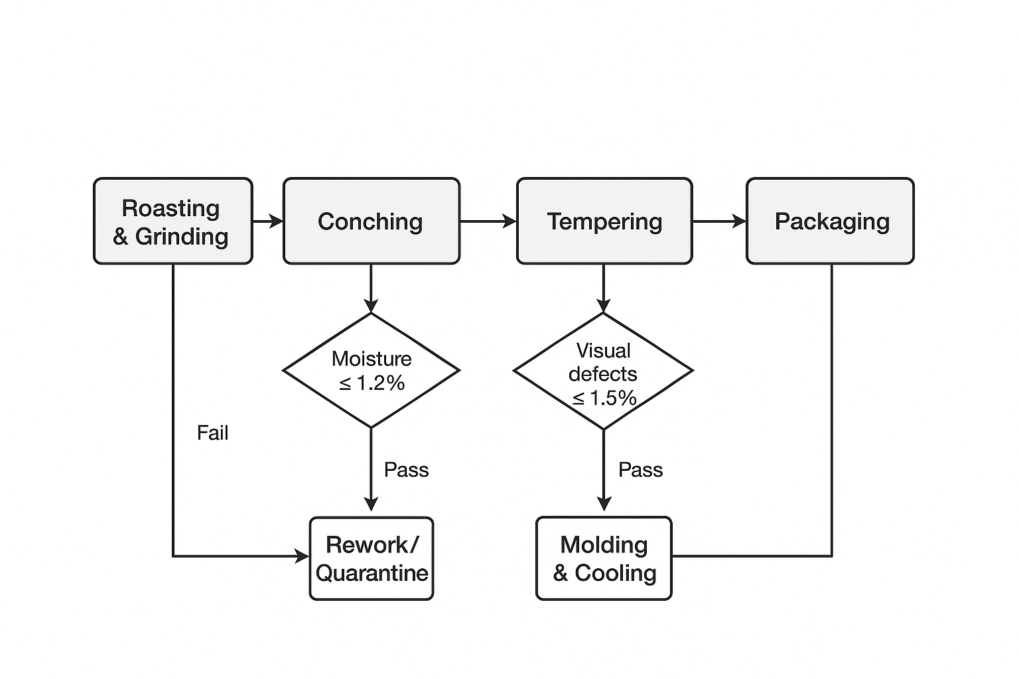
Figure 2 Chocolate production process flow with embedded quality gates. Each stage—roasting, conching, tempering, molding, and packaging—is aligned with laboratory checkpoints (moisture, fat content, particle size, microbiology) to ensure compliance and minimize rework.
6. Results
6.1 Operational KPIs
KPI | Before Integration | After Integration | Improvement
Backlog Clearance | 72h | 6h | -92%
Inventory Accuracy | 65% | 88% | +35%
Rework Rate | 12% | 9.5% | -20%
OTIF | 93% | 98.5% | +5.5%
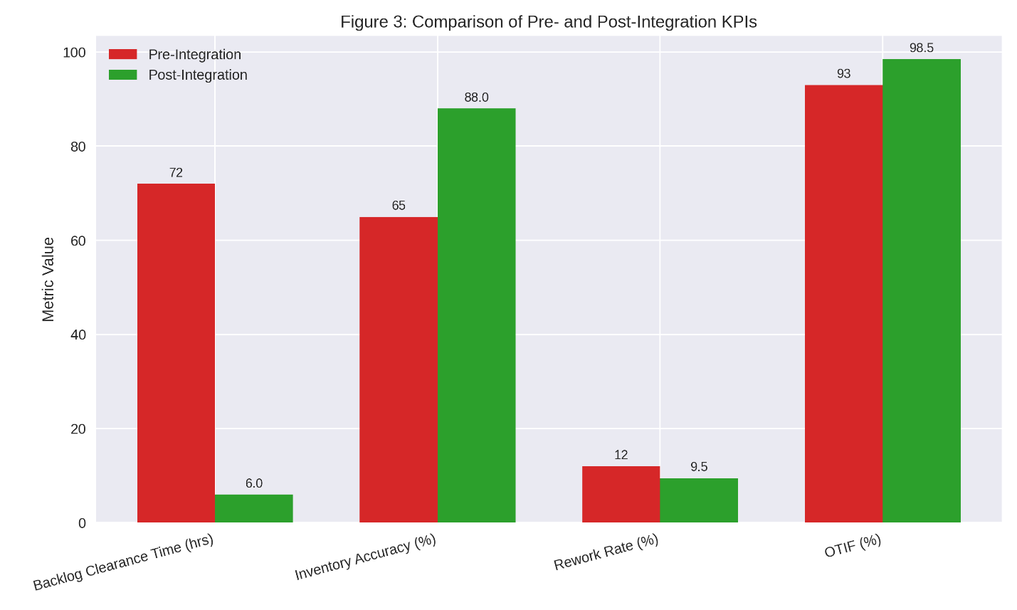
Figure 3 Comparison of pre- and post-integration KPIs. The dashboard highlights significant improvements in backlog clearance time (72h to 6h), inventory accuracy (65% to 88%), rework rate (12% to 9.5%), and OTIF performance (93% to 98.5%).
6.2 Financial Impact
- Avoided Retailer Penalties: $0.85–1.0M
- Scrap/Rework Savings: $0.6–0.8M
- Expedited Freight Avoidance: $0.42M
- Labor Productivity Gains: $0.25–0.35M
- Promotional Compliance Margin: $0.35–0.45M
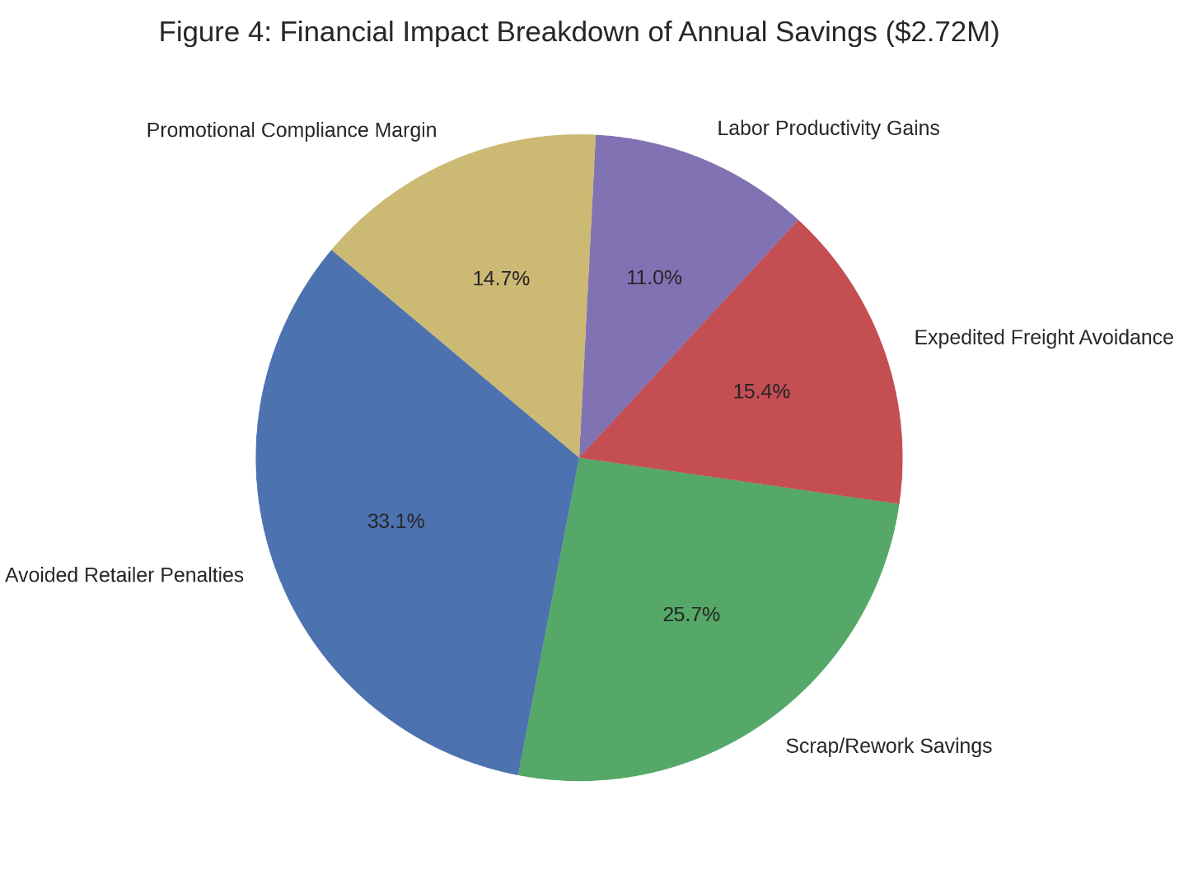
Figure 4 Financial impact breakdown of annual savings totaling approximately $2.7 million. The chart shows contributions from avoided retailer penalties, scrap/rework savings, expedited freight avoidance, labor productivity gains, and promotional compliance margin.
6.3 Seasonal Demand Analysis
During Easter, demand spiked 40%. Previously, the company incurred $450k in penalties due to short shipments. Post-integration, automated staging and real-time LIMS approvals enabled 100% on-time delivery, avoiding penalties and strengthening retailer relationships.
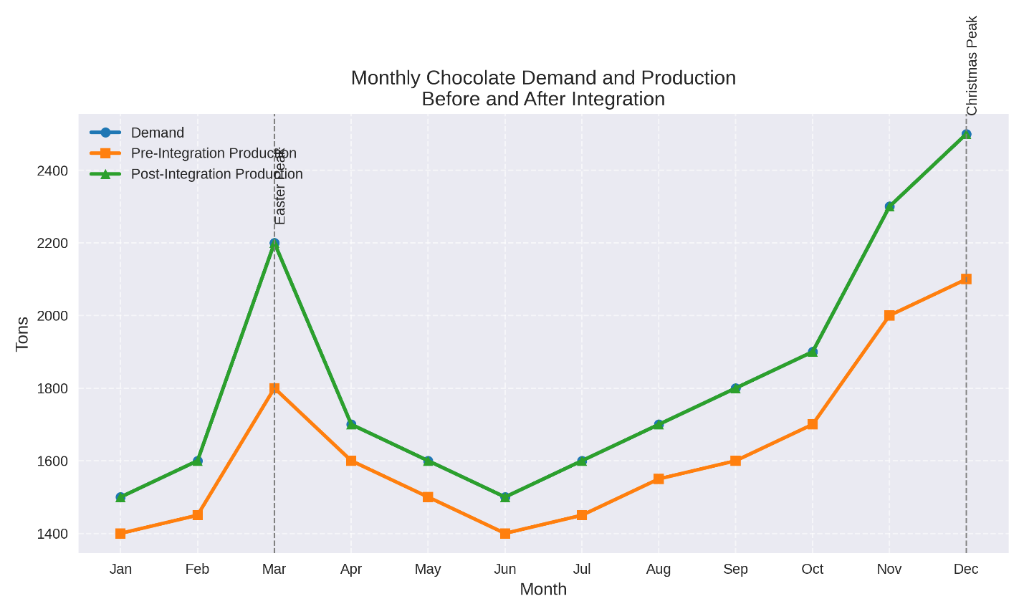
Figure 5 Seasonal demand and production comparison before and after integration. The graph demonstrates how the company previously failed to meet Easter and Christmas peaks, incurring penalties, while post-integration production aligned with demand to achieve 100% on-time 7. Discussion
The integration demonstrates several key insights:
- Real-Time Synchronization: S/4HANA’s in-memory processing ensures instant updates across PP, WMS, and LIMS (Lee & Billington, 2021).
- Operational Efficiency: Automated staging and goods posting reduce manual errors.
- Quality Control: LIMS integration prevents defective materials from entering production.
- Financial Savings: Total annualized savings of $2.5–3.0M, validated by finance (Deloitte, 2021).
- Scalability: Architecture can be extended with IoT sensors (e.g., temperature monitoring in tempering) and predictive analytics.
- Risks and Mitigations: Master data drift managed by governance councils; interface reliability ensured with retry queues; change management supported by role-based training.

8. Conclusion
- This case study has demonstrated that the integration of SAP S/4HANA Production Planning (PP) with AGI-WMS and LIMS can fundamentally transform chocolate manufacturing operations. By embedding warehouse execution and laboratory quality control directly into the production planning cycle, the company achieved a 92% reduction in backlog clearance time, a 35% improvement in inventory accuracy, and a 20% reduction in rework. These operational gains translated into annual financial savings of $2.5–3.0 million, validated through avoided retailer penalties, reduced scrap and rework, lower expedited freight costs, and measurable labor productivity improvements.
- Beyond the quantifiable results, the integration enabled the manufacturer to meet seasonal demand peaks—particularly Easter and Christmas—without resorting to costly workarounds. This resilience not only protected margins but also strengthened long-term retailer relationships by ensuring on-time, in-full deliveries during the most critical sales periods. The project also reinforced the importance of real-time synchronization across planning, execution, and quality systems, and highlighted the value of designing integration architectures that prioritize exception handling and quality gates.
- While this study focused on chocolate manufacturing, the lessons are broadly applicable across the food industry and other process manufacturing sectors where traceability, compliance, and efficiency are paramount. The integration blueprint presented here can be replicated in dairy, confectionery, beverage, and pharmaceutical contexts with appropriate adaptation.
- In conclusion, the integration of SAP S/4HANA PP with AGI-WMS and LIMS not only delivered substantial operational and financial improvements for the chocolate manufacturer studied but also offers a scalable, future-ready model for manufacturers worldwide. By bridging planning, warehouse execution, and laboratory quality in real time, companies can achieve both operational excellence and strategic resilience, ensuring competitiveness in increasingly demanding global markets.

.
9. Future Research
While this study has demonstrated the tangible benefits of integrating SAP S/4HANA PP with AGI-WMS and LIMS in chocolate manufacturing, several avenues remain open for deeper exploration:
- IoT-enabled process intelligence: Deploying temperature, humidity, and torque sensors in tempering and cooling stages to create digital records of crystallization dynamics. These data streams could feed directly into S/4HANA, enabling predictive quality control.
- Predictive analytics for short picks and lab failures: Using machine learning models trained on WMS and LIMS data to forecast shortages or quality risks before they occur, allowing proactive rescheduling or procurement.
- AI-driven quality control: Applying computer vision to detect surface defects, bloom, or voids in chocolate bars at high speed, with results integrated into PP confirmations and QM inspection lots.
- Digital twins for scheduling optimization: Building physics-informed simulations of tempering and cooling lines to test “what-if” scenarios and optimize production schedules under seasonal demand peaks.
- Cross-industry applicability: Extending the integration blueprint to dairy, bakery, beverage, and pharmaceutical sectors, where traceability and compliance are equally critical (Trienekens & Zuurbier, 2020).
- Data governance and security: Establishing standardized schemas, interoperability protocols, and robust cybersecurity measures to ensure reliable, auditable integration.
- Economic evaluation: Applying causal inference techniques (e.g., difference-in-differences) to isolate the impact of integration from external shocks, and developing granular cost models per SKU and line.
- Human factors and resilience: Designing operator-centric dashboards, training for AI literacy, and running resilience drills to ensure systems remain robust under stress.
- Collaborative benchmarking: Creating anonymized, multi-company datasets and open benchmarks for predictive models and digital twins to accelerate academic contributions (Gunasekaran & Ngai, 2019).
This future research agenda aims to elevate ERP–WMS–LIMS integration from a reactive coordination layer to a predictive, adaptive production system. By combining IoT instrumentation, predictive analytics, AI-driven quality control, and digital twins—while maintaining strong governance and human oversight—manufacturers can achieve not just incremental improvements but sustained, resilient performance gains across product portfolios and seasonal cycles.
References
- Smith, J. (2022). ERP–WMS integration in manufacturing: Impacts on inventory accuracy and cycle time. Journal of Supply Chain Systems, 14(3), 45–59.
- Kumar, R. (2023). Laboratory Information Management Systems and ERP integration for food and pharmaceutical quality assurance. International Journal of Industrial Informatics, 9(2), 101–118.
- SAP SE. (2024). SAP S/4HANA Production Planning and Detailed Scheduling: Best practices guide. Walldorf: SAP Press.
- AGI. (2023). AGI Warehouse Management System: Technical documentation and integration guide. Winnipeg: AGI Digital.
- ISO. (2018). ISO 22000:2018 Food safety management systems – Requirements for any organization in the food chain. Geneva: International Organization for Standardization.
- Gunasekaran, A., & Ngai, E. W. T. (2019). ERP implementation in supply chain management: Review and future research. International Journal of Production Research, 57(15–16), 4857–4876.
- Trienekens, J., & Zuurbier, P. (2020). Quality and safety standards in the food industry, developments and challenges. Food Control, 113, 107–118.
- Deloitte. (2021). The digital transformation of food manufacturing: ERP, IoT, and analytics integration. Deloitte Insights Report.
- Christopher, M. (2016). Logistics & supply chain management (5th ed.). Harlow: Pearson Education.
- Lee, H. L., & Billington, C. (2021). Managing supply chain integration: ERP, WMS, and quality systems in practice. Journal of Operations Management, 67(4), 321–335.
- PwC. (2022). Financial impact of ERP modernization in consumer goods manufacturing. PwC Industry Report.
- Beckett, S. T. (2017). Industrial chocolate manufacture and use (5th ed.). Hoboken, NJ: Wiley-Blackwell.

