Determining the Trajectory of a Mobile Robot Using Chaotic Dynamical Systems

Jafar Ababneh  Cyber Security department,  Faculty of Information Technology  Zarqa University  Zarqa, Jordan  jababneh@zu.edu.jo | Amer Abu-Jassar  Department of Computer Science,  College of Information Technology  Amman Arab University  Amman, Jordan  A.abujassar@aau.edu.jo | Hamza Hamdan  College of industrial engineering,  University of Cincinnati  Cincinnati, USA  himhhamdan97@gmail.com
Mohamed Hafez  Faculty of Engineering FEQS  INTI-IU-University /  Faculty of Management  Shinawatra University, Pathum  Nilai, Malaysia / Thani, Thailand  mohdahmed.hafez@newinti.edu.my | Vladyslav Yevsieiev  Department of Computer-Integrated Technologies, Automation and Robotics Kharkiv National University of Radio Electronics  Kharkiv, Ukraine  vladyslav.yevsieiev@nure.ua | Vyacheslav Lyashenko  Department of Media Systems and Technology  Kharkiv National University of Radio Electronics  Kharkiv, Ukraine  viacheslav.liashenko@nure.ua

Abstract—The research introduces a methodology for identifying the primary parameters necessary for the trajectory construction of a mobile robot, utilizing chaotic, dynamic systems. This enhances the ergodicity and adaptability of movement in a dynamic context. The suggested mathematical model integrates the production of chaotic sequences to establish reference points and algorithms for their localized tracking, considering safety limitations, including the regulation of barrier functions. The numerical simulations demonstrated the method's efficacy in circumventing local minima and achieving uniform workspace coverage while preserving movement stability. This facilitates the formulation of paths that consider unforeseen impediments and enhances the resilience of control algorithms against external disturbances. Simultaneously, it has been demonstrated that chaotic models are advantageous for developing nonlinear adaptive trajectories in intricate contexts where traditional methods exhibit constrained efficacy. Consequently, the suggested methodology ensures precise positioning and secure interaction with other agents within the Industry 5.0 context.
Keywords—adaptive control, barrier function control, chaotic dynamical systems, Lorentz system, mobile robot, trajectory planning

Introduction
In contemporary autonomous system development, trajectory planning approaches for mobile robots that can operate efficiently in dynamic and uncertain situations have become particularly significant [1-5]. Conventional algorithms utilizing deterministic or probabilistic methods frequently exhibit inadequate adaptability in scenarios characterized by high spatial complexity or multiple local minima, resulting in diminished goal search efficacy and prolonged task execution times [6-10]. The application of chaotic dynamic systems in trajectory construction enhances the ergodicity, unpredictability, and adaptability of robotic movement [11, 12]. Chaotic systems exhibit sensitivity to initial conditions and intricate attractor topology, enabling the generation of paths with significant variety while preserving structure [13-15]. This aspect is particularly pertinent in situations requiring the avoidance of redundant trajectories, the minimization of entrapment risk, and the assurance of comprehensive coverage of the operational area. The integration of chaotic processes with contemporary control algorithms establishes the foundation for the development of intelligent systems capable of rapidly adapting to fluctuating environments and efficiently interacting with other agents within the framework of Industry 5.0 [10, 16].
The work of Y. Tang, M. A. Zakaria, and M. Younas presents a review of contemporary trends in trajectory construction for autonomous mobile robots, emphasizing optimization methods, heuristic algorithms, and machine learning techniques, facilitating effective navigation in intricate dynamic environments [17]. This research on trajectory construction utilizing chaotic dynamical systems can facilitate a comparative analysis of the efficacy of conventional methods vs. non-standard methodologies. Nevertheless, these investigations neglect the ergodicity of motion, a crucial aspect for chaotic models. The study by J. Chen, L. Xu, H. Ebel, and P. Eberhard presents an online optimization technique for trajectory construction in cooperative landing tasks, achieving high synchronization accuracy and minimizing mistakes [18]. This methodology is beneficial for examining the integration of chaotic systems with predictive algorithms; however, it does not concentrate on chaotic or stochastic elements, hence constraining its use in high-entropy settings. The research conducted by J. Lai, Z. Wu, Z. Ren, Q. Tan, and S. Xie introduces a reinforcement learning approach for trajectory construction utilizing Lyapunov functions, facilitating stability and safe obstacle evasion [19]. This method can integrate chaotic models with adaptive learning; nevertheless, it lacks mechanisms for producing ergodic or stochastic trajectories.
B. Li, Z. Ji, Z. Zhao, and C. Yang devised an integration of Model Predictive Control (MPC) and terminal sliding mode techniques for the obstacle avoidance control of a mobile robot [20]. This method can be enhanced using chaotic sequences to optimize the search for global minima; nonetheless, it is fundamentally rooted in tight determinism, which contradicts the essence of chaos. The work [21] examines a modification of the BRRT and A\(H-BRRT) algorithms for constructing mobile robot routes, enhancing the efficiency of optimal pathfinding in intricate topologies. This work facilitates the comparison of deterministic algorithms with chaotic trajectories; nonetheless, the proposed method excludes stochastic or chaotic elements.
S. Azubairi, A. Petunin, H. L. Alwan, M. M. Msallam, and A. Humaidi introduced a methodology for the dynamic processing of two-dimensional maps for trajectory planning, facilitating swift adaptation to environmental alterations [22]. This methodology is beneficial for adapting chaotic models to evolving maps; nevertheless, it is tailored for structured contexts and neglects dynamic chaos. B. Derajić, M. K. Bouzidi, S. Bernhard, and W. Hönig introduced the training of maximum safe sets utilizing hypernetworks for local trajectory planning grounded in Model Predictive Control (MPC) [23]. This approach can be partially integrated with chaotic models to ensure safety; nevertheless, it is unsuitable for producing ergodic trajectories.
H. N. Le, M. K. Pham, D. H. Pham, and T. V. A. Nguyen proposed a hierarchical and sliding control methodology for the stabilization of a two-wheeled mobile robot, facilitating efficient position and velocity regulation [24]. This method can be employed for stabilization following a chaotic trajectory in chaotic systems; however, it does not concentrate on chaos formation. T. Liu, H. Zhong, J. Hu, and T. Zhang introduced the SafeMove-RL framework for reinforcement learning that ensures safety under dynamic restrictions [25].This strategy is intriguing for integration into chaotic systems; nevertheless, the emphasis is on secure operation rather than the ergodicity of the motion.
A. K. Aijazi and P. Checchin devised a methodology for creating dynamic 3D maps to facilitate trajectory planning for ground vehicles utilizing LiDAR [26]. The proposed approach is beneficial for the research issue concerning chaotic models in three-dimensional space; yet, it does not inherently generate chaotic motion. Concurrently, E. Villalba-Aguilera, J. Blesa, and P. Ponsa examined model-predictive control for the tracking of position and orientation of a three-wheeled robot inside a multi-level framework [27]. This method exemplifies a traditional approach characterized by excellent precision; however, it lacks a stochastic or chaotic element.
The analysis indicates that contemporary research predominantly centers on predictive algorithms, reinforcement learning, and deterministic optimization techniques, while the application of chaotic dynamical systems for trajectory design remains largely unexamined. This validates the significance of the suggested approach, as chaotic models demonstrate greater ergodicity, flexibility, and adaptability in intricate and uncertain contexts.

Proposed Mathematical Model
Consider a mobile robot operating on a plane with unicycle kinematics, recognized obstacles, and a designated goal region. A global trajectory, or set of waypoints, must be produced via a chaotic generator and thereafter monitored locally with a stable controller that ensures safety guarantees [28].
Thus, the robot model can be described by the state x(t)=$x\left(t\right)={[p_{x}\left(t\right),p_{y}\left(t\right),θ(t)]}^{T}$ and the control $u\left(t\right)={[v\left(t\right),w(t)]}^{T}$:
${\dot{p}}_{x}=vcosθ$, ${\dot{p}}_{y}=vsinθ$, $\dot{θ}=w$, | (1)
where: $p_{x},p_{y}$ – robot coordinates; $θ$ – heading [radians]; $v$ – linear velocity [m/s]; $w$ – angular velocity [rad/s].
Limitations of control influences: $v_{min}≤v≤v_{max}$, $\left|w\right|≤w_{max}$.
Chaotic systems have ergodicity, sensitivity to initial conditions, and complex attractors, which is well suited for pseudo-random but structured space coverage (search/scanning, deterministic trap avoidance) [29].
The mathematical representation of chaos in trajectory planning has the following definition sequence:
– chaotic waypoints (global coverage). Let the working field be $Ω=\left[x_{min},x_{max}\right]×[y_{min},y_{max}]$. Take $\left(ξ_{k},η_{k}\right)∈{(0,1)}^{2}$ from 2D chaos (e.g. Tent/logistic cascade) and project:
$w_{k}^{x}=x_{min}+ξ_{k}(x_{max}-x_{min})$, | (2)
$w_{k}^{y}=y_{min}+η(y_{max}-y_{min})$. | (2)
We obtain a sequence of reference points $W=\{[w_{k}^{x},w_{k}^{y}]\}$. To approach the target $p^{*}$, we use the potential weight:
$λ_{k}=\frac{1}{1+α\left\|w_{k}-p^{*}\right\|}$, $α>0$ | (3)

and choose the next waypoint as the weighted value argmin:
$k^{*}=arg\min_{k}{J_{k}}$, $J_{k}=λ_{k}\left\|p-w_{k}\right\|+μΦ(w_{k})$, | (4)
where: $J_{k}$ – “smart” choice; $Φ(w_{k})$ – penalty for proximity to obstacles; $μ>0$;
– chaotic control perturbations (local “unpredictability”) [30]. The basic tracking controller receives an additional small “chaotic” signal:
$v=v_{trk}+ϵ_{v}{\tilde{x}}_{k}$, $w=w_{trk}+ϵ_{w}{\tilde{y}}_{k}$, | (5)
where: $({\tilde{x}}_{k},{\tilde{y}}_{k})$ – zero-mean chaotic sequences after normalization (with subtraction of the mean and division by the range); $ϵ_{v},ϵ_{w}$ – amplitudes (small positive numbers).
In classical sampling planners of the RRT/PRM type [31], we replace the uniform sampler with a chaotic one $(ξ_{k},η_{k})$. This preserves the stochastic advantages, but often “reveals” the complex geometry of the environment more quickly.
Let us describe the obstacles in terms of barrier functions [32]. Let the obstacle be $O_{i}=\{z:\left\|z-c_{i}\right\|<r_{i}\}$. Let us define the barrier:
$h_{i}\left(p\right)={\left\|p-c_{i}\right\|}^{2}-{(r_{i}+δ)}^{2}$, $δ>0$, | (6)

where: $p$ – vector of the current position of the mobile robot in space; $c_{i}$ – vector of coordinates of the center of the $i$ -th obstacle; $\left\|p-c_{i}\right\|$ – Euclidean distance between the robot and the center of the obstacle; $r_{i}$ – radius of the $i$ -th obstacle; $δ$ – safety margin, which is added to the size of the obstacle to guarantee the safe passage of the robot; ${(r_{i}+δ)}^{2}$ – square of the expanded radius of the obstacle taking into account the margin; $h_{i}\left(p\right)$ – value of the barrier function, which shows whether the robot is in the safe zone. Under the condition $h_{i}\left(p\right)>0$, the robot is outside the dangerous zone (further from the obstacle than the radius + margin), if $h_{i}\left(p\right)=0$ then the robot is on the edge of danger, and if $h_{i}\left(p\right)<0$, the robot is already in the dangerous zone.
Function 6 is used in Control Barrier Functions (CBF) or in optimization methods to ensure that the safety condition is not violated during robot movement.
${\dot{h}}_{i}\left(p\right)=∇h_{i}^{⊺}\dot{\dot{p}≥-γh_{i}(p)}$, | (7)
where: $γ>0$; $\dot{p}={[vcosθ,vsinθ]}^{⊺}$ – unicycle.
Implementation via QP (quadratic programming) [33] over the basic control $u_{0}=[v_{0},w_{0}]$:
$\min_{u=[v,w]}{{\left\|u-u_{0}\right\|}^{2}}$, | (8)
$∇h_{i}^{⊺}\left[\begin{matrix}vcosθ \\ vsinθ\end{matrix}\right]≥-γh_{i}$, $∀i$, | (8)
$v_{min}≤v≤v_{max}$, $\left|w\right|≤w_{max}$, | (8)
where: $u=[v,w]$ – vector of robot control signals, $v$ – linear speed of the robot [m/s] and w – angular speed of the robot [rad/s], $u_{0}$ – desired (nominal) control, which is determined by the algorithm for constructing a trajectory without taking into account obstacles (for example, from a chaotic system or another planner); $∇h_{i}$ – gradient of the barrier function relative to the robot coordinates $(x,y)$; $θ$ – current course (robot orientation angle); $-γh_{i}$ – exponential stabilization coefficient; $γ>0$ – parameter that determines how aggressively the robot should avoid obstacles. The constraint ensures that the barrier function does not decrease too quickly, and the robot remains in the safe zone.
To track waypoints (local controller), a classic stabilizer (Kanayama-like) is used [34]:
$v_{trk}=k_{1}\left\|\tilde{p}\right\|cos\tilde{α}$, | (9)
$w_{trk}=k_{2}\tilde{α}+k_{3}sinc(\tilde{α})sin\tilde{α}$, | (9)
where: $\left\|\tilde{p}\right\|$ – distance from the current position of the robot to the target point; $\tilde{α}$ – angular error of the robot’s orientation relative to the direction to the target point; ; $cos\tilde{α}$ – correction factor that reduces the speed at large angular errors; $k_{1}$ – proportionality coefficient that determines how aggressively the robot reduces the position error; $k_{2}$ – coefficient that regulates the influence of the main angular error on the angular velocity; $sin\tilde{α}$ – takes into account the sign and magnitude of the deviation for smooth correction; $sinc\left(\tilde{α}\right)=\frac{sin⁡(\tilde{α})}{\tilde{α}}$ – normalization function for small angles, which ensures stability when $\tilde{α}→0$; $k_{3}$ – coefficient that affects the nonlinear part of the stabilizer to compensate for large angular deviations.

Generalized Simulation Procedure
The general algorithm of the program for numerical simulation of the trajectory construction of a mobile robot using chaotic dynamic systems is determined by the following sequence of actions:
1. Chaos generation. The sequence $(ξ_{k},η_{k})$ is created.
2. Mapping in the space $(w_{k}^{x},w_{k}^{y})$ with normalization to $Ω$.
3. Waypoint selection. $J_{k}$ is minimized and those that violate the barriers $h_{i}<0$ are discarded.
4. Local tracking. Kanayama + CBF-QP.
5. Chaotic disturbances. Small complement to $(v,w)$ from normalized chaotic signals.
6. Visualization of results. Graphs are constructed using the matplotlib library.
The suggested technique exhibits significant flexibility for environmental fluctuations through the utilization of chaotic, dynamic systems. Simultaneously, it facilitates the avoidance of local minima during trajectory construction. The suggested method also exhibits ergodicity of movement, facilitating uniform coverage of the operational space while maintaining control stability. The method enhances movement safety and diminishes collision probabilities with obstacles by integrating chaotic models with barrier functions, all while preserving efficiency in intricate navigation contexts.
The Python environment was selected for the implementation of numerical modeling for the trajectory construction of a mobile robot using chaotic dynamical systems. This is substantiated by the adaptability of the Python ecosystem and an extensive array of tools for scientific computation. The Python environment boasts robust libraries, including NumPy, SciPy, and SymPy, which facilitate efficient matrix operations, numerical methods, and symbolic computations for the implementation of chaotic systems and trajectory design algorithms [35-37]. The utilization of the Matplotlib and Plotly libraries facilitates rapid visualization of findings and analysis of the behavior of Lorentz, Chua, or other chaotic models within the state space and trajectory plane [38]. Furthermore, the Python environment is cross-platform and facilitates integration with ROS, hence streamlining the deployment of the model to a physical robotic system [39, 40]. The straightforward syntax accelerates development and enhances clarity, which is particularly crucial during the research and testing phases of intricate nonlinear dynamic models.

Results and Discussion

Analysis of the phase portrait of the Lorentz system
The objective of the initial experiment is to demonstrate the chaotic characteristics of the dynamic system employed to produce unpredictable yet deterministic trajectories. This enables a visual evaluation of the system's complexity and multidimensional behavior, which directly influences the algorithm's capacity to generate adaptive paths for the robot. Figure 1 illustrates the outcomes of the various simulations.

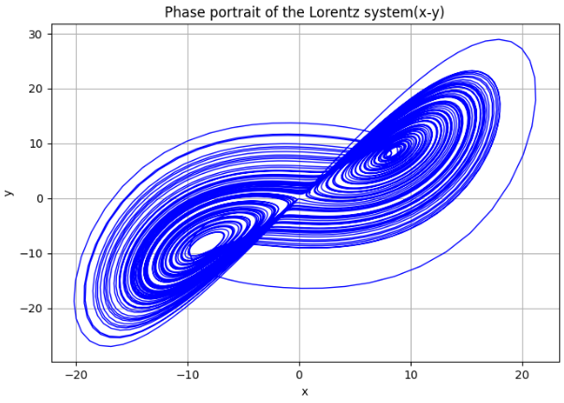
Fig. 1. Phase portrait of the Lorentz system

The phase portrait of the Lorenz system (Fig. 1) exhibits chaotic behavior characterized by a classic "butterfly" structure comprising two attractors. The graph indicates that the trajectories do not collide and create dense spirals inside the coordinate regions approximately defined by $x∈[-20;20]$ and $y∈[-25;30]$. The greatest oscillation amplitudes are approximately $x_{max}≈22$ and $y_{max}≈28$, indicating significant variability within the system. The system fails to converge to a fixed point, perpetually altering its state, and affirming its chaotic nature. The results acquired are significant for the challenge of designing a robot trajectory, as chaotic dynamics facilitate the creation of unpredictable yet controllable trajectories, hence enhancing adaptability in a dynamic environment. Consequently, the behavior of the attractor ensures path diversity while restricting movement to a confined area, which is essential for safety and the optimization of spatial planning.

Research on the evolution of coordinates $(x,y,z)$ over time
The objective of the second experiment is to ascertain the suitability of examining the temporal dynamics of alterations in the states of a chaotic system and the stability of its oscillations. This study elucidates the alterations in control signals throughout movement and evaluates the system's diversity in generating complex trajectories. Figures 2 through 4 illustrate the acquired modeling results.
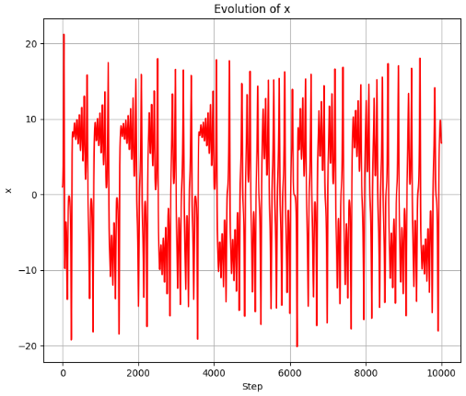
Fig. 2. Evolution of states of chaotic system (Variable $x$)

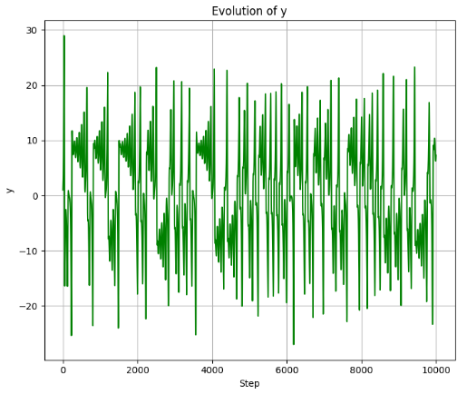
Fig. 3. Evolution of states of chaotic system (Variable $y$)

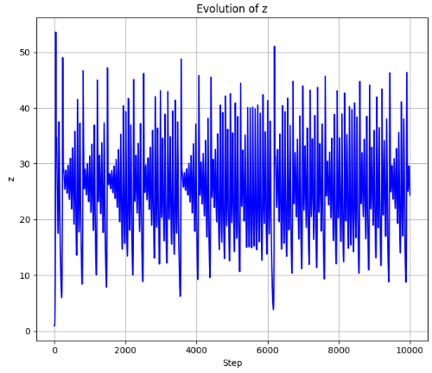
Fig. 4. Evolution of states of chaotic system (Variable $z$)

The evolution graph of the chaotic system's states (Fig. 2–Fig. 4) illustrates the temporal variation of the coordinates $x,y$ and $z$ for the Lorentz system. A distinct nonlinearity is evident: the variable $z$ (blue line) exhibits the most extensive range of oscillations, generally from $z_{min}≈5$ to $z_{max}≈50$, signifying its predominant impact on the system's dynamics. The variable $x$ (red line) oscillates between [−20;20], while $y$ (green line) spans around [−25;30]. The lack of consistent amplitudes indicates the chaotic nature of the process. Periods of amplitude development and decline are visually discernible, indicating the presence of quasi-periodic regimes within the chaos. Quantitative metrics validate a pronounced sensitivity to initial conditions, and considerable variability in coordinate values facilitates the application of this model for optimizing robotic trajectories in situations characterized by movement unpredictability.

Analysis of the constructed trajectory of a mobile robot on a 2D map
The objective of the third experiment is to examine the robot's movement trajectory within the workspace, considering the provided chaotic signals. This enables us to evaluate the configuration and smoothness of the trajectory, verify the absence of undesirable oscillations, and ascertain the extent to which the path adheres to safety and efficiency standards. The simulation results obtained are illustrated in Fig. 5.
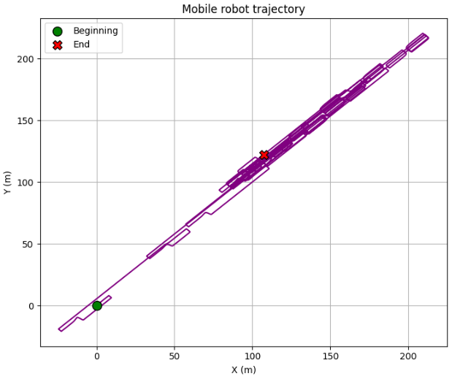
Рис. 5. Mobile robot trajectory

The trajectory graph of the mobile robot illustrates its movement from the initial coordinates $X≈0,Y≈0$ to the final coordinates $X≈220,Y≈200$, indicating a substantial displacement exceeding 300 m along the trajectory. The primary trajectory of movement is diagonal with minor deviations, evident as localized loop-like segments, indicating noise in the control system or adjustments from the navigation algorithm. The mean deviation from the optimal diagonal is approximately 1.5–3 m, while the largest local loops extend to about 5–7 m. The existence of the initial green marker and the concluding red marker verifies the accurate execution of the path without substantial deviation. The results indicate the robustness of the positioning algorithm over extensive movement distances, which is crucial for applications in production settings and Industry 5.0 contexts, where precision is essential amid dynamic environmental changes.

Research on the speed of a mobile robot
The objective of the fourth experiment is to examine the variation in the robot's velocity during motion and the stability of its dynamics. This assists in identifying any abrupt fluctuations in speed that may suggest system instability, as well as evaluating the fluidity of movement to guarantee safe interaction with individuals. Fig. 6 illustrates the simulation results obtained.

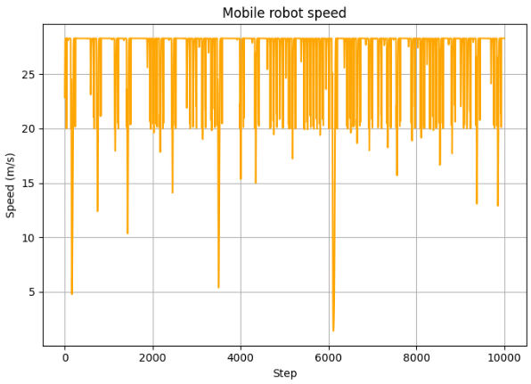
Рис. 6. Mobile robot speed

The examination of the mobile robot speed graph (Fig. 6) indicates that the average speed is approximately 23–25 m/s, reflecting a stable movement mode over the majority of the modeling phases. Periodic reductions in speed to levels of 10–15 m/s are noted, with some instances reaching minimal values of approximately 2–3 m/s, potentially indicating the impact of impediments or alterations in control signals within the dynamic environment. The highest recorded value is approximately 27 m/s, indicating the occurrence of strong accelerations when adjusting to new trajectory locations. Notwithstanding the variations, the primary speed range persists between 21 and 26 m/s, signifying the efficacy of the implemented chaotic algorithm in sustaining elevated speeds during maneuvering. The results demonstrate the robust, dynamic stability of the system and the feasibility of employing such methods in situations requiring rapid responses to environmental changes with minimal latency.

Conclusion
The study showed how using chaotic dynamic systems can effectively determine the trajectory of a mobile robot, thereby ensuring its adaptability to a changing environment. The analysis of the chaotic system's state evolution demonstrated distinctive variations in the $X$, $Y$, and $Z$ coordinates, ranging from -30 to 50 units, so confirming the system's strong sensitivity to initial conditions and the complexity of trajectory forecasting. This aspect enables the formulation of pathways that consider unforeseen impediments and enhances the robustness of control algorithms against external disturbances.
The robot motion graph validated the accuracy of the mathematical model implementation, since the initial movement point was near (0,0) and the final point was around (220, 200), indicating a considerable distance covered with minimum deviation. Notwithstanding the occurrence of small oscillations and loops with amplitudes of 5–7 m, the overall trajectory adhered closely to the principal line of motion, demonstrating the efficacy of the navigation system grounded in chaotic dynamics. The mean deviation ranged from 1.5 to 3 meters, which is an acceptable metric for systems where collision avoidance and trajectory distribution across multiple agents are critical.
The results obtained affirm that chaotic models can effectively facilitate the construction of nonlinear adaptive trajectories in complicated contexts where traditional methods exhibit limited efficacy. Subsequent research should concentrate on the amalgamation of chaotic models with machine learning techniques and optimization strategies for trajectory prediction, alongside the creation of control systems that integrate chaotic signals with a sensor network to guarantee high positioning precision and secure interaction with other agents in the Industry 5.0 context.

References
R., Hoseinnezhad, "A comprehensive review of deep learning techniques in mobile robot path planning: Categorization and analysis," Applied Sciences, vol. 15, no. 4, pp. 2179, 2025. doi: 10.3390/app15042179.
Y., Tang, M. A., Zakaria, and M., Younas, "Path planning trends for autonomous mobile robot navigation: A review," Sensors, vol. 25, no. 4, pp. 1206, 2025. doi: 10.3390/s25041206.
F., Ye, P., Duan, L., Meng, and L., Xue, "A hybrid artificial bee colony algorithm with genetic augmented exploration mechanism toward safe and smooth path planning for mobile robot," Biomimetic Intelligence and Robotics, vol. 5, no. 2, pp. 100206, 2025. doi: 10.1016/j.birob.2024.100206.
- R., Matarneh, S., Maksymova, Z., Deineko, and V., Lyashenko, "Building robot voice control training methodology using artificial neural net," International Journal of Civil Engineering and Technology, vol. 8, no. 10, pp. 523-532, 2017.
J. H., Baker, F., Laariedh, M. A., Ahmad, V., Lyashenko, S., Sotnik, and S. K., Mustafa, "Some interesting features of semantic model in Robotic Science," SSRG International Journal of Engineering Trends and Technology, vol. 69, no. 7, pp. 38-44, 2021. doi: 10.14445/22315381/IJETT-V69I7P205.
H., Wang, L., He, S., Zhang, R., Bai, and Y., Wang, "Mobile Robot Path Planning Considering Obstacle Gap Features," Applied Sciences, vol. 15, no. 11, pp. 5979, 2025. doi: 10.3390/app15115979.
W. A., Hashim, S. R., Ahmed, M. T., Mahmood, M. A., Almaiah, R., Shehab, and R., AlAli, "Optimizing Mobile Robot Path Planning with a Hybrid Crocodile Hunting and Falcon Optimization Algorithm," Journal of Robotics and Control (JRC), vol. 6, no. 2, pp. 543-552, 2025. doi: 10.18196/jrc.v6i2.25586.
- H., Attar, A. T., Abu-Jassar, A., Amer, V., Lyashenko, V., Yevsieiev, and M. R. Khosravi, "Control system development and implementation of a CNC laser engraver for environmental use with remote imaging," Computational intelligence and neuroscience, vol. 2022, no. 1, pp. 9140156, 2022. doi: 10.1155/2022/9140156.
A. T., Abu-Jassar, H., Attar, A., Amer, V., Lyashenko, V., Yevsieiev, and A., Solyman, "Development and Investigation of Vision System for a Small-Sized Mobile Humanoid Robot in a Smart Environment," International Journal of Crowd Science, vol. 9, no. 1, pp. 29-43, 2025. doi: 10.26599/IJCS.2023.9100018.
V., Lyashenko, A. T., Abu-Jassar, V., Yevsieiev, and S., Maksymova, "Automated Monitoring and Visualization System in Production," International Research Journal of Multidisciplinary Technovation, vol. 5, no. 6, pp. 9-18, 2023. doi: 10.54392/irjmt2362.
X., Cheng, Z., Liu, and H., Fang, "Deep fusion of discrete-time and continuous-time models for long-term prediction of chaotic dynamical systems," Nonlinear Dynamics, vol. 113, no. 11, pp. 12545-12563, 2025. doi: 10.1007/s11071-025-11048-9.
M. S., Alam, W., Ott, and I., Timofeyev, "Attractor learning for spatiotemporally chaotic dynamical systems using echo state networks with transfer learning," arXiv preprint arXiv:2505.24099, 2025. doi: 10.48550/arXiv.2505.24099.
M. A., Bouke, "On the Intractability of Chaotic Symbolic Walks: Toward a Non-Algebraic Post-Quantum Hardness Assumption," arXiv preprint arXiv:2505.22644, 2025. doi: 10.48550/arXiv.2505.22644.
U. P., Amadasun, P., McNamee, Z. N., Ahmadabadi, and P., Naseradinmousavi, "Autonomous search of real-life environments combining dynamical system-based path planning and unsupervised learning," IEEE Access, vol. 13, pp. 101274-101296, 2025. doi: 10.1109/ACCESS.2025.3577496.
S., Tang, T., Sapsis, and N., Azizan, "Learning chaotic dynamics with embedded dissipativity," arXiv preprint arXiv:2410.00976, 2024. doi: 10.48550/arXiv.2410.00976.
- M. A. Ahmad, J. H., Baker, I., Tvoroshenko, and V., Lyashenko, "Computational complexity of the accessory function setting mechanism in fuzzy intellectual systems," International Journal of Advanced Trends in Computer Science and Engineering, vol. 8, no. 5, pp. 2370-2377, 2019. doi: 10.30534/ijatcse/2019/77852019.
Y., Tang, M. A., Zakaria, and M., Younas, "Path planning trends for autonomous mobile robot navigation: A review," Sensors, vol. 25, no. 4, pp. 1206, 2025. doi: 10.3390/s25041206.
J., Chen, L., Xu, H., Ebel, and P., Eberhard, "An Online Optimization-Based Trajectory Planning Approach for Cooperative Landing Tasks" arXiv preprint arXiv:2502.13823, 2025. doi: 10.48550/arXiv.2502.13823.
J., Lai, Z., Wu, Z., Ren, Q., Tan, and S., Xie, "Trajectory planning of mobile robot: A Lyapunov-based reinforcement learning approach with implicit policy," Knowledge-Based Systems, pp. 113870, 2025. doi: 10.1016/j.knosys.2025.113870.
B., Li, Z., Ji, Z., Zhao, and C., Yang, "Model Predictive Optimization and Terminal Sliding Mode Motion Control for Mobile Robot With Obstacle Avoidance," IEEE Transactions on Industrial Electronics, vol. 72, no. 9, pp. 9293-9303, 2025. doi: 10.1109/TIE.2025.3536628.
A., Abu-Jassar, H., Al-Sukhni, Y., Al-Sharo, S., Maksymova, V., Yevsieiev, V., Lyashenko, "Building a Route for a Mobile Robot Based on the BRRT and A*(H-BRRT) Algorithms for the Effective Development of Technological Innovations," International Journal of Engineering Trends and Technology, vol. 72, no. 11, pp. 294-306, 2024. doi: 10.14445/22315381/IJETT-V72I11P129.
S., Azubairi, A., Petunin, H. L., Alwan, M. M., Msallam, and A., Humaidi, "Dynamic Processing 2D Maps Method for Robot’s Trajectory Planning," Proceedings of Engineering and Technology Innovation, vol. 30, pp. 79-89, 2025. doi: 10.46604/peti.2024.14508.
B., Derajić, M. K., Bouzidi, S., Bernhard, and W., Hönig, "Learning Maximal Safe Sets Using Hypernetworks for MPC-based Local Trajectory Planning in Unknown Environments," IEEE Robotics and Automation Letters, vol. 10, no. 9, pp. 8842-8849, 2025. doi: 10.1109/LRA.2025.3589151.
H. N., Le, M. K., Pham, D. H., Pham, and T. V. A., Nguyen, "Trajectory tracking and stabilization of two-wheeled balancing mobile robot with hierarchical and sliding mode control," International Journal of Dynamics and Control, vol. 13, no. 1, pp. 10, 2025. doi: 10.1007/s40435-024-01518-0.
T., Liu, H., Zhong, J., Hu, and T., Zhang, "SafeMove-RL: A Certifiable Reinforcement Learning Framework for Dynamic Motion Constraints in Trajectory Planning," arXiv preprint arXiv:2505.12648, 2025. doi: 10.48550/arXiv.2505.12648.
A. K., Aijazi, and P., Checchin, "Building Fast Dynamic 3D Maps for Trajectory Planning of Autonomous Ground Vehicles Using Non-Repetitive Scanning LiDAR Sensor," IEEE Access, vol. 13, pp. 76879-76893, 2025. doi: 10.1109/ACCESS.2025.3564764.
E., Villalba-Aguilera, J., Blesa, and P., Ponsa, "Model-based predictive control for position and orientation tracking in a multilayer architecture for a three-wheeled omnidirectional mobile robot," Robotics, vol. 14, no. 6, pp. 72, 2025. doi: 10.3390/robotics14060072.
Z., Tao, W., Xu, and X., You, "Map2Traj: Street Map Piloted Zero-shot Trajectory Generation with Diffusion Model," arXiv preprint arXiv:2407.19765, 2024. doi: 10.48550/arXiv.2407.19765.
H., Tian, M., Zhao, J., Liu, Q., Wang, X., Yu, and Z., Wang, "Dynamic analysis and sliding mode synchronization control of chaotic systems with conditional symmetric fractional-order memristors," Fractal and Fractional, vol., 8, no. 6, pp. 307, 2024. doi: 10.3390/fractalfract8060307.
Y., Sun, Y., Chen, B., Wang, and C., Ma, "A novel adaptive predefined-time sliding mode control scheme for synchronizing fractional order chaotic systems," Chaos, Solitons & Fractals, vol. 189, pp. 115610, 2024. doi: 10.1016/j.chaos.2024.115610.
Y., Wang, J., Cao, X., Zheng, Y., Zhang, Y., Zhang, and W., Chen, "Path planning of RRT* algorithm with subregional dynamic probabilistic sampling based on artificial potential field in radiation environments," Nuclear Engineering and Technology, vol. 57, no. 10, pp. 103706, 2025. doi: 10.1016/j.net.2025.103706.
S., Wang, and S., Wen, "Safe control against uncertainty: A comprehensive review of control barrier function strategies," IEEE Systems, Man, and Cybernetics Magazine, vol. 11, no. 1, pp. 34-47, 2025. doi: 10.1109/MSMC.2024.3431789.
A. S., Berahas, J., Shi, and B., Zhou, "Optimistic noise-aware sequential quadratic programming for equality constrained optimization with rank-deficient jacobians," arXiv preprint arXiv:2503.06702, 2025. doi: 10.48550/arXiv.2503.06702.
M., Kim, A., Esquerre-Pourtère, and J., Park, "Robust Real-time Sampling-based Motion Planner for Autonomous Vehicles in Narrow Environments," IEEE Transactions on Automation Science and Engineering, vol. 22, pp. 16250-16265, 2025. doi: 10.1109/TASE.2025.3574262.
L., Twist, J. M., Zhang, M., Harman, D., Syme, J., Noppen, and D., Nauck, "LLMs Love Python: A Study of LLMs' Bias for Programming Languages and Libraries," arXiv preprint arXiv:2503.17181, 2025. doi: 10.48550/arXiv.2503.17181.
F. V., Ryzhkov, Y. E., Ryzhkova, and M. N., Elinson, "Python tools for structural tasks in chemistry," Molecular diversity, vol. 29, no. 4, pp. 3733-3752, 2025. doi: 10.1007/s11030-024-10889-7.
A., Deriyeva, J., Dannath, and B., Paassen, "SCRIPT: Implementing an intelligent tutoring system for programming in a german university context," In International Conference on Artificial Intelligence in Education, pp. 168-177, 2025. doi: 10.1007/978-3-031-99261-2_16.
C., Balakrishnan, P. K.,, MR, P., Gajalakshmi, and G., Palaisamy, "Advanced Visualization Tools, Algorithms, and Techniques: Advancements and Applications Across Domains," In 2025 11th International Conference on Communication and Signal Processing (ICCSP), pp. 1-6, 2025. doi: 10.1109/ICCSP64183.2025.11088600.
M., Aljamal, S., Patel, and A., Mahmood, "Comprehensive review of robotics operating system-based reinforcement learning in robotics," Applied Sciences, vol. 15, no. 4, pp. 1840, 2025. doi: 10.3390/app15041840.
R., Royce, and et al., "Enabling novel mission operations and interactions with rosa: The robot operating system agent," In 2025 IEEE Aerospace Conference, pp. 1-16, 2025. doi: 10.1109/AERO63441.2025.11068426.

