Performance Enhancement of Natural Dye-Sensitized Solar Cells via Anthocyanin–Betalain Dyad Photovoltaic Structures

Hamza Karajeh
Jubilee School
Amman, Jordan
hkarajeh@stud.jubilee.edu.jo

Sawsan Jamil Abu Jamma’ah
Jubilee School
Amman, Jordan
sabujammaah@jubilee.edu.jo
Azhar Sameer Ahmad Omar
Jubilee School
Amman, Jordan
azharsameer@yahoo.com

Abstract— Alternatives to traditional silicon-based solar cells have drawn more attention as the need for sustainable energy solutions keeps rising, and that's due to their consistent performance under low illumination, flexibility, and ease of manufacture, dye-sensitized solar cells (DSSCs) present a possible solution. This study investigates the use of natural photosensitizers in single-dye and dyad combinations, including betalain from beetroot and anthocyanin from red cabbage. These natural colors were chosen because of their potent light-absorption capabilities, environmental friendliness, and accessibility. Each dye was used singly or in a combined dyad structure to manufacture DSSCs, which were then assessed for optical and photovoltaic performance. The presence of important functional groups and the properties of dye absorption were assessed using spectroscopic methods such as UV-Vis and ATR-FTIR, in addition, photovoltaic parameters were measured, and according to the results, the dyad design performed better than the single-dye cells. The two pigments have complimentary and wider range of light absorption which causes this performance improvement. These findings demonstrate how mixing natural dyes can increase DSSC efficiency and offer a workable, environmentally responsible strategy for developing next-generation solar technology.
Keywords— Dye-sensitized solar cells (DSSCs), natural dyes, dyad structures

Introduction
Dye-sensitized solar cells (DSSCs) are a promising type of third-generation solar cell that convert light into electricity through the photovoltaic effect, offering a more cost-effective and scalable alternative to traditional silicon-based solar cells. These cells rely on photosensitizer dyes to absorb light and transfer electrons to a semiconductor, typically titanium dioxide (TiO₂), which is critical to their efficiency [1]. The most successful sensitizers in terms of efficiency and stability are based on ruthenium (Ru) bipyridyl compounds. These dyes exhibit excellent characteristics, including high stability, superior absorption in the visible solar spectrum, efficient electron injection, and fast metal-to-ligand charge transfer rates, which prevent recombination reactions. While ruthenium-based dyes are capable of achieving conversion efficiencies exceeding 10%, their high cost, complex preparation processes, and environmental concerns significantly limit their widespread use [2][3]. In contrast, natural dyes are abundant, easily extractable, and ecofriendly, obtained from natural sources such as flower petals and leaves [4]. However, their lower efficiency compared to synthetic dyes presents a significant challenge. Enhancing the performance of natural dye-based DSSCs is vital for advancing their competitiveness and unlocking their potential as accessible, sustainable energy solutions [5].
The development of dye-sensitized solar cells (DSSCs) dates back to 1972 when researchers first experimented with chlorophyll-sensitized zinc oxide photoanodes, though their efficiency remained low due to insufficient surface area for effective light harvesting [6]. A pivotal advancement came in 1991 when Michael Grätzel and Brian O’Regan introduced nanostructured TiO₂ films coated with a ruthenium-based dye, achieving a remarkable efficiency of 7.1–7.9%, marking a turning point in DSSC technology [7].
Research on the use of natural dyes in DSSCs has garnered significant attention as these dyes offer promising sustainable and cost-effective alternatives to synthetic dyes. Plant-based DSSCs are advantageous due to their affordability, non-toxicity, and minimal environmental impact compared to conventional chemical-based DSSCs. Natural plant dyes, including anthocyanin and betalain act as sensitizers, efficiently absorbing sunlight and converting it into electrical energy. Various studies have explored the application of these plant-derived dyes in DSSCs, some examples are shown in TABLE I. However, even though some research has been conducted on mixed dye-based DSSCs, there is a significant lack of studies focusing on natural dye-based dyad DSSCs. This gap highlights the need to explore innovative natural dye configurations to optimize the efficiency of natural dye-based DSSCs further.
Research on mixed natural dyes in DSSCs has demonstrated their potential to enhance performance by broadening light absorption and improving dye interaction with the semiconductor. A study investigating the performance of chlorophyll and xanthophyll pigments extracted from (Cladophora sp.), a type of filamentous freshwater green algae, highlights the value of combining natural pigments for increased efficiency [8]. Another study examined the combination of anthocyanin, betalain, and chlorophyll pigments, showcasing how mixed-dye configurations can improve complementary absorption spectra to improve light-harvesting efficiency and overall DSSC performance [9].
TABLE I
Photoelectrochemical Properties of Various Reported Natural Plant Dyes Used in DSSCs

Plant source | Dye type | FF | η  (%) | Reference
Berberis Integerrima | Berberin | 0.53 | 0.01 | [10]
Punica granatum | Anthocyanin | 0.209 | 0.20 | [11]
Rubus subg. Rubus | Anthocyanin | 0.29 | 0.38 | [12]
Allium cepa | Anthocyanin | 46.63194 | 0.064723 | [13]

The purpose of this study is to investigate the use of natural dyes as sustainable photosensitizers in DSSCs to enhance their performance and commercial viability. Natural dyes extracted from plants—including anthocyanins and betalain from red cabbage (Brassica oleracea L. var. capitata f. rubra) and beetroot (Beta vulgaris)—are analyzed for their affordability, environmental benefits, and interactions with TiO₂ semiconductors. By evaluating the optical properties of both individual and layered dye configurations, alongside key performance parameters. this study aims to advance the development of DSSCs as a cost-efficient and accessible renewable energy technology.
Initially, traditional single-dye DSSCs will be prepared as a control group, while Dyad configurations will be fabricated by sequentially layering two different natural dye sensitizers. These two groups will be analyzed using ATR-IR and UV-Vis Spectroscopy for optical properties, as well as their photoelectrochemical performance, including photocurrent density, open-circuit voltage, fill factor, and power conversion efficiency. Theoretically, dyad configurations can enhance DSSC performance by broadening light absorption and improving dye interaction with the semiconductor. Therefore, it is hypothesized that DSSCs with dyad configurations will exhibit superior overall performance compared to traditional single-dye DSSCs.

Experimental

Materials
The materials used in this study include red cabbage (Brassica oleracea) and beetroot (Beta vulgaris) as sources of natural dyes. Ethanol (95%) was used as a solvent during the extraction and cleaning processes. Fluorine-doped tin oxide (FTO) glass substrates (Qunguan, 20 mm × 20 mm, 2.2 mm thickness, 6–8 Ω/sq sheet resistance, ≥84% light transmittance) served as the conductive electrodes. Titanium dioxide (TiO₂) nanopowder of analytical reagent (AR) grade was employed as the photoanode material. The electrolyte solution was prepared using iodine (I₂) and potassium iodide (KI). All chemicals were of general laboratory grade and were used without further purification. Deionized water was used throughout the experimental procedures for cleaning and dilution purposes.

Dye extraction
Two natural dyes were extracted, anthocyanins from red cabbage (Brassica oleracea L. var. capitata f. rubra) and betalains from beetroot (Beta vulgaris). Both plants were purchased from a local market and thoroughly rinsed with water to remove dust and surface impurities.
For anthocyanin extraction, the red cabbage was chopped into small pieces and manually ground into a fine paste using a mortar and pestle. For every 5 g of cabbage paste, 10 mL of ethanol was added, and the mixture was stirred continuously at 35 °C for 48 hours using a magnetic stirrer set at 1250 rpm. Following extraction, the mixture was filtered using a mesh sieve and centrifuged to remove solid aggregates. The resulting solution was protected from light using aluminum foil and stored in a dark location to prevent photo-oxidation until further use. The molecular structure of anthocyanin is shown in Fig. 1.
For betalain extraction, beetroot was peeled and boiled in distilled water at 98 °C. The water was then partially evaporated to increase dye saturation. After cooling, the solution was filtered using a mesh sieve and centrifuged multiple times to eliminate solid residues. The dye solution was covered with aluminum foil and stored in a dark place to prevent degradation due to photo-oxidation. The molecular structure of betalain is shown in Fig. 2.
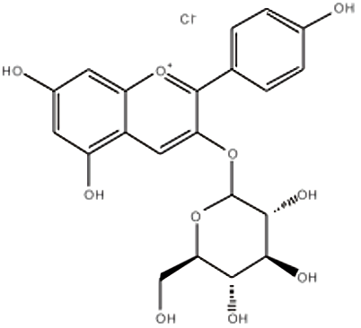
Fig. 1. Molecular structure of anthocyanin [14]
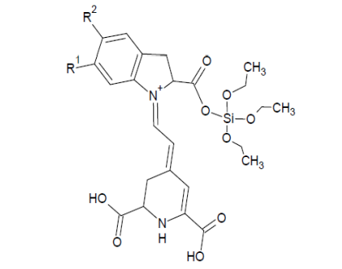
Fig. 2. Molecular structure of betalain [14]

DSSC fabrication
The photoanode was prepared by mixing 5 mL of ethanol with 5 g of TiO₂ to create a TiO₂ paste. The paste was applied to the surface of the FTO glass using the doctor-blading technique to form a uniform thin layer. The coated FTO glass was then annealed on a hot plate at 190 °C for 30 minutes, followed by a 10 minute cooling period. After cooling, the photoanode was immersed in the prepared dye solution for 20 minutes to allow for dye adsorption and then it was heated again at 190 °C for 30 minutes to enhance dye attachment. The CE was fabricated using the candle soot method as a cost-efficient alternative to platinum [15]. The FTO glass was held with tweezers and exposed to a candle flame, forming a thin carbon layer as the catalytic surface. The electrolyte was prepared by mixing iodine I₂ and triiodide I₃⁻ in a 1:11 ratio. To assemble the DSSC, the electrolyte was carefully dropped onto the surface of the photoanode. The carbon-coated CE was then placed over the photoanode, and the components were clamped together using two clamps on each side to secure the cell assembly.

Results and discusion

ATR-IR Spectroscopy
Both anthocyanin and betalain extracts showed broad hydroxyl stretching bands centered around 3300 cm⁻¹, along with distinct peaks near 1600 cm⁻¹ attributed to the carbonyl stretching band as shown in Fig. 3 for anthocyanin and Fig. 4 for betalain. These readings confirm the presence of hydroxyl and carbonyl groups, which are typical of polyphenolic compounds in natural dyes. Such functional groups are known to form strong interactions with metal oxide surfaces, such as TiO₂. Their presence suggests good potential for dye anchoring on the photoanode, which is essential for effective charge transfer, in addition, no abnormal peaks or shifts were detected, indicating that the molecular structures remained intact after extraction.

UV-Vis Spectroscopy
The anthocyanin solution exhibited a sharp absorption peak at approximately 535 nm, while betalain showed a maximum near 485 nm as shown in Fig. 5. These absorption bands fall well within the visible region, making both suitable for solar harvesting. This extended absorption is advantageous in capturing a wider range of photon energies, which can translate to higher photocurrent generation. The combined spectral response indicates that both dyes contribute simultaneously to light absorption in the dyad system, without significant spectral interference.

Photovoltaic Performance
Using a Schottky cell design, the photovoltaic performance of solar cells based on betalain and anthocyanin was tested in simulated sunshine (1 Sun = 1000 W/m2), furthermore, photocurrent–voltage curves were used to calculate important characteristics, such as maximum power density (Pmax), open-circuit voltage (Voc), and short-circuit current density (Jsc), as illustrated in TABLE II. The following equations were used to determine the maximum power, fill factor (FF), and power conversion efficiency (η):

Pmax​=Vmp​×Jmp​ (1)
FF= Pmax​​ / Voc​×Jsc (2)
η= Voc​×Jsc​×FF​ / Pin​ (3)
All of the key photovoltaic metrics clearly improved with the dyad-based DSSCs. Better charge separation and reduced recombination were probably facilitated by the dyad's wider absorption and the complimentary alignment of the two pigments' energy levels. Furthermore, the TiO₂ surface may have had more consistent dye coverage due to the presence of numerous anchoring groups, which would have enhanced interfacial stability and electron transport, in contrast, narrower absorption spectra restricted the performance of both single-dye systems, despite the fact that they demonstrated functional photovoltaic activity. The two pigments in the dyad system, on the other hand, worked in concert to provide stronger and more consistent light harvesting, which increased the total efficiency.

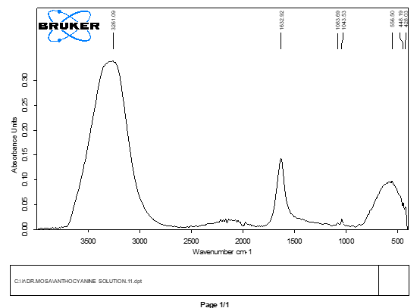
Fig. 3. ATR-IR of anthocyanin solution
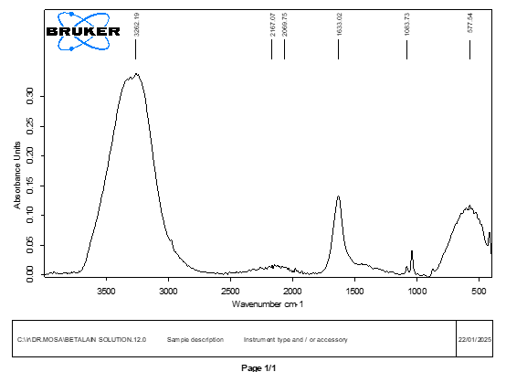
Fig. 4. ATR-IR of betalain solution
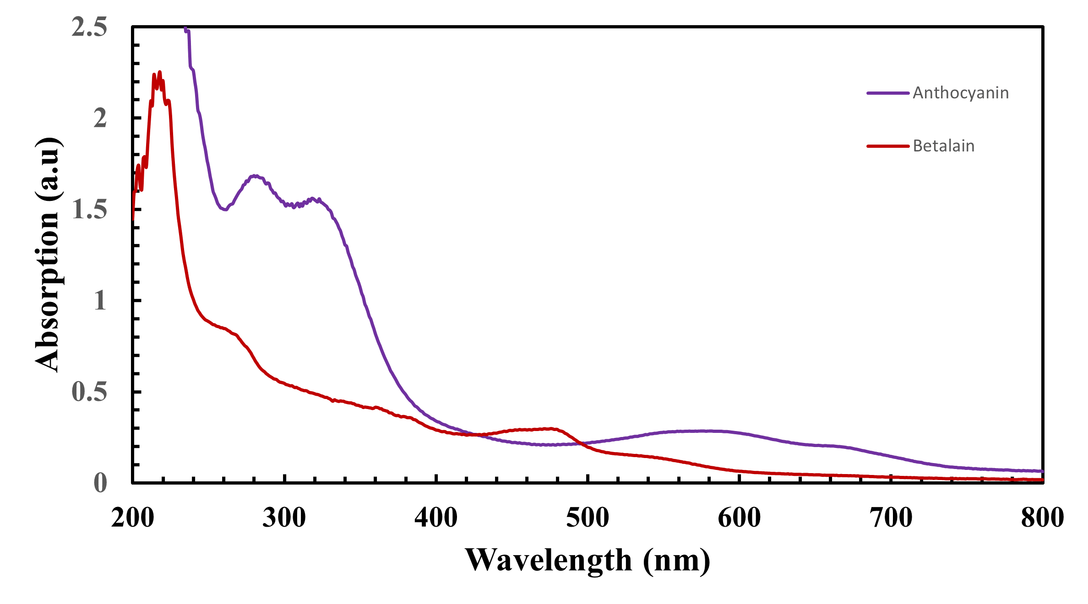
Fig. 5. UV-Vis spectra for anthocyanin and betalain solutions

TABLE II
Photovoltaic Properties of Anthocyanin and Betalain Based DSSCs

Cell type | Voc  (V) | Jsc (μA/cm2) | Pmax  (μW/cm2) | FF | η  (%)
Anthocyanin | 0.002 | 0.3 | 20.083E-6 | 0.03 | 0.02
Betalain | 0.001 | 0.2 | 190.21E-6 | 0.95 | 0.02
Dyad | 0.004 | 0.1 | 25.31E-6 | 0.75 | 0.3

Conclusion
In conclusion, this study suggests that using natural dyes like anthocyanin and betalain in DSSCs can result in decent photovoltaic performance, especially when they are combined in a dyad structure, which seems to take advantage of the broader light absorption range that the two pigments offer together rather than separately. The improved efficiency observed in the dyad-based DSSCs isn’t just a result of more light being absorbed, but possibly also due to better surface coverage or more effective interactions at the dye–semiconductor interface, though that would need deeper investigation to confirm. The extracted dyes retained their chemical structures well, as supported by the IR and UV-Vis data, which reinforces the idea that natural sources can be practical for solar applications, even if not as powerful as synthetic dyes. This study doesn't claim to offer a final solution, but it shows that simple, low-cost, and environmentally friendly materials still have a place in the ongoing research for better solar cell technologies, especially when used innovatively. There’s definitely room for optimization, perhaps by refining the extraction method or improving the layering process, but even in their current form, the results point toward natural dye dyads as a topic worth further investigation.

References
[1] M. E. Yeoh and K. Y. Chan, “Recent advances in photo-anode for dye-sensitized solar cells: a review,” Int J Energy Res, vol. 41, no. 15, pp. 2446–2467, Dec. 2017, doi: 10.1002/ER.3764.
[2] S. Shalini, R. Balasundara Prabhu, S. Prasanna, T. K. Mallick, and S. Senthilarasu, “Review on natural dye sensitized solar cells: Operation, materials and methods,” Renewable and Sustainable Energy Reviews, vol. 51, pp. 1306–1325, Nov. 2015, doi: 10.1016/J.RSER.2015.07.052.
[3] S. K. Das, S. Ganguli, H. Kabir, J. I. Khandaker, and F. Ahmed, “Performance of Natural Dyes in Dye-Sensitized Solar Cell as Photosensitizer,” Transactions on Electrical and Electronic Materials, vol. 21, no. 1, pp. 105–116, Feb. 2020, doi: 10.1007/S42341-019-00158-Y/METRICS.
[4] G. Richhariya, A. Kumar, P. Tekasakul, and B. Gupta, “Natural dyes for dye sensitized solar cell: A review,” Renewable and Sustainable Energy Reviews, vol. 69, pp. 705–718, Mar. 2017, doi: 10.1016/J.RSER.2016.11.198.
[5] D. Ganta, K. Combrink, and R. Villanueva, “Natural Dye-Sensitized Solar Cells: Fabrication, Characterization, and Challenges,” in Energy, Environment, and Sustainability, Springer Nature, 2019, pp. 129–155. doi: 10.1007/978-981-13-3302-6_5.
[6] H. TRIBUTSCH, “REACTION OF EXCITED CHLOROPHYLL MOLECULES AT ELECTRODES AND IN PHOTOSYNTHESIS*,” Photochem Photobiol, vol. 16, no. 4, pp. 261–269, Oct. 1972, doi: 10.1111/J.1751-1097.1972.TB06297.X.
[7] B. O’Regan and M. Grätzel, “A low-cost, high-efficiency solar cell based on dye-sensitized colloidal TiO2 films,” Nature 1991 353:6346, vol. 353, no. 6346, pp. 737–740, Oct. 1991, doi: 10.1038/353737a0.
[8] A. Lim et al., “Higher Performance of DSSC with Dyes from Cladophora sp. as Mixed Cosensitizer through Synergistic Effect,” Journal of Biophysics, vol. 2015, no. 1, p. 510467, Jan. 2015, doi: 10.1155/2015/510467.
[9] N. Patni, S. G. Pillai, and P. Sharma, “Effect of using betalain, anthocyanin and chlorophyll dyes together as a sensitizer on enhancing the efficiency of dye-sensitized solar cell,” Int J Energy Res, vol. 44, no. 13, pp. 10846–10859, Oct. 2020, doi: 10.1002/ER.5752.
[10] M. Hamadanian, J. Safaei-Ghomi, M. Hosseinpour, R. Masoomi, and V. Jabbari, “Uses of new natural dye photosensitizers in fabrication of high potential dye-sensitized solar cells (DSSCs),” Mater Sci Semicond Process, vol. 27, pp. 733–739, Nov. 2014, doi: 10.1016/J.MSSP.2014.08.017.
[11] K. B. Erande et al., “Extraction of natural dye (specifically anthocyanin) from pomegranate fruit source and their subsequent use in DSSC,” Mater Today Proc, vol. 43, pp. 2716–2720, Jan. 2021, doi: 10.1016/J.MATPR.2020.06.357.
[12] A. Sikder et al., “Characterization and Comparison of DSSCs Fabricated with Black Natural Dyes Extracted from Jamun, Black Plum, and Blackberry,” Energies 2023, Vol. 16, Page 7187, vol. 16, no. 20, p. 7187, Oct. 2023, doi: 10.3390/EN16207187.
[13] A. M. Ammar, H. S. H. Mohamed, M. M. K. Yousef, G. M. Abdel-Hafez, A. S. Hassanien, and A. S. G. Khalil, “Dye-Sensitized Solar Cells (DSSCs) Based on Extracted Natural Dyes,” J Nanomater, vol. 2019, no. 1, p. 1867271, Jan. 2019, doi: 10.1155/2019/1867271.
[14] D. Sinha, D. De, D. Goswami, and A. Ayaz, “Fabrication of DSSC with Nanostructured ZnO Photo Anode and Natural Dye Sensitizer,” Mater Today Proc, vol. 5, no. 1, pp. 2056–2063, Jan. 2018, doi: 10.1016/J.MATPR.2017.09.201.
[15] R. A. Toor and M. H. Sayyad, “Candle soot based carbon counter electrode for cost-effective dye sensitized solar cells,” Proceedings of 18th International Bhurban Conference on Applied Sciences and Technologies, IBCAST 2021, pp. 87–92, Jan. 2021, doi: 10.1109/IBCAST51254.2021.9393023.

