Innovative Deep Learning Solutions for Image Forgery Detection

1st Mohammed Hasan Mutar
Department of Computer Technical engineering, College of Information Technology
Imam Ja'afar Al-Sadiq University
Al-Muthanna, Iraq
muhammad.hassan@ijsu.edy.my
4th Rizgar Rahman Ghafour
National University of Science and Technology
Dhi Qar, Iraq
rizgar.r.ghafour@nust.edu.iq
2nd Ramy Al-Fatlawy
Department of Computer Technical Engineering
College of Technical Engineering
The Islamic University
Najaf, Iraq
ramy_riad@iunajaf.edu.iq.
5th Fatima Hashim Abbas
Medical Laboratories Techniques Department
Al-Mustaqbal University
Hillah, Iraq
fatimahashim@mustaqbal-college.edu.iq.
3rd Hussein Ali Rasool
Department of Computer Science
Altoosi University College
Najaf, Iraq
hussein_al-luhiby@altoosi.edu.iq
6th Dulfikar jawad hashim
Department of Computer Techniques Engineering
Mazaya University College
DhiQar, Iraq;
dulfikarjawadhashim@mpu.edu.iq.

Abstract— Digital image forgery detection is crucial in addressing the rapid spread of fake information through manipulated images, especially on social media platforms. Traditional techniques often focus on specific types of forgery, limiting their effectiveness in real-world scenarios. Traditional methods heavily depend on manual feature engineering, which often results in overlooked manipulations, decreased accuracy, adaptability, and scalability issues when handling large datasets or high-resolution images. Deep learning has emerged as a powerful tool for addressing the challenges associated with image forgery detection. The proposed work introduces an innovative method for detecting image forgeries using deep learning techniques, employing convolutional neural networks (CNNs) and specifically evaluating the performance of the EfficientNetb7 model. This method leverages transfer learning to detect copy-move image forgery. It involves generating featured images by calculating the difference between the input image and compressed versions, which are then fed into pre-trained CNN model. The model undergo fine-tuning to adapt to forgery detection. Additionally, the output of the forgery detection process includes both text and audio. This combination enhances the accessibility and interpretability of the detection results, making them more understandable for users with different sensory preferences or impairments. This added feature ensures that the detection outcomes are easily comprehensible and usable across a broader range of users and applications.
Keywords—Rapid Spread; Forged Detection; EfficientNetb7; CNN; Deep Learning; Digital Image.
- Introduction
Digital image forgery occurs when an image is altered to manipulate others, often using software like Adobe Photoshop or GIMP. These fake images are commonly spread on social media platforms like Facebook and Twitter, contributing to misinformation. There are various types of image forgery, such as copy-move forgery, where parts of an image are duplicated and pasted elsewhere, or splicing forgery, where two images are combined. Detecting these forgeries is challenging because they can look realistic. Fig.1. shows the classification of image forgery detection. To detect fake images, two main approaches are used: Active and Passive.
Active methods involve adding specific information to the image during the creation or editing process. This can include digital signatures, watermarks, or other forms of metadata that can be used to verify the authenticity of the image. Passive methods, on the other hand, analyze the image itself for signs of tampering without requiring additional information.
Detecting image forgery is not only important for maintaining the integrity of digital media but also for verifying evidence in legal proceedings and preventing the spread of misinformation. However, the computational complexity of forgery detection algorithms and the diverse nature of image manipulation techniques present significant challenges.
Many existing techniques struggle to detect edited images, especially those that have been resized or blurred. Additionally, detecting multiple types of forgery simultaneously can further increase the complexity of the detection process.
This paper introduces a new method to detect copy - move image forgery, with high accuracy. Pre-trained models and transfer learning are utilized to speed up and optimize the process, even on devices with constrained resources. This approach was tested on a challenging dataset and compared to other techniques in the field.

FIGURE 1. Classification of Image Forgery Detection

Khalid M. Hosny's CNN framework detects copy-move image forgery with integrated preprocessing, achieving 100% accuracy in just 0.83 seconds using batch processing and "rmsprop" optimizer [1]. Jingjing Rao's method combines ResNet with a Transformer decoding layer for detecting tampering methods, utilizing feature extraction, positional embedding, and encoder layers to capture global information [2]. Anjali Diwan's method for copy-move forgery detection in images employs SuperPoint for keypoint
extraction, matching using Euclidean distance, BBF search algorithm, and clustering , enhancing accuracy [3]. Shehin's algorithm detects copy-move duplication in images using DCT and eigenvalues, enabling accurate detection even after rotation attacks [4].Tahira Nazir's approach employs DenseNet-41 and Mask-RCNN models to accurately detect Copy-move forgery in images with high precision rates [5].Mehrad Aria's QDL-CMFD utilizes GANs and CNNs to robustly detect copy-move image forgery, excelling particularly in identifying low-quality forgeries [6]. Xiangyang Wang's method for detecting copy-move forgery improves accuracy and speed by employing dynamic thresholds, feature point extraction, and refined matching and filtering stages, overcoming previous limitations [7]. Kang Hyeon Rhee's approach enhances Copy-Move forgery detection accuracy by synthesizing a novel ground truth image through combining CNN outputs from image classification and semantic segmentation, optimizing information from both processes [8]. Yanzhi Xu's model for detecting image splicing forgery integrates MFEM, Pixel-level Supervised Contrastive Learning, and Multi-loss Progressive Learning to enhance feature representation and surpass previous methods, even in challenging scenarios like noisy or compressed images [9]. Kaiqi Zhao's CAMU-Net utilizes a three-stage methodology, including hierarchical feature extraction, matching, and resource allocation with Coordinate Attention, for copy-move forgery detection [10]. Francesco Marra suggests CNN-based strategies in image forensics, analyzing high-resolution images in patches with gradient check pointing for efficient training, avoiding detail blurring caused by resizing [11]. Ananthi M's AFIFN employs Discrete Cosine Transformation and Y Cr Cb-based pre-processing techniques in a two-layered network with a classification layer, excelling in uncovering manipulated images and outperforming existing methods [12]. G.Nirmalapriya utilizes ASCA, integrating DCNN and SqueezeNet, for digital image forgery detection, effectively distinguishing between authentic and forged images with streamlined training and computational demands [13]. Rachna Mehta's novel approach detects resampling forgery using Markov features from spatial and Discrete Cosine Transform domains, boasting high accuracy, reduced complexity, and a Graphical User Interface for forgery identification [14].
Chaitra B's deep learning system utilizes GoogLeNet and FLHHO to effectively detect Copy Move Forgery (CMF) in images, achieving high testing accuracy and True Negative and True Positive Rates [15]. Kalyani Kadam's Mask R-CNN with MobileNet V1 backbone identifies splicing image forgery and quantifies forged regions, surpassing alternative models with higher precision and F1-Score, achieving 82% precision on MISD [16]. Mashael Maashi's RSADTL-CMFD employs NASNet for feature extraction, RSA for hyperparameter tuning, and XGBoost for image classification, outperforming other techniques in copy-move forgery detection with deep learning [17]. Manaf Mohammed Ali Alhaidery's scheme detects copy-move forgery in images through three stages: identifying duplicated regions, localizing matched areas, and analyzing overlapping Zernike moments, ensuring accurate classification crucial for cybercrime detection and legal evidence [18]. Fatemeh Zare Mehrjardi highlights the importance of employing both traditional and deep learning detection techniques to address image forgery, emphasizing the effectiveness and resilience of deep learning in automatic identification [19]. Ashgan H. Khalil's method for detecting image forgery assesses compression quality variation using a deep neural network and transfer learning, trained on diverse image sets for effective detection, evaluating eight pretrained models for binary classification [20]. Agarwal's method detects fake images, particularly those created through copy-move forgery, by segmenting the image, extracting features using VGGNet, and employing adaptive patch matching to identify tampered regions, ensuring accurate detection despite alterations [21]. Al_Azrak's method employs CNNs and Discrete Fourier Transform to effectively detect copy-move forgery, proving robust against manipulations like digital watermarks or signatures [22]. Abhishek's method utilizes deep convolutional neural networks and semantic segmentation with color illumination post-processing to achieve accurate detection and localization of image forgeries, outperforming other methods with total accuracy exceeding 98% [23]. Jaiswal's proposed deep learning CNN model for copy-move forgery detection utilizes multi-scale input and encoder-decoder blocks to effectively classify pixels as forged or non-forged, addressing challenges with geometric transformations and computational costs [24]. Koul's novel CNN-based approach achieves automatic copy-move forgery detection with an impressive 97.52% accuracy on the MICC-F2000 dataset, outperforming traditional methods by 2.52% [25].
Overall, this deep learning techniques presents a promising approach to detecting image forgery, which is crucial for maintaining trust and accuracy in digital media. However, continued research and development are needed to address remaining challenges and further improve the reliability of forgery detection algorithms.
- PROPOSED APPROACH

The model aims to detect forged images by comparing them with their compressed versions. Initially, the input image is compressed to obtain a compressed version. The difference between the input image and its compressed version (Difference image) is calculated using mathematical subtraction. The difference image highlights the forged parts of the image due to the disparities between the input and compressed images. Difference image is to serve as input for a pre-trained model for further processing.
EfficientNetb7 pre-trained model architecture is modified to suit binary classification (authentic or forged images). The input layer represents the input image data, which could be a forged image or authentic image in the context of image forgery detection. The Convolutional layers perform convolution operations on the input image. These operations help in extracting features from the image, such as edges, textures, and patterns, which are important for detecting potential forgeries. Batch normalization helps in normalizing the activations of the previous layer, making the optimization process more stable and efficient. It ensures that the model trains faster and can generalize better to unseen data, which is crucial for accurate forgery detection. The Swish activation function introduces non-linearity into the model, enabling it to learn complex patterns and relationships within the image data. This non-linearity is essential for capturing the intricate details that may indicate forgery in the image. Mobile Inverted Bottleneck Convolution (MBConv) blocks are the key building blocks of EfficientNet models. These
blocks consist of depthwise separable convolutions and squeeze-and-excitation (SE) blocks. They help in efficiently capturing features at different scales and resolutions, which is beneficial for detecting forged regions of varying sizes and complexities. The Global Average Pooling layer aggregates the features extracted by the convolutional layers across the entire image. This helps in reducing the spatial dimensions of the feature maps while retaining the most important information, facilitating efficient classification of the image as authentic or forged. Dropout regularization is applied to prevent overfitting by randomly dropping out a fraction of the neurons during training. This encourages the model to learn more robust and generalizable features from the data, which improves its performance in detecting forged images, especially in the presence of noise or variations. The Dense layer performs classification based on the features extracted from the input image. In the context of image forgery detection, this layer helps in making predictions about whether the input image is authentic or forged. The architecture of EfficientNetB7 is well-suited for image forgery detection due to its ability to efficiently capture and represent features at different scales and resolutions. The convolutional layers, MBConv blocks, and regularization techniques help in extracting discriminative features from the input image, enabling accurate classification of authentic and forged images. Finally, using EfficientNetb7 as the pre-trained model achieves the highest accuracy, approximately 100 %.

FIGURE 2. Flow Chart of the proposed work
- RESULTS AND DISCUSSION

This section showcases the input image before any processing. Here, the image undergoes compression, illustrating the potential quality degradation resulting from compression algorithms. In this section, the discrepancies between the input image and compressed images are emphasized. If it is forged image, the areas with notable differences are highlighted, potentially assisting in the identification of alterations or irregularities within the image.


(a)
(b)
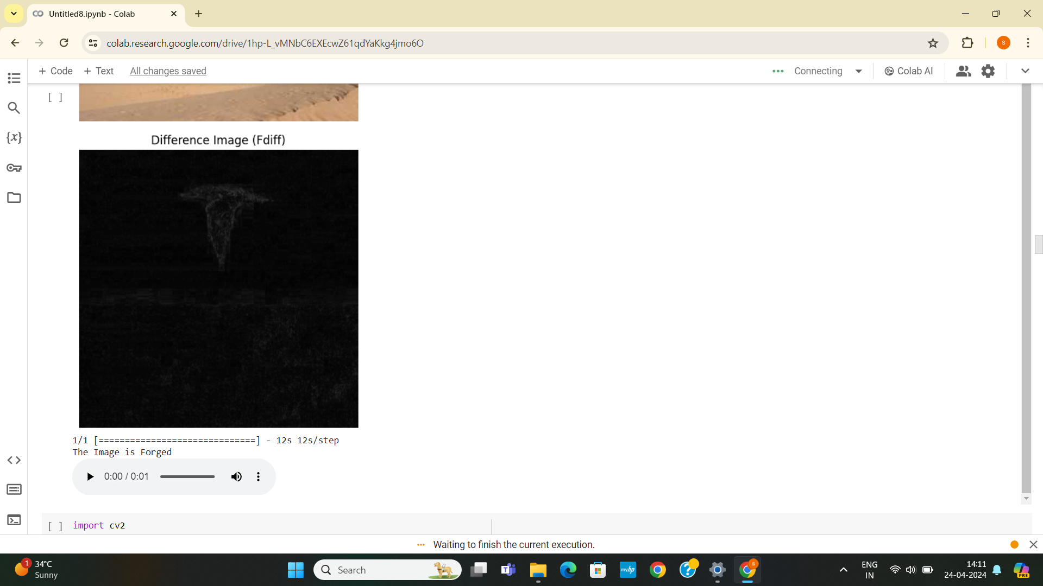
(c)

FIGURE 3. Images generated within the proposed project, using fake image as input.
The classified result, indicating whether the image is forged, is printed. Then, the classification result is converted into speech, saved as an audio file, and automatically played back upon completion of the process.

This section showcases the input image before any processing. Here, the image undergoes compression, illustrating the potential quality degradation resulting from compression algorithms. In this section, the discrepancies between the input image and compressed images are emphasized. If it is authentic image, the areas with notable differences are not highlighted.


(a)
(b)
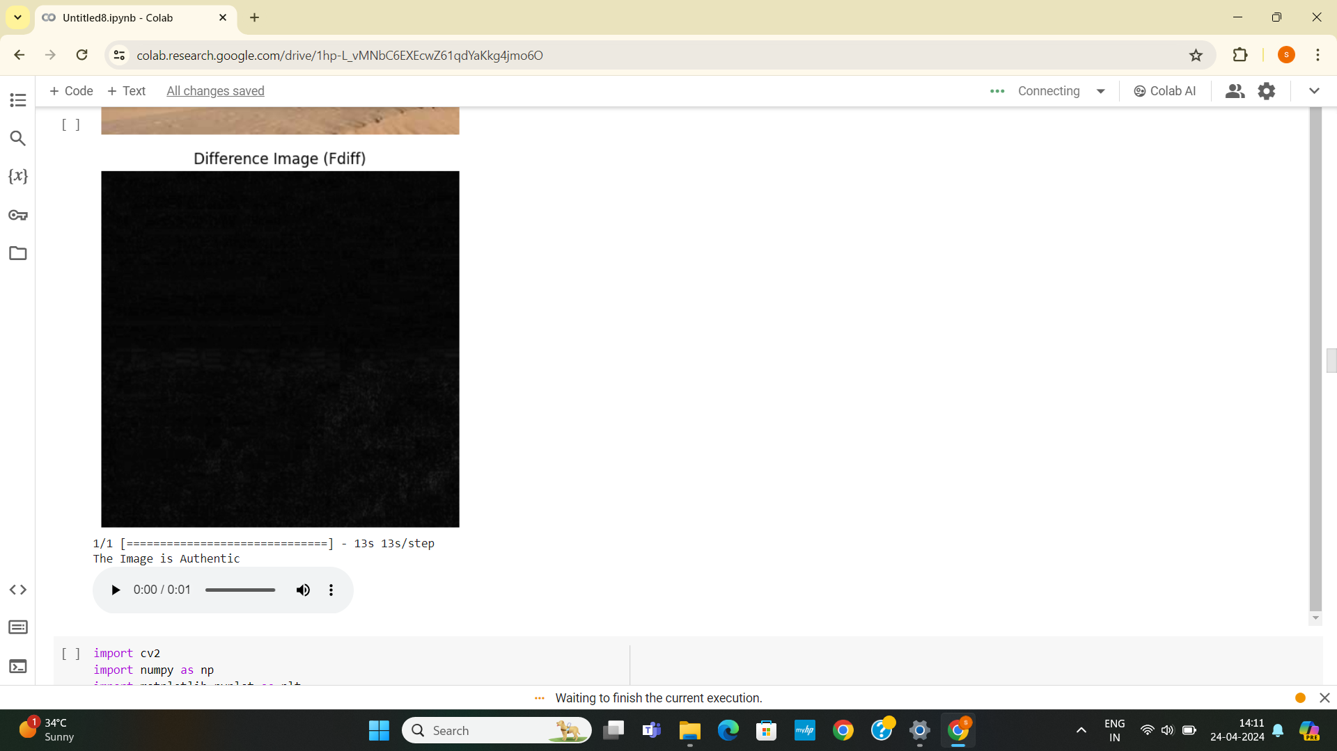
FIGURE 4. Images generated within the proposed project, using real image as input.
The classified result, indicating whether the image is authentic, is printed. Then, the classification result is converted into speech, saved as an audio file, and automatically played back upon completion of the process.

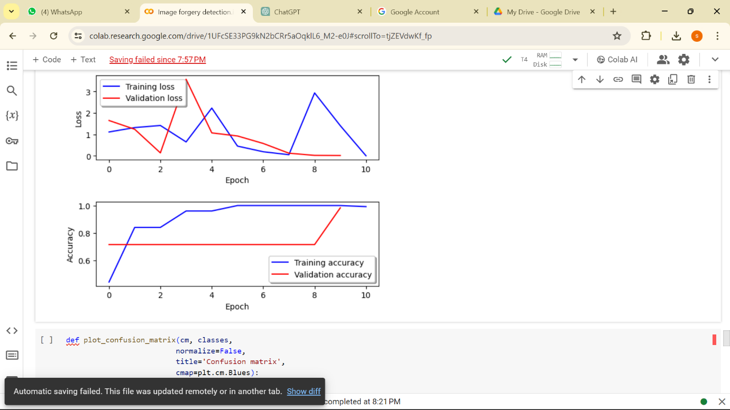
(a) Efficientnetb7 training and validation accuracy curve

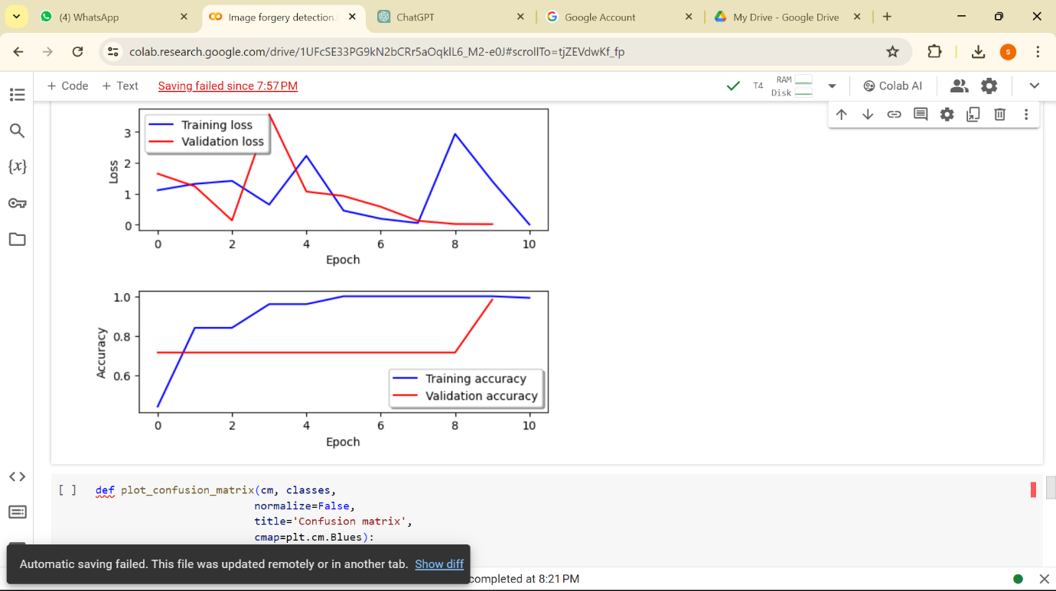
(b) Efficientnetb7 training and validation loss curve

FIGURE 5. Efficientnetb7 training and validation curves

The training and validation curves of EfficientNetB7 depict a gradual enhancement over the training period, with validation loss decreasing as the model learns, while accuracy increases. The training loss curve illustrates the error between predicted and actual values during training, while the validation loss curve measures the error on a separate validation dataset to assess the model's generalization. Accuracy signifies the proportion of correctly classified instances during training and validation phases. As shown in Fig.5 the training loss value achieves 0.003 and training accuracy value achieves 99.21 percentage , the validation loss value achieves 0.0159 and validation accuracy value achieves 98.32 percentage after 10 epochs.
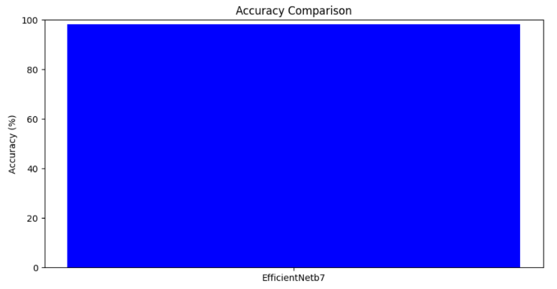
FIGURE 6. EfficientNetb7 Accuracy Chart.

Accuracy measures the overall correctness of predictions. As shown in Fig.6 the accuracy value achieves 98.32 percentage.

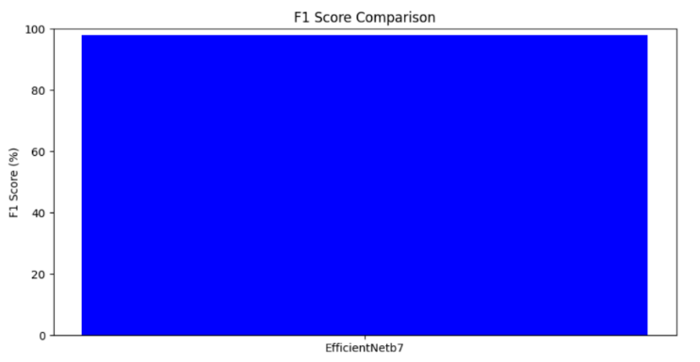

FIGURE 7. EfficientNetb7 F1 Score Chart.

F1 score balances precision and recall, attains a value of 98% as depicted in Figure 7.

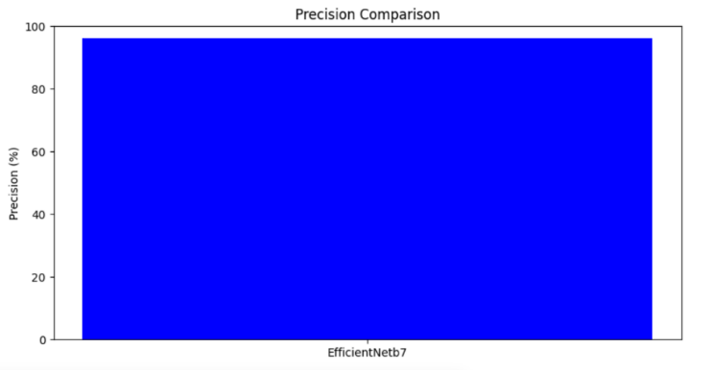
FIGURE 8. EfficientNetb7 Precision Chart.

Precision indicates the ratio of true positives to all positive predictions. As shown in Fig.8 the precision value achieves 96.22 percentage.

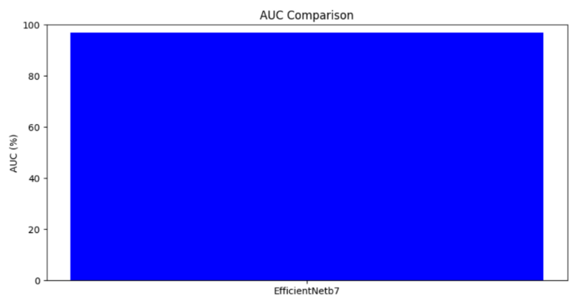
FIGURE 9. EfficientNetb7 AUC Chart.

AUC measures the area under the receiver operating characteristic curve. As shown in Fig.9 the AUC value achieves 97 percentage.
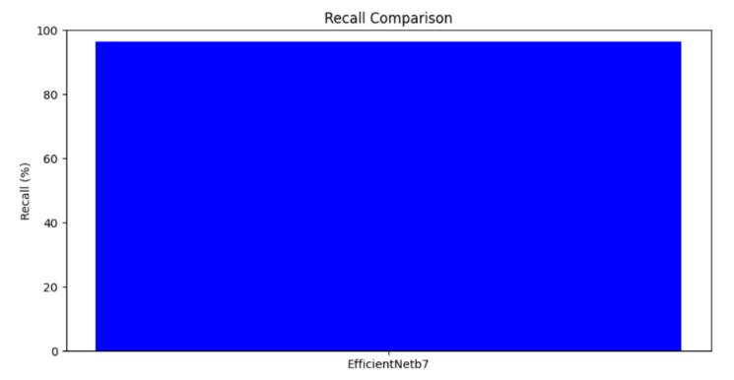
FIGURE 10. EfficientNetb7 Recall Chart.
Recall represents the ratio of true positives to all actual positives, attains a value of 96.41% as depicted in Figure 10.

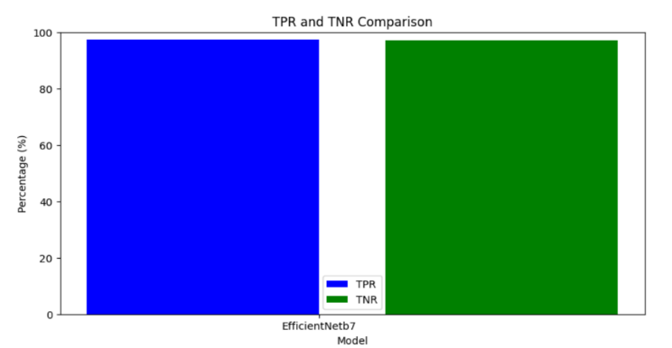
FIGURE 11. EfficientNetb7 TPR and TNR Chart.

TPR (true positive rate) and TNR (true negative rate) denote proportions of correctly identified positives and negatives respectively, TPR attains a value of 97.43% and TNR attains a value of 97 percentage as depicted in Figure 11.

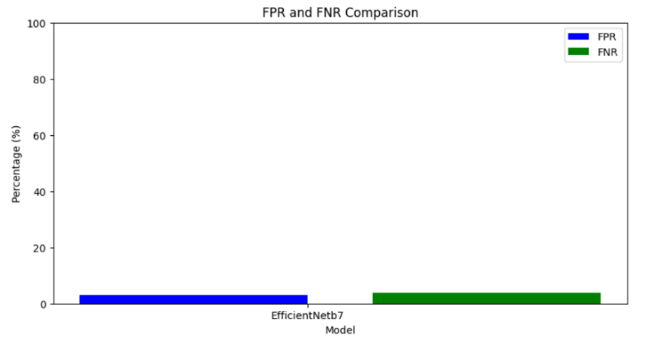
FIGURE 12. EfficientNetb7 FPR and FNR Chart.

FPR (false positive rate) and FNR (false negative rate) represent proportions of incorrectly identified positives and negatives respectively. As shown in Fig.12 FPR value achieves 3.00% and FNR value achieves 3.70 percentage.

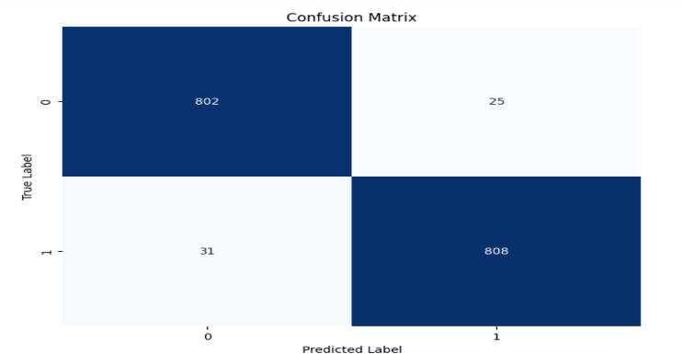

FIGURE 13. Confusion Matrix

As shown in Fig. 13 confusion matrix is a tabular representation summarizing the performance of a classification model by counting true positives, true negatives, false positives, and false negatives, providing insight into the model's accuracy and error tendencies.

TABLE 1. Comparison Of Existing And Proposed Work

WORK | Existing Work | Proposed Work
MODEL | MobileNetV2 | EfficientNetb7
ACCURACY | 86 | 98.32
RECALL | 90 | 96.41
PRECISION | 89 | 96.22
F1 SCORE | 86 | 98.00
TPR | 90 | 97.4
TNR | 89 | 97
FPR | 20 | 3.00
FNR | 12 | 3.70
AUC | 75 | 97

CONCLUSION

In conclusion, the application of deep learning, particularly Convolutional Neural Networks (CNNs) using EfficientNetB7, for image forgery detection holds substantial promise. Through meticulous examination and empirical analysis, it is evident that CNN-based models offer a robust solution for accurately identifying various forms of image tampering. By leveraging their capability to learn hierarchical representations of image features, CNNs can effectively discern subtle inconsistencies and artifacts introduced during forgery attempts.
Furthermore, the adaptability of CNN architectures allows for the detection of different types of forgery, including copy-move, splicing, and content manipulation, thus enhancing the versatility of detection systems. The integration of advanced CNN variants, such as ResNet and other architectures, further enhances detection performance by addressing challenges related to feature extraction and model depth.
However, despite these advancements, challenges persist, particularly in combating adversarial attacks aimed at deceiving CNN-based detectors. Nonetheless, with ongoing advancements in deep learning methodologies and the availability of large-scale annotated datasets, the refinement and deployment of CNN-based solutions for image forgery detection in real-world scenarios continue to show promise.
Future research efforts should focus on addressing remaining challenges and further enhancing the robustness and generalization capabilities of CNN-based detection systems to ensure their effectiveness in combating image forgery in various applications and domains.

