Protection of routing in WSN: Efficient path planning using block chain-assisted dynamic waterwheel plant optimization technique for applications of cyber security

1st K S Balamurugan Professo
Department of ECEKarpaga Vinayaga
College of Engineering and Technology
Tamil Nadu, India
4th Fatima H. A. Alsalamy
Medical Laboratories Techniques Department
Al-Mustaqbal University
Hillah, Iraq
fatimahashim109@gmail.com
2nd A.Manimaran
Department of ECE Karpaga Vinayaga
College of Engineering and Technology Chengalpattu, Tami
Nadu, India..
5th Karar aljawaheri
Department of Computer Science
Altoosi University College
Najaf, Iraq
Karar.aljawaheri@altoosi.edu.iq
3rd Kassem Al attabi
Department of Computer Technical Engineering
College of Technical Engineering
The Islamic University
Najaf, Iraq
kassem.alattabi@iunajaf.edu.iq
6th Hussein M. Hariz
Department of Computer Techniques Engineering
Mazaya University College
DhiQar, Iraq;
huhraiz22@mpu.edu.iq.
Abstract
Efficient routing techniques are critical in wireless sensor network (WSN) to extend network lifetime and preserve energy, providing uninterrupted data transfer across a wide range of applications. In this research, we intend to develop a novel dynamic waterwheel plant optimization (DWPO) strategy for efficient path planning with blockchain for enhancing cyber security in WSN. Our proposed approach utilizes a fitness function that incorporates inter cluster distance along with other relevant parameters. This function strategically contributes to the selection of ideal routes, contributing to the efficacy of our method for improving cyber security in WSN contexts. The experimental validation of the DWPO model is conducted using the MATLAB program and examined in terms of network lifetime (93.6%), packet delivery ratio (90.2%) and energy consumption (18.2J). The experimental results illustrate that the proposed DWPO approach performed better than other existing approaches for protecting the routing nodes through efficient path planning with blockchain assisted DWPO in WSN.
Keywords: Path Planning, Cyber Security, Dynamic Waterwheel Plant Optimization (DWPO), Wireless Sensor Networks (WSN)
- Introduction
The wireless sensor networks (WSNs) in cyber security are accomplished equipment that can gather and transmit information to clients via a single-hop and multi-hop relay over a self-organizing system. Its applications in ecological science, industry, agriculture automation, national defense and the military are frequent [1]. The vast majority of micro-integrated sensor nodes that make up WSN collaborate to perform environmental discernment, environment monitoring and information gathering. Comprising sensor nodes with minimal Random access memory (RAM), Central processing unit (CPU) power and battery life, a WSN is a self-adapting network. These sensor nodes are linked together using wireless technologies including Wi-Fi, Bluetooth and Zigbee [2]. These are reasonably priced, compact devices that gather important data and transfer it from the source region to sink nodes over wireless networks.The cells in these sensing nodes are not interchangeable. Charge deterioration causes the bond to break. Both the sink and these sensors are capable of direct communication [3]. Route planning is one of the several important tasks that these robots must perform. Applications requiring autonomous mobility involve flexible and efficient route planning strategies [4]. The WSNs are made up of an enormous number of sensor nodes that interact with one another to build the network in cyber security. When sensor nodes are dispersed throughout a large geographic region, they are geographically disconnected from one another, which might result in a semi-connected and fully linked sensor network [5]. The intention is to improve cyber security in WSNs by creating a new DWPO technique for effective path planning using blockchain. The inter-cluster distance is included in a fitness function along with other pertinent factors in the suggested methodology.
The article's sections are separated as follows: section 2 presented a related work; a presentation and a detailed explanation of the recommended technique are provided in section 3; a discussion and simulation findings in section 4. The study is concluded in section 5 and offers suggestions for more research.
- Related works
A shared memory between the network's nodes was provided via the routing protocol, which makes use of Blockchain technology. As demonstrated by the simulation results, this technique could work and address the earlier-mentioned problems [6].To provide an improved safe route planning system for the Internet of Drones (IoD) [7] scenarios included search optimization and rescue capabilities. While preserving the security of dynamic data storage, the suggested Optimized Dynamic Storage of Data (ODSD) [8] framework offered remarkable advantages for real-time applications. A Fuzzy Convolutional Neural Network (F-CNN) [9]suggested and prevented a watch on system as well as network activity that looks for signs of hostile behavior. With the use of blockchain-based license plate identification, the article suggested a privacy-preserving solution for the Internet of Vehicles (IoV) [10]. The clustering a technique used in Industrial internet of things (IIoT) operation to identify intrusions and enable Blockchain assisted-Intrusion detection system (BAC-IDS) [11]. By using Machine learning (ML) approaches that were hybrid-optimized for the most possible distance, locationas well asinformation communication, the study suggested safe localization and detection of routing risks in WSN [12]. Multipath routing was used to provide ongoing collaboration among on scene devices, which can help assure connection due to low transmit power. Their future multipath routing method for Public safety networks (PSNs) utilized Reinforcement learning (RL) and Unmanned aerial vehicles (UAVs) for assistance [13]. To advance the performance of intrusion detection systems (IDS), FT-ABC-CNN was employed to enhance convolutional neural networks (CNNs) with fuzzy temporal rules in the artificial bee colony (ABC) optimization approach [14]. To ensure that timely and informed judgments are made in difficult scenarios, ML methods were applied to handle various challenges in WSNs in recent expansions [15]. The utilization of the edge computing approach expedited the creation of charging channels by centralized unit switching with defined edges [16]. The technique for creating routes, locating Rendezvous points (RPs) and figuring out the next stop to reply information to every sensor node was presented for Mobile sinks (MSs) [17]. A few crucial problems need to be solved before blockchain and ML were widely used. These problems include resource management, information processing, scalable operation and security concerns. They provided an overview of the current literature on blockchain and ML technology [18]. To optimally steer a mobile node, they suggested [19] three formulations of Mixed integer linear programming (MILP).
- Proposed method
This section introduces a new trusted routing approach that integrated blockchain technology with the dynamic waterwheel plant optimization technique. Our concept promotes blockchain-based network architecture to improve data routing reliability. We have created an exclusive routing scheduling method called the Dynamic waterwheel plant optimization (DWPO) routing algorithm in addition to the blockchain with a network architecture that is designed. Blockchain (BC) serves as a distributed dataset that requires each node possesses to have an altered copy of the original dataset and required to take advantage of the conclusion of providing more blocks to the dataset. BC serves as a flexible distributed ledger utilizing data traceability and tamper-proof capabilities. The transportation dataset's reliability and resilience are enhanced by the implementation of BC. The algorithm's disadvantage is that it requires time and energy to parse novel blocks, creating it unsuitable for WSNs with lesser processing and battery capacity. This method helps routing nodes choose alternate nodes for routing by utilizing plant optimization techniques. This section describes the mathematical model that corresponds to the algorithm and its purpose.

  - Classification using dynamic waterwheel plant optimization (DWPO)
The waterwheel plant's traps, which resemble tiny transparent flytraps, are distributed over a wide petiole. The purpose of the hair-like bristles is to shield the trap from damage and unintentional interaction with aquatic plants, which might cause false triggers. The lock in several hook-like teeth wrapped along its outside edges, much like a flytrap's teeth, which interlock when the trap closes around its target. Within the trap, there are around forty long trigger hairs, in the contrary, when tripped once and more they are in charge of shutting the clamshell. These predators have glands that secrete acid to support meal digestion in addition to their trigger hairs.These predators have glands that secrete acid in addition to their trigger hairs, which aid in their ability to digest food. The mucus sealant and the trap's interlocking teeth entangle the unfortunate prey, sealing it in place and forcing it down to the trap's base, near the hinge. The trap pushes the remaining water out while most of it gets digested in juices. This section covers the DWPO setup and, next instructions for using an approach that simulates the actual behavior of a waterwheel to update the waterwheel's position throughout exploration and exploitation.
The suggested DWPO a population-based method, via iteration, could provide a suitable solution depending on the population's capacity to explore the universe for potential issue solutions. Each of the waterwheels that make up the DWPO population has a different value for each issue variable depending on the location it resides in the search space. Consequently, a waterwheel symbolizes a potential resolution to the issue, which is expressed mathematically as a vector. The waterwheels across the DWPO population are depicted by matrix, equation (1). At the beginning of the DWPO implementation, the locations of waterwheels in the search space are initialized at random using equation (2).
$O=\left[\begin{aligned}O_{1} \\ ⋮ \\ O_{j} \\ ⋮ \\ O_{M}\end{aligned}\right]= \left[\begin{aligned}O_{1,1} \\ ⋮ \\ O_{j,1} \\ ⋮ \\ O_{M,1}\end{aligned}\begin{aligned}⋯ \\ ⋱ \\ ⋯ \\ ⋰ \\ ⋯\end{aligned}\begin{aligned}O_{1},i \\ ⋮ \\ O_{j,i} \\ ⋮ \\ O_{M,i}\end{aligned}\begin{aligned}⋯ \\ ⋰ \\ ⋯ \\ ⋱ \\ ⋱\end{aligned}\begin{aligned}O_{1,n} \\ ⋮ \\ O_{j,n} \\ ⋮ \\ O_{M,N}\end{aligned}\right]$ (1)
$O_{j,i}={ka}_{i}+q_{j,i}.\left({va}_{i}-{ka}_{i}\right), j=1,2,..,M,i=1,2,…n$ (2)
Where $M$ and $N$ stand for several variables and waterwheels, respectively; ${ka}_{i}$ and ${va}_{i}$ represent the lower as well as higher bounds of the $j$^{th} issue variable, respectively; $O_{j, i}$ is a random integer in a range $[0,1]$; The waterwheel locations' population matrix is denoted by $O$, a $i$^{th} waterwheel (a potential solution) is represented by $O_{j}$ and the problem variable is represented by its $i$^{th} dimension, $O_{j, i}$. It’s potential to compute the goal function for each waterwheel given that each symbolizes a potential fix for the issue. It’s demonstrated that the values that are established in a vector (3) serve as an appropriate representation of the problem's objective function.
$F=\left[\begin{aligned}E_{1} \\ ⋮ \\ E_{j} \\ ⋮ \\ E_{M}\end{aligned}\right]=\left[\begin{aligned}{E(W}_{1}) \\ ⋮ \\ {E(W}_{j}) \\ ⋮ \\ {E(W}_{M})\end{aligned}\right]$ (3)
Where $Fi$the predicted value for the $i$^{th} waterwheel and $F$ is the vector containing all the values of the objective function. The most important measures for choosing the optimal solutions are the objective function evaluations. As a result, the objective function's greatest value indicates the most effective candidate solution, while its lowest value indicates the effective candidate solution. The optimal response must change over time as a result of the waterwheels' varied speeds of movement throughout the search space in the various iterations.
Stage 1: Determine position and search for insects (Examination)
The vicious predators known as waterwheels can find the source of pests because of their strong sense of smell. A waterwheel might assault an insect at once as it enters within its attack range. Once it has located the insect, it assaults and explores the content. By modeling this waterwheel activity, the DWPO mimics the initial step of its population update process.The modeling of an insect assault using a waterwheelcauses the position of a waterwheel in search field to change significantlyas well as DWPO's exploration ability to locate the ideal region and escape from local optima is improved. The waterwheel's new location is found by using the following equation in combination with a simulation involving a waterwheel approaching the problem. The previous position is given up in favor of the one it's described, if moving a waterwheel to that location raises the value of a desired function and follows equations (4) and (5).
$\vec{X}= {\vec{q}}_{1}.(\vec{O}\left(s\right)+2l)$ (4)
$\vec{O}\left(s+1\right)=\vec{O}\left(s\right)+ \vec{X} .(2L+ {\vec{q}}_{2})$ (5)
The response remains unchanged after three repetitions; the waterwheel's location is adjusted using the subsequent equation, as following equation (6):
$\vec{O}\left(s+1\right)=Gaussian \left(μO,σ\right)+{\vec{q}}_{2} (\frac{\vec{O}\left(s\right)+2L}{\vec{X}})$ (6)
Random variables ${\vec{q}}_{2}$ and ${\vec{q}}_{2}$ in this case have values in the ranges $\left[0,2\right]$and$\left[0,1\right]$, respectively. Furthermore, the waterwheel plant uses$K$, a vector representing the circumference of the circle it searches for suitable places$\left[0,1\right]$, an exponential variable having values in the range$\vec{ w}$.
Stage 2: Utilizing the appropriate tube to carry the insect (Exploitation)
A waterwheel catches an issue and sends it to tubing for nutrition. This waterwheel simulation exercise serves as the basis for the second phase of the population update in DWPO. The insect's transfer model to the appropriate tube, which causes slight adjustments to the location of a waterwheel in the area of search, DWPO's exploitation power is boosted during local searches and more effective options are converged close to the ones that were earlier identified. To replicate the waterwheels' natural behavior, DWPO's designers first choose a fresh, random site for every waterwheel in a population that would be an advisable position for consuming insects. As a result, the waterwheel is transferred to the new site in place of the previous one if the objective function value there is greater, as indicated by the following equations (7) and (8):
$\vec{X}= {\vec{q}}_{3}.(L{\vec{O}}_{best}\left(s\right)+ q_{3}\vec{O}\left(s\right))$ (7)
$\vec{O}\left(s+1\right)= \vec{O}\left(s\right)+ L\vec{O}$ (8)
Where the$\vec{O}\left(s\right)$ iteration’s current solution is$S$, ${\vec{O}}_{best}$is the superlative solution and ${\vec{q}}_{3}$is a variable with random values falling inside range$\left[0,2\right]$.To ensure avoiding local minima, a mutation similar to the one used during the exploration phase is performed if a solution fails to improve after three iterations following equation (9):
$\vec{O}\left(s+1\right)= {\vec{q}}_{1}+L)sin⁡(\frac{E}{D} θ)$ (9)
Where, the random variables $E$ and $D$ have values within the range$\left[-5,5\right]$. Furthermore, the following equation shows an exponential reduction in the value of$L$, as shown in equation (10):
$L=(1+\frac{2* s^{2}}{S_{max}}+E)$ (10)
The DWPO is described as an iterative approach. Adjusting the placements of all waterwheels is the last stage after the initial and subsequent stages of the DWPO have been put into practice. The goal function values are compared and the most effective solution candidate is then modified. This method is then repeated for subsequent iteration of the algorithm until the waterwheel positions are modified for the final iteration. Algorithm 1 outlines the phases in the process of implementing DWPO.After the algorithm gets through all of its iterations, DWPO presents a most promising candidate solution that it has preserved.
Algorithm 1: The proposed DWPO
Input: Assignments of the waterwheel plants $O_{j} (j=1,2,..,m)$ for m plants,
and goal function$e_{m}$iterations$S_{max},$parameters of $q, {\vec{q}}_{1}, {\vec{q}}_{2}, {\vec{q}}_{3}, e,dandL$
Dynamic the part of solutions
Calculate the fitness of${ e}_{m}$ each role $O_{j}$
Locate the ideal plantposition${ O}_{best}$
$Set s = 1$;
While $s≤S_{max}do$
for$(j<m + 1 :j = 1 ) do$
if$(q< 0.5) then$
Investigate a water wheel plant search area utilizing:
$$\vec{Y}= {\vec{q}}_{1}.(\vec{O}\left(s\right)+2L)$$
$$\vec{O}\left(s+1\right)=\vec{O}\left(s\right)+ \vec{X} .(2L+ {\vec{q}}_{2})$$
if three iterations yield no change in the solution then
$$\vec{O}\left(s+1\right)=Gaussian\left(μO,σ\right)+{\vec{q}}_{1}((\frac{\vec{O}\left(s\right)+2L}{\vec{Y}})$$
end if
else
Exploit existing techniques to use with the ideal outcome:
$$\vec{X}= {\vec{q}}_{3}.(L{\vec{O}}_{best}\left(s\right)+ q_{3}\vec{O}\left(s\right))$$
$$\vec{O}\left(s+1\right)=\vec{O}\left(s\right)+L\vec{X}$$
if three iterations yield no change in response then
$$\vec{O}\left(s+1\right)=\left({\vec{q}}_{1}+L\right)sin⁡(\frac{F}{D}θ)$$
end if
end if
end for
Decrease the exponential value of K using:
$$L=\left(1+\frac{2*s^{2}}{{\left(S_{max}\right)}^{3}}+e\right)$$
Update$q, {\vec{q}}_{1} , {\vec{q}}_{2}, {\vec{q}}_{3}, e,d$
Calculate the objective function$e_{m}$ em for each position${ O}_{j}$
Find the best position$O_{ best}$
$$Sets = s + 1$$
end while
Transform the optimal result into a dynamic
Return the best solution$O_{best}$

- Result and discussion
In this paper, MATLAB platform has been used for a proposed method and the DWPO for efficient path planning with blockchain for enhancing cyber security in WSN. The recommended DWPO model and other existing models, including the HOA-WSN [20] and DRL-SS [20] models, are compared in this section. Various performance measures, including Energy consumption, Network lifetime and Packet delivery ratio, are taken into account at making the comparison, as shown in Table 1.
Table 1: Numerical evaluation of the existing and proposed models
Methods | Packet delivery ratio (%) | Network lifetime (%) | Energy consumption (J)
DRL-SS [20] | 53.2 | 75.6 | 28.4
HOA-WSN [20] | 46.3 | 80.6 | 34.4
DWPO [proposed] | 90.2 | 93.6 | 18.2

The energy consumption is computed as the variance between the original and residual energy. This number is used to analyze the energy consumption of the system for each job in the WSN scenario. Figure 1 shows the energy consumption for the suggested method is contrasted with existing methods such as DRL-SS and HOA-WSN. While compared to the previous models, DRL-SS model attained 28.4J, the HOA-WSN model attained 34.4J, the suggested DWPO attained (18.2J) less energy, respectively.DWPO performs better than other existing methods.
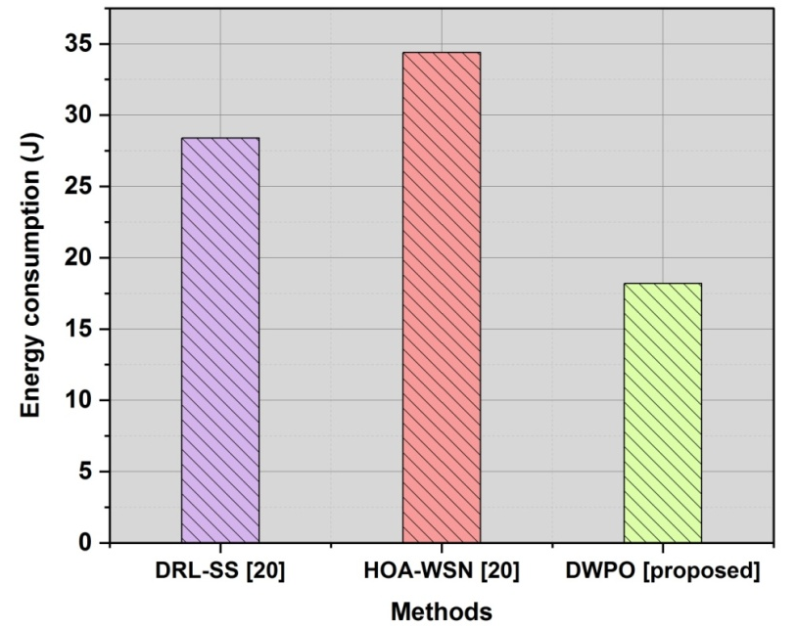
Figure 1: Comparison of energy consumption
This number is used to assess the duration, a sensor network might function. It’s defined as the minimum number of sensor nodes required for the environment to operate and continue to operate for a given amount of time. Figure 2 displays the comparison of network longevity in several rounds. The proposed DWPO achieves 93.6% which is higher than the DRL-SS model that attained 75.6% and 80.6% attained by HOA-WSN.
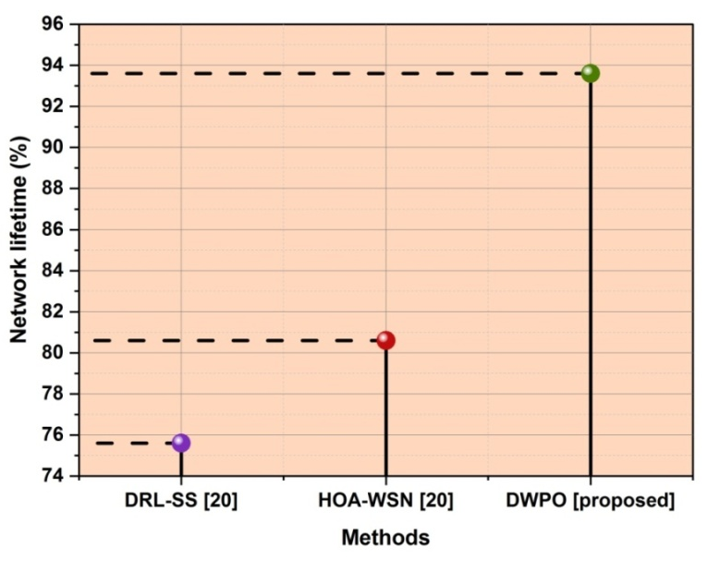
Figure 2: Comparison of network lifetime
The number of packets transmitted and received by the sender and recipient are compared using this statistic. The packet delivery ratio is expressed in graphics for both proposed and current works in Figure 3. The suggested classifier (90.2%) attained the highest ratio; it outperformed the existing algorithms, HOA-WSN (46.3%) and DRL-SS (53.2%). It demonstrated that, in comparison with existing models, the suggested DWPO model delivers a high packet delivery ratio.
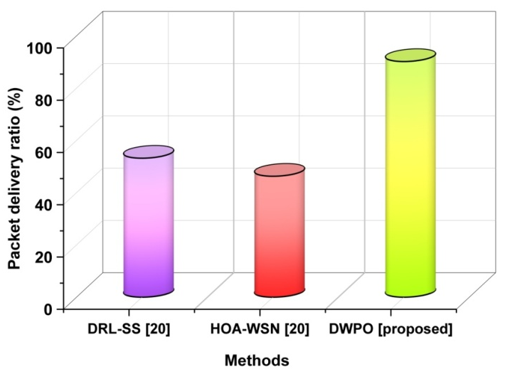
Figure 3: Comparison of Packet delivery ratio

- Conclusion
This work developed a unique DWPO method for effective blockchain path planning to improve cyber security in WSN. The suggested effort carries on main procedures, which are described below, to accomplish this goal: In the beginning, every sensor node is arranged in a DWPO to improve network management capabilities and lessen the complexity brought by haphazard deployment. In this case, alternative routes are furthermore chosen from the reserve agent to minimize information loss resulting from sensor nodes transmitting data from source to destination when energy is scarce. The outcomes of DWPO achieved the energy consumption (18.2J), packet delivery ratio (90.2%) and network lifetime (93.6%). The performance is examined using a number of performance metrics and show that the suggested work performs higher than previous works.
Reference
- Ali, M., El-Moghith, A., Ibrahim, A., El-Derini, M.N. and Darwish, S.M., 2022. Wireless Sensor Networks Routing Attacks Prevention with Blockchain and Deep Neural Network. Computers, Materials & Continua, 70(3).
- Dass, R., Narayanan, M., Ananthakrishnan, G., KathirvelMurugan, T., Nallakaruppan, M.K., Somayaji, S.R.K., Arputharaj, K., Khan, S.B. and Almusharraf, A., 2023. A cluster-based energy-efficient secure optimal path-routing protocol for wireless body-area sensor networks. Sensors, 23(14), p.6274.
- Sankar, S.U., Christo, M.S. and Priyadarsini, P.U., 2023. Secure and Energy Concise Route Revamp Technique in Wireless Sensor Networks. Intelligent Automation and Soft Computing, 35(2), pp.2337-2351.
- Sundarraj, S., Reddy, R.V.K., Babu, B.M., Lokesh, G.H., Flammini, F. and Natarajan, R., 2023. Route Planning for an Autonomous Robotic Vehicle Employing a Weight-Controlled Particle Swarm-Optimized Dijkstra Algorithm. IEEE Access.
- Al-Kaseem, B.R., Taha, Z.K., Abdulmajeed, S.W. and Al-Raweshidy, H.S., 2021. Optimized energy–efficient path planning strategy in WSN with multiple Mobile sinks. IEEE Access, 9, pp.82833-82847.
- Lazrag, H., Chehri, A., Saadane, R. and Rahmani, M.D., 2021. Efficient and secure routing protocol based on Blockchain approach for wireless sensor networks. Concurrency and Computation: Practice and Experience, 33(22), p.e6144.
- S. Alrayes, F., Dhahbi, S., S. Alzahrani, J., Mehanna, A.S., Al Duhayyim, M., Motwakel, A., Yaseen, I. and Atta Abdelmageed, A., 2022. Enhanced search-and-rescue optimization-enabled secure route planning scheme for the Internet of Drones environment. Applied Sciences, 12(15), p.7950.
- Khalaf, O.I. and Abdulsahib, G.M., 2021. Optimized dynamic storage of data (ODSD) in IoT based on blockchain for wireless sensor networks. Peer-to-Peer Networking and Applications, 14, pp.2858-2873.
- Subramani, S. and Selvi, M., 2022. Deep learning-based IDS for secured routing in wireless sensor networks using a fuzzy genetic approach.
- Alharbi, F., Zakariah, M., Alshahrani, R., Albakri, A., Viriyasitavat, W. and Alghamdi, A.A., 2023. Intelligent Transportation Using Wireless Sensor Networks Blockchain and License Plate Recognition. Sensors, 23(5), p.2670.
- Mansour, R.F., 2022. Blockchain-assisted clustering with an intrusion detection system for industrial Internet of things environment. Expert Systems with Applications, 207, p.117995.
- Gebremariam, G.G., Panda, J. and Indu, S., 2023. Secure localization techniques in wireless sensor networks against routing attacks based on hybrid machine learning models. Alexandria Engineering Journal, 82, pp.82-100.
- Minhas, H.I., Ahmad, R., Ahmed, W., Waheed, M., Alam, M.M. and Gul, S.T., 2021. A reinforcement learning routing protocol for UAV-aided public safety networks. Sensors, 21(12), p.4121.
- Yesodha, K., Krishnamurthy, M., Selvi, M. and Kannan, A., 2024. Intrusion detection system extended CNN and artificial bee colony optimization in wireless sensor networks. Peer-to-Peer Networking and Applications, pp.1-26.
- Raut, A.R. and Khandait, S.P., 2021, November. Machine learning algorithms in WSNs and their applications. In 2021 International Conference on Computational Intelligence and Computing Applications (ICCICA) (pp. 1-5). IEEE.
- Cho, H.H., Wu, H.T., Lai, C.F., Shih, T.K. and Tseng, F.H., 2020. Intelligent charging path planning for IoT network over blockchain-based edge architecture. IEEE Internet of Things Journal, 8(4), pp.2379-2394.
- Punriboon, C., So-In, C., Aimtongkham, P. and Leelathakul, N., 2021. Fuzzy logic-based path planning for data gathering mobile sinks in WSNs. IEEE Access, 9, pp.96002-96020.
- Liu, Y., Yu, F.R., Li, X., Ji, H. and Leung, V.C., 2020. Blockchain and machine learning for communications and networking systems. IEEE Communications Surveys & Tutorials, 22(2), pp.1392-1431.
- Zygowski, C. and Jaekel, A., 2020. Optimal path planning strategies for monitoring coverage holes in Wireless Sensor Networks. Ad Hoc Networks, 96, p.101990.
- Prasad, K.V. and Periyasamy, S., 2023. Secure-Energy Efficient Bio-Inspired Clustering and Deep Learning Routing using Blockchain for Edge Assisted WSN Environment. IEEE Access.

