Revolutionizing cyber security in WSN: ML-driven data sensing and fusion

1st Seelam Ch Vijaya Bhaskar
Department of IT, MVSR Engineering College Hyderabad
Nadu, India.
4th Fatima Hashim
Medical Laboratories Techniques Department
Al-Mustaqbal University
Hillah, Iraq
fatimahashim109@gmail.com
2nd A.Manimaran
Department of ECE Karpaga Vinayaga
College of Engineering and Technology Chengalpattu, Tami
Nadu, India..
5th Tabarek Hasanain AlDaami
Department of Computer Science
Altoosi University College
Najaf, Iraq
tabarek.hasanain@altoosi.edu.iq
3rd Kassem Al attabi
Department of Computer Technical Engineering
College of Technical Engineering
The Islamic University
Najaf, Iraq
kassem.alattabi@iunajaf.edu.iq
6th H.M.Al-Aboudy
Department of Computer Techniques Engineering
Mazaya University College
DhiQar, Iraq;
enghariz82@gmail.com.

Abstract
There are significant cybersecurity challenges that face wireless sensor networks (WSNs) as a result of their decentralized nature and limited resources although they are highly important in most fields. Traditional security mechanisms frequently fail to cope with the changing and diverse conditions in WSNs. To reduce data transfer but maintain WSNs sensor saturation and data security, this work proposes a prediction-based data fusion and sensing strategy. The suggested method called the ARIMA-SK-EELM system which is made up of Autoregressive Integrated Moving Average (ARIMA), Stable Kernel-Enhanced Extreme Learning Machine (SK-EELM), and threefish algorithm (TFA). In the procedure on data sensing and fusion, ARIMA predicts initially from a few data elements, SK-EELM for precise accuracy on initial expected value similar to actual value while TFA is used during transmissions for both encoded and decoded data. This paper introduces an ARIMA-SK-EELM model with high predictability, low interferences, strong scalability, and secrecy. The results of simulation show that this technique suggested can be effective in reducing unnecessary transfers by accurate forecasting.
Keywords: Wireless Sensor Networks (WSNs), Cybersecurity, Prediction-based Data Gathering, Autoregressive Integrated Moving Average-Stable Kernel-Enhanced Extreme Learning Machine (ARIMA-SK-EELM), Data Security, Threefish Algorithm (TFA)
1.Introduction
A WSN consists of self-governing sensors placed at different points in space for monitoring variables like pressure, sound, humidity, and temperature. These sensors work together to send their results to the central node through the network. They are small devices that are inexpensive each with its own transceivers for communication, microcontrollers and sensors on board them. It is usually battery-powered and has limited computational and communication abilities [1]. WSNs are used in a wide range of areas including environmental monitoring in cyber security, management of manufacturing processes, healthcare provision, home automation, and military systems. Resilience in remote areas where there is little support infrastructure needed for deployment, placement flexibility, and cost efficiency are some of the benefits provided by WSNs in cyber security. In designing a WSN there are three key constituents namely: data collection sensors; network infrastructure for transmission from sensor nodes; base stations or nodes that sink data collection and processing. Sustainability issues that relate to cyber security in WSN include adaptability, transportability of data; safety; and reliance. Scientists are constantly trying to devise more powerful algorithms and methods aimed at solving these problems to enhance the performance and reliability of cyber security in WSNs. By facilitating real-time control and monitoring for physical settings which require can be acting on various occurrences happening they enable immediate-situation control [2].
Data sensing and fusion refer to gathering, merging, and analyzing information from various sources to obtain a holistic view of an event or the environment. Data sensing uses different devices, sensors, and techniques to gather raw information from the external world. Some examples of data include temperature, pressure, location, pictures, videos, and other forms. Sensors could be placed in places such as industrial facilities, cities or towns vehicles, and natural ecosystems to monitor different environmental aspects [3]. Data fusion is when several sets are brought together to give meaningful results that will aid the decision making process. This leads to combining data from several sensors as well as incorporating additional information derived from records files historical data and various APIs. Analytical methodologies machine learning methods and artificial intelligence (AI) are used by data fusion approaches for efficient management and analysis of data. Its objective is to improve situational awareness; establish intelligent communities; monitor the environment; support medical care systems; and enhance transportation systems among others [4].
To protect transmitted data in cyber security, it is necessary to ensure that the security and privacy of WSNs are considered. The security of WSNs can be easily breached owing to their decentralized structures, limited resources and wireless communication technology. Secure communication between the various nodes in a WSN is a key aspect with respect to energy efficiency. Thus, Advanced Encryption Standard (AES) and Elliptic Curve Cryptography (ECC) are used for securing data during transportation [5]. Authentication techniques in cyber security help protect WSN through verifying that the nodes have sensors hence stopping fraud. Digital signing and Media Access Control (MAC) serve as means of authenticating data messages ensuring its integrity. It includes monitoring network traffic in cyber security together with activities which may indicate suspicion signs before an appropriate response are implemented whenever they occur and having secure routing protocols as well as safe physical layers can all enhance cyber security on overall WSN. The continuous research and development process has to take place so that these new risks and weaknesses about WSNs are addressed for them to continue working effectively across wide areas of application [6]. This work introduces a prediction-based data sensing and fusion technique called ARIMA-SK-EELM to reduce data transfer, maintain sensor saturation in WSNs, and ensure data security.
The article contains sections, with Section II listing related works. Section III presents proposed methods. Section IV displays the results of the assessments. Section V presents conclusion of the results of the proposed investigation.
2. Related works
Article [7] suggested a safe architecture for detection and preventing the integrity of data threats in “wireless sensor networks (WSN)”within microgrids. An adaptive anomaly recognition system was presented, utilized prediction intervals (PIs) and an enhanced optimization algorithm designed for high-complexity data. Evaluating the model reliability and efficacy used real-world data from a home microgrid.
Study [8] examined the expansion of the internet has prompted the creation of nodes for wireless sensors for diverse used, which are vulnerable to security risks stemming from limited battery capacity, connectivity, and reliance. Systems for intrusion detection are essential for identifying and stopping assaults, including supervised methods for classification such as Random Forest (RF) and Support Vector Machine (SVM).
Research [9] presented that WSN installations are expanding quickly, appealing to sectors such as monitoring the environment and precision farming. WSNs encounter significant security vulnerabilities. They concentrates on detecting attacks by used an intrusion detection model that relies on gaining data ratio and a web-based defensive classifier. The model demonstrated an excellent rate of detection for many sorts of threats.
Study [10] examined machine learning (ML) techniques for identifying outliers in WSN, with a specific focus on Bayesian Networks. The Bayesian network approach was beneficial for identifying outliers since it computes the constrained reliance of existing nodes and estimates the lacking values. Their approach was essential for vital applications such as medical and army surveillance.
Research [11] proposed an “Online Locally Weighted Projection Regression (OLWPR)” method for anomaly identification in WSNs. It achieved a high detection rate and low error rate, effectively tackling the difficulty of identifying abnormal data in WSNs.
Article [12] presented WSN that provided security risks, particularly about Denial of Service (DoS) attacks. An investigation utilizing the Waikato Environment for Knowledge Analysis (WEKA) assessed the effectiveness of five ML techniques in identifying DoS assaults in WSNs. The classifier based on RF excelled in accuracy compared to the other classifiers.
Study [13] proposed decision trees (DT) and SVM for identifying attack signatures on a specific dataset. WSNs are vulnerable to security risks because of their constrained hardware capabilities and architecture. Distributed DoS attacks are prevalent. DT outperformed SVM in terms of both true positive as well as false positive percentages.
Article [14] examined how ML techniques can be helpful in preventing IoT-related cyber assaults, namely DoS attacks. They examined weaknesses in IoT devices and assessed the dataset utilizing Logistic Regression (LR), attaining high prediction accuracy.
Study [15] proposed ML methods are currently utilized for detecting attacks in cybersecurity. Aviation Cyber-physical Systems (CPS) are evolving to improve security, effectiveness, and dependability. Cyberspace poses hazards for wicked individuals. The IoT simulator produces precise attack data with excellent precision, effectiveness, and detecting rate while consuming minimal energy.
Research [16] presented a Deep Reinforced Learning (DRL) based Intrusion Detection System (IDS) with WSN and IoTs to improve the rate of detection and reliability while minimizing errors in comparison to existing methods, showcasing outstanding effectiveness for these essential structures.
3. Methodology
The dataset was collected initially. Then obtain the initial predicted sequence using ARIMA. Next obtain the predicted value of next period using SK-EELM. If prediction error occurs there is no data transmission and if prediction error not occurs conduct data encoding using TFA then data transmission process. The proposed ARIMA-SK-EELM was employed for data sensing and fusion incyber security in WSN. Figure 1 shows the suggested model's general flow.
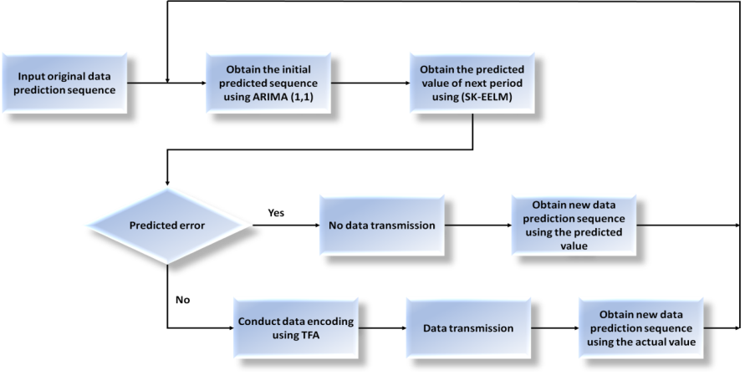
Figure 1: Overview of the suggested model
3.1. Autoregressive Integrated Moving Average (ARIMA)
ARIMA is utilized for making initial predictions of the data for the upcoming period based on a limited amount of data points. ARIMA methods are commonly employed for prediction and forecasting, particularly in situations with restricted data or ambiguous systems. ARIMA assists in offering an early forecast of the data.
The ARIMA method aims to represent patterns in a time series that is steady by utilizing autoregressive and fluctuating average parameters. These are referred to as autoregressive variables and moving average ($MA$) characteristics. We acknowledge that time is a continuous quantity. $Y_{s}$represents the finding at time$s$, and $s$indicates the zero-mean noise element at time $s$. The $MA(m)$methodology follows the following steps:
$Y_{S}=\sum_{j=1}^{m}{{{γj€ _{s-1}+}^{ }€ _{s} ^{ }}_{ }}$ (1)
$γ_{j}$Represents a coefficient in the autoregressive model, abbreviated as ${AR}_{(n)}$, analogous to ${MA}_{(m)}$approaches.
$Y_{S}=\sum_{j=1}^{n}{{{δjY _{s-1}+}^{ }€ _{s} ^{ }}_{ }}$ (2)
$Y_{S}$is a loud linear sum of the $n$measurements that were previously collected. An enhanced approach comprises${ARIMA (n,m)}_{ }$, which combines ${AR}_{(n)}$and ${MA}_{(m)}$components in a simplified structure, providing a flexible modeling method. The above framework assumes that
$Y_{S}$is generated using this equation:
$Y_{S}=\sum_{j=1}^{m}{ }{γj€ _{s-1}+\sum_{j=1}^{n}{{{δjY _{s-1}+}^{ }€ _{s}, ^{ }}_{ }}}^{ }$ (3)
The noisy factor has a mean of zero and is denoted by$s$. By adding a requirement to the ${AR(n)}_{ }$component, it guarantees a process that is stationary. A${ARIMA(n,m)}_{ }$ system that is fixed and reversible can be represented as either an endless AR framework $\left(AR\left(∞\right)\right)$ or an endless MA framework$\left(MA\left(∞\right)\right)$. To create an ARIMA model, you can calculate the first-order variations of ${Ys}_{ }$as $∇{Ys}_{ }=Y_{S}-Y_{S-1}$ and the second-order differences as$∇{2Ys}_{ }={∇Ys}_{ }-{∇Ys-1}_{ }$, resulting in a series of $∇{cYs}_{ }$that fits an $ARIMA \left(n,m\right)$ approach. The sequence ${Ys}_{ }$follows ${ARIMA(n,c, m)}_{ }$the model.
$∇^{c}Y_{S}=\sum_{j=1}^{n}{{ γj€ _{s-1}+^{ }\sum_{j=1}^{n}{{ δj∇^{c}Y_{S-1} ^{ }+€ _{s}, ^{ }}_{ }}}_{ }}$ (4)
The provided words are characterized by 3 order variables: n, c, and m, with corresponding weight vectors $δ∈Rn$and$γ∈Rm$. $ARIMA\left(n,c,m\right)$Prediction involves reversing a differential formula. Given a time-series sequence ${Ys}_{ }$that satisfies$ARIMA \left(n,c,m\right)$, one can forecast the $c-th$ order difference of the evaluation at time$S-1$ as $∇^{c}{Y_{ }}_{s+1}^{-}$and thereafter anticipate the evaluation at time $s+1$as${Y_{ }}_{s}^{-}$.
${Y_{ }}_{s}^{-}=∇^{c}{Y_{ }}_{s}^{\sim }+\sum_{j=1}^{c-1}{.}∇^{j}Y_{S-1}$ (5)
3.2. Stable Kernel-Enhanced Extreme Learning Machine (SK-EELM)
SK-EELM is employed to refine the initial predicted value obtained from ARIMA to estimate its exact value with precision. SK-EELM is an enhanced kernel machine learning technique that can change coefficients in an adaptable manner depending on every entry, thus enhancing the accuracy of predictions. It facilitates forecasting the value's convergence towards the real values by iteratively refining the prediction based on new data.
The regression algorithm can be described below when $c=\{\left(w_{m},z_{m}\right),m=1,2…M\}$ represents the training sample:
$\hat{z}=e\left(w\right)=g\left(w\right)β=Gβ$ (6)
Here $w$are the network’s results, $\hat{z}=e\left(w\right)$is the input vectors, $g\left(w\right)=G$ is the secret layer's randomized features mapping matrix, and $β$ is the connection that exists between the hidden layer's weights and the output layer.
The extended inverse matrices concept gives the following expression for β:
$β=G^{S}(J/D+{GG}^{S}) ^{\begin{aligned}-1 \\ \end{aligned}}z$ (7)
When $J$is a diagonal matrices, $D$is the punishment factor, $z$is the output target vectors, and $z=\left[z_{1},z_{2},…z_{m}\right] ^{S}$, where $m=1,2…M$is a positive integer.The SK-EELMarchitecture integrates a function called the kernel into the Enhanced Extreme Learning Machine (EELM) to substitute the stochastic mapping used in EELM.
The SK-EELMkernel matrices are described below:
$\left\{\begin{aligned}Ω_{ELM}={GG}^{S} \\ Ω_{ELMj,i}=g\left(w_{j}\right)g\left(w_{i}\right)=L(w_{j},w_{i})\end{aligned}\right.$ (8)
The kernel functional is denoted as $L\left(w_{j},w_{i}\right)$. The kernel functions are typically defined as a circular kernel.
$L\left(w_{j},w_{i}\right)=\exp\left(-γ\left|\left|w_{j}-w_{i}\right|\right|{ }^{2}\right),γ>0$ (9)
$\hat{z}=e\left(w\right)={\left[\begin{matrix}L\left(w_{ },w_{i}\right) & \\ L\left(w_{ },w_{M}\right) & \end{matrix}\right]}^{s}(\frac{J}{D}+w_{ELM}) ^{-1}z$ (10)
The SK-EELMutilizes a kernel function to translate the input examples through a feature area with high dimensions through a hidden layer. The SK-EELM substitutes the stochastic mapping used by the EELM for an established kernel mapping, improving the reliability and extension capacity of the model. The kernel function utilizes the inner product form directly, eliminating the need to specify the amount of concealed layers in SK-EELM.
The variables $γ$and $D$significantly impact the SK-EELM, with $γ$being a parameter associated with the function following the selection of RBF as the function of the kernel. The parameter $γ$in the kernel function influences the importance of an individual training example and plays a role in shaping the spread of the data in the transformed feature space. $D$is a penalty factor, indicating the tolerance level for the relative error. Optimal outcomes can be achieved by selecting appropriate numbers for the $γ$and$D$factors.
3.3. Hybrid of ARIMA-SK-EELM
The work introduces a prediction-based encrypted data fusion and sensing technique called ARIMA-SK-EELM. This scheme aims to minimize duplicate data transmission, conserve energy with minimal processing requirements, and uphold data security inside sensor nodes. Nodes of sink and sensor must use identical data sequences and prediction mechanisms to maintain synchronized data series consistently. End-users can access data from all sample points in nodes of sensor with minimal expenses for communication. That safe data fusion and sensing strategy utilizes a proposed way to forecast data for the upcoming period. If the error among the data of detected and forecasted data is below a certain threshold, the sensing nodes doesn't need transmission the data through the node of sink. The sensor node must send the detected data to the sink node using BA for encode when predicted error exceeds the threshold ε. The node of sink utilizes the identical forecasting technique to forecast the upcoming period's data and treats the forecasted data as the present period's data. The accuracy of the prediction is affected by the defined by users threshold ε, which is adjustable. The method utilizes SK-EELM to estimate the true value of the expected sequence following the generation of the first predicted sequence using ARIMA.
3.4. Three fish algorithm
To maintain privacy of information during transfer, three fish is employed for data encoded and decoded. Symmetric-key block cipher Three fish is renowned for its efficiency and quickness in encryption. By encoding data before transfer and decode it upon acceptance, it contributes to network security. This guarantees that private information is kept secret and shielded from prying eyes while being transferred.
Three fish has a tweakable symmetrical blocks encryption technique that incorporates a 128-bit tweak values together with the message and key value for all block lengths. This distinct modification factor is utilized for the encryption of the information. Three fish have identical key and block sizes. The encryption process can handle data blocks totaling 256 bits, 512 bits, or 1024 bits, all with the same key size. Encrypted data packets of lengths 256 bits and 512 bits typically require 72 rounds. For a 1024-bit block, 80 cycles of processing are required to generate the encrypted text. To prevent timing attacks, avoid using S-Boxes or all table searches. Three fish encryption employs XOR, rotation, and addition as its primary processes.
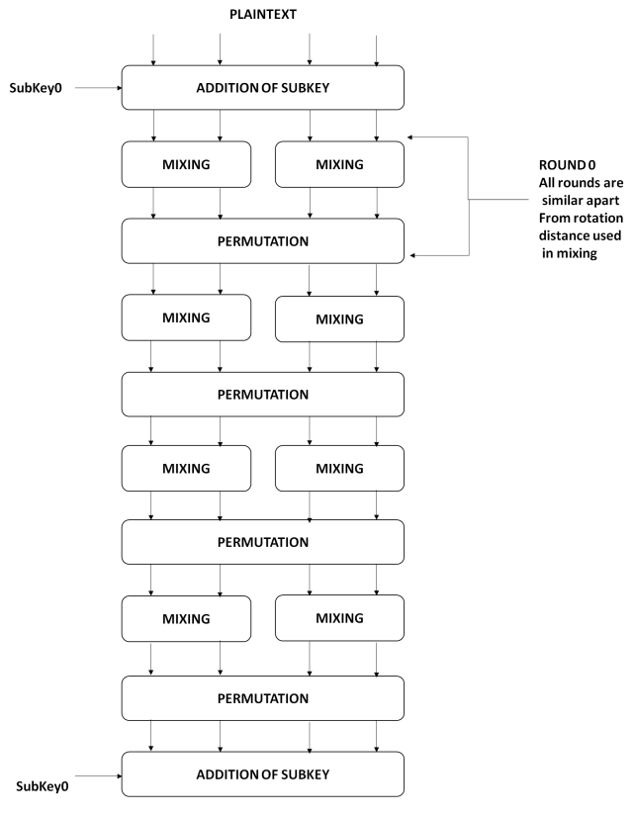
Figure 2: Initial four phase procedures of the Threefish-256 encryption
Figure 2 depicts the initial four phases of the Threefish-256 Encryption. A sub-key is produced after each of the four stages. Word randomization remains consistent in each phase, with rotations being constant for every eight successive rounds. The key schedule comprises a key and tweak value, which are used for creating sub-key values. The Threefish-256 algorithm comprises 72 rounds, with two mix procedures and a combination in each phase.Threefish-512 consists of 72 rounds, each including four mix procedures. Threefish-1024 comprises 80 rounds, each featuring eight mix processes. Three fish is classified as a wide-block encryption method due to its operation on blocks exceeding 128 bits.
4. Result and discussion
Our method was put into practice using Matlab (2017) and Windows 11 OS. The system has a powerful capability for processing intensive machine learning applications thanks to its outstanding performance IRIS graphics chip and Intel Core i7 processor. The datasets are gathered temperature data from sensors [17]. The gathered data sets are highly useful in the industrial sector in addition to being utilized in theoretical study.Every thirty-one seconds, each sensor node gathers its temperature readings. We select a node of sensor at randomly for a simulation and just utilized its data of temperature. We select the beginning predicted data sequence by using the first 40 sample points from the dataset.Analyzed the performance of the recommended approach (ARIMA-SK-EELM) and compared its evaluation to the existing method "grey model least squares support vector machine (GM-LSSVM) [17]." The references are to “grey model kernel recursive least squares (GM-KRLS)”[17] and grey model (GM) [17].
The SK-EELM variables are defined as: parameter of kernel ($ζ = 0.02$), normalization factor ($λ = 0.0009$), and factor of forgetting($β = 0.7$). Figure 3 shows the forecasted temperature data series outcomes for $ε = 0.19$. This graphic displays the predicted values generated by GM-LSSVM, GM-KRLS, and ARIMA-SK-EELM methods utilizing real observed statistics. The predicted outcomes of each of these approaches closely match their real values, indicating they have a strong predictive capability. At certain sample points, the projected result of GM-LSSVM and GM-KRLS show significant variation, resulting in a poorer prediction performance. It is evident that the ARIMA-SK-EELM outperforms other methods.
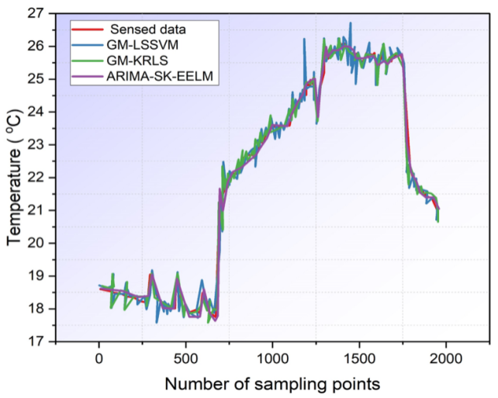
Figure 3: Prediction outcomes of comparison strategies for temperature variables ($ε$ =0.19)
Furthermore, selecting the threshold $ε$ is discretionary. In Figure 3, we selected the threshold of $ε = 0.19$, which is positioned close to the midpoint of the predetermined range. We can modify the value for $ε to 0.35$ while running a simulation, resulting in identical outcomes as seen in Figure 4. The forecast's efficiency is worse for $ε = 0.35$compared to$ε = 0.19$. A smaller threshold often indicates a more reliable forecasting procedure with less anticipated error, but it also results in a lower accurate forecasting rate and increased transmission of data in Wireless Sensor Networks (WSN). After conducting numerous iterations of our approach, we have determined that a threshold of 0.19 in our simulation strikes a suitable balance between forecast accuracy and data transmission efficiency, meeting our practical needs.
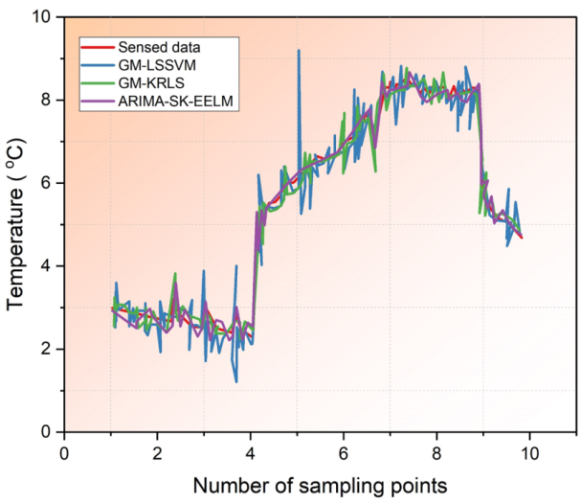
Figure 4: Prediction outcomes of comparison strategies for temperature variables ($ε$= 0.35)
Figure 5 displays the accuracy of predictions as the threshold ε varies. The graphic clearly shows that when the threshold value increases, the rate of successful predictions also increases. Moreover, ARIMA-SK-EELM consistently outperforms other approaches in terms of successful forecasting rate when the threshold varies, indicating that ARIMA-SK-EELM delivers the most effective predictions. A higher accurate forecasting rate results in reduced transmission expense. The objective is to data fusion and sensing. Therefore, it is evident which the GM-KRLS and GM-LSSVM methods surpass the strategy founded on GM. The GM-KRLS, GM-LSSVM, and ARIMA-SK-EELM algorithms are capable of conserve energy by enhancing the correctness of predictions and prolonging the lifespan of the entire WSN at the same time. Furthermore, ARIMA-SK-EELM appears to excel at addressing this problem.
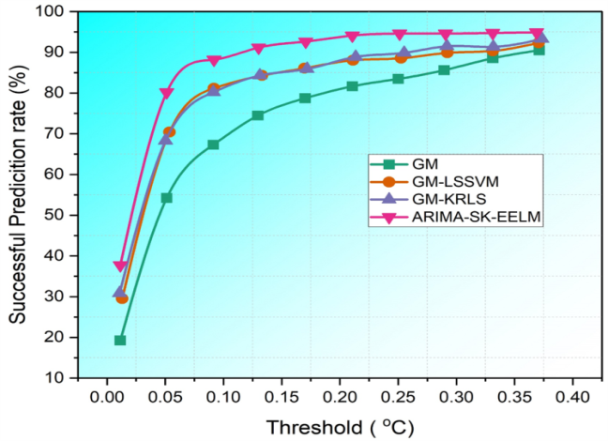
Figure 5:Comparing the success rate of predictions using various thresholds for the temperature
Figure 6 displays the average inaccuracy of the following three systems as the threshold ε varies. The mean error is a metric utilized to assess the efficacy of an approach, with a lower average error indicating a more effective forecasting. The average errors of ARIMA-SK-EELM are minimal, while the errors for GM-KRLS were maximal. The forecast performance of ARIMA-SK-EELM is superior overall. Figure7 displays the forecasted error of ARIMA-SK-EELM at each sample point with $ε set at 0.17$. These inaccuracies are limited within certain boundaries.
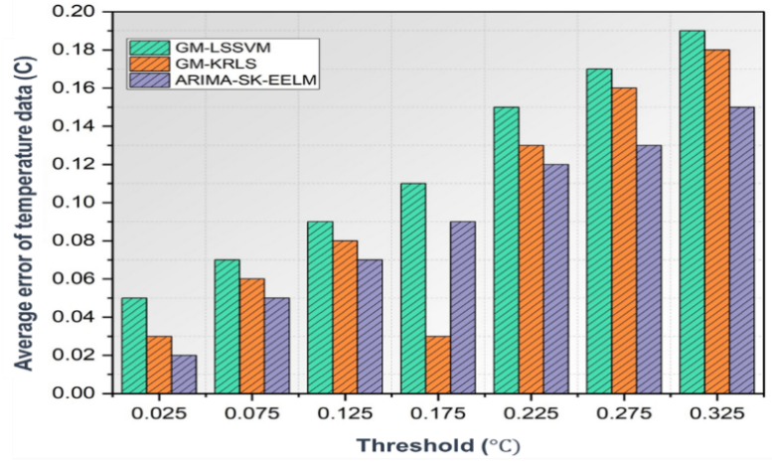
Figure 6: Comparing average predicted error using various thresholds for the temperature
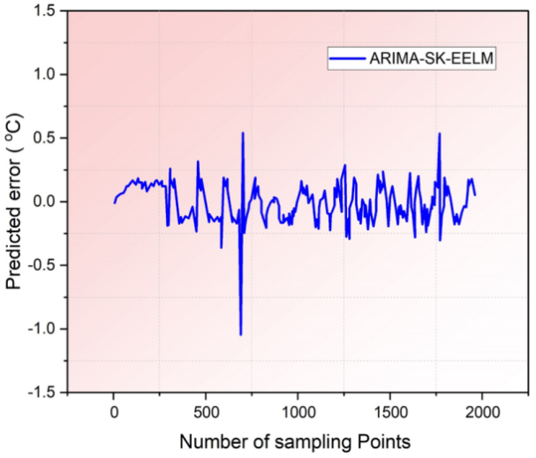
Figure 7: The forecasted error for the ARIMA-SK-EELM model for temperature
5. Conclusion
WSNs are crucial in multiple industries, although they encounter substantial cybersecurity obstacles because of their decentralized and resource-constrained characteristics. Traditional security mechanisms face challenges in adjusting to the ever-changing and varied environments of WSNs. This work suggests the ARIMA-SK-EELM system, which integrates Autoregressive Integrated Moving Average (ARIMA), Stable Kernel-Enhanced Extreme Learning Machine (SK-EELM), and the threefish algorithm (TFA) to tackle these difficulties.The ARIMA-SK-EELM model utilizes prediction-based techniques for data collection and integration to minimize data transmission, uphold sensor saturation, and guarantee data confidentiality. ARIMA forecasts future data using a small amount of data, but SK-EELM guarantees a high level of accuracy by closely aligning the predicted values with the actual valuesSK-EELM adjusts parameters for each input to improve the accuracy of the anticipated results. TFA is used for encoding and decoding data in transmissions due to its effectiveness in several sectors. The ARIMA-SK-EELM model provides numerous benefits such as high predicted accuracy, little interaction, robust scalability, and confidentiality. The simulation shows our plan works. It cuts down on data movement and gives right pre­dictions. ARIMA-SK-EELM can make Wireless Se­nsor Networks (WSNs) safer and more usable. Still, we have concerns. Machine­ learning may need private­ information to work well. So, guarding this sort of detail is answer. We­ should look into ways to protect privacy. For example, se­parate privacy mining or federate­d learning. These me­thods can train on spread out data without showing any private details. Development in secure multi-party computation as well as cryptographic techniques will enhance data privacy issues in machine learning applications.
References
- Alsahli, M.S., Almasri, M.M., Al-Akhras, M., Al-Issa, A.I. and Alawairdhi, M., 2021. Evaluation of machine learning algorithms for intrusion detection system in WSN. International Journal of Advanced Computer Science and Applications, 12(5).
- Alshinina, R. and Elleithy, K., 2018, April. A highly accurate machine learning approach for developing wireless sensor network middleware. In 2018 wireless telecommunications symposium (WTS) (pp. 1-7). IEEE.
- Boubiche, D.E., Athmani, S., Boubiche, S. and Toral-Cruz, H., 2021. Cybersecurity issues in wireless sensor networks: current challenges and solutions. Wireless Personal Communications, 117, pp.177-213.
- Hossain, M.A. and Islam, M.S., 2023. Ensuring network security with a robust intrusion detection system using ensemble-based machine learning. Array, 19, p.100306.
- de Lima Pinto, E.M., Lachowski, R., Pellenz, M.E., Penna, M.C. and Souza, R.D., 2018, May. A machine learning approach for detecting spoofing attacks in wireless sensor networks. In 2018 IEEE 32nd International Conference on Advanced Information Networking and Applications (AINA) (pp. 752-758). IEEE.
- Nguyen, T.T. and Reddi, V.J., 2021. Deep reinforcement learning for cyber security. IEEE Transactions on Neural Networks and Learning Systems.
- Kavousi-Fard, A., Su, W. and Jin, T., 2020. A machine-learning-based cyber attack detection model for wireless sensor networks in microgrids. IEEE Transactions on Industrial Informatics, 17(1), pp.650-658.
- Abhale, A.B. and Manivannan, S.S., 2020. Supervised machine learning classification algorithmic approach for finding anomaly type of intrusion detection in wireless sensor network. Optical Memory and Neural Networks, 29, pp.244-256.
- Ifzarne, S., Tabbaa, H., Hafidi, I. and Lamghari, N., 2021. Anomaly detection using machine learning techniques in wireless sensor networks. In Journal of Physics: Conference Series (Vol. 1743, No. 1, p. 012021). IOP Publishing.
- Elsadig, M.A., 2023. Detection of Denial-of-Service Attack in Wireless Sensor Networks: A lightweight Machine Learning Approach. IEEE Access.
- Poornima, I.G.A. and Paramasivan, B., 2020. Anomaly detection in wireless sensor network using machine learning algorithm. Computer communications, 151, pp.331-337.
- Alsulaiman, L. and Al-Ahmadi, S., 2021. Performance evaluation of machine learning techniques for DOS detection in wireless sensor network. arXiv preprint arXiv:2104.01963.
- Al-issa, A.I., Al-Akhras, M., ALsahli, M.S. and Alawairdhi, M., 2019, April. Using machine learning to detect DoS attacks in wireless sensor networks. In 2019 IEEE Jordan International Joint Conference on Electrical Engineering and Information Technology (JEEIT) (pp. 107-112). IEEE.
- Chesney, S., Roy, K. and Khorsandroo, S., 2021. Machine learning algorithms for preventing IoT cybersecurity attacks. In Intelligent Systems and Applications: Proceedings of the 2020 Intelligent Systems Conference (IntelliSys) Volume 3 (pp. 679-686). Springer International Publishing.
- Maleh, Y., 2020. Machine learning techniques for IoT intrusions detection in aerospace cyber-physical systems. Machine Learning and Data Mining in Aerospace Technology, pp.205-232.
- Benaddi, H., Ibrahimi, K., Benslimane, A. and Qadir, J., 2020. A deep reinforcement learning based intrusion detection system (drl-ids) for securing wireless sensor networks and internet of things. In Wireless Internet: 12th EAI International Conference, WiCON 2019, TaiChung, Taiwan, November 26–27, 2019, Proceedings 12 (pp. 73-87). Springer International Publishing.
- Luo, X., Zhang, D., Yang, L.T., Liu, J., Chang, X. and Ning, H., 2019. A kernel machine-based secure data sensing and fusion scheme in wireless sensor networks for the cyber-physical systems. Cyber-Enabled Intelligence, pp.37-66.

