Improving power allocation and installation in WSN using novel nature-inspired optimization for cyber security applications

1st K S BalamuruganProfessor
Department of ECEKarpaga Vinayagatant
College of Engineering and Technology
Tamil Nadu, India.
4th Waleed Hadi Madhloom Kurdi
Department of Computer Science
Altoosi University College
Najaf, Iraq
waleedalkurdi@altoosi.edu.iq.
2nd Gedela Kalyani PG student
Big Data Analytics,Karpaga Vinayaga
College of Engineering and Technology, Chengalpattu.
Tamil Nadu, India.
5th Fatima Alsalamy
Medical Laboratories Techniques Department
Al-Mustaqbal University
Hillah, Iraq
fatimahashim109@gmail.com
3rd Ramy Al-Fatlawy
Department of Computer Technical Engineering
College of Technical Engineering
The Islamic University
Najaf, Iraq
ramy_riad@iunajaf.edu.iq
6th H.M.Al-Aboudy
Department of Computer Techniques Engineering
Mazaya University College
DhiQar, Iraq;
enghariz82@gmail.com

7th K. Manikandan Asst professor
Department of Biomedical Engineering
College of Technology Salem
college Tiruvannamalai

Abstract
Wireless Sensor Network (WSN) installation and power allocation optimization for cyber security purposes are difficult tasks which include a well-thought-out method that strikes a balance between goals like energy efficiency, connectivity and cyber threat resistance while improving overall system performance and cyber security. A novel Multi-Task Walrus Optimization (MTWO) technique is offered in this study. The Installation and Power Allocation Problem (IPAP) with several jobs is established in this research. The suggested MTWO is used to split the IPAP into numerous scalar components, which are consequently grouped and treated by their desired goals. We evaluate the proposed MTWO approach using simulations and show that it works well in practice. The findings demonstrate that power distribution and installation for cyber security activities on WSNs can be improved by the MTWO. The superiority of the problem specific MTWO over the MOGA has been demonstrated by simulation outcome in several network cases, offering a wide range of excellent network designs to aid in the decision-maker selection.
Keywords: Cyber Security, Wireless Sensor Network (WSN), Installation, Power Allocation,Multi-Task Walrus Optimization (MTWO)
1. Introduction
Wireless sensor networks (WSNs) have partial battery life and difficult-to-reach deployment locations, thus optimizing WSN operations are vital to increasing their efficiency and extending the lifetime of the sensors [1].The Internet of things (IoT) rapid proliferation has led to the development of a wide range that smart gadgets, requiring enormous information creation and communication requirements. Improved Quality of Services (QoS), consistent data transport and efficient energy management are critical components of IoT networks [2]. The intrinsic properties of WSN, such as their distributed design, resource restriction and wireless transmission, make them susceptible to a range of cyber security risks [3].A WSN uses a variety of sensor nodes in the surrounding area to gather, process and send data. These sensor nodes can detect, analyze and transmit substantially more data despite their low cost [4].Network administrators have been utilizing traffic engineering techniques to improve the effectiveness of resource management to handle the constantly growing amount of network traffic [5]. Along international borders, most nations face formidable obstacles in surveillance, incursion detection and prevention. This is impracticable to station military forces at every point along a country's international borders, which can span several hundred to thousands of kilometers [6]. The IoT has become a major area of interest for academics and businesspeople as a result of the widespread use of the internet along with its connected products. The IoT is a network of interconnected physical objects, computer equipment, people and living things that enable information sharing without requiring human intervention [7]. In this article, we suggest an MTWO-based method that systematically tracks problem-specific evolutionary operators and treats each IPAP sub-problem differently according to its WSN specifications.
This part of the paper follows a similar format as the rest: part 2 discusses about literature review. In part 3 the IPAP model is discussed in detail. In part 4, the proposed MTWO is covered in great detail. In part 5, the suggested strategy's experimental design, results and performance evaluation are discussed. The conclusions are summarized in part 6 along with suggestions for more study.
2. Literature Review
The article [8]'s aspects of smart cities were addressed by the creation of three nature-inspired solutions: smart living, smart mobility and cyber security provision. Three strategies have been proposed: controlling electric systems for moth flames in smart houses, using ant colonies as cyber security system that detects intrusionsand applying Internet of Vehicles (IoV) dragon clustering mobility. The article [9] proposed a routing protocol that was optimized for energy efficient and WSN that were connected to the IoT. The protocol used a Tree hierarchical deep convolutional neural network (DCNN) to determine the greatest cluster heads (CHs) for the network, improving network resilience and safe information transport. The research [10] compared hybridization methods with traditional methods to increase WSN energy efficiency. Furthermore, for global optimization issues in WSNs, the Improved Butterfly Optimization Algorithm (IBOA) has been put out. The article [11] offered a thorough analysis of the most recent research on WSNs, coverage optimization and the application of Machine learning (ML) and naturalistic approaches to address coverage problems in WSN. The research[12] methodically reviewed efforts that build trustworthy IoT networks using algorithms inspired by nature and meta-heuristics. Four groups of eighteen articles were examined. The article [13] gathered and kept track of several system or environmental parameters, like temperature, air quality,humidity and more. But even as WSN technology becomes more widely used, yetit faces many obstacles.The research [14] developed a deep learning (DL) used as a safe, energy efficient routing method for WSNs that can identify network intrusions anditwas outfitted with intrusion detection system and cyber security. The article [15] suggested a Nature-Inspired algorithm-based Cross-layer Clustering (NICC) protocol that was based on an algorithm inspired by nature. The design of NICC was to identify a comparatively superior solution for routing and clustering in SF applications and cyber security. The study [16] employed the SHA-256 technique, Elliptic curve cryptography (ECC) and the Aggressive cuckoo search algorithm approach (ACS) to address this issue and improve the cyber security of IoT smart door lock systems. The research [17] presented thata routing protocol using a deep learning model was in an effort to reduce energy consumption and increase network lifetime: hybrid falcon-enhanced ACO inspired by nature optimization. Initially, the falcon optimization process was applied in the constructed model to find the optimal cluster heads and cyber security as quickly as possible.The study [18] provided many kinds of research about Intelligent transportation system (ITS) applications that deal with problem of traffic congestion, cyber security, safety and efficiency in contemporary ITS. The study [19]intended to optimize power utilization in software-defined networks by applying techniques found in nature. There was a comprehensive and distinct classification of energy-efficient options available.
3. Installation and power allocation problem (IPAP)
3.1 System Model
A rectangle sensing zone (A), an array of uniform sensors (N) and an indefinitely powered static sink (H) in the center A comprise a 2-D static WSN. The sensors' straightforward duty is to watch over and notify regularly about any events that are of interest. For the duration of network, the determined power/range assignments are taken into consideration as static. The following energy model equation (1) is used to calculate each sensor node's total energy usage each cycle.
$F_{s}\left(l,c\right)=F_{sw}\left(l,c\right)+F_{qw}\left(l\right)+F_{pq}(l)$ (1)
Where the energy required for transmission and reception a k-bit data packet at a distance of $c$ is represented by the variables $F_{s}\left(l,c\right)$ and$F_{qw}\left(l\right)$,${ F}_{pq}(l)$ respectively. In the interest of simplicity and sensing, we assume a binary sensing model coupled with a grid area.
3.2 Problem formulation
An MOP can be used to formulate the IPAP. $P_{max}$ is the highest transmission power level that all sensors can use. Selection factors for network architecture$W$. $\left(w_{i},z_{i}\right)$Where sensor $i$is located$.$ $O_{i}:$is the sensor$i$'s transmission power level. The proportion of covered grids relative to all grids in A is known as the network coverage$Du\left(W\right)$ and it is assessed in the manner described below in equation (2-3):
$Du\left(W\right)=[\sum_{w^{'}=0}^{w}{\sum_{z^{'}=0}^{z}{h(w^{'},z^{'})] / (w×z),}}$ (2)
$$where wz is the total grids of B and$$
$h\left(w^{'},z^{'}\right)=\left\{\begin{aligned}1 if ∃i ∈\left\{1,…,M\right\},{ c}_{\left(w_{i},z_{i}\right),\left(w^{'},z^{'}\right)≤ Q_{t},} \\ 0 Otherwise, \end{aligned}\right.$ (3)
The above equation shows the grid monitoring status, with its center at$\left(w^{'},z^{'}\right)$.

3.3 IPAP analysis
A single multi-objective IPAP solution is capable of simultaneously optimizing all objectives for cyber security. Therefore, our objective is to provide a set of nearly Pareto-optimal solutions. The Proximate Optimality Principle (POP) states that Pareto optimal solutions that are near each other in the objective space should share a several parallels between one another in the search field. The POP, which forms the basis of most heuristics, presumes that well-structured solutions share a similar structure. The purpose of this subsection is to shed light on the characteristics and attributes of a few specific solutions that could be included in the PF. However, the objective of IPAP is to offer interested customers a wide range of network design options, allowing them to weigh the pros and cons of various extreme solutions inorder to secure the data using cybersecurity strategy. However because there isn't a scalar approach that can build every non-extreme topology in a single run, the process of designing them is difficult.

3.4. Multi-Task Walrus Optimization (MTWO)
Walruses are known to have intricate social structures. A walrus's well-developed upper canine teeth and keen sense of touch are two of its distinguishing features. These anatomical traits are useful for a variety of tasks, including food hunting in the sand as well as mud and self-defense. The pseudocode for MTWO is as follows.
Pseudocode for Multi-Task Walrus Optimization (MTWO)
Step 1: Start MTWO
Step 2:Input all optimization problem information
Step 3:Decide on the total number of iterations and the number of walruses.
Step 4:Initialization process of walrus’s locations
Step 5:For $t=1$; $T$
Step 6: Revise the strongest walrus according to the objective function value standard.
Step 7: For $i=1$:$N$
Step 8: Phase 1: Exploration
Step 9: Calculate the new location of the $j^{th}$walrus
Step 10: Update the $i^{th}$walrus location
Step 11: Phase 2: Migration
Step 12: Choose an immigration destination for the i^{th}walrus
Step 13: Calculate the new location of the j^{th}walrus
Step 14: Update the $i^{th}$walrus location
Step 15: Phase 3: Exploitation
Step 16: Calculate a new position in the neighborhood of the $i^{th}$walrus
Step 17: Update the i^{th}walrus location
Step 18:End
Step 19:Save the top candidate solution up to this point.
Step 20:End
Step 21:Output the best quasi-optimal solution obtained by MTWO for a given problem
Step 22:End MTWO
Phase 1: Initialization: During the optimization process, a first set of randomly generated candidate solutions is employed between the problem variables' upper and lower bounds. Iterations are used to update the walrus agents' positions.
Signals of Danger and Safety: The MTWO describes the safety and danger cues that are essential for understanding walrus behavior. The warning indication of danger is provided by equation (4-8).
Alert for danger = $B × R$ (4)
$B = 2 × α$ (5)
$α = 1$ − $\frac{t}{T}$ (6)
$S$ = $2$ × $q_{1}– 1$ (7)

Alert for danger =$q_{2}$ (8)
Within 0 and 1, there are two random variables, $q_{1}$and${ q}_{2}$. The definition of the safety signal is $q_{2}$. T is the maximum preset number and $t$is the number of iterations.
Phase 2: Migration Phase: The walrus's position is updated based on many factors during the migration phase, which in the algorithm symbolizes exploration: a random integer $q_{3}$and a migration step control factor β. The walrus position is updated using the following equation (9-11):
$W_{ji}^{s+1}= W_{ji}^{s}+ Migration _step$ (9)
$Migration _step =(W_{n}^{s}-W_{m}^{s})×β×q_{3}^{2}$ (10)
$β=1-\frac{1}{1+f^{\frac{-10(s-0.5S)}{S}}}$ (11)
Phase 3: Reproduction Phase: The female walrus position is determined by both a male and the lead walrus, as expressed by the following equation (12-14): The male walrus locations are reallocated using the Halton sequence distribution.
${female}_{ji}^{s+1}={female}_{ji}^{s}=\left(P-{Juvenile}_{ji}^{s}\right)+\left(1-α\right)× W_{best}^{s}-{female}_{ji}^{s})$ (12)
${Juvenile}_{best}^{s+1}=(P-{Juvenile}_{ji}^{s})×O$ (13)
$P= W_{best}^{s}+ {Juvenile}_{ji}^{s}×KE$ (14)
If $O$ is the juvenile walrus's danger coefficient, $P$ is its reference safety position and the vector LF, which indicates LEVY movement, is based on LEVY distribution, which is an improvement over MTWO.
4. Results and Discussion
Java was used to implement all algorithms on a 1.5 GB RAM-equipped Intel Pentium 4 3.2 GHz Windows XP server. The suggested MTWO and existing MOGA's [20] performance are contrasted across multiple network instances.
The trade-offs between the two objectives are depicted in Figure 1, where they are shown to be in direct rivalry with one another and to have a strong negative correlation of roughly -0.77. The very non-linear nature of the design space in a WSN optimization problem arises from the sensors' communication link. Modest network changes could cause network splits or disconnections, which would require major changes to both target functions.
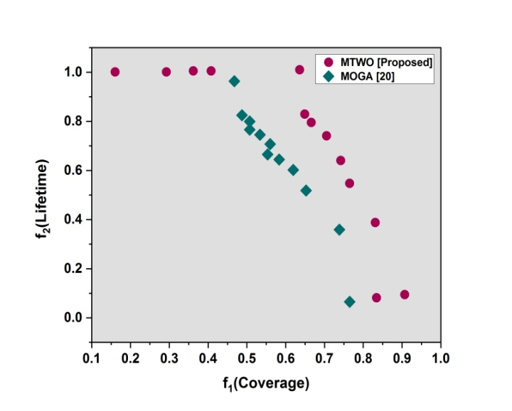
Figure 1:Network Lifetime
Specifically, to obtain the same coverage, we enlarged one of the two options that are not dominant from each method in cybersecurity. Solutions (a) The PF of MOGA and (b) The PF of MTWO yield $f_{cr}$ values of 66% and lifespan differences of about $f_{1f}(b)$ − $f_{1f}(a)$ = 20%, meaning that $f_{1f}(a)$ = 72%. Figure 2 shows the fixed coverage non-dominated solutions.
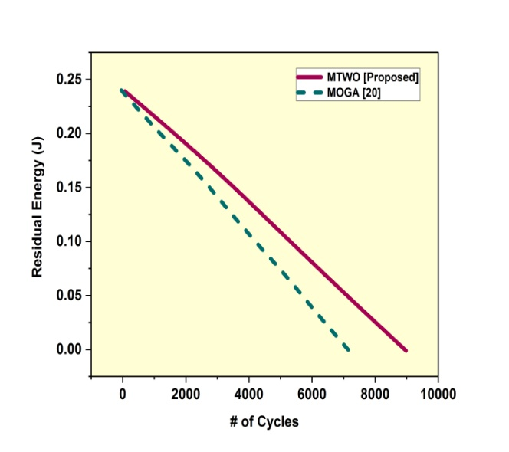
Figure 2:Fixed coverage of non-dominated solutions
Figure 3depicts PFs for every methodology following a predefined number of function evaluations, to evaluate the techniques' convergence speed and initialization of the population in detecting cyber-attacks. Each algorithm's beginning population, or $f.e.$ = 120, is displayed in the first PF. The first solutions offered by MTWO are clearly higher caliber than those offered by MOGA.
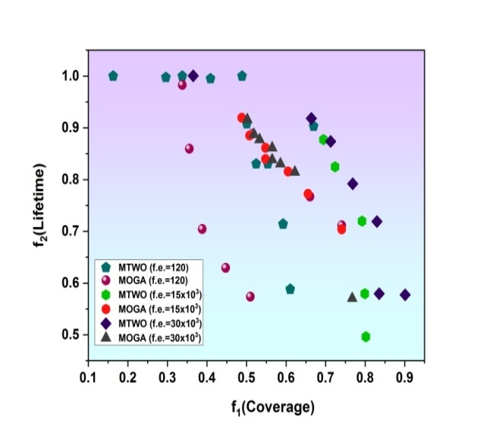
Figure 3: Convergence speed
Every non-dominated solution that MOGA produces is dominated by MTWO. Regarding the trend and distribution of solutions, MOGA's PF and the one offered by extremely similar in cybersecurity applications. The variation in the system model is the primary reason for the slight variation in quality. For topologies with identical lifetimes and solutions with equivalent coverage, with an average lifetime increase of 18%, MTWO offers a coverage advantage of about 12% over MOGA.
5. Conclusion
This study decomposes the IPAP in WSNs into many scalar subproblems and formulates it as a MOP in improving the allocation of power for cyber security uses. This study formulates the IPAP as a novel MOP. To aid a decision maker's selection, we aimed to offer a wide range of excellent options for the IPAP if the objectives were unknown. The MTWO algorithm has been developed and demonstrated to outperform than MOGA in terms of convergence speed and solution quality. Without knowing the target preferences in advance, MTWO generates a large number of excellent WSN designs helps to make a decision. We plan to increase the IPAP's reliability in the future by adding more limitations. Creating low-level, problem-specific local heuristics is a future research project aimed at enhancing MTWO's performance even more for cybersecurity uses.
Reference
- Yadav, R., Sreedevi, I. and Gupta, D., 2022. Bio-inspired hybrid optimization algorithms for energy-efficient wireless sensor networks: a comprehensive review. Electronics, 11(10), p.1545.
- Nithyanandh, S., Omprakash, S., Megala, D. and Karthikeyan, M.P., 2023. Energy Aware Adaptive Sleep Scheduling and Secured Data Transmission Protocol to enhance QoS in IoT Networks using Improvised Firefly Bio-Inspired Algorithm (EAP-IFBA). Indian Journal Of Science And Technology, 16(34), pp.2753-2766.
- Sundaram, P.S.S. and Vijayan, K., 2024. Optimizing energy efficiency and enhancing localization accuracy in wireless sensor networks through genetic algorithms.
- Meenakshi, N., Ahmad, S., Prabu, A.V., Rao, J.N., Othman, N.A., Abdeljaber, H.A., Sekar, R. and Nazeer, J., 2024. Efficient Communication in Wireless Sensor Networks Using Optimized Energy Efficient Engroove Leach Clustering Protocol. Tsinghua Science and Technology, 29(4), pp.985-1001.
- Aboughaly, M. and Hannan, S.A., Enhancing Quality-of-Service in Software-Defined Networks Through the Integration of Firefly-Fruit Fly Optimization and Deep Reinforcement Learning.
- Singh, A., Mousavi, S.M.H. and Nagar, J., 2024. F-TLBO-ID: Fuzzy fed teaching learning-based optimization algorithm to predict the number of k-barriers for intrusion detection. Applied Soft Computing, 151, p.111163.
- Kumar, S., Mahadev, R.G., Kamal, P. and Aggarwal, A., 2024. Original Research Article An optimized deep learning-based fault-tolerant mechanism for energy efficient data transmission in IoT. Journal of Autonomous Intelligence, 7(4).
- Qureshi, K.N., Ahmad, A., Piccialli, F., Casolla, G. and Jeon, G., 2021. Nature-inspired algorithm-based secure data dissemination framework for smart city networks. Neural Computing and Applications, 33, pp.10637-10656.
- Mohammed, M., Imam Rahmani, M.K., Ahmed, M.E., Irshad, R.R., Yasmin, S., Ahmad, S., Mishra, S., Asopa, P. and Islam, A., 2023. Optimized Energy-Efficient Routing Protocol for Wireless Sensor Network Integrated with IoT: An Approach Based on Deep Convolutional Neural Network and Metaheuristic Algorithms. Journal of Nanoelectronics and Optoelectronics, 18(3), pp.367-379.
- Yadav, R., 2023. Evolutionary Algorithms For Improving Energy Efficiency And Security In Wireless Sensor Networks (Doctoral Dissertation).
- Egwuche, O.S., Singh, A., Ezugwu, A.E., Greeff, J., Olusanya, M.O. and Abualigah, L., 2023. Machine learning for coverage optimization in wireless sensor networks: a comprehensive review. Annals of Operations Research, pp.1-67.
- Gong, J., 2023. An application of meta‐heuristic and nature‐inspired algorithms for designing reliable networks based on the Internet of things: A systematic literature review. International Journal of Communication Systems, 36(5), p.e5416.
- Ali, M., 2023. Nature Inspired Data Dissemination Routing Protocol for Wireless Sensor Networks.
- Sakthimohan, M., Deny, J. and Rani, G.E., Secure deep learning-based energy-efficient routing with intrusion detection system for wireless sensor networks. Journal of Intelligent & Fuzzy Systems, (Preprint), pp.1-17.
- Mahajan, H.B. and Badarla, A., 2021. Cross-layer protocol for WSN-assisted IoT smart farming applications using nature-inspired algorithm. Wireless Personal Communications, 121(4), pp.3125-3149.
- Balaji, A., Priyadarsini, C.I., Rao, E.N., Kumar, G.B., Nagaraju, A., Srikanth, N. and Srinivasarao, P., 2024. Handling Information Security Wisely Utilizing the Aggressive Cuckoo Search Algorithm in Lock Systems. International Journal of Intelligent Systems and Applications in Engineering, 12(16s), pp.633-645.
- Krishna, K.P.R. and Thirumuru, R., 2023. Enhanced Qos Energy-Efficient Routing Algorithm Using Deep Belief Neural Network In Hybrid Falcon-Improved Aco Nature-Inspired Optimization In Wireless Sensor Networks. Neural Network World, (3).
- Rajkumar, Y. and Santhosh Kumar, S.V.N., 2024. A comprehensive survey on communication techniques for the realization of intelligent transportation systems in IoT-based smart cities. Peer-to-Peer Networking and Applications, pp.1-46.
- Liu, H., Liao, X. and Du, B., 2023. The applications of nature-inspired meta-heuristic algorithms for decreasing the energy consumption of software-defined networks: A comprehensive and systematic literature review. Sustainable Computing: Informatics and Systems, p.100895.
- Konstantinidis, A., Yang, K. and Zhang, Q., 2008, November. An evolutionary algorithm to a multi-objective deployment and power assignment problem in wireless sensor networks. In IEEE GLOBECOM 2008-2008 IEEE Global Telecommunications Conference (pp. 1-6). IEEE.

