Augmenting cyber security in WSN: AI-based clone attacks recognition framework

1st Seelam Ch Vijaya
Bhaskar, Assistant Professor, Department of IT, MVSR Engineering College Hyderabad
Nadu, India.
4th Fatima Alsalamy
Medical Laboratories Techniques Department
Al-Mustaqbal University
Hillah, Iraq
fatimahashim109@gmail.com
2nd Gedela Kalyani
Big Data Analytics,Karpaga Vinayaga
College of Engineering and Technology, Chengalpattu.
Tamil Nadu, India.
5th Waleed Hadi Madhloom Kurdi
Department of Computer Science
Altoosi University College
Najaf, Iraq
waleedalkurdi@altoosi.edu.iq.
3rd Ramy Al-Fatlawy
Department of Computer Technical Engineering
College of Technical Engineering
The Islamic University
Najaf, Iraq
ramy_riad@iunajaf.edu.iq
6th H.M.Al-Aboudy
Department of Computer Techniques Engineering
Mazaya University College
DhiQar, Iraq;
enghariz82@gmail.com

4th G.Sujatha
Assistant professor/ECEArunai Engineering
college Tiruvannamalai

Abstract
Applications such as industrial automation, healthcare, and environmental monitoring need the use of wireless sensor networks (WSNs). However, due to their dispersed organizational makeup, they have become vulnerable to security risks, particularly clone assaults. To protect confidentiality, availability, and confidentiality, several attacks must be recognized and prevented. This project aims to offer an effective method for identifying and averting clone assaults. To identify cloned both nationally and internationally use a low-cost verification process. In this study, we offer a new adaptive sea-horse optimized light gradient boosting machine (ASHO-LGBM) technique for protecting the network against node identity duplicates. The ASHO approach is used in the ASHO-LGBM framework to improve the recognition accuracy of the LGBM characteristics. The replications with the nodes intrusion detection (ID) are used to choose a most trustworthy communication mode. The procedure is intended to be implemented and used for gathering data through an internet component. Using a Python tool, the suggested technique is simulated and its Delay, Packet Delivery Ratio, Packet Drop and Energy are evaluated. When compared to other approaches, the study's results show that the ASHO-LGBM strategy's performance analysis achieves the highest accuracy rate.
Keywords- Wireless sensor networks (WSN), Cyber Security, Attacks, Recognition, Adaptive Sea-Horse Optimized Light Gradient Boosting Machine (ASHO-LGBM)
1. Introduction
Wireless sensor networks (WSN) have drawn interest from all around globally due to the growth of Micro-Electro-Mechanical Systems (MEMS) technological advances that have made the creation of intelligent detectors easier. Such sensors were less than typical detectors, smaller and had lesser processing and computational power [1]. These node sensors can detect measure and collect data from their surroundings [2]. Energy-efficient gadgets called intelligent sensing networks are comprised of radio waves, a moving component, memories, a light source, a television and multiple sensing [3]. Although the sensors tend to be situated in hard-to-reach areas with little storage space, a wireless link via a radio transmitter can be utilized to send information to an external central station. Due to the large number of connections found in an unregulated WSN, administration tasks like monitoring connections and identifying problems are challenging [4]. Each of the node sensors in the organized WSN can be set up ahead of time. A sensing every node's primary source of electricity is its battery pack. A variety of factors such as the area wherein the sensors can be installed suits its needs, an additional source of electricity that draws energy straight from its surroundings, like rooftop solar panels, could be attached to the electrical nodes. The actuators could be included in the detectors, according to the purpose and kind of sensing utilized. Usually, a WSN contains inadequate or even no infrastructure. It is made up of multiple sensors cooperating to gather environmental information [5]. Cyberspace standards are crucial instruments in the face of an evolving complex online risk scenario and all-encompassing policy for protecting electronic infrastructure, groups and information. A cybercrime strategy functions as a guide, helping companies navigate the intricacies of protecting the digital assets they own and guaranteeing data is accessible, secure and reliable in an environment of changing cyber threats [6]. The system's structure, distribution strategy and scale are all influenced by the surrounding conditions. The monitoring surroundings affect the system's capacity. In interior spaces, fewer links are needed to establish a network in a small space, while outside settings could necessitate additional networks to encompass a wider region [7-9]. The objective of the study is to utilize artificial intelligence (AI) approaches for effective and precise identification to counter the increasing danger of cloned assaults in WSN and to explore, develop and assess a solid foundation that can detect cloning sites throughout the ecosystem and strengthen WSN's safety features. Through the integration of sophisticated AI technologies along with the distinct obstacles presented by wide-area network settings, this study aims to facilitate the development of a dependable and flexible defense system from cloned assaults.
2. Related works
The study [10] illustrated that Traditional methods aren't appropriate for devices featuring Internet of Medical Things (IoMT) because to their scarce funds and computing capacity. This study provided an efficient streaming cipher that uses a code to authenticate messages to safeguard confidentiality, integrity of information and gadget reliability. The study [11] provided the individuals with the knowledge where they require without regard to date or location. The widespread usage of WSN provided a strong basis for the growth of the online world of objects. The article [12] determined the WSN paradigm serves as a formal description enabling this kind of system, outlining the prerequisites and constraints for decentralization and autonomy inside the system. A collection of connected components' operational statuses and a suggested role-based operation define the design. The research [13] created a variety of apps that utilized it. The electronics sector's technical advancement encouraged the production of compact, in expensive, inexpensively computers that had substantial computing capacity. The study [14] garnered a great deal of interest among scholars. Numerous nodes for sensors in an undersea sensor system have been spread across the water's surface at various levels. It's difficult to add fresh gadgets or modify their complexity. The article [15] examined that protection to the networks delivering information to the central nodes, a safe connection known as a slant has been established through the main node towards the clustered ending points. Secured route gains credibility when an agent on the move moves to every relevant node that is next to across its length, gathers the information and encrypts it. The research [16] illustrated that a unique computational framework regarding the spread of malicious software on WSN. In particular, a set of regular differential equations had been utilized to characterize the time-dependent behavior of the recommended framework, which was both world and compartmental. The article [17] analyzed the Cyber security constitutes one regarding the best methods for strengthening the integrity of WSN. It pertains to the process of protecting data through transforming its contents into an arrangement that makes incomprehensible to unauthorized parties.
3. Methodology
The purpose of a cloned threats identification mechanism was to detect and counteract genetic engineering, an attack on safety in which duplicates of authentic objects have been created the aim of tricking or undermining an organization. To discern between real and clone organizations, a system usually uses sophisticated artificial intelligence algorithms to examine tendencies and behaviors.
3.1 Dataset
The substantial utilization of assets in minimum situations is its sole drawback. IPv6 over Low-Power Wireless Personal Area Networks (6LowPAN) network was employed to establish the situation, which included 10 harmful devices using Z1 integrated the internet, 100 Z1-based fake sensing dispersed throughout an area of 10 and 200 meters and one node built from a Zoleria Z1 device [18]. To create each of the final information collections, a trio of topology frameworks has been developed to mimic actual internet activity that included fictitious networks that could be spilled through grabs. 20 networks containing two malevolent detectors made up the initial information set; 50 networks containing 5 unwanted nodes made up the following set; single hundredth devices, ten of those deemed illegitimate made up the third.
3.2 Adaptive sea-horse optimized light gradient boosting machine (ASHO-LGBM)
This flexibility guarantees successful handling of the enormous volumes of information produced by WSNs and improves the structure's resistance to altering network circumstances and developing assault tactics, which helps with actual time cloned surveillance. The fundamental gradient booster approach takes advantage of its efficiency while working with massive cloned data sets. To optimize the simulation's variables, the adaption of Seahorse Optimization incorporates a bio-inspired aspect that imitates the changeable behavior of seahorses. Adaptive Seahorse Optimization (ASHO) is used to design's variables of LGBM and its capacity to change its searching methodology in response to external factors.
3.2.1 Adaptive sea-horse optimization (ASHO)
In this study, the reasoning behind the suggested ASHO method is first described. This part looks at the basic operation of the ASHO method. Next, simulations involving mathematics are created. Seahorse mortality is mostly caused by external variables. Meadows of sea grass and much of the habitats to sea horses Unreported Phrase will be gone in the fifty years that follow as a result of marine debris, according to specialists. This species, currently slaughtered around 30 nations is utilized to cure ailments including cough, headaches and allergies, although it’s primary application is for medications said to address reproductive insufficiency. It remains the unknown number of varieties the creature possesses eighty different kinds are known to be found. Seahorses have a connection to sea instruments, floating straight and lengths that vary between 1.5 to 35 cm. Seahorses tend to be awkward runners due to their skeletal structure and when they get stuck up-to-date they may quickly pass out from exertion. With continual consumption of food, larvae may consume up to 3,000 saltwater prawns every single day due to their extreme facility. The leading edge of the horseshoes that forms a headpiece is located at its highest point. In the area of motion, the seahorse's tails appear severely deteriorated. For buoyancy and navigation, the seahorses mainly depend on their posterior fins for swimming, as well as their pectoral fins, which are found on the sides underneath their skulls. The seahorse tails stand out among various tails mostly because to have a square shape. Seahorses change their color to match the conditions while they sleep or run from their prey. By the resultant the oviduct, the female penetrates the water-filled sack located inside the male's belly pairing. A woman subsequently deposits her ovaries inside for the other man's testosterone to fertilize them. After approximately four to six weeks, birth occurs. ASHO includes a starting populace as well. It might be considered that every seahorse in the community indicates an option for responding to the issues in the area of searching as shown in equation (1);
$seahorses=\left[\begin{matrix}w_{1}^{1} & ⋯ & w_{1}^{dim} \\ ⋮ & ⋱ & ⋮ \\ w_{pop}^{1} & … & w_{pop}^{Dim}\end{matrix}\right]$ (1)
Wherein $Dim$ denotes the length that defines the statistic while pop denotes the sample's number. Given that $AV-AK$, Randomized generation of solutions occurs in the top and bottom limits of the issue.$AV-AK$Inside the searching area in which the $i^{th}$ unique manifestation on $W_{j}$ was calculated as shown in equation (2);
$W_{j}=\left[w_{j}^{1},…,w_{j}^{Dim}\right],w_{j}^{i}=random×\left({AV}^{i}-{AK}^{i}\right)+{AK}^{i}$ (2)
Wherein randomized is an odd number in the interval [0,1]. $w_{j}^{i} , i^{th}jth$ Symbolizes an aspect $i^{th}$ a number that is optimistic and falls among one and pop. In the vicinity of [1, $Dim$], a positive value is utilized to denote$i.{AV}^{i}$ and ${AK}^{i}$ shows the value's optimized issue$i^{th}$. The top athlete denoted in gets the one having the lowest well-being, where the minimal optimization issue is used as an example$W_{elite}$. $W_{elite}$ Was shown in the equation (3) and $e(.)$ denotes the goal function's result in the issue at hand.
$W_{elite}=argmin\left(\left(W_{j}\right)\right)$ (3)
The motion behavior of the sea horses: The different patterns of motion for the early behavior of the seahorses generally correspond to the randomized (0, 1) typical distribution. The global searches take up half of the r1 = 0 cut-offs, compromising both productivity and research, while localized mining takes up the second part. It is described as the seahorse's spiraling motion combined with the swirling phenomenon. Since the chance standard deviation is located on the correct side of the breaking point, it successfully embodies the local instance of ASHO. Sea horses travel in a helical pattern, approaching the $W_{elite}$.
Since seahorses' motion scale can be mimicked by $Lévy$ a flight, it is possible in initial repetitions; they may go to various places, preventing the overuse of ASHO regionally. The seahorse's helical movement changes its rotating position, expanding the possible geographical options currently in existence. This instance involves the mathematics expression of a seahorse's relocation as shown in the equation (4);
$W_{new}^{1}\left(s+1\right)=W_{j}\left(s\right)+Levy\left(λ\right)\left(\left(W_{elite}\left(s\right)-W_{j}\left(s\right)\right)×w×z×y+W_{elite}\left(s\right)\right)$ (4)
$where w = ρ×cos(θ), z =ρ×sin(θ), and y =ρ×θ$ Shows the 3D functions in the $×,z,$ and$y$. Corresponding to a spiraling motion helps to keep the locations of searching robots updated. The total width of the branches is specified with the logarithmic spiraling variables that can be obtained by $ρ=v×f^{θu}(v and w are set to 0.05)$. $[0, 2π]. Lévy(y)$ Was the computation of the Lévy flying distribution formula as shown in the equation (5);
$levy\left(y\right)=t×\frac{X×σ}{{\left|l\right|}^{\frac{1}{λ}}}$ (5)
Where $λ$ randomized integer that has been specified inside $σ$ was calculated as shown in the equation (6);
$σ=\frac{Γ\left(1+λ\right)×sin\left(\frac{πλ}{2}\right)}{Γ\left(\frac{1+λ}{2}\right)×λ×2^{\left(\frac{λ-1}{2}\right)}}$ (6)
ASHO-LGBM is mostly made up of three essential components: development, predatory behavior, and mobility. The interpersonal behaviors of mobility and predatory have been accounted for both global and local methods of searching created to reconcile the finding and usage of ASHO, correspondingly.
3.2.2 Light gradient boosting machine (LGBM)
A light gradient boosting machine (LGBM) is a potent and effective gradient enhancement system made to teach massive neural networks using a dispersed and effective manner. By building branches leaf-by-leaf and giving priority to those components that are contributing more towards the decrease of the eliminated functioning, LGBM creates trees differently from classic decision-tree techniques and develops branches level-wise. All things considered, LGBM shines for its flexible and effective solution for training problems involving gradient boosting algorithms.
LGBM will incorporate several T regression models $\sum_{s=1}^{S}{e_{s}(S)}$ for estimating the final approach, which is specified as follows in equation (7):
$e_{S}\left(W\right)=\sum_{s=1}^{S}{e_{s}\left(W\right)}$ (7)
Regression curves are described as $x_{r(w)}(x), q ∈ \{1, 2,...,M\},$ here $M$ shows the number of tree leaves, $q$ denotes the trees in the decision rule, and $x$it’s an array that represents the leaves of vertices' sampling values. During phase t, the simulation is taught in the following equation (8);
${ Γ}_{s}≅\sum_{i=1}^{M}{K\left(z_{j},E_{s-1}\left(w_{j}\right)+e_{s}\left(w_{j}\right)\right)}$ (8)
The Newtonian technique is quickly used to estimate the goal operation and it becomes simpler if the notion of constants is eliminated as shown in the equation (9);
$Γ_{s}≅\sum_{i=1}^{M}{\left(h_{j}w_{s}\left(w_{j}\right)+\frac{1}{2}g_{j}e_{s}^{2}\left(w_{j}\right)\right)}$ (9)
Here $h_{j}$ and $hi$ are $1^{st}$- and $1^{st}$analytical outcomes of loss equations for ordering slope, when an instance collection leaves $i$were denoted by$J_{i}$;
$Γ_{s}=\sum_{i=1}^{I}{\left(\left(\sum_{jϵJi}{h_{s}}\right)ω_{i}+\frac{1}{2}\left(\sum_{jϵJi}{g_{j}+λ}\right)ω_{i}^{2}\right)}$ (10)
The tree structure $r(w),$the foliage terminals' ideal weights for leaves $ω_{i}^{*}$ statistical figures for $Γ_{L}$ were shown in equation (11) and equation (12);
$ω_{i}^{*}=-\frac{\sum_{jϵJi}{g_{j}}}{\sum_{jϵJi}{g_{j}+λ}}$ (11)
$Γ_{S}^{*}=-\frac{1}{2}\sum_{i=1}^{I}{\frac{{\left(\sum_{jϵJi}{g_{j}}\right)}^{2}}{\sum_{jϵJi}{g_{j}}+λ}}$ (12)
Whenever a tree's architecture grade value method is located $r(w)$ finally, the division has been incorporated to provide the desired operation:
$H=\frac{1}{2}\left(\frac{{\left(\sum_{jϵJi}{g_{j}}\right)}^{2}}{\sum_{jϵJi}{g_{j}}+λ}+\frac{{\left(\sum_{jϵJi}{g_{j}}\right)}^{2}}{\sum_{jϵJi}{g_{j}}+λ}\right)$ (13)
Here $J_{1}$ and $J_{Γ}$ are the illustrations of corresponding opposite branches. Figure 1 depicts the flow of LGBM.
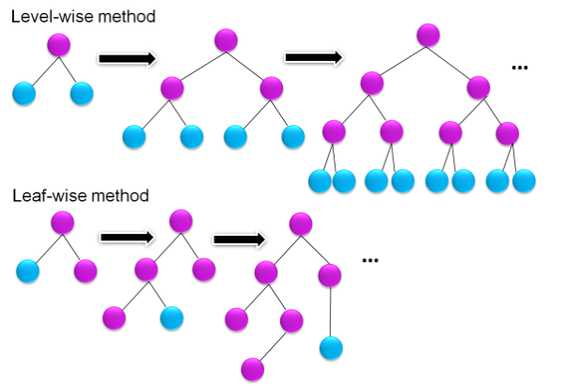
Figure 1: Flow of LGBM
4. Result
In this paper, the experimental setup is equipped with an Intel core i5-825OU CPU with 32GB RAM. We have proposed an Adaptive sea-horse optimized light gradient boosting machine (ASHO-LGBM) and for comparative analysis we using existing methods such as Witness based Clone and Jamming Attack Detection (WBCJAD) [19], Distributed Detection of Clone Attacks (DDCA) [19]. Table 1 depicts the summary of the simulation's variables and configurations are provided. Table 2 illustrates the comparison of Delay, Packet Delivery Ratio, Packet Drop and Energy for existing and proposed methods.
Table 1: Simulation setting
Variables | Outcomes
Spot dimension | 599*599
Quantity of node | 200
Media access control | IEEE 802.10
Routing algorithm | ESRT
Assortment of Gearbox | 249m
Space for Simulations | 49s
Referral source | Case-based reasoning
Frame size | 513
Cost | 50,100,150,199 and 249kb
Initial energy | 10 J
Signal strength | 0.659
Acquiring authority | 0.393
Adversaries | 1 to 5

Table 2: Numerical outcome of existing and proposed methodologies
Cloned nodes (CN) | Delay (Sec) |  |  | Packet Delivery Ratio (%) |  |  | Packet Drop (Packets) |  |  | Energy (Joules)
 | WBCJAD [19] | DDCA [19] | ASHO-LGBM [Proposed] | WBCJAD [19] | DDCA [19] | ASHO-LGBM [Proposed] | WBCJAD [19] | DDCA [19] | ASHO-LGBM [Proposed] | WBCJAD [19] | DDCA [19] | ASHO-LGBM [Proposed]
1 | 1.755 | 5.856 | 1.505 | 0.565 | 0.467 | 0.673 | 1113 | 3872 | 1001 | 8.37 | 9.092 | 7.89
2 | 1.836 | 5.190 | 1.609 | 0.760 | 0.587 | 0.831 | 456 | 3 784 | 378 | 7.93 | 9.18 | 6.03
3 | 1.895 | 5.630 | 1.703 | 0.724 | 0.559 | 0.908 | 84 6 | 3868 | 711 | 8.47 | 9.19 | 7.29
4 | 2.210 | 7.707 | 1.900 | 0.671 | 0.370 | 0.737 | 424 | 6666 | 329 | 7.91 | 9.99 | 6.83
5 | 2.351 | 8.510 | 2.100 | 0.673 | 0.250 | 0.791 | 3 27 | 8435 | 211 | 7.82 | 10.0 | 6.61

Delay: The intentional timing latency takes into traits and behaviors change as time passes to improve the precision of cloning identification. The structure attempts to decrease false alarms and enhance the general accuracy of differentiating between real and cloning objects by examining the behaviors across a certain period. Figure 2 illustrates the comparison of delayed cloned attacks and ASHO-LGBM in CN 1 (1.505 s), CN 2 (1.609 s), CN 3 (1.703 s), CN 4 (1.900 s) and CN 5 (2100 s).
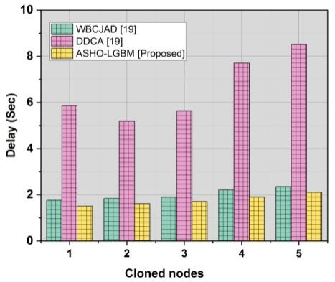
Figure 2: Outcomes of Delay for existing and proposed methods
Packet delivery ratio: The packet delivery ratio calculates the proportion of transmitted messages to all messages transmitted within a system to determine the efficiency of the network. A lowered packet delivery ratio might be a sign of interference through the duplicated organisms messing affecting authentic channels of interaction. Figure 3 depicts the analyzed values in the packet delivery ratio in ASHO-LGBM has occurred 0.673 % for CN 1, 0.831 % for CN 2, 0.908 % for CN 3, 0.737 % for CN 4 and 0.791 % for CN 5.
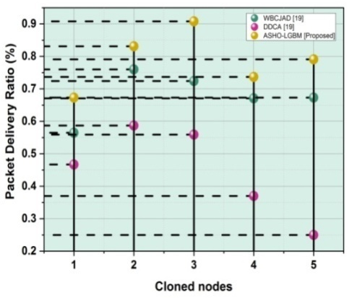
Figure 3: Comparison of packet delivery ratio
Packet drop ratio: A security mechanism detects and neutralizes the hazards that are copied by monitoring the network traffic. Transmission dropping is the deliberate rejection or blockage of dubious network communications which demonstrates the sign of replication efforts. The architecture attempts to stop the harmful activity related to cloning attempts by tracking and discarding messages that exhibit characteristics similar to replicated objects. Figure 4 shows the determination of packet drop and ASHO-LGBM has ranged in CN 1 (1001), CN 2 (378), CN 3 (711), CN 4 (329) and CN 5 (211).
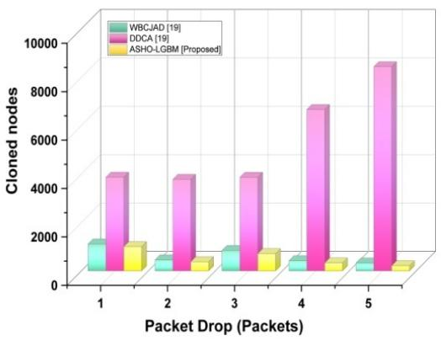
Figure 4: Graphical representation of Packet drop
Energy (Joules): Using resources means making the technique function as well as possible to ensure the system recognizes cloned assaults quickly and precisely with the least amount of processing overhead. This entails improving the training of model protocols, streamlining the removal of feature techniques and putting in place expedited mechanisms for identifying trends connected to cloning operations. Figure 5 illustrates the level of energy occurrence in ASHO-LGBM of CN 1 (7.89 J), CN 2 (6.03 J), CN 3 (7.29 J), CN 4 (6.83 J) and CN 5(6.61 J).
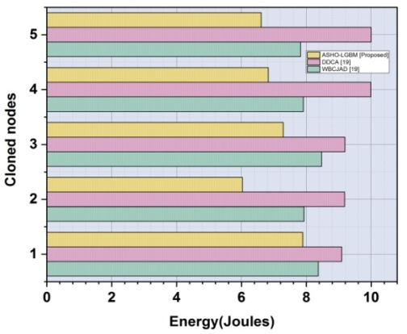
Figure 5: Graphical representation of energy
5. Conclusion
Using an identical threat identification methodology to enhance cyber-attacks in WSNs is an essential phase in protecting the dependability and security of such systems. The use of sophisticated techniques such as detection of anomalies and intelligent machines might improve the WSNs capacity to identify and thwart clone assaults, hence fortifying their defenses against evolving threats. Our proposed method of ASHO-LGBM has calculated the delay range from CN 1 (1.505 s), CN 2 (1.609 s), CN 3 (1.703 s), CN 4 (1.900 s) and CN 5 (2100 s), Packet Delivery Ratio has occurred 0.673 % for CN 1, 0.831 % for CN 2, 0.908 % for CN 3, 0.737 % for CN 4 and 0.791 % for CN 5, Packet Drop were evaluated as CN 1 (1001), CN 2 (378), CN 3 (711), CN 4 (329) and CN 5 (211), and Energy determined CN 1 (7.89 J), CN 2 (6.03 J), CN 3 (7.29 J), CN 4 (6.83 J) and CN 5(6.61 J). Systems such as environmental monitoring and factory automation depend on WSNs and lowering energy usage and communication expenses by implementing safeguards is important. The accuracy and efficiency of WSNs' clone identification might be enhanced by upcoming advances in AI, especially in the areas of comprehensive instruction and learning from experience.
Reference
- Shaukat, H.R., Hashim, F., Shaukat, M.A. and Ali Alezabi, K., 2020. Hybrid multi-level detection and mitigation of clone attacks in mobile wireless sensor network (MWSN). Sensors, 20(8), p.2283.
- Allen, A., Mylonas, A., Vidalis, S. and Gritzalis, D., 2024. Smart homes under siege: Assessing the robustness of physical security against wireless network attacks. Computers & Security, 139, p.103687.
- Almesaeed, R. and Al-Salem, E., 2022. Sybil attack detection scheme based on channel profile and power regulations in wireless sensor networks. Wireless Networks, 28(4), pp.1361-1374.
- Kshirsagar, P.R., 2021. Malicious Node Detection in Adhoc Wireless Sensor Networks Using Secure Trust Protocol. Research Journal of Computer Systems and Engineering, 2(2), pp.12-16.
- Uchendu, B., Nurse, J.R., Bada, M. and Furnell, S., 2021. Developing a cyber security culture: Current practices and future needs. Computers & Security, 109, p.102387.
- Humayun, M., Niazi, M., Jhanjhi, N.Z., Alshayeb, M. and Mahmood, S., 2020. Cyber security threats and vulnerabilities: a systematic mapping study. Arabian Journal for Science and Engineering, 45, pp.3171-3189.
- Sarker, I.H., Kayes, A.S.M., Badsha, S., Alqahtani, H., Watters, P. and Ng, A., 2020. Cybersecurity data science: an overview from a machine learning perspective. Journal of Big Data, 7, pp.1-29.
- Swetha, P.M. and Prasanna, B.T., 2024. A Clone Detection Mechanism For Hybrid Wireless Sensor Networks (Hwsns). Migration Letters, 21(S5), pp.721-738.
- Jacob, S.S., Karthikeyan, B., Johnpeter, T. and Jayamala, R., 2024. Deployment with Location Knowledge by Multi Area Approach for Detecting Replica Nodes in Wireless Sensor Network. Tehnički vjesnik, 31(1), pp.254-261.
- Kumari, P. and Mondal, B., 2024. Lightweight encryption with data and device integrity using NLFSR and PUF for the Internet of Medical Things. Internet of Things, 25, p.101041.
- Huanan, Z., Suping, X., and Jiannan, W., 2021. Security and application of wireless sensor network. Procedia Computer Science, 183, pp.486-492.
- Meleshko, A. and Desnitsky, V., 2024, February. The Modeling and Detection of Attacks in Role-Based Self-Organized Decentralized Wireless Sensor Networks. In Telecom (Vol. 5, No. 1, pp. 145-175). MDPI.
- Jondhale, S.R., Maheswar, R., Lloret, J., Jondhale, S.R., Maheswar, R. and Lloret, J., 2022. Fundamentals of wireless sensor networks. Received Signal Strength Based Target Localization and Tracking Using Wireless Sensor Networks, pp.1-19.
- Lilhore, U.K., Khalaf, O.I., Simaiya, S., Tavera Romero, C.A., Abdulsahib, G.M. and Kumar, D., 2022. A depth-controlled and energy-efficient routing protocol for underwater wireless sensor networks. International Journal of Distributed Sensor Networks, 18(9), p.15501329221117118.
- Patil, H. and Tegampure, V., 2024. Trust aware angle based secure routing approach for wireless sensor network. Bulletin of Electrical Engineering and Informatics, 13(1), pp.529-537.
- Martin-del Rey, A., 2024. A novel model for malware propagation on wireless sensor networks. Mathematical Biosciences and Engineering, 21(3), pp.3967-3998.
- Kumar Shukla, D., Khalaf, O., Vallabhaneni, R., Kumar Srivastava, S. and Algburi, S., 2024. A Three-phase hybrid cryptography algorithm: Utilized in public sensor network for data security with an enhancement of hashing algorithm. International Journal of Computing and Digital Systems, 15(1), pp.1-13.
- Morales-Molina, C.D., Hernandez-Suarez, A., Sanchez-Perez, G., Toscano-Medina, L.K., Perez-Meana, H., Olivares-Mercado, J., Portillo-Portillo, J., Sanchez, V. and Garcia-Villalba, L.J., 2021. A dense neural network approach for detecting clone id attacks on the rpl protocol of the iot. Sensors, 21(9), p.3173.
- Jeyaselvi, M., Suchitra, S., Sathya, M. and Mekala, R., 2021. Energy efficient witness-based clone and jamming attack detection in win. Journal of Green Engineering, 11(2), pp.1525-1548.

