IMAGE ANALYSIS FOR TURNING DEFECT OF COMMUTATOR SURFACE

Zhong-Ping Shao
Department of Mechatronic Engineering
Huafan University
New Taipei, Taiwan
d0662002@mail.hfu.edu.tw
Cheng-Yuan Tang
Department of Technology for Smart Living
Huafan University
New Taipei, Taiwan
cytang@gm.hfu.edu.tw

Abstract—The quality of commutator surfaces in DC motors significantly affects the performance and longevity of the motors. Traditional methods of inspecting commutator surface defects, such as roundness and roughness meters, have limitations in detecting subtle and complex surface irregularities. This study proposes an image analysis technique combined with convolutional neural networks (CNN) to enhance the detection of commutator surface defects. Our method improves the identification and classification of defects, correlating these findings with the assembly quality of DC motors. Although the experimental results are premilitary, it validates the effectiveness of the proposed approach, demonstrating improvements in defect detection accuracy. Future work will focus on expanding the image dataset and refining the CNN model to enhance its accuracy and real-time application capabilities.
Keywords—defect detection, DC motor quality control, surface defects, correlation table, convolutional neural networks (CNN)

Introduction
A DC motor is an electric motor that converts electrical energy into mechanical energy. Its working principle is to use the armature to rotate under force in the magnetic field to generate torque. DC motors are widely employed in various fields, including industrial automation, appliances, and transportation, as essential power devices. The main components of a DC motor are: motor housing, magnet, armature, commutator, bearings, and carbon brushes. The armature and commutator are the key components of the DC motor. The armature is the core part of the DC motor. It is composed of an enameled wire group and a silicon steel sheet. The enameled wire group forms a magnetic circuit on the silicon steel sheet. When the current flows through the enameled wire group, a magnetic field is generated. The armature is forced to rotate in the magnetic field, thereby generating rotation. moment. The commutator is an important component of the armature and is used to convert the alternating current induced in the armature into direct current. The commutator is composed of multiple copper sheets, which are insulated from each other and fixed on the shaft of the armature. The number of commutator sheets is equal to the number of grooves of the armature.
Fig 1 shows the commutator after turning, which is made of copper cylindrical metal. The interior of the cylinder is made of insulating mica, and the outer layer is surrounded by individual copper inserts, with grooves formed between the sheets, or cover the entire copper coil and then score grooves on the surface. The turned commutator has a copper-colored metallic luster. As shown in Fig 2, marks the four main components of the armature: shaft, silicon steel sheet, commutator, and enameled wire, and displays the "armature specifications" - as different sizes of commutator and silicon steel sheet wound enameled wire, the matching wire diameter is required and specifications.

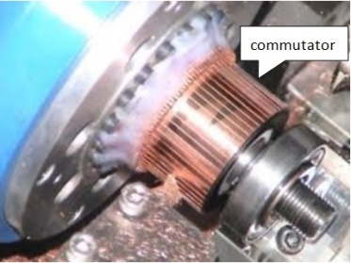
Fig 1. Commutatorsurfaceafter turning

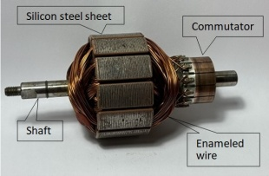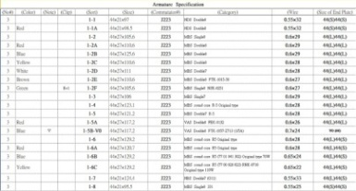
Fig 2. Structure of Armatureand Armature Specification

Currently, relevant research focuses on using image processing and various artificial intelligence [13][14] to improve the identification of commutator surface defects. For example, Shu, Li, Li, Xiong, Cao, and Wen [1] focus on using deep learning technology to improve the identification speed and accuracy of commutator surface defects. Shu, Xiong and Xie 2024 [2] used neural network (NN) to solve the detection problem of commutator surface defects. In 2021 Hu [3] used semantic segmentation (Semantic Segmentation) technology to solve the detection problem of surface defects of motor commutator. In 2023, Ning etc. [4] focus on solving two common problems in electronic commutator surface defect images: noise and blurred details, through image denoising and enhancement technology designed to improve the accuracy of defect detection. In addition, Li and Pan, in 2023 utilized a genetic algorithm (GA) to address the issue of commutator surface defect detection [5]. Niu and Li used the generative adversarial networks (GAN) to generate many defects image samples to expand the training data set, thereby improving the accuracy and robustness of the defect identification model, which is even more impressive.
However, these studies are limited by the difficulty in obtaining actual production data, and rarely discuss the gap between predictions and actual production results. They also lack discussion of actual machines and equipment, and the direction to further improve the quality of DC motors.
Based on the above issues, we proposed methods that combines traditional inspection tools (such as roundness meters and roughness meters) with image analysis. For factory quality control, we first use traditional inspection tools to select qualified commutators, and then use image processing to Analysis, find out the characteristics, and finally use it to determine the OK/NG after assembling the DC motor on the actual production line, revise our analysis and classification, achieve the goal of accurate identification before assembly, and greatly reduce frequent trial assembly, trial and error, and heavy disassembly. thereby increasing production capacity.

Problem statements
Based on our knowledge and observations in factory production, there are a few statements described in the following:

Commutator Turning Machine
Commutator surface turning uses a device called a "Commutator Turning Machine (CTM)". The structure and working principle are like ordinary turning machines, but it is a machine tool specially used to process DC motor commutators. CTM can precisely machine the surface of the commutator to meet specified roundness, roughness and coaxiality requirements. There are three key parts of a commutator turning machine:

Slide tool post - Including the base, height knob, height gauge and tool holder, which is responsible for the height, horizontal movement and feed of the turning tool during turning.

V-block - A seat let the armature shaft to be placed
horizontally, allowing the armature to rotate smoothly.

Belt - Pressing the silicon steel sheet to drive the armature to rotate.
Fig 3(A) - Show the main structure of the CTM “Slide Tool Post”: Including the base, height knob, height gauge and tool holder, which is responsible for the height, horizontal movement, and feed of the turning tool during turning. Fig 3(B) – shows the position of the fixing turning tool screw and the turning tool tip. The fixing turning tool screw is used to lock the turning tool holder to keep the turning tool tip fixed when turning. Fig 3(C) and Fig 3(D) show the "V-shaped block"- a seat let the armature shaft to be placed horizontally, allowing the armature to rotate smoothly, and the "belt"- pressing the silicon steel sheet to drive the armature to rotate respectively. Fig 3(D) also illustrates how the turning tool tip turns the surface of the commutator and the moving direction of the turning tool holder.

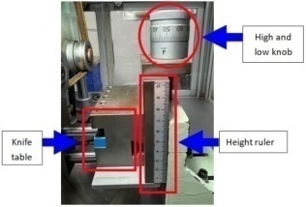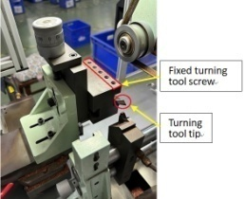
- (B)
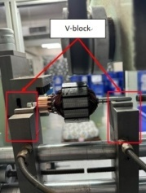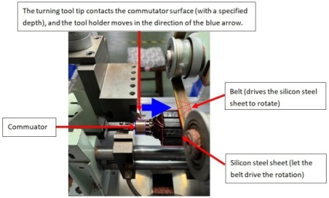
(C) (D)
Fig 3. Commutator Turning Machine

Correlation between Carbon Brushes and Commutators
Carbon brushes and commutators are two essential components in DC electric motors that work together to convert electrical energy into mechanical energy.

Role of Carbon Brushes
Conductivity: Carbon brushes primarily conduct electricity from the external circuit to the rotor of the motor and vice versa.
Commutation: In conjunction with the commutator, carbon brushes reverse the direction of current flow in the rotor windings, creating a continuous rotating magnetic field. Current Collection: Carbon brushes collect the induced current from the rotating rotor windings and send it back to the external circuit.

Interaction between Carbon Brushes and Commutators
Sliding Contact: Carbon brushes maintain a sliding contact with the commutator segments, allowing for the flow of current.
Sparking: Due to the sliding contact, sparking can occur between the carbon brushes and commutator segments. This is caused by factors such as contact resistance and mechanical wear. Wear: Both carbon brushes and commutators experience wear over time due to friction and sparking.

Consequences of Carbon Brush and Commutator Issues
Excessive Sparking: Excessive sparking can damage the commutator surface, wear down the carbon brushes, and reduce the motor's efficiency and lifespan. Poor Contact: Poor contact between the carbon brushes and commutator can lead to inconsistent current flow, causing the motor to vibrate, overheat, or even fail. Severe Wear: Excessive wear on carbon brushes and commutators can result in reduced motor performance and increased maintenance costs.

Commutator thread
The commutator will produce various forms of threads after turning. Generally, good threads have regular spacing, no breaks or defects, and the depth is consistent. However, the following factors can lead to poor threads.

Mechanical Factors
Tool wear or damage: Worn, chipped, or broken cutting tools can result in poor thread profiles, inaccurate dimensions, and burrs. Insecure tool clamping: Loose tool clamping can cause vibration during cutting, leading to rough thread surfaces and chatter. Insecure workpiece clamping: Loose workpiece clamping can cause vibration and affect thread accuracy. Insufficient machine tool accuracy: The accuracy of the machine tool directly affects the accuracy of the workpiece. If the machine tool is not precise enough, it can lead to thread errors. Incorrect cutting parameters: Improper cutting speed, feed rate, and depth of cut can cause various thread defects, such as broken threads, tearing, and burrs.

Material Factors
Commutator material defects: The hardness, toughness, and grain size of the commutator material can affect the quality of the thread. Surface defects in the material: Cracks, pores, and other surface defects in the commutator material can lead to stress concentration and thread breakage.

Operational Factors
Operator skill level: The operator's skill level directly affects the quality of the machining process. Improper operation can lead to various thread defects. Misalignment of the tool holder: This will lead to increased surface roughness of the thread and poor roundness of the commutator, resulting in armature operating noise and unstable current.

Turning Process:
The Turning Process - the commutator turning machine's turning process involves the following steps:
1)Preparation: Place the armature on the V-block.
Adjust the cutting tool "Feed Rate" parameters, including the belt's speed and cutting depth, according to the commutator's size and shape.
2)Rough Turning: The cutting tool operates at a higher
feed rate and cutting depth to rapidly remove excess material from the commutator for establishing the commutator's basic form.

Finish Turning:The cutting tool employs a slower feed rate and shallower cutting depth to ensure the commutator's dimensions and shape are precise for enhancing the commutator's machining accuracy.

Inspection:Once turning is completed, the commutator undergoes inspection to verify that its dimensions, shape, and surface quality meet the required standards.
Note: “Feed Rate” is a crucial parameter in machining processes, defining the distance the cutting tool travels along the workpiece per single revolution of the spindle. It significantly impacts machining efficiency, quality, and cost. Feed rate is typically measured in millimeters per minute (mm/min) or inches per minute (in/min). In machining processes like turning and milling, feed rate must be set and adjusted in advanced.
Usually, the number of turns is two or more times, depending on the accuracy requirements, turning parameters and the bluntness of the turning tool tip. However, this is usually a rule of thumb and relies heavily on manual judgment. When turning quality deteriorates, it takes a lot of time to find the cause, and it is difficult to find clues and rules from traditional measurement tools, and it is also very difficult to digitize and predict.

However, there two key factors that affect the processing quality of the commutator are the surface roundness and roughness of the commutator (including commutator surface threads). The roundness of the commutator surface refers to the degree to which it deviates from an ideal cylindrical shape. Good roundness ensures proper contact between the commutator and carbon brushes, minimizing friction and sparking, enhancing commutation efficiency, reducing noise and vibration, and extending the service life of both the commutator and carbon brushes. The roughness and threading of the commutator surface pertain to the microscopic irregularities present on the surface. Appropriate roughness and regular threading increase the contact area between the commutator and carbon brushes, improving commutation efficiency, lowering friction, and sparking, and prolonging the lifespan of carbon brushes. Better roundness, surface roughness and threading can effectively reduce the vibration and noise levels when the DC motor is running, especially when the motor is running in a quiet environment, such as the interior space of a car that has particularly strict requirements.

Roundness Meter and Roughness Meter:
Traditionally, two types of equipment are used to check the surface roundness and roughness of a commutator: “roundness meter” and “roughness meter”. A roundness meter is an instrument used to measure the roundness of a cylinder's surface. It consists of a spindle, a probe, and an indicator. Install the commutator on the spindle of the roundness meter, scan the commutator surface with a probe, and the indicator will show the roundness error on the commutator surface. A roughness meter is an instrument used to measure the surface roughness of an object. It consists of a probe and an indicator. Drag the probe along the commutator surface and the indicator will show the roughness value of the commutator surface.

Pros and Cons of Roundness meter and Roughness meter:
The advantages of the roundness meter are: direct measurement of roundness, various choices (mechanical and laser), and high accuracy (microns); the disadvantages are: mechanical measurement has errors that vary from person to person, laser measurement operation is complex, and only the energy measures the deviation from a circle but cannot obtain the complete 3D shape of the surface. The advantages of the roughness meter are: various choices (mechanical and laser), the mechanical operation is simple and fast, and the disadvantages are: only linear roughness can be measured each time, mechanical measurement has errors that vary from person to person, and the measurement plane Roughness is very time-consuming (requires multiple straight lines to estimate).
We use image analysis to assist traditional equipment. Its characteristics are: reducing operating errors that vary from person to person, easy operation and obtaining complete 3D information, and rapid 3D image capture to greatly shorten the interpretation time. The most important thing is that the images can be directly used as training AI model data to predict the correlation between commutator quality and motor quality, which can significantly reduce the time required to assemble the motor to determine whether the motor is OK/NG.
Moreover, roundness meters and roughness meters cannot conduct a characteristic and comprehensive analysis of the distribution of threading on the surface of the commutator as images can, especially if the thread texture spacing is inconsistent or broken. Even the same threading has a different heights and different texture types after crossing the grooves. These are all problems that are difficult to solve with traditional meters.

Proposed Methods
Thread defect detection and the actual assembly quality of DC motors are the focus of our attention. The correlation between the two is rarely mentioned in research, but we believe that this is the information that is really needed in actual factory production. Therefore, we propose a so-called "Correlation Table" in Section IV which combines the correlation between thread defect detection and the actual assembly quality of DC motors.
The central cylinder of the commutator is made of insulating and non-conductive mica, and the periphery is made of individual copper inserts or a whole copper coil around the central cylinder. Whether it is inserted or rolled, there must be reservations or grooves at equal intervals. The commutator groove is an important part of the DC motor commutator. Its main function is to insulate each commutator segment, prevent short circuit between adjacent commutator segments, ensure the smooth flow of current and realize the conversion of electrical energy.
In this paper, one of our proposed methods is hot rings methods. If the complete commutator image is divided into four rings (R1/R2/R3/R4), the "hot rings" are R2 and R3. When the carbon brush contacts the surface of the commutator, it is a sliding contact, not a fixed contact, and the contact area is not completely fixed. However, more than 98% of the width of the carbon brush is still in contact with the hot zone, so the commutation outside the hot zone Surface defects of the device can usually be ignored. There are five types classified in this paper.
Type I (as shown in Fig 4): the thread gloss (brightness) and the distinction between each thread are good, and the pitch between adjacent threads is consistent. Only one thread in R4 (red frame) in Fig 4 is damaged and broken. The remaining items such as 5) scratches on the commutator surface, 6) damage to the adjacent slot edges, and 7) other messy threads are not present.
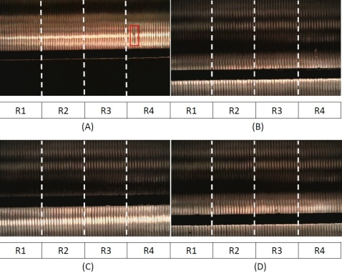
Fig 4. Type I: General normal threads

Type II (as shown in Fig 5) is covered with many "white frames" and other miscellaneous patterns according to Table 1.
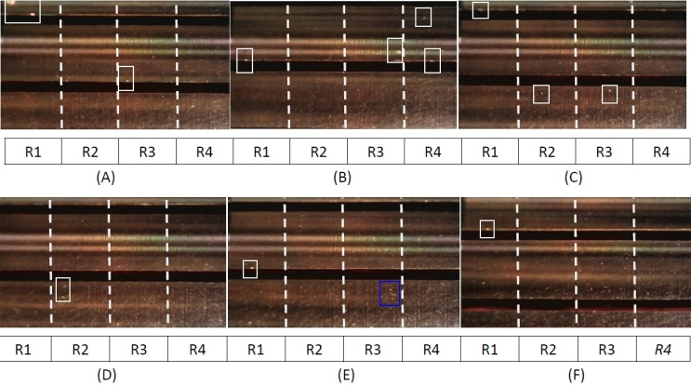
Fig 5. Type II: Normal slightly dark threads

Fig 6 (as shown in Type III) is in the worst condition among the five types. According to the definition of Table 1, it is covered with many "red frames" (threads are damaged and broken), "blue frames" (commutator surface is scratched) and "green frames" (damage adjacent to trench edge).

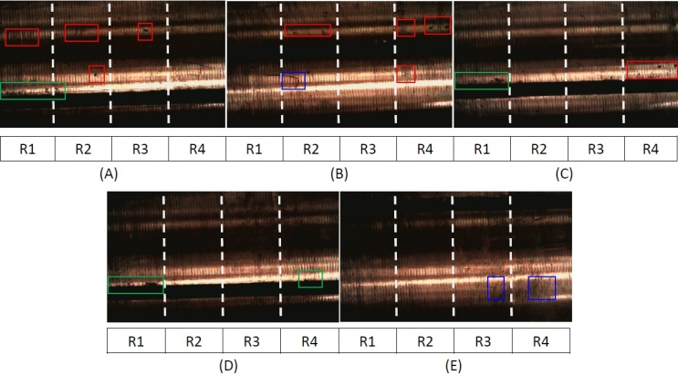
Fig 6. Type III: Surface defective threads

Type VI (as shown in Fig 7): there are many reasons for vague image, usually caused by shooting equipment, shooting methods, light, or even unclear threads on the surface of the commutator. In addition to improving the above problems, image processing will also be used to overcome them.

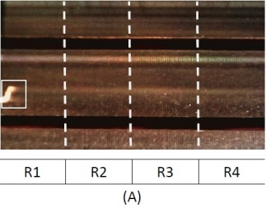
Fig 7. Type IV: Vague threads

Type V (as shown in Fig 8): "Not obvious threads" means that very few threads in the image can be identified, which is different from "Type IV". Although the image is said to be clear and there are even very few threads that can be identified, it is not possible. Most threads are not obvious.
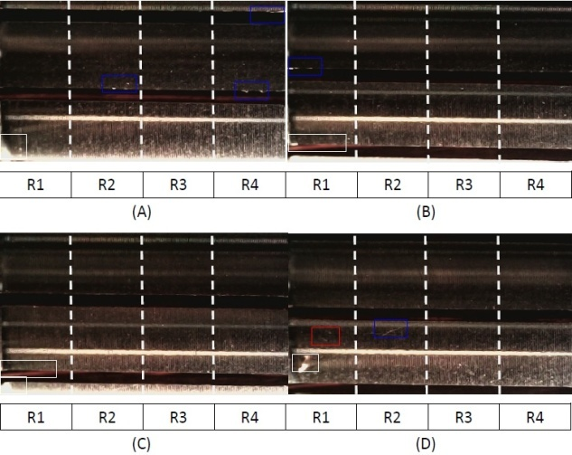
Fig 8. Type V: Notobvious threads

Image Analysis:
Based on these five types described above, we try to apply image analysis to classify them. First, we try to use some algorithms of image processing to process them, and then check the results processed to fine the better processing methods.
If we can collect enough image datasets, we plan to apply CNN to train can classify them.

Experimental results and analysis
The device we use to photograph the surface threads of the commutator is the USB Microscope as shown in Fig 9, and the user interface (UI) is a software called DLScope as shown in Fig 10. The USB Microscope has an adjustable focal length range and a maximum magnification of 1600 times. It is connected to a PC via USB and paired with the DLScope UI. Although it is a simple tool, it is sufficient for capturing images of the commutator surface threads.

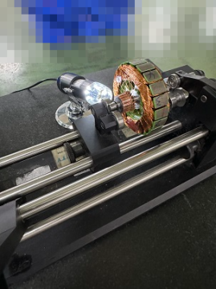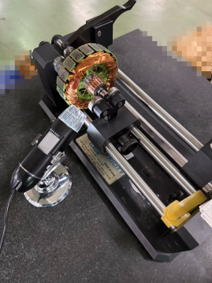
Fig 9. USB Microscope

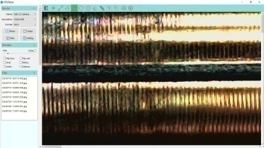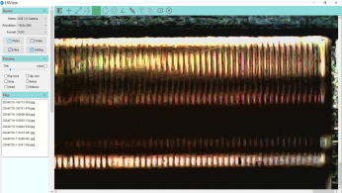
Fig 10. USB Microscope UI

Commutator thread comparison table:
It is known from [11], [12] that common commutator surface defects mainly include scratches, abrasions, cracks, oil stains, black spots, etc., and the quality of the image is closely related to the identification effect of the defect type. Therefore, in order to analyze commutator surface defects more effectively and make them more effective in improving production quality, we directly compare the five types of measured threads images: 1) General normal, 2) Normal slightly dark, 3) Surface defective, 4) Vague, 5) Not obvious, and the quality of the actual assembled motor are OK/NG. A comparison table was built. Based on relevant research and practical experience, seven commutator surface defects were listed as Analysis items of the “Commutator Thread Comparison Table”: 1) Thread gloss (thread brightness) 2) Thread clarity (distinction of each thread) 3) Thread spacing (distance between adjacent threads) 4) Discontinuous thread damage (the same copper piece and the same thread are damaged Damage and breakage) 5) Scratches on the surface of the commutator (damage that is not parallel to the direction of the thread, and the damaged line width is much smaller than the thread line width) 6) Damage to the edge of the adjacent groove (the copper sheet is adjacent to the thread of the same * groove Damaged or broken) 7) Other noise. Table 1 analyzes and organizes seven commutator surface defects from Type I to Type V.

Table 1. Commutator Thread Comparison Table
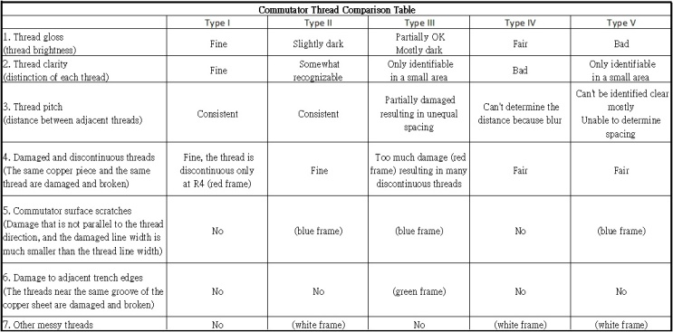

Correlation Table:
In order to well combine detection and assembly (theory and practice), we designed a "Correlation" to classify the detected thread defects into two conditions (OK/NG), and the DC motor assembly quality is also classified into two conditions (OK/NG), so there are 2x2=4 statuses:

The detection classification is qualified and the assembly quality is qualified.

The detection classification is qualified, but the assembly quality is unqualified. (misjudgement)

The detection classification is unqualified and the assembly quality is qualified. (misjudgement)

The detection classification is unqualified and the assembly quality is unqualified.

Table 2. Correlation Table
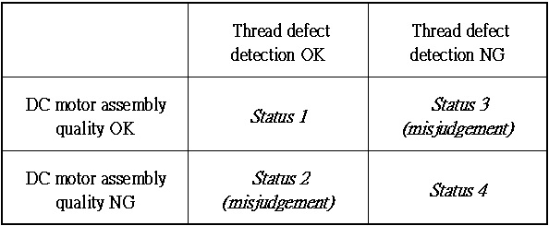

Image Anslysis:
Based on these five types described above, we try to apply image analysis to classify them. First, we try to use some algorithms of image processing to process them, and then check the results processed to fine the better processing methods.
Since it takes time to collect defects image datasets, the size of image dataset is limited. It leads to our premilitary results using CNN should is not good, and it should be improved soon! If we can collect enough image datasets, we plan to apply CNN to train can classify them.

Conclusion
In this paper, we have explored the effectiveness of integrating traditional inspection tools with advanced image processing techniques for the detection of surface defects in commutators. Our proposed methodology demonstrates improvements in identifying and classifying defects, which directly correlates with the assembly quality of DC motors. The experimental results validate our approach, showing that image-based analysis can overcome the limitations of traditional roundness and roughness meters, particularly in detecting subtle and complex surface irregularities. The implementation of a "Correlation Table" further bridges the gap between defect detection and practical assembly outcomes, providing a robust framework for quality control in production lines.
Future work will focus on expanding our image dataset and refining the CNN model to improve its accuracy and generalizability. Additionally, exploring real-time defect detection systems could offer further benefits in enhancing production efficiency and reducing downtime. By combining theoretical research with practical applications, this study contributes to the advancement of quality assurance technologies in the manufacturing of DC motors, ultimately leading to higher production standards and better product performance.

References
- YF Shu, B Li, X Li, C Xiong, S Cao, XY Wen, "Deep learning-based fast recognition of commutator surface defects", Measurement, 2021.
- Y Shu, C Xiong, Z Xie "Research on Commutator Surface Defect Detection Technology based on Class Neural Network", 2024 bit.kuas.edu.tw.
- S Hu"Surface Defect Detection Model of Motor Commutator Based on Semantic Segmentation", Journal of Engineering Mechanics and Machinery, 2021.
- P Ning, WU Hao, QI Zi-yuan,"An Algorithm for Image Denoising and Enhancement of Surface Defects of Electronic Commutator", Journal of Hebei 2023.
- X Li, X Pan "Commutator Surface Defect Detection Algorithm based on Genetic Algorithm", 4th International Conference for Emerging Technology (INCET), 2023.
- D Gaiotto, S Gukov, N Seiberg "Surface defects and resolvents", Journal of High Energy Physics, 2013.
- S Niu, B Li, X Wang, H Lin, "Defect image sample generation with GAN for improving defect recognition", IEEE Transactions on Automation Science and Engineering, 2020.
- D Tabernik, S Šela, J Skvarč, D Skočaj "Deep-learning-based computer vision system for surface-defect detection", Computer Vision Systems: 12th International Conference, ICVS 2019.
- KVS Kumari, DR Jana, A Kumar,“Effects of Tool Setting on Tool Cuttting Angle on Turning Operation”, Vol 5 No 5 May 2010, ARPN Journal of Engineering and Applied Science, 2010.
- JP Costes, “Apredictive surface profile model for turning based on spectral analysis”, Journal of Materials Processing Technology, 2013.
- YF Shu, B Li, X Li, C Xiong, SCao, XY Wen, “Deep learning-based fast recognition of commutator surface defects”, Measurement, 2021.
- Y Shu,C Xiong, Z Xie.“Research on Commutator Surface Defect Detection Technology based on Class Neural Network”, Journal of Network Intelligence Taiwan Ubiquitous Information, Volume 9, Number 1, February 2024.
- S. Russell and P. Norvig. Artificial Intelligence: A Modern Approach, 3rd Edition, Prentice-Hall, Upper Saddle River, 2011.
- Ian Goodfellow, Yoshua Bengio and Aaron Courville, Deep Learning (Adaptive Computation and Machine Learning), MIT Press, 2016.

