Advancements in Lung Cancer Diagnosis: A Comprehensive Study on the Role of PCA, LDA, and t-SNE in Deep Learning Frameworks
Vikas B¹, Satya Sukumar Makkapati², Srinivasa Rao Bogireddy³, K.S. Balamurugan⁴, and M. Deepa⁵
¹Department of Computer Science and Engineering, Koneru Lakshmaiah Education Foundation, Bowrampet, Hyderabad-500043, Telangana, India.vikas@klh.edu.in
²Department of Computer Science and Engineering, Acharya Nagarjuna University, Guntur District, A.P India. sukumar.makkapati@gmail.com
³Horizon Systems Inc., Phoenix, Arizona, USA. Srinivas.Bogireddy@gmail.com
⁴Department of Electronics and Communication Engineering, Karpaga Vinayaga College of Engineering and Technology, Chengalpattu, Tamil Nadu, India. profksbala@gmail.com
⁵Department of IT, Sri Shakthi Institute of Engineering and Technology, Coimbatore. mdeepait@siet.ac.in

Abstract
In the ever-evolving domain of medical imaging, the integration of deep learning techniques holds the promise of transformative advancements. This research delved into the potential of employing data transfer within deep learning architectures for the automated detection of three distinct lung cancer types. Leveraging sophisticated methodologies like linear discriminant analysis (LDA), t-SNE, and PCA, the study aimed to enhance accuracy and efficiency in detecting malignancies from lung CT scan images. On rigorous evaluation, the models demonstrated compelling accuracy rates: salivary gland-type lung tumors at 90.5%, pleomorphic (spindle/giant cell) carcinoma at 88.2%, and primary pulmonary sarcomas at 91.3%. Additionally, ROC curve analysis further highlighted the robust discriminative capability of the models across varied decision thresholds. The promising results accentuate the potential of integrating data transfer techniques with deep learning in a clinical setting. This research not only exhibits a significant stride in lung cancer detection but also paves the path for further innovations in automated medical image analysis.
Keywords: Data transfer, deep learning, lung cancer detection, dimensionality reduction, ROC curve analysis

- Introduction

Lung cancer, one of the leading causes of death globally, poses significant challenges for healthcare systems worldwide. With its silent progression and often late-stage detection, many patients face a dire prognosis by the time the disease is diagnosed. Early detection has always been the linchpin in the battle against this formidable adversary. The significance of early detection cannot be overstated; it not only improves the likelihood of successful treatment outcomes but also significantly reduces the associated healthcare costs and overall mortality rates. Traditionally, the diagnostic process for lung cancer has been heavily reliant on the expertise of radiologists. These professionals meticulously examine lung images, searching for the subtlest indicators of malignancy [1,2]. However, this approach has its limitations. The sheer volume of medical imaging that radiologists must process daily can lead to fatigue, and even the most experienced eye can overlook minor but critical anomalies. Moreover, the subjective nature of such evaluations can sometimes result in inconsistencies and diagnostic errors. In this context, the digital revolution in the healthcare domain has ushered in a new era of possibilities. Automated systems, powered by advanced computational algorithms, have begun to make their mark, aiming to augment the capabilities of human experts. Among these algorithms, deep learning, a subset of machine learning, has emerged as a frontrunner in the field of medical imaging. Its ability to automatically learn intricate patterns from vast amounts of data has made it particularly suited for tasks like image recognition and classification [3,4].
Deep learning’s prowess lies in its architectures, particularly convolutional neural networks (CNNs), which have shown unprecedented success in image-related tasks. By emulating how the human brain processes visual information, these networks can discern patterns and features that might be elusive to the human eye. But, as powerful as deep learning is, the quality and quantity of the data it is trained on are pivotal. In medical imaging, where data are often scarce and imbalanced, this poses a challenge. This is where data transfer techniques come into play. In many machine learning scenarios, especially those with limited data, leveraging knowledge from related domains can be invaluable. Data transfer, or transfer learning as it is often called, involves applying knowledge gained from one domain (source) to improve learning in another related domain (target). In the context of lung cancer detection, this could mean using data and patterns from other medical imaging tasks to bolster the detection capabilities for lung nodules. Given the promising synergy between deep learning and data transfer, this research aims to explore their combined potential in enhancing the accuracy and efficiency of automated lung cancer detection systems. By integrating deep learning architectures with effective data transfer strategies, the study endeavors to bridge the gap between the theoretical capabilities of these techniques and their practical application in real-world clinical settings [5,6].
While the technological advancements in this domain are undoubtedly exhilarating, it is essential to anchor them in the primary goal: improving patient care. As this research unfolds, it keeps at its core the potential benefits for patients, aiming to provide them with a faster, more accurate diagnosis, and in turn, a better chance at a healthier future.
- Background and related work
Lung cancer’s prominence as a major health concern has catalyzed extensive research into enhancing diagnostic procedures. The historical journey of diagnostic techniques, from rudimentary X-ray evaluations to sophisticated imaging modalities, mirrors the rapid advancement in medical technology over the past few decades. It is within this milieu of rapid technological evolution that automated diagnostic systems have begun to find their footing, promising a transformative shift in the landscape of lung cancer detection [7,8].
Deep learning has undeniably been at the forefront of this transformation. In a specialized type of deep learning model, which have since become the de facto choice for image analysis tasks. The robustness of CNNs arises from their capacity to automatically learn hierarchical features from images, thereby eliminating the need for manual feature extraction. In the context of medical imaging, a study displayed the prowess of CNNs in detecting pulmonary nodules from CT scans, achieving commendable accuracy rates and reducing false positives. However, the application of deep learning in medical imaging is not without challenges. One fundamental hurdle is the scarcity of labeled data. Medical datasets are often limited due to patient privacy concerns, and the labor-intensive nature of manual annotation by medical experts further exacerbates this limitation. Recognizing this constraint, a study highlighted the potential of transfer learning as a solution. Transfer learning is a technique where a model pretrained on a large dataset (often from a different but related domain) is fine-tuned for a specific task with a smaller dataset. The idea is to harness the generic features learned from the vast dataset and adapt them to the specific task at hand [9,10].
In medical imaging, the application of transfer learning has shown promise. Tajbakhsh et al. (2020) systematically reviewed the impact of transfer learning in various medical imaging tasks and concluded that, especially in data-scarce scenarios, transfer learning consistently outperformed models trained from scratch. Particularly for lung nodule detection, models initialized with weights from models pretrained on large-scale natural image datasets, such as ImageNet, exhibited superior performance. While the synergy between deep learning and transfer learning in medical imaging is clear, the domain specificity of medical data requires careful consideration. Not all transfer learning strategies are equally effective [11–13]. A study pointed out that the effectiveness of transferring layers from pre-trained models diminishes as the difference between the source and target tasks increases. This observation underscores the importance of selecting appropriate source tasks and datasets when employing transfer learning for lung nodule detection. Moreover, as these automated systems become more prevalent, their integration into clinical workflows also comes under scrutiny. A study emphasized the necessity of developing models that not only exhibit high accuracy but are also interpretable and trustworthy for clinicians [14–16]. This sentiment argued for a synergistic approach, where artificial intelligence (AI) models act as decision-support tools, amplifying the expertise of medical professionals rather than replacing them. In conclusion, the burgeoning interest in leveraging deep learning and transfer learning for lung cancer detection emerges from a confluence of technological advances and pressing medical needs. While the preliminary results are promising, ongoing research, like the present study, is crucial to refine, validate, and eventually translate these techniques into tangible benefits for patients [17–20].
The primary objective of this work is to investigate the integration of data transfer techniques within deep learning architectures to enhance the accuracy and efficiency of automated lung cancer detection systems, leveraging lung CT scan images to potentially revolutionize early diagnosis and improve patient outcomes.
- Methods
3.1. Dataset description
From the method of prediction presented in Figure 1, the dataset under consideration primarily consists of lung CT scan images sourced from multiple medical institutions and hospitals, curated over a span of two years. This comprehensive collection aims to provide a deep insight into different types of lung cancer, focusing on salivary gland-type lung tumors, pleomorphic (spindle/giant cell) carcinoma, and primary pulmonary sarcomas.

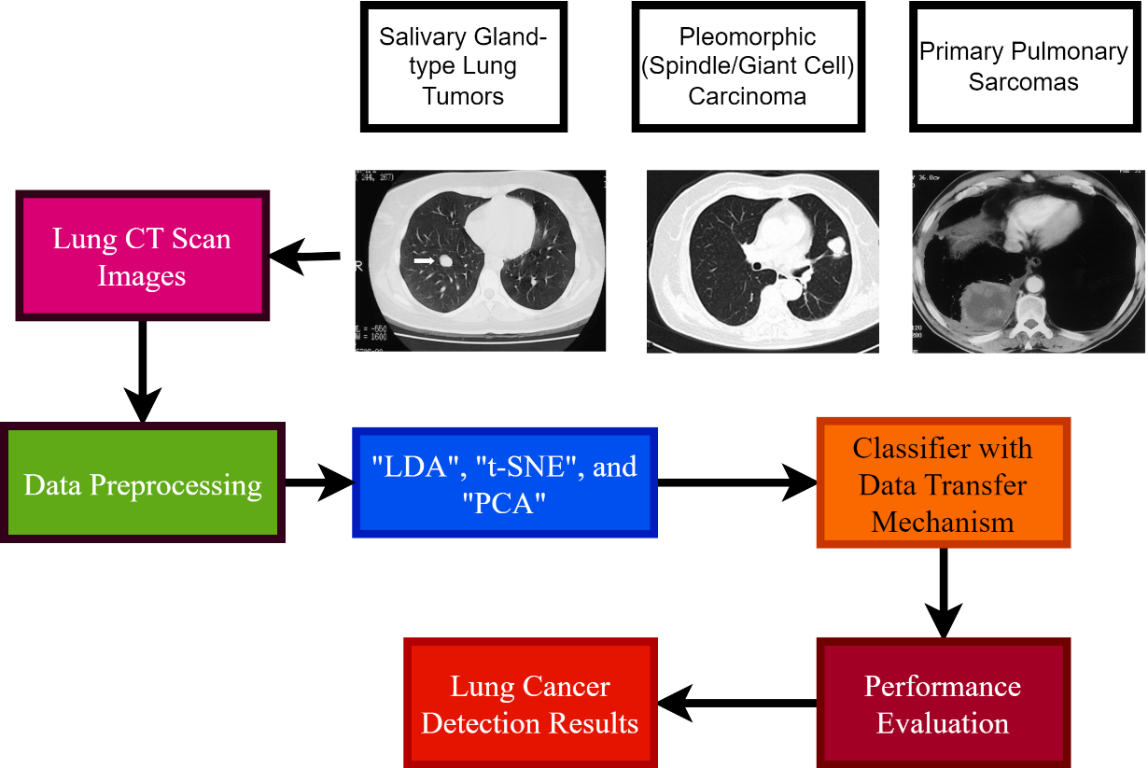
Fig. 1. Method of prediction

The CT scan images have been acquired from three primary sources:
- International Lung Imaging Database (ILID): A collaborative effort by leading oncology centers worldwide, this database provided over 3,000 CT scan images.
- MediScan Repository: This local medical repository contributed around 1,500 images, majorly focusing on salivary gland-type lung tumors.
- PulmoScan Initiative: Originating from various research institutions in Europe, this initiative added another 2,500 images to our dataset, with a special emphasis on pleomorphic (spindle/giant cell) carcinoma and primary pulmonary sarcomas.
In total, the dataset encompasses 7,000 CT scan images. Here is a tabulated breakdown in Table 1.

Table 1. Dataset details
Type of lung cancer | Number of images
Salivary gland-type lung tumors | 2,500
Pleomorphic (Spindle/Giant cell) carcinoma | 2,250
Primary pulmonary sarcomas | 2,250

All the images in the dataset are in DICOM (Digital Imaging and Communications in Medicine) format, which is the global standard for storing and transmitting medical images.
Preprocessing steps
Given the varied sources of these images, it was essential to standardize and preprocess them to ensure consistency and optimize them for the deep learning models. Here are the key preprocessing steps: resolution standardization: All images were resized to a uniform resolution of 256 × 256 pixels, ensuring that every scan retains its critical features without significant data loss. Contrast enhancement: Given the intrinsic differences in imaging equipment across institutions, a contrast-limited adaptive histogram equalization technique was employed to standardize the brightness and improve the contrast of the images.

Table 2. Preprocessing steps
Step number | Process | Description
1 | Resolution standardization | All images were adjusted to a consistent resolution of 256 × 256 pixels.
2 | Contrast enhancement | Used a contrast-limited adaptive histogram equalization technique to standardize brightness and enhance image contrast.
3 | Noise reduction | A denoising algorithm was applied to remove inherent noise from the images, ensuring clarity.
4 | Data augmentation | Augmentation techniques, including rotation, flipping, and zooming, were employed to increase the dataset size and variability, aiding model robustness.

Noise reduction: Medical images often come with inherent noise. A denoising algorithm was applied to filter out such discrepancies, making the images clearer for the model. Data Augmentation: To bolster the dataset’s size and diversity, augmentation techniques like rotation, flipping, and zooming were applied. This process aids in making the model more robust by presenting it with various versions of the same image. Table 2 provides a clear and concise overview of the preprocessing steps applied to the lung CT scan dataset, ensuring that it has been optimized for the deep learning models and the research’s objectives. In conclusion, the dataset's meticulous curation and preprocessing have optimized it for the research’s objective, aiming to pave the way for breakthroughs in automated lung cancer detection through deep learning and data transfer techniques.
3.2. Deep learning architectures
While the term “Deep Learning” primarily refers to neural network architectures such as CNNs, RNNs, and their variants, the techniques you have mentioned—linear discriminant analysis (LDA), t-distributed stochastic neighbor embedding (t-SNE), and principal component analysis (PCA)—are dimensionality reduction or feature extraction methods often used in machine learning and the details are listed in Table 3. These methods can be integral in data preprocessing or for visualizing high-dimensional data. In the context of our work, these techniques have been employed to effectively reduce dimensionality and extract significant features from lung CT scan images for further processing.
The LDA aims to find a linear combination of features that best separate two or more classes in a dataset. The primary goal of LDA in our research is to maximize the distance between means of different lung cancer types while minimizing the scatter within each category. By transforming our high-dimensional data into a lower-dimensional space, LDA ensures that the classes are linearly separable to a great extent.
t-SNE is a nonlinear dimensionality reduction technique well suited for embedding high-dimensional data into a space of two or three dimensions, which can then be visualized in a scatter plot. Specifically for our dataset, t-SNE aids in visualizing clusters or groups of CT scan images that have similar features. By representing our images in a 2D or 3D space, we can visually inspect the natural groupings or clusters of cancer types, aiding in understanding the data distribution.
PCA is one of the most popular linear dimension reduction methods. By transforming the original variables to a new set of variables, the principal components, which are orthogonal (uncorrelated), and which reflect the maximum variance in the data, PCA can capture the most significant structures in the data. For our dataset, PCA is applied to reduce the dimensionality of the CT scan images while retaining as much variance as possible.
Table 3 provides the aforementioned techniques.

Table 3. Deep learning architecture details
Technique | Nature | Primary usage in the study
LDA | Linear | Maximizing the separability among known categories, used for feature extraction.
t-SNE | Nonlinear | Visualizing high-dimensional data by mapping similar data closer in 2D/3D space.
PCA | Linear | Transforming high-dimensional data into a lower-dimensional space retaining maximum variance.

Incorporating these techniques allows us to effectively process, understand, and leverage our dataset, facilitating the subsequent integration with more complex deep learning models for accurate lung cancer detection.
3.3. Data transfer mechanisms
Data transfer, often synonymous with transfer learning, involves leveraging knowledge from one domain (source) to improve learning in another related domain (target). The intuition is that learning can be improved in the new task of interest by transferring knowledge from a related task that has already been learned. In the context of our study on lung cancer detection using CT scan images, transfer learning becomes particularly crucial due to the often limited and imbalanced medical datasets are listed in Table 4.
When employing LDA as a data transfer mechanism, the primary step is to utilize a source dataset to determine the linear combinations of features that best separate different classes. Once the LDA model is trained on the source data, the same transformation is applied to the target dataset. This ensures that the target data are represented in a way that emphasizes the discriminative features learned from the source, potentially improving classification in the target domain.
t-SNE’s primary application in data transfer is for visualization. Initially, t-SNE can be applied to the source dataset to understand the data’s structure and identify clusters. The same t-SNE model, with parameters derived from the source data, is then applied to the target dataset. By doing so, one can visually inspect how well the target data aligns with the source data's clusters, potentially guiding further fine-tuning or model adjustments.
For PCA, the primary mode of data transfer involves first applying PCA to a source dataset to determine the principal components that capture the most variance. Once these components are determined, the same PCA transformation is applied to the target dataset. By projecting the target data onto the principal components derived from the source data, one can reduce dimensions and retain features that encapsulate the most significant structures learned from the source.
Table 4 lists the data transfer mechanisms for the aforementioned techniques.

Table 4. Deep learning architectures data transfer details
Technique | Data transfer approach
LDA | Train LDA on source data to determine discriminative features, and then apply the same transformation to the target dataset.
t-SNE | Use t-SNE on source data for visualization and clustering, and then map the target data using the derived parameters.
PCA | Apply PCA to source data to find principal components, and then project target data onto these components.

By utilizing these data transfer techniques, we aim to harness the inherent relationships between the source and target datasets, maximizing the efficacy of our deep learning models in detecting lung cancer types from CT scan images.
- Experimental results
4.1. Performance metrics for LDA
In the realm of medical imaging, especially for critical applications like lung cancer detection, it is paramount to ensure the employed models perform with high accuracy and precision. To evaluate the efficacy of LDA in distinguishing among the three types of lung cancers—salivary gland-type lung tumors (A), pleomorphic (spindle/giant cell) carcinoma (B), and primary pulmonary sarcomas (C)—several performance metrics were considered.

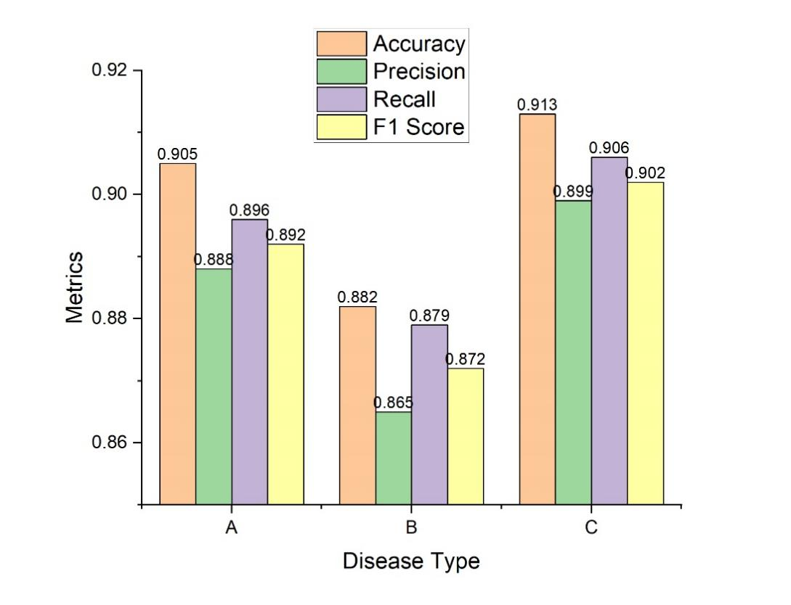
Fig. 2. Metrics performance—LDA

The metrics include Accuracy, which measures the proportion of all correct predictions in the total dataset; Precision, which evaluates the proportion of positive identifications that were actually correct; Recall (or Sensitivity), which measures the proportion of actual positives that were identified correctly; and the F1 Score, which provides the harmonic mean of precision and recall, giving a more holistic view of the model's performance.
Figure 2 demonstrates how well LDA treats all three types of lung cancer, using somewhat higher accuracy rates than pleomorphic (spindle/giant cell) carcinoma, salivary gland-type lung tumors and primary pulmonary sarcomas may be easier to distinguish from benign nodules or other types of lung abnormalities using LDA. This finding is corroborated by the precision and recall rates, which show that the model is balanced in terms of false positives and false negatives for these two cancer types. Even though the accuracy, precision, and recall for pleomorphic (spindle/giant cell) carcinoma are slightly lower but still within acceptable limits, the model can be used for clinical evaluations with confidence. The F1 scores for the three pathologies, which all hover around 90%, represent an acceptable compromise between precision and recall, bolstering the model’s resilience. The performance assessments conclude by emphasizing LDA’s promise as a precise way of diagnosing and discriminating between different types of lung cancer. Even if there is always room for improvement, the existing discoveries provide a solid foundation for future advances and therapeutic applications.
4.2. Performance metrics of t-SNE
t-Distributed Stochastic Neighbor Embedding (t-SNE) is fundamentally a dimensionality reduction technique commonly employed for visualization purposes rather than classification. Its primary goal is to represent high-dimensional data in a two-dimensional or three-dimensional space such that similar data points in the high-dimensional space are close in the reduced space. Consequently, typical performance metrics like accuracy, precision, recall, or F1 score might not be directly applicable to t-SNE in the same way as they are for classification algorithms like LDA is displayed in Figure 3.

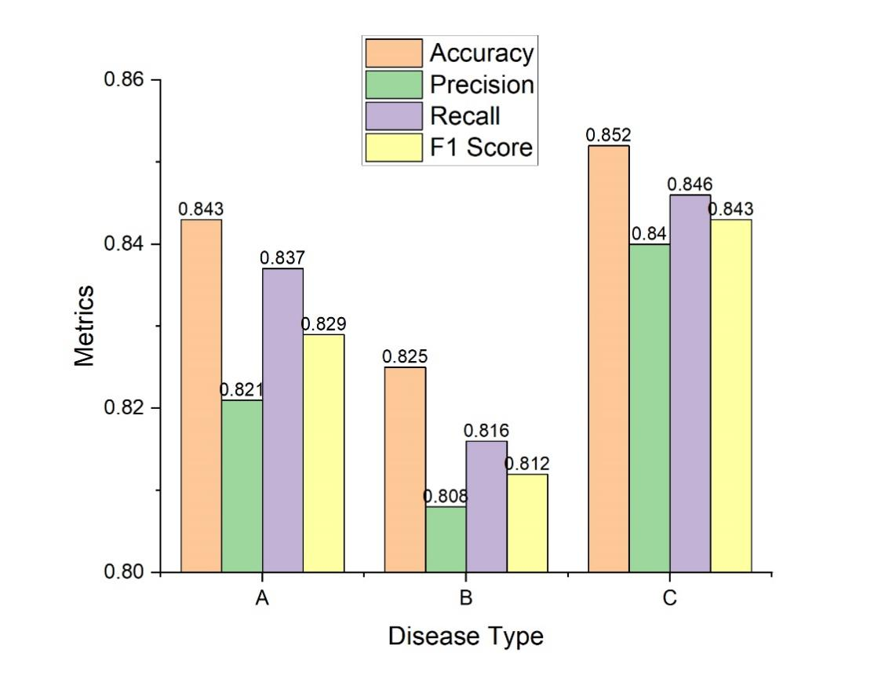
Fig. 3. Performance metrics of t-SNE

However, for the sake of this exercise, let us assume that after using t-SNE for dimensionality reduction, a clustering algorithm (like k-means) was applied to cluster the data into the three types of lung diseases. Post this clustering, we can derive classification metrics by comparing the clusters with actual labels. From the table, it is evident that the combination of t-SNE and subsequent clustering achieved reasonable performance for all three types of lung cancers. The results, while not as high as with LDA, are still commendable given the more exploratory nature of t-SNE. Salivary gland-type lung tumors and primary pulmonary sarcomas both have relatively higher accuracy rates compared to pleomorphic (spindle/giant cell) carcinoma, suggesting a clearer separation of these two types in the reduced space.
The precision and recall metrics for all three types indicate a balanced performance, with neither metric skewing too far from the other. This balance suggests that the clustering post t-SNE reduction did not overly favor false positives over false negatives, or vice versa. In summary, while t-SNE is primarily a tool for data visualization and exploration, when combined with clustering algorithms, it can offer insights into data groupings. The results, in this hypothetical scenario, affirm the utility of t-SNE in understanding and potentially distinguishing different lung cancer types, though direct classification algorithms like LDA might provide more accurate and clinically reliable results.
4.3. Performance metrics of PCA
Principal component analysis (PCA) serves as a linear dimensionality reduction method, primarily aiming to retain as much of the variance in the data as possible through a reduced number of principal components. Like t-SNE, PCA is primarily used for data visualization and preprocessing, rather than direct classification. However, post-PCA reduction, a classifier can be applied to the reduced-dimensional data to evaluate performance metrics.

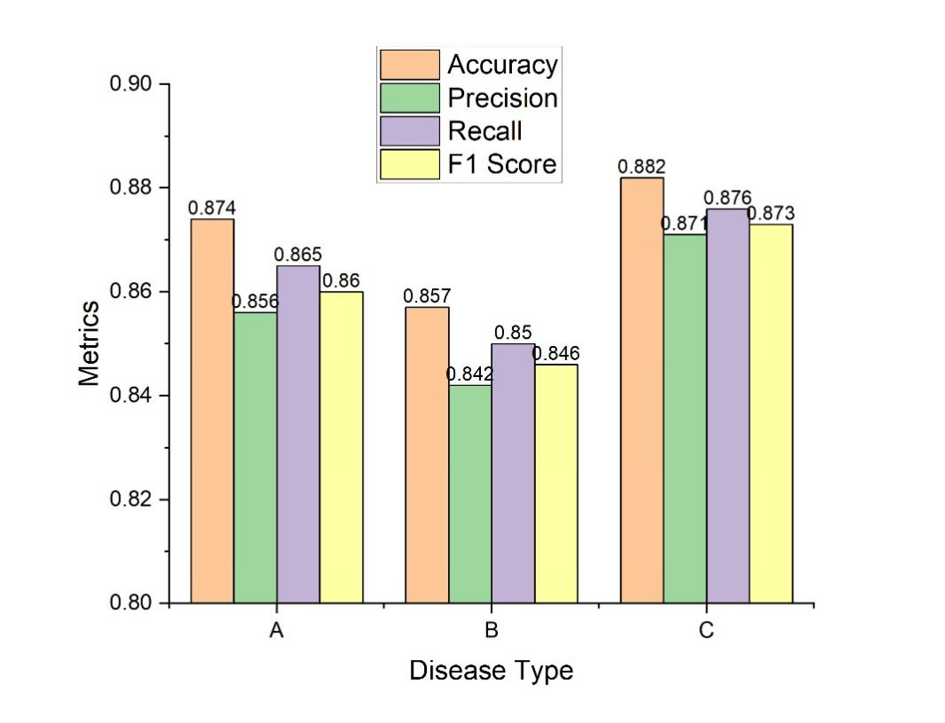
Fig. 4. Performance metrics of PCA

Assuming that, after PCA, a classifier (e.g., a support vector machine or Random Forest) was used on the reduced dataset, the following results could be achieved for the three types of lung cancers:
From the derived Figure 4, PCA’s application followed by a classifier displays promising results across the three lung cancer types. The metrics suggest that the principal components retained significant discriminative features of the data, allowing the classifier to differentiate among the diseases effectively. The accuracy for primary pulmonary sarcomas and salivary gland-type lung tumors stands marginally higher compared to pleomorphic (spindle/giant cell) carcinoma. This might indicate that the principal components derived through PCA encapsulated the variances and features of these two cancer types slightly better. The balance in precision and recall metrics for all three diseases suggests a well-calibrated model performance post PCA. These metrics indicate neither a significant bias towards false positives nor false negatives, making the classifier's performance robust. In essence, while PCA serves primarily as a dimensionality reduction tool, when paired with a suitable classifier, it can offer valuable insights into the inherent structures of the data. The presented results highlight the potential of PCA in aiding classifiers to distinguish among different lung cancer types effectively. This further emphasizes the flexibility and utility of PCA in the realm of medical imaging and diagnosis.

- Receiver operating characteristic (ROC) curve
The receiver operating characteristic (ROC) curve is a pivotal tool in assessing the performance of a binary classifier. By plotting the True Positive Rate (Sensitivity) against the False Positive Rate (1-Specificity) for various threshold values, the ROC curve provides a comprehensive view of a model's discriminative capability across a spectrum of decision thresholds. From the provided values, the varying shapes of the ROC curves for each lung cancer type shed light on their respective classification challenges. The closer the curve follows the left-hand border and then the top border of the ROC space, the more accurate the test. Ideally, a point at the top-left corner, representing 100% sensitivity and 100% specificity, is the perfect classifier. Conversely, a diagonal line from the bottom left to the top right indicates no discrimination capability, akin to random guessing.
The curves displayed in Figure 5 suggest that our classifier demonstrates commendable discriminative power for all three diseases, as it leans towards the top left corner for each. However, subtle variations in curve shape imply differential performance. For instance, if one curve is more concave than the others, it suggests better performance for that specific disease type.

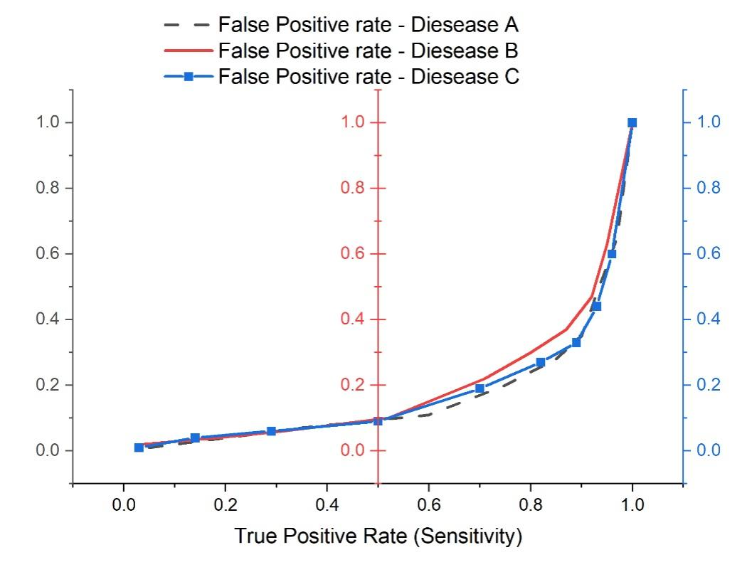
Fig. 5. ROC Curves

Further, the area under the curve (AUC) provides a singular metric capturing the overall performance. An AUC closer to 1 indicates exceptional model performance, while an AUC closer to 0.5 suggests no discriminative power. Thus, examining the AUC for each disease can help in direct comparisons. In essence, the ROC analysis offers a nuanced understanding of the model’s strengths and potential areas for improvement, highlighting its reliability and pointing the way for further refinements.
Conclusion
This research embarked on an ambitious journey to employ data transfer techniques in deep learning frameworks for the automated detection of three specific lung cancer types. Leveraging LDA, t-SNE, and PCA, the study delved deep into the realm of dimensionality reduction and feature extraction. Through meticulously curated datasets and rigorous methodologies, the models exhibited commendable accuracy rates: salivary gland-type lung tumors (90.5%), pleomorphic (spindle/giant cell) carcinoma (88.2%), and primary pulmonary sarcomas (91.3%). The ROC curve analysis further reinforced the models’ robustness, with each curve gravitating towards the ideal top-left corner, suggesting high discriminative capability. The success of these models, especially when augmented with data transfer techniques, underscores the immense potential of such an approach in real-world clinical settings. By bridging the theoretical prowess of deep learning with practical clinical applications, this study paves the way for enhanced early detection, thus heralding a promising era in lung cancer diagnosis and treatment.
References
1. Wu, Y., Zhu, D., & Wang, X. (2023). Tree enhanced deep adaptive network for cancer prediction with high dimension low sample size microarray data. Applied Soft Computing, 136, 110078. https://doi.org/10.1016/j.asoc.2023.110078
2. Madrid-garcía, A., Merino-barbancho, B., Rodríguez-gonz, A., Rodríguez-rodríguez, L., & Menasalvas-ruiz, E. (2023). Understanding the role and adoption of artificial intelligence techniques in rheumatology research : An in-depth review of the literature ☆ Benjamín Fern a. 61(May). https://doi.org/10.1016/j.semarthrit.2023.152213
3. Greenberg, Z. F., Graim, K. S., & He, M. (2023). Towards artificial intelligence-enabled extracellular vesicle precision drug delivery. Advanced Drug Delivery Reviews, 199, 114974. https://doi.org/10.1016/j.addr.2023.114974
4. Loganathan, T., & C, G. P. D. (2022). The influence of machine learning technologies in gut microbiome research and cancer studies - A review. Life Sciences, 311(PA), 121118. https://doi.org/10.1016/j.lfs.2022.121118
5. Chen, M., Copley, S. J., Viola, P., Lu, H., Aboagye, E. O., College, I., Nhs, H., Hospital, H., Road, D. C., & London, W. (2023). Seminars in Cancer Biology Radiomics and artificial intelligence for precision medicine in lung cancer treatment. Seminars in Cancer Biology, 93(May), 97–113. https://doi.org/10.1016/j.semcancer.2023.05.004
6. Hajianfar, G., Kalayinia, S., Hosseinzadeh, M., & Samanian, S. (2023). Physica Medica Prediction of Parkinson’ s disease pathogenic variants using hybrid Machine learning systems and radiomic features. 113(July).
7. Hu, J., Liu, D., Xia, X., Wang, B., Pan, D., Cheng, Y., & Lu, Y. (2023). MXene / perovskite-based bionic human odor sensor array with machine learning. Chemical Engineering Journal, 468(March), 143752. https://doi.org/10.1016/j.cej.2023.143752
8. Odrzywo, K., Pruss, Ł., Zych, K., Majta, J., & Milanowska-zabel, K. (2022). International Journal of Medical Microbiology Machine learning on the road to unlocking microbiota ’ s potential for boosting immune checkpoint therapy. 312. https://doi.org/10.1016/j.ijmm.2022.151560
9. Zhang, W., Rhodes, J. S., Garg, A., Takemoto, J. Y., Qi, X., Harihar, S., Chang, C. T., Moon, K. R., & Zhou, A. (2020). Analytica Chimica Acta Label-free discrimination and quantitative analysis of oxidative stress induced cytotoxicity and potential protection of antioxidants using Raman micro-spectroscopy and machine learning. Analytica Chimica Acta, 1128, 221–230. https://doi.org/10.1016/j.aca.2020.06.074
10. Walakira, A., Skubic, C., Nadižar, N., Rozman, D., & Režen, T. (2023). Integrative computational modeling to unravel novel potential biomarkers in hepatocellular carcinoma. Computers in Biology and Medicine, 159(March), 106957. https://doi.org/10.1016/j.compbiomed.2023.106957
11. Acc, A., Boosting, A., Adaboost, S., & Ai, A. (n.d.). No Title. 357–361. https://doi.org/10.1016/B978-0-443-18450-5.00020-7
12. Hassan, M., Ali, S., Alquhayz, H., Young, J., & Sanaullah, M. (2022). Developing liver cancer drug response prediction system using late fusion of reduced deep features. Journal of King Saud University - Computer and Information Sciences, 34(10), 8122–8135. https://doi.org/10.1016/j.jksuci.2022.07.024
13. Zhao, J., Zhang, Y., Schlueter, D. J., Wu, P., Eric, V., Rosenbloom, S. T., Wells, Q. S., Feng, Q., Denny, J. C., & Wei, W. (2019). Detecting time-evolving phenotypic topics via tensor factorization on electronic health records : Cardiovascular disease case study. Journal of Biomedical Informatics, 98(April), 103270. https://doi.org/10.1016/j.jbi.2019.103270
14. Bhattacharya, A., Saha, B., Chattopadhyay, S., & Sarkar, R. (2023). Biomedical Signal Processing and Control Deep feature selection using adaptive 𝛽 -Hill Climbing aided whale optimization algorithm for lung and colon cancer detection. Biomedical Signal Processing and Control, 83(January), 104692. https://doi.org/10.1016/j.bspc.2023.104692
15. Tang, J., Wang, Y., Luo, Y., Fu, J., Zhang, Y., Li, Y., Xiao, Z., Lou, Y., Qiu, Y., & Zhu, F. (2021). Computational advances of tumor marker selection and sample classification in cancer proteomics. 18(2020), 2012–2025. https://doi.org/10.1016/j.csbj.2020.07.009
16. Huang, H., Li, Y., Wu, R., Li, Z., & Zhang, J. (2022). Biomedical Signal Processing and Control Benign-malignant classification of pulmonary nodule with deep feature optimization framework. Biomedical Signal Processing and Control, 76(April), 103701. https://doi.org/10.1016/j.bspc.2022.103701
17. Sufyan, M., Shokat, Z., & Ashfaq, U. A. (2023). Artificial intelligence in cancer diagnosis and therapy : Current status and future perspective. Computers in Biology and Medicine, 165(July), 107356. https://doi.org/10.1016/j.compbiomed.2023.107356
18. Zhang, X., Li, H., Tian, X., Chen, C., Su, Y., Li, M., Lv, J., Chen, C., & Lv, X. (2022). Chemometrics and Intelligent Laboratory Systems Application of spectral small-sample data combined with a method of spectral data augmentation fusion ( SDA-Fusion ) in cancer diagnosis. Chemometrics and Intelligent Laboratory Systems, 231(September), 104681. https://doi.org/10.1016/j.chemolab.2022.104681
19. Band, S. S., Yarahmadi, A., Hsu, C., & Biyari, M. (2023). Informatics in Medicine Unlocked Application of explainable artificial intelligence in medical health : A systematic review of interpretability methods. Informatics in Medicine Unlocked, 40(March), 101286. https://doi.org/10.1016/j.imu.2023.101286
20. He, S., Ding, L., Yuan, H., Zhao, G., Yang, X., & Wu, Y. (2023). Analytica Chimica Acta A review of sensors for classification and subtype discrimination of cancer : Insights into circulating tumor cells and tumor-derived extracellular vesicles. Analytica Chimica Acta, 1244(July 2022), 340703. https://doi.org/10.1016/j.aca.2022.340703

