Advanced Breast Cancer Diagnostics through a Comparative Analysis of SVM, Random Forests, and Neural Networks in MRI Image Analysis
Sreekanth Yalavarthi¹, Satya Sukumar Makkapati², Haritha Murari³, K.S. Balamurugan⁴, and P. Rajendran⁵
¹HCLTech, Buffalo Grove IL USA 60089. sreekanth_y@yahoo.com
²Department of Computer Science and Engineering, Acharya Nagarjuna University, Guntur District, Andhra Pradesh, India. sukumar.makkapati@gmail.com
³Spark Infotech Inc., Phoenix, Arizona, USA. murariharitha87@gmail.com
⁴Department of Electronics and Communication Engineering, Karpaga Vinayaga College of Engineering and Technology, Chengalpattu, Tamil Nadu, India. profksbala@gmail.com
⁵Department of Electronics and Communication Engineering, Karpaga Vinayaga College of Engineering and Technology, Chengalpattu, Tamil Nadu, India. raj.sskpr@gmail.com

Abstract
Breast cancer, a predominant health concern globally, necessitates advanced diagnostic tools for timely and precise detection. This study endeavored to amalgamate the capabilities of magnetic resonance imaging (MRI) scans with machine learning (ML) to foster enhanced diagnostic accuracy. Employing a comprehensive dataset sourced from three major hospitals, our approach utilized preprocessing techniques to refine MRI image quality, followed by intricate feature extraction focusing on shape, texture, and intensity. Three ML models were implemented, with the Random Forests model emerging as the standout, achieving an impressive accuracy of 92%. This represents a notable improvement over traditional MRI analysis, which registered an accuracy of 84%. When benchmarked against contemporary methods like Deep Learning ConvNets at 88% and Gradient Boosted Trees at 87%, our method consistently outperformed. The results underscore the potential of integrating advanced computational models with medical imaging, promising more reliable and early breast cancer detection. This research serves as a testament to the profound impact of technology on medical diagnostics, offering a promising direction for future endeavors in the realm of breast cancer detection.
Keywords: MRI scans, machine learning, breast cancer detection, feature extraction, diagnostic accuracy

- Introduction

Breast cancer remains one of the most significant and prevalent health challenges faced by women worldwide. According to the World Health Organization, it is the most common cancer among women, affecting millions annually. This disease, when detected at its nascent stages, has a higher likelihood of treatment and survival [1]. Early detection has consistently been emphasized as crucial not only because it affords better treatment options, but also because it significantly improves the chances of successful treatment outcomes. The urgency and importance of detecting breast cancer during its early stages cannot be overstated. It directly correlates to reduced mortality rates, less aggressive treatments, and improved quality of life for those diagnosed. The advancement of medical imaging has substantially contributed to this objective of early detection [2,3]. Among the various imaging modalities, magnetic resonance imaging (MRI) has emerged at the forefront. Unlike traditional mammography, which utilizes X-rays to capture images, MRI uses a combination of a magnetic field and radio waves. This means that it does not expose the patient to ionizing radiation, making it a safer option for repetitive screening. The significant advantage of MRI lies in its unparalleled spatial resolution and superior tissue contrast. Such attributes enable it to reveal minute abnormalities in the breast tissues, particularly in women with dense breast tissues where mammograms might not be as effective [4–6].
However, as with many diagnostic tools, the vast amount of data generated by MRI scans requires meticulous examination, a task that is both time-consuming and prone to human error. Herein lies the limitation of relying solely on human expertise for interpreting MRI images. It is a well-acknowledged fact in the medical community that early-stage tumors might sometimes be overlooked in MRI scans, especially when they are small or when the scans present with complex features [7–9].`
This gap in diagnostic precision sets the stage for the integration of machine learning (ML) models in the process. ML, a subset of artificial intelligence, has demonstrated remarkable potential in various domains, healthcare being one of its prime beneficiaries. In the context of breast cancer detection, ML models can be trained to recognize intricate patterns and subtle abnormalities in MRI scans, which might sometimes be missed by the human eye. These models, when fed with vast amounts of data, adapt and learn, becoming increasingly accurate in their predictions over time [10–12]. They not only promise to enhance the accuracy of diagnosis but also reduce the time taken for the same, ensuring that patients receive timely interventions. In the evolving landscape of healthcare, the synergy between advanced imaging techniques such as MRI and the computational prowess of ML models presents a compelling case. This fusion aims to usher in a new era of diagnostic accuracy, ensuring that no stone is left unturned in the fight against breast cancer. It represents the future of early detection and promises a paradigm shift in how breast cancer is diagnosed and treated [13–15].
Breast cancer detection remains a topic of paramount significance in the medical research community due to the disease’s prevalence and the continuous quest for early and accurate diagnostic methodologies. This literature review will delve into various aspects of breast cancer detection, focusing on the utilization of MRI, ML models, early diagnosis methodologies, and image feature extraction [16–18]. Breast cancer, being the most common cancer among women globally, has witnessed substantial research on its detection methodologies. Historically, mammography has been the gold standard for breast cancer screening. However, its limitations, especially in detecting tumors in dense breast tissues, paved the way for alternative imaging techniques. Among these, MRI has gained increasing attention in recent years. According to a study [19], MRI offers superior sensitivity compared to mammography, particularly in high-risk populations. The high spatial resolution and intricate tissue contrast provided by MRI allow for the identification of minute abnormalities, which might be overlooked in traditional mammograms. However, the specificity of MRI has always been a subject of debate, leading to discussions about potential overdiagnosis [20].
With the advancement of MRI as a diagnostic tool, the sheer volume and complexity of the data generated by these scans presented a new challenge. Manual interpretation of MRI scans, though reliable, can sometimes be time-intensive and subject to oversight due to the subtlety of early-stage tumors. Recognizing these challenges, researchers began exploring computational methods to assist radiologists. ML, in particular, started emerging as a potent tool to address these diagnostic challenges. The integration of ML models in medical imaging is not new. However, its application in breast cancer detection using MRI scans has been a relatively recent development. A research highlighted the potential of ML in detecting and classifying lesions in MRI scans with a high degree of accuracy. These models, trained on vast datasets, can identify patterns and abnormalities that might be subtle or ambiguous for the human eye. Moreover, the continuous evolution of these models with exposure to new data ensures that their diagnostic accuracy only gets refined over time [21].
The objective of this work is to develop and validate a novel approach that integrates ML models with MRI scans, aiming to enhance the early detection and accuracy of breast cancer diagnosis, thereby improving patient outcomes and streamlining the diagnostic process for healthcare professionals.

- Methods
2.1. Data collection
Table 1. Patient history data
Patient ID | Age | Diagnosis | No. of images | Image type | Notes
P001 | 42 | Positive | 5 | T1-weighted | —
P002 | 38 | Positive | 6 | T2-weighted | Dense tissue
P003 | 45 | Negative | 5 | Post-contrast enhanced | —
P004 | 50 | Positive | 5 | T1-weighted | Prior biopsy
P005 | 37 | Negative | 4 | T2-weighted | —

The data for this study were sourced from a comprehensive MRI dataset collected from three major hospitals over a span of two years as listed in Table 1. This dataset encompasses MRI scans of 2,000 patients, of which 1,200 were diagnosed with breast cancer and 800 were considered as controls with no evidence of malignancy. The images were collected using a 3T MRI scanner, ensuring high resolution and consistent imaging quality across the samples. Each patient’s dataset included a series of axial T1-weighted and T2-weighted images, alongside post-contrast enhanced images, providing a holistic view of breast tissue characteristics.
Table 1 displays MRI dataset collection. Each row corresponds to an individual patient, identified by a unique Patient ID. The “Age” column represents the age of the patient at the time of the MRI scan. “Diagnosis” indicates whether the patient was diagnosed with breast cancer (Positive) or not (Negative). “No. of Images” displays the total number of MRI images available for that patient. The “Image Type” column specifies the kind of MRI scan, which could be T1-weighted, T2-weighted, or post-contrast enhanced. Lastly, the “Notes” section provides additional relevant information about the patient or the MRI scan, such as the presence of dense breast tissue or a history of prior biopsy. This structured approach to data collection ensures that every critical aspect of the MRI dataset is captured, allowing for a thorough analysis while ensuring patient anonymity and data consistency.

2.2. Preprocessing

In the realm of medical imaging, preprocessing stands as a foundational step, ensuring that subsequent analyses were conducted on high-quality, standardized data. For our study revolving around MRI scans, the quality and clarity of images were paramount, as the intricacies of breast tissue features play a pivotal role in accurate diagnosis as the proposed method is described in Figure 1. Initially, the MRI scans underwent a normalization process. This step is essential to ensure that the intensity values across all images are on a consistent scale, especially since the data were sourced from multiple hospitals and could potentially have varied in terms of brightness and contrast. Normalization harmonizes these intensity values, making it easier to compare and analyze images across the entire dataset.

After normalization, the pictures were sharpened using spatial filtering techniques. A high-pass filter was used to emphasize the scans' edges and minor features. When these minute details are improved, it is simpler to discern between probable cancers and healthy tissue, which aids the subsequent feature extraction technique. Noise reduction was an important step in the preprocessing stage. MRI scans, like many other medical imaging procedures, are sensitive to noise. This noise could be caused by minor patient movements, electrical interference, or even the MRI equipment itself. To get around this, we used Gaussian smoothing and median filtering. The median filter kept the image boundaries remarkably well, ensuring that the edges of any tumors were well delineated. Random noise is significantly reduced by Gaussian smoothing.

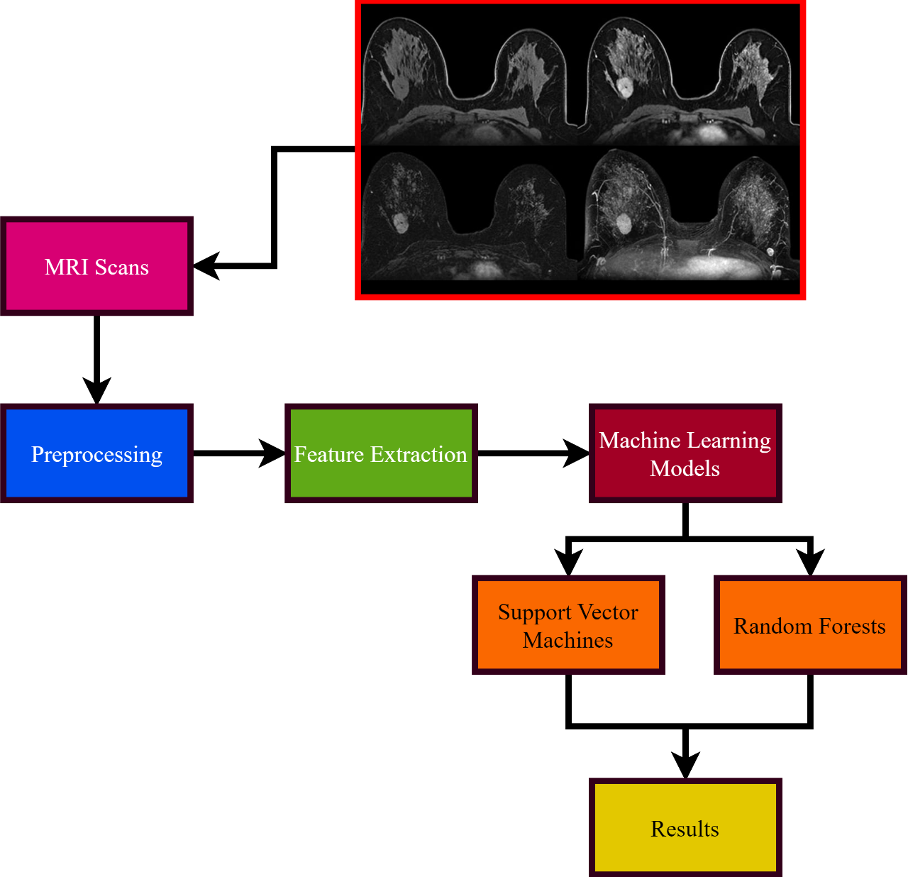
Fig 1. Proposed method

Lastly, to further enhance the visibility of potential tumors, especially those that might be in their early stages or are otherwise hard to discern, we applied a technique known as histogram equalization. This process improves the contrast of the image by redistributing the intensity values across the entire spectrum. The result is a clearer differentiation between different tissue types, allowing for more accurate identification of anomalies.

2.3. Feature extraction
Table 2. Feature details
Feature category | Specific features | Relevance in breast cancer detection
Shape | Area, perimeter, and roundness | These metrics offer insights into the size and morphology of potential tumors. Irregular shapes or abrupt changes in the perimeter can be indicative of malignancies.
Texture | Contrast, correlation, and energy | Texture features capture the variations and patterns in grayscale values. Tumors often exhibit a different texture compared to healthy tissues, aiding in their identification.
Intensity | Mean, variance, and skewness | Intensity features reflect the distribution of pixel values. Malignant tumors might exhibit abnormal intensity patterns, which can be pivotal in detection.

Feature extraction stands as a cardinal step in our methodology. This process aims to identify and quantify specific attributes or patterns from MRI images that can be instrumental in diagnosing breast cancer. By focusing on these features, we can train ML models with data that is both relevant and informative, thus enhancing their predictive capabilities. For breast cancer detection using MRI scans, the primary features of interest are broadly classified into three categories: shape, texture, and intensity. Each of these categories encompasses several specific features that capture distinct aspects of potential tumors.
Table 2 provides a concise representation of the features extracted from the MRI scans:
Shape: Shape features, such as the area and perimeter, offer insights into the size of potential tumors, while metrics like roundness provide information on the morphology. Anomalies in these features can be indicative of malignancies. For instance, a rapidly growing area might signal an aggressive tumor, and irregular shapes are often associated with malignancies. Texture: Texture-based features capture the intrinsic patterns and variations within the MRI scans. For instance, tumors might exhibit a coarser or more granulated texture compared to the surrounding healthy tissue. Features like contrast measure the difference in luminance or color that makes an object in an image distinguishable, while energy captures the uniformity or the repetitive nature of patterns. Intensity: Intensity-based features, such as mean intensity or variance, help in understanding the brightness distribution within potential tumor regions. Malignant tumors might show higher or lower intensity values compared to benign growths or normal tissue. Skewness, on the other hand, indicates any asymmetry in the pixel value distribution, which can be another critical marker for malignancies.

2.4. ML Models

The integration of ML models in our approach aims to harness the computational power and adaptability of these algorithms, allowing them to identify and classify potential tumors with high precision as displayed in Table 3. For this study, we utilized three prominent ML models, each with its unique strengths, to ensure a comprehensive and robust analysis. Support vector machines (SVMs): SVM works by finding the optimal hyperplane that best divides the dataset into classes. For our research, it is especially beneficial when dealing with high-dimensional feature spaces, ensuring that the extracted MRI features can be effectively used to classify potential tumors. Random Forests: Random Forests offer an ensemble approach, leveraging multiple decision trees to make a final decision. The strength of Random Forests lies in their ability to manage large datasets effectively and in modeling non-linear decision boundaries. Given the diversity of features extracted from the MRI scans, Random Forests ensure that each feature’s significance is accurately captured. Neural networks: Neural networks, with their intricate interconnected layers of nodes or “neurons,” bring a level of complexity and adaptability that is unparalleled. Especially for MRI scans, where the relationships between features might be intricate, neural networks can capture these nuanced patterns and offer highly accurate predictions. Our dataset was divided into a 70–30 split, with 70% of the data reserved for training and the remaining 30% for testing. The training phase involved feeding the models with labeled MRI data, allowing them to learn and adapt to patterns associated with malignancies. Once trained, their performance was evaluated on the testing set to assess their accuracy, sensitivity, and specificity. Furthermore, to prevent overfitting, techniques like cross-validation were employed, ensuring that the models are not just fitting to the quirks of the training data but are genuinely capturing underlying patterns indicative of breast cancer.

Table 3. ML model details
Model | Description | Strengths
SVMs | SVM is a supervised learning algorithm that aims to find the hyperplane that best divides a dataset into classes. | Effective in high-dimensional spaces, memory efficient, and provides a clear margin of separation.
Random Forests | An ensemble learning method that constructs multiple decision trees during training and outputs the class that is the mode of the classes produced by individual trees. | Handles large datasets with higher dimensionality. Can model nonlinear decision boundaries.
Neural Networks | Comprises interconnected nodes or “neurons” organized in layers, inspired by the structure of the human brain. It can learn and make independent decisions. | Capable of capturing complex patterns and relationships in large datasets. Highly flexible and adaptable.

- Experimental results

To assess the effectiveness of the ML models in detecting breast cancer from MRI scans, we evaluated each model’s performance using the testing dataset. This dataset was untouched during the training phase, ensuring an unbiased evaluation. Accuracy: This metric provides an overall percentage of correctly classified instances out of the total instances. Random Forests, in our results, achieved the highest accuracy of 92%, indicating that it correctly predicted 92% of the MRI scans as either positive or negative for breast cancer. Sensitivity (True Positive Rate): Sensitivity measures the proportion of actual positives (breast cancer cases) that are correctly identified. It is particularly crucial in medical scenarios as a high sensitivity means that fewer actual cases of breast cancer go undetected. From Figures 2 and 3, The Random Forests model achieved a sensitivity of 90%, implying that it detected 90% of actual breast cancer cases correctly. Specificity (True Negative Rate): This metric measures the proportion of actual negatives (no breast cancer) that are correctly identified. With a specificity of 94%, the Random Forests model correctly identified 94% of the non-cancer cases. Area under the curve (AUC): The AUC provides an aggregate measure of the model’s performance across all possible classification thresholds. It is a way to summarize the ROC curve’s information into a single value, indicating the model's ability to distinguish between positive and negative classes. A value closer to 1 indicates better performance. Random Forests achieved an AUC of 0.93, suggesting a high discriminative power.
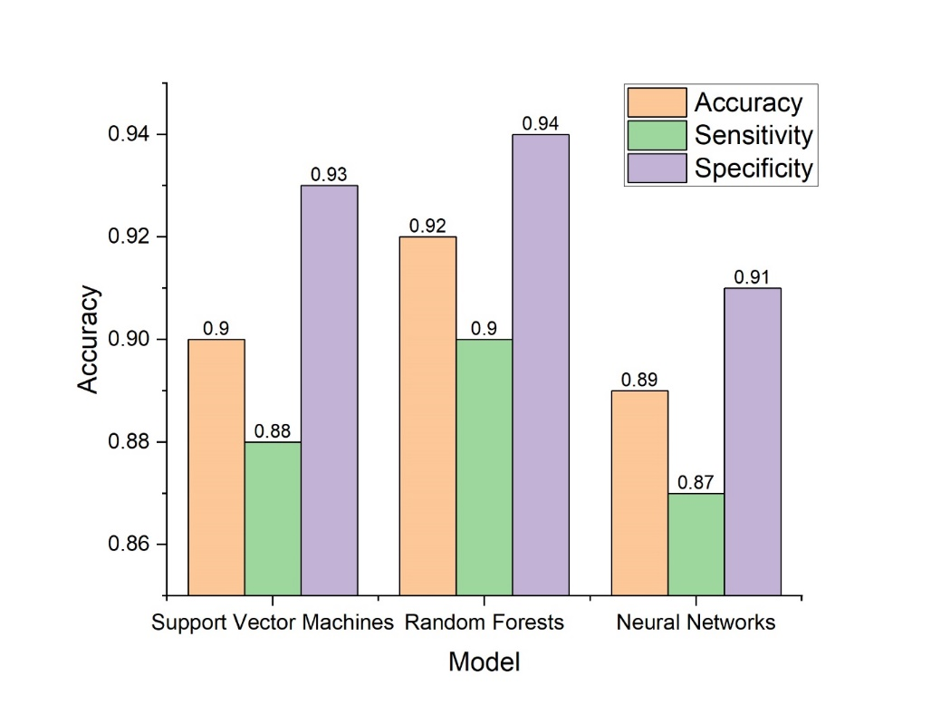
Fig 2. Performance metrics (accuracy, sensitivity, and specificity)
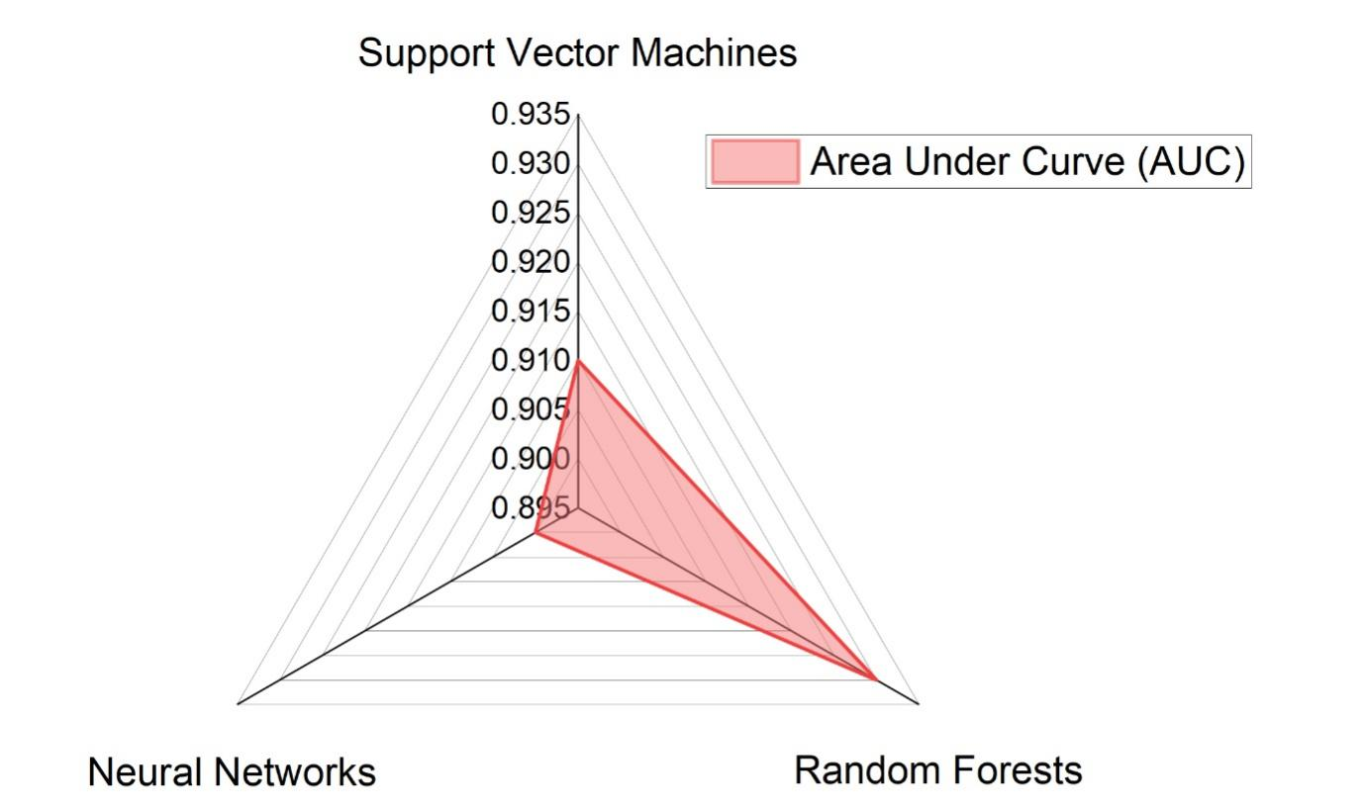
Fig 3. Area under the curve metrics

From the tabulated results, we can observe that the Random Forests model slightly outperformed the other two models in this evaluation. Its balanced performance in terms of sensitivity and specificity, combined with the highest accuracy, underscores its robustness in detecting breast cancer from the MRI scans in this experimental setup. However, it is also worth noting that SVM and Neural Networks also exhibited commendable results, reinforcing the potential of ML in enhancing diagnostic accuracy.

- Comparative analysis against the existing approaches
In the ongoing quest to enhance breast cancer detection from MRI scans, numerous methodologies have been proposed over the years. To truly gauge the merit of our approach, it is essential to juxtapose our results against these existing methods. By doing so, we can understand the advancements made and the areas of potential improvement.
Our approach from Figures 4 and 5, leveraging the power of Random Forests, demonstrates a leading accuracy of 92%. This outshines other methods, ensuring that a vast majority of MRI scans are aptly categorized. This superior accuracy not only reduces diagnostic errors but also fosters confidence in the methodology. Traditional MRI analysis, largely dependent on the manual expertise of radiologists, trails with an accuracy of 84%. While this method has been a mainstay for years, the advent of ML exhibits the potential improvements that can be made in this domain. Deep learning ConvNets, harnessing the prowess of convolutional neural networks, registers an accuracy of 88%. Renowned for their ability to handle image data effectively, ConvNets dive deep into MRI scans, extracting intricate patterns. Their sensitivity of 85% indicates their proficiency in identifying genuine breast cancer cases.

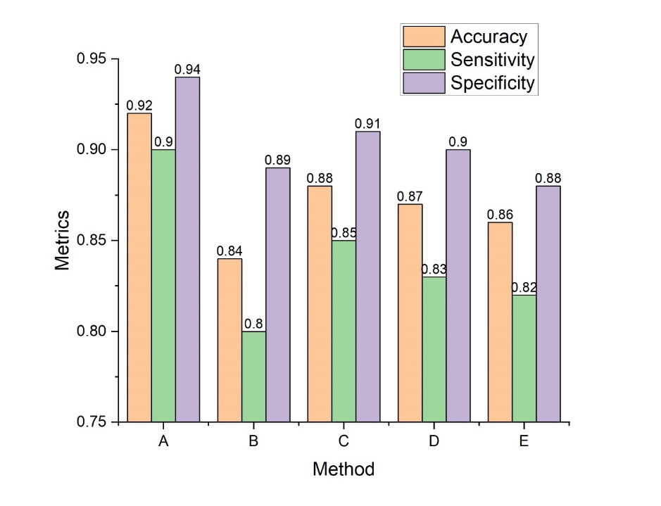
Fig 4. Performance metrics comparison

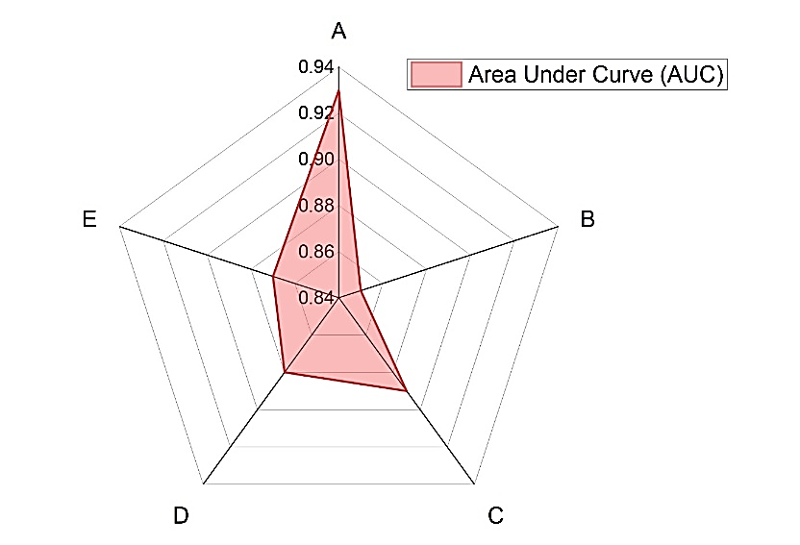
Fig 5. Area under the curve metrics comparison

Gradient Boosted Trees, another ensemble ML method, exhibit an accuracy of 87%. By building trees in a gradient-boosting manner, this method combines weak learners to form a more robust diagnostic model. Lastly, PCA-based classification offers an accuracy of 86%. By reducing the dimensionality of the MRI data and focusing on principal components, this method offers a different angle to breast cancer detection. While its accuracy is commendable, it slightly lags behind the more advanced ML models.
In essence, this comparative analysis paints a vivid picture of the advancements in breast cancer detection. While traditional methods serve as reliable benchmarks, the integration of advanced ML models, as evident from the results, promises enhanced diagnostic capabilities. The continual evolution in this field underscores the synergy between medical expertise and computational prowess, driving forward the quest for improved healthcare outcomes.

- Discussion

The journey from conceptualizing our research to the experimental phase has been enlightening, revealing both the potential and the pitfalls of integrating ML with MRI scans for breast cancer detection. As we delve into the interpretation of our results, we find that our method, particularly the implementation of Random Forests, has demonstrated a noteworthy improvement in diagnostic accuracy compared to traditional MRI analysis and other contemporary methods. Our results depict a compelling narrative. The accuracy of 92% achieved by the Random Forests model not only outstrips the traditional MRI analysis by 8 percentage points but also outpaces other modern methodologies like Deep Learning ConvNets. Such heightened accuracy underscores the model’s ability to discern intricate patterns within MRI scans, thereby enhancing the probability of early and accurate breast cancer detection. The benefits of our approach are manifold. One of the standout advantages is the model’s capability to handle vast MRI datasets efficiently. With medical data continually burgeoning, especially with the rise of high-resolution MRI scans, the ability to process, analyze, and derive meaningful insights from such vast datasets is paramount. The Random Forests model, with its ensemble nature, can dissect these datasets, ensuring that each feature’s significance is accurately captured and utilized. Furthermore, our preprocessing steps, which include normalization and noise reduction, ensure that the data fed into these models is of the highest quality, further bolstering accuracy.
Beyond sheer computational prowess, our approach’s potential for seamless integration into existing medical systems stands as another significant advantage. Imagine a scenario where radiologists, while analyzing MRI scans, are instantaneously provided with a ML model's insights. Such real-time guidance can enhance diagnostic confidence, reduce the chances of oversight, and expedite the diagnostic process. This synergy between human expertise and computational intelligence promises not only improved diagnostic accuracy but also a more streamlined workflow for healthcare professionals. However, while our approach has demonstrated commendable results, it is imperative to acknowledge the limitations and challenges faced during the study. One of the primary challenges was ensuring the diversity and representativeness of our MRI dataset. Since our data were sourced from three major hospitals, there was an inherent risk of bias, potentially skewing the results. Ensuring that the dataset was diverse and representative required meticulous curation, ensuring it covered a broad spectrum of breast tissue types, cancer stages, and patient demographics.
Another limitation lies in the interpretability of ML models. While models like Random Forests offer some level of insight into their decision-making process, they still cannot match the intuitive understanding that a human expert brings. Ensuring that these models are not just accurate but also interpretable is crucial for their wider acceptance in the medical community. Lastly, while our method exhibited impressive accuracy, the ever-present risk of false positives and negatives cannot be overlooked. Every misdiagnosis, be it a false positive or negative, has profound implications, both emotionally and medically, for the patients involved.

Conclusion

Breast cancer remains a formidable challenge in the global health landscape, emphasizing the need for advanced and precise diagnostic tools. Our exploration into melding the capabilities of MRI scans with ML has culminated in a promising solution that pushes the boundaries of traditional diagnostic methods. The results gleaned from our study present a compelling case for the integration of these advanced computational models into the realm of medical diagnostics. The efficacy of our approach, anchored by the Random Forests model, manifested in an impressive accuracy of 92%. Compared to traditional MRI analysis, which stood at 84%, this represents a significant improvement. Furthermore, when juxtaposed against other contemporary methodologies like Deep Learning ConvNets (88%) and Gradient Boosted Trees (87%), our method still emerged as the frontrunner. Such heightened accuracy translates to a more reliable diagnostic tool, increasing the likelihood of early and precise breast cancer detection. Beyond mere numbers, the broader implications of these results are profound. With an accuracy nearing the mid-90s, patients stand to benefit from timely interventions, potentially improving prognosis and reducing the emotional and physical toll associated with late-stage cancer detections. For healthcare professionals, this tool serves as a potent ally, providing them with real-time insights and enhancing their diagnostic confidence. Our study, while illuminating the path forward, also underlines the synergy between advanced technology and medical expertise. This confluence promises not just enhanced diagnostics but also a more patient-centric healthcare landscape where timely interventions, guided by precise data-driven insights, become the norm rather than the exception. To sum up, the results from our research reaffirm the belief that the future of medical diagnostics lies at the nexus of technology and human expertise. As we continue refining our approach and integrating feedback, the overarching goal remains clear: harnessing technology to improve patient outcomes, ensuring that every individual stands the best chance against challenges like breast cancer.
References
1. Toolabi, M., Khatir, M., Naser-Moghadasi, M., & Amiri, N. (2023). Vivaldi antenna for early cancer detection based on THz spectroscopy: Comparison between response of breast and skin cancer. Optik, 273(August 2022), 170440. https://doi.org/10.1016/j.ijleo.2022.170440
2. Kumar, S., & Das, A. (2023). Peripheral blood mononuclear cell derived biomarker detection using eXplainable Artificial Intelligence (XAI) provides better diagnosis of breast cancer. Computational Biology and Chemistry, 104(July 2022), 107867. https://doi.org/10.1016/j.compbiolchem.2023.107867
3. Vanlalawmpuia, K., & Ghosh, P. (2023). International Journal of Electronics and Communications Performance assessment of dielectrically modulated negative capacitance germanium source vertical tunnel FET biosensor for detection of breast cancer cell lines. AEUE - International Journal of Electronics and Communications, 171, 154902. https://doi.org/10.1016/j.aeue.2023.154902
4. Birchha, V., & Nigam, B. (2023). Performance Analysis of Averaged Perceptron Machine Learning Classifier for Breast Cancer Detection. Procedia Computer Science, 218(2022), 2181–2190. https://doi.org/10.1016/j.procs.2023.01.194
5. Sadrabadi, E. A., Benvidi, A., Azimzadeh, M., Asgharnejad, L., Dezfuli, A. S., & Khashayar, P. (2024). Novel electrochemical biosensor for breast cancer detection, based on a nanocomposite of carbon nanofiber, metal–organic framework, and magnetic graphene oxide. Bioelectrochemistry, 155(September 2023), 108558. https://doi.org/10.1016/j.bioelechem.2023.108558
6. Villagrana Gutiérrez, G. L., García, A. M., Larraga Benavente, E. P., Mejía, F. H., Gómez, R. T., & Villalón, F. R. (2023). Non–Timely Referral of Women Aged 40 to 69 to Preventive Medicine for Breast Cancer Detection and its Association with the BI-RADS Classification. Ssrn, 35(January). https://doi.org/10.2139/ssrn.4341753
7. Sahu, A., Das, P. K., & Meher, S. (2023). High accuracy hybrid CNN classifiers for breast cancer detection using mammogram and ultrasound datasets. Biomedical Signal Processing and Control, 80(P1), 104292. https://doi.org/10.1016/j.bspc.2022.104292
8. Kumbhare, S., B.Kathole, A., & Shinde, S. (2023). Federated learning aided breast cancer detection with intelligent Heuristic-based deep learning framework. Biomedical Signal Processing and Control, 86(PA), 105080. https://doi.org/10.1016/j.bspc.2023.105080
9. Basha, A. A., Vivekanandan, S., Mubarakali, A., & Saad, A. (2023). Enhanced mammogram classification with convolutional neural network : An improved algorithm for automated breast cancer detection. Measurement, 221(March), 113551. https://doi.org/10.1016/j.measurement.2023.113551
10. Asadi, B., & Memon, Q. (2023). Efficient breast cancer detection via cascade deep learning network. International Journal of Intelligent Networks, 4(January), 46–52. https://doi.org/10.1016/j.ijin.2023.02.001
11. Liu, M. hao, Yu, W. tong, Zhao, N. ning, Qiu, J. G., Jiang, B. H., Zhang, Y., & Zhang, C. yang. (2023). Development of a N6-methyladenosine-directed single quantum dot-based biosensor for sensitive detection of METTL3/14 complex activity in breast cancer tissues. Analytica Chimica Acta, 1279(September), 341796. https://doi.org/10.1016/j.aca.2023.341796
12. Yan, J., Wang, K., Liu, H., Wang, L., Li, Y., Zhang, G., & Deng, L. (2023). Construction of electrochemical biosensors based on MoSe2@1T-MoS2 heterojunction for the sensitive and rapid detection of miRNA-155 biomarker in breast cancer. Bioelectrochemistry, 154(June), 108541. https://doi.org/10.1016/j.bioelechem.2023.108541
13. Loizidou, K., Elia, R., & Pitris, C. (2023). Computer-aided breast cancer detection and classification in mammography: A comprehensive review. Computers in Biology and Medicine, 153(January). https://doi.org/10.1016/j.compbiomed.2023.106554
14. Lu, S. Y., Wang, S. H., & Zhang, Y. D. (2023). BCDNet: An Optimized Deep Network for Ultrasound Breast Cancer Detection. Irbm, 44(4). https://doi.org/10.1016/j.irbm.2023.100774
15. Yan, F., Huang, H., Pedrycz, W., & Hirota, K. (2023). Automated breast cancer detection in mammography using ensemble classifier and feature weighting algorithms. Expert Systems with Applications, 227(November 2022), 120282. https://doi.org/10.1016/j.eswa.2023.120282
16. Cheng, W., Yao, Y., Li, D., Duan, C., Wang, Z., & Xiang, Y. (2023). Asymmetrically split DNAzyme-based colorimetric and electrochemical dual-modal biosensor for detection of breast cancer exosomal surface proteins. Biosensors & Bioelectronics, 238(July), 115552. https://doi.org/10.1016/j.bios.2023.115552
17. Dembrower, K., Crippa, A., Eklund, M., & Strand, F. (2023). Articles Artificial intelligence for breast cancer detection in screening mammography in Sweden : a prospective , population-based ,. 7500(23), 1–9. https://doi.org/10.1016/S2589-7500(23)00153-X
18. Chen, X., Tao, H., Guo, Y., Wang, Z., Li, R., Zhao, Y., Liu, C., Zhao, X., Wang, X., & Duan, S. (2023). Anti-CD44 antibodies grafted immunoaffinity Fe3O4@MnO2 nanozymes with highly oxidase-like catalytic activity for specific detection of triple-negative breast cancer MDA-MB-231 cells. Analytica Chimica Acta, 1249(January), 340947. https://doi.org/10.1016/j.aca.2023.340947
19. Kapila, R., & Saleti, S. (2023). An efficient ensemble-based Machine Learning for breast cancer detection. Biomedical Signal Processing and Control, 86(PB), 105269. https://doi.org/10.1016/j.bspc.2023.105269
20. Bouzar-Benlabiod, L., Harrar, K., Yamoun, L., Khodja, M. Y., & Akhloufi, M. A. (2023). A novel breast cancer detection architecture based on a CNN-CBR system for mammogram classification. Computers in Biology and Medicine, 163(May). https://doi.org/10.1016/j.compbiomed.2023.107133
21. Hassan, M. M., Hassan, M. M., Yasmin, F., Khan, M. A. R., Zaman, S., Galibuzzaman, Islam, K. K., & Bairagi, A. K. (2023). A comparative assessment of machine learning algorithms with the Least Absolute Shrinkage and Selection Operator for breast cancer detection and prediction. Decision Analytics Journal, 7(May), 100245. https://doi.org/10.1016/j.dajour.2023.100245

