Dynamic Multipath Routing with Intelligent Optimization in Mobile Ad-hoc Networks
Nujod Alkhazraji
Department of Computer Technical Engineering ,Imam Al-Kadhum College (IKC) ,Al-Diwaniyah, Iraq; nujodalkhazraji@gmail.com .
Zahraa Hameed Jaber
National University of Science and Technology, Dhi Qar, Iraq; zahraa.h.jaber@nust.edu.iq
F.H. Abbas
Medical Laboratories Techniques Department,Al-Mustaqbal University,Hillah, Iraq; fatimahashim109@gmail.com .

Abstract
In the Mobile Ad hoc Network (MANETs) the nodes which are present in the coverage area will communicate with the devices which are present in the external environment. Achieving reliable communication among the devices which are present in different environments is highly complicated in the dynamical changing topology based network model. To
Index Terms: Mobile Ad hoc Network (MANETs), Dynamic Multipath Routing, Intelligent Optimization and Reliable Communication
1 Introduction
Mobile Ad hoc Network (MANETs) is a kind of wireless network which performs communication in both infrastructure [1] based and infrastructure less [2] models. The importance of mobile communication is developed because of special characteristics like dynamic topology [3], high speed moment of the devices and its cost effectiveness [4]. This mobile communication is mainly utilized in several emergency situations by military [5] and a natural disaster based applications [6]. The nodes movement of highly unpredictable [6] and as well it is very difficult to control at the time of data transmission [7]. Maintaining the data which gets communicated from one place to another in an increased traffic load [8] based environmental conditions is a complicated task [9]. In such conditions providing efficient routing and optimal path selection among the devices is a complicated task which helps to achieve better performance among the devices [10]. For that purpose in this article a dynamic multipath routing model is developed with an intelligent optimization process and the major contribution of this article is described as
2 Related Works
In [11] author, Rajesh Puree Author described MANETs known for their dynamism face threats like the black-hole attack and brought an advanced binary partition clustering algorithm for improved detection and prevention with high power consumption as drawback.In [12], author Khulood Moosa Omran enhances routing performance using FOA (Fruit fly Optimized Algorithm) in MANET which improved efficiency and reduced delay time compared to traditional methods like AODV and PSO, but the disadvantages here is high delay. In [13], author Hua Xiao presents A-AODV an improved routing protocol utilizing ship location information from AIS to reduce flooding with experiments confirming enhanced multi-hop broadband data transmission efficiency but the disadvantages here is high overhead. In [14], author Anh Ngoc Le implemented a simulation model for mobile nodes with multiple radio interfaces in MANET, showing improved network performance as the number of interfaces increases with the high power consumption.
In [15], Takeru Terai explained blackhole attacks in mobile ad-hoc networks involve malicious nodes spreading fake routing information for, traditional defenses fail against smart BH attacks. This method effectively detects and contains these threats, reducing the attack success rate with high delay. In author [16], Mario Kolberg integrated MANET with other networks enhances services and reduces costs and suggests an optimized link state routing (OLSR) system to seamlessly connect MANET with the Internet, eliminating the need for mobile node registration with specific gateways. In [17], author T.P. Latchoumi RAMP is a reactive routing algorithm for congestion control in MANETs, assigning trusted values to nodes which evaluate RAMP based on criteria like packet delivery ratio. In [18], author S. Deepak explores the AODV Routing Protocol, a reactive approach that establishes routes on demand using messages like RREQ, RREP, and RERR for route discovery and maintenance with the high packet loss. In [19], author Xin Li proposed a congestion prediction-based cross-layer algorithm (CLRACP) in MANETs to tackle packet loss and congestion by exempting high-load nodes from message forwarding and incorporating link quality information and the disadvantage is high delay.
In [20], author Mihaela Ilie discusses strategies to mitigate passive node behavior in MANETs emphasizing the Vickery Clarke Groves algorithm for low overhead but the drawback is high overhead. In [21], Pooja Rani introduces a secure AODV routing protocol for MANET-based IoT utilizing ABC, ANN, and SVM techniques to detect Black Hole Attacks. Simulation results in MATLAB show improved performance compared to Decision Tree and Random Forest approaches. A blockchain-based trust management system with a lightweight consensus algorithm was proposed by author Jinhyuk Yim in [22] for MANETs. This method helps to improve security and reduce validation time, but it has a significant overhead. In contrast to previous methods, Yufeng Ye's innovative

3. Proposed DMRIO Approach
To provide efficient routing among the mobile devices for the dynamic multiple topologies and to transmit the data in an optimal manner this proposed DMRIO is developed. The core ideology of this DMRIO is to provide a proper routing process with an optimal path to travel the data from the node to the destination at the time of high speed mobility of the devices. The work flow of the DMRIO is illustrated in figure 1.

Figure 1 – DMRIO Model Workflow
3.1 System Model:
In this technique, the actual topological condition is dynamically adjusted by setting it to three times the current HEI after each computation cycle. We concentrate on the flying node-based intermediate layer of the three-layer model. There are $n$ nodes in the network, designated as set $N$, of which $i$ and $j$ are belongs to $N$. There is an accessible connection, $l_{ij}$, where the set of available links in the network is indicated by $L$, when the two nodes are situated within each other's communication scope. If $l_{ij}$ is present and belongs to $L$, then $j$ is one of $i$ 's neighbours, indicated

3.2 Device Mobility Model:
The node mobility model influences the accuracy of link maintenance time forecast, although the nodes in this article move linearly in a uniformly variable manner and follow a straight track. All nodes have random beginning coordinates, speed, and direction of motion upon start up, and their combined velocity and coordinate range are restricted to a certain region. Nodes move in accordance with the following requirements. Every node moves in a

3.3 Dynamic Multipath Routing:
Pushing for better show quality and lowering the advantage overhead due to concerns about planning figures. The Multipath Progressive Routing (MPR), which we have developed as a controlling check, is focused on disjoint using received signal strength. It is evident that proactive steering makes advantage of abundant transmission capacity to maintain coordination of information, while responsive steering accounts for lengthy course request delays. Similarly,

MPRP: Multipath Progressive Routing (MPR)
Terms using MPRP: Adhoc On-Demand Distance Vector AODV, Threshold Value TV, Transport Layer TL, Received Signal Strength RSS, Neighbor Node NN, Root Request RREQ, Root Reply RREPs, Link State Request LSR, LSRREP Link State Reply.
Input: Packets with header information (P)
Source Node (SN)
Destination
07: Produce the SN's RREQ.
08: Turn on the RREQ.
09: Proceed to step 12 if a node (SN) has not received the RREP; otherwise, move to step 4.
010: Go to step 11.
011: Drop the RREP if NN has previously transmitted it for the same SN and DN combination; otherwise,
012: Send the RREP. Go to step 9.
013: Utilize only three of the routing table's entries.
014: Eliminate from the table of route.

Accordingly, compared to other existing routing protocols, the proposed multipath hub disjoint calculation will operate more dynamically. Multiple paths are established between a source and a goal via multipath routings that are resilient to correspondence errors. When every guiding route in the system fails in this computation, a new course disclosure action is generated. It has been suggested to use multipath direction for ad hoc systems like MANETs. Even if multipath protocols put together several courses, the majority of them only build up hub disjoint multipath.

3.4 Intelligent Optimization Algorithm:
As a population that depends on a computer approach, the particle swarm optimization strategy is defined. As proposed by Kennedy and Eberhart in 1995, it is based on the behavior of flocks in nature, such as swarms of birds and schools of fish. It is used in many applications to determine the necessary parameters for either maximizing or minimizing. Each time, (1) and (2) are used to update a particle's posi and spin vector in each dimension i. The vector posi represents each particle of i. The activity for every particle is found using the fitness function. Every particle will fly differently based on their past experiences, their present location, and their social surroundings. The particle i 's experience of the optimal place discovered by these particles is represented as ptbest. Every member has a memory that retains the optimal past search sites together with the fitness function at that specific place, which is updated over time. Particles with the best positions gt inside the flock of particles served as a representation for the information gathered from the surroundings; particle i 's current location is indicated by posi(t). Initialization, the first stage of PSO, comprises the population size n, the number of iterations, and the inertia weight W. Positive constants that represent cognitive learning are the coefficients of acceleration, c1 and c2. In addition, the population was used in the next phase as a random matrix with values in the interval [0,1]. The initialization of position and speed is then accomplished in this stage, allowing us to set each particle's location and velocity values to zero before calculating
4. Experimental Results:
We used the NS2 simulator to test its performance against the RSDTA [21], BLTMM [22], and DTDMA [23] protocols in order to analyse the proposed DMRIO network routing protocol. Performance metrics such as Accuracy (%), Data loss (%), Routing Overhead (pkts), Throughput (kbps) and Average delay (ms) are used throughout the assessment process and as well the parameters which are involved in the construction of the proposed network model are given in table 2.

Table 2 – Input Parameters of Proposed Model
4.1 Data Accuracy: The term "accuracy" refers to the degree to which the output of a system is accurate or precise in comparison to the output. Figure 2 shows the performance of the accuracy.
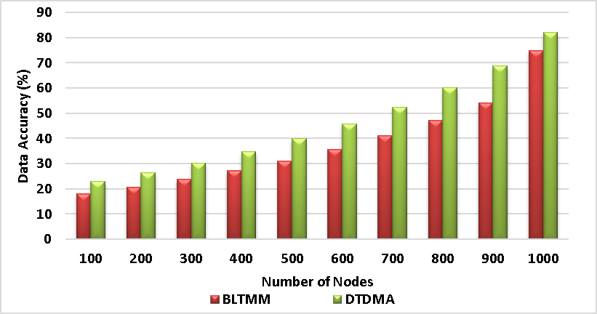
Figure 2: Performance of the accuracy calculation
The highest accuracy values show the system reliability. Hence the proposed ERCRM system achieves the highest accuracy of 93% when compared to the existing technique. This shows the superior performance of the proposed system.
4.2 Data loss: It is defined as the ratio of failed data packets to the total number of data packets sent in the network. The figure 2 shows the performance of the data loss rate calculation.
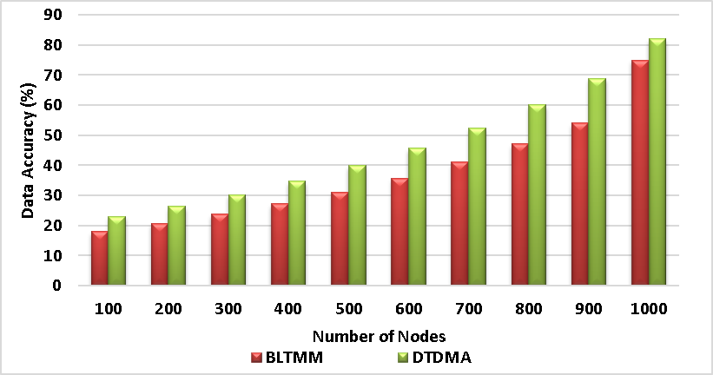
Figure 3. Performance of data loss rate
Form figure 3, the proposed DMRIO method demonstrates the lowest data loss rate of 7% when compared to the existing techniques which showing its effectiveness in reducing data loss and enhance the data transmission effectively.
4.3 Routing Overhead: Routing overhead is the term used to describe the extra data packets that are produced by routing protocols to manage the information about network routing. The figure 4 shows the performance of Routing overhead.

Figure 4: performance of routing overhead
Generally, higher routing head increases the congestion in the network. Due to the presence efficient algorithm, this proposed ERCRM method incurs the lowest routing overhead of 214 packets when compared to the existing techniques of QBOAR (564 packets), ABDSM (417packets), and RTAMU (362 packets). This shows the effective performance of the proposed method.
4.4 Throughput: It is defines as the rate of speed at which the data packets transferred to destination from source. The figure 5 shows the performance of throughput.

Figure 5: performance of throughput calculation
From the figure 5, the proposed DMRIO method achieved the 658 kbps which higher than the existing techniques. This shows the faster data transmission. This confirms that the proposed technique can handle more data transmission efficiently.
4.5 Network Delay: It is the time used for data packets to travel from their origin to their destination inside a network. Figure 6 shows the performance of delay.

Figure 6: performance of network delay
When compared to the existing technique DMRIO has a delay of 130 ms, BLTMM has 171 ms and DTDMA has a delay of 159 ms, the Proposed ERCRM attains the minimum delay of 102 ms and this shows the significant performance of the proffered model and the final results are described in table 3.
Table 3. Performance of existing methods and proposed method

5 Conclusion
In this paper we discussed the various challenges which are present in the mobile communication such as highly dynamical network topology, work cluster based mobile devices are created to improve the density of the devices.
6 References
[1]. M.M. Hamdi, L. Audah, and S.A. firefly optimization," IEEE Access, v
[2]. H.F. Mahdi, M.S. Abood, and M.M. Hamdi, "Performance evaluation for vehicular ad-hoc networks based
[3]. S. Alani, A. Baseel, M.M. Hamdi, and S.A. Rashid, "A hybrid technique for single-source shortest path-based on A* algorithm and ant colony
[4]. Nafea, Ahmed Adil, et al. "Enhancing Using Ensemble Modeling." Iraqi Journal For
[5]. Aliesawi, Salah, Moha of Engineering and Natural Sciences 7.3 (2019): 1041-1053.‏
[6]. Mohammed, Noor Sabah, et al. "Secure Smart Contract
[7]. Nafea, Ahmed Adil, Nazlia Omar, and Zohaa Mubarak Al-qfail. "Artificial Neural Network and Latent Semantic Analysis for A

