Improved LEACH Model with Efficient Data Gathering Scheme for Mobile Internet of Things
Nujod Alkhazraji
Department of Computer Technical Engineering ,Imam Al-Kadhum College (IKC) ,Al-Diwaniyah, Iraq; nujodalkhazraji@gmail.com .

Abstract
The Internet of Things (IoT) is a rapidly emerging field that is gaining a lot of interest from the academic and industrial sectors. It facilitates the communication of extremely huge amounts of data from a variety of smart devices. Owing to the diverse range of IoT devices, the network experienced several issues like excessive power consumption, latency, and data congestion.
Index Terms: Internet of Things (IoT), Heterogeneous Network, Improved LEACH Model and Efficient Data Gathering Scheme
1 Introduction
In recent times Internal of Things (IoT) is integrated with several technologies to improve the communication quality and to provide effective monitoring around the environment in an efficient manner [1]. IoT applications are white spread in several areas such as smart home [2], medical applications and agriculture applications [3]. The deployment of IoT devices [4] in the monitoring area is necessary to accomplish effective data collecting among various applications. various devices are capable of sensing factors such as temperature, pressure, and humidity [5]. Certain obstacles exist in the mobile IoT context, such as device energy limits [6], difficulty replacing or recharging sensors, latency, and data congestion [7]. Mainly to improve the energy efficiency of the smart devices in recent times a clustering mechanism is developed which is the process of grouping of the devices to prolong the network lifetime [8]. Clustering methods suffer by several problems in terms of data aggregation of huge amounts of data in the particular time period can significantly reduce the network lifetime [9]. In the clustering process the sensors are divided into certain groups and each group is controlled by the header called Cluster Head (CH). In this case the sensors which are not present in any of the clusters suffer to transfer the data from one place to another. Due to ineffective network topology the delay and high-power utilization is created in the network [10]. To overcome these drawbacks in this article an improved leech model with an efficient data gathering scheme is developed in the mobile IoT environment. This article's primary contribution is explained in the following manner.
2 Related Works
In [11] F.Al-Turjman et al., mentioned improving the speed of big data applications and utilizing the network sources by using new scheduling and routing techniques. Data size, delay, load, and capacity, based on these requirements the routing approach has considered, the source and destination. In [12] Syed Yasmeen Shahdad et al., mentioned the importance of routing protocol in the proposed work. Mainly the routing protocol is used for huge network constraints and data transmission between node-to-node communications. In [13] Trupti Mayee Behera et al., proposed to improve the heterogeneous network by selecting the cluster head based on a threshold in the existing stable election protocol. The nodes are normal, intermediate, and advanced types. In [14] Shahzad et al., developed to improve the network lifetime for large-scale IoT by using flexible IoT path programming. To fulfill the requirements Software-defined networking and deep packet inspection technology were used.
In [15] Komkit Suwandhada et al., developed to analyze the energy consumption of different parameters by using an energy-efficient routing technique. The suggested protocol is applied to extend the network's lifespan. In [16] Samaneh Hoghooghi et al., proposed to improve the mobility of networks by modifying the RPL routing protocol and reducing the hand-offs by using continuous connection. At the same time, the network lifetime of the network is low. In [17] Abudakar Gidado Halilu et al., proposed to improve the QoS in application areas but existing is not possible. To address these problems, they combine two protocols to perform as one. The proposed protocol was implemented in the simulation field. In [18] Samson Hansen Sackey et al., improve the network lifetime of IoT by using a bio-inspired technique and intelligent routing algorithm. Finding the best path for transmission by using knowledge discovery technology is concentrated. In [19], Zahra Aghapour et al. suggested utilizing an enhanced swarm algorithm and an optimum routing approach to send data to the fog in order to lower the energy consumption of IoT networks.
In [20] Johnny Choque et al., mentioned the flexible network has an integrated solution, implementing a wide range of areas for transmission. The proposed technique is more complex to implement. Using a lightweight multi-hop routing protocol, Kennedy Chinedu et al. devised in [21] to extend the network lifespan of the system. It can improve signal stability and reduce cost flow. Himani Bhardwaj et al. invented the current mode signaling technology in [22] in order to lower power consumption and interconnect circuit latency. The performance of tiny device connectivity was the primary emphasis of the suggested approach. Hongzhang Han et al. developed enhanced ant colony optimization in [23] to tackle the optimal path problem. The shortest path for information transmission in the WSN is determined using the upgraded ant colony algorithm. The drawbacks of the earlier works are summarized in table 1.

3. Proposed ILEDGM Model:
The ILEDGM model is developed to provide efficient data gathering for IoT enabled mobile devices with the presence of the clustering process. Mainly to improve the lifespan and efficiency of the smart devices certain modules are constructed here are network energy model construction, improved leach model and communication process. The major functions of this ILEDGM are given in figure 1.
3.1 Network Energy Model Construction:
A radio consumption model is used to calculate the decapitation energy of the deployed sensor nodes. The energy needed to transmit l-bit data at a distance " $d$ " is denoted by the variable$E_{tx}\left(l,d\right)$, which may be calculated as following:
The new threshold considers $En\left(n\right)$ and $ReCH\left(r\right)$ two more important variables, similarly to equation (4). $ReCH\left(r\right)$ is a ratio between the number of sensor nodes that are currently alive and those that were not selected as cluster leaders during the preceding 1/p round. It is reset at each 1/p round. Equation (6), which is derived from equation (4), uses the additional parameter $En\left(n\right)$ to account for the pertinent nodes. Equation (4) represents the current energy level of sensor node n, or$E_{cur}(n)$. The initial energy level is$E_{init}$. ${Nbr}_{n}$is the number neighbor of a sensor node. The greatest number of neighbours that a node can have been${Nbr}_{max}$, which is calculated using information from all nodes in the network. While ${dtoBS}_{n}$represents the distance among a sensor node and the center station,
, while node C is eligible to be selected since its neighbor distances are greater than$R_{CoverCH}$.
3.3 Communication Process:
This stage involves the CH node's communication with the mobile sink after the CM nodes have communicated with it. Single-hop architecture is used by the CLRP-MMS technique for both intra- and inter-cluster communications. Parts of this phase include communication inside and between clusters. A node notifies its neighbors of its membership when it is selected as the CH. If a node receives this message from two or more CHs, it selects the CH node with the
1)Intra-cluster communication:

All cluster's nodes are listed on the CH node. Removing a node from the list and informing associated nodes of the updated TDMA schedule occurs when a node fails to send data for two consecutive sessions. Cumulative ack, which is distributed by the CH node at the conclusion for every framework, controls movement. The CH node certifies that it receives data from other nodes. A node gets orphaned due to its mobility if it does not receive a confirmation message from its CH node. The new CH node receives a Join Request (JReq) from the orphan node asking for collaboration. When a new node joins the cluster

2)Inter-cluster communication:

For a movable sink, there are many motion kinds. The sink's predicted mobility was employed in this investigation. If the sink position needs to be updated often and the mobile sink path is constantly changing, the network's overall energy consumption will increase and there will be more collisions. Furthermore, the proposed method permits several mobile sinks inside the network, resulting in lower network energy usage. CH nodes use the periodic motion to determine the right moment to send data to the sink depending on its location and schedule. This proposed ILEDGM network produced better performance and the whole process is described in the pseudo code below.

The Pseudo Code of the Proposed ILEDGM

4. Experimental Results:
We used the NS3 simulator to test its performance of the earlier methods LMRP [21], POCST [22], and WROIA [23] protocols in order to analyse the proposed ILEDGM network. Performance metrics such as Accuracy (%), Data loss (%), Routing overhead (packets), Throughput (kbps) and Delay (ms) are used throughout the assessment process. and as well the parameters which are involved in the construction of the proposed network model are given in table 2.
4.1 Accuracy: "Accuracy" describes how close or how exact the output of a system is in relation to the input. Figure 2 displays the accuracy's performance.
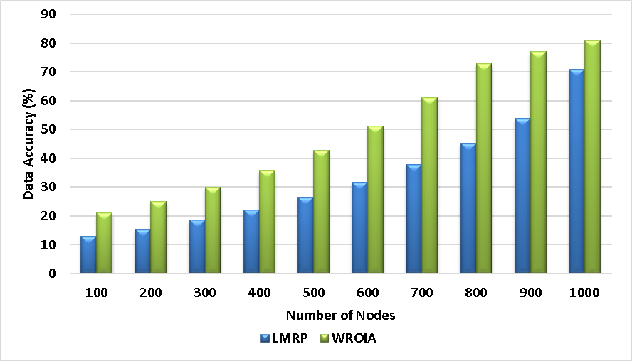
Figure 2: Performance of the accuracy calculation
The highest accuracy values show the system reliability. Hence the proposed ILEDGM system achieves the highest accuracy of 89% when compared to the existing technique. This shows the superior performance of the proposed system.
4.2Data loss rate is the proportion of successfully transferred data packets to all data packets sent over the network. Figure 3 displays the results of the data success rate computation.
Figure 3: Performance of Data loss ratio calculation
Form figure 3, the proposed ILEDGM method attains the minimum loss ratio of 95% when compared to the other routing methods of LMRP has 34
4.3 Routing Overhead: Routing overhead is the term used to describe the extra data packets that are produced by routing protocols in order to handle the information about network routing. The figure 4 shows the performance of Routing overhead.
Figure 4: performance of routing overhead
Generally, higher routing head increases the congestion in the network. Due to the presence efficient algorithm, this proposed ILEDGM
4.4 Network throughput: The pace at which data is successfully sent through a network is referred to collectively as throughput. The figure 5 shows the performance of the throughput.
Figure 5. Performance of throughput calculation
From the figure 5
4.5 Network Delay: The duration of a data packet's journey from its source to its destination inside a network is referred to by this word. Figure 6 displays the delay's performance.
Figure 6 : performance of network delay
When compared to the existing technique LMRP has a delay of 196 ms, POCST has a delay of 182 ms and WROIA has a delay of 176 ms, the Proposed ILEDGM attains the minimum delay of 121 ms. And this shows the significant performance of the proposed method and overall performance is described in table 3.
5 Conclusion
We have presented an updated leach model with an efficient data collection technique in this research, which is an efficient data collecting approach for the heterogeneous web of things. This proposed approach creates a novel model for clustering processes where the CH is
6 References
- H.F. Mahdi, M.S. Abood, and M.M. Hamdi, "Performance evaluation for vehicular ad-hoc networks based routing protocols
- S. Alani, A. Baseel, M.M. Hamdi, and S.A. Rashid, "A hybrid technique for single-source shortest path-based on A* algorithm and
- A. S. Abdalkafor and S. A. Aliesawi, "Data aggregation techniques in wireless sensors networks (WSNs): Taxonomy and an accur
- Khalifa, Marwa Mohammed, Osman Nuri Ucan, and Khattab M. Ali Alheeti. "New Intrusion Detection System to
- S. Aliesawi, C. C. Tsimenidis, B. S. Sharif, and M. Johnston, "Efficient channel estimation for chip multiuser detection on underwater ac
- Abdaljabar, Zainab Hussam, Osman Nuri Uçan, and Khattab M. Ali Alheeti. "An Efficient Intelligent Intrusion Detection System for
- H. Mahdi, B. Al-Bander, M. H. Alwan, M. S. Abood, and M. M. Hamdi, "Vehicular Networks Performance Evaluation Based
- M. M. Hamdi, L. Audah, S. A. Rashid, M. S. Abood, A. S. Mustafa, and M. S. Noori, "A hybrid Algorithms to Improve the Quality of Service in
- S. A. Rashid, M. M. Hamdi, and S. Alani, "An overview on quality of service and data dissemination in VANETs," in 2020
- M.M. Hamdi, L. Audah, and S.A. Rashid, "Data dissemination in VANETs using clustering and probabilistic
- S. Sugave, B. Jagdale and D. Rosaci, "Monarch-EWA: Monarch-Earthworm-Based Secure Routing
- N. G. Razafindrobelina, R. Anggoro and A. M. Shiddiqi, "The development of a routing protocol based on Reverse-AODV by considering an
- N. C. Almeida, R. P. Rolle, E. P. Godoy, P. Ferrari and E. Sisinni, "Proposal of a Hybrid LoRa Mesh / LoRaWAN
- M. Mahyoub, A. S. Hasan Mahmoud, M. Abu-Amara and T. R. Sheltami, "An Efficient RPL-Based Mechanism for Node-to-Node

