Efficient Intelligent MANET Routing for IoT-Oriented Smart Devices
Nejood F. Abdulsattar
Department of Computer Technical Engineering ,Imam Al-Kadhum College (IKC) ,Al-Diwaniyah, Iraq;nejodfaisal@gmail.com.
Mohammed I. Habelalmateen
Department of Computer Technical Engineering, College of Technical Engineering, The Islamic University, Najaf, Iraq; moh.almateen@gmail.com.

Abstract
The Internet of Things (IoT) is heavily used in smart environments and has drawn the majority of programs that are associated with mobile ad hoc networks (MANETs) in recent years. Nevertheless, as the number of smart devices rises, a massive amount of heterogeneous data is constantly being exchanged across wireless media. In the IoT enabled MANETs environment due to the moving devices various challenges are created like transmission delay, lower generation of throughput
Index Terms: Energy Model Construction, Intelligent Routing Protocol, Mobile Ad hoc Networks (MANETs), Internet of Things (IoT), and Efficient System Generation
1 Introduction
An essential component of the internet of things (IoT) [2] is the mobile ad hoc network (MANET), which offers an effective infrastructure-less network paradigm [3]. The devices' inadequate power supply causes an increase in overhead events and delays [4]. Numerous issues with the network emerged as a result of a significant imbalance in energy consumption [6] and a high communication latency [5]. In a number of commercial and healthcare sectors, these problems are unacceptable [8]. Efficient data transmission among the source to the destination and efficient routing model is needed hence the data travels in a mobile nature [9]. So that in recent times several routing models are developed but still this topic is in an open research area [10]. This article presents the development of an automated routing model that can manage the smart devices in the network, hence increasing device efficiency and data success ratio. The following is a summary of this article's main content.
2 Related Works
In [11] Muhamad Asvial et al., solved the IoT obstacles in the network by using the adaptive power control-based Physarum routing method. The last node and the final destination node receive enough power from the suggested strategy. In [12] Pallavi Yarde et al., based on the LEACH algorithm have created multi-hop cluster LEACH as a proposed algorithm. This algorithm is involved in the physical, MAC, and network layers. In conclusion, the throughput of the algorithm is less in IoT networks. In [13] Chavi Kapoor et al., a proposed new routing scheme is developed to avoid blackhole attacks, physical damage, and malfunctioning. Mainly focus on avoiding misguided data analysis in IoT data collection applications. In [14] Jithin Jagannath et al., developed a Heterogeneous network, that functions as a WiFi hotspot so that end customers may download a personalized app. Each of them is communicated with by the suggested method to create a network based on LoRa.
Jose V.V. Sobral et al. suggested using the routing protocol in [15] to increase the effectiveness of IoT networks. Through the control communication, the upgraded next-generation node will determine whether or not its neighbors' nodes are available. Denis Kutuzov et al. discussed in [16] how decentralized routing devices process Internet of Things traffic using the Gaussian distribution approach. Additional routing devices with simultaneous processing and decentralized management are included in the suggested architecture. In [17] Nedal Ababneh et al., proposed work is developed to find the best solution for network lifetime and various parameters for IoT networks. The network lifetime analytics techniques have been applied in various routing protocols and find the best solution. Akhilesh Panchal et al. created a hybrid routing protocol using the residual energy in [18] to choose the best node and cluster head. To improve the efficiency of IoT applications, a packet routing strategy has been used.
In [19] Vijeth J Kotagi et al., developed multipath and multi-technologies as a proposed system. By transmitting the real-time data in the proposed protocol via multiple wireless interfaces is utilized. To analyze the packet delivery ratio and throughput by using split window automatic repeat request. In [20] Rakesh Kumar Lenka et al., proposed a data-transferring with low power sensor by using an energy-efficient routing protocol. IoT sensing infrastructure deals with reliable routing protocol in the proposed technique. This proposed work reduces energy consumption and reliability has increased, but unfortunately, the throughput is very low. In [21], Alain Bertrand Bomgni et al., use an effective permutation routing system to overcome the permutation routing challenge in the Internet of Things. The proposed scheme solves this problem in the single-hop environment. In [22] Bhukya Suresh et al., developed an efficient routing scheme by using the LEACH protocol, this proposed protocol is a cluster-based environment. The selection of the cluster head is determined by the amount of distance between base stations, demand rate, and node penetration. An IoT priority-based routing strategy for healthcare data transfer was suggested by Ben Othman Soufiene et al. in [23]. The proposed work is divided into two health data, in an emergency is a high priority and transfers the data immediately. Vital health data is monitoring the patients via multi-hop communication. The methods of the earlier researches and its drawbacks are summarized in table 1.

3. Proposed EIMRIS Approach
This proposed EIMRIS is mainly developed to increase the routing process and provide energy optimization among the devices in the network. An efficient routing process and energy model construction are the two main phases of this research. Figure 1 illustrates how the suggested EIMRIS would operate.
3.1 System Environment
This subchapter presents an environmental monitoring scenario that makes use of mobile communication, a crucial component of IoT. The standard architecture of the time-varying mobile communication may employ the Sensor-OpenFlow (SOF) protocol to construct the network interface protocol between the control and data planes. We employ IEEE 802.15.4 as the MAC protocol in the meantime. The Network Controller (NC) may quickly accept application-specific requests from the application layer via Application Programming Interfaces (APIs). Based on a global perspective of mobile communication acquired from the information gathering process, the NC can then undertake routing-decision operations in a centralized style. Using relay nodes and the data link, Flow-based messages are created by the programmable WSN sensor nodes and are followed by forwarding policies when they are sent to the sink. By using SOF to manipulate user-customizable flow tables, all sensor nodes are made SDN-capable. For every sensor node, the NC defines and installs the forwarding rules that are kept in flow tables. The sensor node and the NC can establish a connection through multi-hop communications via SOF via the sink. Whenever the routing-decision procedure is finished, the NC utilizes SOF to install the forwarding rules to the routing-request nodes via the control path.
3.2 Energy Model
The radio energy consumption model is used to compute the dissipation of energy of the distributed sensor nodes. $E_{tx}$, the energy used in the transmission of l-bit data across an interval of d, is calculated as follows:
3.3 Intelligent Routing Protocol
The reactive protocol of AODV, A technique of routing without loops in ad hoc mobile networks, concentrates on creating routes as needed. It forges its own route while avoiding a number of difficulties, including packet losses, connection failure, and node movements. The traditional routing tables, which include a single entry for each destination and a sequence number, are used to maintain information current and dodge routing loops. This protocol's main advantage is that it uses time-based states, which remove any unnecessary routing entries from each node and update the data in neighboring nodes. With hop-to-hop routing, Nodes only generate route requests (RREQs) when they want to find their destination path. The node intermediates then continue with the path request while concurrently creating a route reply (RREP) containing the arrival hop number. Apart from the duty of relaying the reply to the source node, every node creates a forward path to reach the destination.
4. Simulation Results:
By using the NS2 simulator, the performance of the EEPRI [21], EESRS [22], and PEERP [3] protocols and the proposed EIMRIS is analyzed. Numerous characteristics are taken into account throughout the inspection process, including the packet delivery ratio (%), throughput (kbps), average delay (ms), routing overhead (pkts), and energy efficiency (joules). Table 2 lists the parameters that were used to build the suggested network architecture.
Table 2 – Parameters Details
4.1Packet delivery ratio: Because of any packets that are sent for transmission, the packet delivery ratio is the percentage of data packets that reach their destinations after being delivered effectively. The packet delivery ratio computation is displayed in Figure 2.
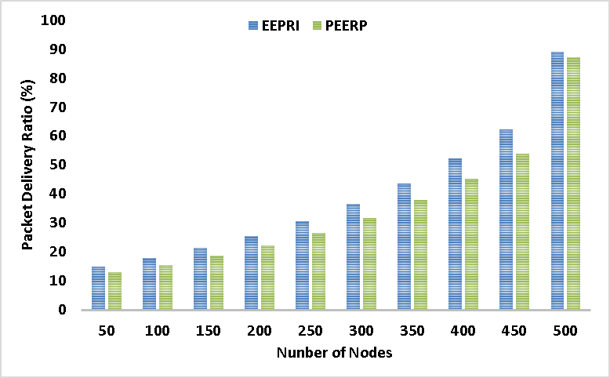
Figure 2. Performance of Packet delivery ratio
While the suggested approach, EIMRIS, attained the maximum delivery ratio of 95%, the current methods, EEPRI, EESRS, and PEERP, have packet delivery rates of 89%, 85%, and 87, respectively. This demonstrates the suggested method's transmission effectiveness.
4.2 Throughout: It refers to the rate of speed of successful transmission of the data packets form origin to target. Figure 3 shows the throughput calculation.
Figure 3. Performance of throughput
4.3 Average Delay: The mean time taken by a packet to travel from its source to its destination is its definition. Figure 4 displays the typical delay's effectiveness.
Figure 4. Performance of Average delay
4.4 Routing Overhead: It is the additional packets produced by the routing protocol to manage the network traffic in the system. The figure 5 shows the performance of routing overhead.

Figure 5. Performance of routing overhead
4.5 Energy Efficiency: When data is transmitted from a source to a destination, it refers to the energy consumed by the data per unit. The energy efficiency is displayed in Figure 6.
Figure 6. Performance of Energy Efficiency
The presence of the efficient routing protocol, reduce the power consumption in data transmission. Hence the
Table 3. Performance of existing method and proposed method.
5 Conclusion
In this paper, an intelligent route in the model is developed mainly to achieve effective communication in the IoT enabled MANETs
6 References
- M.M. Hamdi, L. Audah, and S.A. Rashid, "Data dissemination in VAN
- H.F. Mahdi, M.S. Abood, and M.M. Hamdi, "Performance evaluation for vehicular ad-hoc networks based routing protocols," Bulletin of
- S. Alani, A. Baseel, M.M. Hamdi, and S.A. Rashid, "A hybrid te
- H. Mahdi, B. Al-Bander, M. H. Alwan, M. S. Abood, and M. M. Hamdi, "Vehicular Networks Performance Evaluation Based on
- M. M. Hamdi, L. Audah, S. A. Rashid, M. S. Abood, A. S. Mustafa, and M. S. Noori, "A hybrid Algorithms to Improve the Quality of Service in Vehicular Ad-Hoc Networks: A Framework
- S. A. Rashid, M. M. Hamdi, and S. Alani, "An o
- Mohammed, Noor Sabah, et al. "Secure Smart Contract
- R. K. Lenka, A. K. Rath and S. Sharma, "Building Reliable Routing
- Alain Bertrand Bomgni, Miguel Landry Foko Sindjoung, Dhalil Kamdem Tchibonsou, Mthulisi Velempini, Jean Frédéric Myoupo, NESEPRIN: A new scheme for energy-efficient permutation routing in IoT networks, Computer Networks, Vol
- Bhukya Suresh, G. Shyama Chandra Prasad, An Energy Efficient Secure routing Scheme using LEACH protocol in WSN for IoT networks,
- Ben othman soufiene, Abdullah Ali Bahattab, Abdelbasset Trad, Habib Youssef, PEERP: An Priority-Based Energy-Efficient Routing Protocol for

