Opportunistic Network Model with Gray Wolf Algorithm based Multipath Routing in IoT Environment
Nejood F. Abdulsattar
Department of Computer Technical Engineering ,Imam Al-Kadhum College (IKC) ,Al-Diwaniyah, Iraq;nejodfaisal@gmail.com.
Rizgar Rahman Ghafour
National University of Science and Technology, Dhi Qar, Iraq; rizgar.r.ghafour@nust.edu.iq

Abstract
Internet of Things (IoT) is the kind of network which communicates and combines the network which includes even a small smart device. This technology is the connection of smarter devices that greatly improves the standard of any human hand. Advantages using the technology in the real time applications but still it consists of certain drawbacks in achieving maximum quality among the devices. The major drawbacks are concentrated here are routing issues and path selection issues. To improve the network from such flaws in this article and opportunistic network model with grey wolf algorithm based multipath routing
Index Terms: Internet of Things (IoT), Opportunistic Network Model, Gray Wolf Algorithm and Multipath Routing Protocol
1 Introduction
One network structure that comprises physical objects that are connected to the internet via detection is the Internet of Things (IoT) [1]. It is described as the integration of tangible items with technology, namely infrastructure [2]. and it is able to transfer the data from one place to another in a wireless medium [3]. The given network structure is specifically used to change the data in the communication module with or without any human participation [4]. This technology is developed in a huge manner by enabling other technology like big data [5], cloud computing [6], wireless communication and fog computing [7]. A collection of devices is able to create an internet based network which consists of subnets and sub structures. Sensors network is one of the major subset of the internet based communication in terms of its functionality to include the devices into the stream [8]. The major processes inside the network are data collection, data processing and propagation which is the basic form of communication in the sensor networks [9]. In recent years, incorrect routing and erratic data transfer have been highlighted as the main problems [10]. This paper develops an opportunistic network model with multipath routing based on the grey wolf algorithm, primarily to mitigate such network shortcomings. The primary focus of this article is to enhance the network's quality of service, which is enumerated as its key contribution.
2 Related Works
In [11], Abdallah Ouhab et al. suggested a two-level control mechanism: one is a software-defined networking based on a q-routing method to enhance the network's quality of service, and the other is a low-power and lossy network based on a multi-hop clustering technique. In [12], Michika Ohnishi et al. noted that our suggested approach successfully built a large-scale network with numerous nodes and was dependable and efficient in end-to-end communication in DTN, with other nodes connected through intermittent communication links. In [13] Liu Lu et al., mentioned the adaptive routing algorithm for the on-chip network has been improved in communication and connection. And find that communication is more flexible based on path-aware and load-aware methods. In [14] Adeel Ahmed et al., developed two mechanisms together, one is energy energy-efficient routing protocol, and the second is a thermal-aware routing protocol. These two combined technologies produce a Cost Function based on distance, temperature, and residual energy. In [15] Mraduraje Sisodiya et al., developed a multicasting technique to resolve the trust mechanism issues in the IoT network. The proposed mechanisms involve low-power and lossy networks, improve the security of the network, and protect it from untrusted nodes.
In [16] Lijun Dong et al., presented the Named-data routing protocol has been extended in the IPv6 routing protocol to get more security in LLNs network. The proposed NRPL has supported security and multipath routing in storing and non-storing modes. In [17] Sowmya Sanagavarapu et al., developed a topology-based system by using a Ryu controller in an SDN environment, and it could be performed as a dynamic deep neural routing. The proposed learning model has been performed in network routing. In [18] Emmanuel Effah et al., proposed clustering-based Agricultural IoT to implement based on the total communication cost metric in multi-hop routing. The proposed work has more scalability but less throughput. In [19] Syeda Mariam Muzammal et al., developed to increase the security in IoT by using the SMTrust concept. It was given more security and protection from RPL attacks, Blackhole, etc. In this method, the sensor nodes and sink nodes are considered to be mobility metrics. In [20] Nileshkumar R Patel et al., based on replacing hop count in a cross-layer variant of AODV with quality in link and collision count. The proposed technique, the physical layer has link quality information, and the MAC layer has collision count.
In [21] B.H.D.D. Priyanka et al., mentioned improving energy-efficient and IoT applications for sustainability by using Region-based clustering and cluster heads in the agricultural environment. Despite the fact that the shortest path and least expensive algorithms might increase energy efficiency. Using the shortest path technique, P.Ajay et al.'s cluster-tree-based routing protocol in an Internet of Things-based transportation system was proposed in [22] and increased network efficiency. Using the game theoretic technique to choose cluster heads is another crucial step. Using a bee colony algorithm, Fattaneh Ramezanzadeh et al. created a two-level hierarchical chain routing strategy in [23], and it has reduced transmission delay and improved chain communication. The sensor node and base station have Euclidean distance. The principles which are followed in the earlier researches are identified and that is summarized in table 1.

3. Proposed QGWMR-IoT Approach
Mainly to improve the routing standard of the internet devices in this article efficient routing model and optimization process is carried out. In the internal of things-based network huge number of devices is incorporated that leads to affects the reliability. The best route for data transport is selected primarily to increase device stability. Figure 1 depicts the workflow for this proposed QGWMR-IoT.

Figure 1 - QGWMR-IoT Work and Process
3.1 System Model Construction:
Because there isn't a set route to a certain location, opportunistic networks are unstructured and unstable because they are movable and decentralized. This exposes the network to severe security flaws. By integrating blockchain on opportunistic networks, we aim to address these security flaws. The suggested system concept uses a probability-based routing mechanism to incorporate blockchain technology into IoT communications. Each node in a network has an identity number, an energy level, a credibility factor, a status (alive or dead), a list of its current neighbors, a series of modules that include data, timestamps, hashes of the previous and current blocks, hop counts, destinations, and a buffer capacity that restricts how many communications a node may retain. If the storage space is filled and the data production rate is high, the subsequent messages are rejected. Every time a host node communicates with a carrier node in the

3.2 Gray Wolf Algorithm:
A routing optimization method called the Gray Wolf Optimizer (GWO) is suggested to determine the best route between the devices. The proposed algorithm, in fact, borrows its cues from the hunting behavior of gray wolves. Consequently, the GWO algorithm's optimization problem is the hunting process, where:
- makes use of three vectors. The GWO method presents the procedure for choosing and computing the components of these vectors. In actuality, the
3.3 Multipath Routing Protocol:
The functioning of the proposed protocol is based on the optimality principle, as seen in Figure 1. The intermediate node looks everywhere for its next hop in order to determine the optimal route to the destination. The best 1-hop nearby node is selected by the protocol using the OCF, which is determined by taking into account the node's congestion level and expected lifespan. We therefore obtain the node with the highest Lifetime and lowest amount of congestion. The best route for a successful data transmission to the destination then gradually becomes apparent. The following stages are carried out by the protocol:
Initialization/Setup: During this stage, every node computes the values of its optimum cost factor (OCF) components, obtains neighborhood data, and saves it in its routing table. This data aids in route discovery and setup by pointing out the optimal subsequent hop-node to the target.
Locating and establishing routes Step: In the event that a path to the target is unknown, the source node initiates the route-finding process by distributing a Path discovers request packet (PDReq) to its one-hop neighbors. Using the OCF of their 1-hop neighbor node, which is kept in its
Data forwarding step:
4. Simulation results:
We used the NS2 simulator to test its performance against the EACS-IoT [21], ECET-IoT [22], and EBHC-IoT [23] protocols in order to analyse the proposed QGWMR-IoT network. Performance metrics such as throughput (kbps), delay (ms), routing overhead (pkts), accuracy (%), and energy efficiency (joules) are used throughout the assessment process. Table 2 lists the input factors that are taken into account for this investigation.
Table 2 – Parameters Settings
4.1 Network throughput: The total speed at which information is transmitted across a network is called throughput. Figure 2 displays the throughput's performance.
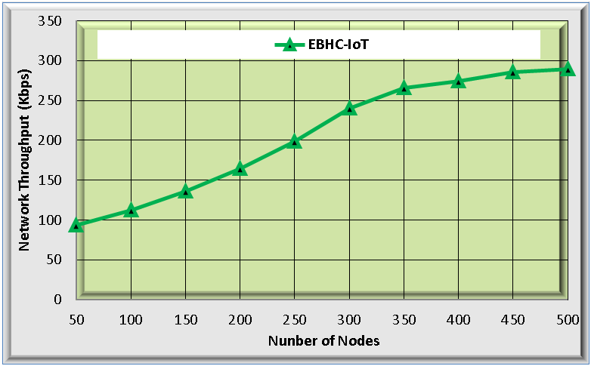
Figure 2. Performance of throughput calculation
4.2 Network Delay: This phrase refers to how long it takes for a data packet to go throughout a network from its point of origin to its conclusion. Figure 3 displays the delay's effectiveness.
Figure 3: performance of network delay
4.3 Routing Overhead: Routing overhead is the term used to describe the extra data packets that are produced by routing protocols in order to handle the information about network routing. The figure 4 shows the performance of Routing overhead.
Figure 4: performance of routing overhead
Generally, higher routing head increases the congestion in the network. Due to the presence efficient algorithm, this proposed QGWMR-IoT method incurs the lowest routing overhead of 214 packets when compared to the existing
4.4 Accuracy: "Accuracy" describes how close or how exact the output of a system is in relation to the input. Figure 5 displays the accuracy's performance.
Figure 5: Performance of the accuracy calculation
4.5 Energy Efficiency: The quantity of energy that is utilized for each unit of data transmission from source to destination. The figure 6 shows the energy efficiency calculation.
Figure 6 performance of energy efficiency calculation
The Proposed QGWMR-IoT data transmission when compared with Table 3 shifts the final findings and the alternative approaches.
Table 3. Performance of the existing method and proposed method

5 Conclusion
This proposed QGWMR-IoT is developed to improve the routing capabilities and optimal path selection process to obtain overall efficiency among the internet devices. reliable transfer of data from the point of origin to the conclusion in a specific standard mainly to achieve this multipath routing is developed among the internet devices. In order to transfer the data in an optimal path mainly to reduce the delay and routing overhead a grey wolf optimization model is utilized. From the result and discussion it is proven that the QGWMR-IoT network model improves the transmission accuracy and efficiency of the devices when it is compared with the earlier baseline methodology. In future direction clustering models are concentrated to improve the efficiency.
6 References
- M.M. Hamdi, L. Audah, and S.A. Rashid, "Data dissemination in VANETs using clustering and probabilistic forwarding based on adaptive
- M.M. Hamdi, "Data dissemination in VANETs using clustering and probabilistic forwarding based on adaptive
- H.F. Mahdi, M.S. M.M. Hamdi, "Performance evaluation for vehicular ad-hoc networks based routing protocols
- S. Alani, A. Baseel, M.M. Rashid, "A hybrid technique for single-source shortest path-based on
- Nafea. "Enhancing Student's Performance Classification." Iraqi
- Aliesawi, Rashid. "Iterative multipacket detection with FDE based MAC protocol in vehicular ad hoc networks." Periodicals of
- Mohammed, Noor Sabah, et al. "Secure Smart Contract Based on Blockchain to Prev
- Nafea, Ahmed Adil, Nazlia Omar, and Zohaa Mubarak Al-qfail. "
- H. Mahdi, B. Al-Bander, M. H. Alwan, M. S. Abood, and M. M. Hamdi, "Vehicular Networks Performance Evaluation Based on Downlink Sche

