Efficient Routing Using Multipath Routing Protocol with Genetic Algorithm in Mobile Ad Hoc Networks
Nejood F. Abdulsattar
Department of Computer Technical Engineering ,Imam Al-Kadhum College (IKC) ,Al-Diwaniyah, Iraq;nejodfaisal@gmail.com.
Fatima Hashim Abbas
Medical Laboratories Techniques Department,Al-Mustaqbal University,Hillah, Iraq; fatimahashim@mustaqbal-college.edu.iq.
Mohammed I. Habelalmateen
Department of Computer Technical Engineering, College of Technical Engineering, The Islamic University, Najaf, Iraq; moh.almateen@gmail.com.

Abstract
Mobile Adhoc Network (MANETs) is a kind of wireless communication technology which is in the area of adhoc network main lead consisting of both infrastructure and infrastructure less environment. The major issues which are mainly concentrated in this article are providing efficient routing among the mobile devices and to provide an optimal path for the source to transfer the data to the destination in an effective manner without any delay and traffic congestion.
Index Terms: Mobile Adhoc Network (MANETs), Efficient Routing Using Multipath Routing Protocol and Genetic Algorithm
1 Introduction
Mobile Ad hoc Networks (MANETs) is one among the autonomous network models [1] which is the part of the ad hoc networks and it consists of mobile devices [2] which perform communication without any base station [3]. To improve the performance of the infrastructure based environmental model [4] networking is highly essential when it is applied to several confidential applications [5]. In recent times due to the high speed of the devices several challenges are occur in the mobile communication [6] so that it becomes very essential to improve the communication methodologies [7] which are present in the earlier days to achieve better performance and data transmission among the devices [8]. Some of the design issues of mobile communication are rapidly changing topology, network separation, band with available, high error and loss ratio of the devices, interference occurrences and energy constraints among the devices [9]. In recent times the MANETs technology is adapted for several applications which have limited battery power in the devices. So prolonging the lifetime of the devices is the primary task and key challenges in this technology. Several traditional methods are developed in this section but still this research is open and it needs improvement [10]. To address this in this article efficient routing using multipath routing protocol with genetic algorithm is developed and the major contribution of the article is described as follows.
2 Related Works
In [11], author Vinod Jain proposed a framework using the Artificial Bee Colony algorithm for cluster-based routing to optimize routes and ensure QoS with minimal delay and improved scalability but the drawback here is high overhead. In [12], K.G. Santhiya This paper explained a framework using the Artificial Bee Colony algorithm for cluster-based routing to optimize routes and ensure QoS with minimal delay and improved scalability. In [13], author Subha R Fuzzy theory predicts entity states well and AFLIPLFFM improves MANETs by forecasting path stability with triangular membership functions and the Mamdani Fuzzy Inference Engine helps in boosting network performance with the high power consumption. In [14], Surabhi Patel implemented a quadratic regression method with signal strength for estimating link failure time in MANETs, comparing its accuracy to an interpolation-based technique using Network Simulator 2.35, BonnMotion and MOVE tools with the high delay.
In [15], author S.K. Srivatsa proposed ACO algorithm using position and energy metrics, outperforms classical AODV especially in high-mobility scenarios ensuring better throughput but the drawback is high power consumption. In [16], author developed a tailored Intrusion Detection System using game theory to counter the "Malicious Packet Dropping Attack" in ad hoc networks achieving a 42% increase in packet delivery ratio but with high overhead. In [17], Zhihao Guo introduces OLSR_EA, an energy-aware routing method for MANETs that predicts and optimizes energy consumption using the Optimized Link State Routing Protocol improving network performance across diverse scenarios but with the high overhead. In [18], Haili Zheng introduced a stable connected dominating set construction algorithm for MANETs relying on node velocity with the Threshold Neighborhood Distance Ratio constraint to ensure stability and exclude unstable edges with the disadvantages of high delay.
In [19], author presents a stable connected dominating set algorithm for MANETs, ensuring stability by using node velocity the Strong Neighborhood concept and the Threshold Neighborhood Distance Ratio constraint, but the drawback is high delay. In [20], Emna Fki implemented an enhancing information dissemination in MANET's systems involves tackling QoS challenges and reconfiguration rules happens using graphs and GMTE to select efficient solutions based on evaluation criteria and the disadvantages here is high delay. In [21], author Rakesh Sahu developed the AOMDV-ER protocol optimizes network performance in MANETs through a varying recoil off-time technique and addressing power conservation and outperforming existing AODV-based algorithms with significant energy savings and the drawback here is high overhead. In [22], T. Kunz author examines how mobility models affect simulations in unmanned aerial ad hoc networks. The study finds the enhanced Gauss–Markov model most suitable among the five evaluated models for UAANET and the disadvantages here is high packet loss. In [23], author introduced AntOR, an ACO routing protocol for mobile ad hoc networks emphasizing disjoint-link and disjoint-node routes for multiprocessor architectures and with high power consumption. The earlier methods are studied and its drawbacks are discussed in table 1.

3. Proposed EMGAM Approach:
To achieve maximum efficiency among the mobile devices the efficient multipath routing and optimization model is concentrated in this proposed article. Flow of the proposed EMGAM which consists of efficient routing and optimization with MAC model is described in figure 1.

3.1 Multipath Routing Protocol:
When employing the AOMDV routing protocol, which needs the sender to broadcast a route request (RREQ) to the recipient node in order to identify the route, there may be more than one route available between the sender and receiver pair. Regardless of the overall quality of the route, the AOMDV algorithm chooses the one with the fewest hops out of all the alternatives. In light of this, we provide an updated fitness function (FFn) for the genetic algorithm (GA). As a result, we suggest the AOMDV-FFn, a multipath routing protocol built on the AOMDV protocol. Next, we propose an alternative routing protocol, AOMDV-GA, which also uses the genetic algorithm (GA). When an RREQ is broadcast and multiple routes are received, the sender node in the proposed algorithm will have to select a specific route to find the shortest and most optimized route with the least amount of traffic and energy consumption, taking into account the possibility of link failure that causes random packet loss. That is, the following will be taken into account by the FFn:

3.2 MAC Model:
Within NS-3, the MAC layer defines the protocols that dictate how and when data should be sent to the transmitting medium. Carrier Sense Multiple Access (CSMA) and Time Division Multiple Access (TDMA) are the most used MAC layer technologies. NS-3 uses the default MAC protocol, known as CSMac, in combination with the YansWiFiChannel. However, the MAC protocol layer of the OceanNet design makes advantage of TDMA. The reason OceanNet uses TDMA is to reduce the issue of hidden nodes and enable long-range access. The majority of simulators, such as NS-3, do not include TDMA MAC protocol implementation. But, their functionality is severely constrained, and they don't work well for the general use case. As such, in the OceanNet simulation, we use CSMA by default and provide extension to TDMA in the event that a TDMA module is supported in the future.

3.3 Mobility Layer:
The movement of nodes across time is defined by mobility models. Many mobility models are available for simulations in NS-3. The Random Walk Model and the Random Way Point Model will be the primary tools we use in our simulation to model node movement. We choose the mobility models to model every kind of node according to NS-3 attributes as follows:

3.4 Genetic Algorithm
An algorithm called a genetic algorithm is inspired by nature and employs the process of evolution to solve optimization issues. When faced with a challenge, it employs its unique operators—selection, cross across, and mutation. In this study, the power consumption of mobile Adhoc network routing is optimized by the application of genetic algorithms. It chooses one to increase the network's lifespan. Routing path with fewer nodes than 2 and choose the routing route nodes with the highest RBP (remaining battery power) values. In GA, the assessment of chromosomal fitness (routing routes) is crucial. It determines fitness by choosing nodes with high RBP values and minimal numbers of nodes. The fitness function operates in this manner: Assume that a routing route has N nodes. The term ARBP refers to the average of the routing route nodes and remaining battery power.

4. Experimental results:
The proposed model and its optimization with mobility model are conducted in NS2 simulator. Here, the performance of this proposed EMGAM method is evaluated with the presence of the key parameters like Data success rate (%), Data loss rate (%), Average Delay (ms), Throughput (kbps) and Routing overhead (packets). The obtained results are compared with the earlier methods like ERMRP [21], UEMRP [22] and ACORP [23]. The input parameters which are given into consideration for this analysis is given in table 2.

4.1 Data success Ratio: The amount of data packets reached successfully to the destination from the total data packets transmitted. The figure 2 shows the performance of the Data success Ratio.
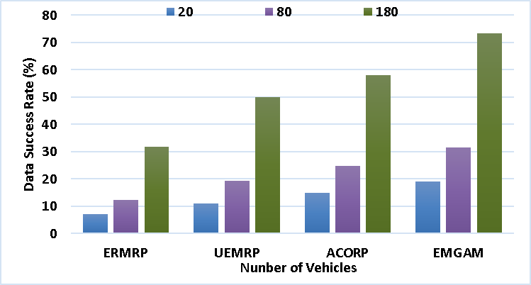
Figure 2. Performance of Data success Ratio
4.2 Data loss Ratio: The amount of data packets reached unsuccessfully to the destination from the total data packets transmitted. The figure 3 shows the performance of the data loss ratio.

4.3 Average Delay: It represents the total time used for the data packets successfully transmit to destination. The figure 4 shows the Average delay calculation.
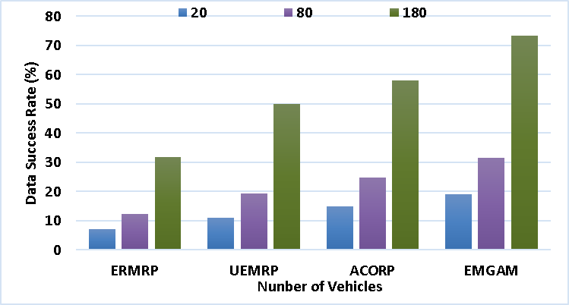
Figure 4: performance of Average delay calculation
4.4 Throughout: It refers to the rate of speed of successful transmission of the data packets form origin to target. Figure 5 shows the throughput calculation.
Figure 5. Performance of throughput
4.5 Routing Overhead: It refers the extra data packets produced by the routing protocol to manage the network congestion. The Figure 6 shows the Routing overhead calculation.
The proposed EMGAM method has the minimum routing packets of 324 packets whereas the existing method has higher routing overhead. This shows the highly efficient management of the proposed EMGAM method and the results are given in table 3.
5 Conclusion
This paper illustrates a new technique with the concept of efficient routing protocol and optimization to reduce the congestion occurrences and energy consumption among the mobile devices in the network. From the experimental results this proposed model attains
6 References
[1]. M.M. Hamdi, "Data dissemination in VANETs using clustering and probabilistic forwarding based on adaptive
[2]. H.F. Mahdi, M.S. M.M. Hamdi, "Performance evaluation for vehicular ad-hoc networks based routing protocols
[3]. S. Alani, A. Baseel, M.M. Rashid, "A hybrid technique for single-source shortest path-based on
[4]. Nafea. "Enhancing Student's Performance Classification." Iraqi
[5]. Aliesawi, Rashid. "Iterative multipacket detection with FDE based MAC protocol in vehicular ad hoc networks." Periodicals of
[6]. Mohammed, Noor Sabah, et al. "Secure Smart Contract Based on Blockchain to Prev
[7]. Nafea, Ahmed Adil, Nazlia Omar, and Zohaa Mubarak Al-qfail. "
[8]. H. Mahdi, B. Al-Bander, M. H. Alwan, M. S. Abood, and M. M. Hamdi, "Vehicular Networks Performance Evaluation Based on Downlink Sche
[9]. Rakesh Sahu,"Energy Reduction Multipath Routing Protocol for MANET Using Reco
[10]. T. Kunz, "Unmanned Aerial ad Hoc Networks: Simulation-Based Evaluation of Entity Mobility Models’
[11]. Delfín Rupérez Cañas,"A Family of ACO Routing Protocols for Mobile Ad Hoc Networ

