Intelligent Cluster Head Selection with Trust Computation in Mobile Ad Hoc Networks
Nejood F. Abdulsattar
Department of Computer Technical Engineering ,Imam Al-Kadhum College (IKC) ,Al-Diwaniyah, Iraq;nejodfaisal@gmail.com.
Rizgar Rahman Ghafour
National University of Science and Technology, Dhi Qar, Iraq; rizgar.r.ghafour@nust.edu.iq
Zahraa Hassan Ward Surname
Department of Computer Techniques Engineering , Mazaya University College, DhiQar, Iraq;Eng.co.zahraa@mpu.edu.iq.

Abstract
In the Mobile Ad hoc Network (MANETs), in recent times a centralized administrative mechanism is introduced to achieve a highly flexible and cost effective network model with the presence of multi hop data transmission. To achieve high reliability during data transfer among the mobile devices it is very essential to reduce the power utilization and delay at each instant of the time period.
Index Terms: Mobile Ad hoc Network (MANETs), An Intelligent Cluster Head Selection Mechanism and Trust Computation Model
1 Introduction
In recent times, in Mobile Ad hoc Networks (MANETs) [1] the communication intelligence diversified which needs to solve major optimization issues [2] at the time of dynamical topological changes which occurred in the mobile devices [3]. In earlier research several deterministic techniques were developed [4] with a set of rules to obtain effective communication among the mobile devices [5]. To achieve effective infrastructure based multi hop wireless connectivity [6] among the mobile devices we need to concentrate on the reduction of power utilization and delay [7]. Besides improving the network scalability is also a major concentration in the field of communication [8]. The idea of clustering becomes an optimal solution [9] to solve various problems which are occurred in the mobile devices. Clustering is a concept of dividing the network into certain groups which is controlled by the leaders. The leaders are otherwise called as cluster heads and the other devices which are present in the cluster are termed as cluster members [10]. This process is mainly used to improve the efficiency of the devices but still it needs improvement hence it is applied to handle the large scale devices in highly dynamical topology. For that purpose in this article an intelligent cluster head selection processes carried out with the presence of trust computation process. The major contribution of the article is described as follows.
2 Related Works
In [11], author S. Pariselvam explained a mobile node cluster without infrastructure that deals with energy challenges in MANET and the solution for LE-AODV uses RSSI in AODV routing for better network lifetime, the disadvantages are high dealy. In [12], author Teresia Ankome described MANETs' flexibility makes them popular yet their changing topology challenges traditional IDS. HCIDM, a distributed intrusion detection method outperforms CCIDM in securing packet routing during a black hole attack in MANETs with the drawback of high overhead. In [13], author Chia-Cheng Hu suggested a hierarchical peer-to-peer streaming approach in MANETs optimizing peer clustering and propagation delay estimation for enhanced network capacity and data received rates in simulations, but the disadvantages here is high overhead. In [14], author S. Naveena explained the MANET lacks fixed infrastructure making it susceptible to attacks. To address the black-hole attack, a trust-based routing scheme proposes Data Retrieval (DR) and route development stages for secure data packet transmission with high overhead.
In [15], author Puyuan Zhao improves the Cluster Head Protocol to alleviate heavy cluster head load and achieving increased stability and reduced load in OMNET experiments but the disadvantages are high energy consumption. In [16], author Anuj Jain demonstrated MANETs with self-configuring abilities that encounters routing challenges due to node mobility. This framework suggests using an artificial neural network-assisted routing algorithm to improve packet success ratios and throughput. In [17], author Madhuri Pal explains growth in wireless technology especially in networking has increased the face security challenges due to limited energy reserves. The research focuses on terminating the cluster head algorithm and using a finite state machine for attack identification with high packet loss. In [18], author Michail Chatzidakis demonstrated a MANET without fixed topology or infrastructure, this paper proposes a stable clustering scheme for trust information diffusion and a trust scheme to manage energy resources and detect malicious nodes. In [19], author Riheng Jia explores how correlated mobility impacts transmission reuses in MANETs, quantifying it as multicast gain, the drawback of high power consumption.
In [20], author J. R. E. Leite dynamic networks like AdHoc and IoT non-optimized packet routing can cause inefficiencies especially in emergencies. The study uses simulation to show a 30% reduction in CPUs with optimized routing and includes steps for redundancy calculation and inclusion with the high overhead. In [21], Huamin Wang proposed AO-AOMDV routing protocol excels in packet delivery, network lifetime and end-to-end delay according to NS3 experiments. In [22], author Salama Mostafa explained that MANET is a dynamic infrastructure formed by wireless mobile nodes facing high energy consumption challenges. The proposed Bat Optimized Link State Routing (BOLSR) protocol enhances energy efficiency compared to other protocols, as demonstrated in MATLAB simulations. In [23], Bukohwo Michael Esiefarienrhe ensuring security and Quality of Service (QoS) in decentralized MANETs is challenging. This paper introduces a QoS-aware security framework using OLSR, significantly improving network performance during attacks with the high overhead. The whole articles which are given in this related works are analyzed and its flaws are described in table 1.
3. Proposed ICHCM Model:
This proposed ICHCM is mainly developed to improve the efficiency of the devices which are present in the mobile network. By reducing the power utilization and delay the overall performance of the network can be improvised and that is mainly concentrated in the article. The models which are present here are an effective system model, trust computation process and cluster formation model. The work flow of the proposed ICHCM is given in figure 1.
3.1 Effective System Model:
The suggested model divides an enormous network into clusters using a clustering structure, allowing the clusters to function independently of one another without inter-cluster interference.
3.2 Trust Computation Process
We have chosen to use the conventional weighting method, which involves calculating each node's trust level based on its energy level, transmitted packet rate, and packet loss rate. We will concentrate more on calculating the trust level using the packet drop and energy level since the target attacks are black hole attacks. When a node receives packets while not being the destination node, it must forward them in accordance with the routing table that is kept in its memory. If it is a hacked node, on the other hand, it will drop them instead of forwarding them. At the transmitting node $i$, we use the following formula to create a packet drop ratio ${PDR}_{ij }$ in order to monitor its one-hop neighboring node $j$:

3.3 Cluster formation Model:
A typical clustering process that gives each node a weight value is called the node weight clustering mechanism. Each node has a unique weight value, and the cluster head is chosen from among its neighbouring nodes based on which node has the most weight. This study takes into account many aspects, such as node residual energy, node movement speed, and node connection, when computing the weight. The quantity of a node's one-hop neighbours is referred to as node connectivity. As the cluster head manages more members, the number of clusters and cluster heads that inter-cross packets pass through will decrease. After then, the packet time delay will decrease. Because ad hoc networks include mobile nodes, the network architecture will change and node connections will vary. The neighbour change rate is used in this research to show how the wireless connections between a node and its neighbours have changed. Ad hoc network nodes depend on the battery for power in order to operate.. In a hierarchical structure, the cluster head has more responsibilities, and as a result, their power consumption is more than that of the cluster members. There is a corresponding rise in power consumption with the number of cluster members. From the study provided, a novel weight calculation model is developed.
Initially, an ad hoc network is represented as a directed graph $G(V, E\left(t\right))$, where $G$ denotes the structure of the network. The set $V$ represents the nodes of graph $G$. Every node is assigned a unique identification denoted as $ϑ_{i}$.
The link set $E\left(t\right)$of graph $G$ at time $t$ consists of wireless links represented by $e_{ij}$, connecting $ν_{i}$ and $ν_{j}$. This implies that $ν_{i}$ may receive data from $ν_{j}$.The term "one-hop neighbour" may be used to refer to $ν_{j}$ as it relates to node $ν_{i}$. The connectivity $d_{i_t}$ of node $ν_{i}$ at time $t$ reflects the number of its neighbour nodes. The set of neighbours of node $ν_{i}$ at time $t_{1}$ is denoted as $S_{i_t_{1}}$, while the set of neighbours at time $t_{2}$ is denoted as $S_{i_t_{2}}$. During the time interval $T=t_{1}-t_{2}$, the rate at which neighbours change, denoted as $N_{i_T}$, may be expressed as:

4. Simulation Results:
By using the NS2 simulator, we assessed the performance of the AOARP [21], BOLSR [22], and NQSFS [23] protocols to analyse the proposed ICHCM network. The assessment procedure incorporates many indicators such as performance Packet delivery Ratio (%), Throughput (kbps), Routing overhead (packets), Energy Efficiency (joules), and Energy consumption (joules). The input parameters are given in table 2.
4.1 Packet delivery Ratio: The packet delivery ratio is the ratio of data packets that are delivered to the total number of packets used in the transmission. Figure 2 shows the packet delivery ratio calculation.
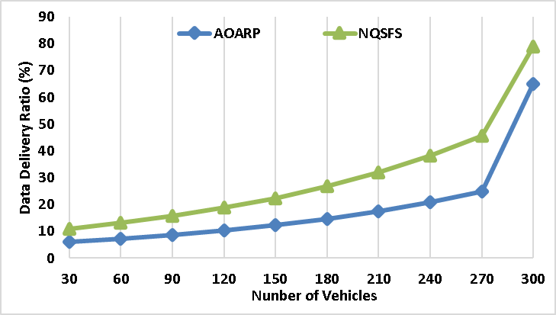
Figure 2. Performance of Packet delivery ratio
The existing methods of FFROR, QACOM, and ESORP has packet delivery rate of 76%, 79% and 85 respectively whereas the proposed method MTAGA achieved highest delivery ratio of 92%. This shows the transmission performance of the proposed method.
4.2 Throughout: It refers to the rate of speed of successful transmission of the data packets form origin to target. Figure 3 shows the throughput calculation
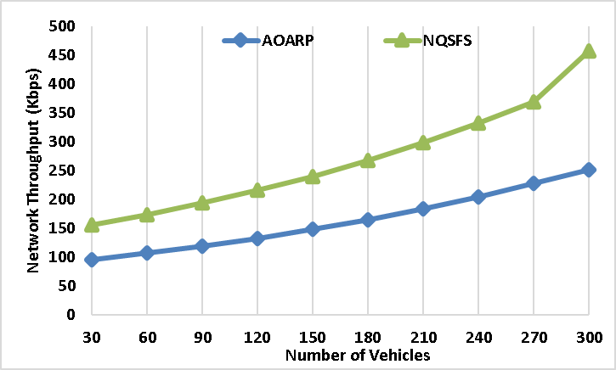
Figure 3. Performance of throughput
Due to the fast and efficient routing algorithm, the proposed MTAGA method has achieved the 496 kbps whereas the existing technique of FFROR, QACOM, and ESORP of 256 kbps, 325 kbps, and 356 kbps correspondingly. Hence this indicates that the data packets reached destination efficiently.
4.3 Routing Overhead: It is the additional packets produced by the routing protocol to manage the network traffic in the system. The figure 4 shows the performance of routing overhead.
The proposed ICHCM method has routing packets of 254 packets which is low when compared to the existing technique of AOARP – 652 packets, BOLSR - 525 packets, and NQSFS - 496 packets. This confirms that the proposed ICHCM method has high efficient management network.
4.4 Energy Efficiency: It is refers the amount of energy utilized by the data per unit for transmitting the data from source to destination. The figure 5 shows the energy efficiency.
The presence of the efficient routing protocol, reduce the power consumption in data transmission. Hence the proposed ICHCM system has high energy efficiency of 458 joules whereas the existing techniques have low energy efficiency. This indicates the more optimized energy optimization method.
4.5 Energy consumption: It refers the total amount of energy consumed by network devices during data transmission. Figure 6 shows the energy consumption.
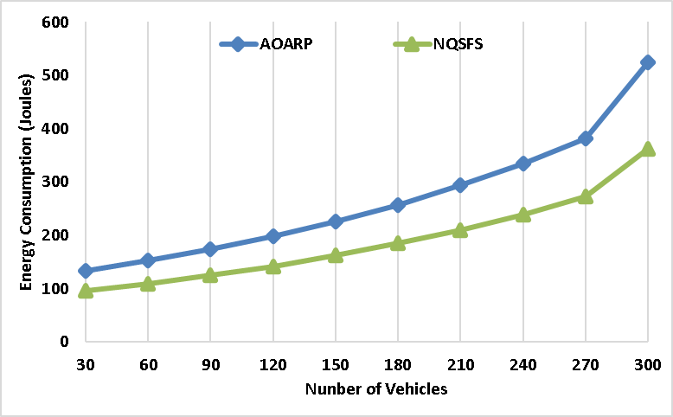
Figure 6 performance of energy consumption
The proposed ICHCM method reduces energy usage compared to existing methods, AOARP exhibits the highest energy consumption at 524 joules, BOLSR and NQSFS has 412 joules and 362 joules, respectively. This reduction helps prolong network device battery life. From this analysis it is proven that this Proposed ICHCM achieves better performance in terms of efficiency and delivery ratio and its results are described in table 3.

6 Conclusion
The issues which are mainly concentrated in the mobile communication are high data conjunction and power utilization at the time of data transmission.
7 References
[1]. M.M. Hamdi, "Data dissemination in VANETs using clustering and probabilistic forwarding based on adaptive
[2]. H.F. Mahdi, M.S. M.M. Hamdi, "Performance evaluation for vehicular ad-hoc networks based routing protocols
[3]. S. Alani, A. Baseel, M.M. Rashid, "A hybrid technique for single-source shortest path-based on
[4]. Nafea. "Enhancing Student's Performance Classification." Iraqi
[5]. Aliesawi, Rashid. "Iterative multipacket detection with FDE based MAC protocol in vehicular ad hoc networks." Periodicals of
[6]. Mohammed, Noor Sabah, et al. "Secure Smart Contract Based on Blockchain to Prev
[7]. Nafea, Ahmed Adil, Nazlia Omar, and Zohaa Mubarak Al-qfail. "
[8]. H. Mahdi, B. Al-Bander, M. H. Alwan, M. S. Abood, and M. M. Hamdi, "Vehicular Networks Performance Evaluation Based on Downlink Sche

