AOMDV routing protocol based Crow Search Algorithm to Improve efficiency in VANETs
Nujod Alkhazraji
Department of Computer Technical Engineering ,Imam Al-Kadhum College (IKC) ,Al-Diwaniyah, Iraq; nujodalkhazraji@gmail.com .
F.H. Abbas
Medical Laboratories Techniques Department,Al-Mustaqbal University,Hillah, Iraq; fatimahashim109@gmail.com .
Mohammed Ihsan
Department of Computer Technical Engineering, College of Technical Engineering, The Islamic University, Najaf, Iraq; moh.mtech89@iunajaf.edu.iq .

Abstract:
Vehicular ad-hoc network (VANET) considered as one of the promising technologies which occupy the maximum of the applications of an intelligent transmission system (ITS). The communication modes of vehicles are inter-vehicular communication and infrastructure based communication. Due to high speed vehicles certain drawbacks occurred in the network such as high delay, high power utilization and routing overhead. To attend reliable communication it becomes very essential to improvise the routing and path selection process among the vehicles in the network. For that purpose in this article ad-hoc on demand multipath distance vector routing protocol (AOMDV) is constructed and to obtain optimal path among the vehicles crow search algorithm (ARCSAV) is incorporated in the network.

Index Terms: Vehicular ad-hoc network (VANET), ad-hoc on demand multipath distance vector routing protocol
1 Introduction:
Rapid wireless technology is used nowadays to enhance the environment infrastructures in terms of safety, infotainment and effective transportation [1-3]. VANETs are a kind of route network which is mainly utilized to improve the travel safety and driving experience of the people [4-8]. The vehicles which are present in the networks are the combination of on board units (OBU) and roadside units (RSU) [9-11]. An OBU is constructed to perform communication among one device to another which is present in the coverage area of the RSU [12-16]. The core model which is present for the data transmission among the vehicles are dedicated short range communication system (DSRC) it performs both vehicle to vehicle data transmission and vehicle to infrastructure based data transmission [17-21]. The RSU manages the traffic flow and safety of each vehicle which is present in its coverage area [22-25].
The major characteristics of vehicles which are present in vehicular communication are high speed, rapid data transmission, unpredictable mobility changes which reduces the communication quality and that affects the vehicle lifetime [26-30]. In order to overcome such kinds of drawbacks in the network in earlier days effective routing models and optimization algorithms are developed [31-35] but still the vehicular communication consists of certain drawbacks and this area is under open research [36-40]. To overcome such drawbacks in the densely populated vehicular network in this article an effective routing protocol and crow search algorithm is introduced mainly to improve the efficiency of vehicular communication. The contribution of the article is described below.
2. Related Works:
In [41], author Mohammed introduced a novel framework utilizing ABOGA and K-means algorithms for efficient VANET congestion management ensuring a stable and high-performance network also with high power consumption. In [42], author Sulaiman described WSN applications demand improved security and coverage and “Hybrid Security in AOMDV Routing Protocol with Improved Salp Swarm Algorithm” (HSA-ISSA) excels in stability and key metrics by combining defense wiyth high delay. In [43], Majeed Dhafer developed a subset of MANETs which offer safety applications but face challenges including the Sybil attack where malicious vehicles assume multiple identities and threatening network integrity, the drawback here is high overhead. In [14], Mohammed Salah introduced an enhanced Best-CQI scheduling algorithm that surpassing other algorithms in throughput under Line-of-Sight conditions for Vehicular Long Term Evolution (LTE-V) at 2.6 GHz, the drawback is high delay. In [45], author Atheer Basee The suggested Ant Colony Optimization (ACO) approach for the single-source shortest path (SSSP) issue achieves a 13.5% average decrease in time complexity, as tested in a parking system, but the negative is substantial overhead.
In [46], Hussain enhance protection and comfort through wireless networks in VANET by evaluating AODV, DSDV and DSR protocols. DSR achieves higher throughput, while DSDV excels in end-to-end delay. In author [47], Ahmed Shamil assesses the impact of MANET on routing protocols specifically on AODV and GPSR demonstrates superior efficiency with reduced output and lower E2E delay compared to AODV. In [48], Salah A. Aliesawi expalined ROAONC, a clustering technique using Remora optimization algorithm for Vehicular Ad Hoc Networks (VANETs) showing improved performance over other clustering protocols with high power consumption. In [49] Lukman Audah presents AJ-MOFA an enhanced firefly algorithm integrated with CFM for efficient VANET data dissemination incorporating clustering and probabilistic forwarding the outperforms benchmarks in PDR, E2E-delay, and dropped packets. In [50], Meriem Houmer explained VANETs by enhancing traffic safety and real-time data exchange, the proposed ANFC-QGSOR protocol outperforms existing technologies in simulations using the Network Simulator (NS3 tool) with high delay. In [51], Chen Chen addresses the TLBGR protocol data acquisition challenges in Vehicular Ad-hoc Networks (VANETs) by improving data delivery rates in urban traffic trunk lines and overcoming congestion and local optimum problems with the drawback of high overhead. In [52], author Vivek Sethi expressed the destination-aware context-based routing scheme optimizes cluster formation and leader election by utilizing link numbers, motor mobility and connectivity for improved packet delivery in urban VANETs. In [53], Mohammad A. R. Abdeen enhances the D-LAR protocol energy efficiency and location support for moving vehicles in a vehicle-to-vehicle communication system, resulting in improved security and reduced collision attack detection delay. The earlier research issues are discussed in the table 1 which includes its merits and demerits.

3. Proposed ARCSAV Model:
This ARCSAV model is primarily intended to improve the routing quality and efficiency effectiveness of the vehicular network. The core modules of the ARCSAV are to improve the routing model which consists of neighbor discovery and path planning. Secondly the crow search algorithm is developed to find an optimal path among the high speed vehicles. The work flow of the ARCSAV is described in figure 1.

3.1 Improved Routing Model:
The route-finding procedure is the cornerstone of the AOMDV approach. Route Request (RREQ) packets are sent in torrential amounts from the source to the destination, which is uniquely recognized by its identification. The relay node may discard the replicated RREQ because an intermediary node broadcasts the two RREQ and Route Reply (RREP) messages through the initiator node until it has a valid and clean connection to the destination. Following the backward path that relay node constructed during the discovery phase, the first RREQ message rebroadcasts an RREP control message upon reaching its destination. Repetitive RREQ packets that the destination receives are not kept. The limitation of AODV is that it produces a one method to the end point. A new route has to be discovered if current one fails. However, the AOMDV protocol is made to allow for the creation of many pathways to the target utilizing a single path discovery method. AOMDV makes use of duplicate RREQ messages to open up a wide range of pathways inside the source and intermediary nodes. The destination node responds with an RREP message to each RREQ message received from a different hop. AOMDV employs HELLO messages to identify damaged connections.
4.1.1. Neighbor discovery
Finding the right nearby nodes is the main goal of the neighbor discovery process in order to build a better network. With the use of network ID, the sensor node first begins broadcasting HELLO packets. The specific node changes its routing table with the ID number, distance, and Received Signal Strength Indication (RSSI) as soon as it receives a HELLO packet. Furthermore, the nodes in the place will
4.1.2. Path planner
To optimize coverage in a wireless sensor network, an agent that flows from the base station to the uncovered zone must be installed. Here, our focus is on agent node path planning with energy awareness. Static nodes, for instance, have limited power. If they keep sending packets through fixed intermediary
3.2 Crow Search Optimization Process: Modern swarm intelligence meta-heuristic optimization algorithms like the Crow Search (CSA) algorithm.This optimization system conceals food by utilizing the crow's social behavior, memory, and communication abilities. It is composed of four essential ideas:
1. Crows are gregarious;
2. They learn to remember where their food sources are hidden;
3.3 Effective Mobility Model
Among the popular mobility models for VANETs, U-AODV chooses the OpenStreetMap mobility model. Numerous vertical and horizontal streets exist in the simulation area of this model, and mobile nodes are moving inside the street lanes. Every street has many lanes in both directions, and at intersections, the vertical and horizontal streets may cross one another. At a junction, the mobile nodes are expected to
Case One: when two vehicles are moving apart from one another. In this instance, the linkages can fail quickly.
Case Two: In this instance, there are three possible outcomes when the vehicles are moving in the same direction:
1. Because the vehicles are going inside the coverage range at comparable speeds, the links between them will remain active for a significant period of time.
2. The speeds at which the vehicles are moving. When the first car—the speedier one—crosses the coverage distance in this scenario, the link will break. When the distance between the vehicles is zero, the closest distance between the source and receiver is displayed.
Case Three: There are two possible outcomes in this scenario when the vehicles are moving perpendicularly:
4. Simulation Environment:
The construction of the vehicular network with efficient routing model and optimization model is carried out in the software ns2 which is the incorporation of c++ and python. The numbers of vehicles which are considered for this simulation are 500 vehicles. The parameters which are taken to analyses the performance of the vehicles are packet delivery ratio, network throughput, energy efficiency, average delay and routing overhead. The calculated results of compared with the other methods like GRPT [51], CSDA [52] and DLRS [53] and as well the input parameters which are present in this simulation experimentation are given in table 2.
4.1 Packet Delivery Ratio: It is the calculation of the amount of data packets which are transmitted from the source and it is successfully received by the destination. The optimization models which are present here is to improve the delivery ratio of the vehicles which are travelling at high speed with random mobility. In figure 2 the delivery ratio calculation of the ARCSAV is described and it is compared with the earlier methodology like GRPT, CSDA and DLRS. Using the effective routing model and optimization process the delivery ratio of the ARCSAV is around 8% higher than the other methods.
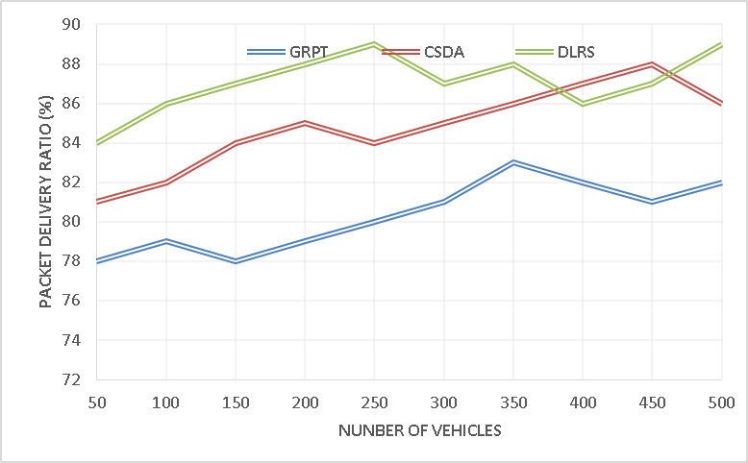
Figure 2 - Packet Delivery Ratio
4.2 Network Throughput: It is the calculation of the amount of data packets which is generated successfully by the source and which becomes ready for transmission. In figure 3 the throughput calculation of the ARCSAV is constructed and it is compared with the other methods like GRPT, CSDA and DLRS. With the presence of this crow search optimization process the transmission is carried out in an efficient manner and that leads to maximize the throughput generation of the vehicles. From the result it is proven that the obtained throughput level of the ARCSAV is around 100 kbps higher than the other methods.
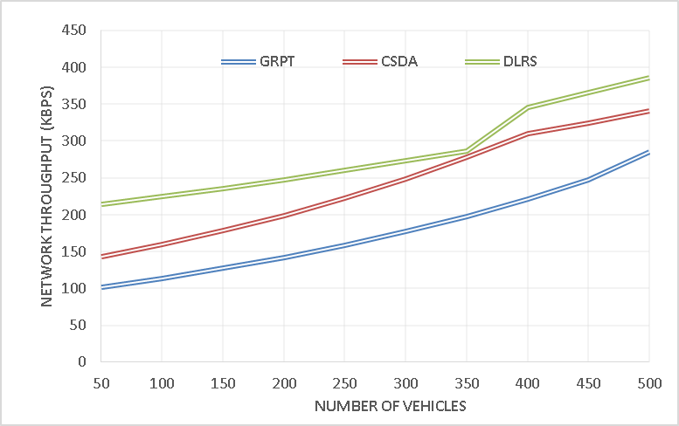
Figure 3 - Network Throughput
4.3 Energy Efficiency: It is the calculation of the remaining energy which is maintained in the network at the end of the transmission. In order to achieve reliable communication among the high speed vehicles maximizing the energy efficiency is very essential. In figure 4 energy efficiency calculation is performed among the ARCSAV and the other methods like GRPT, CSDA and DLRS. The intelligent routing model and the optimization model is combined here to increase the efficiency of the ARCSAV and as the result The generated efficiency of the ARCSAV is around 200 joules higher than the other methods.
4.4 Average Delay: It is the calculation of delay time from which the data gets transmitted from the source and which it is received from the destination. Increased delay directly affects the communication quality of the vehicular network so that it is very essential to minimize the delay occurrence and the network. In figure 5 the delay calculation of the ARCSAV is described and it is compared with the earlier methods like GRPT, CSDA and DLRS. Utilizing the efficient routing process the data transmission among the vehicles are normalized in the ARCSAV and the generated delay of this model is around 30 ms lower than the other methods.
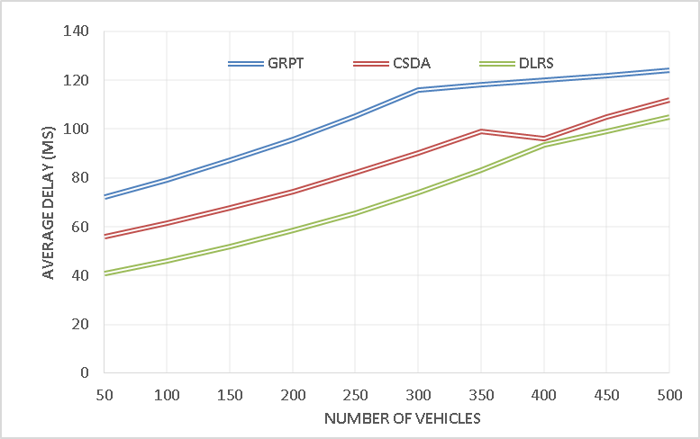
Figure 5 - Average Delay
4.5 Routing Overhead: This is the calculation of data forwarded ratio at the time of high speed data transmission among the vehicles. Reducing the routing overhead of the vehicles is the primary concentration of this proposed model. In figure 6 the overhead calculation of the proposed model is described and it is compatible the earlier methodology like GRPT, CSDA and DLRS. Using the idea of effective routing and optimization, the overhead occurrences of the ARCSAV is measured which is around 300 packets lower than the other works.
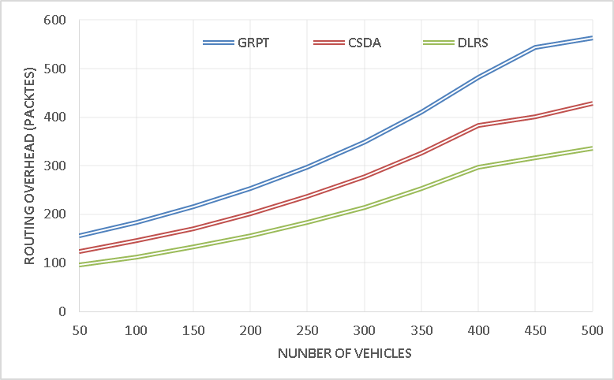
Figure 6 - Routing Overhead
5. Conclusion:
The main aim of this proposed ARCSAV is to reduce the delay and routing overhead of the devices which are present in the network. For that purpose effective routing and optimal path selection is concentrated. AOMDV protocol is used for routing process so that multipath communication is effectively handled it reduces the delay and power utilization of the devices. To find an optimal path for data transmission between any two devices the crow search algorithm is utilized and through that routing overhead among the devices is reduced and that increases the communication quality of devices.
6. References
- H. S. Mansour, M. H. Mutar, I. A. Aziz, S. A. Mostafa, H. Mahdin, A. H. Abbas, M. H. Hassan, N. F. Abdulsattar, and M. A. Jubair, "Cross-Layer and Energy-Aware AODV
- A. H. Abbas, H. Mansour, and A. Al-Fatlawi, "Self-Adaptive Efficient Dynamic Multi-Hop Clustering (SA-EDMC) Approach for Improving VANET’s Performance,"
- M. A. Jubair, S. A. Mostafa, D. A. Zebari, H. M. Hariz, N. F. Abdulsattar, M. H. Hassan, A. H. Abbas, F. H. Abbas, A. Alasiry, and M. Turki-Hadj, "A QoS Aware Cluster Head Selection
- M. I. Habelalmateen, A. J. Ahmed, A. H. Abbas, and S. A. Rashid, "TACRP: Traffic-Aware Clustering-Based Routing Protocol for
- A. H. Abbas, A. J. Ahmed, S. A. Rashid, M. A. Jubair, N. F. Abdulsattar, H. S. Mansour, and M. I. Habelalmateen, "Hybrid ANT Based Continuous Cuckoo Search Optimization Algorithm
- M. K. Hasan, M. M. Ahmed, N. F. Wani, A. H. Abbas, L. M. Alkwai, S. Islam, A. K. M. A. Habib, and R. Hassan, "Dynamic load modeling for bulk load-using
- A. H. Abbas, A. J. Ahmed, and S. A. Rashid, "A Cross-Layer Approach MAC/NET with Updated-GA (MNUG-CLA)-Based Routing Protocol for VANET Network,"
- S. A. Rashid, M. I. Habelalmateen, A. J. Ahmed, A. H. Abbas, M. A. Jubair, M. H. Hassan, A. Abdulhadi, S. Hammed, and L. Audah, "Congestion Aware Genetic
- A. H. Abbas, A. J. Ahmed, S. A. Rashid, N. F. Abdulsattar, M. H. Hassan, M. A. Jubair, and M. I. Habelalmateen, "Predictive Hybrid Routing with Multi Objective
- M. A. Jubair, M. H. Hassan, S. A. Mostafa, H. Mahdin, A. Mustapha, L. H. Audah, F. S. Shaqwi, and A. H. Abbas, "Competitive analysis of single and multi-path
- A. H. Abbas, N. F. Abdulsattar, H. S. Mansour, M. H. Mutar, M. I. Habelalmateen, L. Audah, N. A. M. Alduais, and A. Mohammed, "A New Hybrid
- M. I. Habelalmateen, A. H. Abbas, L. Audah, and N. A. M. Alduais, "Dynamic multiagent method to avoid duplicated information at intersections in VANETs,"
- S. A. Rashid, A. J. Ahmed, M. H. Hassan, A. H. Abbas, M. I. Habelalmateen, M. A. Jubair, L. Audah, and W. Al-Azzawi, "Ranking Based Routing
- A. J. Ahmed, A. H. Abbas, S. A. Rashid, M. A. Jubair, M. H. Hassan, A. Abdulhadi, N. F. Abdulsattar, and M. I. Habelalmateen, "Congestion Aware

