Intelligent Optimization through Elephant Herding with Dynamic Route Reconfiguration in MANETs
Nujod Alkhazraji
Department of Computer Technical Engineering ,Imam Al-Kadhum College (IKC) ,Al-Diwaniyah, Iraq; nujodalkhazraji@gmail.com .
Zahraa Hameed Jaber
National University of Science and Technology, Dhi Qar, Iraq; zahraa.h.jaber@nust.edu.iq
Hussein M. H.
Department of Computer Techniques Engineering , Mazaya University College, DhiQar, Iraq; huhraiz22@gmail.com .
F.H. Abbas
Medical Laboratories Techniques Department,Al-Mustaqbal University,Hillah, Iraq; fatimahashim109@gmail.com .
Mohammed Ihsan
Department of Computer Technical Engineering, College of Technical Engineering, The Islamic University, Najaf, Iraq; moh.mtech89@iunajaf.edu.iq .

Abstract
A Mobile Adhoc Network (MANETs) is one among the unique technology which is used to handle the functional characteristics of the network model like dynamic topology and infrastructure with the absence of centralized authority and as well it consists of limited power resources with the variable nature of data transmission based network. Due to its dynamic nature certain drawbacks occurred in the network which needed to get concentrated to achieve better performance among the mobile devices. The issues like high power consumption, data loss and delay occur in the mobile devices which directly affect the performance of the network. To overcome these drawbacks in this article intelligent optimization through elephant herding with the dynamic route reconfiguration model (IOEHDR) is developed. In this model the overall power utilization of the network is minimized with the presence of optimal path selection process and the routing overhead
1 Introduction
A Mobile Ad hoc Network (MANETs) is the most important technology which is concentrated by maximum of the industrial [1] and academic research [2] and to improve the efficiency in the packet transmission and reduces the loss of packets with lower power utilization of the vehicles several technology is developed in recent times [3]. With this process, this technology still consists of certain other challenges like path disconnections [4] from all the nodes and the time of dynamic modeling [5] and high power utilization among the vehicles. To maintain the standard of communication a development of optimal path selection model among the vehicles [6] which is able to monitor the dynamic path based data transmission becomes highly essential [7].
On the other side of communication in the routing part providing a single or multiple routing tables can help to maintain the broadcasting messages which are able to provide effective network topology which is in the predefined manner to monitor the network in an easy way [8]. For that lots of routing models are developed in the recent times which are able to provide dynamic multipath routing in an effective pathway [9]. But still due to improper optimization for path selection, the quality of service of the mobile devices is still moderate in the changing environment and still it needs improvement and the research area is open [10]. In order to overcome these drawbacks in this article intelligent optimization with dynamic route reconfiguration is concentrated in the mobile network. The major contribution of the article is described as follows.
2 Related Works
In [11], author S Hashempour and Amir A. Suratgar presented a distributed nonconvex optimization algorithm for boosting energy efficiency in MANETs. It addresses flaws in existing algorithms and demonstrates enhanced convergence through dynamic systems in MATLAB simulations but the disadvantage is high delay. In [12], Valanto Alappatt and P M Joe Prathap described the BPSO method for extending the lifetime of MANET, achieving promising results in NS2 simulations for throughput, PDR and residual energy compared to other methods but the disadvantages are high packet loss. In [13] author K. Suthendran explained MANETs, lacking infrastructure and face challenges with limited hard-to-recharge batteries which is causing short transmission ranges and disrupted network lifetimes due to power failures, these issues has been addressed by conserving energy, optimizing network lifetime and improving overall performance. In [14], author Li Jiayu and Li Hai adapting to high node velocity in ad hoc networks is crucial. The paper proposes using the exponentially weighted moving average (EWMA) of the topology instability metric (TIM) to dynamically adjust topology update intervals in proactive routing protocols, effectively reducing unnecessary overhead in stable scenarios, as demonstrated in simulations but the disadvantages are high delay.
In [15], author explained MANET, unmanned vehicles transmit real-time multimedia data to a central node and proposed centralized TDMA slot and power scheduling schemes to maximize energy efficiency through a non-concave ratio optimization problem, demonstrating effective algorithms in numerical results and the disadvantage is high power consumption. In [16] author Qiaoyu Wang and Haixia Cui expressed a wireless networks varying antenna numbers among users affect transmit rates and powers, influencing QoE and performance. The paper suggests a utility function-based approach to optimize total system throughput and energy efficiency in MIMO-enabled MANETs, with the algorithm demonstrating global convergence and quick adaptation to changes in antenna array size and user density in simulations and the disadvantage is high delay. In [17], author S. Sindhuja demonstarted a wireless infrastructure-less service, faces challenges like load imbalance and communication delays. The proposed Extensible Particle Swarm Optimization technique aims to improve reliability, network lifetime, and efficiency by optimizing paths and selecting efficient node sets. Author Kouichi Genda suggested mobile ad hoc network topology control in [18], which uses less energy than previous approaches by optimizing topology for each update interval while taking surrounding nodes' dynamic locations. The approach is practical, requiring only a few milliseconds for optimization but the disadvantages are high delay. In [19] author Yan Li Presented MANet, a compact and efficient end-to-end network for light field depth estimation. It outperforms the leading method, Epinet, being about three times smaller and faster, as demonstrated on HCI, CVIA-HCI, and EPFL Lytro light field datasets but the drawback is high overhead.
In [20], author Gi Tae Kim efficiently managing network resources and ensuring high QoS are crucial in both military and civilian MANETs. This paper adapts wired network traffic engineering mechanisms to CSMA MANETs, demonstrating superior performance with innovative approaches like interference-aware multi-path selection and robust rate adaptation leveraging P4-based network programmability and the drawback is high power consumption. In [21], author optimized data transmission in a MANETs selecting the right routing protocol is crucial. This study adjusted parameters in the AODV protocol, resulting in improved performance compared to default AODV and Optimized Link State Routing protocols. In [22], author Valmik Tilwari established communication infrastructure in disaster-affected or remote areas with intermittent cellular services, deploying an end-to-end connection over MANETs is efficient. The MRLAM routing scheme optimizes routes with energy-efficient nodes, significantly improving overall network performance. In [23], Aslinda Hassan author developed AFB-GPSR protocol in MANETs dynamically adjusts beacon intervals using fuzzy logic, reducing routing overhead and enhancing performance metrics. Simulation results show a 14% improvement in packet-delivery ratio and a 35% reduction in routing cost compared to traditional protocols and the disadvantages are high delay. The earlier design issues are discussed in the table 1.
3. Proposed IOEHDR Approach
This IOEHDR model is designed to provide an optimal path selection process among the mobile devices and to produce an effective dynamic path selection model among the devices. The core modules of this IOEHDR include two categories: the dynamic route reconfiguration process and elephant herding optimization model. The work flow of the IOEHDR is illustrated in the figure 1.

3.1 Dynamic Route Reconfiguration Process:
The routing conduct of MANET is mostly impacted by the foraging activity of the ants. The ants have an ability to select the most efficient route to rapidly reach the food source. They perform this by emitting a chemical substance called Pheromone along the road, which helps other ants in following and tracing this path. If all ants continuously choose that path, then the fundamental feature of pheromone diffusion/attenuation is that the surviving ants must refill the evaporated pheromone. Along this manner, the ants endeavour to maintain the pheromone concentration consistently, even when there are modifications or disruptions along the route. The DRP is expected to have a high population density due to all nodes using this route, resulting in congestion and traffic jams. The nodes in the congestion CFL assume responsibility for building a SFL to alleviate congestion. They conduct this by selecting nodes to participate in the route construction process using an opinion mining model. This load balancing system effectively alleviates the DRP from significant traffic congestion. The primary routing path experiences a Dynamic Route Reconfiguration (DR2) due to various factors such as load balancing, changes in the location of the destination or intermediate nodes, link failure, changes in network topology, bandwidth disruption, and unavailability of intermediate nodes due to handoff, selfish behaviour, malfunction, greed, and malicious actions.
3.2 Elephant Herding Optimization:
Elephant herding optimization (EHO) is a business BIA approach that mimics an elephant herd's behaviour. When a matriarch is present, different groups of female elephants and juvenile males live side by side. Adult male elephants are usually alone, although they communicate with one another by sending low-frequency vibrations. The behaviour of elephants in clans is determined by two operators. Elephant positions within a clan are tracked and updated by the Clan Updating Operator. The separation operator is employed to simulate the dispersal of adult male elephants from clans, contributing to population variety in subsequent search stages.
The EHO may be succinctly summarized into four phases.
- The categorization of the elephant population into clans.
- In each herd, the matriarch is the oldest cow and the most powerful elephant.
- Elephants have two operators that are used to customize their herding behaviour. The matriarch, the most physically fit elephant in the clan, has the power to influence the changes made to each elephant's position by the clan updating operator. The location of the matriarch is modified in accordance with data collected from each elephant within the clan.
4. Simulation Results:
The simulation experiments was performed using NS2 simulator. The performance of the proposed IOEHDR method is evaluated using the parameters like Data success Rate (%), Throughput (kbps), Routing Overhead (packets), Data loss rate (%) and Average Delay (ms). The calculated results are compared with the earlier methods like OMRPA [21], MRLMP [22] and AFBGR [23] and as well the input parameters which are present in this simulation experimentation are given in table 2.
4.1 Data Success Rate: It is defined as the ratio of successful transmitted data packets to the total number of data packets used in the network. The figure 2 shows the performance of the data success rate calculation.
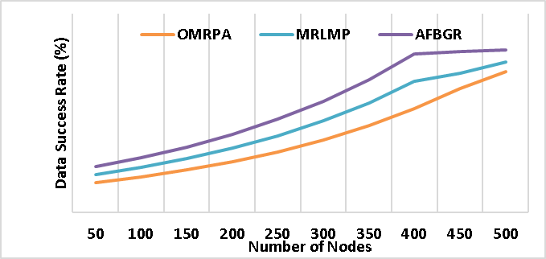
Figure 2: Performance of Data success ratio calculation
Form figure 2, the proposed IOEHDR method attains the maximum delivery ratio of 95% when compared to the other routing methods of OMRPA has 71%, MRLMP has 76% and AFBG has 82%. The higher data transmission rate shows the network reliability and effectiveness in data transmission.
4.2 Throughput: It is defines as the rate of speed at which the data packets travel from source to destination. The figure 3 shows the performance of throughput.
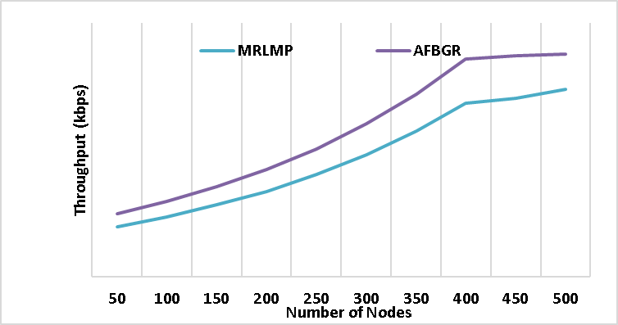
Figure 3: performance of throughput calculation
From the figure 3, the proposed IOEHDR method achieved the 521kbps which higher than the existing techniques. This shows the faster data transmission. This confirms that the proposed technique can handle more data transmission efficiently.
4.3 Routing overhead: It is defined as the amount of data control packets produced by the protocol to maintain additional network traffic among the devices. The figure 4 shows the performance of routing overhead calculation.
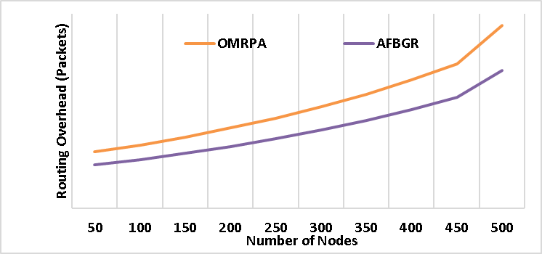
Figure 4. Performance of routing overhead calculation
In terms of routing overhead, the proposed IOEHDR method achieved minimum value of 254 packets when compared to other existing technique like OMRPA has 658 packets, MRLMP has 574 packets, and AFBGR has 496 packets. This shows that the proposed method can manage additional network path with lower packets.
4.4 Data Loss Rate: It is the ratio of failed data packets to the number of data packets used for the transmission in the network. The figure 2 shows the performance of the data loss rate calculation.
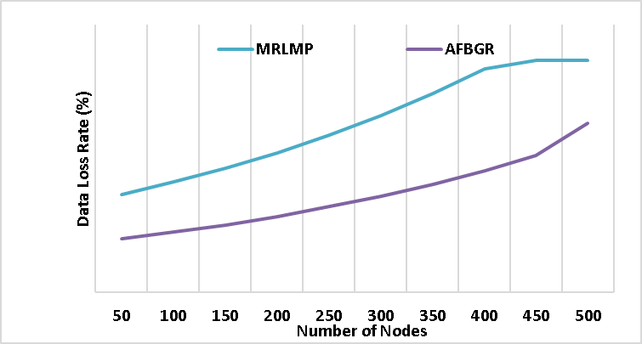
Figure 5. Performance of data loss rate
Form figure 5, the proposed IOEHDR method demonstrates the lowest data loss rate of 15% when compared to the existing techniques which showing its effectiveness in reducing data loss and enhance the data transmission effectively.
4.5 Average Delay: It is the average time used by a data packet to travel from source to destination. Figure 6 shows the performance of average delay.
The proposed IOEHDR method exhibits the minimum average delay of 123 ms when compared to the previous techniques OMRPA at 186 ms, MRLMP at 156 ms, and AFBGR at 141 which provide efficient data delivery. The overall results analysis is given in table 3.

5 Conclusion
This article is mainly developed to optimize the power utilization and reduce the routing overhead of the mobile devices. After analyzing various research articles and its drawbacks this proposed model is designed which is the combination of intelligent optimization through elephant herding algorithm and effective dynamic route reconfiguration process. Experimentation of these techniques is conducted in the software
6 References
[1]. H. Mahdi, B. Al-Bander, M. H. Alwan, M. S. Abood, and M. M. Hamdi, "Vehicular Networks Performance Evaluation Based on Downlink Scheduling Algorithms for High-Speed Long Term Evolution--Vehicle," International Journal of
[2]. M. M. Hamdi, L. Audah, S. A. Rashid, M. S. Abood, A. S. Mustafa, and M. S. Noori, "A hybrid Algorithms to Improve the Quality of Service in Vehicular Ad-Hoc Networks: A Framework
[3]. S. A. Rashid, M. M. Hamdi, and S. Alani, "An overview on quality of service and data dissemination in VANETs," in 2020 International Congress on
[4]. A. S. Abdalkafor and S. A. Aliesawi, "Data aggregation techniques in wireless sensors networks (WSNs): Taxonomy and an accurate literature survey
[5]. Mohammed, Noor Sabah, et al. "Secure Smart Contract Based on Blockchain to Prevent the Non-Repudiation
[6]. S. Aliesawi, C. C. Tsimenidis, B. S. Sharif, and M. Johnston, "Efficient channel estimation for chip multiuser detection on underwater acoustic channels," in 2010 7th International
[7]. Nafea, Ahmed Adil, Nazlia Omar, and Zohaa Mubarak Al-qfail. "Artificial Neural Network and Latent
[8]. M.M. Hamdi, L. Audah, and S.A. Rashid, "Data dissemination in VANETs using clustering and probabilistic forwarding
[9]. H.F. Mahdi, M.S. Abood, and M.M. Hamdi, "Performance evaluation for vehicular ad-hoc networks based routing protocols
[10]. S. Alani, A. Baseel, M.M. Hamdi, and S.A. Rashid, "A hybrid technique for single-source shortest path-based on A* algorithm and ant colony
[11]. S Hashempour and Amir A. Suratgar, “Distributed Nonconvex Optimization for Energy Efficiency in Mobile Ad Hoc Networks
[12]. Valanto Alappatt and P M Joe Prathap, “A Hybrid Approach Using Ant Colony Optimization and Binary Particle Swarm Optimization (ACO: BPSO) for Energy Efficient Multi-path Routing in MANET,
[13]. K. Anish Pon Yamini and K. Suthendran, “Power Optimized Cross Layer design based Protocol for Performance Enhancement in MANETs”
[14]. Li Jiayu and Li Hai, “Optimization Scheme of Proactive Routing Protocol for High Mobility MANETs”, IEEE 2nd International Conference on Electronics Technology (ICET), 2019, doi: 10.1109/ELTECH.2019.8839577.
[15]. Jae Seang Lee and Yoon-Sik Yoo, “Energy-Efficient TDMA Scheduling for UVS Tactical MANET”

