An Intelligent Network and Communication Model based Ad-hoc On Demand Multipath Distance Vector Routing for VANETs
Mohammed I. Habelalmateen
Department of Computer Technical Engineering, College of Technical Engineering, The Islamic University, Najaf, Iraq; moh.almateen@gmail.com.
Nejood F. Abdulsattar
Department of Computer Technical Engineering ,Imam Al-Kadhum College (IKC) ,Al-Diwaniyah, Iraq;nejodfaisal@gmail.com.
Rizgar Rahman Ghafour
National University of Science and Technology, Dhi Qar, Iraq; rizgar.r.ghafour@nust.edu.iq

Abstract
Vehicular Ad hoc networks, or VANETs, are designed to facilitate intelligent communication between vehicles. However, because of their extremely dynamic topology, there is a significant rise in network congestion and power consumption, which has an immediate impact on the vehicles' communication standards. Consequently, the network's main responsibility is to manage vehicle traffic and power. An intelligent network and communication model based efficient routing system (INCAMV) is created in the vehicular network to address the aforementioned shortcomings in this paper. The effective network model, traffic model, and communication model are the three main components of this INCAMV. The network's efficiency increases when these mechanisms are in place because they decrease data loss and connection failure during communication.
1 Introduction
A recently developed technology utilized for specific purpose intelligent transportation systems (ITS) is called vehicular ad hoc networks (VANETs) [1]. to use a data distribution technique to convert data across locations so that people can live comfortably [2]. The study of the social behavior of the vehicles becomes complex because to their unique characteristics, which include fast speed and fluctuating network concentration. This affects the effectiveness of the data dissemination procedure [3]. At the time of confidential data transmission these fast-moving vehicles create more congestion and data loss that directly affects how well the network performs [4]. These days, it is crucial to enhance both infrastructure-based and intravehicular interaction as vehicle transmission methods [5]. The roadside unit’s great tea helps the vehicles to perform long distance communication by reducing the road accidents and traffic congestion [6]. The frequent broadcast of the beacon messages transmit the network state are emergency information about the vehicles to its adjacent vehicles [7].
Currently the number of vehicles which are present at any particular point is tremendously increased which creates a necessity to improve the communication capability [8]. The current generation vehicles are needed to perform effective multi hop data transmission with rapidly changing topology and it needs to concentrate on certain things like traffic management, quality of service and so on [9]. Reducing device latency and energy use is crucial for enhancing the standard of automotive services [10]. This article builds an intelligent network model with an improved routing strategy to address these types of issues in the automotive context. Its primary feature is outlined below.
2 Related Works
In [11], Vijay Kumar et al., proposed a MAC scheme for VANETs which operates dynamically adjusting the interval between channels and it is based on real-time network traffic. In [12], Omar Chakroun et al., introduced a prioritization strategy on-hop communications across relays for taking into account the distance from the event the source, according to the 802.11p standard. It investigates the differences between message reneging and message queues with modest delays. Mohammed I. Habelalmateen et al. presented an innovative solution for internet congestion in [13]: a protocol for routing networks based on traffic-aware grouping. For internet traffic control, it uses a Traffic Management Unit equipped with RSUs. In [14], Mustafa Maad Hamdi et al., focused on VANETs, integral to ITS. VANETs differ significantly from MANETs. Early incident detection, vital for driver and passenger safety, relies on Traffic Monitoring Centers. In
[15], Sami AbdulJabbar Rashid et al., introduced a novel approach to address challenges in VANETs, integral to ITS. A clustering approach, speed-based movement estimation, link-based multiple paths transportation, and cluster-based VANET creation are all used. In [16], Sami Abduljabbar Rashid et al., provided a survey on VANETs, emphasizing their potential in enhancing road safety and QoS. The survey is structured into a comprehensive review of QoS, an exploration of challenges impacting QoS, and a review of data dissemination along with its various types. In [17], Congestion aware based Routing for VANETs is a revolutionary technology that was presented by Sami Abduljabbar Rashid et al. The approach includes trickle timer-based genetic Q-Learning, predominant path selection, and network and mobility modeling. In [18], Ali Hashim Ab et al., proposed a novel MAC/NET approach using a genetic model in a cross-layer design for VANETs. A revised GA method for optimum path selection was developed, along with a multi-channel MAC architecture and a neighbor detection protocol. Hussain Falih Mahdi et al. used the SUMO, MOVE, and NS-2 simulators in [19] to assess the AODV, DSDV, and DSR routing protocols in VANETs. Across five node densities, throughput, packet delivery ratio, and end-to-end latency are investigated.
To improve routing efficiency and interaction amongst moving vehicles, Koppisetti Giridhar et al. presented a unique protocol in [20]. By using adaptive clustering for CH selection and assembly, coupled with quantum GSO-based routing for route optimization is developed. In [21], Swathi Konduru et al., proposed the Remora Optimization based Clustering model for enhancing node clustering in VANETs. This method leverages the Remora optimization. In [22] Sathish Kaveripakam et al., introduces the Clustering with Optimization algorithm for sensor nodes in UWSN. To figure out how many clusters are best for routing, it uses a distributed routing technique. The table 1 discusses the prior research concerns.

3. Proposed INCAMV Network:
This INCAMV model is designed to achieve high performance with the presence of intelligent routing and communication models. One of the INCAMV's primary components is an autonomous network. environment, traffic model and communication model. Flow of the INCAMV is described in figure 1.
3.1 Network Model
Vehicles on VANETs exchange messages with one another. To communicate information to nearby cars about their position, speed, acceleration, braking status, and other factors, vehicles are outfitted with a variety of technologies, including GPS, radar, and OBU. Messages can be broadcast or multihop sent using V2V and V2I communication. Each vehicle modifies its speed, acceleration, and other parameters according on the signals it receives from neighbors in order to preserve the network's state and behavior. Using the F-RouND architecture, we divide the vehicles into two groups: rogue nodes and honest nodes. While rogue nodes are those that inject fake data before broadcasting it to the network, honest nodes are vehicles that broadcast real messages to nearby vehicles.
3.2 Traffic Model
Our approach of simulating traffic flows on highways and in urban settings is based on the Greenshield traffic flow model idea. The Greenshield model is a straightforward and rather accurate model for forecasting the traffic patterns seen in actual situations. It functions under the presumption that vehicle speed (S) and density (ρ) are inversely associated. The definition of the link between density and speed is as follows:
where C is an amount that depends on how far the car can communicate. Vehicle speed and density in the region are negatively correlated, meaning that as vehicle velocity decreases, so does density. When the density hits zero, the highest possible movement is (Smax), and the location at which the speed reaches zero is the greatest density ($ρ_{max}$). For instance, take a look at the highway scene where vehicles are moving quickly (60–70 mph). In these circumstances, the network's rogue nodes broadcast low-speed values in beacon messages to every car in the area, feigning a traffic collision.
3.3 Communication Model
Through the use of Vehicle-to-Infrastructure (V2I) and Vehicle-to-Vehicle (V2V) interactions, cooperative work offloading amongst the remote cloud, edge servers, and vehicles will be carried out in this research, as seen in Fig. 1. In particular, a vehicle can use a V2I connection to c onnect to the neighboring RSU or a V2V link to connect with the vehicle next to it. Assume that there is no interference between the V2I and V2V communication channels because they are on separate frequency bands. Every vehicle needs a unique V2I and V2V bandwidth assigned by the boundary cloud for communication. For the V2I connection and the V2V link, the system will allocate a total throughput of $k_{c}$ and $λ_{c}$, correspondingly. For the V2I and V2V connections, let Γ0 and λ0 represent the bandwidth minimum allocation units, respectively. $σ^{2}$. is the noise power. The capacity allotment for V2I and V2V lines is completed by the border of the cloud, and the transmission rate of these links may be stated as following.
3.4 Routing Protocol
AOMDV is simply an extension of the Ad-hoc on-demand distance vector routing (AODV) protocol. It makes use of the distance vector routing algorithms and hop-by-hop ideas. The route-finding process used in AODV is also used in AOMDV. The number of pathways that may be identified between these two protocols, however, differs. In AOMDV, several intermittent, loop-free paths may be identified among a pair of sources and destinations, whereas in AODV, there is only one path that can be found. Another difference is that AOMDV only starts the route discovery process if none of the routes it has already discovered work. The protocol can perform fewer route explorations thanks to many paths, which significantly lowers end-to-end latency, routing expenses, and packet loss by 40% and 30%, respectively. The AOMDV uses the four message sets in a similar way as the AODV. Initially, routes between a source and a destination are found using the route request (RREQ) message. In order to do this, AOMDV carries out route acceptance and marketing, tasks that AODV does not carry out. The protocol is kept free from path loops by the route acceptance and marketing. Route replies (RREPs) are second-order communications that are used to reply to the source from the destination or from a node that is intermediate and has an alternate route from the node to the point of origin.
4. Simulation Results:
The implementation of the INCAMC-UAV network is done in the software NS2 simulator and it is compared with the existing technique ECHOR-UAV [20], ROACT-UAV [21], and CDOAU-UAV [22]. In order to analyze the effectiveness of the work that is suggested, its assessment metrics—Packet delivery ratio (%), Throughput (kbps), Energy Efficiency (joules), Average delay (ms), and the routing process overhead (pkts)—are calculated. Table 2 lists the parameters that are used to build the HEMAOM model.

4.1Packet Delivery Ratio: This statistic indicates the proportion of transmitted packets that arrive at their intended location error-free. Achieving optimal efficiency is crucial for enhancing the vehicles' ability to communicate. Figure 2 shows the INCAMC-UAV delivery ratio evaluated in relation to other efforts such as ECHOR-UAV, ROACT-UAV, and CDOAU-UAV. These findings demonstrate that the INCAMC-UAV outperformed the others in terms of delivery rate.
4.2 A form of communication channel's efficiency is the speed at which data may be effectively sent; this increases the volume of data produced at the source at the moment of data transfer. Figure 3 shows the measurement and comparison of INCAMC-UAV's productivity with those of other UAVs, such as ECHOR-UAV, ROACT-UAV, and CDOAU-UAV. When compared with previous works, this demonstrates that the INCAMC-UAV achieves maximum performance.
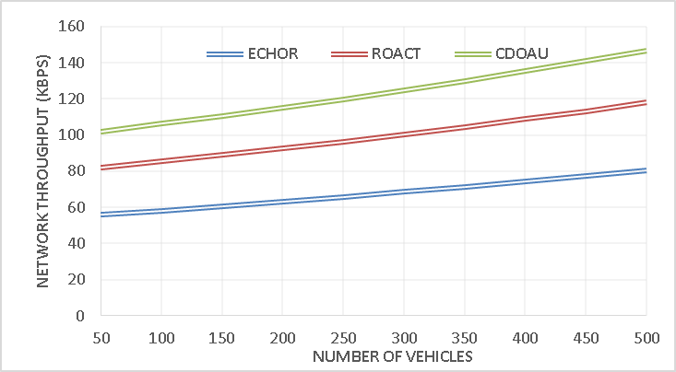
Figure 3 - Throughput
The throughput of the proposed INCAMV method at 282 kbps is greater than the existing technique of ECHOR at 81 kbps, ROACT at 118 kbps, and CDOAU at 147 kbps. This reveals that the proposed INCAMV technique can handle more data which increase the transmission efficiency.
4.3 Energy Efficiency: Energy efficiency is defined as the useful energy output divided by the energy intake throughout the transfer of data. Figure 4 compares the energy efficiency of INCAMC-UAV with previous studies such as ECHOR-UAV, ROACT-UAV, and CDOAU-UAV.
With an energy efficiency of 479 joules, the proposed INCAMV method surpasses the existing technique for ECHOR at 256 joules, ROACT at 296 joules, and CDOAU at 352 joules. This reveals that the proposed INCAMV method uses less energy to transmit data more effectively.
4.4 Average Delay: Data packets travel across networks for a normal amount of time, from their source to their destination. This is known as the average delay. Figure 5 shows the INCAMC-UAV's determined delay in comparison to other studies such as ECHOR-UAV, ROACT-UAV, and CDOAU-UAV.
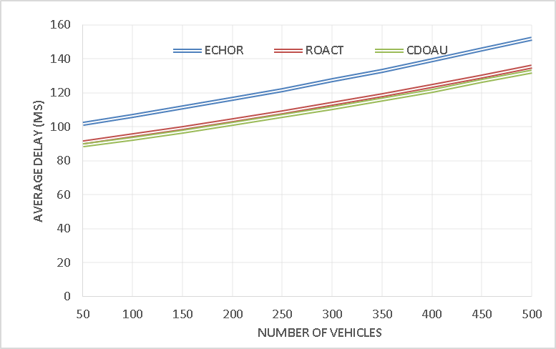
Figure 5 - Average Delay
The Average Delay of the proposed INCAMV approach is 83 ms, which is less than the existing technique for ECHOR at 152 ms, ROACT at 136 ms, and CDOAU at 133 ms. This Proposed INCAMV technique indicate faster data transmission and minimum delay.
4.5 Routing Overhead: The extra data packets needed for routing information in a network are referred to equivalent to routing expense. Figure 6 shows the measurement of INCAMC-UAV's overheard and a comparison with previous research, including ECHOR-UAV, ROACT-UAV, and CDOAU-UAV.
5 Conclusion
A novel intelligent communication model has been developed in this article mainly to increase the vehicle network's dependability and efficiency. At the initial stage in the network model vehicles are properly localized and it allows the adjacent vehicles to transmit and receive the data in an efficient manner. Which is the presence of multipath routing process the data transmission and the communication path fixing process becomes flexible and it reduces during data transfer, the power use and network latency. The actual findings show that in terms of delivery ratio and efficiency, the suggested model outperformed the previous approaches. The future design is about the data aggregation process among the vehicles at the densely populated area.
6 References
- H.F. Mahdi, M.S. Abood, and M.M. Hamdi, "Performance evaluation for vehicular ad-hoc networks based routing protocols," Bulletin
- S. Alani, A. Baseel, M.M. Hamdi, and S.A. Rashid, "A hybrid technique for single-source shortest path-based on A* algorithm and ant colony optimization
- A. S. Abdalkafor and S. A. Aliesawi, "Data aggregation techniques in wireless sensors networks (WSNs): Taxonomy and an accurate literature survey
- Aliesawi, Salah, Mohammed Ahmed, and Ahmed Rashid. "Iterative multipacket detection with FDE based MAC protocol in vehicular ad hoc networks.
- S. Aliesawi, C. C. Tsimenidis, B. S. Sharif, and M. Johnston, "Efficient channel estimation for chip multiuser detection on underwater acoustic channels," in 2010 7th International Symposium on Communication Systems, Netwo
- M. H. Wasmi, S. A. Aliesawi, and W. M. Jasim, "Distributed semi-clustering protocol for large-scale wireless sensor networks,"
- H. Mahdi, B. Al-Bander, M. H. Alwan, M. S. Abood, and M. M. Hamdi, "Vehicular Networks Performance Evaluation Based on Downlink Scheduling Algorithms for High-Speed Long Term Evolution--Vehicle," International Journal
- M. M. Hamdi, L. Audah, S. A. Rashid, M. S. Abood, A. S. Mustafa, and M. S. Noori, "A hybrid Algorithms to Impro
- S. A. Rashid, M. M. Hamdi, and S. Alani, "An overview on quality of service and data dissemination in VANETs," in 2020 International Congress on Human-
- M.M. Hamdi, L. Audah, and S.A. Rashid, "Data dissemination in VANETs using clustering and probabilistic forwarding based on adaptive jumping multi-objective
- V. K. Singh and R. Kumar, "Multichannel MAC scheme to deliver real-time safety packets in dense VANET," Procedia computer science, vol. 143, 2018,
- of message reneging in multi-hop 802.11 p vanets," Procedia Computer Science, vol. 52, 2015, pp. 614-621,doi: 10.1016/j.procs.2015.05.047.
- M. I. Habelalmateen et al., "TACRP: Traffic-Aware Cl: 10.3390/designs6050089.
- M. M. Hamdi et al., "Techniques of Early Incident Det, doi: 10.12720/jcm.15.12.896-904.
- S. A. Rashid et al., "Link stability based multipath routing and effective mobility prediction in cognitive radio enabled vehicular ad hoc network," Bulletin o

