A Novel VANETs System Design with Efficient Clustering and Smart Data Forwarding Process
Nejood F. Abdulsattar
Department of Computer Technical Engineering ,Imam Al-Kadhum College (IKC) ,Al-Diwaniyah, Iraq;nejodfaisal@gmail.com.
Fatima Hashim Abbas
Medical Laboratories Techniques Department,Al-Mustaqbal University,Hillah, Iraq; fatimahashim@mustaqbal-college.edu.iq.

Abstract
In the intelligent communication system, recently a most promising technology is developed to achieve high quality communication is Vehicular Ad hoc networks (VANETs) which are developed to provide vehicle to vehicle based communication. In this technology several challenges or present hence the vehicle travels in a path which changes its topology frequently and as well the data delivery at such high speed creates several drawbacks because of the vehicle's speed over time. At this time it is very essential to reduce the routing overhead occurrences and high power consumption issues among the vehicles in the network to achieve maximum communication reliability and network stability. In order to overcome such drawbacks in the earlier days plastic models are developed ones maximize the link quality and the vehicle functionality. But still it needs improvement when it's applied to densely populated areas with the presence of high speed vehicles.
1 Introduction
Vehicular Ad hoc network (VANETs) is a kind of mobile communication which is carried out in the vehicular infrastructure [1]. To achieve the real time demand in the vehicular technology like user convenience, user safety and efficient transportation vehicle based technology is developed and it places a major role in the intelligent transportation system (ITS) [2]. Due to its general characteristics, several challenges occurred in the deployment and communication phase [3] of vehicles as well as issues occurred because of inefficient network Power utilization [4].
At the time of high speed data transmission more storage space is consumed that leads to frequent data overhead at the time of rapid topological changes in the vehicular network [5]. To properly control the routing overhead occurrences several routing protocols are introduced in the earlier researches [6]. But those protocols consume more resource which creates and imbalance in the data transmission because various control messages utilizes the flooding model that creates more power utilization in the dynamic network environment [7]. To maintain the routing and to reduce the energy consumption in recent times clustering based approaches or introduced to maintain the routing overhead and to discovery among the vehicles during the period of fast data transfer [8]. The clustering process is the combination of grouping the vehicles and selecting the leader for each group of vehicles. The node which maintains high connectivity among the other nodes in its coverage area is selected as a leader to monitor the network [9]. Because of the functionalities of clustering process it is utilized for several kinds of simplification of a routing process but still the routing based clustering model causes collision at the time of high speed data transmission. Still reducing the energy consumption and providing proper road discovery is an open research area in the vehicular communication [10]. For that purpose in the article an efficient clustering model and smart data forwarding process is introduced and the major contribution of the researches listed below.
2 Related Works
In [11], Khalid Diaa et al., proposed the development of an advanced VANET Routing Protocol with Obstacle Prediction Based on. It introduces innovative features such as upgraded predictive routing, prioritizing reliable packet transfer, and incorporating intelligent logic for the selection of intermediate nodes. In [12], For effective routing in VANETs, Mahesh et al. presented a unique Cluster-Based SMART Routing system. These clustering algorithms designed for MANETs, the proposed scheme considers link quality and vehicle behavior for cluster structure in VANETs. In [13], Taking into account many parameters including movement orientation and cluster formation, Bukuroshe Elira et al. developed a destination-aware contextual-based routing system for VANETs. The technique uses motor mobility and link number for head selection and cluster construction. The QoS-Aware Node Selection Algorithm was introduced by Ahmad Mostafa et al. in [14] and is intended for routing protocols in VANETs. It uses a "bridging approach" to forward messages, wherein cars choose which vehicles to hop on to depending on which way they are located (east or west). In [15], maria Claudia surugiu et al., emphasized the development of active safety systems for vehicles, incorporating autonomous technologies such as radar, video cameras, and image processing. This focus is on intelligent solutions across diverse wireless networks in transportation applications.
Dharani Kumari et al. presented the AHP-based Multimetric Geographical Routing Protocol in [16]. This routing protocol uses the Analytical Hierarchical Process to take into account a number of routing attributes. It includes node the density, node status, movement metric, and link lifespan. In [17], Mustafa Maad Hamdi et al., proposed a model for congestion control in VANETs using a combination of K-means and Scatter Search (SS) techniques. K-means is utilized for clustering messages based on various attributes, and SS finds feasible pathways between source and destination nodes. In [18], Abduljabbar Rashid et al., discussed the challenges faced by VANETs a subset of MANETs, with a focus on improving road safety and QoS. It further covers different aspects of data dissemination in VANETs. In [19], MUSTAFA MAAD HAMDI et al., proposed an Effective data distribution in VANETs is achieved by the integration of an adaptive jumping multi-objective firefly algorithm with a grouping and queuing mechanism. This approach combines multi-objective optimization with a meta-heuristic search algorithm.
In [20], A brand-new Java Macaque Algorithm for the best route finding in VANETs was presented by Dinesh Karunanidy et others. It strikes an equilibrium between exploiting and investigating throughout the search phase, drawing inspiration from the genetic and social behavior of Java macaque monkeys. To maximize the transfer of packets time, Yashar Ghaemi et al. presented the Time delay-based Multipath Routing protocol for VANETs in [21]. This algorithm chooses routes with short round-trip times within the threshold and gives alert signals priority. Mumtaz Ali Shah and colleagues presented the Optimal Path Routing Protocol for Warning Messages in [22], which aims to distribute information on highway VANETs that is more efficiently. In order to improve cluster formation, lower transmission overhead, and guarantee communication validity, this makes use of mobility metrics. The merits and demerits of the earlier researches are discussed in table 1.
3 Proposed NVECSD Process:
This NVECSD model is mainly designed to perform effective clustering between vehicles to lower the electricity consumption at the time of high speed data transmission. By the process of vehicles grouping the data is aggregated so that the repeated consumption of power is neglected which leads to increase the efficiency and lifespan of the vehicles. The core modules of the proposed model are improved system design, clustering process and the data forwarding process. The work flow of the NVECSD is described in figure 1.
3.1 System Design
A 100 by 100-dimensional roadway network has been built. There are N number of automobiles in the dimension. Every vehicle has been dynamic and has been traveling at a constant speed of thirty kilometers per hour. Every car has a distinct ID. They also have a location to find out where it is right now; it makes use of a system (like GPS). The RSU's communication range is the same in each lane. The "IEEE 802.11pcompliant radio transceiver" is used for communication between the RSU and the network's vehicles.” Every vehicle usually exchanges its geographic proximity data, which is crucial for traffic control.
3.2 Clustering Process
Clustering algorithms play a crucial role in VANETs, which are employed to classify automobiles with comparable traits or actions together. However, consistency—maintaining trustworthy and stable clusters over time—is a challenge for clustering algorithms in a dynamic context such as VANETs. This consistency has a number of effects on real-world applications and scholarly study. Clusters are crucial logical units in VANETs that provide effective resource management and allocation. For example, clusters are frequently used to provide efficient data distribution, in which data is exchanged inside a particular cluster instead of being disseminated over the network. Nonetheless, incoherent or unstable clusters might result in wasteful resource use and jeopardize VANET applications' overall performance.
3.3 Data Forwarding Process
In the data distribution phase, there are three distinct components, including:
- Route discovery
- Route reply
- Transmission of data.
4. Simulation results:
The effectiveness of the suggested NVECSD-UAV network is compared with the existing technique like IORDM-UAV [20], ITDMP-UAV [21], and OPRPW-UAV [22] and it gets implemented using the NS2 simulator and the vehicles mobility is generated through SUMO mobility generator. The evaluation metrics are Data delivery Ratio (%), Throughput (kbps), Routing overhead (pkts), Energy Efficiency (joules) and Energy consumption (joules). The parameters which are taken to construct the proposed network structure are given in table 2.

4.1Data Delivery Ratio: This is the percentage of successfully delivered data packets over all packets sent. Figure 2 shows the delivery ratio of the suggested NVECSD-UAV and compares it to the methods used by IORDM-UAV, ITDMP-UAV, and OPRPW-UAV.
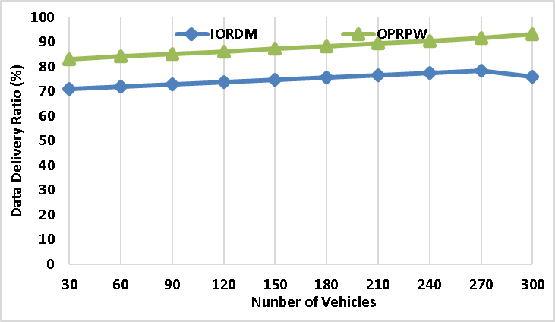
Figure 2 - Data Delivery Rate
The Proposed NVECSD method succeeds the existing technique of IORDM at 76%, ITDMP at 82%, and OPRPW at 93%, with a high Data Delivery Ratio of 99%. This reveals that reliable and flawless data transmission
4.2 Throughput: It describes the speed at which information gets transmitted effectively via a communication link. In figure 3, throughput of proposed NVECSD-UAV is calculated and it is compared with IORDM-UAV, ITDMP-UAV, and OPRPW-UAV methods.
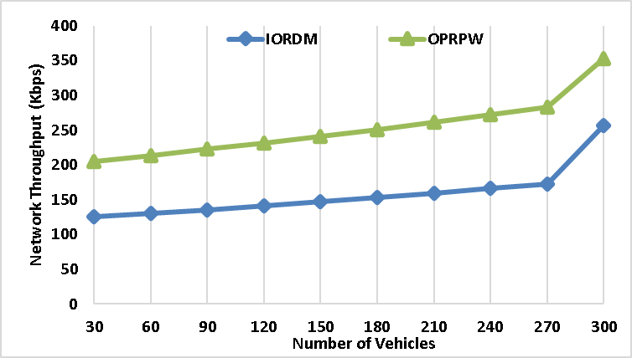
Figure 3 – Network Throughput

In comparison to the existing method of IORDM at 256kbps, ITDMP at 289 kbps, and OPRPW at 352 kbps, the proposed NVECSD obtains a greater throughput value of 469%. This demonstrates that the suggested NVECSD technique can handle larger data transfer volumes.
4.3Routing overhead: This refers to the extra data packets that are sent along with the routing information. Figure 4 shows the routing overhead of the suggested NVECSD-UAV and compares it with the approaches used by IORDM-UAV, ITDMP-UAV, and OPRPW-UAV.
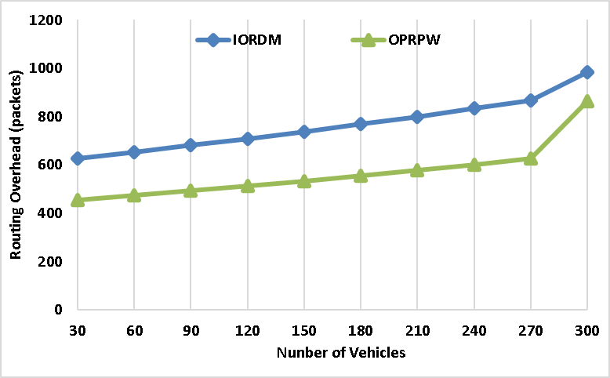
Figure 4 - Routing Overhead
The suggested NVECSD method's routing overhead of 658 packets is less than that of the IORDM methodology, which is currently in use at 985 packets, ITDMP at 902 packets, and OPRPW at 864 packets. Hence the proposed method has minimum routing overhead which is very effective for data transmission.
4.4 Energy Efficiency: The ratio of effective energy output to energy input during data transmission. In figure 5, efficiency of proposed NVECSD-UAV is calculated and it is compared with IORDM-UAV, ITDMP-UAV, and OPRPW-UAV methods.
When compared to the existing techniques of IORDM at 254 joules, ITDMP at 286 joules, and OPRPW at 325 joules, the Proposed NVECSD achieves higher Energy Efficiency of 489 joules. It can be concluded that the Proposed NVECSD utilize minimum energy to transmit data.
4.5 Energy Consumption: The total energy utilized for data transmission is called energy consumption. In figure 6, energy consumption of proposed NVECSD-UAV is calculated and it is compared with IORDM-UAV, ITDMP-UAV, and OPRPW-UAV methods.

The energy consumption of the proposed NVECSD is 156 joules, which is less than the existing technique of IORDM at 356 joules, ITDMP at 301 joules, and OPRPW at 289 joules. Hence, the suggested NVECSD technique is more efficient than the others method and their final results are shown in table 3.
5 Conclusion
When using dynamic topology-based vehicular interaction, an effective clustering technique is first used to track energy fluctuations. Due to the high speed of the vehicles that is always possible it is for quickly disconnected communication among the vehicles. For that a smart data forwarding model is developed which is able to maintain the reliability of the vehicles which is the most challenging task. In this model the ability of the cluster is effectively analyzed which leads to achieving maximum reliability and stable data dissemination among the vehicles.
6 References
- A. S. Abdalkafor and S. A. Aliesawi, "Data aggregation techniques in wireless sensors networks (WSNs): Taxonomy and an accurate literature survey.
- Mohammed, Noor Sabah, et al. "Secure Smart Contract Based on B.
- Al-Din, Saif, and Shokhan M. Al-Barzinji. "IoMT recruitment for safe transmission and authentication of medicinal data via mcloud: towards preserving .
- Aliesawi, Salah, Mohammed Ahmed, and Ahmed Rashid. "Iterative multipacket detection with FDE based MAC protocol in vehicular ad hoc networks." Periodicals of .
- H. Mahdi, B. Al-Bander, M. H. Alwan, M. .of Interactive Mobile Technologies, vol. 15, no. 21, 2021, pp. 1-7, doi: 10.3991/ijim.v15i21.22475.
- M. M. Hamdi, L. Audah, S. A. Rashid, M. S. Abood, A. S. Mustafa, and M. S. Noori, .
- S. A. Rashid, M. M. Hamdi, and S. Alani, "An overview on quality of service and data dissemination in VANETs.
- H.F. Mahdi, M.S. Abood, and M.M. Hamdi, "Performance evaluation for vehicular ad-hoc networks based routing protocols.
- S. Alani, A. Baseel, M.M. Hamdi, and S.A. Rashid, "A hybrid technique for single-source shortest path-based on A* algorithm and ant colony optimization.
- M.M. Hamdi, L. Audah, and S.A. Rashid, "Data dissemination in VANETs using clustering and probabilistic forwarding based on adaptive jumping multi-objective firefly optimization.

