Design and Experimentation of Efficient Routing and Queuing Model for Vehicular Communication
Nejood F. Abdulsattar
Department of Computer Technical Engineering ,Imam Al-Kadhum College (IKC) ,Al-Diwaniyah, Iraq;nejodfaisal@gmail.com.
Rizgar Rahman Ghafour
National University of Science and Technology, Dhi Qar, Iraq; rizgar.r.ghafour@nust.edu.iq
Fatima Hashim Abbas
Medical Laboratories Techniques Department,Al-Mustaqbal University,Hillah, Iraq; fatimahashim@mustaqbal-college.edu.iq.

Abstract
In order to provide optimized and effective communication mechanisms among the This study introduces vehicle Ad hoc networks (VANETs), a unique Design and Experimentation of Efficient Routing and Queuing Models (DERQM) is developed. To achieve congestion free routing among the high speed vehicles Adhoc MAC model is developed which chooses proper relay nodes for the dynamically varying vehicles which helps to minimize the link failure occurrences. This method effectively monitors the broadcasting information so that the adjacent nodes are able to know about the relay information that helps to reduce the data forwarding ratio at the time of high-speed data transmission.

1 Introduction
Intelligent Transportation Systems (ITS) include Vehicular Ad Hoc Networks (VANETs) as one of its essential elements [1]. To transfer the information from one place to another in the vehicular communication it uses the infrastructure and inter vehicular communication model [2]. The network's sustainability and dependability are lessened [3–4] due to the unique qualities of cars, such as their rapid speed and random ability, as well as the large number of vehicles in the network. Enhancing the connection stability between the high-speed vehicles also becomes crucial [5]. Many routing models have been presented in previous studies to increase connection stability during high-speed data transfer, but when used to highly populated areas, they still require development [6].
To improve the data scheduling process in recent times time division multiplexing model [7] is constructed among the moving vehicles and each vehicle consists of various time slots to perform data transmission in order for it to function more effectively [8]. In order to minimize overhead and delays during high-speed data transmission, high-speed vehicles are permitted to transport data across numerous channels [9]. The framework has to be improved considerably at the time of data transmission in a highly populated region [10].

2 Related Works
A method for VANETs known as MAC-layer-Attack-Resistant Pseudonym was presented by Zishan Liu et al. in [11]. Through the use of time divisions multiplexing accessibility, it ensures unlinkability by allowing cars to cooperatively switch transmitting slots and fictitious names. In [12]. Tianjiao Zhang et al., introduced the Enhanced Vehicular Cooperative Time Division Multiple Access protocol in VANETs. This dynamically selects relay nodes based on relative speeds and buffer lengths when transmitting multi-hop messages. In [13], Muhammad Bilal Latif et al., proposed the Emergency Message Delivery Time Division Multiple Access protocol for timely reporting critical events in VANETs, ensuring road safety. This method incorporates intelligent event-driven messages to enhance efficiency In [14], developed the Hybrid Medium Access Control protocol, which uses bitmaps to improve the dependability of communication via broadcast in VANETSs. To reduce transmission expenses, a fixed-size image is utilized, integrates CSMA with TDMA slot reservations. In [15], MUHAMMET ALI KARABULUT et al., proposed OEC-MAC protocol for VANETs introduces Orthogonal Frequency Division Multiple Access. It incorporates mechanisms for subcarrier channel assignment, access, and relay selection for cooperative communication.
In [16], Baozhu Li et al., introduces the novel protocol, which is designed for efficient emergency message delivery in VANETs. This utilizes a Medium Access control method that maximizes efficiency using Time Division Multiple Access. By modifying transmitting probability in accordance with cluster size, SHAHEN SHAH et al. improved the Cluster-Based Medium Access Control protocol for VANETs in [17]. It presented an optimal transmission probability Markov chain model. Hamed Mosavat-Jahrom and colleagues presented a new cluster-based MAC) protocol in [18] for VANETs. By varying the transmission probability in proportion to the cluster size, this protocol optimizes performance and provides effective cluster size control. Dongxiao Deng and colleagues introduced a cluster-based MAC protocol for VANETs in [19]. In order to improve performance, this maximizes the transmission probability with cluster size.
In [20], mainly to improve the network safety and to maintain the reliability an improved MAC protocol is developed among the vehicles and an extensive simulation is carried out to obtain better results. In [21], to improve the quality service of the vehicles an enhanced MAC model is developed. In [22], to maximize the resource allocation among the vehicles in the network a novel neighbor information table generation-based data transmission is carried out among the vehicles that are able to provide better resource allocation at the time of high-speed data transmission. It is clear from examining the preceding approaches there is still a problem with the routing and queuing procedure, and table 1 provides a summary of previous studies.

3. Proposed DERQM Model:
This DERQM is developed to meet the primary goals like providing effective routing and reducing the congestion among the vehicles. The core modules of this DERQM are effective network model creation, improved routing process and queuing model. Figure 1 describes the DERQM's work flow.

3.1 Network Model:
The protocol in this article is designed using the certificate management process. It, enrollment certificates serve as a passport for each vehicle, enabling the acquisition of extra pseudonym credentials by the root/enrollment Certificate Authority (CA). The On-Board Units (OBUs) must get the CA certifications in for certification, the enrollment certificate, and the information needed to find the registration authority, each vehicle must first undergo bootstrap and enrollment before it can join the network. Vehicles must seek fresh pseudonym certificates before to a new trip. The registration authority verifies, processes, and forwards the requests to PCA stands for the Pseudonym Certificates Authorities. The PCA should provide devices with temporary identity certificates, and the request coordination body ought to guarantee that nobody's device requests multiple sets of certificates concurrently within a certain time period. We leave out the explanation of the entire framework and direct readers for a more thorough analysis. The linked entities to certificate management are referred to as TAs in this study. The three primary components of the VANET system under consideration are the TAs, the RSUs positioned along the highways, and the OBUs installed in the vehicles.

  - Routing Protocol
For use in virtual area networks, the distributed TDMA-based ADHOC MAC protocol was created. Every protocol node maintains track of a synchronized time, which is then split into frames consisting of a particular amount of time slots with a set length. Each time slot in a frame, for instance, lasts one millisecond. Every node should only get one slot in its Two Hop Neighbor Set (THS) every frame in order to prevent buried terminals. During their time slot, each node must broadcast the Frame Information (FI) in order to communicate the condition of every slot in the preceding frame. From there, each node may obtain a free slot by learning about the slot occupancy inside the THS. The FI has N vectors that provide the state descriptions of the N time periods. The slot state might be either "FREE" or "BUSY by vehicle I." A slot is in the state "FREE" if vehicle I has broadcast a packet in it; otherwise, it is in the state "BUSY by vehicle I." Every vehicle marks every slot as "RESERVED," which indicates a vehicle has obtained the slot based on the FI provided in the data packet delivered in each frame's slot, or "AVAILABLE," which indicates no vehicle is utilizing the slot.

3.3 Queuing Process
Following First-In, First-Out (FIFO) protocol, following data storage in the buffer, the node broadcasts these packets. The buffer state of each node may be seen as a single node queuing model. The top image shows the standard node's queuing architecture, in which each frame's data is held in a buffer that has the capacity to hold Lmax packets. As soon as the node is able to send packets, it follows the FIFO rule and sends the first packet. With the exception of the incoming packets, which might originate from other nodes or from the relay node itself, the bottom picture illustrates the relay node's queuing model. Additionally, the relay node's buffer, which has a lesser buffer length, houses the relay packets.
4. Simulation results:
The effectiveness of the suggested DERQM-UAV in comparison to the existing technique like SMBRM-UAV [20], DCFMV-UAV [21], and DRTRH-UAV [22] techniques are implemented using the NS2 simulator. The evaluation metrics are Accuracy (%), Data loss rate (%), Routing overhead (pkts), Throughput (kbps), and Average delay (ms). Table 2 lists the input factors that are taken into account for this investigation.

4.1 Data Accuracy: The ratio of successfully transferred data from source to destination is known as accuracy. It is very essential to accuracy level to obtain maximum efficiency in data transmission among the vehicles in the network. In figure 2, the data accuracy calculation of the planned DERQM-UAV is done and it gets associated with the other works like SMBRM-UAV, DCFMV-UAV, and DRTRH-UAV.
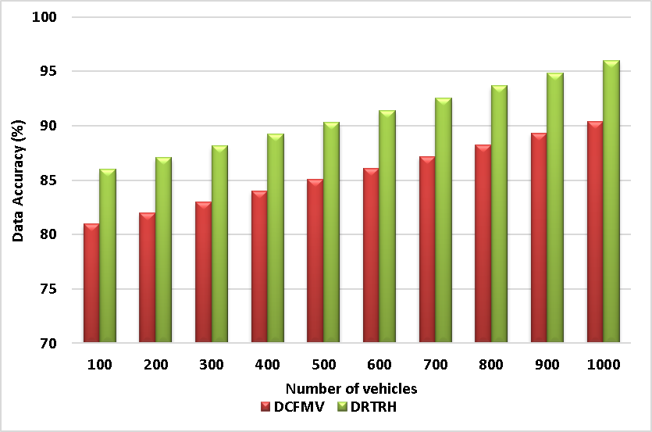
Figure 2 - Data Accuracy
The proposed DERQM obtains a high accuracy of 99%, which is higher than the accuracy of the existing technique of SMBRM at 85%, DCFMV at 90%, and DRTRH at 96%. Hence the proposed DERQM method that has been proposed is extremely successful in data transmission.
4.2 Data loss Ratio: The fraction of data packets that are unsuccessful in reaching their destination during transmission is known as the data loss rate. Figure 3 shows the data loss calculation for the suggested DERQM-UAV and compares it to the previous efforts. like SMBRM-UAV, DCFMV-UAV, and DRTRH-UAV.
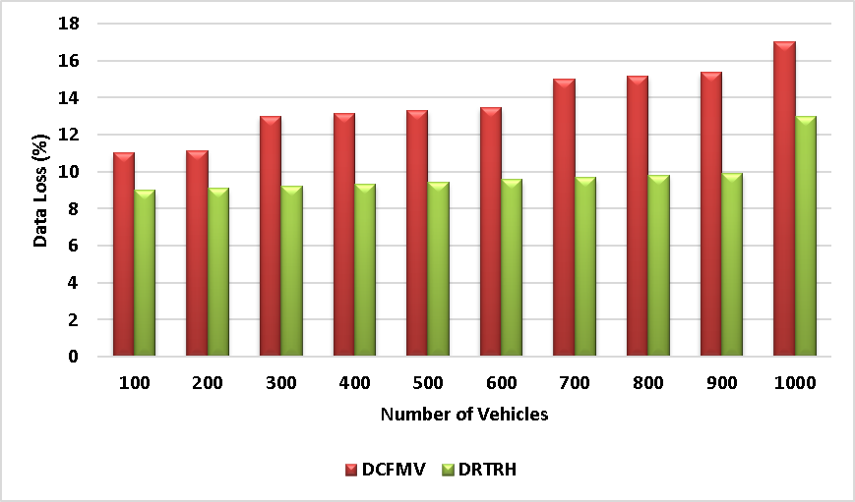
Figure 3 – Data Loss
The proposed DERQM method has a low data loss rate of 6%, compared to the existing technique of SMBRM at 23%), DCFMV at 17%, and DRTRH at 13%. Hence the proposed method has minimum loss rate which is efficient in data transmission.
4.3 Routing overhead: Routing Overhead pertains to the additionally data packets used for transmitting routing information. In figure 4, the routing overhead measurements of the DERQM-UAV are computed and contrasted with the results of previous investigations. like SMBRM-UAV, DCFMV-UAV, and DRTRH-UAV.
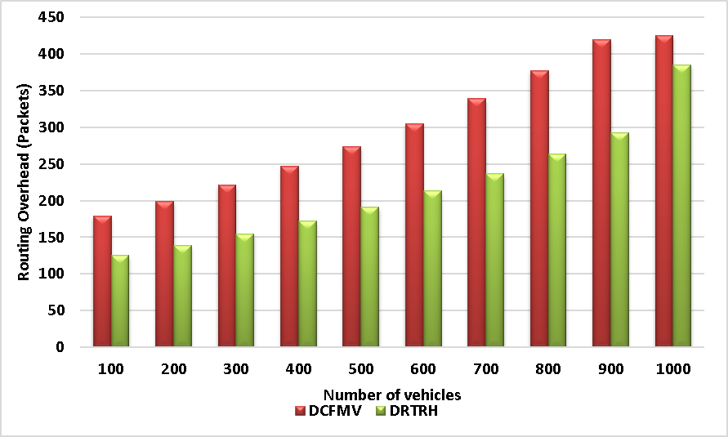
Figure 4 - Routing overhead
The proposed DERQM method has a reduced Routing Overhead of 204 packets which succeeds the existing method of SMBRM at 563 packets, DCFMV at 425 packets, and DRTRH at 385 packets. Hence, the proposed DERQM method had minimum routing overhead which leads high efficient data transmission.
4.4 Throughput: It refers to the rate at which data is successfully transferred via a communication channel. In figure 5, The suggested DERQM-UAV's performance measurements are finished, and they are contrasted with the two other works. like SMBRM-UAV, DCFMV-UAV, and DRTRH-UAV.
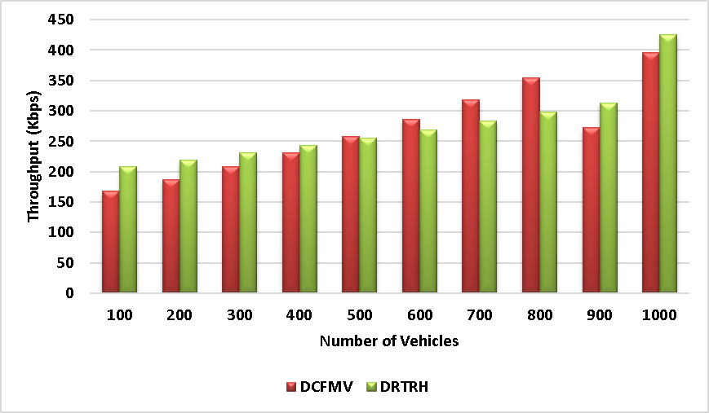
Figure 5 – Network Throughput
The proposed DERQM method has a greater throughput of 635 kbps than the existing technique of SMBRM at 235 kbps, DCFMV at 396 kbps, and DRTRH at 425 kbps. This reveals that the proposed DERQM method can manage a higher amount of data.
4.5 The average delay measures how long it typically takes for data packets to get from one location inside the network to another. In figure 6, the average delay calculation of the DERQM-UAV is done and it gets compared with the other works like SMBRM-UAV, DCFMV-UAV, and DRTRH-UAV.

The proposed DERQM approach has a shorter average delay of 110 ms than the existing technique of SMBRM at 156 ms, DCFMV at 142 ms, and DRTRH at 130 ms. In the Proposed DERQM technique, a shorter delay indicates faster data transmission. This analysis proves that the proposed DERQM achieved effective overall performance and the results are given in table 3.

5 Conclusion
This paper presents an improved routing model to maximize the communication standard of the vehicular network. In general, because vehicles are traveling at a fast speed most of the time data forwarding occurs that increases the routing overhead and delay among the vehicles. As the result frequent link disconnection and information loss occurs in the network that directly affects the lifespan of the vehicles. This improved routing process greatly increased the data success rate and throughput and it is excellently working with the high speed mobility vehicles. In the future scope we may concentrate on the improvisation of roadside unit selection and relay node maintenance in the vehicular network.
6 References
- H.F. Mahdi, M.S. Abood, and M.M. Hamdi, "Performance evaluation for vehicular ad-hoc networks based routing protocols," Bulletin of Electrical Engineering and Informatics, vol. 10, no. 2, 2021, pp. 1080-1091, doi: 10.11591/eei.v10i2.2943.
- S. Alani, A. Baseel, M.M. Hamdi, and S.A. Rashid, "A hybrid technique for single-source shortest path-based on A* algorithm and ant colony optimization," IAES International Journal of Artificial Intelligence, vol. 9, no. 2, 2020, pp. 356, doi: 10.11591/ijai.v9.i2.pp356-363.
- Mohammed, Noor Sabah, et al. "Secure Smart Contract Based on Blockchain to Prevent the Non-Repudiation Phenomenon." Baghdad Science Journal 21.1 (2024): 0234-0234.‏
- Aliesawi, Salah, Mohammed Ahmed, and Ahmed Rashid. "Iterative multipacket detection with FDE based
- Al-Din, Saif, and Shokhan M. Al-Barzinji. "IoMT recruitment for safe transmission and authentication of medicinal data via mcloud: towards preserving patient
- Nafea, Ahmed Adil, et al. "Enhancing Student's Performance Classification Using Ensemble Modeling." Iraqi Journal
- H. Mahdi, B. Al-Bander, M. H. Alwan, M. S. Abood, and M. M. Hamdi, "Vehicular Networks Performance Evaluation Based on Downlink Scheduling Algorithms for High-Speed Long
- M. M. Hamdi, L. Audah, S. A. Rashid, M. S. Abood, A. S. Mustafa, and M. S. Noori, "A hybrid Algorithms to Improve the Quality of Service in Vehicular Ad-Hoc Networks: A Framework,
- S. A. Rashid, M. M. Hamdi, and S. Alani, "An overview on quality of service and data dissemination in VANETs," in 2020 International Congress on Human-Computer Interaction
- M.M. Hamdi, L. Audah, and S.A. Rashid, "Data dissemination in VANETs using clustering and probabilistic forwarding based on adaptive

