Effective Communication Model with Genetic Algorithm based Resource Allocation for Vehicular Network
Nejood F. Abdulsattar
Department of Computer Technical Engineering ,Imam Al-Kadhum College (IKC) ,Al-Diwaniyah, Iraq;nejodfaisal@gmail.com.
Rizgar Rahman Ghafour
National University of Science and Technology, Dhi Qar, Iraq; rizgar.r.ghafour@nust.edu.iq
Zahraa Hassan Ward Surname
Department of Computer Techniques Engineering , Mazaya University College, DhiQar, Iraq;Eng.co.zahraa@mpu.edu.iq.
Fatima Hashim Abbas
Medical Laboratories Techniques Department,Al-Mustaqbal University,Hillah, Iraq; fatimahashim@mustaqbal-college.edu.iq.
Mohammed I. Habelalmateen
Department of Computer Technical Engineering, College of Technical Engineering, The Islamic University, Najaf, Iraq; moh.almateen@gmail.com.

Abstract
Nowadays several technologies have emerged to improve the communication standard and one of the most important technologies is vehicular communication which provides a way to communicate together with additional vehicles and infrastructure. The high degree of mobility and the quick topological changes between the vehicles make it tougher to allocate resources between them in a way that maximizes efficiency. Increasing communication efficiency and data dependability is the main goal of this network model architecture. For that purpose, in this article an Effective Communication Model with Genetic Algorithm Based Resource Allocation (ECGARA) is performed in the vehicular network.
Index Terms: Vehicular Communication, Effective Communication Model and Genetic Algorithm based Resource Allocation
1 Introduction
When devices are connected to the Internet to enable remote monitoring or control, the process is referred to as "vehicular communication" [1]. The most popular way to achieve this high degree of connectedness is through the use of wireless technology [2]. Vehicular Adhoc Networks (VANETs) are widely acknowledged as revolutionizing the networking business [3]. These low-cost, battery-powered cars are positioned all over a region to collect data, which they then wirelessly transmit to bigger "sink" vehicles. These sensors are all capable of communicating with the sink or with one another [4]. One major issue facing WSNs is the limited energy resources of individual nodes [5]. Implementing strong self-organization, clustering, and routing protocols is essential since lowering electricity consumption can extend the lifespan of the network. WSNs also have limitations because of their absence of computational capacity and buffering-capable memory [6]. Wireless sensors can be helpful for VANET applications as they can gather and process data, extract significant data, and transfer it to the end user. At times, individuals are unable to accomplish this on their own. For this reason, it may be seen of as one of the essential elements of Internet of Things applications [7].
IoT devices, including mobile devices and sensors, have limited capacity compared to conventional devices that have sufficient manufacturing, archiving, and computational power [8]. Because of this, the structure of a suh program should take into account the various resource capacities of the many heterogeneous devices that make up the Internet of Things. The need to offer a communication environment for billions of devices is the primary explanation that scalability is a barrier in the Internet of Things [9]. Large amounts of data produced by numerous devices and systems also need to be processed and stored [10].
2 Related Works
Ren-Hung Hwang et al. presented a computational framework in [11] for compute and transmission offloading to RSUs and gNB. An approach that utilizes sub-gradients is used to find the best loading likelihood. In reference [12], Anjan Rayamajhi and colleagues have conducted a comparative study of two different CAV communications technologies: DSRC and C-V2X. This provides information on parameters like accuracy, burst packet loss, and packet loss. In [13], Ibtissem Brahmi et al. introduced V2X networks, addressing traffic safety and transport system efficiency. In order to guarantee QoS for CUEs and VUEs, it suggests a resource allocation strategy for V2X based on genetic algorithms. A genetic algorithm-based resource allocation approach for V2X networks was introduced by Kyungtae Kim et al. in [14] to guarantee QoS for CUEs and VUEs. JiHyun Choi et al. introduced a congestion management technique in [15] that enables V2X security applications to give priority to particular QoS characteristics based on their needs. The plan is to consistently lower channel use.
In [16], Yosuke Segawa et al., investigatedprovides a sidelink-based relaying mechanism to improve distribution speeds and maximize radio utilization of resources. It also combines sidelink and cellular communications. Under the Long-Term Evolution accepted, Shubhangi Bhadauria et al. presented a QoS-aware decentralized resource allocation for V2X communication in [17]. Using a deep reinforcement learning framework, this suggested method as part of the 3rd Generation Partnership Project standard, Zixuan Chen et al. developed a distributed allocation of resources mechanism for V2X communication in [18]. This scheme utilizes a DRL framework and incorporates QoS parameters, In [19], Khandaker Foysal Haque et al., proposed a LoRa-based V2X communication architecture to address safety concerns in the growing number of vehicles. This architecture is designed for reliability, robustness, and low power consumption.
In [20], and improved congestion control model is developed in the regular communication that enhances the level of service quality provided by fast-moving automobiles. In [21], to reduce the latency of the high speed vehicles a multi mobile network generated based new model is introduced. In [22], and efficient cognitive routing model is introduced among the vehicles mainly to monitor the dynamic nature of it and to increase the trustworthiness among the vehicles. Following examining these prior studies, it became clear that additionally updating was required to increase the vehicles' effectiveness. Table 1 summarizes the past studies.

3. Proposed ECGARA Model:
The primary goal of developing this ECGARA model is to improve high-speed vehicle communication effectiveness. The core modules of this model are efficient system creation and resource allocation using Generic Algorithm. Figure 1 illustrates how the ECGARA works.

3.1 System Model:
Through the PC5 air interface, A UE can communicate with other UEs immediately. nearby via sidelink, enabling direct C-V2X communication. Messages broadcast by the sending UE are intercepted by many Rxs attempting to receive the same data, this connection called point-to-multipoint. This chapter describes the results of the at the system level modeling for network-assisted direct C-V2X transmission in a highway traffic scenario. Every UE is linked to a single Radio Access Network (RAN) Base Station (BS). Information on scheduling and resource management is sent from base stations (BSs) to user equipment (UEs) over the radio interface'sThe C-plane, or vehicle-to-network (V2N) control plane. By instantly broadcasting its Vehicle-to-Vehicle (V2V) or Vehicle-to-Infrastructure (V2I) sidelink data packets to the neighboring Rxs within its communication range, the transmitting Tx minimizes latency. The RAN can provide network control necessary for direct C-V2X communication. Two alternate sidelink transmission modes exist for 3GPPdefined C-V2X. These are:
3.2 Resource Allocation Using Genetic Algorithm:
This section aims to outline our suggested GA-based resource allocation plan. To strategically distribute the RBs and provide a decent, optimum solution, GA is applied. When an analytical or algorithmic solution cannot be computed in an acceptable amount of time, GA offers answers to such challenges. This procedure generates numerous roughly suitable solutions, or the genotypes, which are subsequently put through an evaluation procedure modeled after the evolution of species. According to the theory, a population evolves over multiple generations by combining and modifying the best answers, subsequently repeating this process several times in an effort to obtain the ideal solution. The most optimal solutions to the issue are thought to live longer than the less optimal ones. The following steps make up our recommended course of conduct.
Step 0: Our initial task is to define the individual and chromosomal structures in order to apply the GA. In a V2X network, U, N, and V stand for the set of CUEs, non-safety VUEs, and safety VUEs. There are also S RBs and U+ V+N users. All humans are made up of S chromosomes, where S is the total number of possible RB assignments. On each chromosome are T genes, where T denotes the total amount of communicators. If the linked transmitter employs the RB under evaluation, each gene may have a value of 1, and if not, it may have a number of 0.
We choose an example, which represents {U1}, {V1, V2}, and {S1, S2}, respectively, to provide a clearer understanding. There are two VUEs, two RBs, and one CUE in this set. The genetic algorithm initially encodes a solution on a data structure like a chromosome.
Step 1: Initialization and assessment are the initial steps. ρ chromosomes are created by the GA at this stage, The community's size is represented by ρ. When assessing a single chromosome, the throughput is utilized to show the maximal throughput for the associated RB. The lowest throughput attained by the transmitter is an individual's level of fitness. As a result, a low-throughput system will be less suitable.
4. Simulation results:
The effectiveness of the suggested ECGARA-UAV network in comparison with the existing technique like ARRIC-UAV [20], ILMSM-UAV [21], and FMMTC-UAV [22] and it is simulated using the NS2 simulator. The evaluation metrics are Energy Efficiency (joules), Energy consumption (joules), Average Delay (ms), Throughput (kbps), and Packet Delivery ratio (%) and as well Table 2 provides the input variables used in the aforementioned research.
Table 2 – Input Parameters Table
Input Parameters | Values
Running Time | 150 ms
Coverage Distance | 500m*500m
No of Nodes | 100 Nodes
Node Radius | 100m
Initial Energy | 100 Joules
Transmission Power | 0.500 Joules
Receiving Power | 0.050 Joules

4.1The ratio of useful energy output to energy input during the data transfer procedure is used to quantify energy efficiency. Figure 2 presents the ECGARA-UAV's performance calculation and comparison against various operates, including ARRIC-UAV, ILMSM-UAV, and FMMTC-UAV.
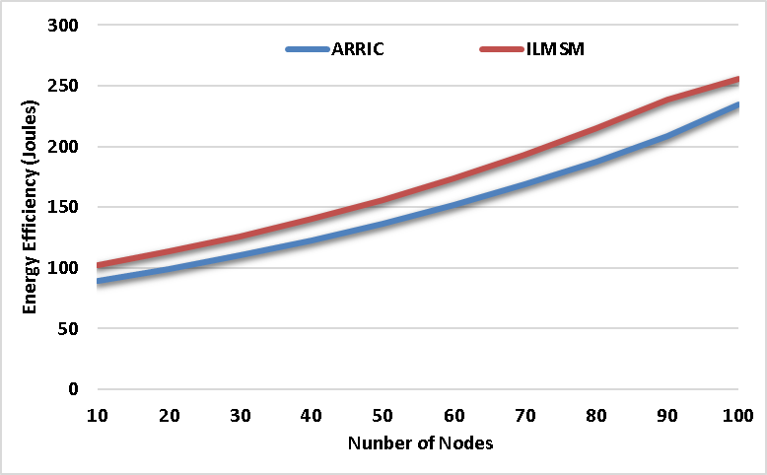
Figure 2 - Energy Efficiency
The Proposed ECGARA method has an energy efficiency of 352 joules, which succeeds the existing technique of ARRIC at 235 joules, ILMSM at 256 joules, and FMMTC at 279 joules. This implies that the ECGARA approach that is being suggested is quite effective.
4.2 Energy consumption: Energy Consumption refers to the collective quantity of energy used during the process of data transmission. Figure 3 shows how much power the ECGARA-UAV uses. is calculated and it gets compared with the other works like ARRIC-UAV, ILMSM-UAV, and FMMTC-UAV
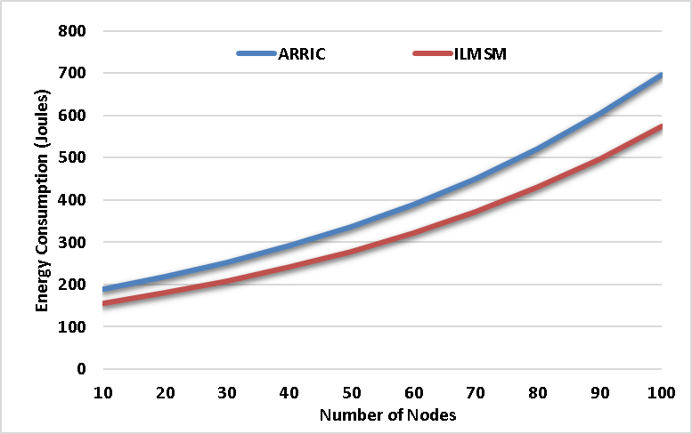
Figure 3 - Energy consumption
The proposed ECGARA model shows a reduced energy consumption of 240 joules, in contrast to the existing method had higher energy consumption of ARRIC at 697 joules, ILMSM at 575 joules, and FMMTC at 376 joules. The Proposed ECGARA technique reveals higher energy efficiency through reduced energy usage.
4.3 Average Delay: This is the average time that data packets take inside a network to go from their source to their conclusion. Figure 4 shows the average delay of the ECGARA-UAV and compares it with the results of other studies such as ARRIC-UAV, ILMSM-UAV, and FMMTC-UAV.

Figure 4 - Average Delay
The proposed ECGARA technique has a shorter Average Delay of 121 ms in comparison to the existing method of ARRIC at 174 ms, ILMSM at 156 ms, and FMMTC at 140 ms. The Proposed ECGARA method achieves fast data transmission.
4.4 Throughout: The term pertains to the efficient transmission rate of data across a transmission connection. Figure 5 shows the calculation and comparison of the ECGARA-UAV's network speed with the other studies. like ARRIC-UAV, ILMSM-UAV, and FMMTC-UAV
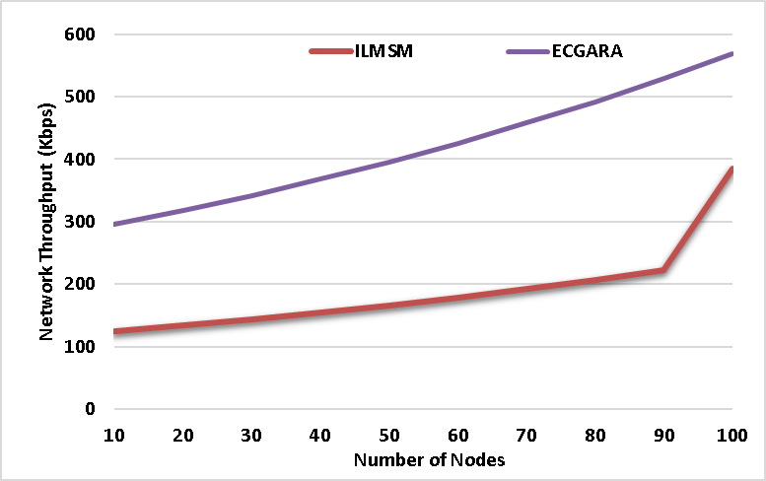
Figure 5 – Network Throughout
The Proposed ECGARA method provides a greater throughput of 569 kbps in comparison to the existing technique of ARRIC at 256 kbps, ILMSM at 385 kbps, and FMMTC at 425 kbps. These values reveal that the Proposed ECGARA method can handle large amount of data.
4.5 The percentage of effectively delivered packets to all packets sent over the network is known as the packet delivery ratio. Figure 6 shows the ECGARA-UAV's packet delivery ratio computed and contrasted to the results of the other research. like ARRIC-UAV, ILMSM-UAV, and FMMTC-UAV
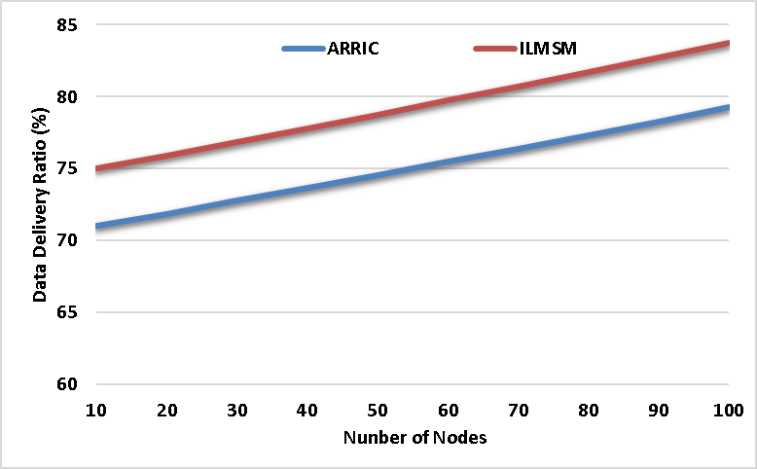
Figure 6 - Packet Delivery Ratio
The Planned ECGARA has a superior Packet Delivery Ratio of 96%, outperforming the existing technique of ARRIC at 79%, ILMSM at 84%, and FMMTC at 88%. This reveals that the Proposed ECGARA method is effective transmission of data when compared with the other method and as well the overall performance of the methods which are participated in this research is given in table 3.
6 References
- S. Alani, A. Baseel, M.M. Hamdi, and S.A. Rashid, "A hybrid technique for single-source shortest path-based on A* algorithm and ant colony optimization," IAES International Journal of Artificial Intelligence, vol. 9, no. 2, 2020, pp. 356, doi: 10.11591/ijai.v9.i2.pp356-363.
- A. S. Abdalkafor and S. A. Aliesawi, "Data aggregation techniques in wireless sensors networks (WSNs): Taxonomy and an accurate literature survey," in AIP Conference Proceedings, vol. 2400, no. 1, 2022, doi: 10.1063/5.0112212.
- Nafea, Ahmed Adil, et al. "Enhancing Student's Performance Classification Using Ensemble Modeling." Iraqi Journal For Computer Science and Mathematics 4.4 (2023): 204-214.‏
- Mohammed, Noor Sabah, et al. "Secure Smart Contract Based on Blockchain to Prevent the Non-Repudiation Phenomenon." Baghdad Science Journal 21.1 (2024): 0234-0234.‏
- Al-Din, Saif, and Shokhan M. Al-Barzinji. "IoMT recruitment for safe transmission and authentication of medicinal data via mcloud: towards preserving patient privacy and critical emedicinal records." AIP Conference Proceedings. Vol. 2400. No. 1. AIP Publishing, 2022.‏
- Aliesawi, Salah, Mohammed Ahmed, and Ahmed Rashid. "Iterative multipacket detection with FDE based MAC protocol in vehicular ad hoc networks." Periodicals of Engineering and Natural Sciences 7.3 (2019): 1041-1053.‏
- H. Mahdi, B. Al-Bander, M. H. Alwan, M. S. Abood, and M. M. Hamdi, "Vehicular Networks Performance Evaluation Based on Downlink Scheduling Algorithms for High-Speed Long Term Evolution--Vehicle," International Journal of Interactive Mobile Technologies, vol. 15, no. 21, 2021, pp. 1-7, doi: 10.3991/ijim.v15i21.22475.
- M. M. Hamdi, L. Audah, S. A. Rashid, M. S. Abood, A. S. Mustafa, and M. S. Noori, "A hybrid Algorithms to Improve the Quality of Service in Vehicular Ad-Hoc Networks: A Framework," in 2021 5th International Symposium on Multidisciplinary Studies and Innovative Technologies (ISMSIT), 2021, pp. 323-328.
- S. A. Rashid, M. M. Hamdi, and S. Alani, "An overview on quality of service and data dissemination in VANETs," in 2020 International Congress on Human-Computer Interaction, Optimization and Robotic Applications (HORA), 2020, pp. 1-5, doi: 978-1-7281-9352-6/20.
- M.M. Hamdi, L. Audah, and S.A. Rashid, "Data dissemination in VANETs using clustering and probabilistic forwarding based on adaptive jumping multi-objective firefly optimization," IEEE Access, vol. 10, 2022, pp. 14624-14642, doi: 10.1109/ACCESS.2022.3147498.
- H.F. Mahdi, M.S. Abood, and M.M. Hamdi, "Performance evaluation for vehicular ad-hoc networks based routing protocols
- R. H. Hwang, M. M. Islam, M. A. Tanvir, M. S. Hossain, and Y. D. Lin, "Communication and computation offloading for 5G V2X: Modeling and optimization,"
- A. Rayamajhi et al., "Preliminary performance baseline testing for dedicated short-range communication (DSRC) and cellular vehicle-to-everything (C-V2X),
- I. Brahmi, H. Koubaa, and F. Zarai, "Genetic algorithm based resource allocation for V2X communications
- K. Kim, S. Koo, and J. W. Choi, "Analysis on path rerouting algorithm based on V2X communication for traffic flow improvement

