Enhancing Security in Online Learning Platforms: Implementing IoT-Based Two-Factor Authentication for TOEFL ITP MOOCs

¹ Haris
Department of Educational Technology
Jakarta State University
Jakarta, Indonesia
haris_9902921018@mhs.unj.ac.id https://orcid.org/0009-0000-0590-164X
² Basuki Wibawa
Department of Educational Technology
Jakarta State University
Jakarta, Indonesia
bwibawa@unj.ac.id https://orcid.org/0000-0002-0290-1617
⁴ Daryanto
Department of Teacher Professional Education
Jakarta State University
Jakarta, Indonesia
daryanto@unj.ac.id https://orcid.org/0000-0002-6961-1841
³ Moch. Sukardjo
Department of Educational Technology
Jakarta State University
Jakarta, Indonesia
msoekardjo@unj.ac.id https://orcid.org/0000-0002-5393-7716

Abstract— In today’s highly connected digital era, security has become a crucial concern for online learning platforms, particularly in programs such as the TOEFL ITP (Test of English as a Foreign Language Institutional Testing Program) and Massive Open Online Courses (MOOCs). This study examines the use of Internet of Things (IoT) technology to strengthen security through two-factor authentication (2FA) on TOEFL ITP MOOCs platforms. IoT provides an advanced and efficient solution for securing user access by utilizing connected devices, such as smartphones and wearables, to verify user identity in real time. The research explores the architecture of IoT technology that facilitates 2FA integration, analyzing its advantages and challenges, and evaluating its impact on both security and user experience. By implementing IoT-based 2FA, the system protects personal data and prevents unauthorized access, ensuring that only authenticated users can access learning resources or participate in the TOEFL ITP exam. Furthermore, this study underscores how enhanced security through IoT can foster trust among users and encourage wider adoption of online learning technologies. The findings suggest that IoT-based 2FA not only bolsters security but also upholds academic integrity in an increasingly complex digital landscape.
Keywords: IoT, Two-Factor Authentication, TOEFL ITP, MOOCs

Introduction
In today's globalized world, learning English is crucial for enhancing one's language skills [1]. Students recognize that proficiency in English is vital for their future success [2]. To improve learning outcomes, incorporating technology into English education is essential [3], as well as implementing e-assessment systems for evaluating student progress [4]. Achieving a high score on the TOEFL ITP (Test of English as a Foreign Language Institutional Testing Program) has become particularly important, as it is now a requirement for completing Master's (S2) and Doctoral (S3) studies. Consequently, students must undergo rigorous preparation for the TOEFL ITP test.
The TOEFL ITP consists of three sections: listening comprehension, structure and written expression, and reading comprehension [5]. Adequate preparation, particularly in listening comprehension, requires consistent practice with relevant questions [6].
As communication and education in today's digital world increasingly rely on connectivity, ensuring the security of online platforms is more critical than ever. This is especially true for educational initiatives that depend on the internet for content delivery and assessment, such as Massive Open Online Courses (MOOCs) and the TOEFL ITP (Test of English as a Foreign Language Institutional Testing Program). While online learning has significantly expanded access to education, it has also introduced serious security risks, including unauthorized access, data breaches, and academic dishonesty.
To address these challenges, modern security measures must be implemented. This study explores how two-factor authentication (2FA) combined with the Internet of Things (IoT) can enhance the security of TOEFL ITP and MOOCs platforms. IoT, with its network of interconnected devices, offers an intelligent and efficient way to secure user access. By leveraging wearables, smartphones, and other connected devices, IoT enables real-time identity verification, ensuring that only authorized individuals can access sensitive learning materials or participate in tests.
This report examines the technological architecture that enables IoT-based 2FA integration and provides a comprehensive analysis of its benefits, drawbacks, and overall impact on security and user experience. Key objectives include safeguarding personal information, preventing unauthorized access, and maintaining the integrity of the educational process. Additionally, the study explores how enhanced security through IoT can increase user trust, thereby encouraging greater adoption of online learning tools.
The findings suggest that IoT-enabled 2FA not only strengthens security measures but also upholds academic integrity in an increasingly complex digital environment. As security concerns become more prevalent, this approach helps maintain the legitimacy and reliability of online education by ensuring that only verified users can access learning platforms and exams.
This research emphasizes the importance of robust security in online learning, particularly for programs like TOEFL ITP and MOOCs. It demonstrates how connected devices, such as smartphones and wearables, can be used for real-time identity authentication through the integration of IoT and 2FA. The primary innovation of this study lies in the application of IoT technology to enhance online learning security for TOEFL ITP and MOOCs.

CONCEPT OVERVIEW

Massive Open Online Courses (MOOCs)
Massive Open Online Courses (MOOCs) are a groundbreaking innovation in education, democratizing access for millions of individuals globally. Despite some drawbacks, their flexibility, affordability, and accessibility make them invaluable for skill development and lifelong learning in the digital era [7][8].
MOOCs are typically offered at no cost or a reduced fee, aiming to reach a large, diverse student population. Their primary mission is to provide flexible, easily accessible education, often from prestigious universities and organizations, to anyone with an internet connection. Platforms like Coursera, edX, and Udacity offer MOOCs on a wide range of subjects, including professional development, technology, humanities, and sciences.
Key characteristics of MOOCs [9][10] include: 1) Open Enrollment: MOOCs are accessible to learners of all backgrounds, without official admission requirements; 2) Interactive and Engaging: They often feature readings, video lectures, quizzes, peer assessments, and discussion forums for interaction between students and instructors; 3) Self-paced Learning: Many MOOCs allow students, working professionals, and lifelong learners to progress at their own pace; 4) Certificates: While auditing MOOCs is usually free, some platforms offer paid certificates of completion, enhancing learners’ professional credentials.

Internet of Things (IoT)
The Internet of Things (IoT) refers to a network of physical objects ("things") connected through sensors, smart devices, and other technologies that allow these objects to exchange data and communicate with other devices and systems over the internet. The concept behind IoT is to transform ordinary objects into "smart" devices by enabling them to collect, exchange, and process data in real time, securely and continuously.
IoT has revolutionized the way common objects collect and share data, marking a significant paradigm shift [11]. This technology has a profound impact on various industries, including manufacturing, healthcare, education, and smart cities. IoT began with simple RFID tags and has since evolved into complex systems incorporating artificial intelligence (AI), cloud computing, and advanced sensors. Key advancements, such as the development of IPv6 (which allowed a vast number of devices to connect to the internet) and the introduction of 5G and other wireless communication technologies, have been instrumental in this evolution.
The IoT field is vast and dynamic, encompassing a wide range of technologies and applications. Its essential components include logic, data collection, sensors, actuators, and user interfaces. Sensors and actuators are the physical elements responsible for gathering and processing data. Device-to-device communication is enabled by networks like Wi-Fi, cellular, and LoRaWAN [12]. Large-scale data processing and analysis are typically handled by cloud or edge computing platforms. Lastly, accessible user interfaces, such as web browsers or mobile apps, allow individuals to interact with and control IoT systems.
IoT technology has broad applications across multiple industries. In healthcare, IoT can improve patient care by tracking vital signs in real time and alerting healthcare providers to any issues, potentially reducing hospital admissions. In industrial settings, IoT enables predictive maintenance, where sensors monitor machine conditions and schedule repairs only when necessary. At home, IoT devices such as smart lighting, security systems, and thermostats enhance comfort and security [13].
The benefits of IoT are extensive. It increases productivity, improves decision-making through data-driven insights, enhances operational efficiency, and boosts customer satisfaction. For example, in agriculture, IoT sensors can monitor soil conditions and optimize crop production, leading to higher yields and better soil preservation. In transportation, IoT improves logistics and inventory management by enabling real-time tracking of workers and cargo, reducing costs, and speeding up delivery times.

Two-Factor Authentication (2FA)
Two-Factor Authentication (2FA) is a security process in which the user provides two distinct authentication factors to verify their identity [14]. By adding an extra layer of security, 2FA significantly enhances protection against unauthorized access to a user’s account or sensitive data. Unlike standard single-factor authentication, which typically relies on something the user knows (such as a password), 2FA requires an additional factor. This additional factor can be something the user has (like a smartphone) or something they are (such as a fingerprint).
Two-Factor Authentication (2FA) consists of several main components: 1) Something You Know: This is typically a password or PIN and serves as the first line of defense; 2) Something You Own: This includes a tangible object that generates a time-sensitive code, such as a smart card, hardware token, or smartphone; 3) Something You Are: This type of verification uses biometrics, such as retinal scans, fingerprints, or facial recognition [15].

IoT-Based Two-Factor Authentication
IoT-Based Two-Factor Authentication (2FA) is a security feature that leverages the Internet of Things (IoT) to provide an additional layer of protection for user authentication. It ensures that even if one authentication factor is compromised, unauthorized access is still prevented by combining something the user knows (such as a password) with something the user owns (an IoT device).
Advantages of IoT-Based 2FA: 1) Enhanced Security: By adding an extra layer of authentication, IoT-based 2FA significantly reduces the risk of unauthorized access; 2) User Convenience: IoT devices, such as wearables, are often readily accessible to users, making the authentication process simple and intuitive; 3) Real-Time Verification: IoT devices offer real-time authentication, ensuring immediate response to any access attempt.

METHODOLOGY
This paper investigates the application of Internet of Things (IoT)-based Two-Factor Authentication (2FA) on the TOEFL ITP (Test of English as a Foreign Language Institutional Testing Program) and Massive Open Online Courses (MOOCs) platforms using a mixed-methods approach. The research instruments included achievement tests and interview guidelines, which were validated by three experts. Instrument reliability was tested on a sample of 30 postgraduate students from the Postgraduate Program at Indraprasta PGRI University, Jakarta.
The methodology consists of the following steps: Literature Review: To determine the essential elements of IoT-based 2FA systems, their technological framework, and their use in online learning settings, a thorough literature research was carried out. Academic articles, technical reports, and case studies on 2FA, IoT, and online education security are some of the sources.
System Design and Architecture Analysis: A conceptual model for an IoT-based 2FA system for the TOEFL ITP and MOOCs platforms was designed. This process involved identifying the required hardware (e.g., smartphones and wearables) and software (e.g., authentication servers and cloud services) necessary to implement the 2FA solution.
IoT Architecture Examination: The IoT technology architecture was thoroughly analyzed to determine how various components interact to provide secure user access. The focus was on how IoT devices integrate with data flow, communication protocols, and authentication servers to enable real-time identity verification.
This methodology provides a structured approach to evaluating the implementation of the IoT-based 2FA system, aiming to enhance the security of the learning platform while ensuring a positive user experience.
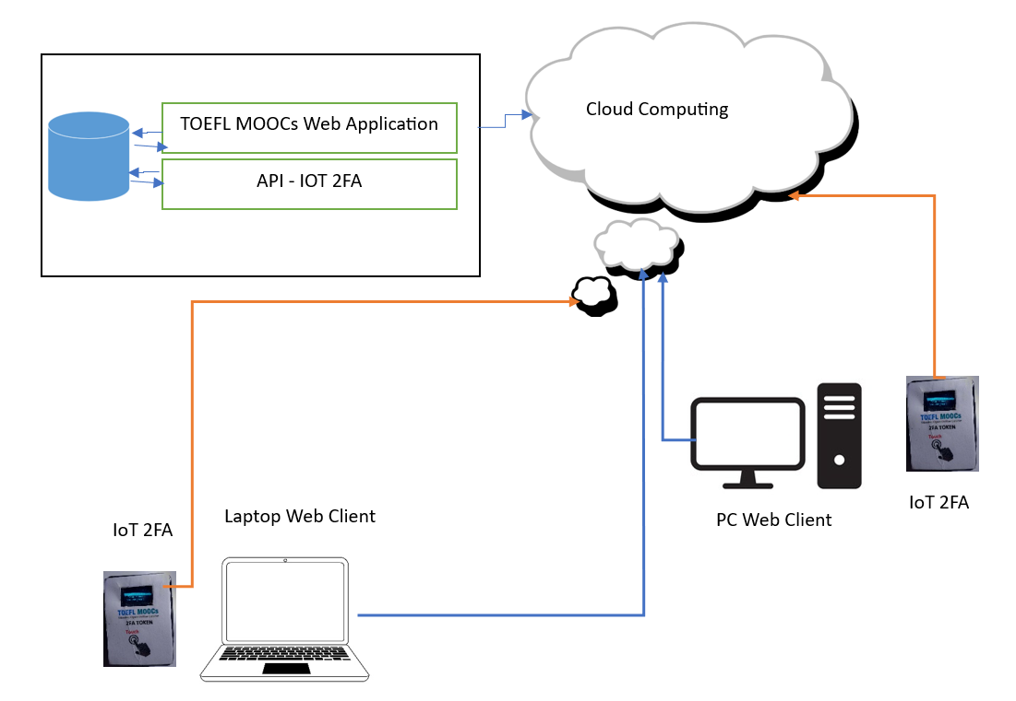
Figure 1. Software Architecture IoT TOEFL MOOC

RESULTS AND DISCUSSION

Interface of IoT TOEFL MOOCs
The user interface of the IoT TOEFL MOOCs application consists of two key components: an interface on the web application and an interface on the IoT 2FA device.
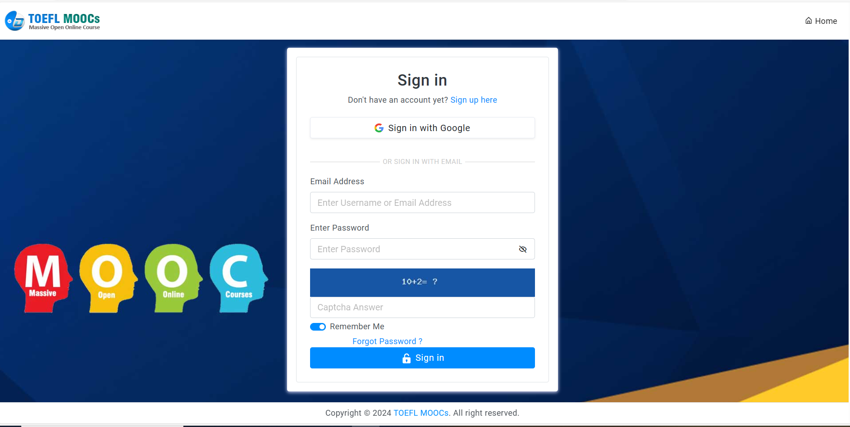
Figure 2. Login Form

To access the learning materials and exams in the IoT TOEFL MOOCs application, users must enter their username, password, and a captcha. Upon successfully logging in, a Two-Factor Authentication (2FA) form will appear.
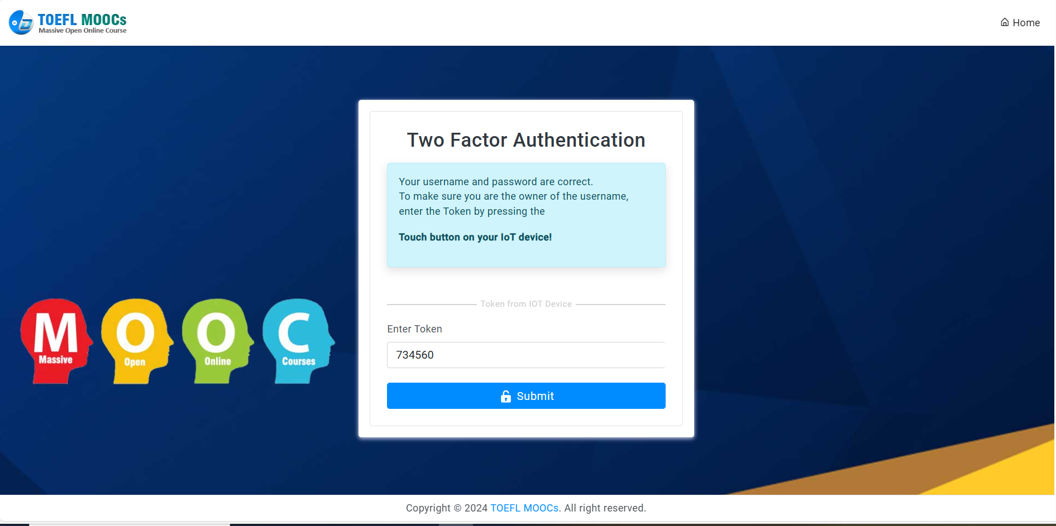
Figure 3. Two-Factor Authentication Form

To generate the token required for 2FA, users must activate the IoT 2FA device.

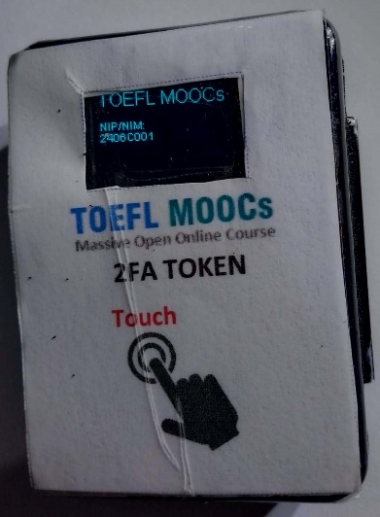

Figure 4. IoT 2FA Device

Once the text "TOEFL MOOCs" appears on the IoT 2FA device, users should press the Touch button on the device to proceed.

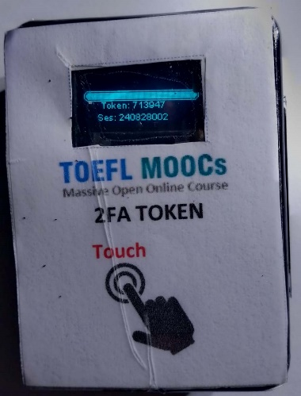

Figure 5. Token and Session in IoT 2FA

After receiving the token from the IoT 2FA device, the user must enter it into the 2FA form on the web application. If the token is valid, the IoT TOEFL MOOCs application dashboard will be displayed.

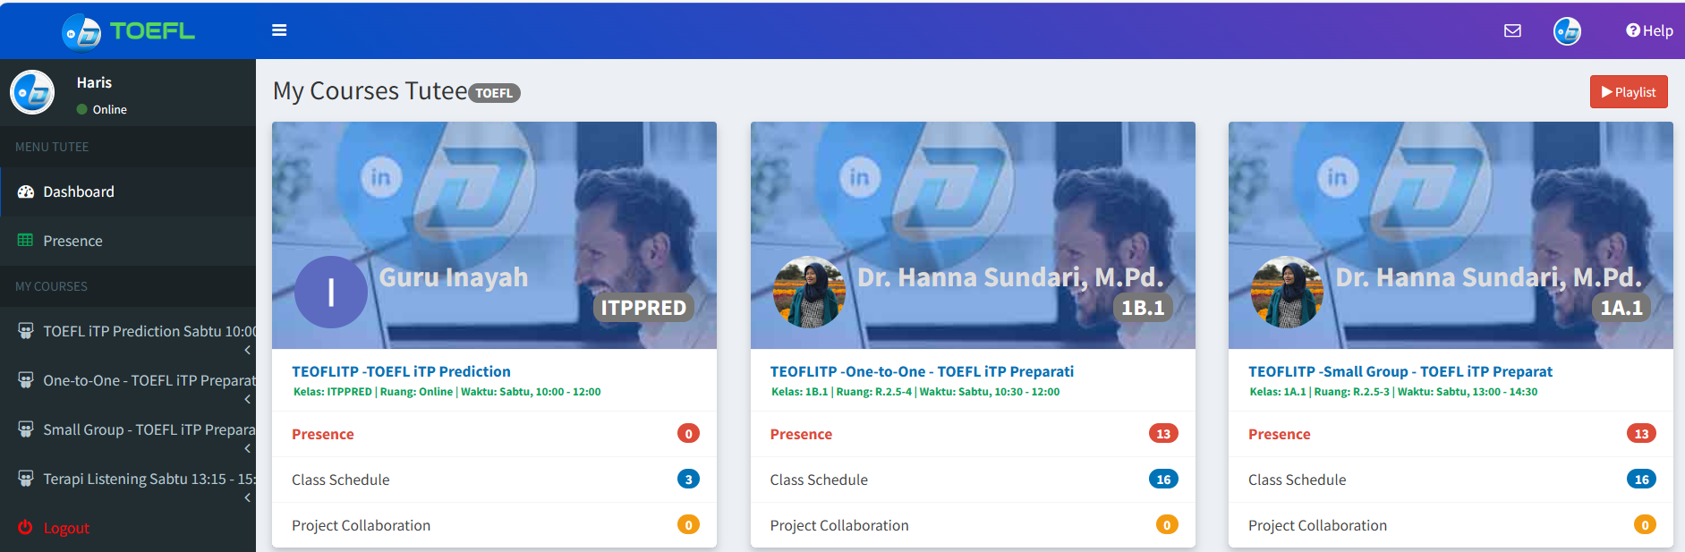

Figure 6. IoT TOEFL MOOCs Dashboard

To begin studying, users should select TOEFL ITP Preparation from the dashboard.

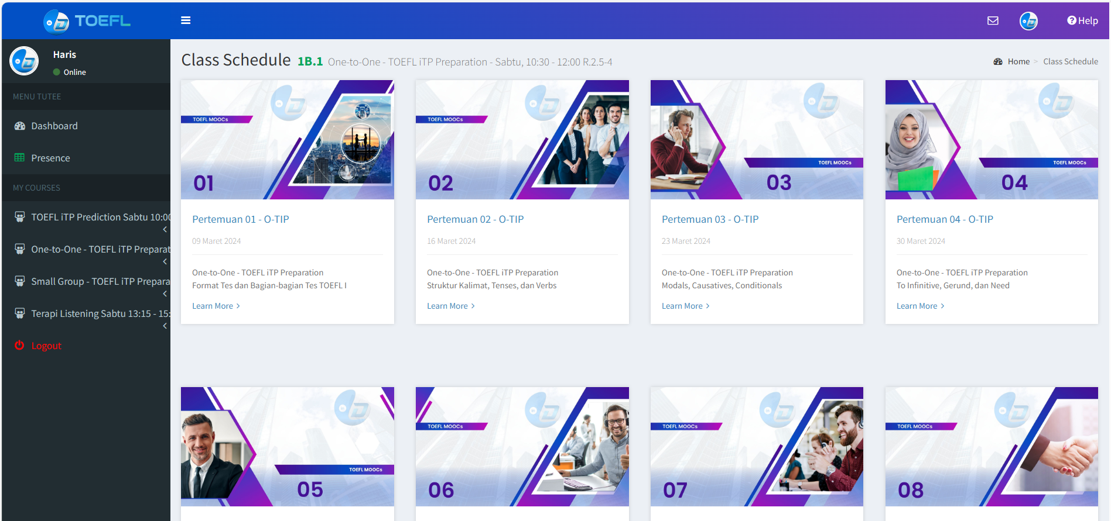
Figure 7. TOEFL ITP Preparation

For example, when a user selects Class Meeting 01, a list of learning materials will be displayed. Users must access each material, and a thumbs-up icon will appear once the material is marked as studied.


Figure 8. TOEFL ITP Preparation Class

In addition to the TOEFL ITP Preparation class, the platform also offers a TOEFL ITP Prediction exam. To access the exam, users need to enter the registered session ID, which can be obtained from the IoT 2FA device by pressing the Touch button.

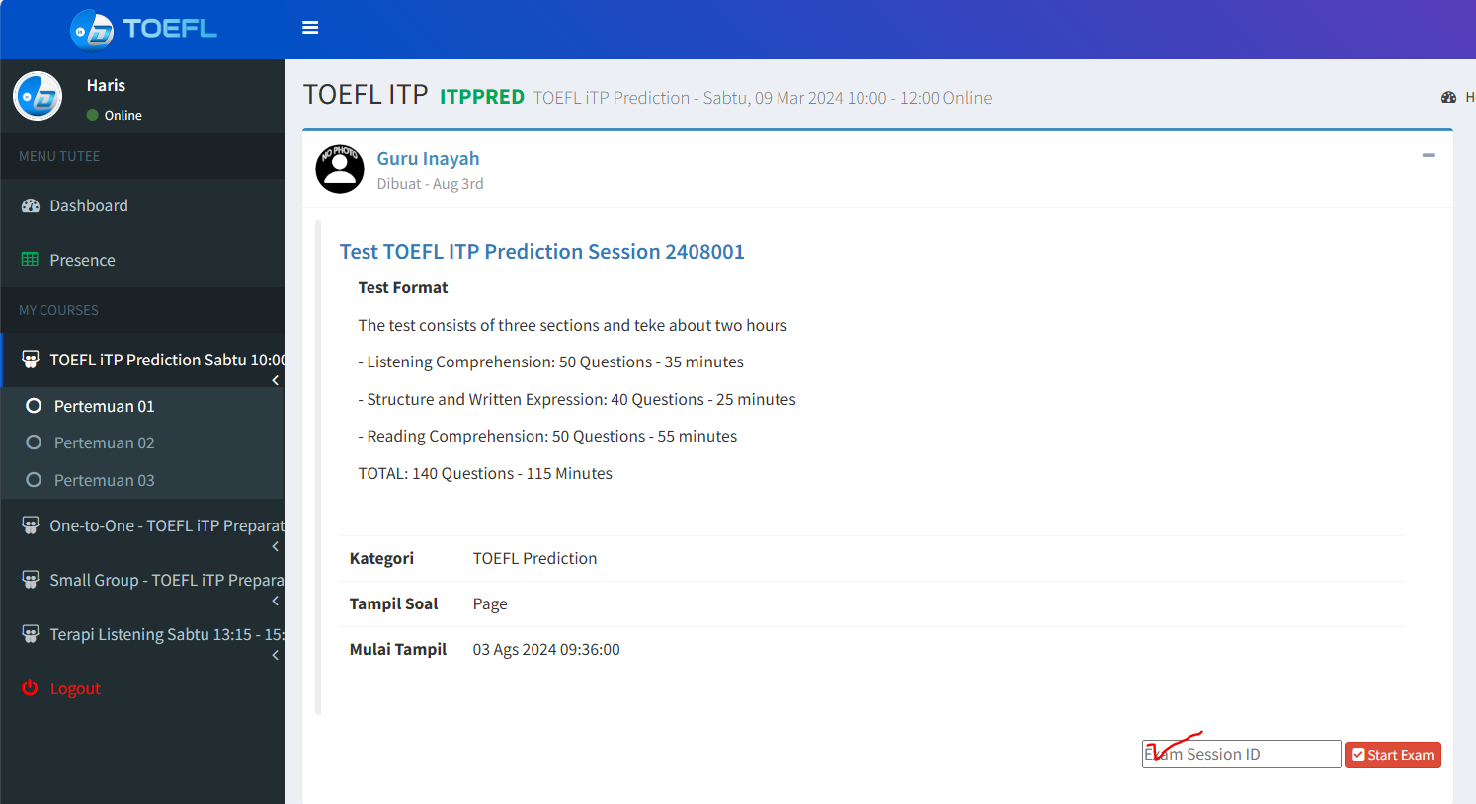
Figure 9. Exam Session Start Form

Users should input the session ID from Row 2 on the IoT 2FA device display.

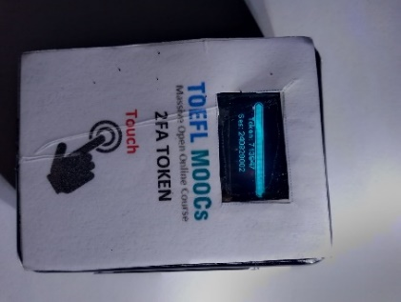

Figure 10. IoT 2FA Session Exam

Once the session ID is validated, the TOEFL ITP Exam will be displayed. The exam consists of three sections: 50 Listening Comprehension questions, 40 Structure and Written Expression questions, and 50 Reading Comprehension questions.

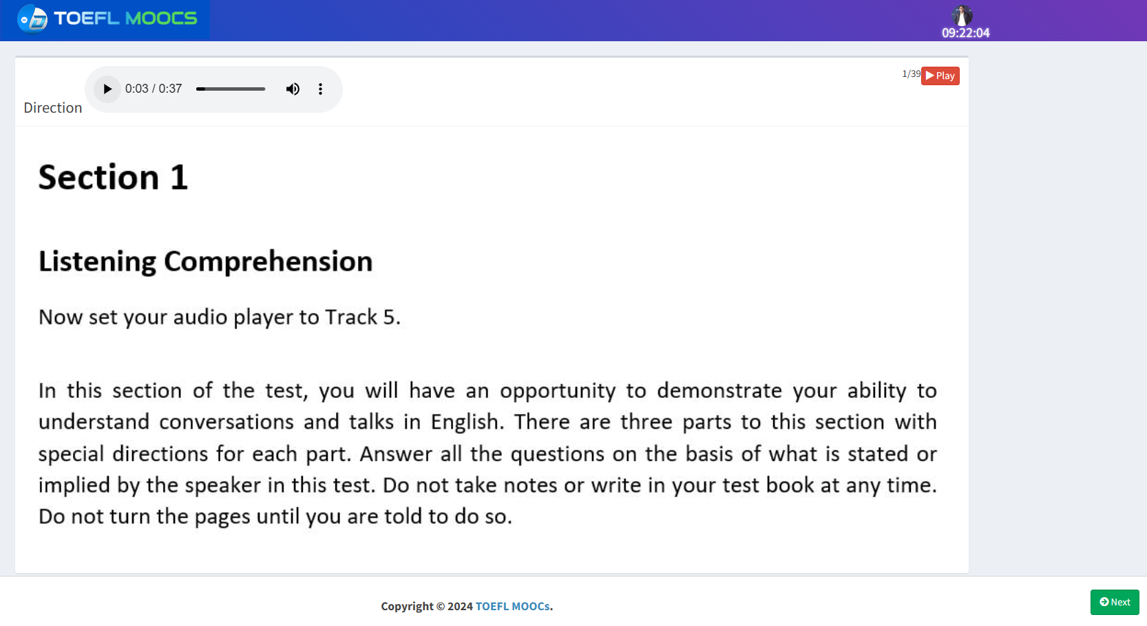
Figure 11. Listening Comprehension Test

After completing all the exam sections, the TOEFL ITP score will be displayed. The results will include the total score along with a breakdown of the number of correct answers in each section: Listening Comprehension, Structure and Written Expression, and Reading Comprehension.

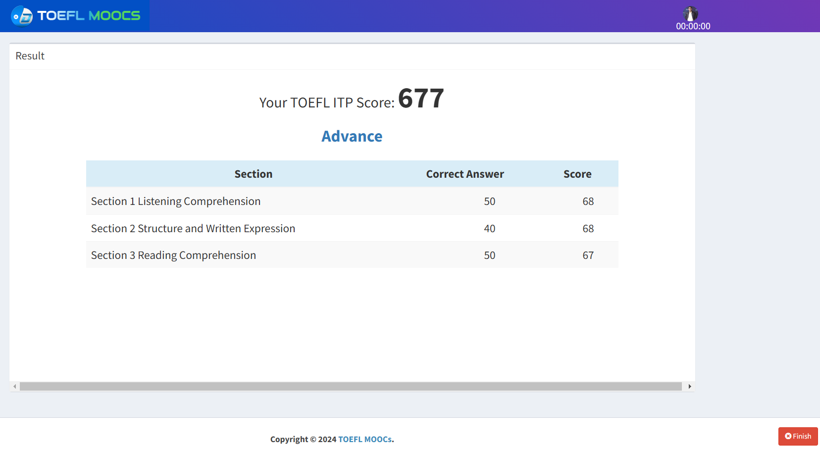
Figure 12. TOEFL ITP Exam Results

CONCLUSION
The security of online learning platforms, such as TOEFL ITP and MOOCs, has become increasingly critical in today’s connected digital age. This study demonstrates how implementing IoT-based Two-Factor Authentication (2FA) significantly enhances security by utilizing wearables, smartphones, and other connected devices to verify user identities in real time. By integrating IoT technology into the authentication process, the system ensures that only authenticated users can access educational resources and take exams, while simultaneously safeguarding personal data and preventing unauthorized access. This additional layer of protection is essential for maintaining academic integrity and building user trust, both of which are crucial for the continued growth and adoption of online learning technologies.
As IoT technology continues to evolve, the sophistication of IoT-based 2FA systems is expected to increase. Future research may explore the integration of advanced biometric sensors and AI-driven analytics into IoT devices to further improve the accuracy and reliability of user verification. Additionally, addressing security vulnerabilities in IoT devices themselves will be vital to ensuring the overall resilience of the 2FA system. For IoT-based security solutions to achieve widespread adoption, it will also be necessary to develop standardized protocols that ensure interoperability across various IoT platforms and devices. Ultimately, ongoing advancements in authentication and IoT technologies will pave the way for more secure and convenient virtual learning environments, advancing education worldwide in the digital age.

Acknowledgment
This research was supported by a grant from the Directorate General of Higher Education (DIKTI), Indonesia. We extend our sincere gratitude to DIKTI for their financial assistance and unwavering support, which made this study possible. Their commitment to advancing education and technology research in Indonesia has been instrumental to our work. We also wish to thank the institutions and individuals who contributed to the success of this research.

References

[1] D. T. Noerhidayat, “The importance of english in the modern era,” Asian J. Multidimens. Res., vol. 8, no. 1, p. 7, 2019, doi: 10.5958/2278-4853.2019.00001.6.
[2] P. I. Wuisan and B. Wibawa, “Using electronic assessment system in higher education: Challenges and solutions for lectures, students and institutions,” Int. J. Recent Technol. Eng., vol. 8, no. 2 Special Issue 9, pp. 673–678, 2019, doi: 10.35940/ijrte.B1141.0982S919.
[3] A. Rahman, B. Wibawa, and S. Sumantri, “Developing e-module of English for tourism based on brain-based learning approach at state polytechnic of Lampung,” Int. J. Innov. Creat. Chang., vol. 6, no. 2, pp. 29–47, 2019.
[4] Y. P. Putra et al., “The implementation of cipp evaluation model on a memory-enhanced english learning program,” Int. J. Adv. Sci. Technol., vol. 29, no. 4 Special Issue, pp. 1684–1693, 2020.
[5] ETS, Official guide to the TOEFL ITP Test. 2014.
[6] G. Buck, “Assessing Listening Cambridge: Cambridge University,” 2001.
[7] O. Pilli and W. Admiraal, “Students’ Learning Outcomes in Massive Open Online Courses (MOOCs): Some Suggestions for Course Design,” Yuksekogretim Derg., vol. 7, no. 1, pp. 46–71, 2017, doi: 10.2399/yod.17.001.
[8] A. Hassani and S. A. Ghanouchi, “Modeling of a collaborative learning process in the context of MOOCs,” Proc. - 2016 3rd Int. Conf. Syst. Collab. SysCo 2016, 2017, doi: 10.1109/SYSCO.2016.7831336.
[9] A. Margaryan, M. Bianco, and A. Littlejohn, “Instructional quality of Massive Open Online Courses (MOOCs),” Comput. Educ., vol. 80, pp. 77–83, 2015, doi: 10.1016/j.compedu.2014.08.005.
[10] K. F. Hew and W. S. Cheung, “Students’ and instructors’ use of massive open online courses (MOOCs): Motivations and challenges,” Educ. Res. Rev., vol. 12, pp. 45–58, 2014, doi: 10.1016/j.edurev.2014.05.001.
[11] M. Lombardi, F. Pascale, and D. Santaniello, “Internet of things: A general overview between architectures, protocols and applications,” Inf., vol. 12, no. 2, pp. 1–21, 2021, doi: 10.3390/info12020087.
[12] A. Singh, “A Review about Wireless Sensor Networks and the Internet of Things,” J. Internet Things, vol. 4, no. 2, pp. 69–73, 2022, doi: 10.32604/jiot.2022.026170.
[13] O. Ali, M. K. Ishak, M. K. L. Bhatti, I. Khan, and K. Il Kim, “A Comprehensive Review of Internet of Things: Technology Stack, Middlewares, and Fog/Edge Computing Interface,” Sensors, vol. 22, no. 3, pp. 1–43, 2022, doi: 10.3390/s22030995.
[14] A. Basta, N. Basta, and M. Brown, Computer Security and Penetration Testing. Stamford, Connecticut : Cengage Learning, 2013. [Online]. Available: https://books.google.com/books?id=fiPpAwAAQBAJ&pgis=1
[15] J. Saxena, N., & Clark, “Security and Usability Challenges of Two-Factor Authentication and Beyond,” Int. J. Inf. Secur., pp. 15(4), 269-276., 2016.

