CONVOLUTIONAL NEURAL NETWORK AND HAVERSINE FORMULA IN PRESENCE SYSTEM FOR EASY ATTENDANCE
*Note: Sub-titles are not captured in Xplore and should not be used

1st Andy Victor Pakpahan
Informatics Engineering
Institute Digital Ekonomi LPKIA
Bandung, Indonesia
abang@lpkia.ac.id

Abstract—As COVID-19 cases continue to rise, minimizing physical contact is essential to curb the virus's spread. IDE LPKIA, an educational institution, currently uses a centralized attendance system based on fingerprint scanning, which increases physical contact and thus the potential for virus transmission. To address this issue, this research proposes a new attendance system that allows employees to mark their attendance independently using their personal smartphones, eliminating the need for centralized attendance stations. The proposed system integrates facial recognition and location radius technology. Facial recognition is implemented using a convolutional neural network (CNN) to ensure accurate identification, while the Haversine formula is employed to calculate the location radius, ensuring attendance can only be registered within a specific geographic area around the institution. This approach not only reduces physical contact but also prevents attendance fraud, as employees can only check in based on their facial identity and within the defined location radius. This system aims to enhance safety and integrity in attendance tracking amidst the ongoing pandemic.

Keywords— Face Recognition; attendance; convolutional neural network; haversine formula.

Introduction
Currently the number of the spread of COVID-19 is increasing, so a system is needed to reduce the spread of COVID-19. One place that is no exception is institutions, likes educational, health, office and government agencies. Therefore, the use of information technology in today's era is so important. Technology that is currently used in various aspects of human life is currently using information technology in everyday life[1]. This is also inseparable from the application of technology in the attendance system A concise and factual abstract is required[2], [3].
To further enhance the effectiveness of these technology-driven attendance systems, several key advancements can be incorporated. For instance, implementing contactless biometric systems, such as facial recognition or iris scanning, can streamline the check-in process while minimizing physical contact. Additionally, incorporating real-time health monitoring features, such as temperature checks or symptom reporting, into the attendance system can provide an added layer of precaution. This allows institutions to quickly identify and address potential health risks, thereby preventing potential outbreaks.
Moreover, integrating geo-fencing technology with attendance systems can ensure that individuals are present within designated areas and comply with location-specific health regulations. Data analytics can also play a crucial role by analyzing attendance patterns and detecting anomalies that may indicate potential health concerns or breaches in protocol. These data-driven insights can inform decision-making and help institutions respond proactively to emerging trends.
Overall, the integration of advanced technologies in attendance systems not only enhances operational efficiency but also aligns with public health measures, contributing to a safer and more responsive environment. As the pandemic continues to evolve, ongoing innovation and adaptation of these systems will be essential in supporting institutional resilience and safeguarding public health.
Attendance is an activity that is often carried out almost every day both for employees at work, currently the attendance device used by employees, or the community is quite developed and diverse, such as one of them using fingerprints and so on [4], but it is very unfortunate that the attendance method still has several shortcomings such as hardware damage and being required to make physical contact so that this can be a medium for the spread of COVID-19[5].
The Attendance System is an important factor for a government office or a company to achieve work goals, this is related to discipline which has an impact on the performance of each employee. So the face recognition system for the attendance system can reduce physical contact and reduce the chances of spreading and adjusting the location when attendance can also be a consideration for not taking attendance outside the reach of an agency.
Convolutional Neural Network (CNN) is a type of neural network commonly used in image data. CNN can be used to detect and recognize objects in an image . CNN is a technique inspired by the way mammals and humans produce visual perception [6]. Haversine method The formula of this method is used to calculate the distance between points on the earth's surface using latitude and longitude as input variables . The haversine formula is an important equation of navigation, giving the great circle distance between two points on the surface of a sphere (earth) based on longitude and latitude .
Based on this, it is necessary to develop the existing Attendance System because several attendance systems in agencies Currently the attendance recording process is still mostly done manually and is considered less effective [7], so in this study the attendance recording process will be carried out with face and face recognition[8]. checking radius from agencies using the android platform which is considered capable of efficient attendance recording time and reducing physical contact so as to reduce the spread of COVID-19.
To address the shortcomings of current attendance systems, this study proposes the implementation of advanced technology that integrates facial recognition and location radius assessment[9][10]. Facial recognition technology based on Convolutional Neural Networks (CNNs) will be used to ensure accurate and rapid identification. CNNs, inspired by how humans and mammals process visual information, are effective in detecting and recognizing image patterns, including facial features [11]. This technology will help reduce the risk of attendance fraud and minimize the need for hardware that may malfunction or become a source of physical contact, which is crucial for preventing the spread of COVID-19.
In addition to facial recognition, the Haversine formula will be applied to calculate the distance between points on the Earth's surface based on latitude and longitude [12]. This formula allows the system to verify that attendance can only be recorded within a specified geographic radius around the institution[13], ensuring data accuracy and preventing attendance from unauthorized locations.
Furthermore, integrating the Haversine formula into the attendance system introduces an additional layer of verification by cross-referencing the geographic coordinates of a user's location with predefined attendance zones. This geographical constraint helps ensure that attendance records are accurate and reflect the physical presence of individuals within the designated area, thereby mitigating risks associated with fraudulent attendance practices.
By setting up geofencing parameters, the system can automatically flag or reject attendance entries from outside the approved radius, thereby enhancing the integrity of attendance tracking. This approach not only improves the precision of location-based verification but also reinforces the security of the attendance process, making it less susceptible to manipulation or misuse. Future updates could explore combining this geographic data with other contextual information, such as time stamps or additional authentication methods, to further bolster the system’s reliability and robustness.

METHOD

To This study aimed to face recognition research and radius processing which is applied in the form of a mobile application in the presence system is built with a prototype model. The prototype model is used in this study to carry out the application development process. Each process has its own specifications so that the system can be developed according to what is desired (right on target).
In the application development process, there is an algorithm that is used to carry out the classification process, which is using a convolutional neural network & haversine formula. The following is a flowchart of the research design described in Figure 1.

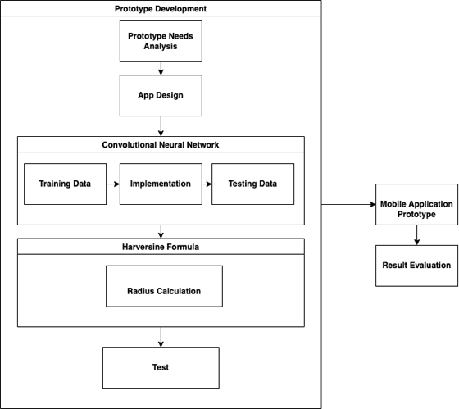

Figure 1. Application research and development flow

In Figure 1 above is a research flow from system development, then ends with an evaluation of the results, in the prototype development process, there are sub-processes in it, because in the system development process there is a system development model, namely the prototype.

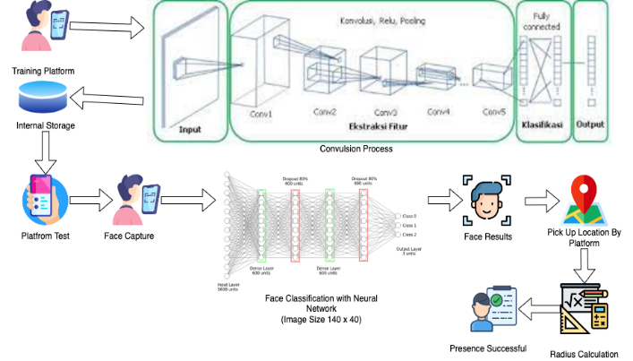

Figure 2. Analysys Prototype

The initial process is to do data training then do the convolutional neural network process which consists of convolution, filtering, pooling, flattening, then stored in internal storage . The face recognition authentication process uses a classification neural network which is the same as the previous training data. If a face is detected, it will then take the user's location and check the radius that has been determined. If the location is already within the radius, attendance can be done.
The GPS signal strength falls below a certain threshold (e.g., less than -80 dBm) or GPS signal is unavailable within a 450-meter radius from the reference point, the system should automatically switch to an alternative location determination method such as Wi-Fi triangulation or Bluetooth beacons. Implementing rule-based or machine learning algorithms for switching, along with testing in various environments, can help determine the best method based on signal conditions and ensure effective transitions between GPS and alternative methods.

RESULTS AND DISCUSSION

The At this stage according to the prototype. Information of thirty faces is stored in database and one location that has been set for testing, namely the LPKIA IDE which will be used later for system testing. Face information that has been stored in the database is registered through the mobile prototype. The mobile prototype will communicate with the database using an API either during verification or registration and that applies to face recognition and radius calculations. The mobile prototype for face recognition and radius calculation as shown in Figure 3.

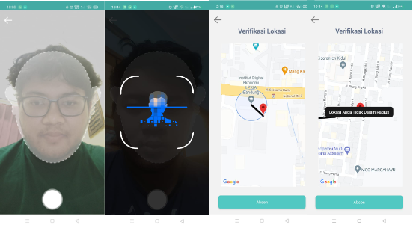

Figure 3. Mobile Prototype

The experimental results on face recognition using the cnn model are shown in Tables 1 and 2, and Figure 4 while the haversine formula is shown in table 3. Face recognition testing uses a static match test model. The static match test aims to determine the speed performance of the face recognition/face identification application in recognizing an input image.
The results of the static match test are shown in table 1.
Table 1. The performance of Static Match.

Image Testing  Name | Face Identification
Image Testing  Name | Time Second | Error Rate
Rizqy1 | 0.11 | 0.29
Rizqy2 | 0.11 | 0.32
Rizqy3 | 0.13 | 0.41
Rizqy4 | 0.12 | 0.42
Rizqy5 | 0.13 | 0.36
Taufik1 | 0.13 | 0.34
Taufik2 | 0.14 | 0.37
Taufik3 | 0.11 | 0.26
Taufik4 | 0.11 | 0.31
Taufik5 | 0.12 | 0.39
Anisa1 | 0.13 | 0.33
Anisa2 | 0.15 | 0.30
Anisa3 | 0.17 | 0.29
Anisa4 | 0.13 | 0.28
Anisa5 | 0.12 | 0.32
Rizky1 | 0.17 | 0.35
Rizky2 | 0.13 | 0.45
Rizky3 | 0.16 | 0.42
Rizky4 | 0.15 | 0.47
Rizky5 | 0.11 | 0.49
Rizal1 | 0.12 | 0.43
Rizal2 | 0.11 | 0.45
Rizal3 | 0.15 | 0.32
Rizal4 | 0.14 | 0.35
Rizal5 | 0.11 | 0.33
Reza1 | 0.14 | 0.24
Reza2 | 0.16 | 0.25
Reza3 | 0.17 | 0.33
Reza4 | 0.13 | 0.38
Reza5 | 0.12 | 0.45

The table 1. describes the results of the static math test with the aim of knowing the results of application performance and the error rate results generated from the neural network process at the fully connected layer stage. This test only tests face identification, because it focuses on testing system performance and finding the error rate from the training data results.
The implications of the results presented in Table 1 are significant for evaluating both the performance and the reliability of the application. By focusing exclusively on face identification, the test highlights how well the application’s neural network performs in accurately recognizing and distinguishing faces[14], [15]. The observed error rate provides valuable insights into the effectiveness of the fully connected layer stage within the neural network.
- Performance Assessment: The data indicates how well the application can perform face identification tasks under static conditions. High accuracy suggests that the application can effectively use neural network processing to identify faces[16], [17], making it reliable for scenarios where face recognition is crucial.
- Error Rate Analysis: The error rate results offer an understanding of the potential limitations and areas for improvement within the system. A higher error rate may point to issues such as insufficient training data, suboptimal network architecture, or inadequate feature extraction methods. This analysis can guide future adjustments and enhancements to reduce errors and improve overall performance.
- System Reliability: By concentrating on face identification, the results shed light on the application’s capability to handle specific tasks. This focused testing approach allows developers to pinpoint specific challenges related to face recognition and address them, potentially increasing the system's robustness.
- Training Data Insights: The results from the training data can help in assessing the quality and representativeness of the dataset used. If the application performs well with the given data, it implies that the training data is of good quality. Conversely, if the error rate is high, it may necessitate revising the dataset to include more diverse and comprehensive samples.
Overall, these implications underscore the importance of continuous testing and refinement. By addressing identified issues and leveraging insights gained from error rate analysis, developers can enhance the accuracy and reliability of the face identification system in real-world applications.

Then will be presented a graph of the overall results of the test results are shown in Figure 4.
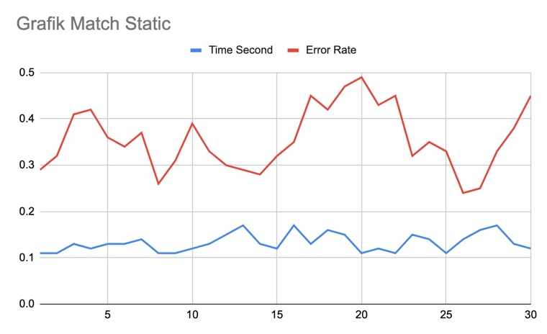

Figure 4. Mobile Prototype

The line graph illustrates the results of the static match test by 30 test data. In the graph, it can be concluded that the fastest time obtained is 0.11 second and the lowest error rate is 0.26. for the longest time obtained is 0.18 second and the highest error value is 0.38
The results obtained by the application from the performance test and error rate test are very dependent on field conditions, many factors support the test results, such as camera quality, light intensity, performance of the device used[18], [19]. From the results of the static match test, it can be obtained the assessment results in the form of the average of the maximum, minimum, and average of the total test data carried out which is presented in the following table.

Table 2. The assessment match static

Assessment | Time Second | Error Rate
Minimum | 0.11 | 0.24
Maximum | 0.17 | 0.49
Average | 0.132 | 0.356
From the assessment table above, it can be concluded that from the total data, the entire application can recognize an input image in the fastest time of 0.11 seconds with the lowest error rate ranging from 0.24. Then the longest level of time taken by the application in recognizing an input image is around 0.17 seconds with the highest error rate of 0.49. Then the average of the fastest time and the error rate by the application is 0.132 second and the error rate is around 0.356.
Next, verify the user's position with an agency as mentiod earlier radius of 50m inside and outside the radius. At this stage, a comparison is made between the distance calculated from the Haversine formula and the distance calculated from the Google Maps API calculation to get effective results. the result are shown in table 3.
Table 3. Calculations Effectives Results

No | Agency Location | User Location | Haversine Distrance (Km) | Google API Distance (Km) | Differen | Result Test
1 | Jl. Soekarno Hatta no. 456  Bandung  (-6.949757, 107.6246)  Inside Radius | (-6.949821, 107.6246) | 0.09 | 0.12 | 0.03 | Success
1 |  | (-6.949679, 107.62447) | 0.05 | 0.09 | 0.04 | Success
1 |  | (-6.949652, 107.62467) | 0.03 | 0.1 | 0.07 | Success
1 |  | (-6.949740, 107.62477) | 0.07 | 0.17 | 0.010 | Success
1 |  | (-6.949817, 107.62463) | 0.1 | 0.16 | 0.06 | Success
2 | Jl. Soekarno Hatta no. 456  Bandung  (-6.949757, 107.6246)  Outside Radius | (-6.949821, 107.6246) | 0.5 | 0.67 | 0.17 | Failed
2 |  | (-6.962751, 107.62663) | 1.5 | 1.8 | 0.3 | Failed
2 |  | (-6.952825, 107.62148) | 1.3 | 2.1 | 0.8 | Failed
2 |  | (-6.94992, 107.623833) | 0.3 | 0.5 | 0.2 | Failed
2 |  | (-6.949867, 107.62643) | 0.4 | 0.25 | 0.15 | Failed
From the tests that have been carried out with different user positions within the radius and outside the radius, the results can be seen in the table above, that this application has a good accuracy in determining the distance based on the comparison provided by Google Maps API with the Haversine calculation formula. The use of this application will be better if it is used indoors, because if it is used indoors, the accuracy will decrease or be inaccurate. This is because there is a possibility that the GPS signal used will interfere with other signals or the GPS signal will be blocked by buildings.
To address these limitations and improve accuracy, several enhancements can be considered[3], [20]. Implementing indoor positioning systems such as Wi-Fi triangulation or Bluetooth beacons could significantly boost location precision in environments where GPS signals are weak or obstructed. Additionally, incorporating algorithms that can intelligently switch between GPS and other positioning methods based on signal strength or availability may further enhance reliability[21], [22]. Further testing in various indoor settings will help refine these approaches and ensure that the application maintains its performance across different conditions. Continuous updates and optimizations, informed by user feedback and technological advancements, will be essential for maximizing the effectiveness of the application in diverse environments.

Critical Review of the Study's Limitations

1. Limited Data and Sample Size:
- Small Data Set: Currently, the database includes information from only thirty faces. This may not be sufficient to provide a comprehensive understanding of the system's performance, especially in real-world scenarios that may involve a wider range of variables and facial diversity.
- Data Variability: If the facial data used for testing is not sufficiently diverse, the results obtained may not accurately reflect the system's performance outside the sample used. For instance, the results from testing a specific group of individuals may differ from those of a more diverse population.
2. Static Match Test Evaluation:
- Limitations of Static Match Test: This test only evaluates the speed and error rate in face identification without considering other variables such as lighting conditions, viewpoint, or facial expressions. Additional testing under various lighting conditions and facial angles would provide a more comprehensive understanding of the system's robustness.
- Error Analysis: Although the data presents the range of times and error rates, a detailed analysis of the specific causes of errors (e.g., lighting conditions or camera quality) is lacking. This could provide deeper insights into how to reduce errors.
3. Haversine Formula and Google Maps API Comparison:
- Comparison Limitations: The comparison between the Haversine formula and Google Maps API provides insights into accuracy but does not address the limitations of each method. For example, the Haversine formula assumes the Earth is a perfect sphere, whereas its shape is slightly oblate.
- Environmental Impact: Distance measurement accuracy may be affected by environmental conditions such as obstructed or weak GPS signals. A more in-depth evaluation is needed to understand how these factors influence the results.
4. Recommendations for Improvement:
- Indoor Positioning Methods: Implementing indoor positioning systems like Wi-Fi triangulation or Bluetooth beacons could indeed enhance accuracy in areas with weak GPS signals. However, further implementation and testing in various indoor environments are required to ensure their effectiveness.
- Adaptive Algorithms: Incorporating algorithms that can intelligently switch between positioning methods based on signal strength or availability could further enhance reliability. Evaluating how these algorithms perform in different scenarios is necessary.
By addressing these limitations, it is anticipated that future research and system development will place greater emphasis on enhancing accuracy and reliability under diverse operational conditions.

CONCLUSION
From the results of research and testing that have been carried out for the implementation of the convolutional neural network method and the haversine formula method for the presence system, it can be applied according to the method and the results obtained are the use of the convolutional neural network method and the haversine formula method can be combined reliably to support the presence independently, because it uses biometric authentication in the form of face recognition and calculation of the distance from the user's point in real time with a predetermined radius so as to reduce the spread of COVID-19.
.

References
[1] M. L. Chiu and C. N. Lin, “Developing supply chain open innovation capability: The mediating role of the knowledge creation process, governance mechanism and technology as a driver,” J. Innov. Knowl., vol. 7, no. 4, Oct. 2022, doi: 10.1016/j.jik.2022.100264.
[2] M. Shahzad, Y. Qu, S. U. Rehman, and A. U. Zafar, “Adoption of green innovation technology to accelerate sustainable development among manufacturing industry,” J. Innov. Knowl., vol. 7, no. 4, Oct. 2022, doi: 10.1016/j.jik.2022.100231.
[3] P. C. Patel, M. Stenmark, V. Parida, and P. K. Tran, “A socio-institutional perspective on the reluctance among the elderly concerning the commercialization of 3D surgical video technology in Sweden,” J. Innov. Knowl., vol. 8, no. 2, Apr. 2023, doi: 10.1016/j.jik.2023.100361.
[4] M. T. Ballestar, E. Camiña, Á. Díaz-Chao, and J. Torrent-Sellens, “Productivity and employment effects of digital complementarities,” J. Innov. Knowl., vol. 6, no. 3, pp. 177–190, Jul. 2021, doi: 10.1016/j.jik.2020.10.006.
[5] S. T. Hussain, S. Lei, T. Akram, M. J. Haider, S. H. Hussain, and M. Ali, “Kurt Lewin’s change model: A critical review of the role of leadership and employee involvement in organizational change,” J. Innov. Knowl., vol. 3, no. 3, pp. 123–127, Sep. 2018, doi: 10.1016/j.jik.2016.07.002.
[6] B. Wassmann, M. Siegrist, and C. Hartmann, “The role of heuristics for composing an environmentally friendly meal,” J. Clean. Prod., vol. 402, May 2023, doi: 10.1016/j.jclepro.2023.136818.
[7] Y. T. Yadgar, “The effect of individual factors on user behaviour and the moderating role of trust: an empirical investigation of consumers’ acceptance of electronic banking in the Kurdistan Region of Iraq,” Financ. Innov., vol. 6, no. 1, Dec. 2020, doi: 10.1186/s40854-020-00206-0.
[8] A. Musamih, K. Salah, R. Jayaraman, I. Yaqoob, Y. Al-Hammadi, and J. Antony, “Blockchain-based solution for COVID-19 vaccine waste reduction,” J. Clean. Prod., vol. 372, Oct. 2022, doi: 10.1016/j.jclepro.2022.133619.
[9] G. Muchenje and M. Seppänen, “Unpacking task-technology fit to explore the business value of big data analytics,” Int. J. Inf. Manage., vol. 69, Apr. 2023, doi: 10.1016/j.ijinfomgt.2022.102619.
[10] M. Steen and J. Nauta, “Advantages and disadvantages of societal engagement: a case study in a research and technology organization,” J. Responsible Innov., vol. 7, no. 3, pp. 598–619, 2020, doi: 10.1080/23299460.2020.1813864.
[11] R. M. Puertas Medina, J. M. Martín Martín, J. M. Guaita Martínez, and P. Serdeira Azevedo, “Analysis of the role of innovation and efficiency in coastal destinations affected by tourism seasonality,” J. Innov. Knowl., vol. 7, no. 1, Jan. 2022, doi: 10.1016/j.jik.2022.100163.
[12] Y. K. Dwivedi et al., “Metaverse beyond the hype: Multidisciplinary perspectives on emerging challenges, opportunities, and agenda for research, practice and policy,” Int. J. Inf. Manage., vol. 66, Oct. 2022, doi: 10.1016/j.ijinfomgt.2022.102542.
[13] A. Alferaih, “Starting a New Business? Assessing University Students’ Intentions towards Digital Entrepreneurship in Saudi Arabia,” Int. J. Inf. Manag. Data Insights, vol. 2, no. 2, p. 100087, 2022, doi: 10.1016/j.jjimei.2022.100087.
[14] R. Sharma, A. Kumar, and C. Chuah, “Turning the blackbox into a glassbox: An explainable machine learning approach for understanding hospitality customer,” Int. J. Inf. Manag. Data Insights, vol. 1, no. 2, Nov. 2021, doi: 10.1016/j.jjimei.2021.100050.
[15] Q. Jiang, X. Huang, and Z. Chen, “Antecedents and consequences of consumers’ trust in electronic intermediaries: An empirical study of hotel booking websites,” Front. Bus. Res. China, vol. 3, no. 4, pp. 647–666, 2009, doi: 10.1007/s11782-009-0031-1.
[16] Y. Zhai, “Design of Oral English Training System Based on Big Data Content Recommendation Algorithm,” in Procedia Computer Science, Elsevier B.V., 2022, pp. 420–426. doi: 10.1016/j.procs.2022.10.059.
[17] J. Gao, Q. Feng, T. Guan, and W. Zhang, “Unlocking paths for transforming green technological innovation in manufacturing industries,” J. Innov. Knowl., vol. 8, no. 3, Jul. 2023, doi: 10.1016/j.jik.2023.100394.
[18] G. D. Sharma, S. Kraus, M. Srivastava, R. Chopra, and A. Kallmuenzer, “The changing role of innovation for crisis management in times of COVID-19: An integrative literature review,” J. Innov. Knowl., vol. 7, no. 4, Oct. 2022, doi: 10.1016/j.jik.2022.100281.
[19] C. Li, A. Khan, H. Ahmad, and M. Shahzad, “Business analytics competencies in stabilizing firms’ agility and digital innovation amid COVID-19,” J. Innov. Knowl., vol. 7, no. 4, Oct. 2022, doi: 10.1016/j.jik.2022.100246.
[20] M. Skare and D. Riberio Soriano, “How globalization is changing digital technology adoption: An international perspective,” J. Innov. Knowl., vol. 6, no. 4, pp. 222–233, Oct. 2021, doi: 10.1016/j.jik.2021.04.001.
[21] I. Kulkov et al., “Technology entrepreneurship in healthcare: Challenges and opportunities for value creation,” J. Innov. Knowl., vol. 8, no. 2, Apr. 2023, doi: 10.1016/j.jik.2023.100365.
[22] L. P. Qu and H. Li, “Analysis of distribution path optimization algorithm based on big data technology,” J. King Saud Univ. - Sci., vol. 34, no. 5, Jul. 2022, doi: 10.1016/j.jksus.2022.102019.

IEEE conference templates contain guidance text for composing and formatting conference papers. Please ensure that all template text is removed from your conference paper prior to submission to the conference. Failure to remove template text from your paper may result in your paper not being published.

