Cluster Head Selection and Data Dissemination with Multicast Protocol in Vehicular Communication

1st Mohammed Ihsan
Department of Computer Technical Engineering
College of Technical Engineering
The Islamic University
Najaf, Iraq
moh.mtech89@iunajaf.edu.iq.
4th Waleed Hadi Madhloom Kurdi
Department of Computer Science
Altoosi University College
Najaf, Iraq
waleedalkurdi@altoosi.edu.iq
2nd Hussein Al-Aboudy
Department of Computer Techniques Engineering
Mazaya University College
DhiQar, Iraq;
huhraiz22@mpu.edu.iq.
5th Fatima H. Alsalamy
Medical Laboratories Techniques Department
Al-Mustaqbal University
Hillah, Iraq
fatimahashim109@gmail.com.
3rd Gayatri Parasa
Department of Computer Science and Engineering
Koneru Lakshmaiah Education Foundation
Vaddeswaram, India
fatimahashim109@gmail.com.
6th Zahraa Saad Abdulali
National University of Science and Technology
Dhi Qar, Iraq
zahraa.s.abdulali@nust.edu.iq.

Abstract— In vehicular ad hoc network (VANETs), vehicles travel at high speed from one place to another that create certain issues like congestion, delay and high power consumption. Reducing the delay and power consumption is the primary task to attend effective performance among the vehicles. For that purpose in this article cluster head (CH) selection and the data dissemination with multicast protocol (CHDMV) is concentrated. The subsections of this model are the vehicles clustering process, cluster maintenance and multicast protocol, with the presence of this processes the efficiency of the network is improved even if the vehicle travels at high speed with rapidly changing topology. The parameters which are measured to analyze the outcomes are packet delivery ratio, network throughput, average delay, energy efficiency and routing overhead. From the calculator result it is shown that the CHDMV attends maximum performance in terms of efficiency and delivery ratio.
Keywords— Vehicular ad hoc network (VANETs), CH Selection Process, Data Dissemination and Multicast Routing Protocol.

Introduction
Capabilities of vehicles which are present in the VANETs are rapidly changing topology and high speed which becomes the biggest challenge and it’s slow down the standard of such a promising technology [1-3]. Development of vehicular architecture is not easy nowadays hence it is highly attracted by the research scholars and industrial experts [4-8]. The network types which are suitable for vehicular communication are ad hoc, computer network, Internet of Things (IOTs) and Unmanned Arial Vehicles (UAVs) [9-12]. Some of the issues which are present in the vehicular technology are limited battery power and delay occurrences due to rapid mobility [13-16]. It is very important to design a model with provides effective power utilization among the devices to maximize the lifetime of it [17-20]. For that process maximum of the time selected technology is clustering and it is highly suitable for vehicular communication to improve the energy factors [21-24].
In cluster communication devices are grouped into various clusters [25-28] and each cluster consists of its cluster head (CH) and its members [29-32]. This clustering is suitable for vehicular communication to reduce its energy consumption and it can able to provide a stable bunching procedure so that it can able to improve the performance of both vehicle to vehicle and infrastructure based communication [33-36]. At the initial stage the node with high residual energy is selected as CH and the nodes which are present in its coverage area become its members and the CH monitors the communications which are carried out by the devices which are present in its coverage area. In terms of densely populated and high speed mobility the earlier methodologies are not sufficient and still this research is in an open area and it need further improvement to maximize the communication quality of vehicular network [37-40]. For that purpose in this article cluster head selection and data dissemination with multicast protocol is developed and the major roles are described below.
The primary goal of this suggested approach is to increase device efficiency by offering a multicast protocol and an efficient clustering mechanism that allow cars to efficiently manage their neighbor list and speed. This procedure reduces the vehicles' delays and power consumption, which extends their lifespan and increases their efficiency.

Related Works
In [41], suggested an LTE-based multi-hop multicast network that uses CMMP and CMBMP for efficient alert notification dissemination, demonstrating superior performance in simulations and the drawback is high delay. In [42], explained CVoEG to improve communication reliability in high-speed VANETs, introducing CEG-RAODV for enhanced performance compared to existing approaches with high overhead as disadvantage. In [43], VANET stability and reliability. PMC improves inter-cluster node reliability during cluster head selection and outperforms N-HOP, VmaSC and DMCNF algorithms in the NS2 environment. In [44], facilitates dynamic information distribution, especially in Intelligent Transport System applications. The trust-based clustering proposed enhances security and stability, outperforming existing approaches and the disadvantage here is high delay.
In [45], explores a rapid message dissemination clustering mechanism in vehicular communication networks, utilizing a two-step approach for optimized beamforming and clustering with consistent adherence to backhaul rate constraints in simulations. In [46], author Sami Ullah enhances reliable emergency message delivery, showing significant performance improvements in diverse traffic conditions but the disadvantages are high power consumption. In [47], suggests CLLTR, a novel central lane-based routing protocol for cluster-based VANETs, the drawback is high delay. In [48], author K. Srinija introduces a secure VANET authentication method, Identity Mapping with a cluster-based revocation approach, which outperforms existing works, as validated through simulations and comparative analysis.
In [49], proposes resilient power control techniques and collaborative clustering to overcome these issues, validated by numerical simulations for high-dynamic systems but the drawback here is high packet loss. In [50], modifying transmission probability based on cluster size, enhancing performance in terms of productivity, PDR, and latency by analytical studies and simulations, however the negative is the significant overhead. In [51], introduces an efficient VANET clustering routing protocol using an enhanced ACO framework, demonstrated through NS2 simulations, the proposed DA-TRPED technique and optimized ACO promise improved road safety and message routing with high delay. In [52], evaluates the usefulness of an element interaction model in VANET, boosting efficiency through clustering, especially when integrating RSUs into clusters with sharing cache. The drawback is substantial packet loss. In [53], address interference and congestion the proposed VLC-based clustering algorithm improves data rates in urban and highway scenarios but the disadvantage is high delay. The earlier design issues are given in Table I.
- Earlier Design Issues.
No | Methodology | Advantages | Disadvantages
[45] | Rapid Message Dissemination Clustering Mechanism | Optimized beamforming and clustering | Low throughput
[48] | Identity Mapping and Cluster-based Revocation Approach | Provides high security | High energy consumption
[50] | Transmission Probability Adjustment based on Cluster Size | Improved throughput, PDR, and delay | High overhead
[51] | Efficient VANET Clustering Routing Protocol | Improved road safety and message routing | High delay
[52] | Element Interaction Model | Enhanced efficiency | High packet loss
[53] | VLC-based Clustering Algorithm | Improved data rates | High delay

Proposed CHDMV Model.
This CHDMV is mainly designed to provide high efficiency to the vehicular communication.
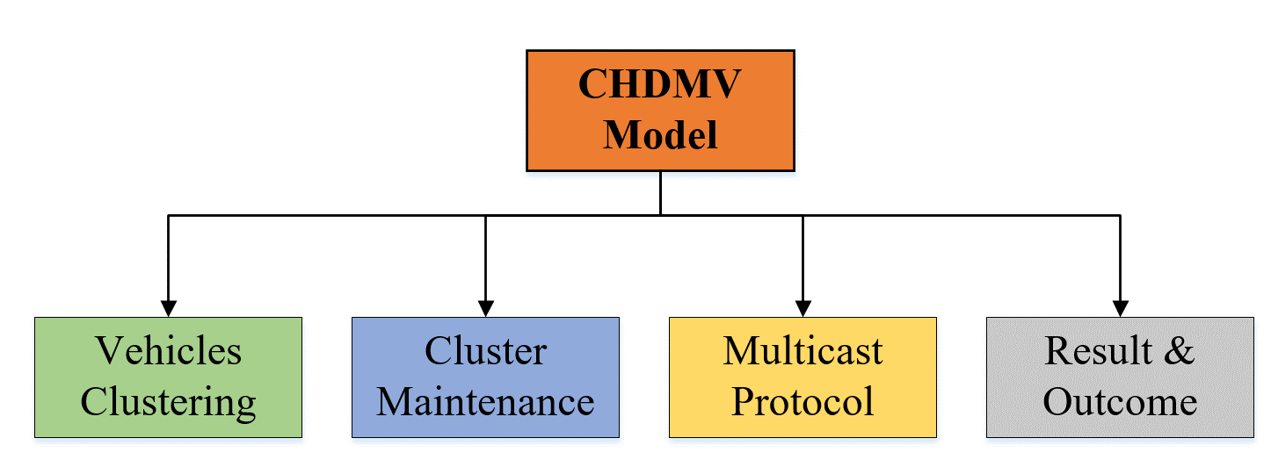
- CHDMV Workflow.
The core modules of this model are the vehicles clustering process, cluster maintenance and multicast protocol. The flow of the CHDMV is described in “Fig.1”.

Vehicles Clustering Process.
This is the first algorithm that we have presented for the approach. The process uses all of the automobiles as input, and the output is the deployment of a VANET network to find routes. During the first iteration, automobiles will initially be deployed via the network. Node migration will start with the second repeat. Calculate the total number of centroids needed and the separation between the center and each node. The coordinates of each vehicle (vx and vy) must be saved in a file called K-means data before a network is clustered using the k-means technique. The best method for transmitting data will then be chosen after determining the source and destination of the network. Proceed if the discovered path.

Cluster Maintenance
Because vehicles move so quickly, creating a highly dynamic topology and numerous network disconnections, the clusters require regular and ongoing maintenance when they are successfully formed. Two scenarios need clustering maintenance: Case 1: A vehicle certifies a few things when it is a Cluster Member (CM): It is constantly monitoring the CH, and if it loses the vehicle, it will exit the cluster, return to the NS, and search for another appropriate cluster. It determines if the eyesight range is enough and the cluster's road monitoring is unnecessary. Case 2: When a vehicle is classified as a Cluster Head, it performs two tests: If the viewing area is not sufficient, it disbands the cluster and returns the CH to the network server. When the CH determines that every CM has departed, the cluster will be dissolved.

Multicast Protocol
We introduce the CMBMP algorithm, which is the second approach and distributes WM messages throughout an AOR using both broadcast and multicast methods. According to the CMMP, this approach uses a designated slot to transmit the WM message within the source cluster. Once the WM message reaches the source cluster's CH, the CH uses the LTE Physical Uplink Shared Channel (PUSCH) to transfer the WM to the eNodeB over the uplink. When the eNodeB gets the caution note, it uses the Traffic Map Controller (TMC) to compute an Area of Responsibility (AOR) and broadcasts the message to every CH that is part of an AOR. Using an LTE broadcast channel, the eNodeB will simultaneously broadcast the WM to every CH. Figure 8 illustrates the CMBMP's usage of the time-staggered resource allocation approach. After receiving the WM after the source cluster head ${CH}_{i}$, the eNodeB will use the LTE broadcast channel to downlink the identical WM to all succeeding clusters in an AOR, ${CH}_{i+1}$ and ${CH}_{i+2}$. AOR-wide, the eNodeB will allocate the reserved slots (TMM slot) to all clusters ${CH}_{i+1}$, ${CH}_{i+2}$...CHn+N via downlink using the PDCCH in various LTE time frames, n + 1 and n + 2, and so forth, while simultaneously broadcasting the cautionary alert. Furthermore, by using the selected slot TWMslot, each CH in the AOR will multicast the similar WM in its own cluster. The CMMP and CMBMP vary in that the former distributes messages in a chain process, while the latter uses a staggered transmission manner.

Simulation Results.
The implementation of the proposed network model is constructed in the software NS2 which is the combination of c++ and object tool command language. This networking software is incorporated with the Ubuntu operating system. To generate the vehicular mobility which is the presence of real time traffic scenarios the software of Open Street map and sumo mobility generator is used. The output parameters which are calculated to measure the network performance are packet delivery ratio, network throughput, average delay, energy efficiency and routing overhead. The calculated results are compared with the earlier baseline methodologies like EACO [51], CBVE [52] and ECVC [53] and as well the input parameters which are present in this simulation experimentation are given in table II.
- Input Parameters Table
Input Parameters | Values
Running Time | 150 ms
Coverage Distance | 1000m*900m [54]
Number of Nodes | 200 Nodes [55]
Node Radius | 150m [56]
Initial Energy | 100 Joules [57]
Transmission Power | 0.500 Joules [58]
Receiving Power | 0.050 Joules [58]

Packet Delivery Ratio.
It is the calculation of success rate of the generator packets which is successfully transmitted to the destination from the source at the time of high speed data transmission with random mobility.
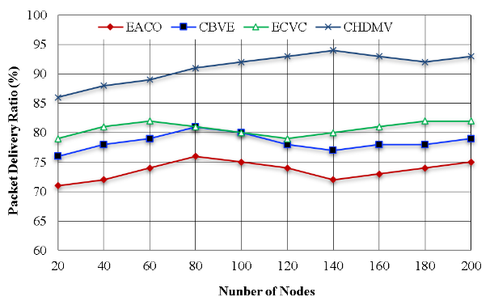
- Packet Delivery Ratio.
The initial goal of this article is to attain maximum delivery ratio among the devices in the network. In “Fig.2”, the delivery ratio performance of the CHDMV is calculator and it is compared with the earlier works like EACO, CBVE and ECVC. With the presence of cluster based network construction and its maintenance the data transmission rate which gets successfully received by the destination is greatly increased. From this result it is proven that the CHDMV around 8% better delivery ratio than the earlier methods.

Network Throughput
It is the calculation of the amount of packets which are generated in the source vehicles before the data transmission. Increase of delivery ratio maximizes the generation of data packets among the devices. In “Fig.3”, the throughput calculation of the CHDMV is described and it is compared with the earlier methods like EACO, CBVE and ECVC. With the presence of an efficient clustering model this CHDMV achieves maximum throughput which is around 200kbps higher.

Average Delay.
It is the calculation of the travel speed of the vehicles from the predefined time period and the delay time.
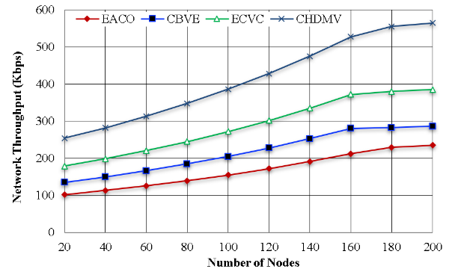
- Network Throughpu.
To attend efficient communication among the high speed vehicles it is very essential to reduce the delay occurrences among the vehicles at the time of data transmission. In “Fig.4”, the delay calculation of the CHDMV is described and it is compared with the other methods like EACO, CBVE and ECVC. With the presence of an efficient clustering process and the cluster maintenance the delay occurrences are reduced in the CHDMV which is up to 30ms lower than the other methods.
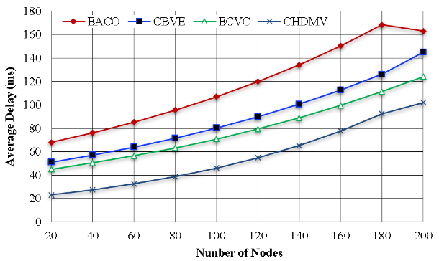
- Average Delay.

Energy Efficiency
The high-speed vehicles with random mobility engage in vehicle-based network communication. A specific quantity of energy is used at each transmission in order for it to carry out its intended function. Additionally, after the conclusion of the simulation, a specific quantity of energy is still present in the network; this is known as the network's residual energy or energy efficiency. The major goal of this CHDMV is to increase the high-speed vehicles' energy efficiency. “Fig.5”, describes the CHDMV's energy calculation and compares the results with the previous baseline procedures. As a consequence, the CHDMV achieves an efficiency that is approximately 250 joules greater than that of the other methods.
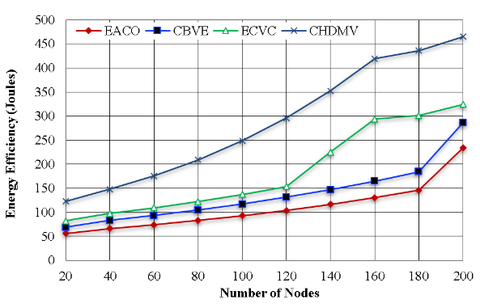
- Energy Efficiency.

Routing Overhead.
It is the calculation of the data forwarded ratio which is calculated when the generated data crosses the threshold of the transmission limit. Reduction of routing overhead results in achieving maximum efficiency among the vehicles in the network. In “Fig.6”, the overhead calculation of the CHDMV is given and it is compared with the other methods. The result shows that the CHDMV produces lower overhead which is around 100 packets lower than the other methods.
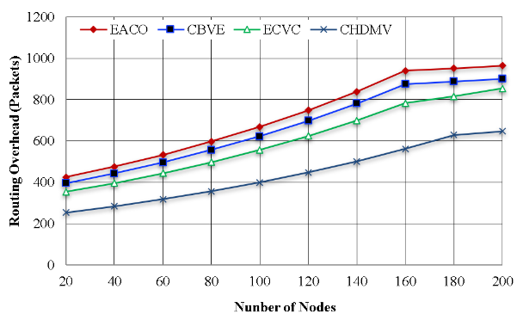
- Routing Overhead.

Conclusion.
The aim of CHDMV is to increase the energy efficiency and to reduce the delay occurrences of the vehicular communication. To increase the energy efficiency and to reduce the power utilization, clustering model is concentrated here the vehicles are grouped so that repeated data transmissions are reduced and that will reduce the power utilization of the devices. With the presence of the multicast routing process the data transmission is effectively monitored and that reduces the delay and packet loss. From the final result it is proven that CHDMV attends better performance when compared with the earlier methodologies in terms of energy efficiency and delivery ratio. In future direction load balancing is concentrated to monitor the high speed vehicles and densely populated area and remote monitoring.

References
- A. H. Abbas, A. J. Ahmed, S. A. Rashid, M. A. Jubair, N. F. Abdulsattar, H. S. Mansour, and M. I. Habelalmateen, "Hybrid ANT Based Continuous Cuckoo Search Optimization Algorithm for Vehicle Adhoc Networks," in 2022 5th International Conference on Engineering Technology and its Applications (IICETA), pp. 447-452, May 31-June 1, 2022. https://doi.org/10.1109/IICETA54559.2022.9888404.
- R. Q. Malik, K. N. Ramli, Z. H. Kareem, M. I. Habelalmatee, A. H. Abbas, and A. Alamoody, "An Overview on V2P Communication System: Architecture and Application," in 2020 3rd International Conference on Engineering Technology and its Applications (IICETA), pp. 174-178, 2020. doi: https://doi.org/10.1109/IICETA50496.2020.9318863.
- Y.S. Jghef, M.J.M. Jasim, H.M.A. Ghanimi, A.D. Algarni, N.F. Soliman, W. El-Shafai, S.R.M. Zeebaree, A. Alkhayyat, A.S. Abosinnee, N.F. Abdulsattar, A.H. Abbas, H.M. Hariz, and F.H. Abbas, "Bio-Inspired Dynamic Trust and Congestion-Aware Zone-Based Secured Internet of Drone Things (SIoDT)," Drones, vol. 6, no. 11, pp. 337, 2022. https://doi.org/10.3390/drones6110337.
- G.G. Shayea, D.A. Mohammed, A.H. Abbas, and N.F. Abdulsattar, "Privacy-Aware Secure Routing through Elliptical Curve Cryptography with Optimal RSU Distribution in VANETs," Designs, vol. 6, no. 6, pp. 121, 2022. doi: https://doi.org/10.3390/designs6060121.
- A. H. Najim, A. H. Abbas, K. Al-sharhanee, and H. M. Hariz, "Reinforcement Learning-based Topology-Aware Routing Protocol with Priority Scheduling for Internet of Drones in Agriculture Application," International Journal of Intelligent Engineering and Systems, vol. 16, no. 5, pp. 395-405, 2023. doi: https://doi.org/10.22266/ijies2023.1031.34.
- A. H. Abbas, A. J. Ahmed, S. A. Rashid, N. F. Abdulsattar, M. H. Hassan, M. A. Jubair, and M. I. Habelalmateen, "Predictive Hybrid Routing with Multi Objective Optimization Model for Opportunistic Routing for VANET," in 2022 5th International Conference on Engineering Technology and its Applications (IICETA), pp. 470-476, 2022. doi: https://doi.org/10.1109/IICETA54559.2022.9888274.
- M.H. Hassan, A.H. Abbas, M.H. Mutar, M.A. Jubair, S.A. Rashid, A.J. Ahmed, M.I. Habelalmateen, A. Mohammed, and L. Audah, "Investigative Study on Routing Protocols in Flying Ad Hoc Networks Environment," in 2022 5th International Conference on Engineering Technology and its Applications (IICETA), pp. 460-463, 2022. doi: https://doi.org/10.1109/IICETA54559.2022.9888600.
- N.F. Abdulsattar, A.H. Abbas, M.H. Mutar, M.H. Hassan, M.A. Jubair, and M.I. Habelalmateen, "An Investigation Study for Technologies, Challenges and Practices of IoT in Smart Cities," in 2022 5th International Conference on Engineering Technology and its Applications (IICETA), pp. 554-557, 2022. DOI: https://doi.org/10.1109/IICETA54559.2022.9888474.
- M. K. Hasan, M. M. Ahmed, N. F. Wani, A. H. Abbas, L. M. Alkwai, S. Islam, A. K. M. A. Habib, and R. Hassan, "Dynamic load modeling for bulk load-using synchrophasors with wide area measurement system for smart grid real-time load monitoring and optimization," Sustainable Energy Technologies and Assessments, vol. 57, p. 103190, 2023. doi: https://doi.org/10.1016/j.seta.2023.103190
- A. H. Abbas, M. I. Habelalmateen, L. Audah, and N. A. M. Alduais, "A novel intelligent cluster-head (ICH) to mitigate the handover problem of clustering in VANETs," International Journal of Advanced Computer Science and Applications, vol. 10, no. 6, pp. 281-287, 2019. DOI: https://doi.org/10.14569/IJACSA.2019.0100627.
- N. F. Abdulsattar, D. A. Mohammed, A. Alkhayyat, S. Z. Hamed, H. M. Hariz, A. S. Abosinnee, A. H. Abbas, M. H. Hassan, M. A. Jubair, F. H. Abbas, A. D. Algarni, N. F. Soliman, and W. El-Shafai, "Privacy-Preserving Mobility Model and Optimization-Based Advanced Cluster Head Selection (P2O-ACH) for Vehicular Ad Hoc Networks," Electronics, vol. 11, no. 24, p. 4163, 2022, DOI: https://doi.org/10.3390/electronics11244163.
- F. Abedi, S. R. M. Zeebaree, Z. S. Ageed, H. M. A. Ghanimi, A. Alkhayyat, M. A. M. Sadeeq, S. N. Mahmood, A. S. Abosinnee, Z. H. Kareem, A. H. Abbas, W. K. Al-Azzawi, M. M. Jaber, and M. Dauwed, "Severity Based Light-Weight Encryption Model for Secure Medical Information System," Computers, Materials & Continua, vol. 74, no. 3, pp. 5691-5704, 2023. DOI: https://doi.org/10.32604/cmc.2023.034435.
- N.F. Abdulsattar, F. Abedi, H.M.A. Ghanimi, S. Kumar, A.H. Abbas, A.S. Abosinnee, A. Alkhayyat, M.H. Hassan, and F.H. Abbas, "Botnet Detection Employing a Dilated Convolutional Autoencoder Classifier with the Aid of Hybrid Shark and Bear Smell Optimization Algorithm-Based Feature Selection in FANETs," Big Data and Cognitive Computing, vol. 6, no. 4, article no. 112, 2022. DOI: https://doi.org/10.3390/bdcc6040112.
- V. O. Nyangaresi, I. M. Al-Joboury, K. A. Al-sharhanee, A. H. Najim, A. H. Abbas, and H. M. Hariz, "A biometric and physically unclonable function–Based authentication protocol for payload exchanges in internet of drones," e-Prime - Advances in Electrical Engineering, Electronics and Energy, vol. 7, pp. 100471, 2024. DOI: https://doi.org/10.1016/j.prime.2024.100471
- A. H. Abbas, L. Audah, and N. A. M. Alduais, "An Efficient Load Balance Algorithm for Vehicular Ad-Hoc Network," in 2018 Electrical Power, Electronics, Communications, Controls and Informatics Seminar (EECCIS), pp. 207-212, 2018. https://doi.org/10.1109/EECCIS.2018.8692827
- A. H. Kadhim, A. M. Razaq, M. A. Jubair, N. F. Abdulsattar, A. H. Abbas, M. H. Hassan, A. Jamal Ahmed, S. AbdulJabbar Rashid, and M. I. Habelalmateen, "A Real-Time Low-Cost Remote Doctor Monitoring System," in 2022 5th International Conference on Engineering Technology and its Applications (IICETA), pp. 558-561, 2022. doi: https://doi.org/10.1109/IICETA54559.2022.9888536.
- F. Abedi, H. M. A. Ghanimi, A. D. Algarni, N. F. Soliman, W. El-Shafai, A. H. Abbas, Z. H. Kareem, H. M. Hariz, and A. Alkhayyat, "Computational Intelligence Driven Secure Unmanned Aerial Vehicle Image Classification in Smart City Environment," Computer Systems Science and Engineering, vol. 47, no. 3, pp. 3127-3144, 2023. DOI: https://doi.org/10.32604/csse.2023.038959.
- A. H. Abbas, H. Mansour, and A. Al-Fatlawi, "Self-Adaptive Efficient Dynamic Multi-Hop Clustering (SA-EDMC) Approach for Improving VANET’s Performance," International Journal of Interactive Mobile Technologies (iJIM), vol. 16, no. 14, pp. 136-151, Jul. 2022. DOI: https://doi.org/10.3991/ijim.v16i14.31081.
- M. I. Habelalmateen, A. H. Abbas, L. Audah, and N. A. M. Alduais, "Dynamic multiagent method to avoid duplicated information at intersections in VANETs," Telkomnika (Telecommunication Computing Electronics and Control), vol. 18, no. 2, pp. 613-621, 2020. DOI: http://doi.org/10.12928/telkomnika.v18i2.13947.
- I. S. Al-Hawary, E. Ali, S. M. H. Kamona, L. Hussain Saleh, A. S. Abdulwahid, D. N. Al-Saidi, M. S. Alhassan, F. A. Rasen, H. Abdullah Abbas, A. Alawadi, A. H. Abbas, and M. Sina, "Prediction of geomechanical bearing capacity using autoregressive deep neural network in carbon capture and storage systems," Heliyon, vol. 9, no. 11, pp. e21913, Nov. 2023. doi: https://doi.org/10.1016/j.heliyon.2023.e21913.
- M. R. M. Alsemawi, M. H. Mutar, E. H. Ahmed, H. O. Hanoosh, and A. H. Abbas, "Emotions recognition from human facial images based on fast learning network," Indonesian Journal of Electrical Engineering and Computer Science, vol. 30, no. 3, pp. 1478-1487, 2023. doi: http://doi.org/10.11591/ijeecs.v30.i3.pp1478-1487.
- J. Tang, A. K. Abbas, N. A. Koka, N. Sadoon, J. K. Abbas, R. A. Abdalhuseen, M. Abosaooda, N. M. Ahmed, and A. H. Abbas, "Optimization of thermal biofuel production from biomass using CaO-based catalyst through different algorithm-based machine learning approaches," Case Studies in Thermal Engineering, vol. 50, p. 103419, 2023. doi: https://doi.org/10.1016/j.csite.2023.103419.
- F. Abedi, H. M. A. Ghanimi, A. D. Algarni, N. F. Soliman, W. El-Shafai, A. H. Abbas, Z. H. Kareem, H. M. Hariz, and A. Alkhayyat, "Chimp Optimization Algorithm Based Feature Selection with Machine Learning for Medical Data Classification," Computer Systems Science and Engineering, vol. 47, no. 3, pp. 2791–2814, 2023. doi: https://doi.org/10.32604/csse.2023.038762.
- M. A. A. Albadr et al., "Online sequential extreme learning machine approach for breast cancer diagnosis," Neural Computing and Applications, vol. Volume, no. Issue, pp. Page, 2024. DOI: https://doi.org/10.1007/s00521-024-09617-x.
- M. S. Alshuhri, S. G. Al-Musawi, A. A. Al-Alwany, H. Uinarni, I. Rasulova, P. Rodrigues, A. T. Alkhafaji, A. M. Alshanberi, A. H. Alawadi, and A. H. Abbas, "Artificial intelligence in cancer diagnosis: Opportunities and challenges," Pathology - Research and Practice, vol. 253, pp. 154996, 2024. https://doi.org/10.1016/j.prp.2023.154996.
- F. Abedi, H. M. A. Ghanimi, M. A. M. Sadeeq, A. Alkhayyat, Z. H. Kareem, S. N. Mahmood, A. H. Abbas, A. S. Abosinnee, W. K. Al-Azzawi, M. M. Jaber, and M. Dauwed, "Hybrid Deep Learning Enabled Load Prediction for Energy Storage Systems," Computers, Materials & Continua, vol. 75, no. 2, pp. 3359-3374, 2023. DOI: https://doi.org/10.32604/cmc.2023.034221.
- I. Ahmad, S. Hussain, S. N. Mahmood, H. Mostafa, A. Alkhayyat, M. Marey, A. H. Abbas, and Z. Abdulateef Rashed, "Co-Channel Interference Management for Heterogeneous Networks Using Deep Learning Approach," Information, vol. 14, no. 2, article no. 139, 2023. DOI: https://doi.org/10.3390/info14020139.
- A. M. Abdulkarem, F. Abedi, H. M. A. Ghanimi, S. Kumar, W. K. Al-Azzawi, A. H. Abbas, A. S. Abosinnee, I. M. Almaameri, and A. Alkhayyat, "Robust Automatic Modulation Classification Using Convolutional Deep Neural Network Based on Scalogram Information," Computers, vol. 11, no. 11, article no. 162, 2022. DOI: https://doi.org/10.3390/computers11110162.
- S. Alsubai, A. K. Dutta, A. H. Alkhayyat, M. M. Jaber, A. H. Abbas, and A. Kumar, "Hybrid deep learning with improved Salp swarm optimization based multi-class grape disease classification model," Computers and Electrical Engineering, vol. 108, p. 108733, 2023. DOI: https://doi.org/10.1016/j.compeleceng.2023.108733.
- A. H. Abbas, N. F. Abdulsattar, H. S. Mansour, M. H. Mutar, M. I. Habelalmateen, L. Audah, N. A. M. Alduais, and A. Mohammed, "A New Hybrid Approach Cluster-Heads Election to reduce the number of clusters in VANETs," in 2022 5th International Conference on Engineering Technology and its Applications (IICETA), pp. 436-440, 2022. DOI: https://doi.org/10.1109/IICETA54559.2022.9888442.
- M. A. Jubair, S. A. Mostafa, D. A. Zebari, H. M. Hariz, N. F. Abdulsattar, M. H. Hassan, A. H. Abbas, F. H. Abbas, A. Alasiry, and M. Turki-Hadj, "A QoS Aware Cluster Head Selection and Hybrid Cryptography Routing Protocol for Enhancing Efficiency and Security of VANETs," IEEE Access, vol. 10, pp. 124792-124804, 2022. doi: https://doi.org/10.1109/ACCESS.2022.3224466.
- A. Abdulbari, S. K. Abdul Rahim, F. Abedi, P. J. Soh, A. Hashim, R. Qays, S. Ahmad, and M. Y. Zeain, "Single-Layer Planar Monopole Antenna-Based Artificial Magnetic Conductor (AMC)," International Journal of Antennas and Propagation, vol. 2022, pp. 6724175, 2022. https://doi.org/10.1155/2022/6724175.
- S. Saleem, A. H. Jabbar, M. H. Jameel, A. Rehman, Z. H. Kareem, A. H. Abbas, Z. Ghaffar, S. A. Razzaq, R. A. Pashameah, E. Alzahrani, E.-P. Ng, and S. M. Sapuan, "Enhancement in structural, morphological, and optical properties of copper oxide for optoelectronic device applications," Nanotechnology Reviews, vol. 11, no. 1, pp. 2827-2838, 2022.DOI: https://doi.org/10.1515/ntrev-2022-0473.
- A. H. Abbas, A. J. Ahmed, and S. A. Rashid, "A Cross-Layer Approach MAC/NET with Updated-GA (MNUG-CLA)-Based Routing Protocol for VANET Network," World Electric Vehicle Journal, vol. 13, no. 5, article no. 87, 2022. DOI: https://doi.org/10.3390/wevj13050087.
- H. S. Mansour, M. H. Mutar, I. A. Aziz, S. A. Mostafa, H. Mahdin, A. H. Abbas, M. H. Hassan, N. F. Abdulsattar, and M. A. Jubair, "Cross-Layer and Energy-Aware AODV Routing Protocol for Flying Ad-Hoc Networks," Sustainability, vol. 14, no. 15, article no. 8980, 2022. DOI: https://doi.org/10.3390/su14158980.
- M. I. Habelalmateen, A. J. Ahmed, A. H. Abbas, and S. A. Rashid, "TACRP: Traffic-Aware Clustering-Based Routing Protocol for Vehicular Ad-Hoc Networks," Designs, vol. 6, no. 5, article no. 89, 2022. DOI: https://doi.org/10.3390/designs6050089.
- S. A. Rashid, M. I. Habelalmateen, A. J. Ahmed, A. H. Abbas, M. A. Jubair, M. H. Hassan, A. Abdulhadi, S. Hammed, and L. Audah, "Congestion Aware Genetic Q-learning Based RPL Routing Protocol for Vehicle Ad-Hoc Networks," in 2022 5th International Conference on Engineering Technology and its Applications (IICETA), pp. 464-469, 2022. doi: https://doi.org/10.1109/IICETA54559.2022.9888583.
- A. H. Alwan, A. A. Aziz, M. A. Jubair, A. H. Abbas, M. H. Hassan, S. Alheejawi, N. F. Abdulsattar, A. S. Mustafa, and M. I. Habelalmateen, "Monitoring the Impact of the Nodes Density on the MANETs’ Environment," in 2022 5th International Conference on Engineering Technology and its Applications (IICETA), pp. 546-549, 2022. doi: https://doi.org/10.1109/IICETA54559.2022.9888339.
- Mostafa, S.A., Mustapha, A., Ramli, A.A., Jubair, M.A., Hassan, M.H., Abbas, A.H. (2021). Comparative Analysis to the Performance of Three Mobile Ad-Hoc Network Routing Protocols in Time-Critical Events of Search and Rescue Missions. In: Cassenti, D., Scataglini, S., Rajulu, S., Wright, J. (eds) Advances in Simulation and Digital Human Modeling. AHFE 2020. Advances in Intelligent Systems and Computing, vol 1206. Springer, Cham. https://doi.org/10.1007/978-3-030-51064-0_16.
- M. H. Hassan, M. A. Jubair, A. H. Abbas, A. J. Ahmed, S. A. Rashid, M. H. Mutar, H. S. Mansour, A. Ali, and M. I. Habelalmateen, "AODV based Crow Search Algorithm for Improving the QoS of MANET," in 2022 5th International Conference on Engineering Technology and its Applications (IICETA), pp. 424-428, 2022. DOI: https://doi.org/10.1109/IICETA54559.2022.9888484.
- Jamil Y. Khan and Duy T. Ngo, "Clustered Multicast Protocols for Warning Message Transmissions in a VANET", IEEE Vehicular Networking Conference (VNC), 2019, doi:10.1109/VNC48660.2019.9062775.
- Zahid Khan and Pingzhi Fan, "An Unsupervised Cluster-Based VANET-Oriented Evolving Graph (CVoEG) Model and Associated Reliable Routing Scheme", IEEE Transactions on Intelligent Transportation Systems, vol.20, no.10, pp.3844 - 3859, 2019, doi:10.1109/TITS.2019.2904953.
- Degan Zhang and Hui Ge, "New Multi-Hop Clustering Algorithm for Vehicular Ad Hoc Networks", IEEE Transactions on Intelligent Transportation Systems, vol.20, no.4, pp.1517 - 1530, doi:10.1109/TITS.2018.2853165.
- Kamran Ahmad Awan and Ikram Ud Din, "StabTrust—A Stable and Centralized Trust-Based Clustering Mechanism for IoT Enabled Vehicular Ad-Hoc Networks",IEEE Access , vol.8, pp.21159 - 21177, doi:10.1109/ACCESS.2020.2968948.
- Yi-Wun Lee and Feng-Tsun Chien, "Vehicles Clustering for Low-Latency Message Dissemination in VANET", IEEE 4th International Conference on Computer and Communication Systems (ICCCS),2019, doi:10.1109/CCOMS.2019.8821645.
- Sami Ullah and Ghulam Abbas, "RBO-EM: Reduced Broadcast Overhead Scheme for Emergency Message Dissemination in VANETs", IEEE Access, vol.8, 175205 - 175219, doi:10.1109/ACCESS.2020.3025212.
- Md. Ashfaqul Islam and Monir Hossen, "Central Lane-based Life Time Routing Protocol in Vehicular Ad Hoc Network", 2nd International Conference on Advanced Information and Communication Technology (ICAICT), 2020, doi:10.1109/ICAICT51780.2020.9333500.
- M. Naresh and K. Srinija, "Identity Mapping using Cluster-based Certificate technique for Vehicular Ad-Hoc Networks", 2019, doi: 10.1109/ICCS45141.2019.9065402.
- Yuan-ai Xie and Zhixin Liu, "Energy-Spectral Efficiency Optimization in Vehicular Communications: Joint Clustering and Pricing-Based Robust Power Control Approach", IEEE Transactions on Vehicular Technology , vol.69, no.11, pp.13673 - 13685, 2020 doi:10.1109/TVT.2020.3021478.
- A. F. M. Shahen Shah and Muhammet Ali Karabulut, "Performance Optimization of Cluster-Based MAC Protocol for VANETs", IEEE Access, vol.8, pp.167731 - 167738, doi: 10.1109/ACCESS.2020.3023642.
- Akhilesh Bijalwan, "Enhanced Ant Colony Optimization for Vehicular Ad Hoc Networks Using Fittest Node Clustering", vol.15, no.22, doi:10.3390/su152215903.
- Andrei Vladyko and Gleb Tambovtsev, "Cluster-Based Vehicle-to-Everything Model with a Shared Cache", 2023, doi:10.3390/math11133017.
- Yu-Yen Chen and Pi-Chung Wang, " Efficient Clustering of Visible Light Communications in VANET", 2023, doi:10.3390/inventions8040083.
- A. J. Ahmed, A. H. Abbas, S. A. Rashid, M. A. Jubair, M. H. Hassan, A. Abdulhadi, N. F. Abdulsattar, and M. I. Habelalmateen, "Congestion Aware Q-Learning (CAQL) in RPL Protocol – WSN based IoT Networks," in 2022 5th International Conference on Engineering Technology and its Applications (IICETA), pp. 429-435, 2022. doi: https://doi.org/10.1109/IICETA54559.2022.9888322.
- S. A. Rashid, A. J. Ahmed, M. H. Hassan, A. H. Abbas, M. I. Habelalmateen, M. A. Jubair, L. Audah, and W. Al-Azzawi, "Ranking Based Routing Protocol for Residual Energy Estimation in Wireless Sensor Network Based IoT Network," in 2022 5th International Conference on Engineering Technology and its Applications (IICETA), pp. 453-459, 2022. https://doi.org/10.1109/IICETA54559.2022.9888349.
- M. A. Jubair, M. H. Hassan, S. A. Mostafa, H. Mahdin, A. Mustapha, L. H. Audah, F. S. Shaqwi, and A. H. Abbas, "Competitive analysis of single and multi-path routing protocols in MANET," Indonesian Journal of Electrical Engineering and Computer Science, vol. 19, no. 1, pp. 293-300, 2020. http://doi.org/10.11591/ijeecs.v19.i1.pp293-300.
- A. J. Ahmed, S. A. Rashid, A. H. Abbas, N. F. Abdulsattar, H. S. Mansour, M. H. Hassan, M. I. Habelalmateen, and A. Hussain, "An Effectual Secure Cryptography Scheme for Multipath Routing in A Wsn-Based IoT Environment," in 2022 5th International Conference on Engineering Technology and its Applications (IICETA), pp. 441-446, 2022. doi: https://doi.org/10.1109/IICETA54559.2022.9888604.
- A. J. Ahmed, A. H. Abbas, and S. A. Rashid, "Multi level trust calculation with improved ant colony optimization for improving quality of service in wireless sensor network," IAES International Journal of Artificial Intelligence, vol. 12, no. 3, pp. 1224–1237, 2023. doi: https://doi.org/10.11591/ijai.v12.i3.pp1224-1237..

