A Hybrid Multi-Agent Adaptive Clustering Algorithm Using Whale Optimization in VANETs Network

1st Zahraa Saad Abdulali
National University of Science and Technology
Dhi Qar, Iraq
zahraa.s.abdulali@nust.edu.iq.
4th Fatima H. Alsalamy
Medical Laboratories Techniques Department
Al-Mustaqbal University
Hillah, Iraq
fatimahashim109@gmail.com.
2nd Hussein Al-Aboudy
Department of Computer Techniques Engineering
Mazaya University College
DhiQar, Iraq;
huhraiz22@mpu.edu.iq.
5th Maysam Reyad Hadi
Department of Computer Science
Altoosi University College
Najaf, Iraq
maysam.reyad@altoosi.edu.iq.
3rd S. Sri Nandhini Kowsalya
Vel Tech Multi Tech Dr.Rangarajan Dr.Sakunthala Engineering College
Chennai, India
srinandhinikowsalya@gmail.com.
6th Mohammed Ihsan
Department of Computer Technical Engineering
College of Technical Engineering
The Islamic University
Najaf, Iraq
moh.mtech89@iunajaf.edu.iq.

Abstract—Mainly to improve the efficiency to reduce the power utilization in earlier researches the clustering model is concentrated. It is the formation of clusters in the network which increases the connection degree fundamentally and with the leaders the network stability is also increased. With the presence of a huge number of devices even the earlier clustering models consists of certain drawbacks like data loss and delay. Overcome such drawbacks in this article a hybrid multi agent adaptive algorithm with whale optimization (HMACWO) is developed so that an optimal clustering is introduced which is able to increase the efficiency of the vehicular network. The core modules which are present in this article are an efficient clustering process and whale optimization with an improved clustering model. Experimental demonstration of this model is done in NS3 software and using certain parameters like cluster efficiency, CH lifetime, packet delivery ratio, network throughput and average delay the performance of the network is analyzed. From the result it is shown that HMACWO attains maximum cluster efficiency and CH lifetime when compared with the earlier methods.
Keywords— Vehicular Adhoc Network (VANETs), Hybrid Multi-Agent Adaptive Clustering and Whale Optimization Algorithm.

Introduction
With the increase of vehicles, traffic congestion and environmental conditions, an effective way to provide proper communication in a highly flexible manner becomes an essential issue in intelligent transmission systems (ITSs) [1-4]. The general modes of communication of the vehicles are inter-vehicular communication and infrastructure based communication [5-8]. The monitor the huge number of vehicles and to reduce the power utilization and delay and efficient methods are needed among the vehicles which can be able to monitor the high mobility of vehicles [9-11]. As is well known, clustering is a prominent method to improve the scalability of the large scale network by reducing the power utilization of the device [12-15]. Due to an efficient clustering algorithm you are able to improve the packet delivery ratio, routing overhead and efficiency of the network [16-20]. So that it becomes necessary and urgent to learn about the new clustering models to improve the network performance [21-24].
Once after analyzing the high mobility and rapid topology changing [25-28] of the vehicles that cluster stability needs to be fixed [29-32]. Higher cluster stability results in a better clustering model to balance the vehicle mobility in a global manner [33]. In order to attend maximum stability of the vehicles [34-36] in this article a hybrid multi agent adaptive casting algorithm with improved optimization is developed in vehicular communication.
This paper makes the following contributions. It is a combination of efficient cluster algorithms that accomplish cluster formation and cluster head selection. Secondly, optimization-based enhanced clustering models are available to maximize vehicle efficiency.

Related Works
In [37], developed Vehicular Ad hoc Networks (VANETs) face communication challenges due to dynamic topology. We propose WOCANET, a clustering algorithm inspired by Whale Optimization Algorithm (WOA), aiming to minimize clusters and reduce end-to-end delays, confirmed through MATLAB testing but the disadvantages are high delay. In [38], describes were DSCA improves VANET clustering with effective cluster head selection and merging and the surpassing other algorithms in head duration and cluster count. The major disadvantages are high packet loss. In [39], proposed MRV-M method, inspired by K-Medoids, improves cluster stability and network performance by addressing the challenge of selecting Cluster Heads with varying velocities in VANET with the drawbacks of high packet loss.
In [40], proposed a clustering algorithm in VANET to address packet transmission failures during disasters. The algorithm, based on trust, distance, and velocity, selects double cluster heads for reliable and timely packet delivery but the disadvantages are high packet loss. [41]. In order to pick the cluster head (CH) based on velocity, trust, and geographical separation, this research suggests a unique VANET clustering technique that uses a weighted formula. However, the main disadvantage of this structure is its high power consumption. The Efficient Cluster Head Selection (ECHS) scheme for vehicular communications is introduced In [42]. It meets design objectives like CH and Average Packet Delay while optimizing clustering distribution.
In [43], introduced an "Effective Data Filtering Scheme (EDFS)" for VANETs that filters fake data beyond the need for RSUs by employing identification of outliers and classification methods. The success of the plan is confirmed by experiments. In [44], suggests enhanced clustering and cluster head selection in VANETs, incorporating k-means, direction vectors, and fuzzy-based PROMETHEE. The drawbak of this framework is high packet loss. In [45], described a CCA-IoV, a “Collaborative Clustering Algorithm for the Internet of Vehicles (IoV)”, utilizes modern vehicles' computing capabilities to enhance performance and addressing dynamic topology and scalability challenges with also high power consumption.
In [46], presents a innovative SDN-based vehicle clustering addresses diverse QoS requirements efficiently, demonstrating advantages in simulations and the disadvantages are high packet loss. In [47], proposed destination-aware context-based routing framework optimizes cluster formation, head selection the drawback high overhead. In [48], explained ROAONC, an algorithm-based Enhanced Clustering Technique which improves vehicular ad hoc Networks (VANETs) by enhancing cooperation and outperforming other clustering protocols in various aspects and the majoy drawback is high delay. In [49], developed Vehicular Ad hoc Networks (VANETs)which enhances traffic safety and real-time data exchange. The proposed ANFC-QGSOR protocol outperforms existing technologies in simulations using the Network Simulator (NS3 tool) and the drawback is high delay.

Proposed HMACWO Model.
This proposed framework is developed to increase the efficiency of the network by using an effective optimization and clustering algorithm. The core modules of this process are the clustering model, improved clustering process using whale optimization. The flow of the HMACWO is stated in the “Fig.1”.
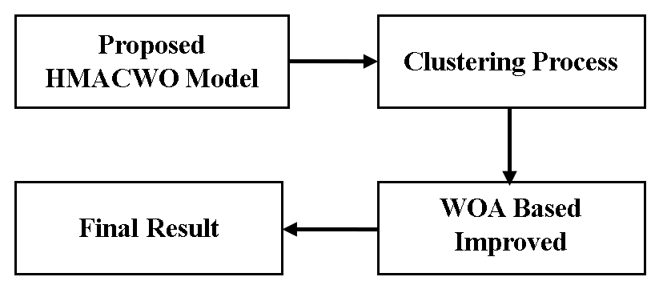
- Flow of the HMACWO.

Clustering Process.
Essentially, the AREA approach aims to be a powerful cluster detection tool that may be used in conjunction with the IEEE 802.11p standard. Using this standard, a fluid link can be created between RSUs and conventional On-Board Units (OBUs) mounted in operating vehicles. Because of all of these factors, nodes with inadequate or nonexistent connections undergo clustered transformation, transitioning to an IVC architecture in which networks are completely ad hoc coupled to similar peer networks. After the algorithm has completed its runs, the primary step in the reformation procedure is choosing the CH, or acquire node, and is going to be chosen in a manner that is distributed. The more secure the cluster revival, the greater the amount of time the chosen node will continue to function as CH.
In order to guarantee network connectivity, the planned AREA conducts a cluster reformation election for the CH, taking into account the node that has the longest likelihood of remaining in the cluster after being chosen for CH. With numerous connected components, this criteria is increasingly difficult. It uses three different criteria to choose a CH. To achieve sustained cluster transformation, an essential initial stage is determining the traveling vehicle's velocity with respect to the remaining contestants in the CH election. If the corresponding speed of a CH candidate exceeds a threshold, they are more inclined to quit the current grouping rapidly and compel the current clustering to run for retention. This allows all the cars in the range to know about each other and calculate the disparity in average speeds among all the cars in the range. For this computation, the subsequent procedure is utilized “(1)”.
$V_{dj}=\frac{1}{n-1}\sum_{i=1}^{n-1}{|V_{j}-V_{i}|}$ 1
In the equation above, j is an integer between 1 and n, denoting the total vehicles in vehicle j's range. $V_{j}$ represents the vehicle j's velocity. Vehicle j could normalize the stabilization factor (${SF}_{j}$), which characterizes the relative velocity of vehicle j, using “(2)”:
${SF}_{j}=1-\frac{V_{dj}}{V_{max}}$ 2
A CH member moving versus the majority of other possibilities in a possible clustering could result in an enormous decrease in speeds with respect to the remaining candidates within reach, much as how direction mattered. This immediately altered the framework of the network as a whole. Regular topology changes result in higher network overhead and much worse network efficiency. Nodes traveling in the same direction are maintained inside the same cluster in order to solve this issue. The node chosen to be the cluster head for that cluster is the one with the greatest number of neighbors within that range. The following formula is used to determine each node's distance from every other node in order to count the neighbors in “(3)”:
$D=\sqrt{\left(x_{v1}-x_{v2}\right)+(y_{v1}-y_{v2})}$ 3
The vehicle coordinates, v1 and v2, are represented by x and y in the equation above, where D < $D_{max}$ denotes the maximum communication range between the two vehicles. Another crucial component that has to be considered is the inter-nodal distance, which is the distance measured across the CH candidate and each subsequent vehicles in the possible cluster. Establishing clustering durability is facilitated by the short inter-nodal distance, which makes the nodes appeared to be adjacent to one another. If the gap were to rise, the candidate would be declared ineligible for the CH election. In the case when P_{i} is the CH candidate and P_{j} is the other nearby node, the inter-nodal distance can potentially be demonstrated utilizing in “(4)”.
$f\left(x\right)=\sum_{i=1}^{N}{\sqrt{P_{i}\left(h\right)-P_{j}\left(h\right);i≠j}}$ 4

WOA Based Improved Clustering Process
In Table I, we have included every symbol that is utilized in the proposal. Each search agent in our method is equipped with knowledge about possible cluster head vehicles as well as member vehicles. The suggested method chooses the cluster head's neighbors after determining the cluster head. Take note of the next two restrictions.
- Vehicle cannot lead more than one cluster as a CH. In other words, the CH has to be in a single cluster.
- One is unable to become a CH from a car in another CH's transmission.
To optimize the formation of vehicle clusters, agents that search are placed at random throughout the problem space in an attempt to identify the optimum solution (i.e., the optimal number of cluster). Vehicles are scattered around the searching area according to the size of the grid. All the agents of search arrive at a different solution by using the hunting pattern of the whale to generate a cluster matrix. A search agent adds the randomly selected car to the cluster matrices once it has been designated as the CH in the search space. Following that, the search mechanism finds nearby properties of the elected CH. Then, based on the fitness value, more nodes are added to the cluster matrix. Every vehicle is assigned a probability based on its fitness value; the vehicle exhibiting the highest probability is designated as the CH. Vehicles that don't fit the requirements are taken out of the repository and aren't eligible to be chosen as cluster leaders.

Objective Function:
The function known as the objective is used to evaluate the performance of each search agent. Delta difference (F1) and distance neighbor (F2) are both objective functions, in that order. The maximum amount of terminals that a cluster can support is equal to the delta variance, which is the difference among the actual number of cars in the cluster during the simulation and that number. For F1, as in “(5)”:
$F1=\sum_{i=1}^{l}{\left|δ-{CM}_{i}\right)|}$ 5
${CM}_{i}$ represented the actual number of vehicles acquired in the $i_{th}$ cluster, and δ indicates every nodes that an ith cluster may serve. The lowest possible amount of the delta variation is what is needed to reduce the number of clusters. The separation from a neighbor is the overall length of time that separates each cluster's CHs from each other. It is computed in “(6)”:
$F2=\sum_{i=1}^{l}{\left[\sum_{j=1}^{{CM}_{j}}{D({CH}_{i},{CM}_{j})}\right]}$ 6
In this case, ${CM}_{j}$ is the cluster member and ${CH}_{i}$ is the CH of the ith cluster. There are l clusters in total. The search agent with the smallest distance neighbor should be chosen as members of a CH will receive sent messages with more dependability when their distance is lower.

Updating Search Agent Positions:
The optimal search agent with the greatest number of vehicular clusters is chosen using the objective functions. Following the specification of the optimal search agent, additional agents adjust their positions in a random manner (for exploration behavior) or in a direction towards the optimal search agent (for exploitation behavior) that has been identified thus far. To get closer to a more ideal dominating set of CHs, search agents must adjust their positions. A is used search agent’s location updates based on their activity during exploration and exploitation. The search agent updates their position by following exploration behavior when the ~A is larger than one and by following exploitation behavior when the ~A is less than one. The orientation of the searching agent is updated with respect to the ideal search agent using 2 behaviors: the shrinking encircling technique and the spiral mobility approach. Probability is used to motivate agents of search to act in this manner concurrently. According to this, the agent used for searching is moved towards the best search operator for a probability of greater than or equal to 0.5 using the spiral movement and updated its location approaching the agent with the greatest potential with a probability of under or equal to 0.5 using the decreasing circumferential operation. In mathematics as in “(7)”;
$\vec{X}\left(t+1\right)=\left\{\begin{aligned}{\vec{D}}^{'}.e^{bl}.\cos\left(2πl\right)+{\vec{X}}_{s}\left(t\right), P≥0.5 \\ {\vec{X}}_{s}\left(t\right)-\vec{A}.\vec{D}, P≤0.5\end{aligned}\right.$ 7
The separation between the whale and the optimal solution achieved is shown by ~D 0. The random integer, l, is chosen so that −1 ≤ l < 1. The constant number b defines the logarithmic spiral form. In the current iteration ${\vec{X}}_{s}\left(t\right)$ represents the position of the finest solution with the optimal number of clusters. ~X is the search agents' locations vector. The term A represents the co-efficient vectors which are given in the equation. Operation: Procedure: one of the algorithm is to initialize the list of search agents. The outcome from every single agent of search is evaluated using the objective function. Following the definition of the optimal agent, search agents arrange themselves in accordance with the guidelines. With the presence of these methods the efficiency of the proposed HMACWO is improvised and the working process is given in Pseudo Code.
The Pseudo Code of the proposed HMACWO method
Inputs: Clustering Process and WOA based Clustering Process
Step 1 – Clustering Process
Average Velocities - $V_{dj}=\frac{1}{n-1}\sum_{i=1}^{n-1}{|V_{j}-V_{i}|}$
Relative Velocity - ${SF}_{j}=1-\frac{V_{dj}}{V_{max}}$
Node Distance - $D=\sqrt{\left(x_{v1}-x_{v2}\right)+(y_{v1}-y_{v2})}$
Adjacent Node - $f\left(x\right)=\sum_{i=1}^{N}{\sqrt{P_{i}\left(h\right)-P_{j}\left(h\right);i≠j}}$
Step 2 - WOA based Clustering Process
Objective Function 1 - $F1=\sum_{i=1}^{l}{\left|δ-{CM}_{i}\right)|}$
Objective Function 2 - $F2=\sum_{i=1}^{l}{\left[\sum_{j=1}^{{CM}_{j}}{D({CH}_{i},{CM}_{j})}\right]}$
Probability Calculation - $\vec{X}\left(t+1\right)=\left\{\begin{aligned}{\vec{D}}^{'}.e^{bl}.\cos\left(2πl\right)+{\vec{X}}_{s}\left(t\right), P≥0.5 \\ {\vec{X}}_{s}\left(t\right)-\vec{A}.\vec{D}, P≤0.5\end{aligned}\right.$
Step 3 – Performance Analysis

Simulation Results.
The implementation of the HMACWO is constructed in the software ns3 which is the incorporation of c++ and python. Network is constructed in the operating system called Ubuntu and to generate a vehicular mobility the open street map software called sumo is used. The parameters which are taken for the performance analysis are cluster efficiency, CH lifetime, packet delivery ratio, network throughput and average delay and as well the calculated results are compared with the earlier methodologies such as CDAR [47], ROCR [48] and ECCH [49] and as well the parameters which are used in the network formation in simulation are given in table II.
- Input Parameters Table
Input Parameters | Values
Running Time | 300 ms
Coverage Distance | 2000m*2000m
No of Vehicles | 1000 Vehicles
Vehicles Radius | 100m
Initial Energy | 100 Joules
Transmission Power | 0.500 Joules
Receiving Power | 0.050 Joules

Cluster Efficiency.
In this network model the vehicles are clustered into several groups and the vehicular efficiency decides the efficiency of the overall network. It is very essential to achieve maximum cluster efficiency to increase the reliability of the vehicles. In “Fig.2”, the cluster efficiency of the HMACWO is described and it is compared with the earlier works like CDAR, ROCR and ECCH. With the presence of optimization based clustering process this HMACWO reduced maximum cluster efficiency which is around 15% higher than the earlier works.
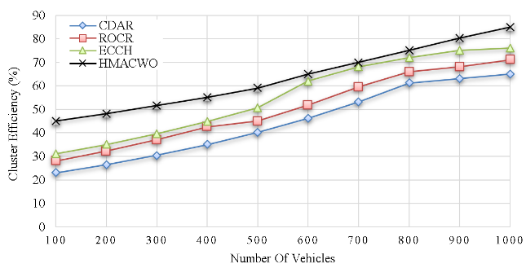
- Cluster Efficiency.

CH Lifetime
CH is the head of each cluster which is present in the communication in the HMACWO. By increasing the cluster efficiency the lifespan of the cluster head is improvised. With the presence of optimization based clustering models the HMACWO achieves maximum CH efficiency and it is around 50 joules higher than the earlier methods. In “Fig.3”, the performance of the proposed model in terms of cluster head efficiency is described and it is compared with the earlier works.
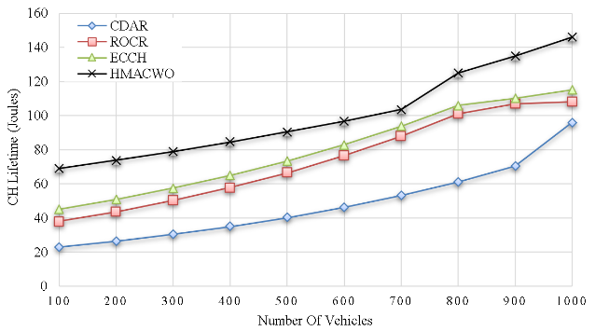
- CH Lifetime.

Packet delivery ratio.
It is the calculation of the generated package which is produced in the source vehicles and it is successfully transmitted to the receiver. The success rate of the data which gets transmitted from the source to the destination vehicle is termed as a packet delivery ratio. Achieving the maximum delivery ratio is the primary target of the network to provide flexible and reliable communication among the vehicles. In “Fig.4”, the delivery ratio performance of the HMACWO is described and it is compared with the other methods. From the calculator result it is shown that the HMACWO achieves around 5% better delivery ratio than the earlier methods.
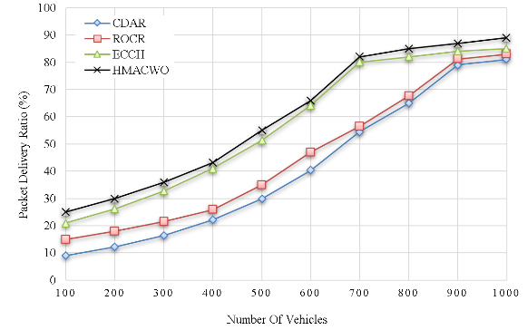
- Packet Delivery Ratio.

Network Throughput
It is the calculation of the amount of data packet which is generated in the source and it is ready for the data transmission. Increasing the number of throughput increases the overall efficiency of the vehicular communication. In “Fig.5”, the throughput performance of the HMACWO is described and it is compared with the earlier methods like CDAR, ROCR and ECCH. With the presence of the clustering model the amount of data generation is increased hence it reduces the power utilization of the devices. From the calculated result it is observed that the HMACWO generates throughput which is around 200 kbps higher than the earlier methods.
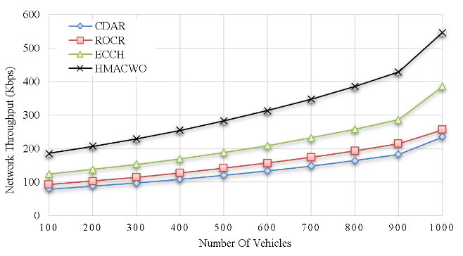
- Network Throughput .

Average delay.
It is defined as time difference between the predefined data transmission time period and the delay time.
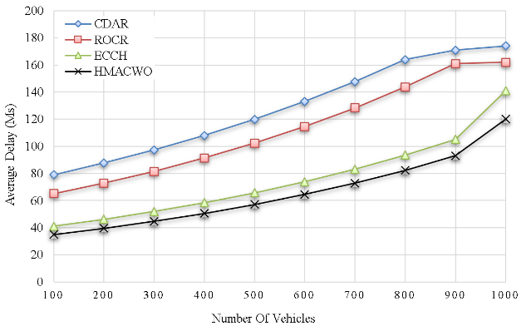
- Average Delay.
In order to achieve efficient communication it is very essential to reduce the daily occurrences among the high speed vehicles in the network. In “Fig.6”, the delay performance of the HMACWO is illustrated and it is compared with the baseline methods like CDAR, ROCR and ECCH. With the presence of efficient optimization based clustering model the delay occurrences of the HMACWO greatly reduced which is around 25ms lower than the earlier works.

Conclusion.
The main aim of this article is to develop a model which reduces the power utilization of the devices and to increase the lifespan. For that purpose optimization based clustering is developed which includes hybrid multi agent adaptive clustering and whale optimization algorithms. These methods greatly increase the energy efficiency by reducing the power utilization of the devices at each time period and each data transmission. From the final result it is understood that HMACWO greatly reduces the power utilization so that it attends maximum cluster efficiency and CH lifetime when compared with the earlier works. In future mainly to increase the communication quality of the remote areas unmanned aerial vehicles (UAVs) are concentrated.

References
- A. H. Abbas, A. J. Ahmed, S. A. Rashid, M. A. Jubair, N. F. Abdulsattar, H. S. Mansour, and M. I. Habelalmateen, "Hybrid ANT Based Continuous Cuckoo Search Optimization Algorithm for Vehicle Adhoc Networks," in 2022 5th International Conference on Engineering Technology and its Applications (IICETA), pp. 447-452, May 31-June 1, 2022. https://doi.org/10.1109/IICETA54559.2022.9888404.
- A. H. Najim, A. H. Abbas, K. Al-sharhanee, and H. M. Hariz, "Reinforcement Learning-based Topology-Aware Routing Protocol with Priority Scheduling for Internet of Drones in Agriculture Application," International Journal of Intelligent Engineering and Systems, vol. 16, no. 5, pp. 395-405, 2023. doi: https://doi.org/10.22266/ijies2023.1031.34.
- A. H. Abbas, A. J. Ahmed, S. A. Rashid, N. F. Abdulsattar, M. H. Hassan, M. A. Jubair, and M. I. Habelalmateen, "Predictive Hybrid Routing with Multi Objective Optimization Model for Opportunistic Routing for VANET," in 2022 5th International Conference on Engineering Technology and its Applications (IICETA), pp. 470-476, 2022. doi: https://doi.org/10.1109/IICETA54559.2022.9888274.
- Y.S. Jghef, M.J.M. Jasim, H.M.A. Ghanimi, A.D. Algarni, N.F. Soliman, W. El-Shafai, S.R.M. Zeebaree, A. Alkhayyat, A.S. Abosinnee, N.F. Abdulsattar, A.H. Abbas, H.M. Hariz, and F.H. Abbas, "Bio-Inspired Dynamic Trust and Congestion-Aware Zone-Based Secured Internet of Drone Things (SIoDT)," Drones, vol. 6, no. 11, pp. 337, 2022. https://doi.org/10.3390/drones6110337.
- G.G. Shayea, D.A. Mohammed, A.H. Abbas, and N.F. Abdulsattar, "Privacy-Aware Secure Routing through Elliptical Curve Cryptography with Optimal RSU Distribution in VANETs," Designs, vol. 6, no. 6, pp. 121, 2022. doi: https://doi.org/10.3390/designs6060121.
- M.H. Hassan, A.H. Abbas, M.H. Mutar, M.A. Jubair, S.A. Rashid, A.J. Ahmed, M.I. Habelalmateen, A. Mohammed, and L. Audah, "Investigative Study on Routing Protocols in Flying Ad Hoc Networks Environment," in 2022 5th International Conference on Engineering Technology and its Applications (IICETA), pp. 460-463, 2022. doi: https://doi.org/10.1109/IICETA54559.2022.9888600.
- N.F. Abdulsattar, F. Abedi, H.M.A. Ghanimi, S. Kumar, A.H. Abbas, A.S. Abosinnee, A. Alkhayyat, M.H. Hassan, and F.H. Abbas, "Botnet Detection Employing a Dilated Convolutional Autoencoder Classifier with the Aid of Hybrid Shark and Bear Smell Optimization Algorithm-Based Feature Selection in FANETs," Big Data and Cognitive Computing, vol. 6, no. 4, article no. 112, 2022. DOI: https://doi.org/10.3390/bdcc6040112.
- V. O. Nyangaresi, I. M. Al-Joboury, K. A. Al-sharhanee, A. H. Najim, A. H. Abbas, and H. M. Hariz, "A biometric and physically unclonable function–Based authentication protocol for payload exchanges in internet of drones," e-Prime - Advances in Electrical Engineering, Electronics and Energy, vol. 7, pp. 100471, 2024. DOI: https://doi.org/10.1016/j.prime.2024.100471
- N.F. Abdulsattar, A.H. Abbas, M.H. Mutar, M.H. Hassan, M.A. Jubair, and M.I. Habelalmateen, "An Investigation Study for Technologies, Challenges and Practices of IoT in Smart Cities," in 2022 5th International Conference on Engineering Technology and its Applications (IICETA), pp. 554-557, 2022. DOI: https://doi.org/10.1109/IICETA54559.2022.9888474.
- M. K. Hasan, M. M. Ahmed, N. F. Wani, A. H. Abbas, L. M. Alkwai, S. Islam, A. K. M. A. Habib, and R. Hassan, "Dynamic load modeling for bulk load-using synchrophasors with wide area measurement system for smart grid real-time load monitoring and optimization," Sustainable Energy Technologies and Assessments, vol. 57, p. 103190, 2023. doi: https://doi.org/10.1016/j.seta.2023.103190
- N. F. Abdulsattar, D. A. Mohammed, A. Alkhayyat, S. Z. Hamed, H. M. Hariz, A. S. Abosinnee, A. H. Abbas, M. H. Hassan, M. A. Jubair, F. H. Abbas, A. D. Algarni, N. F. Soliman, and W. El-Shafai, "Privacy-Preserving Mobility Model and Optimization-Based Advanced Cluster Head Selection (P2O-ACH) for Vehicular Ad Hoc Networks," Electronics, vol. 11, no. 24, p. 4163, 2022, DOI: https://doi.org/10.3390/electronics11244163.
- A. H. Kadhim, A. M. Razaq, M. A. Jubair, N. F. Abdulsattar, A. H. Abbas, M. H. Hassan, A. Jamal Ahmed, S. AbdulJabbar Rashid, and M. I. Habelalmateen, "A Real-Time Low-Cost Remote Doctor Monitoring System," in 2022 5th International Conference on Engineering Technology and its Applications (IICETA), pp. 558-561, 2022. doi: https://doi.org/10.1109/IICETA54559.2022.9888536.
- F. Abedi, H. M. A. Ghanimi, A. D. Algarni, N. F. Soliman, W. El-Shafai, A. H. Abbas, Z. H. Kareem, H. M. Hariz, and A. Alkhayyat, "Computational Intelligence Driven Secure Unmanned Aerial Vehicle Image Classification in Smart City Environment," Computer Systems Science and Engineering, vol. 47, no. 3, pp. 3127-3144, 2023. DOI: https://doi.org/10.32604/csse.2023.038959.
- A. H. Abbas, H. Mansour, and A. Al-Fatlawi, "Self-Adaptive Efficient Dynamic Multi-Hop Clustering (SA-EDMC) Approach for Improving VANET’s Performance," International Journal of Interactive Mobile Technologies (iJIM), vol. 16, no. 14, pp. 136-151, Jul. 2022. DOI: https://doi.org/10.3991/ijim.v16i14.31081.
- F. Abedi, H. M. A. Ghanimi, M. A. M. Sadeeq, A. Alkhayyat, Z. H. Kareem, S. N. Mahmood, A. H. Abbas, A. S. Abosinnee, W. K. Al-Azzawi, M. M. Jaber, and M. Dauwed, "Hybrid Deep Learning Enabled Load Prediction for Energy Storage Systems," Computers, Materials & Continua, vol. 75, no. 2, pp. 3359-3374, 2023. DOI: https://doi.org/10.32604/cmc.2023.034221.
- A. M. Abdulkarem, F. Abedi, H. M. A. Ghanimi, S. Kumar, W. K. Al-Azzawi, A. H. Abbas, A. S. Abosinnee, I. M. Almaameri, and A. Alkhayyat, "Robust Automatic Modulation Classification Using Convolutional Deep Neural Network Based on Scalogram Information," Computers, vol. 11, no. 11, article no. 162, 2022. DOI: https://doi.org/10.3390/computers11110162.
- S. Alsubai, A. K. Dutta, A. H. Alkhayyat, M. M. Jaber, A. H. Abbas, and A. Kumar, "Hybrid deep learning with improved Salp swarm optimization based multi-class grape disease classification model," Computers and Electrical Engineering, vol. 108, p. 108733, 2023. DOI: https://doi.org/10.1016/j.compeleceng.2023.108733.
- A. H. Abbas, N. F. Abdulsattar, H. S. Mansour, M. H. Mutar, M. I. Habelalmateen, L. Audah, N. A. M. Alduais, and A. Mohammed, "A New Hybrid Approach Cluster-Heads Election to reduce the number of clusters in VANETs," in 2022 5th International Conference on Engineering Technology and its Applications (IICETA), pp. 436-440, 2022. DOI: https://doi.org/10.1109/IICETA54559.2022.9888442.
- M. A. Jubair, S. A. Mostafa, D. A. Zebari, H. M. Hariz, N. F. Abdulsattar, M. H. Hassan, A. H. Abbas, F. H. Abbas, A. Alasiry, and M. Turki-Hadj, "A QoS Aware Cluster Head Selection and Hybrid Cryptography Routing Protocol for Enhancing Efficiency and Security of VANETs," IEEE Access, vol. 10, pp. 124792-124804, 2022. doi: https://doi.org/10.1109/ACCESS.2022.3224466.
- M. I. Habelalmateen, A. H. Abbas, L. Audah, and N. A. M. Alduais, "Dynamic multiagent method to avoid duplicated information at intersections in VANETs," Telkomnika (Telecommunication Computing Electronics and Control), vol. 18, no. 2, pp. 613-621, 2020. DOI: http://doi.org/10.12928/telkomnika.v18i2.13947.
- I. S. Al-Hawary, E. Ali, S. M. H. Kamona, L. Hussain Saleh, A. S. Abdulwahid, D. N. Al-Saidi, M. S. Alhassan, F. A. Rasen, H. Abdullah Abbas, A. Alawadi, A. H. Abbas, and M. Sina, "Prediction of geomechanical bearing capacity using autoregressive deep neural network in carbon capture and storage systems," Heliyon, vol. 9, no. 11, pp. e21913, Nov. 2023. doi: https://doi.org/10.1016/j.heliyon.2023.e21913.
- M. R. M. Alsemawi, M. H. Mutar, E. H. Ahmed, H. O. Hanoosh, and A. H. Abbas, "Emotions recognition from human facial images based on fast learning network," Indonesian Journal of Electrical Engineering and Computer Science, vol. 30, no. 3, pp. 1478-1487, 2023. doi: http://doi.org/10.11591/ijeecs.v30.i3.pp1478-1487.
- J. Tang, A. K. Abbas, N. A. Koka, N. Sadoon, J. K. Abbas, R. A. Abdalhuseen, M. Abosaooda, N. M. Ahmed, and A. H. Abbas, "Optimization of thermal biofuel production from biomass using CaO-based catalyst through different algorithm-based machine learning approaches," Case Studies in Thermal Engineering, vol. 50, p. 103419, 2023. doi: https://doi.org/10.1016/j.csite.2023.103419.
- M. A. A. Albadr et al., "Online sequential extreme learning machine approach for breast cancer diagnosis," Neural Computing and Applications, vol. Volume, no. Issue, pp. Page, 2024. DOI: https://doi.org/10.1007/s00521-024-09617-x.
- M. S. Alshuhri, S. G. Al-Musawi, A. A. Al-Alwany, H. Uinarni, I. Rasulova, P. Rodrigues, A. T. Alkhafaji, A. M. Alshanberi, A. H. Alawadi, and A. H. Abbas, "Artificial intelligence in cancer diagnosis: Opportunities and challenges," Pathology - Research and Practice, vol. 253, pp. 154996, 2024. https://doi.org/10.1016/j.prp.2023.154996.
- A. Abdulbari, S. K. Abdul Rahim, F. Abedi, P. J. Soh, A. Hashim, R. Qays, S. Ahmad, and M. Y. Zeain, "Single-Layer Planar Monopole Antenna-Based Artificial Magnetic Conductor (AMC)," International Journal of Antennas and Propagation, vol. 2022, pp. 6724175, 2022. https://doi.org/10.1155/2022/6724175.
- S. Saleem, A. H. Jabbar, M. H. Jameel, A. Rehman, Z. H. Kareem, A. H. Abbas, Z. Ghaffar, S. A. Razzaq, R. A. Pashameah, E. Alzahrani, E.-P. Ng, and S. M. Sapuan, "Enhancement in structural, morphological, and optical properties of copper oxide for optoelectronic device applications," Nanotechnology Reviews, vol. 11, no. 1, pp. 2827-2838, 2022.DOI: https://doi.org/10.1515/ntrev-2022-0473.
- A. H. Abbas, A. J. Ahmed, and S. A. Rashid, "A Cross-Layer Approach MAC/NET with Updated-GA (MNUG-CLA)-Based Routing Protocol for VANET Network," World Electric Vehicle Journal, vol. 13, no. 5, article no. 87, 2022. DOI: https://doi.org/10.3390/wevj13050087.
- H. S. Mansour, M. H. Mutar, I. A. Aziz, S. A. Mostafa, H. Mahdin, A. H. Abbas, M. H. Hassan, N. F. Abdulsattar, and M. A. Jubair, "Cross-Layer and Energy-Aware AODV Routing Protocol for Flying Ad-Hoc Networks," Sustainability, vol. 14, no. 15, article no. 8980, 2022. DOI: https://doi.org/10.3390/su14158980.
- M. I. Habelalmateen, A. J. Ahmed, A. H. Abbas, and S. A. Rashid, "TACRP: Traffic-Aware Clustering-Based Routing Protocol for Vehicular Ad-Hoc Networks," Designs, vol. 6, no. 5, article no. 89, 2022. DOI: https://doi.org/10.3390/designs6050089.
- S. A. Rashid, M. I. Habelalmateen, A. J. Ahmed, A. H. Abbas, M. A. Jubair, M. H. Hassan, A. Abdulhadi, S. Hammed, and L. Audah, "Congestion Aware Genetic Q-learning Based RPL Routing Protocol for Vehicle Ad-Hoc Networks," in 2022 5th International Conference on Engineering Technology and its Applications (IICETA), pp. 464-469, 2022. doi: https://doi.org/10.1109/IICETA54559.2022.9888583.
- A. H. Alwan, A. A. Aziz, M. A. Jubair, A. H. Abbas, M. H. Hassan, S. Alheejawi, N. F. Abdulsattar, A. S. Mustafa, and M. I. Habelalmateen, "Monitoring the Impact of the Nodes Density on the MANETs’ Environment," in 2022 5th International Conference on Engineering Technology and its Applications (IICETA), pp. 546-549, 2022. doi: https://doi.org/10.1109/IICETA54559.2022.9888339.
- S. A. Rashid, A. J. Ahmed, M. H. Hassan, A. H. Abbas, M. I. Habelalmateen, M. A. Jubair, L. Audah, and W. Al-Azzawi, "Ranking Based Routing Protocol for Residual Energy Estimation in Wireless Sensor Network Based IoT Network," in 2022 5th International Conference on Engineering Technology and its Applications (IICETA), pp. 453-459, 2022. https://doi.org/10.1109/IICETA54559.2022.9888349.
- A. J. Ahmed, A. H. Abbas, S. A. Rashid, M. A. Jubair, M. H. Hassan, A. Abdulhadi, N. F. Abdulsattar, and M. I. Habelalmateen, "Congestion Aware Q-Learning (CAQL) in RPL Protocol – WSN based IoT Networks," in 2022 5th International Conference on Engineering Technology and its Applications (IICETA), pp. 429-435, 2022. doi: https://doi.org/10.1109/IICETA54559.2022.9888322.
- A. J. Ahmed, S. A. Rashid, A. H. Abbas, N. F. Abdulsattar, H. S. Mansour, M. H. Hassan, M. I. Habelalmateen, and A. Hussain, "An Effectual Secure Cryptography Scheme for Multipath Routing in A Wsn-Based IoT Environment," in 2022 5th International Conference on Engineering Technology and its Applications (IICETA), pp. 441-446, 2022. doi: https://doi.org/10.1109/IICETA54559.2022.9888604.
- A. J. Ahmed, A. H. Abbas, and S. A. Rashid, "Multi level trust calculation with improved ant colony optimization for improving quality of service in wireless sensor network," IAES International Journal of Artificial Intelligence, vol. 12, no. 3, pp. 1224–1237, 2023. doi: https://doi.org/10.11591/ijai.v12.i3.pp1224-1237.
- Asad Ali and Syed Adeel Ali Shah, "VANET Clustering Using Whale optimization Algorithm", International Symposium on Recent Advances in Electrical Engineering (RAEE), 2019, doi:10.1109/RAEE.2019.8886982.
- Abhay Katiyar and Satyam Kumar Gupta, "A dynamic single-hop clustering algorithm (DSCA) in VANET", 11th International Conference on Computing, Communication and Networking Technologies (ICCCNT), 2020, doi: 10.1109/ICCCNT49239.2020.9225285.
- Ronald Adrian and Selo Sulistyo, "MRV-M: A Cluster Stability in Highway VANET using Minimum Relative Velocity based on K-Medoids", 5th International Conference on Science and Technology (ICST), 2019, doi: 10.1109/ICST47872.2019.9166290.
- Grace Khayat and Hoda Maalouf, "Successful Delivery in VANETs with Damaged Infrastructures Based on Double Cluster Head Selection", IEEE 25th International Workshop on Computer Aided Modeling and Design of Communication Links and Networks (CAMAD), 2020, doi:10.1109/CAMAD50429.2020.9209259.
- Grace Khayat and Hoda Maalouf, "VANET Clustering Based on Weighted Trusted Cluster Head Selection", International Wireless Communications and Mobile Computing (IWCMC), 2020, doi:10.1109/IWCMC48107.2020.9148339.
- Mustafa Banikhalaf and Moaiad Ahmad Khder, "A Simple and Robust Clustering Scheme for Large-Scale and Dynamic VANETs", IEEE Access, vol.8, pp.103565 - 103575, doi: 10.1109/ACCESS.2020.2999368.
- Dongmei Zhang and Jieyao Xu, "An Effective Data Filtering Scheme Based on Context in VANETs", IEEE 20th International Conference on Communication Technology (ICCT), 2020, doi: 10.1109/ICCT50939.2020.9295828.
- Tarak Nandy and Mohd Yamani Idna Bin Idris, "A Multiple-Criteria Decision Analysis Clustering and Cluster Head Selection Algorithm in Vehicular Network", IEEE 8th R10 Humanitarian Technology Conference (R10-HTC), 2020, doi: 10.1109/R10-HTC49770.2020.9356964.
- Mahmoud Bersali and Abderrezak Rachedi, "A New Collaborative Clustering Approach for the Internet of Vehicles (CCA-IoV)", Second International Conference on Embedded & Distributed Systems (EDiS), 2020, doi:10.1109/EDiS49545.2020.9296436.
- Ran Duo and Yusheng Ji, "Context-Aware Clustering for SDN Enabled Network", IEEE 28th International Conference on Network Protocols (ICNP), 2020, doi:10.1109/ICNP49622.2020.9259403.
- Bukuroshe Elira and K.P. Keerthana , "Clustering scheme and destination aware context based routing protocol for VANET", vol.2, pp.148-155, 2021, doi:10.1016/j.ijin.2021.09.006.
- Swathi Konduru and M. Sathya, "Remora optimization algorithm-based optimized node clustering technique for reliable data delivery in VANETs", vol.3, pp.74-79, 2022, doi:10.1016/j.ijin.2022.07.002.
- Koppisetti Giridhar and C. Anbuananth, "Energy efficient clustering with Heuristic optimization based Ro/uting protocol for VANETs", vol.27, 2023, doi:10.1016/j.measen.2023.100745..

