Dynamic Mobility based Effective Load Balancing and QoS-Aware Network Selection in UAV Networks

1st Hussein Al-Aboudy
Department of Computer Techniques Engineering
Mazaya University College
DhiQar, Iraq;
huhraiz22@mpu.edu.iq.
4th Zahraa Saad Abdulali
National University of Science and Technology
Dhi Qar, Iraq
zahraa.s.abdulali@nust.edu.iq.
2nd Waleed Hadi Madhloom Kurdi
Department of Computer Science
Altoosi University College
Najaf, Iraq
waleedalkurdi@altoosi.edu.iq.
5th Mohammed Ihsan
Department of Computer Technical Engineering
College of Technical Engineering
The Islamic University
Najaf, Iraq
moh.mtech89@iunajaf.edu.iq
3rd U. Pavan Kumar
Department of CSE(Data Science
Dayananda Sagar University
Bengaluru, India
drpavankumaru-ds@dsu.edu.in.
6th Fatima H. Alsalamy
Medical Laboratories Techniques Department
Al-Mustaqbal University
Hillah, Iraq
fatimahashim109@gmail.com

Abstract—In vehicular ad hoc networks (VANETs) due to high-speed vehicles several challenges occurred like vehicle integrity management, speed management and effective data collection with road traffic event management. To monitor the huge number of vehicles in an efficient way in a large-scale coverage area in recent times unmanned aerial vehicles (UAVs) are developed. This technology provides effective communication among the ground level and the air medium. To attend high quality communication of the vehicles in this article dynamic mobility based effective load balancing and QoS aware network selection (DELQNU) among the UAVs are constructed. The core modules of this proposed DELQNU are UAV network model, mobility model and QoS model. Using these ideas monitoring a huge number of vehicles even at the densely populated and high-speed technology becomes possible and highly efficient. The implementation analysis are packet delivery ratio, throughput, delay, routing overhead and energy efficiency. From the final outcome it is proven that DELQNU attends maximum results in terms of delivery ratio and throughout when compared with the earlier baseline methodologies.
Keywords— VANETs, QoS, UAVs, Dynamic Mobility and Effective Load Balancing.

Introduction
Using traditional networks handling the high-speed vehicles becomes more complicated in vehicular communication that limits the communication quality of the network [1-4]. To attend maximum efficiency among the vehicles in recent times unmanned aerial vehicles (UAVs) are introduced in the vehicular communication which are otherwise called as drones and it is used in several applications like military applications [5-8], disaster monitoring [9-12] and urban areas [13-15]. This network becomes highly flexible and cost effective and it is able to provide line of side connectivity and as well it acts like a moving based station which monitors the ground level vehicles in an efficient manner [16-20]. These UAVs experience rapid change in vehicle topology and frequent link connection failure can occur that suffers from intermittent communication among the links [21-25].
The present drawbacks in the UAVs which are identified in the earlier researchers [26-30] are improper mobility handling [31-34] and ineffective load balancing [35-37] which reduces the quality of service of the vehicular network [38-40]. In order to overcome these drawbacks in this article dynamic mobility and effective load balancing with QoS aware network models is created.
The contributions of the paper are given below. This article's key subsections are: UAV network model construction, mobility model, and quality of service model. Using this procedure, the device's efficiency is boosted, resulting in a maximum lifetime for the vehicular network.

Related Works
In [41], demonstrates a growing vehicular network which includes applications like automatic driving demand low latency. The disadvantages are high packet loss. In [42], explained the fog paradigm addresses real-time constraints for IoT applications. Our proposed load-balancing mechanism that tested in NS2 simulations and efficiently manages mobility in a networked cluster of autonomous vehicles serving IoT devices and the drawback here is high overhead in order to overcome issues with wireless communication, In [43] suggested a load balancing and QoS-aware changeover system for diverse VANET. Our scheme outperforms benchmark solutions in successful handoffs and load balancing across various scenarios, the drawback here is high packet loss.
In [44], focuses on load balancing challenges in vehicular fog computing for marine tasks with unmanned surface vehicle (USV) clusters. The proposed minimum response time-based algorithm reduces blocking probability effectively, as shown in analytical models and simulations and the disadvantages are high packet loss. In [45], developed NFV Aand SDN provide flexibility in network control functions and resource usage. The disadvantages are high overhead. In [46], proposed the small-cell architecture in cellular networks lacks spectrum temporal efficiency. The paper proposes D2D load balancing, reducing spectrum requirements by 25% in real-world 4G data evaluations with the disadvantages are high delay.
In [47], recommends improving mobility management in Software Defined Networking (SDN) for better vehicular access network performance, the disadvantages are high delay. In [48], demonstrated LEO network with its multitude of satellite nodes faces load balancing challenges due to topology changes and uneven user distribution, the “Selective Iterative Dijkstra Algorithm (SIDA) and Selective Split Load Balancing Strategy (SSLB)”, effectively optimize path finding and alleviate link congestion for improved load distribution in LEO satellite networks with the disadvantages of high overhead. In [49], Park introduced MMMP system enhances reliability with diverse communication paths. The proposed adaptive load balancing algorithm uses Gaussian Process Regression for dynamic traffic allocation without prior information, proving effective in real-world traffic simulations but the drawback here is high delay.
In [50], author designed VANET data dissemination focuses on efficient V2I communication by addressing real-world time delays. Our Adaptive Load balancing approach, compared to standalone and other load balancing methods which demonstrates superior performance but the drawback here is high overhead. In [51], suggested a VANET architecture with a permissioned blockchain for data integrity in road traffic events which incorporating micro-transactions to reduce overhead. Simulations confirm its effectiveness surpassing related works in the literature and the drawback here is high routing overhead. In [52], introduced the ROAONC Technique utilizing the Remora optimization algorithm, showcasing superior performance in node clustering compared to competitive protocols in unpredictable node density scenarios that requires enhanced cooperation for optimal routing and scalability with the disadvantages of high delay. The earlier design issues are described in Table I.
- Earlier Research Issues.
No | Model | Advantages | Disadvantages
[41] | Multi-Timescale Load Balancing Method | Reduces service delays | High power consumption
[42] | FiWi-enhanced VECN Scheme | Efficiently reduces processing delays | High packet loss
[43] | Load-Balancing Mechanism | Efficiently manages mobility | High overhead
[49] | Adaptive Load Balancing Algorithm | Enhances reliability | High delay
[50] | Adaptive Load Balancing Approach | Efficient V2I communication | High overhead
[51] | Blockchain for Data Integrity | Effectively reduces overhead | High routing overhead
[52] | Remora Optimization Algorithm for Node Clustering | Superior performance in node clustering | High delay

Proposed DELQNU Model.
This DELQNU is mainly designed to provide effective communication among the aerial vehicles and it aims to achieve maximum energy efficiency.
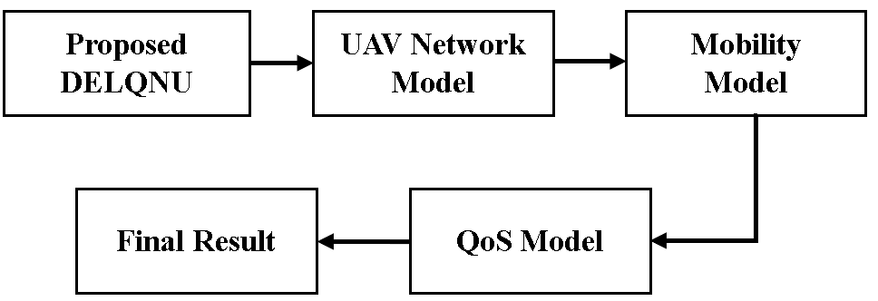
- DELQNU Workflow.
The major categories of this model are Aerial network model construction, efficient load balancing, mobility model creation and quality of service model construction. The work flow of the DELQNU is described in the “Fig.1”.

UAV Network Model.
To monitor communication traffic between and among UAVs, as well as between UAVs and UEs, we used the Wireshark network analyzer. Mininet-Wi-Fi replicates every wireless signal to each virtual wireless connection in a network scenario, resulting in the hwsim0 interface, which is a software link. Wireshark captures data packets from the portable interface and then displays Bluetooth control traffic. After running the ping instructions, Wireshark displays the wireless communications, including the ICMP answers contained in the wireless frames. It has collected.
In SDN-based networks, UE, UAV, and SDN controller are three distinct categories of interfacing devices that are being examined. Through the help of wireless local area network (WLAN) access technology, the Wi-Fi Access Points (APs) installed on the UAVs build a mesh network in the atmosphere. Any gadget on ground level that transmits data over the aerial UAV-created backbone connection is referred to as UE. These equipment include smartphones, sensors, and other such gadgets. The UEs are randomly distributed around the ground, however each UE requires the assistance of at least one UAV. Sending and receiving control packets from each UAV is done through communication with the SDN controller, which is situated on the ground. By using multihop transmission, the UAVs may speak with another vehicle directly or throughout.
The ground control station for UAVnet, known as the SDN controller, combines network data and UAV specifications utilizing the precisely computed discoveries to arrive at the optimal decisions. The SDN controller is a device that controls UAV and networking data and negotiates with the UAV controller as a representative of the former. The UAV operator is in charge of tracking the position of the drones and managing the flight of them. When it notices a poor connection to the wireless network or other link issues, for instance, the SDN controller alerts the UAV operator. UAVs can change their flight path or elevation to establish an accurate communication link at the demand of the UAV commander. Through data analysis and network monitoring, we are equipped to design optimal decisions and critical procedures for UAV network support, traffic management, balance of loads, and numerous other areas. To analyze and handle the information collected from the UAV system, the SDN controller features an integrated surveillance platform. After that, a load balancing method is suggested according to analytical findings from the surveillance platforms with the goal to make the most of the UAV capabilities and avoid overcrowding.
Algorithm 1: LB-UAV net: Load Balancing for UAV net
Result: Load vectors for balanced paths.;
While $current_control_cycle$do
${flow}_{th}=average\left({flow}_{i}:i=1:N\right);$
[flow, path_ vectors=monitor (UAV net);
if ${flow}_{i}<{flow}_{th}$ then
path_ vectors=Dijkstra_ optimal_ path (flow, path_ vectors);
switch_ flow (path_ vectors);
else
maintain path_ vectors;
monitor (UAV net);
end
end

Mobility Model
Every cell advertises itself and the services it offers by sending out broadcast packets on a regular basis. All of the cells that are within a car's range are displayed as neighbors, in addition to the cell's ID, location, cost, loading capability, and timing of the advertising. Particularly with Het-VeNET, vehicle mobility is a crucial consideration in the network selection process. As such, we specify one's mobility characteristics as the first set of measurements to be considered whenever the handover process starts. Following the vehicle's position, velocity, and direction, the decision-making procedure will start by eliminating any undesired routes of entry in the area. Continuing with the previously mentioned analogy, small-cells should not be taken into consideration when a vehicle's mobility is high unless there are no other possibilities nearby. The vehicle's route and distance will determine which eligible access points are able to offer it a reasonable residual time within its range, providing that the vehicle keeps its speed and direction utilizing the connection time duration calculation as presented in “(1)”.
$LDT=\frac{R-|dist\left(x_{i},a_{j}\right)|}{v_{i}}$ 1
Where v represents the vehicle's current velocity, R denotes the access point's communication range, and dist(.) represents the Euclidean distance among the vehicle (x_{i}) and an access point (a_{j}). Next, a list of potential connections that ensure a duration time greater than λ is produced. If the car has several access point options, the user's penchant for the QoS will determine the next selection method.

QoS Model
Three primary factors often initiate the handover process: i) to lessen the microcell’s strain, ii) the vehicle is looking for a higher Quality of Service (QoS) in relation to price or bandwidth; iii) or a vehicle needs a new registration since it is outside the communication range of the serving cell. The following is how a desired quality of service cell's selection mechanism operates. Every cell has a QoS parameter set, and the changeover process is initiated by vehicles searching for a better point of access to move to in regards of latency, bandwidth and cost. The vehicle uses intended throughput, delay, and loss to establish its preferences.
Algorithm 1: Network Selection Method
Require: $B,F\left(c\right),{List}_{n}, cAP$
1: procedure HANDOVER TRIGGER
2: while every $T$ time do
3: Update vehicle’s link duration time LDT with $cAP$
4: Get cAP RSSI
5: if $LDT<{thresh}_{1}or RSSI<{thresh}_{2}$ then
6: Select_ Network ()
7: end if
8: end while
9: end procedure
10: procedure SELECT NETWORK
11: Eliminate undesired Aps from ${List}_{n}$
12: New short list L
13: get vehicle’s QoS vector $(B,β)$
14: for each AP in L calculate Eq (2)
15: get maximum ${AP}_{i}$ function value
16: if ${AP}_{i}==cAP$ then
17: $continue$
18: else
19: Start handover process with ${AP}_{i}$
20: end if
21: end procedure
We define the QoS vector based on several characteristics in both points of connection and mobility. Vehicle QoS vector respects client preferences regarding the smallest bandwidth and uses the weight value β. Furthermore, after sharing use charges and bandwidth on hand with automobiles throughout communication, every connection will keep its QoS vector intact range. Given the necessary QoS and the available data regarding the AP associated with the vehicle, every single QoS mechanism is able to select an AP as in “(2)”.
$F\left(b,c\right)=βF\left(b\right)-\left(1-β\right)F(c)$ 2
The values shown indicate the weight value (β), cost function F(c), and bandwidth function F(b) on the AP's bandwidth between 0 and 1. The computation of the cost and bandwidth functions is done by “(3)”.
$F\left(b\right)=\left\{\begin{aligned}1 if b≥B \\ 0 if b<B\end{aligned}\right.$ 3
Where, B represents the user's preferred minimum bandwidth. Consequently, the above formula may be used to calculate the QoS operation of each accessible AP, allowing the vehicle to connect to the access point with the greatest function value that best suits its preferences.

Simulation Results.
The implementation of the proposed model is carried out in the software ns3 which is the combination of python and c++. The mobility of the vehicle is constructed using the software called SUMO which is on among the open street map based mobility generator. The vehicles which are considered for these simulation experiments are 500 vehicles and the parameters which are considered for the performance analysis are packet delivery ratio, throughput, delay, routing overhead and energy efficiency and as well it is compared with the earlier baseline methodology like ALED [50], SBTD [51] and ROOC [52] and as well the input parameters which are present in this simulation experimentation are given in table II.
- Input Parameters Table
Input Parameters | Values
Running Time | 250 ms
Coverage Distance | 2000m*2000m [52]
Number of Vehicles | 500 Vehicles [53]
Vehicles Radius | 100m
Initial Energy | 100 Joules
Transmission Power | 0.500 Joules [54]
Receiving Power | 0.050 Joules

Packet Delivery ratio.
It is the calculation of the data packets which is collected successfully from the destination when it is transferred from the source vehicles at the time of high speed. This article mainly concentrates on increasing the delivery ratio of the transmitted package among the vehicles and as well it leads to increase the network efficiency. In “Fig.2”, the delivery ratio performance of the DELQNU is calculated and it is compared with the earlier works like ALED, SBTD and ROOC. With the presence of effective mobility model and quality of service model the DELQNU achieves delivery ratio which is around 15% higher than the earlier methods.
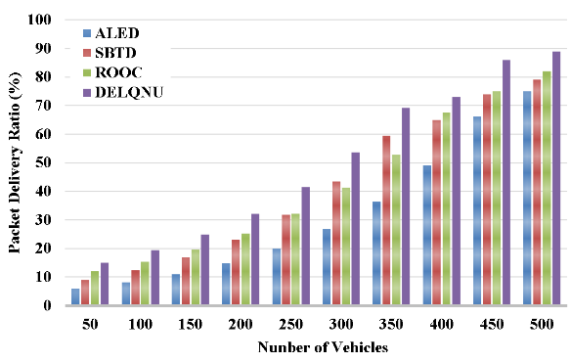
- Packet Delivery Ratio.

Throughput
It is the calculation of the data packets which is successfully generated in the source vehicles. Throughput maximization is their primary goal of any network to achieve maximum efficiency. In “Fig.3”, the calculation of throughput of the DELQNU is described which is compared with the earlier works like ALED, SBTD and ROOC. With the presence of effective aerial vehicle network construction the DELQNU attends maximum throughput which is around 150 kbps higher than earlier works.
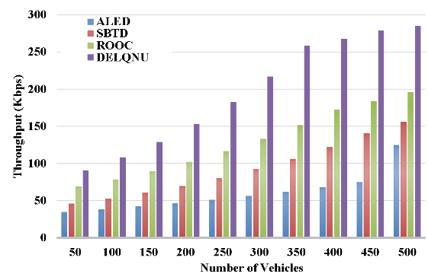
- Network Throughput.

Average delay.
It is the measure of the time difference between the allocated time and the transmitter time among the high speed vehicles in the aerial vehicular network. Achieving lower delay is the core concentration of this proposed model.
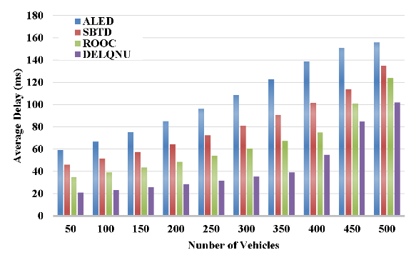
- Average Delay.
From the “Fig.4”, it is proven that the DELQNU performed better than the earlier works like ALED, SBTD and ROOC. By the use of the efficient quality of service and proper mobility construction this DELQNU generates a delay which is around 50ms lower than the other models.

Routing overhead
It is the measure of the amount of data which gets forwarded to the source without reaching its destination. Reducing the routing overhead is very essential to achieve high quality communication among the aerial vehicles. In “Fig.5”, it is shown that the routing overhead generation of the DELQNU is lower than the earlier works like ALED, SBTD and ROOC. With the presence of efficient deployment of the aerial vehicles and proper qualities service the generated routing overhead of DELQNU is around 400 packets lower than the earlier works.
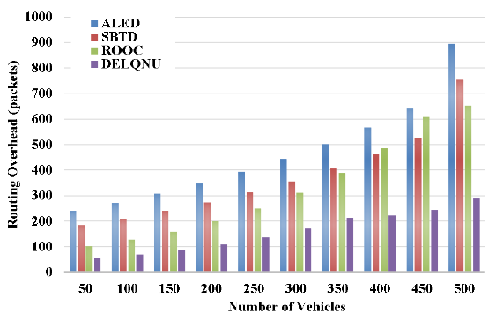
- Routing Overhead.

Energy Efficiency.
It is the calculation of the remaining energy which is calculated at the end of the simulation among the aerial vehicles. To increase the lifetime of the vehicles it is very essential to achieve maximum energy efficiency among the aerial vehicles. In “Fig.6”, the efficiency calculation of the DELQNU is compared with the earlier works like ALED, SBTD and ROOC. From this calculation it is proven that the DELQNU attends maximum efficiency than other methods which is around 200 joules higher.
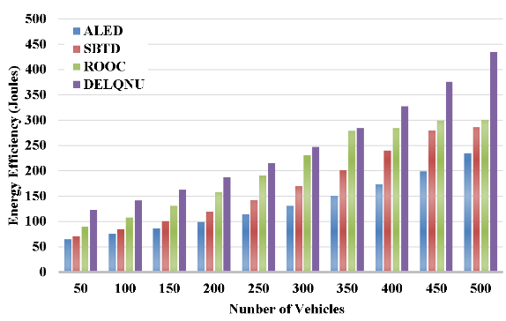
- Energy Efficiency .

Conclusion.
This DELQNU model is mainly developed to provide effective mobility control and load balancing to the high speed vehicles which are present in the network. For that purpose effective dynamic mobility management and QoS management is concentrated in the efficient UAV based network model. The parameters which attain maximum results when compared with the earlier methods are energy efficiency, delivery ratio and throughput. In the future, efficient clustering is concentrated to attend intelligent data transmission among the UAVs in the network.

References
- Y.S. Jghef, M.J.M. Jasim, H.M.A. Ghanimi, A.D. Algarni, N.F. Soliman, W. El-Shafai, S.R.M. Zeebaree, A. Alkhayyat, A.S. Abosinnee, N.F. Abdulsattar, A.H. Abbas, H.M. Hariz, and F.H. Abbas, "Bio-Inspired Dynamic Trust and Congestion-Aware Zone-Based Secured Internet of Drone Things (SIoDT)," Drones, vol. 6, no. 11, pp. 337, 2022. https://doi.org/10.3390/drones6110337.
- G.G. Shayea, D.A. Mohammed, A.H. Abbas, and N.F. Abdulsattar, "Privacy-Aware Secure Routing through Elliptical Curve Cryptography with Optimal RSU Distribution in VANETs," Designs, vol. 6, no. 6, pp. 121, 2022. doi: https://doi.org/10.3390/designs6060121.
- M.H. Hassan, A.H. Abbas, M.H. Mutar, M.A. Jubair, S.A. Rashid, A.J. Ahmed, M.I. Habelalmateen, A. Mohammed, and L. Audah, "Investigative Study on Routing Protocols in Flying Ad Hoc Networks Environment," in 2022 5th International Conference on Engineering Technology and its Applications (IICETA), pp. 460-463, 2022. doi: https://doi.org/10.1109/IICETA54559.2022.9888600.
- N.F. Abdulsattar, F. Abedi, H.M.A. Ghanimi, S. Kumar, A.H. Abbas, A.S. Abosinnee, A. Alkhayyat, M.H. Hassan, and F.H. Abbas, "Botnet Detection Employing a Dilated Convolutional Autoencoder Classifier with the Aid of Hybrid Shark and Bear Smell Optimization Algorithm-Based Feature Selection in FANETs," Big Data and Cognitive Computing, vol. 6, no. 4, article no. 112, 2022. DOI: https://doi.org/10.3390/bdcc6040112.
- V. O. Nyangaresi, I. M. Al-Joboury, K. A. Al-sharhanee, A. H. Najim, A. H. Abbas, and H. M. Hariz, "A biometric and physically unclonable function–Based authentication protocol for payload exchanges in internet of drones," e-Prime - Advances in Electrical Engineering, Electronics and Energy, vol. 7, pp. 100471, 2024. DOI: https://doi.org/10.1016/j.prime.2024.100471.
- R. Q. Malik, K. N. Ramli, Z. H. Kareem, M. I. Habelalmatee, A. H. Abbas, and A. Alamoody, "An Overview on V2P Communication System: Architecture and Application," in 2020 3rd International Conference on Engineering Technology and its Applications (IICETA), pp. 174-178, 2020. doi: https://doi.org/10.1109/IICETA50496.2020.9318863.
- Mostafa, S.A., Mustapha, A., Ramli, A.A., Jubair, M.A., Hassan, M.H., Abbas, A.H. (2021). Comparative Analysis to the Performance of Three Mobile Ad-Hoc Network Routing Protocols in Time-Critical Events of Search and Rescue Missions. In: Cassenti, D., Scataglini, S., Rajulu, S., Wright, J. (eds) Advances in Simulation and Digital Human Modeling. AHFE 2020. Advances in Intelligent Systems and Computing, vol 1206. Springer, Cham. https://doi.org/10.1007/978-3-030-51064-0_16.
- M. H. Hassan, M. A. Jubair, A. H. Abbas, A. J. Ahmed, S. A. Rashid, M. H. Mutar, H. S. Mansour, A. Ali, and M. I. Habelalmateen, "AODV based Crow Search Algorithm for Improving the QoS of MANET," in 2022 5th International Conference on Engineering Technology and its Applications (IICETA), pp. 424-428, 2022. DOI: https://doi.org/10.1109/IICETA54559.2022.9888484.
- M. A. Jubair, M. H. Hassan, S. A. Mostafa, H. Mahdin, A. Mustapha, L. H. Audah, F. S. Shaqwi, and A. H. Abbas, "Competitive analysis of single and multi-path routing protocols in MANET," Indonesian Journal of Electrical Engineering and Computer Science, vol. 19, no. 1, pp. 293-300, 2020. http://doi.org/10.11591/ijeecs.v19.i1.pp293-300.
- S. A. Rashid, A. J. Ahmed, M. H. Hassan, A. H. Abbas, M. I. Habelalmateen, M. A. Jubair, L. Audah, and W. Al-Azzawi, "Ranking Based Routing Protocol for Residual Energy Estimation in Wireless Sensor Network Based IoT Network," in 2022 5th International Conference on Engineering Technology and its Applications (IICETA), pp. 453-459, 2022. https://doi.org/10.1109/IICETA54559.2022.9888349.
- A. J. Ahmed, A. H. Abbas, S. A. Rashid, M. A. Jubair, M. H. Hassan, A. Abdulhadi, N. F. Abdulsattar, and M. I. Habelalmateen, "Congestion Aware Q-Learning (CAQL) in RPL Protocol – WSN based IoT Networks," in 2022 5th International Conference on Engineering Technology and its Applications (IICETA), pp. 429-435, 2022. doi: https://doi.org/10.1109/IICETA54559.2022.9888322.
- A. H. Abbas, A. J. Ahmed, S. A. Rashid, M. A. Jubair, N. F. Abdulsattar, H. S. Mansour, and M. I. Habelalmateen, "Hybrid ANT Based Continuous Cuckoo Search Optimization Algorithm for Vehicle Adhoc Networks," in 2022 5th International Conference on Engineering Technology and its Applications (IICETA), pp. 447-452, May 31-June 1, 2022. https://doi.org/10.1109/IICETA54559.2022.9888404.
- A. H. Abbas, L. Audah, and N. A. M. Alduais, "An Efficient Load Balance Algorithm for Vehicular Ad-Hoc Network," in 2018 Electrical Power, Electronics, Communications, Controls and Informatics Seminar (EECCIS), pp. 207-212, 2018. https://doi.org/10.1109/EECCIS.2018.8692827.
- M. I. Habelalmateen, A. H. Abbas, L. Audah, and N. A. M. Alduais, "Dynamic multiagent method to avoid duplicated information at intersections in VANETs," Telkomnika (Telecommunication Computing Electronics and Control), vol. 18, no. 2, pp. 613-621, 2020. DOI: http://doi.org/10.12928/telkomnika.v18i2.13947.
- M. A. Jubair, S. A. Mostafa, D. A. Zebari, H. M. Hariz, N. F. Abdulsattar, M. H. Hassan, A. H. Abbas, F. H. Abbas, A. Alasiry, and M. Turki-Hadj, "A QoS Aware Cluster Head Selection and Hybrid Cryptography Routing Protocol for Enhancing Efficiency and Security of VANETs," IEEE Access, vol. 10, pp. 124792-124804, 2022. doi: https://doi.org/10.1109/ACCESS.2022.3224466.
- A. H. Abbas, A. J. Ahmed, S. A. Rashid, N. F. Abdulsattar, M. H. Hassan, M. A. Jubair, and M. I. Habelalmateen, "Predictive Hybrid Routing with Multi Objective Optimization Model for Opportunistic Routing for VANET," in 2022 5th International Conference on Engineering Technology and its Applications (IICETA), pp. 470-476, 2022. doi: https://doi.org/10.1109/IICETA54559.2022.9888274.
- M. I. Habelalmateen, A. J. Ahmed, A. H. Abbas, and S. A. Rashid, "TACRP: Traffic-Aware Clustering-Based Routing Protocol for Vehicular Ad-Hoc Networks," Designs, vol. 6, no. 5, article no. 89, 2022. DOI: https://doi.org/10.3390/designs6050089.
- S. A. Rashid, M. I. Habelalmateen, A. J. Ahmed, A. H. Abbas, M. A. Jubair, M. H. Hassan, A. Abdulhadi, S. Hammed, and L. Audah, "Congestion Aware Genetic Q-learning Based RPL Routing Protocol for Vehicle Ad-Hoc Networks," in 2022 5th International Conference on Engineering Technology and its Applications (IICETA), pp. 464-469, 2022. doi: https://doi.org/10.1109/IICETA54559.2022.9888583.
- M. K. Hasan, M. M. Ahmed, N. F. Wani, A. H. Abbas, L. M. Alkwai, S. Islam, A. K. M. A. Habib, and R. Hassan, "Dynamic load modeling for bulk load-using synchrophasors with wide area measurement system for smart grid real-time load monitoring and optimization," Sustainable Energy Technologies and Assessments, vol. 57, p. 103190, 2023. doi: https://doi.org/10.1016/j.seta.2023.103190.
- A. H. Abbas, M. I. Habelalmateen, L. Audah, and N. A. M. Alduais, "A novel intelligent cluster-head (ICH) to mitigate the handover problem of clustering in VANETs," International Journal of Advanced Computer Science and Applications, vol. 10, no. 6, pp. 281-287, 2019. DOI: https://doi.org/10.14569/IJACSA.2019.0100627.
- A. H. Najim, A. H. Abbas, K. Al-sharhanee, and H. M. Hariz, "Reinforcement Learning-based Topology-Aware Routing Protocol with Priority Scheduling for Internet of Drones in Agriculture Application," International Journal of Intelligent Engineering and Systems, vol. 16, no. 5, pp. 395-405, 2023. doi: https://doi.org/10.22266/ijies2023.1031.34.
- A. H. Alwan, A. A. Aziz, M. A. Jubair, A. H. Abbas, M. H. Hassan, S. Alheejawi, N. F. Abdulsattar, A. S. Mustafa, and M. I. Habelalmateen, "Monitoring the Impact of the Nodes Density on the MANETs’ Environment," in 2022 5th International Conference on Engineering Technology and its Applications (IICETA), pp. 546-549, 2022. doi: https://doi.org/10.1109/IICETA54559.2022.9888339.
- I. Ahmad, S. Hussain, S. N. Mahmood, H. Mostafa, A. Alkhayyat, M. Marey, A. H. Abbas, and Z. Abdulateef Rashed, "Co-Channel Interference Management for Heterogeneous Networks Using Deep Learning Approach," Information, vol. 14, no. 2, article no. 139, 2023. DOI: https://doi.org/10.3390/info14020139.
- A. M. Abdulkarem, F. Abedi, H. M. A. Ghanimi, S. Kumar, W. K. Al-Azzawi, A. H. Abbas, A. S. Abosinnee, I. M. Almaameri, and A. Alkhayyat, "Robust Automatic Modulation Classification Using Convolutional Deep Neural Network Based on Scalogram Information," Computers, vol. 11, no. 11, article no. 162, 2022. DOI: https://doi.org/10.3390/computers11110162.
- S. Alsubai, A. K. Dutta, A. H. Alkhayyat, M. M. Jaber, A. H. Abbas, and A. Kumar, "Hybrid deep learning with improved Salp swarm optimization based multi-class grape disease classification model," Computers and Electrical Engineering, vol. 108, p. 108733, 2023. DOI: https://doi.org/10.1016/j.compeleceng.2023.108733.
- I. S. Al-Hawary, E. Ali, S. M. H. Kamona, L. Hussain Saleh, A. S. Abdulwahid, D. N. Al-Saidi, M. S. Alhassan, F. A. Rasen, H. Abdullah Abbas, A. Alawadi, A. H. Abbas, and M. Sina, "Prediction of geomechanical bearing capacity using autoregressive deep neural network in carbon capture and storage systems," Heliyon, vol. 9, no. 11, pp. e21913, Nov. 2023. doi: https://doi.org/10.1016/j.heliyon.2023.e21913.
- M. R. M. Alsemawi, M. H. Mutar, E. H. Ahmed, H. O. Hanoosh, and A. H. Abbas, "Emotions recognition from human facial images based on fast learning network," Indonesian Journal of Electrical Engineering and Computer Science, vol. 30, no. 3, pp. 1478-1487, 2023. doi: http://doi.org/10.11591/ijeecs.v30.i3.pp1478-1487.
- A. H. Abbas, H. Mansour, and A. Al-Fatlawi, "Self-Adaptive Efficient Dynamic Multi-Hop Clustering (SA-EDMC) Approach for Improving VANET’s Performance," International Journal of Interactive Mobile Technologies (iJIM), vol. 16, no. 14, pp. 136-151, Jul. 2022. DOI: https://doi.org/10.3991/ijim.v16i14.31081.
- N. F. Abdulsattar, D. A. Mohammed, A. Alkhayyat, S. Z. Hamed, H. M. Hariz, A. S. Abosinnee, A. H. Abbas, M. H. Hassan, M. A. Jubair, F. H. Abbas, A. D. Algarni, N. F. Soliman, and W. El-Shafai, "Privacy-Preserving Mobility Model and Optimization-Based Advanced Cluster Head Selection (P2O-ACH) for Vehicular Ad Hoc Networks," Electronics, vol. 11, no. 24, p. 4163, 2022, DOI: https://doi.org/10.3390/electronics11244163.
- F. Abedi, S. R. M. Zeebaree, Z. S. Ageed, H. M. A. Ghanimi, A. Alkhayyat, M. A. M. Sadeeq, S. N. Mahmood, A. S. Abosinnee, Z. H. Kareem, A. H. Abbas, W. K. Al-Azzawi, M. M. Jaber, and M. Dauwed, "Severity Based Light-Weight Encryption Model for Secure Medical Information System," Computers, Materials & Continua, vol. 74, no. 3, pp. 5691-5704, 2023. DOI: https://doi.org/10.32604/cmc.2023.034435.
- A. H. Kadhim, A. M. Razaq, M. A. Jubair, N. F. Abdulsattar, A. H. Abbas, M. H. Hassan, A. Jamal Ahmed, S. AbdulJabbar Rashid, and M. I. Habelalmateen, "A Real-Time Low-Cost Remote Doctor Monitoring System," in 2022 5th International Conference on Engineering Technology and its Applications (IICETA), pp. 558-561, 2022. doi: https://doi.org/10.1109/IICETA54559.2022.9888536.
- J. Tang, A. K. Abbas, N. A. Koka, N. Sadoon, J. K. Abbas, R. A. Abdalhuseen, M. Abosaooda, N. M. Ahmed, and A. H. Abbas, "Optimization of thermal biofuel production from biomass using CaO-based catalyst through different algorithm-based machine learning approaches," Case Studies in Thermal Engineering, vol. 50, p. 103419, 2023. doi: https://doi.org/10.1016/j.csite.2023.103419.
- F. Abedi, H. M. A. Ghanimi, A. D. Algarni, N. F. Soliman, W. El-Shafai, A. H. Abbas, Z. H. Kareem, H. M. Hariz, and A. Alkhayyat, "Chimp Optimization Algorithm Based Feature Selection with Machine Learning for Medical Data Classification," Computer Systems Science and Engineering, vol. 47, no. 3, pp. 2791–2814, 2023. doi: https://doi.org/10.32604/csse.2023.038762.
- M. A. A. Albadr et al., "Online sequential extreme learning machine approach for breast cancer diagnosis," Neural Computing and Applications, vol. Volume, no. Issue, pp. Page, 2024. DOI: https://doi.org/10.1007/s00521-024-09617-x.
- M. S. Alshuhri, S. G. Al-Musawi, A. A. Al-Alwany, H. Uinarni, I. Rasulova, P. Rodrigues, A. T. Alkhafaji, A. M. Alshanberi, A. H. Alawadi, and A. H. Abbas, "Artificial intelligence in cancer diagnosis: Opportunities and challenges," Pathology - Research and Practice, vol. 253, pp. 154996, 2024. https://doi.org/10.1016/j.prp.2023.154996.
- F. Abedi, H. M. A. Ghanimi, A. D. Algarni, N. F. Soliman, W. El-Shafai, A. H. Abbas, Z. H. Kareem, H. M. Hariz, and A. Alkhayyat, "Computational Intelligence Driven Secure Unmanned Aerial Vehicle Image Classification in Smart City Environment," Computer Systems Science and Engineering, vol. 47, no. 3, pp. 3127-3144, 2023. DOI: https://doi.org/10.32604/csse.2023.038959.
- A. Abdulbari, S. K. Abdul Rahim, F. Abedi, P. J. Soh, A. Hashim, R. Qays, S. Ahmad, and M. Y. Zeain, "Single-Layer Planar Monopole Antenna-Based Artificial Magnetic Conductor (AMC)," International Journal of Antennas and Propagation, vol. 2022, pp. 6724175, 2022. https://doi.org/10.1155/2022/6724175.
- S. Saleem, A. H. Jabbar, M. H. Jameel, A. Rehman, Z. H. Kareem, A. H. Abbas, Z. Ghaffar, S. A. Razzaq, R. A. Pashameah, E. Alzahrani, E.-P. Ng, and S. M. Sapuan, "Enhancement in structural, morphological, and optical properties of copper oxide for optoelectronic device applications," Nanotechnology Reviews, vol. 11, no. 1, pp. 2827-2838, 2022.DOI: https://doi.org/10.1515/ntrev-2022-0473.
- A. H. Abbas, N. F. Abdulsattar, H. S. Mansour, M. H. Mutar, M. I. Habelalmateen, L. Audah, N. A. M. Alduais, and A. Mohammed, "A New Hybrid Approach Cluster-Heads Election to reduce the number of clusters in VANETs," in 2022 5th International Conference on Engineering Technology and its Applications (IICETA), pp. 436-440, 2022. DOI: https://doi.org/10.1109/IICETA54559.2022.9888442.
- F. Abedi, H. M. A. Ghanimi, M. A. M. Sadeeq, A. Alkhayyat, Z. H. Kareem, S. N. Mahmood, A. H. Abbas, A. S. Abosinnee, W. K. Al-Azzawi, M. M. Jaber, and M. Dauwed, "Hybrid Deep Learning Enabled Load Prediction for Energy Storage Systems," Computers, Materials & Continua, vol. 75, no. 2, pp. 3359-3374, 2023. DOI: https://doi.org/10.32604/cmc.2023.034221.
- Jie Zhang and Hongzhi Guo, "Task Offloading in Vehicular Edge Computing Networks: A Load-Balancing Solution", IEEE Transactions on Vehicular Technology, vol.69, no.2, pp.2092 - 2104, 2020, doi:10.1109/TVT.2019.2959410.
- Kashif Munir and Saif ul Islam, "Load-balancing of computing resources in vehicular fog computing", 3rd International Conference on Data Intelligence and Security (ICDIS), 2020, doi: 10.1109/ICDIS50059.2020.00020.
- Noura Aljeri and Azzedine Boukerche, "Load Balancing and QoS-Aware Network Selection Scheme in Heterogeneous Vehicular Networks", IEEE International Conference on Communications (ICC), 2020, doi: 10.1109/ICC40277.2020.9149168.
- Kuntao Cui and Wenli Sun, "Load Balancing Mechanisms of Unmanned Surface Vehicle Cluster Based on Marine Vehicular Fog Computing", 16th International Conference on Mobility, Sensing and Networking (MSN), 2020, doi: 10.1109/MSN50589.2020.00136.
- Zeshan Iqbal and Peer Azmat Shah, "Traffic Load Balancing Using Software Defined Networking (SDN) Controller as Virtualized Network Function", IEEE Access , vol.7, pp.46646 - 46658, doi:10.1109/ACCESS.2019.2909356.
- Lei Deng and Yinghui He, "Device-to-Device Load Balancing for Cellular Networks", IEEE Transactions on Communications , vol. 67, no.4, pp.3040 - 3054, 2019, doi: 10.1109/TCOMM.2018.2890225.
- Leo Mendiboure and Mohamed Aymen Chalouf, "Load-Aware and Mobility-Aware Flow Rules Management in Software Defined Vehicular Access Networks", IEEE Access, vol.8, pp.167411 - 167424, doi: 10.1109/ACCESS.2020.3023500.
- Jiang Liu and Ruizhi Luo, "A Load Balancing Routing Strategy for LEO Satellite Network", IEEE Access, vol.8, pp.155136 - 155144, doi:10.1109/ACCESS.2020.3017615.
- Jeongseop Kim and Jinsoo Park, "Gaussian Process Regression-Based Traffic Load Balancing for Multimedia Multipath Systems", IEEE Transactions on Network and Service Management, vol.17, no.2, pp.1211 - 1223, 2020, doi:10.1109/TNSM.2019.2961627.
- Vijayakumar V and Suresh Joseph K, "Adaptive Load Balancing Schema for efficient data dissemination in Vehicular Ad-Hoc Network VANET", vol.58, no.4, 2019, pp. 1157-1166, doi: 10.1016/j.aej.2019.01.005.
- El-hacen Diallo and Omar Dib, "A scalable blockchain-based scheme for traffic-related data sharing in VANETs", vol.3, no.3, 2022, doi:10.1016/j.bcra.2022.100087.
- Swathi Konduru and M. Sathya, "Remora optimization algorithm-based optimized node clustering technique for reliable data delivery in VANETs", vol.3,pp.74-79, 2022, doi:10.1016/j.ijin.2022.07.002.
- N.F. Abdulsattar, A.H. Abbas, M.H. Mutar, M.H. Hassan, M.A. Jubair, and M.I. Habelalmateen, "An Investigation Study for Technologies, Challenges and Practices of IoT in Smart Cities," in 2022 5th International Conference on Engineering Technology and its Applications (IICETA), pp. 554-557, 2022. DOI: https://doi.org/10.1109/IICETA54559.2022.9888474.
- A. J. Ahmed, A. H. Abbas, and S. A. Rashid, "Multi level trust calculation with improved ant colony optimization for improving quality of service in wireless sensor network," IAES International Journal of Artificial Intelligence, vol. 12, no. 3, pp. 1224–1237, 2023. doi: https://doi.org/10.11591/ijai.v12.i3.pp1224-1237.

