Improved Routing with Multi-channel Clustering in Vehicular Communication

1st Safwet Alan Ali Aldaweri
Directorate General OF Education KARKH II
Ministry of Education
Baghdad, Iraq
safwet.alan@gmail.com.
2nd Ali Muhamed Ali
Directorate of scholarships and cultural Relationships
Ministry of Higher Education and Scientific Research
Baghdad, Iraq
amuhamedali2014@fau.edu.
3rd Amit Gangopadhyay
Department of Electronics and Communication Engineering
Erstwhile Sree Vidyanikethan Engineering College
Mohan Babu University
Tirupati, India
ag102091@gmail.com

Abstract—The major drawbacks of the vehicular network are it reduce the performance of the vehicles are energy utility because of high speed. Sometimes there is significant data loss during high-speed data transfer as a result of incorrect routing. To overcome such drawbacks in this article improved routing with multi-channel clustering (IRMCV) is developed. The core concepts which are present in this model are effective data transmission between the automobiles and the cluster-based routing methodology. With the presence of this process the routing issues are reduced and the energy utility is reduced with the presence of an effective clustering model and that enhances the cars' overall performance when they participate in vehicular communication. Energy efficiency, energy consumption, vehicle longevity, cluster efficiency, and data delivery ratio are all measures of the cars' performance. The ultimate outcome indicates that, in comparison to previous studies, the suggested IRMCV model outperformed the others in terms of cluster efficiency and vehicle longevity.
Keywords— ITS, Vehicular Communication, Improved Routing and Multi-Channel Clustering.

Introduction
The vehicles which are present in the vehicular communication are equipped with on-board units (OBUs) and roadside units (RSUs) [1-4]. The possibilities of any vehicle to transmit the data to its neighboring vehicles are termed as V2V communication [5-8]. The vehicles which communicate with the roadside units are called infrastructure based communication [9-12]. These two processes are the major mode of transmission in the vehicular communication based network. The key shortcomings of the older system include poor routing and excessive power consumption during data transmission in heavily populated areas. [13-17]. An effective routing protocol is usually necessary while designing the vehicular network. [18-22]. The routing process is able to monitor the dynamic changing topology of the vehicles with the high speed vehicle movement and also it is able to reduce the packet loss ratio and delay [23-28].
Development of effective routing and reduction of power utilization [29-32] is the major concentration of this article [33-35]. Focusing on demand routing with appropriate route discovery and root maintenance is crucial for the routing process. [36-38]. In terms of reduction of power utilization clustering is concentrated by grouping the vehicles to reduce its energy consumption [39-40]. For this process in this article improved routing and multi-channel clustering is concentrated.
This study focusses on two main aspects: efficient data transmission among the cars in the network and the use of cluster-based routing to combine vehicles and minimize power consumption. The use of these technologies enhances the efficiency of the vehicles, hence maximizing the lifespan of the network.

Related Works
In [41], introduces AB-HARQ an adaptive communication method to enhance the reliability of safety messages in VANET showing superior performance in simulations compared to HARQ with the high delay . In [42], suggested the Dynamic Window Algorithm (DWA) to enhance V2R communication within VANET, showing a 32% throughput improvement and an 88% reduction in delay in simulations compared to the IEEE 802.15.4 standard. In [43], employs MAT a unique key exchange algorithm for node trust and assigns special nodes for information trust enhancing overall security and efficiency in cluster stability and group lifetime with high delay. In [44], compares the multipoint relaying (MPR) technique with the chain-branch-leaf (CBL) scheme finding that CBL reduces relay nodes lowers routing traffic and improves network stability.
In [45], explores successful uplink communication in Vehicular ad-hoc networks during natural disasters proposing a connectionless retransmission scheme for improved success probability analyzed using MATLAB simulations with the disadvantages high overheaad. In [46], proposes integrating fog nodes into trust evaluations in VANETs to enhance services and applications efficiently using historical records and the drawback is overhead. In [47], implemented TDCR mechanism in an SDN-enabled hybrid vehicular network to optimize data delivery with a two-stage heuristic algorithm considering tradeoffs among cellular bandwidth and end-to-end delays with drawback of high delay. In [48], developed an “Optimal RSU orchestration” While using fog computing with VANET, ensuring improved response times and cost-effective RSU deployment through a randomized gossip protocol and the downside here is high delay. In [49], focuses on identity management for security and privacy. It introduces a decentralized protocol for Emergency Vehicles (EMVs) to safeguard against attacks with the drawback high power consumption.
This has a significant drawback since the author of [50] addresses issues such quick channel fluctuations and information transmission impacts while increasing performance for V2V and V2I connections and enhancing cellular user performance. The author of [51] described RK-Means, a new method that combines covering rough set and K-Means clustering. It executes better than present approaches, exhibiting higher cluster resemblance greater dependability, and notable error a decrease of 32.5% and 24.2%, respectively, when contrasted with . The disadvantage is a high delaying. In [52], introduces the p-WOA algorithm, optimizing clusters and reducing communication costs by 75%, demonstrating superiority in performance over existing methods. In [53], enhanced rider optimization algorithm (ROA), showing superior performance in NS-2 simulations compared to existing methods and the disadvantage here high delay. The earlier design issues are given in Table I.
- Earlier Design Issues.
No | Methodology | Advantages | Disadvantages
[46] | Smart Trust Management | Enhanced Efficiency | Overhead
[47] | Traffic Differentiated Clustering Routing | Optimization of data delivery | High delay
[49] | Deployment and decentralized identity management | Enhanced security a | High power consumption
[50] | An Effective Resource Management Scheme Based on Clusters | Improved cellular user performance | High delay
[51] | RK-Means clustering method | significant error reductions | High delay
[52] | bio-inspired cluster optimization schema | High traffic reduction | Low throughput
[53] | Enhanced rider optimization algorithm (ROA) | High network performance | High delay

Proposed IRMCV Model.
Enhancing the effectiveness of fast automobiles in distant and metropolitan areas is the primary goal behind the IRMCV concept. Two of this strategy main components are cluster-based sequencing and efficient data transfer amongst the cars. “Fig.1”, describes the IRMCV's work flow.
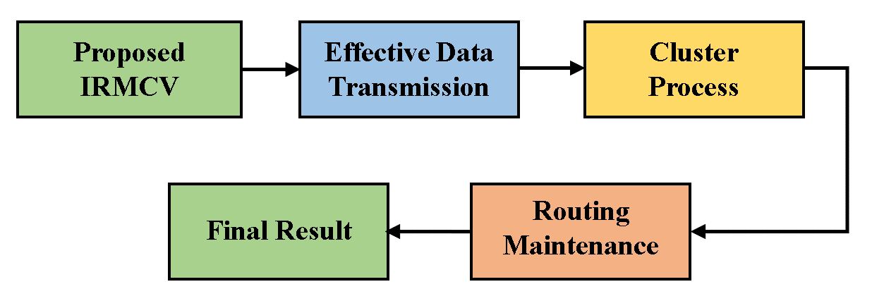
- Workflow of the IRMCV.

Effective Data Transmission in VANETs.
To enhance the conventional BEB’s We give a unique backoff approach called Dynamic Window technique (DWA) that offers performance in terms of delay and throughput. in this section. The traditional BEB's exponential backoff may lead to longer backoff periods, which is why DWA was developed. This conduct impacts channel use and causes excessive communication delays. The reduction of collision-related loss of information, throughout its entirety latency, and component energy use are the main objectives of VANETs. One viable option for ensuring low-power telecommunications with increased performance and lower latency is the IEEE 802.15.4 CSMA-CA approach. In this study, we intend to uncover new ways to increase throughput and decrease latency by optimizing the “CSMA-CA mechanism” (via optimization of its BEB algorithm). It is believed that nodes in the DWA algorithm are arranged in clusters and have queues. How quickly queues fill up will be used to gauge how frequently a node tries to connect to the wireless medium and transfer data. As far as retrieving wireless media is concerned, it is true that nodes with full queue should be given precedence over those with empty ones. Put another way, the number of messages A node's backoff window gets smaller the longer it is in its queue. Conversely, the number of clusters dictates how many interactions occur over the wireless medium. There is more competition for the medium in a cluster of several nodes, increasing the likelihood of accidents. Nodes should delay accessing the media in order to lessen these collisions. When determining The DWA additionally considers the backoff window for each node. The backoff window (W) at a persuaded cluster member node must thus be determined utilizing, according to DWA.
- The quantity of structures now accessible in that node's queue, or the queue size (Q).
- The total nodes in the cluster, or the cluster size (N). In light of the above discussion, DWA connects Q and N to W using the following expression:
$W=\frac{N}{Q}$ 
According to “(1)”, the W has an inverse relationship with the number of frames that are now accessible in the node's queue and a direct relationship with the cluster's size. We suggest the following strategy for how the IEEE 802.15.4 MAC should operate while implementing DWA using “(1)”:
- The default BEB is initially present on every node.
- According to the traditional BEB, a node continues to operate as long as there is no more than half of a queue waiting.
- The node turns to using DWA if a queue achieves 50% occupancy or higher in order to facilitate quicker movement of the medium's resources and start clearing its backlog.
- When the node's queue fills up less than half full, it reverts to the conventional BEB. “Fig.2”, displays the mechanism's flow chart. The flow graphic illustrates how DWA and conventional BEB differ only in how the backoff window is calculated; all other features are the same.

Cluster based Routing Process:
When routing utilizing AODV, two procedures are used: route maintenance and route discovery.

The Process of Route Discovery:
In the absence Finding a path begins on the starting node and is fundamentally a requirement of routing information and interaction. Finding the route starts with a question, and choosing the optimal line of action depends critically on the answer to the inquiry. The transmission Route discovery begins with the receipt of an RREQ message. The route reply packet gives the required answer to the route, and the route links the neighbors to the destination. The neighbors rebroadcast the route packet message in case the link cannot be established. Still, a portion of the query packets get through to their intended recipient. Once the RREP message is received, a route is also formed. The numerous Nodes linked to various kinds of nodes can receive RREP messages from the source nodes. In a longer sequence of numbers, the routing messages have been changed so that only RREP contains new information.

Route Maintenance Process:
The initiation of direction preservation occurs upon the failure of a connection. As the nodes travel around the network, the link is probably going to break. A link breakage is identified when a particular node is unable to detect a Hello message broadcast by its neighbors for a certain amount of time, known as the Hello interval. The neighbor's table entry will be marked as invalid in the event of a link break. Therefore, to notify the other nodes that there is a connection break, the RERR message is issued. When a link fails, RRER messages will alert all of the sources that utilize it [12]. There are several approaches of optimizing AODV. The improvement of AODV, which is utilized in applications related to vehicle safety, can be facilitated by the availability of a channel. The route-finding method might make use of the mobility characteristics. Another technique that may be employed is grouping the network's nodes into clusters and ensuring that the cluster leaders are competent in managing packet routing. Making ensuring that the nodes have been split up into many distinct groups, or clusters, and establishing the cluster's structure are the main goals of clustering. By limiting the routing procedure to a subset of network nodes, clustering makes the task of routing simpler. A message that is completely different from the RREQ messages is likely to be sent to the cluster heads in a network of clusters.
As a result, the needed data for cluster member routing is easily accessible to the CHs. To ensure that the RREQ communications are not noticed, a path needs to be accessible in order for the message to reach its destination to the node as RREP. If not, the CHs will receive the RREQ messages, that have been sent to them via nodes at the gateway. Because it lessens potential network congestion, the decrease in control messages is significant. Additionally, it could lessen the number of packets that need to be maintained, which would enhance AODV's performance.

Simulation Results.
The IRMCV implementation is built within the ns3 program, and the performance analysis parameters that are utilized are energy efficiency, energy consumption, vehicles lifetime, cluster efficiency and data delivery ratio. To perform comparative analysis the computed results when contrasted with the previous techniques, such as NHCT [51], BCOE [52] and POACH [53] and as well Table II lists the input parameters that are used in this simulation experiment.
- Input Parameters Table
Input Parameters | Values
Running Time | 100 ms
Coverage Distance | 500m*600m [54]
Number of Nodes | 100 Nodes [55]
Node Radius | 100m [56]
Initial Energy | 100 Joules [57]
Transmission Power | 0.500 Joules [58]
Receiving Power | 0.050 Joules [58]

Energy Efficiency.
It is the approximation of the remaining energy determined at the conclusion of a high-speed vehicle simulation in vehicular communication. Maximizing energy efficiency is critical to increasing the lifespan of the network's vehicles. The figure describes the efficiency calculation of the IRMCV and compares it to earlier baseline methodologies such as NHCT, BCOE, and POACH. With the existence of cluster-based routing models, vehicle power use is lowered, resulting in optimal energy efficiency. The computed result shows that the IRMCV is approximately 200 joules more efficient than the other approaches.
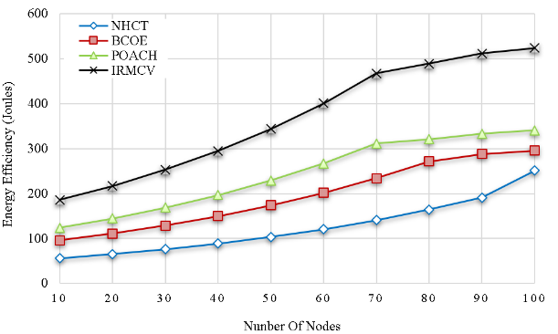
- Energy Efficiency.

Energy Consumption
It is the calculation of the amount of energy which is utilized to perform communication between the fast-moving automobiles. Vehicle longevity is increased by reducing energy use. Figure 3 shows the IRMCV's energy consumption calculation and a comparison to the previous baseline methods, including NHCT, BCOE, and POACH. The cars are organized into many clusters when an effective clustering model is present, which lowers the vehicles' power consumption. As a result, the IRMCV uses around 300 joules less energy than the other techniques.
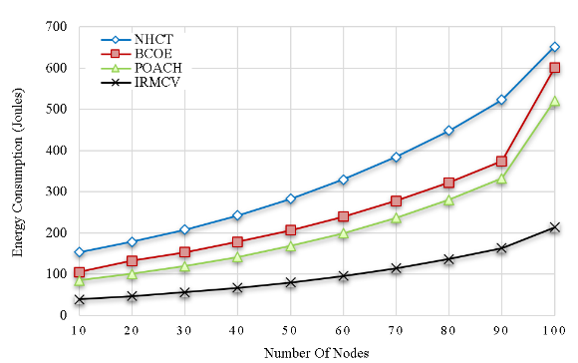
- Energy Consumption.

Vehicles Lifetime.
The lifetime of the vehicles are calculated according to the performance and efficiency of the vehicles. Achieving the longest possible vehicle lifetime among high-speed vehicles is the primary goal of the IRMCV. In figure 4 the analysis results of IRMCV vehicle lifetime calculation is described and it is compared with the other methods like NHCT, BCOE and POACH. From this result it is proven that the IRMCV achieves around 15% higher lifetime than the other methods.
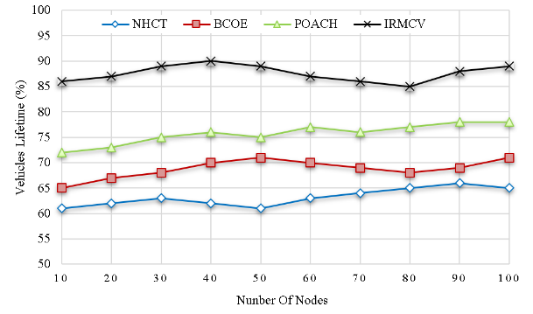
- Vehicles Lifetime.

Cluster Efficiency.
The cluster efficiency is calculated according to the performance of the individual cluster in the vehicular communication. It is very essential to maximize the cluster efficiency to lengthen the vehicles' lifespan. Figure 5 shows the results of the IRMCV's cluster efficiency calculation in comparison to other baseline techniques including NHCT, BCOE, and POACH. From the result it is proven that the IRMCV produces maximum efficiency which is around 5% higher than the other methods.
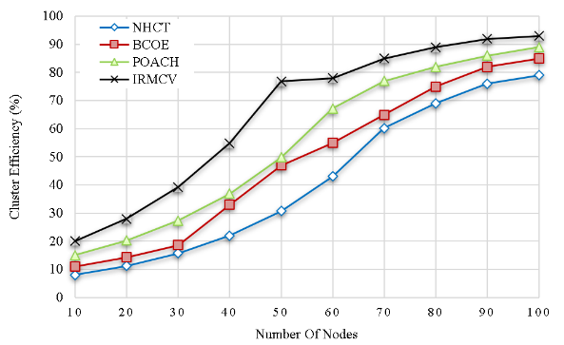
- Cluster Efficiency.

Data Delivery Ratio.
It is the computation of a data packet creation that is successful. and when it is successfully received by the destination. Increasing the amount of delivery ratio leads to high reliability and scalability among the vehicles in the system. Figure 6 describes the IRMCV's delivery ratio computation and compares it to alternative approaches. like NHCT, BCOE and POACH. By utilizing the cluster process the delivery ratio of the IRMCV is increased around 4 percent higher than the other methods.
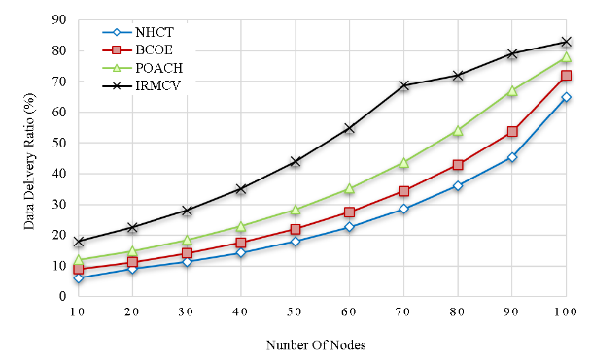
- Data Delivery Ratio.

Conclusion.
This article's goal is to provide efficient vehicle routing and vehicle clustering to lower the cars' power consumption. Improved routing using a multi-channel clustering approach is created for that reason. By this method, the network's total lifespan is increased and the cars' efficiency is enhanced. When compared to the other approaches, the suggested IRMCV model attends to superior efficiency and delivery ratio, as demonstrated by the final outcome. Intelligent clustering will be focused in the future to keep an eye on the cars in the heavily inhabited region.

References
- R. Q. Malik, K. N. Ramli, Z. H. Kareem, M. I. Habelalmatee, A. H. Abbas, and A. Alamoody, "An Overview on V2P Communication System: Architecture and Application," in 2020 3rd International Conference on Engineering Technology and its Applications (IICETA), pp. 174-178, 2020. doi: https://doi.org/10.1109/IICETA50496.2020.9318863.
- A. H. Abbas, A. J. Ahmed, S. A. Rashid, M. A. Jubair, N. F. Abdulsattar, H. S. Mansour, and M. I. Habelalmateen, "Hybrid ANT Based Continuous Cuckoo Search Optimization Algorithm for Vehicle Adhoc Networks," in 2022 5th International Conference on Engineering Technology and its Applications (IICETA), pp. 447-452, May 31-June 1, 2022. https://doi.org/10.1109/IICETA54559.2022.9888404.
- A. H. Abbas, N. F. Abdulsattar, H. S. Mansour, M. H. Mutar, M. I. Habelalmateen, L. Audah, N. A. M. Alduais, and A. Mohammed, "A New Hybrid Approach Cluster-Heads Election to reduce the number of clusters in VANETs," in 2022 5th International Conference on Engineering Technology and its Applications (IICETA), pp. 436-440, 2022. DOI: https://doi.org/10.1109/IICETA54559.2022.9888442.
- M. I. Habelalmateen, A. H. Abbas, L. Audah, and N. A. M. Alduais, "Dynamic multiagent method to avoid duplicated information at intersections in VANETs," Telkomnika (Telecommunication Computing Electronics and Control), vol. 18, no. 2, pp. 613-621, 2020. DOI: http://doi.org/10.12928/telkomnika.v18i2.13947.
- M. K. Hasan, M. M. Ahmed, N. F. Wani, A. H. Abbas, L. M. Alkwai, S. Islam, A. K. M. A. Habib, and R. Hassan, "Dynamic load modeling for bulk load-using synchrophasors with wide area measurement system for smart grid real-time load monitoring and optimization," Sustainable Energy Technologies and Assessments, vol. 57, p. 103190, 2023. doi: https://doi.org/10.1016/j.seta.2023.103190.
- F. Abedi, S. R. M. Zeebaree, Z. S. Ageed, H. M. A. Ghanimi, A. Alkhayyat, M. A. M. Sadeeq, S. N. Mahmood, A. S. Abosinnee, Z. H. Kareem, A. H. Abbas, W. K. Al-Azzawi, M. M. Jaber, and M. Dauwed, "Severity Based Light-Weight Encryption Model for Secure Medical Information System," Computers, Materials & Continua, vol. 74, no. 3, pp. 5691-5704, 2023. DOI: https://doi.org/10.32604/cmc.2023.034435.
- A. H. Kadhim, A. M. Razaq, M. A. Jubair, N. F. Abdulsattar, A. H. Abbas, M. H. Hassan, A. Jamal Ahmed, S. AbdulJabbar Rashid, and M. I. Habelalmateen, "A Real-Time Low-Cost Remote Doctor Monitoring System," in 2022 5th International Conference on Engineering Technology and its Applications (IICETA), pp. 558-561, 2022. doi: https://doi.org/10.1109/IICETA54559.2022.9888536.
- F. Abedi, H. M. A. Ghanimi, A. D. Algarni, N. F. Soliman, W. El-Shafai, A. H. Abbas, Z. H. Kareem, H. M. Hariz, and A. Alkhayyat, "Computational Intelligence Driven Secure Unmanned Aerial Vehicle Image Classification in Smart City Environment," Computer Systems Science and Engineering, vol. 47, no. 3, pp. 3127-3144, 2023. DOI: https://doi.org/10.32604/csse.2023.038959.
- F. Abedi, H. M. A. Ghanimi, M. A. M. Sadeeq, A. Alkhayyat, Z. H. Kareem, S. N. Mahmood, A. H. Abbas, A. S. Abosinnee, W. K. Al-Azzawi, M. M. Jaber, and M. Dauwed, "Hybrid Deep Learning Enabled Load Prediction for Energy Storage Systems," Computers, Materials & Continua, vol. 75, no. 2, pp. 3359-3374, 2023. DOI: https://doi.org/10.32604/cmc.2023.034221.
- A. H. Abbas, H. Mansour, and A. Al-Fatlawi, "Self-Adaptive Efficient Dynamic Multi-Hop Clustering (SA-EDMC) Approach for Improving VANET’s Performance," International Journal of Interactive Mobile Technologies (iJIM), vol. 16, no. 14, pp. 136-151, Jul. 2022. DOI: https://doi.org/10.3991/ijim.v16i14.31081
- I. Ahmad, S. Hussain, S. N. Mahmood, H. Mostafa, A. Alkhayyat, M. Marey, A. H. Abbas, and Z. Abdulateef Rashed, "Co-Channel Interference Management for Heterogeneous Networks Using Deep Learning Approach," Information, vol. 14, no. 2, article no. 139, 2023. DOI: https://doi.org/10.3390/info14020139.
- A. M. Abdulkarem, F. Abedi, H. M. A. Ghanimi, S. Kumar, W. K. Al-Azzawi, A. H. Abbas, A. S. Abosinnee, I. M. Almaameri, and A. Alkhayyat, "Robust Automatic Modulation Classification Using Convolutional Deep Neural Network Based on Scalogram Information," Computers, vol. 11, no. 11, article no. 162, 2022. DOI: https://doi.org/10.3390/computers11110162.
- A. H. Abbas, L. Audah, and N. A. M. Alduais, "An Efficient Load Balance Algorithm for Vehicular Ad-Hoc Network," in 2018 Electrical Power, Electronics, Communications, Controls and Informatics Seminar (EECCIS), pp. 207-212, 2018. https://doi.org/10.1109/EECCIS.2018.8692827.
- A. H. Abbas, A. J. Ahmed, and S. A. Rashid, "A Cross-Layer Approach MAC/NET with Updated-GA (MNUG-CLA)-Based Routing Protocol for VANET Network," World Electric Vehicle Journal, vol. 13, no. 5, article no. 87, 2022. DOI: https://doi.org/10.3390/wevj13050087.
- H. S. Mansour, M. H. Mutar, I. A. Aziz, S. A. Mostafa, H. Mahdin, A. H. Abbas, M. H. Hassan, N. F. Abdulsattar, and M. A. Jubair, "Cross-Layer and Energy-Aware AODV Routing Protocol for Flying Ad-Hoc Networks," Sustainability, vol. 14, no. 15, article no. 8980, 2022. DOI: https://doi.org/10.3390/su14158980.
- M. A. Jubair, S. A. Mostafa, D. A. Zebari, H. M. Hariz, N. F. Abdulsattar, M. H. Hassan, A. H. Abbas, F. H. Abbas, A. Alasiry, and M. Turki-Hadj, "A QoS Aware Cluster Head Selection and Hybrid Cryptography Routing Protocol for Enhancing Efficiency and Security of VANETs," IEEE Access, vol. 10, pp. 124792-124804, 2022. doi: https://doi.org/10.1109/ACCESS.2022.3224466.
- M. I. Habelalmateen, A. J. Ahmed, A. H. Abbas, and S. A. Rashid, "TACRP: Traffic-Aware Clustering-Based Routing Protocol for Vehicular Ad-Hoc Networks," Designs, vol. 6, no. 5, article no. 89, 2022. DOI: https://doi.org/10.3390/designs6050089.
- S. A. Rashid, M. I. Habelalmateen, A. J. Ahmed, A. H. Abbas, M. A. Jubair, M. H. Hassan, A. Abdulhadi, S. Hammed, and L. Audah, "Congestion Aware Genetic Q-learning Based RPL Routing Protocol for Vehicle Ad-Hoc Networks," in 2022 5th International Conference on Engineering Technology and its Applications (IICETA), pp. 464-469, 2022. doi: https://doi.org/10.1109/IICETA54559.2022.9888583.
- A. H. Abbas, A. J. Ahmed, S. A. Rashid, N. F. Abdulsattar, M. H. Hassan, M. A. Jubair, and M. I. Habelalmateen, "Predictive Hybrid Routing with Multi Objective Optimization Model for Opportunistic Routing for VANET," in 2022 5th International Conference on Engineering Technology and its Applications (IICETA), pp. 470-476, 2022. doi: https://doi.org/10.1109/IICETA54559.2022.9888274.
- A. H. Najim, A. H. Abbas, K. Al-sharhanee, and H. M. Hariz, "Reinforcement Learning-based Topology-Aware Routing Protocol with Priority Scheduling for Internet of Drones in Agriculture Application," International Journal of Intelligent Engineering and Systems, vol. 16, no. 5, pp. 395-405, 2023. doi: https://doi.org/10.22266/ijies2023.1031.34.
- A. H. Alwan, A. A. Aziz, M. A. Jubair, A. H. Abbas, M. H. Hassan, S. Alheejawi, N. F. Abdulsattar, A. S. Mustafa, and M. I. Habelalmateen, "Monitoring the Impact of the Nodes Density on the MANETs’ Environment," in 2022 5th International Conference on Engineering Technology and its Applications (IICETA), pp. 546-549, 2022. doi: https://doi.org/10.1109/IICETA54559.2022.9888339.
- Mostafa, S.A., Mustapha, A., Ramli, A.A., Jubair, M.A., Hassan, M.H., Abbas, A.H. (2021). Comparative Analysis to the Performance of Three Mobile Ad-Hoc Network Routing Protocols in Time-Critical Events of Search and Rescue Missions. In: Cassenti, D., Scataglini, S., Rajulu, S., Wright, J. (eds) Advances in Simulation and Digital Human Modeling. AHFE 2020. Advances in Intelligent Systems and Computing, vol 1206. Springer, Cham. https://doi.org/10.1007/978-3-030-51064-0_16.
- M. H. Hassan, M. A. Jubair, A. H. Abbas, A. J. Ahmed, S. A. Rashid, M. H. Mutar, H. S. Mansour, A. Ali, and M. I. Habelalmateen, "AODV based Crow Search Algorithm for Improving the QoS of MANET," in 2022 5th International Conference on Engineering Technology and its Applications (IICETA), pp. 424-428, 2022. DOI: https://doi.org/10.1109/IICETA54559.2022.9888484.
- M. A. Jubair, M. H. Hassan, S. A. Mostafa, H. Mahdin, A. Mustapha, L. H. Audah, F. S. Shaqwi, and A. H. Abbas, "Competitive analysis of single and multi-path routing protocols in MANET," Indonesian Journal of Electrical Engineering and Computer Science, vol. 19, no. 1, pp. 293-300, 2020. http://doi.org/10.11591/ijeecs.v19.i1.pp293-300.
- S. A. Rashid, A. J. Ahmed, M. H. Hassan, A. H. Abbas, M. I. Habelalmateen, M. A. Jubair, L. Audah, and W. Al-Azzawi, "Ranking Based Routing Protocol for Residual Energy Estimation in Wireless Sensor Network Based IoT Network," in 2022 5th International Conference on Engineering Technology and its Applications (IICETA), pp. 453-459, 2022. https://doi.org/10.1109/IICETA54559.2022.9888349.
- A. J. Ahmed, A. H. Abbas, S. A. Rashid, M. A. Jubair, M. H. Hassan, A. Abdulhadi, N. F. Abdulsattar, and M. I. Habelalmateen, "Congestion Aware Q-Learning (CAQL) in RPL Protocol – WSN based IoT Networks," in 2022 5th International Conference on Engineering Technology and its Applications (IICETA), pp. 429-435, 2022. doi: https://doi.org/10.1109/IICETA54559.2022.9888322.
- A. H. Abbas, M. I. Habelalmateen, L. Audah, and N. A. M. Alduais, "A novel intelligent cluster-head (ICH) to mitigate the handover problem of clustering in VANETs," International Journal of Advanced Computer Science and Applications, vol. 10, no. 6, pp. 281-287, 2019. DOI: https://doi.org/10.14569/IJACSA.2019.0100627.
- Y.S. Jghef, M.J.M. Jasim, H.M.A. Ghanimi, A.D. Algarni, N.F. Soliman, W. El-Shafai, S.R.M. Zeebaree, A. Alkhayyat, A.S. Abosinnee, N.F. Abdulsattar, A.H. Abbas, H.M. Hariz, and F.H. Abbas, "Bio-Inspired Dynamic Trust and Congestion-Aware Zone-Based Secured Internet of Drone Things (SIoDT)," Drones, vol. 6, no. 11, pp. 337, 2022. https://doi.org/10.3390/drones6110337.
- G.G. Shayea, D.A. Mohammed, A.H. Abbas, and N.F. Abdulsattar, "Privacy-Aware Secure Routing through Elliptical Curve Cryptography with Optimal RSU Distribution in VANETs," Designs, vol. 6, no. 6, pp. 121, 2022. doi: https://doi.org/10.3390/designs6060121.
- M.H. Hassan, A.H. Abbas, M.H. Mutar, M.A. Jubair, S.A. Rashid, A.J. Ahmed, M.I. Habelalmateen, A. Mohammed, and L. Audah, "Investigative Study on Routing Protocols in Flying Ad Hoc Networks Environment," in 2022 5th International Conference on Engineering Technology and its Applications (IICETA), pp. 460-463, 2022. doi: https://doi.org/10.1109/IICETA54559.2022.9888600.
- N.F. Abdulsattar, F. Abedi, H.M.A. Ghanimi, S. Kumar, A.H. Abbas, A.S. Abosinnee, A. Alkhayyat, M.H. Hassan, and F.H. Abbas, "Botnet Detection Employing a Dilated Convolutional Autoencoder Classifier with the Aid of Hybrid Shark and Bear Smell Optimization Algorithm-Based Feature Selection in FANETs," Big Data and Cognitive Computing, vol. 6, no. 4, article no. 112, 2022. DOI: https://doi.org/10.3390/bdcc6040112.
- V. O. Nyangaresi, I. M. Al-Joboury, K. A. Al-sharhanee, A. H. Najim, A. H. Abbas, and H. M. Hariz, "A biometric and physically unclonable function–Based authentication protocol for payload exchanges in internet of drones," e-Prime - Advances in Electrical Engineering, Electronics and Energy, vol. 7, pp. 100471, 2024. DOI: https://doi.org/10.1016/j.prime.2024.100471.
- I. S. Al-Hawary, E. Ali, S. M. H. Kamona, L. Hussain Saleh, A. S. Abdulwahid, D. N. Al-Saidi, M. S. Alhassan, F. A. Rasen, H. Abdullah Abbas, A. Alawadi, A. H. Abbas, and M. Sina, "Prediction of geomechanical bearing capacity using autoregressive deep neural network in carbon capture and storage systems," Heliyon, vol. 9, no. 11, pp. e21913, Nov. 2023. doi: https://doi.org/10.1016/j.heliyon.2023.e21913.
- M. R. M. Alsemawi, M. H. Mutar, E. H. Ahmed, H. O. Hanoosh, and A. H. Abbas, "Emotions recognition from human facial images based on fast learning network," Indonesian Journal of Electrical Engineering and Computer Science, vol. 30, no. 3, pp. 1478-1487, 2023. doi: http://doi.org/10.11591/ijeecs.v30.i3.pp1478-1487.
- J. Tang, A. K. Abbas, N. A. Koka, N. Sadoon, J. K. Abbas, R. A. Abdalhuseen, M. Abosaooda, N. M. Ahmed, and A. H. Abbas, "Optimization of thermal biofuel production from biomass using CaO-based catalyst through different algorithm-based machine learning approaches," Case Studies in Thermal Engineering, vol. 50, p. 103419, 2023. doi: https://doi.org/10.1016/j.csite.2023.103419.
- F. Abedi, H. M. A. Ghanimi, A. D. Algarni, N. F. Soliman, W. El-Shafai, A. H. Abbas, Z. H. Kareem, H. M. Hariz, and A. Alkhayyat, "Chimp Optimization Algorithm Based Feature Selection with Machine Learning for Medical Data Classification," Computer Systems Science and Engineering, vol. 47, no. 3, pp. 2791–2814, 2023. doi: https://doi.org/10.32604/csse.2023.038762.
- M. A. A. Albadr et al., "Online sequential extreme learning machine approach for breast cancer diagnosis," Neural Computing and Applications, vol. Volume, no. Issue, pp. Page, 2024. DOI: https://doi.org/10.1007/s00521-024-09617-x.
- M. S. Alshuhri, S. G. Al-Musawi, A. A. Al-Alwany, H. Uinarni, I. Rasulova, P. Rodrigues, A. T. Alkhafaji, A. M. Alshanberi, A. H. Alawadi, and A. H. Abbas, "Artificial intelligence in cancer diagnosis: Opportunities and challenges," Pathology - Research and Practice, vol. 253, pp. 154996, 2024. https://doi.org/10.1016/j.prp.2023.154996.
- A. Abdulbari, S. K. Abdul Rahim, F. Abedi, P. J. Soh, A. Hashim, R. Qays, S. Ahmad, and M. Y. Zeain, "Single-Layer Planar Monopole Antenna-Based Artificial Magnetic Conductor (AMC)," International Journal of Antennas and Propagation, vol. 2022, pp. 6724175, 2022. https://doi.org/10.1155/2022/6724175.
- S. Saleem, A. H. Jabbar, M. H. Jameel, A. Rehman, Z. H. Kareem, A. H. Abbas, Z. Ghaffar, S. A. Razzaq, R. A. Pashameah, E. Alzahrani, E.-P. Ng, and S. M. Sapuan, "Enhancement in structural, morphological, and optical properties of copper oxide for optoelectronic device applications," Nanotechnology Reviews, vol. 11, no. 1, pp. 2827-2838, 2022.DOI: https://doi.org/10.1515/ntrev-2022-0473.
- Sijing Zhang and Enjie Liu, "An Adaptive and Reliable Communication Method for Road Safety Applications of VANET", 25th International Conference on Automation and Computing (ICAC), 2019, doi:10.23919/IConAC.2019.8895036.
- Mounib Khanafer and Marwa Kandil, "Enhancements to IEEE 802.15.4 MAC Protocol to Support Vehicle-to-Roadside Communications in VANETs", ICC 2019 - 2019 IEEE International Conference on Communications (ICC), 2019, doi:10.1109/ICC.2019.8761245.
- T PerarasI and S Vidhya,"Malicious vehicles identifying and trust management algorithm for enhance the security in 5G-VANET", 2020
- Lucas Rivoirard and Martine Wahl, "Multipoint Relaying Versus Chain-Branch-Leaf Clustering Performance in Optimized Link State Routing-Based Vehicular Ad Hoc Networks", IEEE Transactions on Intelligent Transportation Systems , vol.21, no.3, pp.1034 - 1043, 2020, doi:10.1109/TITS.2019.2900767.
- Grace Khayat and Constandinos X. Mavromoustakis, "Retransmission-based Successful Delivery Tuning in Damaged Critical Infrastructures for VANETs", ICC 2020 - 2020 IEEE International Conference on Communications (ICC), 2020, doi:10.1109/ICC40277.2020.9148999
- Paola Flocchini and Amiya Nayak, "Towards Smart Trust Management of VANETs", IEEE Canadian Conference on Electrical and Computer Engineering (CCECE), 2020, doi:10.1109/CCECE47787.2020.9255766.
- Weijing Qi and Björn Landfeldt, "Traffic Differentiated Clustering Routing in DSRC and C-V2X Hybrid Vehicular Networks", IEEE Transactions on Vehicular Technology, vol.69, no.7, pp.7723 - 7734, 2020, doi:10.1109/TVT.2020.2990174.
- R. Raja Subramanian and Karthick Seshadri, "Randomized Gossip Algorithm based RSU Distribution for VANETs leveraging Fog Computing", IEEE International Conference on Clean Energy and Energy Efficient Electronics Circuit for Sustainable Development (INCCES), 2019, doi:10.1109/INCCES47820.2019.9167694.
- S. Patil and L. Ragha, "Deployment and Decentralized Identity Management for VANETs," 2020 3rd International Conference on Emerging Technologies in Computer Engineering: Machine Learning and Internet of Things (ICETCE), Jaipur, India, 2020, pp. 202-209, doi: 10.1109/ICETCE48199.2020.9091766.
- Gang Liu and Pingzhi Fan, "An Efficient Cluster Based Resource Management Scheme and its Performance Analysis for V2X Networks", IEEE Access, vol.8, pp.87071 - 87082, doi:10.1109/ACCESS.2020.2992591.
- Goh Chin Hock and Nadia M. L. Tan, "Modeling and Analysis of New Hybrid Clustering Technique for Vehicular Ad Hoc Network", 2020, doi:10.3390/math10244720.
- G Sikander and A Ali, S Lim, " A bio-inspired cluster optimization schema for efficient routing in vehicular ad hoc networks (VANETs)", vol.16, no.3, 2023, doi:10.3390/en16031456.
- N. F. Abdulsattar, D. A. Mohammed, A. Alkhayyat, S. Z. Hamed, H. M. Hariz, A. S. Abosinnee, A. H. Abbas, M. H. Hassan, M. A. Jubair, F. H. Abbas, A. D. Algarni, N. F. Soliman, and W. El-Shafai, "Privacy-Preserving Mobility Model and Optimization-Based Advanced Cluster Head Selection (P2O-ACH) for Vehicular Ad Hoc Networks," Electronics, vol. 11, no. 24, p. 4163, 2022, DOI: https://doi.org/10.3390/electronics11244163.
- N.F. Abdulsattar, A.H. Abbas, M.H. Mutar, M.H. Hassan, M.A. Jubair, and M.I. Habelalmateen, "An Investigation Study for Technologies, Challenges and Practices of IoT in Smart Cities," in 2022 5th International Conference on Engineering Technology and its Applications (IICETA), pp. 554-557, 2022. DOI: https://doi.org/10.1109/IICETA54559.2022.9888474.
- S. Alsubai, A. K. Dutta, A. H. Alkhayyat, M. M. Jaber, A. H. Abbas, and A. Kumar, "Hybrid deep learning with improved Salp swarm optimization based multi-class grape disease classification model," Computers and Electrical Engineering, vol. 108, p. 108733, 2023. DOI: https://doi.org/10.1016/j.compeleceng.2023.108733.
- A. H. Abbas, M. I. Habelalmateen, S. Jurdi, L. Audah, and N. A. M. Alduais, "GPS based location monitoring system with geo-fencing capabilities," AIP Conference Proceedings, vol. 2173, no. 1, p. 020014, Nov. 2019. DOI: https://doi.org/10.1063/1.5133929.
- A. J. Ahmed, S. A. Rashid, A. H. Abbas, N. F. Abdulsattar, H. S. Mansour, M. H. Hassan, M. I. Habelalmateen, and A. Hussain, "An Effectual Secure Cryptography Scheme for Multipath Routing in A Wsn-Based IoT Environment," in 2022 5th International Conference on Engineering Technology and its Applications (IICETA), pp. 441-446, 2022. doi: https://doi.org/10.1109/IICETA54559.2022.9888604.
- A. J. Ahmed, A. H. Abbas, and S. A. Rashid, "Multi level trust calculation with improved ant colony optimization for improving quality of service in wireless sensor network," IAES International Journal of Artificial Intelligence, vol. 12, no. 3, pp. 1224–1237, 2023. doi: https://doi.org/10.11591/ijai.v12.i3.pp1224-1237..

