Effective Spectrum Allocation with Priority Function and Multipoint Relay based Routing in VANETs

1st F.H. Abbas
Medical Laboratories Techniques Department
Al-Mustaqbal University
Hillah, Iraq
fatimahashim@mustaqbal-college.edu.iq
4th Riyadh Rashid Hameed
National University of Science and Technology
Dhi Qar, Iraq
riyadh.r.hameed@nust.edu.iq
2nd Hussein Muhi Hariz
Department of Computer Techniques Engineering
Mazaya University College
DhiQar, Iraq;
huhraiz22@gmail.com.
5th Zaid Mohammed Alshukur
Department of Computer Science
Altoosi University College
Najaf, Iraq
zaid.alshukur@altoosi.edu.iq
3rd Siva Shankar S
Department of CSE
KG Reddy College of Engineering and Technology
Hyderabad, India
drsivashankars@gmail.com
6th Mohammed I. Hashim
Department of Computer Technical Engineering
College of Technical Engineering
The Islamic University
Najaf, Iraq
moh.mtech89@gmail.com

Abstract—The vehicles which are present in the network communicate with the adjacent vehicles and the roadside units through the routing model using the standard of IEEE 802.11p. To make the routing more flexible the vehicles undergo certain challenges hence the mobility of the vehicles is so high and that result in the failure in communication link. Additionally due to irregular spectrum allocation the emergency data transmission is disturbed and that greatly reduces the communication quality. In order to overcome these drawbacks in this article effective spectrum allocation with priority function and multipoint relay based efficient routing model (ESPMRR) is developed in the vehicular communication. The core modules are network construction, channel model creation, priority-based data transmission and multipoint relay-based routing. Through this process the earlier drawbacks are rectified and that leads to attend an effective communication among the vehicles. The ESPMRR is constructed the energy efficiency, routing overhead, packet delivery ratio, network throughput and average delay are measured. The simulation results prove that ESPMRR attends better results when compared with the previous works.
Keywords— VANETs, Priority Function, Effective Spectrum Allocation and Multipoint Relay based Routing.

Introduction
In recent times several technology sir developed to expand the communication quality such as artificial intelligence [1-5] and 5th generation models [6-9]. The interconnections of devices with respect to Ad hoc networks which are used to connect the road environment through vehicles are termed as vehicular adhoc networks VANETs [10-14]. The major applications of vehicular communication sir it occupies maximum of the technology which are present in the intelligent communication system (ITS) [15-18], connecting smart cities which are highly functional, and providing various services [19-22]. The primary services which are enabled with the communication are transmission in emergency situations and hazard control systems [23-25].
In order to achieve better performance in the emergency situation the system requires a proper management of data dissemination towards the source and the destination [26-29]. Vehicles perform communication to other vehicles and roadside units to transmit the emergency data packets to ensure the situation condition [30-33]. Due to improper spectrum allocation [34-37] the emergency transmission for interruptions that affects the quality of the data and as well providing confidentiality is disturbed [38-40]. In order to overcome these drawbacks in this article effective spectrum allocation is concentrator and as well improved routing model is initiated.
This proposed model is mainly developed to achieve highly accurate emergency data transmission with priority function. The core modules which are present in this article are an effective network model, channel model, priority model and multipoint relay based routing model. With the presence of these models the priority of the emergency vehicles is greatly improved and that reduces the delay and loss of packets at the time of confidential data transmission among the high speed vehicles.

Related Works
In [41], introduced clustering protocol to address challenges in highly dynamic vehicular networks. It incorporates a Traffic Management Unit and clustering, grouping vehicles in an effective manner. In [42], introduced the Software Defined Network paradigm, offering a global traffic view, as an efficient solution to enhance network performance. It also delves into the combination of SDN into the IoV architecture to meet the demands of ITS. In [43], introduced a Traffic Management Unit for centralized traffic control using Roadside Units and forms vehicle clusters based on similar speed and direction. The clustering model enhances network stability and reduces energy consumption. In [44], proposed an SINR-based model for QoS analysis in VANETs. This study includes a mechanism to map physical layer performance to higher-layer QoS quantification, enabling QoS prediction for IEEE 802.11bd-driven VANETs. In [45], proposed a comprehensive approach to tackle spectrum scarcity VANETs by leveraging Cognitive Radio (CR) technology. The strategies introduced, namely CASGA and SMDP-CAS, were designed to optimize network throughput under varying load conditions.
In [46] proposed a prioritization approach for wireless VANETs. It incorporates a priority classifying mechanism to categorize traffic information into different priorities, optimizing VANET communications. In [47] proposed the cooperative algorithm based clustering model as an enhancement to the Optimized Link State Routing Protocol for VANETs. Additionally, cluster-based Quality of Service (QoS) algorithm was employed. In [48], proposed a novel Traffic-Aware Clustering-based Routing protocol for VANETs. This approach introduced a Traffic Management Unit and clusters vehicles based on similar speed and direction. In [49], proposes a novel routing called improved ACO with ACK packet broadcasting in VANETs. This algorithm utilizes Ant Colony Optimization to enhance the forwarding of packets.
In [50], a quality of service based hybrid optimization algorithm is developed in the vehicular network to reduce the congestion issue among the vehicles and a feasible pathway is provided to them. In [51], an intelligent communication is developed to achieve effective resource allocation among the vehicles in the network. Mainly to solve the optimization based issues and to achieve maximum quality this model is constructed with virtual allocation of resources. In [52], an intelligent traffic management system is developed among the vehicular network to increase the data authenticity and availability. After analyzing the earlier methodology which is related to the vehicular communication we understood still there is some of the research gap present in terms of spectrum allocation and routing which is described in table I.
- Earlier Research Gap.
No | Model | Advantages | Disadvantages
[43] | Traffic Management Unit | Enhances network stability and reduces energy consumption | Limited scalability
[48] | Traffic-Aware Clustering-based Routing protocol | enhances network stability | High routing overhead
[49] | Routing algorithm using Ant Colony Optimization | enhance packet forwarding, reduces routing overhead | High optimization complexity
[50] | Quality of Service (QoS) based hybrid optimization algorithm | Reduces congestion issues | High packet loss
[51] | Intelligent communication for effective resource allocation | Achieves effective resource allocation | High delay
[52] | Intelligent traffic management system | Increases data authenticity and availability | Low throughput

Proposed ESPMRR Model.
In this section the ESPMRR model is elaborated and the core modules of the research like vehicular network construction, effective channel model creation, priority based data transmission and multipoint relay based routing process. The work flow of the ESPMRR model is given in the “Fig.1”.

Network Model.
The highway functions as the CR-VANET network, and numerous task-based scenarios are developed. of this scenario, fundamental equipment includes the base station (BS), road side units (RSUs), main unit (PU), and secondary unit (SU) of the CR-VANET. DSRC is a communication protocol. The RSUs are positioned along a specific stretch of the route. Because we are not addressing the distribution of RSU sites, we will assume that RSU locations are evenly distributed over the roadway and cover the entire highway segment. Next, RSUs may be used to split the whole highway into unit sections, with each RSU covering a D-width segment of the roadway. The situation consists of a single RSU and the PU is dispersed randomly and is static on the roadway within the RSU's coverage area. We also assume that the PU's coverage is random. OBU allows vehicle users to check if the PU channel is available.
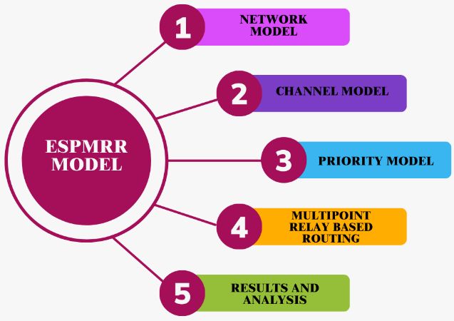
- ESPMRR Model Workflow.

Channel Model.
It is expected in CR-VANET that N available channels are detected by the RSU and that each channel is competent to provide the minimal level of service needed for various services. When the PU is not in use, the vehicle can utilize the channel. The availability state of channel n during time slot t is shown by Xn(t). When channel n is idle at time t, Xn(t) = 1; otherwise, Xn(t) = 0. According to our channel model, a stable Bernoulli random process above t determines whether the channel is active or idle. Vehicle transmissions planned to a certain channel may clash or cause a conflict with the channel that the PU is sending since the RSU is unaware of the channel's precise status. Like the current CR network , we assume that the PU can withstand a specific collision probability, i.e., the collision probability on channel n produced by the dis-patching vehicle must not be more than $λ_{n}$. The PU channel controls this system parameter [21].RSU is able to determine the maximum permitted scheduling time $T_{n}^{r}$on each channel with this collision probability limit. “Equation (1) is utilized to compute the collision probability $P_{coll}$”.
$P_{coll}=Pr\left\{t_{n}≤T_{n}^{r}\right\}=\int_{0}^{T_{n}^{r}}{f_{n}\left(t_{n}\right)dt_{n}=F_{n}(T_{n}^{r})}≤γ_{n}$1
Consequently, “ (1)” may be used to measure the channel transmission time $T_{n}^{r}$. The scheduling time on channel n is $t_{n}=min\left\{T_{n}^{r}, T\right\}$, where T is the scheduling period, as channel allocation starts at each scheduling cycle.

Priority Model:
The suggested method for figuring out the priority message ${(P}_{M}$) for packets that are forwarded in the present vehicle node is explained in the Section that follows. These data packets are sent to the vehicle node for forwarding in decreasing order of the ${(P}_{M}$). Here the message priority is represented as $P_{M}$ and it implies the function of $∆_{T}, ∆_{rel}, ∆_{V}, D_{IR}$ specified in “(2)”.
$P_{M}=f(∆_{T},∆_{rel,}∆_{V},D_{IR})$ 2
The variables $D_{IR}, ∆_{T},∆_{rel,}∆_{V},$denote the relative direction, the timestamp of the data, and its relative velocity of the receiving and forwarding node. The following results from splitting the priority function into two states: $D_{IR }$=1 and $D_{IR }$=0, given in “(3)”, and “(4)”, respectively.
$P_{M}=In\frac{(∆_{V}+1)}{\left(D_{rel}+1\right)X(X_{T}+1)}$ 3
$P_{M}=In\frac{(\left(D_{rel}+1\right)X(X_{T}+1))}{\left(∆_{V}+1\right)}$ 4
Here, the priority function delineated in “(3)” and “(4)” determines the message priority, as follows:
- Compared to the $D_{IR }$=0 packet, the$D_{IR }$=1packet has a comparatively higher priority. It is more probable that the subsequent hop vehicle will pass outside the forwarding vehicle's current transmission range as it moves away from it, which might result in sporadic routing route breaks.
- In order to confirm that the real-time data reaches its endpoint quickly, data using lower ΔT hold the position of highest priority among the standard data.
- When $D_{IR }$=0, packets with greater $D_{IR }$=1and lower $D_{IR }$ will be given higher priority. The packet will be transmitted if the adjacent vehicle approaches the present one; else, the routing routes may be disrupted by the next vehicle using $∆_{V}$ and less $D_{rel}$ that travels farther than the vehicle's transmission distance to forward the packet.
- When $D_{IR }$=1, packets with bigger $D_{rel}$and larger $∆_{V}$have a higher prioritization. The next vehicle with a maximum $∆_{V}$and less $D_{rel}$may transfer within the coverage area to which will forward the data they may create link failure. This is due to the next hop vehicle being driven away from the present node transmitting the data.

Multipoint Relay based Routing:
The routing method known as OLSR Link State was designed specifically for MANETs. It is a mobile wireless protocol that is an improvement on standard pure linkstate protocols. A Multipoint Relay (MPR) technique selects only the nodes that generate link-state information, providing a potential option to reduce control packet size. To execute this operation, each vehicle selects an MPR set, or collection of surrounding nodes, using a CH. To reduce repeated data transmissions, each source vehicle sends out a HELLO-Interval and control messages. The network is then partitioned into clusters to identify the optimal MPR set. As a result, if an MPR scheme defines symmetric connections in its relay selection set, OLSR offers the shortest paths to every destination
A vehicle begins estimating the link standard and quality which is based on link-state data when it gets HELLO packets from the vehicles to its adjacent once. Simple mobility information via one-hop and two-hop neighbors should be included in this data. Vehicles must acquire link connection quality data from HELLO packets in order to compute the MPR set. Every vehicles level of will must also be taken into account. This technique is only used if this adjacent covers the greatest number of two-hop neighbors with a high degree of link reachability and the link to this adjacent is symmetric. In the following algorithmic selection cycle, the two-hop nodes covered by a candidate MPR will not be taken into consideration. To locally reduce the number of MPR, the MPR vehicle repeat this process until all two-hop adjacent are covered. This method was used to choose the route with the best connection quality and the fewest MPR.
The functionality of OLSR adjusts nicely to the ongoing changes in topology. In addition to operating simply, it was designed to offer a very competitive latency in dynamic networks using ad hoc network designs. This protocol is readily implemented into VANETs systems because to its OLSR characteristics. However, the effectiveness of OLSR routing operation is greatly impacted by the vehicle's speed and the problems presented by the roads, which leads to frequent link disconnections and a large overhead of control messages needed to properly maintain routes. The cars, or nodes, lack the exact sort of neighbor position knowledge that makes it difficult for them to swiftly calculate the next hops for data transfers. These variables restrict the quality of the route selection process and mobility information to guarantee consistent message delivery. The goal of this study is to obtain an optimal path to decrease the issue of broadcast overhead. As the whole the proposed ESPMRR-UAV helps to maximize the efficiency and delivery ratio of the high-speed vehicles.

Simulation Results.
The performance of the existing technique like QoSHA-UAV [49], IRQoS-UAV [50], and RTIMD-UAV [51] methods with the proposed ESPMRR-UAV methods using the NS2 simulator is elaborated. The evaluation metrics are energy efficiency (joules), routing overhead (packets), packet delivery ratio (%), throughput (kbps) and delay (ms) and as well the parameters used for the process of simulation are given in table II.
- Input Parameters Table
Input Parameters | Values
Simulation Time | 200 ms
Coverage Distance | 2000m*2000m
Number of Vehicles | 1000 Vehicles [52]
Vehicles Radius | 100m
Initial Energy | 100 Joules [53]
Transmission Power | 0.500 Joules
Receiving Power | 0.050 Joules

Energy Efficiency.
It is quantified as the ratio of usable energy output to the energy input during the process of data transmission.
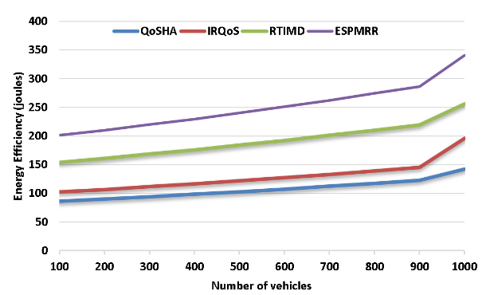
- Energy Efficiency.
In “Fig.2”, the calculation of efficiency of the ESPMRR-UAV is given and it is compared with the QoSHA-UAV, IRQoS-UAV, and RTIMD-UAV earlier methods. In terms of energy efficiency, the proposed ESPMRR method achieved 341 joules which exceeds the existing technique of RTIMD at 256 joules, IRQoS at 196 joules, and QoSHA at 142 joules. This reveals that the data transmission is more efficient.

Routing overhead
It pertains to the additionally data packets used for transmitting routing information. In “Fig.3”, the calculation of routing overhead of the ESPMRR-UAV is given and it is compared with the QoSHA-UAV, IRQoS-UAV, and RTIMD-UAV earlier methods.
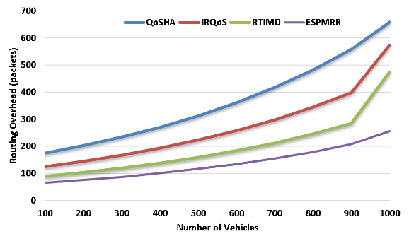
- Routing Overhead.
In routing overhead, the existing techniques of QoSHA at 658 packets, IRQoS at 574 packets, and RTIMD at 475 packets, and the Proposed ESPMRR has a reduced Routing Overhead of 256 packets. Hence, the proposed method has minimum routing overhead.

Packet delivery ratio.
The ratio of packets that have been successfully transmitted compared to the total number of packets transmitted in the network. In “Fig.4”, the calculation of packet delivery ratio of the ESPMRR-UAV is given and it is compared with the QoSHA-UAV, IRQoS-UAV, and RTIMD-UAV earlier methods.
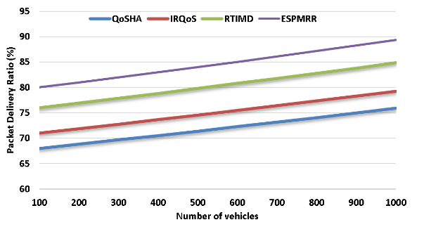
- Packet Delivery Ratio.
The Proposed ESPMRR achieved a Packet Delivery Ratio of 89%outperforms the existing technique of QoSHA at 76%, IRQoS at 79%, and RTIMD at 85%. This reveals that the Proposed ESPMRR is more successful.

Throughput
It refers to the rate of speed at which data is successfully transferred over a channel of communication. In “Fig.5”, the calculation of throughput of the ESPMRR-UAV is given and it is compared with the QoSHA-UAV, IRQoS-UAV, and RTIMD-UAV earlier methods.
In terms of throughput, the proposed ESPMRR outperforms QoSHA (156 kbps), IRQoS (241 kbps), and RTIMD (296 kbps) with a throughput of 358 kbps. This confirms that the Proposed ESPMRR technique can handle more data which leads the increase the data transmission.
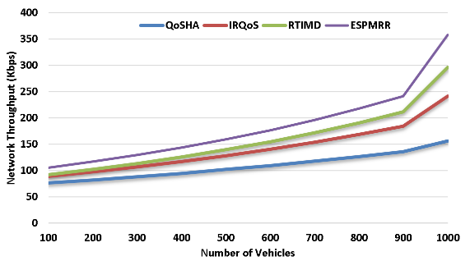
- Network Throughput .

Average delay.
It refers to the average amount of time it takes for data packets to transit from the source to the destination node. In “Fig.6”, the calculation of average delay of the ESPMRR-UAV is given and it is compared with the QoSHA-UAV, IRQoS-UAV, and RTIMD-UAV earlier methods.
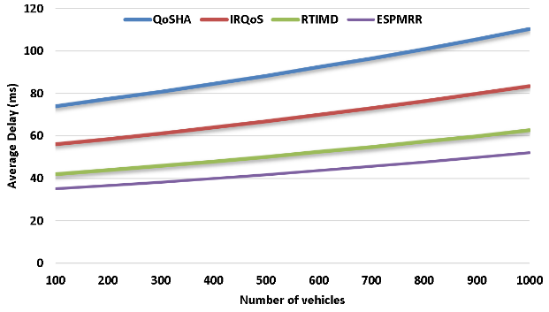
- Average Delay.
In comparison to existing technique, QoSHA at 110 ms, IRQoS at 83 ms, and RTIMD at 63 ms, the proposed ESPMRR approach shows a shorter delay of 52 ms.

Conclusion.
They study presence an efficient routing and proper spectrum allocation with supports for emergency data transmission in the vehicular communication. This is used to determine the proper communication link between the vehicles so that it is able to transmit higher package size of data and that directly maximize the throughput level of the vehicles. From the simulator result it is proven that the proposed model attends maximum efficiency and throughput when compared with the earlier baseline methodologies. In the future work clustering models are concentrated to improve the energy efficiency if these technologies apply to the densely populated area to access the emergency data which is present in the remote areas.

References
- M. A. Jubair, S. A. Mostafa, D. A. Zebari, H. M. Hariz, N. F. Abdulsattar, M. H. Hassan, A. H. Abbas, F. H. Abbas, A. Alasiry, and M. Turki-Hadj, "A QoS Aware Cluster Head Selection and Hybrid Cryptography Routing Protocol for Enhancing Efficiency and Security of VANETs," IEEE Access, vol. 10, pp. 124792-124804, 2022. doi: https://doi.org/10.1109/ACCESS.2022.3224466.
- S. A. Rashid, M. I. Habelalmateen, A. J. Ahmed, A. H. Abbas, M. A. Jubair, M. H. Hassan, A. Abdulhadi, S. Hammed, and L. Audah, "Congestion Aware Genetic Q-learning Based RPL Routing Protocol for Vehicle Ad-Hoc Networks," in 2022 5th International Conference on Engineering Technology and its Applications (IICETA), pp. 464-469, 2022. doi: https://doi.org/10.1109/IICETA54559.2022.9888583.
- A. H. Abbas, A. J. Ahmed, S. A. Rashid, N. F. Abdulsattar, M. H. Hassan, M. A. Jubair, and M. I. Habelalmateen, "Predictive Hybrid Routing with Multi Objective Optimization Model for Opportunistic Routing for VANET," in 2022 5th International Conference on Engineering Technology and its Applications (IICETA), pp. 470-476, 2022. doi: https://doi.org/10.1109/IICETA54559.2022.9888274.
- A. H. Abbas, N. F. Abdulsattar, H. S. Mansour, M. H. Mutar, M. I. Habelalmateen, L. Audah, N. A. M. Alduais, and A. Mohammed, "A New Hybrid Approach Cluster-Heads Election to reduce the number of clusters in VANETs," in 2022 5th International Conference on Engineering Technology and its Applications (IICETA), pp. 436-440, 2022. DOI: https://doi.org/10.1109/IICETA54559.2022.9888442.
- M. I. Habelalmateen, A. H. Abbas, L. Audah, and N. A. M. Alduais, "Dynamic multiagent method to avoid duplicated information at intersections in VANETs," Telkomnika (Telecommunication Computing Electronics and Control), vol. 18, no. 2, pp. 613-621, 2020. DOI: http://doi.org/10.12928/telkomnika.v18i2.13947.
- M. K. Hasan, M. M. Ahmed, N. F. Wani, A. H. Abbas, L. M. Alkwai, S. Islam, A. K. M. A. Habib, and R. Hassan, "Dynamic load modeling for bulk load-using synchrophasors with wide area measurement system for smart grid real-time load monitoring and optimization," Sustainable Energy Technologies and Assessments, vol. 57, p. 103190, 2023. doi: https://doi.org/10.1016/j.seta.2023.103190.
- A. H. Abbas, A. J. Ahmed, and S. A. Rashid, "A Cross-Layer Approach MAC/NET with Updated-GA (MNUG-CLA)-Based Routing Protocol for VANET Network," World Electric Vehicle Journal, vol. 13, no. 5, article no. 87, 2022. DOI: https://doi.org/10.3390/wevj13050087.
- H. S. Mansour, M. H. Mutar, I. A. Aziz, S. A. Mostafa, H. Mahdin, A. H. Abbas, M. H. Hassan, N. F. Abdulsattar, and M. A. Jubair, "Cross-Layer and Energy-Aware AODV Routing Protocol for Flying Ad-Hoc Networks," Sustainability, vol. 14, no. 15, article no. 8980, 2022. DOI: https://doi.org/10.3390/su14158980.
- A. H. Najim, A. H. Abbas, K. Al-sharhanee, and H. M. Hariz, "Reinforcement Learning-based Topology-Aware Routing Protocol with Priority Scheduling for Internet of Drones in Agriculture Application," International Journal of Intelligent Engineering and Systems, vol. 16, no. 5, pp. 395-405, 2023. doi: https://doi.org/10.22266/ijies2023.1031.34.
- A. H. Abbas, M. I. Habelalmateen, L. Audah, and N. A. M. Alduais, "A novel intelligent cluster-head (ICH) to mitigate the handover problem of clustering in VANETs," International Journal of Advanced Computer Science and Applications, vol. 10, no. 6, pp. 281-287, 2019. DOI: https://doi.org/10.14569/IJACSA.2019.0100627.
- S. A. Rashid, A. J. Ahmed, M. H. Hassan, A. H. Abbas, M. I. Habelalmateen, M. A. Jubair, L. Audah, and W. Al-Azzawi, "Ranking Based Routing Protocol for Residual Energy Estimation in Wireless Sensor Network Based IoT Network," in 2022 5th International Conference on Engineering Technology and its Applications (IICETA), pp. 453-459, 2022. https://doi.org/10.1109/IICETA54559.2022.9888349.
- A. J. Ahmed, A. H. Abbas, S. A. Rashid, M. A. Jubair, M. H. Hassan, A. Abdulhadi, N. F. Abdulsattar, and M. I. Habelalmateen, "Congestion Aware Q-Learning (CAQL) in RPL Protocol – WSN based IoT Networks," in 2022 5th International Conference on Engineering Technology and its Applications (IICETA), pp. 429-435, 2022. doi: https://doi.org/10.1109/IICETA54559.2022.9888322.
- N.F. Abdulsattar, F. Abedi, H.M.A. Ghanimi, S. Kumar, A.H. Abbas, A.S. Abosinnee, A. Alkhayyat, M.H. Hassan, and F.H. Abbas, "Botnet Detection Employing a Dilated Convolutional Autoencoder Classifier with the Aid of Hybrid Shark and Bear Smell Optimization Algorithm-Based Feature Selection in FANETs," Big Data and Cognitive Computing, vol. 6, no. 4, article no. 112, 2022. DOI: https://doi.org/10.3390/bdcc6040112.
- V. O. Nyangaresi, I. M. Al-Joboury, K. A. Al-sharhanee, A. H. Najim, A. H. Abbas, and H. M. Hariz, "A biometric and physically unclonable function–Based authentication protocol for payload exchanges in internet of drones," e-Prime - Advances in Electrical Engineering, Electronics and Energy, vol. 7, pp. 100471, 2024. DOI: https://doi.org/10.1016/j.prime.2024.100471
- N.F. Abdulsattar, A.H. Abbas, M.H. Mutar, M.H. Hassan, M.A. Jubair, and M.I. Habelalmateen, "An Investigation Study for Technologies, Challenges and Practices of IoT in Smart Cities," in 2022 5th International Conference on Engineering Technology and its Applications (IICETA), pp. 554-557, 2022. DOI: https://doi.org/10.1109/IICETA54559.2022.9888474.
- A. H. Abbas, L. Audah, and N. A. M. Alduais, "An Efficient Load Balance Algorithm for Vehicular Ad-Hoc Network," in 2018 Electrical Power, Electronics, Communications, Controls and Informatics Seminar (EECCIS), pp. 207-212, 2018. https://doi.org/10.1109/EECCIS.2018.8692827.
- A. H. Alwan, A. A. Aziz, M. A. Jubair, A. H. Abbas, M. H. Hassan, S. Alheejawi, N. F. Abdulsattar, A. S. Mustafa, and M. I. Habelalmateen, "Monitoring the Impact of the Nodes Density on the MANETs’ Environment," in 2022 5th International Conference on Engineering Technology and its Applications (IICETA), pp. 546-549, 2022. doi: https://doi.org/10.1109/IICETA54559.2022.9888339.
- Mostafa, S.A., Mustapha, A., Ramli, A.A., Jubair, M.A., Hassan, M.H., Abbas, A.H. (2021). Comparative Analysis to the Performance of Three Mobile Ad-Hoc Network Routing Protocols in Time-Critical Events of Search and Rescue Missions. In: Cassenti, D., Scataglini, S., Rajulu, S., Wright, J. (eds) Advances in Simulation and Digital Human Modeling. AHFE 2020. Advances in Intelligent Systems and Computing, vol 1206. Springer, Cham. https://doi.org/10.1007/978-3-030-51064-0_16.
- M. H. Hassan, M. A. Jubair, A. H. Abbas, A. J. Ahmed, S. A. Rashid, M. H. Mutar, H. S. Mansour, A. Ali, and M. I. Habelalmateen, "AODV based Crow Search Algorithm for Improving the QoS of MANET," in 2022 5th International Conference on Engineering Technology and its Applications (IICETA), pp. 424-428, 2022. DOI: https://doi.org/10.1109/IICETA54559.2022.9888484.
- M. A. Jubair, M. H. Hassan, S. A. Mostafa, H. Mahdin, A. Mustapha, L. H. Audah, F. S. Shaqwi, and A. H. Abbas, "Competitive analysis of single and multi-path routing protocols in MANET," Indonesian Journal of Electrical Engineering and Computer Science, vol. 19, no. 1, pp. 293-300, 2020. http://doi.org/10.11591/ijeecs.v19.i1.pp293-300.
- N. F. Abdulsattar, D. A. Mohammed, A. Alkhayyat, S. Z. Hamed, H. M. Hariz, A. S. Abosinnee, A. H. Abbas, M. H. Hassan, M. A. Jubair, F. H. Abbas, A. D. Algarni, N. F. Soliman, and W. El-Shafai, "Privacy-Preserving Mobility Model and Optimization-Based Advanced Cluster Head Selection (P2O-ACH) for Vehicular Ad Hoc Networks," Electronics, vol. 11, no. 24, p. 4163, 2022, DOI: https://doi.org/10.3390/electronics11244163.
- F. Abedi, S. R. M. Zeebaree, Z. S. Ageed, H. M. A. Ghanimi, A. Alkhayyat, M. A. M. Sadeeq, S. N. Mahmood, A. S. Abosinnee, Z. H. Kareem, A. H. Abbas, W. K. Al-Azzawi, M. M. Jaber, and M. Dauwed, "Severity Based Light-Weight Encryption Model for Secure Medical Information System," Computers, Materials & Continua, vol. 74, no. 3, pp. 5691-5704, 2023. DOI: https://doi.org/10.32604/cmc.2023.034435.
- A. H. Kadhim, A. M. Razaq, M. A. Jubair, N. F. Abdulsattar, A. H. Abbas, M. H. Hassan, A. Jamal Ahmed, S. AbdulJabbar Rashid, and M. I. Habelalmateen, "A Real-Time Low-Cost Remote Doctor Monitoring System," in 2022 5th International Conference on Engineering Technology and its Applications (IICETA), pp. 558-561, 2022. doi: https://doi.org/10.1109/IICETA54559.2022.9888536.
- F. Abedi, H. M. A. Ghanimi, A. D. Algarni, N. F. Soliman, W. El-Shafai, A. H. Abbas, Z. H. Kareem, H. M. Hariz, and A. Alkhayyat, "Computational Intelligence Driven Secure Unmanned Aerial Vehicle Image Classification in Smart City Environment," Computer Systems Science and Engineering, vol. 47, no. 3, pp. 3127-3144, 2023. DOI: https://doi.org/10.32604/csse.2023.038959.
- I. Ahmad, S. Hussain, S. N. Mahmood, H. Mostafa, A. Alkhayyat, M. Marey, A. H. Abbas, and Z. Abdulateef Rashed, "Co-Channel Interference Management for Heterogeneous Networks Using Deep Learning Approach," Information, vol. 14, no. 2, article no. 139, 2023. DOI: https://doi.org/10.3390/info14020139.
- A. M. Abdulkarem, F. Abedi, H. M. A. Ghanimi, S. Kumar, W. K. Al-Azzawi, A. H. Abbas, A. S. Abosinnee, I. M. Almaameri, and A. Alkhayyat, "Robust Automatic Modulation Classification Using Convolutional Deep Neural Network Based on Scalogram Information," Computers, vol. 11, no. 11, article no. 162, 2022. DOI: https://doi.org/10.3390/computers11110162.
- F. Abedi, H. M. A. Ghanimi, M. A. M. Sadeeq, A. Alkhayyat, Z. H. Kareem, S. N. Mahmood, A. H. Abbas, A. S. Abosinnee, W. K. Al-Azzawi, M. M. Jaber, and M. Dauwed, "Hybrid Deep Learning Enabled Load Prediction for Energy Storage Systems," Computers, Materials & Continua, vol. 75, no. 2, pp. 3359-3374, 2023. DOI: https://doi.org/10.32604/cmc.2023.034221.
- S. Alsubai, A. K. Dutta, A. H. Alkhayyat, M. M. Jaber, A. H. Abbas, and A. Kumar, "Hybrid deep learning with improved Salp swarm optimization based multi-class grape disease classification model," Computers and Electrical Engineering, vol. 108, p. 108733, 2023. DOI: https://doi.org/10.1016/j.compeleceng.2023.108733.
- I. S. Al-Hawary, E. Ali, S. M. H. Kamona, L. Hussain Saleh, A. S. Abdulwahid, D. N. Al-Saidi, M. S. Alhassan, F. A. Rasen, H. Abdullah Abbas, A. Alawadi, A. H. Abbas, and M. Sina, "Prediction of geomechanical bearing capacity using autoregressive deep neural network in carbon capture and storage systems," Heliyon, vol. 9, no. 11, pp. e21913, Nov. 2023. doi: https://doi.org/10.1016/j.heliyon.2023.e21913.
- M. R. M. Alsemawi, M. H. Mutar, E. H. Ahmed, H. O. Hanoosh, and A. H. Abbas, "Emotions recognition from human facial images based on fast learning network," Indonesian Journal of Electrical Engineering and Computer Science, vol. 30, no. 3, pp. 1478-1487, 2023. doi: http://doi.org/10.11591/ijeecs.v30.i3.pp1478-1487.
- J. Tang, A. K. Abbas, N. A. Koka, N. Sadoon, J. K. Abbas, R. A. Abdalhuseen, M. Abosaooda, N. M. Ahmed, and A. H. Abbas, "Optimization of thermal biofuel production from biomass using CaO-based catalyst through different algorithm-based machine learning approaches," Case Studies in Thermal Engineering, vol. 50, p. 103419, 2023. doi: https://doi.org/10.1016/j.csite.2023.103419.
- F. Abedi, H. M. A. Ghanimi, A. D. Algarni, N. F. Soliman, W. El-Shafai, A. H. Abbas, Z. H. Kareem, H. M. Hariz, and A. Alkhayyat, "Chimp Optimization Algorithm Based Feature Selection with Machine Learning for Medical Data Classification," Computer Systems Science and Engineering, vol. 47, no. 3, pp. 2791–2814, 2023. doi: https://doi.org/10.32604/csse.2023.038762.
- M. A. A. Albadr et al., "Online sequential extreme learning machine approach for breast cancer diagnosis," Neural Computing and Applications, vol. Volume, no. Issue, pp. Page, 2024. DOI: https://doi.org/10.1007/s00521-024-09617-x.
- M. S. Alshuhri, S. G. Al-Musawi, A. A. Al-Alwany, H. Uinarni, I. Rasulova, P. Rodrigues, A. T. Alkhafaji, A. M. Alshanberi, A. H. Alawadi, and A. H. Abbas, "Artificial intelligence in cancer diagnosis: Opportunities and challenges," Pathology - Research and Practice, vol. 253, pp. 154996, 2024. https://doi.org/10.1016/j.prp.2023.154996.
- A. Abdulbari, S. K. Abdul Rahim, F. Abedi, P. J. Soh, A. Hashim, R. Qays, S. Ahmad, and M. Y. Zeain, "Single-Layer Planar Monopole Antenna-Based Artificial Magnetic Conductor (AMC)," International Journal of Antennas and Propagation, vol. 2022, pp. 6724175, 2022. https://doi.org/10.1155/2022/6724175.
- S. Saleem, A. H. Jabbar, M. H. Jameel, A. Rehman, Z. H. Kareem, A. H. Abbas, Z. Ghaffar, S. A. Razzaq, R. A. Pashameah, E. Alzahrani, E.-P. Ng, and S. M. Sapuan, "Enhancement in structural, morphological, and optical properties of copper oxide for optoelectronic device applications," Nanotechnology Reviews, vol. 11, no. 1, pp. 2827-2838, 2022.DOI: https://doi.org/10.1515/ntrev-2022-0473.
- A. H. Abbas, H. Mansour, and A. Al-Fatlawi, "Self-Adaptive Efficient Dynamic Multi-Hop Clustering (SA-EDMC) Approach for Improving VANET’s Performance," International Journal of Interactive Mobile Technologies (iJIM), vol. 16, no. 14, pp. 136-151, Jul. 2022. DOI: https://doi.org/10.3991/ijim.v16i14.31081.
- A. H. Najim, H. S. Mansour, and A. H. Abbas, "Characteristic analysis of queue theory in Wi-Fi applications using OPNET 14.5 modeler," Eastern-European Journal of Enterprise Technologies, vol. 2, no. 9-116, pp. 35–43, 2022. doi: http://doi.org/10.15587/1729-4061.2022.255520.
- M.H. Hassan, A.H. Abbas, M.H. Mutar, M.A. Jubair, S.A. Rashid, A.J. Ahmed, M.I. Habelalmateen, A. Mohammed, and L. Audah, "Investigative Study on Routing Protocols in Flying Ad Hoc Networks Environment," in 2022 5th International Conference on Engineering Technology and its Applications (IICETA), pp. 460-463, 2022. doi: https://doi.org/10.1109/IICETA54559.2022.9888600.
- A. H. Abbas, A. J. Ahmed, S. A. Rashid, M. A. Jubair, N. F. Abdulsattar, H. S. Mansour, and M. I. Habelalmateen, "Hybrid ANT Based Continuous Cuckoo Search Optimization Algorithm for Vehicle Adhoc Networks," in 2022 5th International Conference on Engineering Technology and its Applications (IICETA), pp. 447-452, May 31-June 1, 2022. https://doi.org/10.1109/IICETA54559.2022.9888404.
- M. I. Habelalmateen, A. J. Ahmed, A. H. Abbas, and S. A. Rashid, "TACRP: Traffic-Aware Clustering-Based Routing Protocol for Vehicular Ad-Hoc Networks," Designs, vol. 6, no. 5, article no. 89, 2022. DOI: https://doi.org/10.3390/designs6050089.
- B. Sarra et al., "Ensuring QoS and Efficiency of Vehicular Networks by SDVN-IoV," in 2020 International Conference on Advanced Aspects of Software Engineering (ICAASE), Nov. 2020, pp. 1-6, doi: 10.1109/ICAASE51408.2020.9380115.
- F. M. Malik et al., "Performance evaluation of data dissemination protocols for connected autonomous vehicles," in IEEE Access, vol. 8, 2020, pp. 126896-126906, doi: 10.1109/ACCESS.2020.
- X. Ma and K. S. Trivedi, "SINR-based analysis of IEEE 802.11 p/bd broadcast VANETs for safety services," in IEEE Transactions on Network and Service Management, vol. 18, no. 3, 2021, pp. 2672-2686, doi: 10.1109/TNSM.2021.3069206.
- R. Li and P. Zhu, "Spectrum allocation strategies based on QoS in cognitive vehicle networks," in IEEE Access, vol. 8, 2020, pp. 99922-99933, doi: 10.1109/ACCESS.2020.2997936.
- K. Nisar et al., "Reliable Priority Based QoS Real-Time Traffic Routing in VANET: Open Issues & Parameter," in 2020 IEEE 14th International Conference on Application of Information and Communication Technologies (AICT), Oct. 2020, pp. 1-6, doi: 10.1109/AICT50176.2020.9368689.
- N. M. Al-Kharasani et al., "An adaptive relay selection scheme for enhancing network stability in VANETs," in IEEE Access, vol. 8, 2020, pp. 128757-128765, doi: 10.1109/ACCESS.2017.
- J. Zhao et al., "Interference-based QoS and capacity analysis of VANETs for safety applications," in IEEE Transactions on Vehicular Technology, vol. 70, no. 3, 2021, pp. 2448-2464, doi: 10.1109/TVT.2021.3059740.
- S. Ghosh and I. S. Misra, "Enhanced QoS Performance with Reduced Route Overhead by Ant Colony Optimization Algorithm for VANET," in 2020 IEEE Applied Signal Processing Conference (ASPCON), Oct. 2020, pp. 237-241, doi:978-1-7281-6882-1/20.
- Mustafa Maad Hamdi and Lukman Audah, “Performance Evaluation of Quality of Service (QoS) by using Hybrid Algorithms in VANETs”, International Congress on Human-Computer Interaction, Optimization and Robotic Applications (HORA), 2022, doi: 10.1109/HORA55278.2022.9799896
- Haotong Cao and Sahil Garg, “Intelligent Virtual Resource Allocation of QoS-Guaranteed Slices in B5G-Enabled VANETs for Intelligent Transportation Systems”, IEEE Transactions on Intelligent Transportation Systems, vol. 23, no. 10, pp. 19704 – 19713, doi: 10.1109/TITS.2022.3178267
- G.G. Shayea, D.A. Mohammed, A.H. Abbas, and N.F. Abdulsattar, "Privacy-Aware Secure Routing through Elliptical Curve Cryptography with Optimal RSU Distribution in VANETs," Designs, vol. 6, no. 6, pp. 121, 2022. doi: https://doi.org/10.3390/designs6060121
- A. J. Ahmed, A. H. Abbas, and S. A. Rashid, "Multi level trust calculation with improved ant colony optimization for improving quality of service in wireless sensor network," IAES International Journal of Artificial Intelligence, vol. 12, no. 3, pp. 1224–1237, 2023. doi: https://doi.org/10.11591/ijai.v12.i3.pp1224-1237.

