A Hybrid Traffic Management in SDN-enabled Multi-Layer VANET Network

1st Mohammed I. Hashim
Department of Computer Technical Engineering
College of Technical Engineering
The Islamic University
Najaf, Iraq
moh.mtech89@gmail.com
4th Hussein Muhi Hariz
Department of Computer Techniques Engineering
Mazaya University College
DhiQar, Iraq;
huhraiz22@gmail.com.
2nd Waleed Hadi Madhloom Kurdi
Department of Computer Science
Altoosi University College
Najaf, Iraq
waleedalkurdi@altoosi.edu.iq
5th F.H. Abbas
Medical Laboratories Techniques Department
Al-Mustaqbal University
Hillah, Iraq
fatimahashim@mustaqbal-college.edu.iq.
3rd Dr.B.Nancharaiah
Professor and HoD ECE Department
Usha Rama College of Engineering and Technology, Telaprolu
Andhra Pradesh, India;
nanch_bn@yahoo.com
6th Riyadh Rashid Hameed
National University of Science and Technology
Dhi Qar, Iraq
riyadh.r.hameed@nust.edu.iq

Abstract— In this article A hybrid traffic management in SDN enabled multilayer Vehicular communication (HTMSMV) is developed. The core modules are SDN network construction, data generation model, mobility model and traffic management model. With the presence of these methods communication constraints are received and it helps to manage the larger environment of the vehicles. The HTMSMV is implemented in the simulation software NS3 and the mobility of the vehicles are generated using the sumo model. Output parameters which are calculated are packet delivery ratio, network throughput, average delay, routing overhead and energy efficiency. From the result it is identified that the HTMSMV achieves maximum efficiency than the previous methods.
Keywords— Vehicular Communication Multilayer, VANETs, SDN, Unpredictable Mobility and Hybrid Traffic Management.

Introduction
In recent times much advancement are developed in the area of an intelligent transportation system in terms of providing better safety, efficiency and wellbeing [1-4]. Vehicular communication is the key technology which concentrates on the maximum number of applications of intelligent communication [5-9]. The modes of transmission which are present in this technology are vehicular and infrastructure [10-13]. The vehicular communication in the urban area and the non-urban roads needs proper data receiver's so that it needs to concentrate to deploy with required equipment [14-18]. The major challenges which are present in the vehicular communication are maintaining proper network connectivity among the vehicles in the highway, urban [19-20] and non-urban areas [21-23].
Due to the movement of the high speed vehicles and its rapid position modifications [24-28], the communication link failures between the vehicles are constantly increased [29-32] which directly affect the performance by increasing the delay and loss of packets [33-37]. In recent studies to improve the communication between the vehicles several standards are introduced but still this topic is under an open research area and it needs improvement in terms of handling a huge number of vehicles so that it is able to incorporate with intelligent vehicles [38-40]. The key issues which are commonly present in the vehicular communication are functional limitations, lack of efficient routing and trust monitoring, network connectivity issues and mobility limitations with lower battery power. In these drawbacks we mainly concentrate on providing efficient trust management and avoiding the link failures among the high speed vehicles.
This article focuses mostly on the development of the SDN system. Other supporting models in this technology include data generation, mobility, and traffic management. These techniques improve the gadgets' efficiency and trustworthiness.

Related Works
In [41],proposes novel solutions to address spectrum scarcity challenges in VANETs through the integration of Cognitive Radio technology. This study investigates effective spectrum allocation strategies in CR-VANET, considering distinct scenarios of high-load and low-load. In [42], introduced a effective transmission model with the presence of selective forwarding and vehicle neighbor selection by enhancing the delivery of emergency alerts and mitigating traffic congestion. In [43], proposed a prioritization and resource management algorithm for packet processing in vehicular networks. This algorithm, formulated as the Penalized Multiple Knapsack Problem, is shown to be NP-Hard. In [44], provided a preliminary analysis of VANETs characteristics, considering several parameters. It differentiates between low and high traffic density. In [45], introduced a distributed VANET-based solution addressing the growing concern of traffic accidents in urban centers. It employs accident detection and warning message dissemination in multiple hops.
In [46], proposed an RSU-based solution for automatic incident detection. The RSU employs multiple detection mechanisms, validation processes, and communication with the intelligent traffic management system. In [47], introduced, a novel vehicular communication-based traffic management system. It operates in Request and Response phases, enabling vehicles to request and share traffic information with neighboring road segments. In [48], introduced an trust management in an distributive manner with the presence of secure event detection. In [49], proposed a collaborative localization finding process for the destination vehicles using roadside units. It addresses the placement and optimal selection of RSUs for effective location management services.
In [50], an effective traffic management model is developed among the vehicles to improve the communication quality. In [51], an improved routing mechanism is developed among the vehicles in the network which concentrates on vehicular traffic information collection and efficient data dissemination. In [52], is secured wireless communication is developed by incorporating hybrid trust mechanisms with clustering models. Through these methods the delay and overhead of the vehicular network is reduced but it is not exactly suitable for the high speed networks with rapidly changing topology. The earlier drawbacks are described in table I.
- Earlier Research Issues.
No | Model | Advantages | Disadvantages
[46] | RSU-Based Automatic Incident Detection | High traffic management | High routing overhead
[47] | Vehicular Communication-Based Traffic Management System | High data transmission | High delay
[48] | Incentive-Based Distributed Trust Management System | High network performance | High network complexity
[49] | Collaborative Vehicle Location Management | High network performance | Limited scalability
[50] | Effective Traffic Management Model | Improves communication quality | High delay
[51] | Improved Routing Mechanism | Efficient data dissemination | Limited scalability
[52] | Hybrid Trust Mechanisms and Clustering Models | Securing wireless communication | Network complexity

Proposed HTMSMV Approach.
As previously said, the SDN network and traffic management system are being created in this article primarily to address the earlier disadvantages of vehicular communication. The primary elements of this study are data generation, mobility, and traffic management. the work flow of the HTMSMV depicts “Fig.1”.
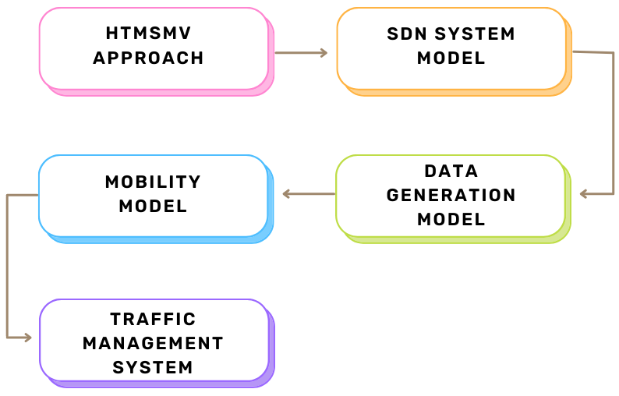
- HTMSMV Workflow.

SDN System Model.
With the help of switches providing global network data, the SDN controller in the suggested setup functions as a centralized monitoring system to carry out effective routing. In order to prevent collisions, IoV communication is utilized in a number of road safety applications. One such application is the delivery of accident alarm messages. By separating the control and data planes, the system is meant to employ a single SDN controller that handles message routing and reduces control costs. Reduction of traffic congestion is affected by the alert message's quick transmission throughout the network. The SDN controller has built-in features that allow it to preserve a directed graph and a location component table that includes the road segment and the associated road side units. An intersection or junction serves as the vertex in a directed graph, while the road segments that connect junctions serve as the edges. To determine if a road segment could enter the accident location, the SDN controller uses the directed graph of the road network. The alert message is sent by the SDN controller to those RSUs, and the cars in that specific road segment get the information broadcast.
Accident data from an automobile is sent to the SDN controller via a nearby roadside unit. Using V2V or V2I communication, the vehicle tells the RSU of the impacted road segment, as well as the vehicle and RSU IDs. Using a directed graph of the road network, the SDN controller locates the probable road segment that approaches the accident site and then delivers notifications via relevant RSUs. As a result, the individual lane is omitted from the graph until the RSU confirms that there are no accidents along the route. The RSU sent a route-free message to the SDN controller and the other RSUs. SDN activates the impacted connection when it receives the route-free message, and the RSUs stop relaying the alert message to

Data Generation Model.
There are two probability models that are used to create the data. “Equation (1) illustrates how the anticipated number of packets is generated using the first distribution, which is the normal distribution”. “Equation (2) illustrates how the second model, the exponential distribution, is utilized to calculate the time gap between one packet and the next”.
$P\left(n\right)=\frac{1}{σ \sqrt{2π}} e^{-\frac{{\left(n-μ\right)}^{2}}{{2 σ}^{2}}}$ 1
$P\left(T\right)=\left\{\begin{aligned}{λe}^{-λT }, T≥0 \\ 0, T<0 \end{aligned}\right.$ 2

Mobility Model
We use a mobility model that represents the vehicle movement in a dynamic way in order to guarantee the practicality of the VANET model. The acceleration produced by the driving behavior model serves as the foundation for the mobility model. The distance is created using velocity and the mathematical expression for these calculations are stated in “(3)” and “(4)”. the acceleration is first generated, and then the velocity is computed based on integration and summation. “Equation (5) shows about the vehicles driving behavior (DB) and it includes about the aggressiveness factor (AGG) and the probability factor pr. Finally, the granularity is represented as $T_{u}$”.
$v_{t}= v_{t}-1+T_{u}a_{t}$ 3
$x_{t}= x_{t}-1+T_{u}v_{t}$ 4
$a_{t}=DB(AGG,pr)$ 5

Traffic Management System:
The Traffic Management Unit (TMU), which primarily creates route planning, assumes command of the whole network. It gathers specific data, such as the intended location and the current position of cars, in addition to the number of vehicles on different routes. A certain number of cars in a specific area are grouped together into clusters based on the information about the vehicle. Priority is used to determine which vehicles are chosen for each cluster; emergency vehicles are given first priority, followed by passenger and freight vehicles. The cluster head (CH) oversees each cluster. The RSU monitors a cluster or clusters at a certain place. The controlling authority, or TMU, receives data about the cars from the RSU and processes it. The TMU processes the data it receives from the RSU regarding the cars and vehicular data. The cars are rated using the available data. Cars are grouped based on region. The vehicle type, prioritized by the CH, the vehicle's moving speed, which ranges from 0 to 90 km/h, the vehicle's remaining energy, and its address are the data that are gathered from the cars for the clustering process. The cars are arranged in groups based on their final location. The vehicles that are headed to the same place take precedence. The TMU maintains the path selection procedure from source to destination by analyzing the vehicle density on every road. Following the commencement of the clustering path selection process, routes are selected according to factors such as priority, less traffic, ideal and less congested roads to the destination. When communicating, cars with the same priority typically choose the same route to get at their destination.
VANET is a network architecture that moves dynamically. It indicates that periodic replacement of cars in clusters is based on vehicle mobility. The neighboring CH must receive a request message from the vehicle CM if it needs to get removed from the present cluster. Following clearance, the departing CM gets separates and subsequently gets connected to the new cluster. As quickly as possible, the CH has to identify a successor. Following that, the routing table is modified based on the level of connection. Consequently, the CM with the highest connection is nominated to be the CH member. Next, in a decentralized way, the CH reconstructs the cluster to maximize the CM count. Accordingly, when a CM departs a cluster, it sends a message to all of the other CM as well as the relevant CH and it updates the routing table. To interact with the new CH, the departing CM resets its CH's ID to null. At that moment, the request message is sent by the New CH to the available CM. If required, CM also sends the request message to join a new cluster at the same time. Consequently, the proposal to fill the slot is immediately approved by the new CH. The CM of the previous cluster empties its CH ID at the same moment. The CM who is prepared to join the new cluster is likewise given the new ID. Subsequently, the CH transmits the data and modifies its routing database. By utilizing this clustering process the proposed HTMSMV-UAV network can able to achieve maximum efficiency at the time of data transmission. The pseudo code of HTMSMV-UAV network is described below.
The pseudo code of proposed HTMSMV-UAV
Inputs: SDN System, Data Generation Model, Mobility Model and Traffic Management
Step 1 – System includes IOV vehicles, and RSUs
Step 2 - Data Generation Model
Probability Models 1- $P\left(n\right)=\frac{1}{σ \sqrt{2π}} e^{-\frac{{\left(n-μ\right)}^{2}}{{2 σ}^{2}}}$
Probability Models 2 - $P\left(T\right)=\left\{\begin{aligned}{λe}^{-λT }, T≥0 \\ 0, T<0 \end{aligned}\right.$
Step 3 – Mobility Model Creation
Distance Calculation - $v_{t}= v_{t}-1+T_{u}a_{t}$, $x_{t}= x_{t}-1+T_{u}v_{t}$
Step 4 - Traffic Management through CH
Step 5 – Performance Analysis

Simulation Results.
Using the NS3 simulator, we evaluate the performance of proposed HTMSMV-UAV network as well as the existing technique of RTIM-UAV [50], IRSVT-UAV [51], and SVCHT-UAV [52] methods. The performance metrics are packet delivery ratio (%), throughput (kbps), average delay (ms), routing overhead (pkts), and energy efficiency (joules) and as well the inputs which are existent in this experimentation are given in table II.
- Input Parameters Table
Input Parameters | Values
Running Time | 250 ms
Coverage Distance | 2000m*2000m [53]
No of Vehicles | 500 Vehicles [54]
Vehicles Radius | 100m
Initial Energy | 100 Joules [55]
Transmission Power | 0.500 Joules
Receiving Power | 0.050 Joules

Packet Delivery ratio.
The ratio of packets that have been successfully transmitted compared to the total number of packets transmitted in the network. In “Fig.2”, the packet delivery ratio of the HTMSMV-UAV network is discussed which gets compared with RTIM-UAV, IRSVT-UAV, and SVCHT-UAV.
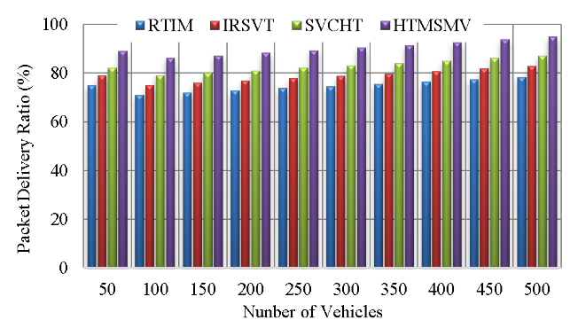
- Packet Delivery Ratio.
The Proposed HTMSMV method has highest Packet Delivery Ratio of 95%, which is higher than the the existing techniques of RTIM at 78%, IRSVT at 83%, and SVCHT at 87%. This reveals that the Proposed HTMSMV method is more efficient in transmission of data.

Throughput
Throughput refers to the rate of speed at which data is successfully transferred over a channel of communication. In “Fig.3”, the throughput of the HTMSMV-UAV network is discussed which gets compared with RTIM-UAV, IRSVT-UAV, and SVCHT-UAV.
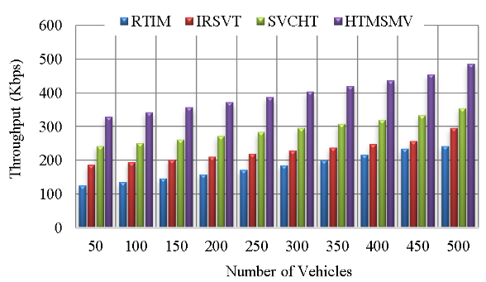
- Network Throughput.
The Proposed HTMSMV provides a superior throughput of 485 kbps in comparison to the existing technique of RTIM at 241 kbps, IRSVT at 296 kbps, and SVCHT at 354 kbps. This reveals that the Proposed HTMSMV technique is capable of handling a greater amount of data.

Average delay.
The average delay refers to the average amount of time it takes for data packets to transit from the source to the destination node. In “Fig.4”, the average delay of the HTMSMV-UAV network is discussed which gets compared with RTIM-UAV, IRSVT-UAV, and SVCHT-UAV.
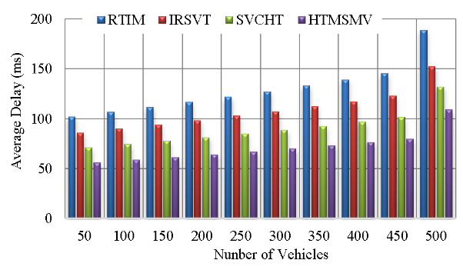
- Average Delay.
The Proposed HTMSMV technique has a shorter Average Delay of 109 ms in comparison to the existing technique of RTIM at 189 ms, IRSVT at 152 ms, and SVCHT at 132 ms. The Proposed HTMSMV technique achieved faster data transmission minimum delay.

Routing overhead
Routing Overhead pertains to the additionally data packets used for transmitting routing information. In “Fig.5”, the routing overhead of the HTMSMV-UAV network is discussed which gets compared with RTIM-UAV, IRSVT-UAV, and SVCHT-UAV.
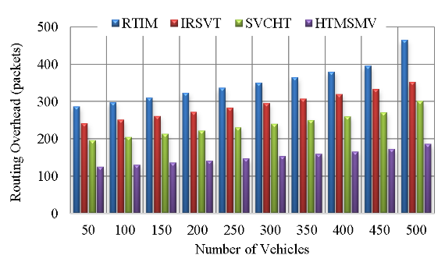
- Routing Overhead.
The Proposed HTMSMV has a reduced Routing Overhead of 186 packets in comparison to the existing technique of RTIM at 465 packets, IRSVT at 352 packets, and SVCHT at 301 packets. Reduced routing overhead reveals a more efficient routing algorithm.

Energy Efficiency.
Energy efficiency is quantified as the ratio of usable energy output to the energy input during the process of data transmission. In “Fig.6”, the energy efficiency of the HTMSMV-UAV network is discussed which gets compared with RTIM-UAV, IRSVT-UAV, and SVCHT-UAV.
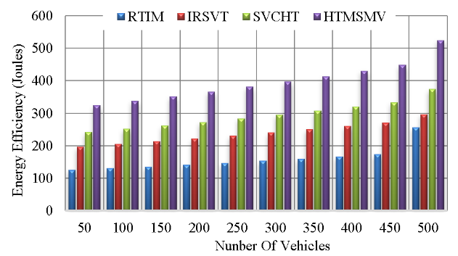
- Energy Efficiency Calculation.
The Proposed HTMSMV has reduced energy consumption per unit of data, with a value of 524 joules, as compared to the existing technique of RTIM at 256 joules, IRSVT at 296 joules, and SVCHT at 374 joules.

Conclusion.
In this article, a hybrid traffic management system is developed mainly to improve the communication quality of the vehicular network. With the presence of the data generation model and mobility model the throughput of the network is maximized. Finally using the traffic management system the efficiency of the network is increased and the delay and power utilization is reduced. In future scope, efficient resource management is concentrated to improve the performance of the network in densely populated areas.

References
- A. H. Abbas, N. F. Abdulsattar, H. S. Mansour, M. H. Mutar, M. I. Habelalmateen, L. Audah, N. A. M. Alduais, and A. Mohammed, "A New Hybrid Approach Cluster-Heads Election to reduce the number of clusters in VANETs," in 2022 5th International Conference on Engineering Technology and its Applications (IICETA), pp. 436-440, 2022. DOI: https://doi.org/10.1109/IICETA54559.2022.9888442.
- M. I. Habelalmateen, A. H. Abbas, L. Audah, and N. A. M. Alduais, "Dynamic multiagent method to avoid duplicated information at intersections in VANETs," Telkomnika (Telecommunication Computing Electronics and Control), vol. 18, no. 2, pp. 613-621, 2020. DOI: http://doi.org/10.12928/telkomnika.v18i2.13947.
- M. K. Hasan, M. M. Ahmed, N. F. Wani, A. H. Abbas, L. M. Alkwai, S. Islam, A. K. M. A. Habib, and R. Hassan, "Dynamic load modeling for bulk load-using synchrophasors with wide area measurement system for smart grid real-time load monitoring and optimization," Sustainable Energy Technologies and Assessments, vol. 57, p. 103190, 2023. doi: https://doi.org/10.1016/j.seta.2023.103190.
- A. H. Abbas, A. J. Ahmed, and S. A. Rashid, "A Cross-Layer Approach MAC/NET with Updated-GA (MNUG-CLA)-Based Routing Protocol for VANET Network," World Electric Vehicle Journal, vol. 13, no. 5, article no. 87, 2022. DOI: https://doi.org/10.3390/wevj13050087.
- H. S. Mansour, M. H. Mutar, I. A. Aziz, S. A. Mostafa, H. Mahdin, A. H. Abbas, M. H. Hassan, N. F. Abdulsattar, and M. A. Jubair, "Cross-Layer and Energy-Aware AODV Routing Protocol for Flying Ad-Hoc Networks," Sustainability, vol. 14, no. 15, article no. 8980, 2022. DOI: https://doi.org/10.3390/su14158980.
- M. A. Jubair, S. A. Mostafa, D. A. Zebari, H. M. Hariz, N. F. Abdulsattar, M. H. Hassan, A. H. Abbas, F. H. Abbas, A. Alasiry, and M. Turki-Hadj, "A QoS Aware Cluster Head Selection and Hybrid Cryptography Routing Protocol for Enhancing Efficiency and Security of VANETs," IEEE Access, vol. 10, pp. 124792-124804, 2022. doi: https://doi.org/10.1109/ACCESS.2022.3224466.
- M. I. Habelalmateen, A. J. Ahmed, A. H. Abbas, and S. A. Rashid, "TACRP: Traffic-Aware Clustering-Based Routing Protocol for Vehicular Ad-Hoc Networks," Designs, vol. 6, no. 5, article no. 89, 2022. DOI: https://doi.org/10.3390/designs6050089.
- S. A. Rashid, M. I. Habelalmateen, A. J. Ahmed, A. H. Abbas, M. A. Jubair, M. H. Hassan, A. Abdulhadi, S. Hammed, and L. Audah, "Congestion Aware Genetic Q-learning Based RPL Routing Protocol for Vehicle Ad-Hoc Networks," in 2022 5th International Conference on Engineering Technology and its Applications (IICETA), pp. 464-469, 2022. doi: https://doi.org/10.1109/IICETA54559.2022.9888583.
- A. H. Abbas, A. J. Ahmed, S. A. Rashid, N. F. Abdulsattar, M. H. Hassan, M. A. Jubair, and M. I. Habelalmateen, "Predictive Hybrid Routing with Multi Objective Optimization Model for Opportunistic Routing for VANET," in 2022 5th International Conference on Engineering Technology and its Applications (IICETA), pp. 470-476, 2022. doi: https://doi.org/10.1109/IICETA54559.2022.9888274.
- A. H. Najim, A. H. Abbas, K. Al-sharhanee, and H. M. Hariz, "Reinforcement Learning-based Topology-Aware Routing Protocol with Priority Scheduling for Internet of Drones in Agriculture Application," International Journal of Intelligent Engineering and Systems, vol. 16, no. 5, pp. 395-405, 2023. doi: https://doi.org/10.22266/ijies2023.1031.34.
- A. H. Abbas, L. Audah, and N. A. M. Alduais, "An Efficient Load Balance Algorithm for Vehicular Ad-Hoc Network," in 2018 Electrical Power, Electronics, Communications, Controls and Informatics Seminar (EECCIS), pp. 207-212, 2018. https://doi.org/10.1109/EECCIS.2018.8692827.
- A. H. Alwan, A. A. Aziz, M. A. Jubair, A. H. Abbas, M. H. Hassan, S. Alheejawi, N. F. Abdulsattar, A. S. Mustafa, and M. I. Habelalmateen, "Monitoring the Impact of the Nodes Density on the MANETs’ Environment," in 2022 5th International Conference on Engineering Technology and its Applications (IICETA), pp. 546-549, 2022. doi: https://doi.org/10.1109/IICETA54559.2022.9888339.
- Mostafa, S.A., Mustapha, A., Ramli, A.A., Jubair, M.A., Hassan, M.H., Abbas, A.H. (2021). Comparative Analysis to the Performance of Three Mobile Ad-Hoc Network Routing Protocols in Time-Critical Events of Search and Rescue Missions. In: Cassenti, D., Scataglini, S., Rajulu, S., Wright, J. (eds) Advances in Simulation and Digital Human Modeling. AHFE 2020. Advances in Intelligent Systems and Computing, vol 1206. Springer, Cham. https://doi.org/10.1007/978-3-030-51064-0_16.
- M. H. Hassan, M. A. Jubair, A. H. Abbas, A. J. Ahmed, S. A. Rashid, M. H. Mutar, H. S. Mansour, A. Ali, and M. I. Habelalmateen, "AODV based Crow Search Algorithm for Improving the QoS of MANET," in 2022 5th International Conference on Engineering Technology and its Applications (IICETA), pp. 424-428, 2022. DOI: https://doi.org/10.1109/IICETA54559.2022.9888484.
- M. A. Jubair, M. H. Hassan, S. A. Mostafa, H. Mahdin, A. Mustapha, L. H. Audah, F. S. Shaqwi, and A. H. Abbas, "Competitive analysis of single and multi-path routing protocols in MANET," Indonesian Journal of Electrical Engineering and Computer Science, vol. 19, no. 1, pp. 293-300, 2020. http://doi.org/10.11591/ijeecs.v19.i1.pp293-300.
- A. H. Abbas, M. I. Habelalmateen, L. Audah, and N. A. M. Alduais, "A novel intelligent cluster-head (ICH) to mitigate the handover problem of clustering in VANETs," International Journal of Advanced Computer Science and Applications, vol. 10, no. 6, pp. 281-287, 2019. DOI: https://doi.org/10.14569/IJACSA.2019.0100627.
- S. A. Rashid, A. J. Ahmed, M. H. Hassan, A. H. Abbas, M. I. Habelalmateen, M. A. Jubair, L. Audah, and W. Al-Azzawi, "Ranking Based Routing Protocol for Residual Energy Estimation in Wireless Sensor Network Based IoT Network," in 2022 5th International Conference on Engineering Technology and its Applications (IICETA), pp. 453-459, 2022. https://doi.org/10.1109/IICETA54559.2022.9888349.
- A. J. Ahmed, A. H. Abbas, S. A. Rashid, M. A. Jubair, M. H. Hassan, A. Abdulhadi, N. F. Abdulsattar, and M. I. Habelalmateen, "Congestion Aware Q-Learning (CAQL) in RPL Protocol – WSN based IoT Networks," in 2022 5th International Conference on Engineering Technology and its Applications (IICETA), pp. 429-435, 2022. doi: https://doi.org/10.1109/IICETA54559.2022.9888322.
- N.F. Abdulsattar, F. Abedi, H.M.A. Ghanimi, S. Kumar, A.H. Abbas, A.S. Abosinnee, A. Alkhayyat, M.H. Hassan, and F.H. Abbas, "Botnet Detection Employing a Dilated Convolutional Autoencoder Classifier with the Aid of Hybrid Shark and Bear Smell Optimization Algorithm-Based Feature Selection in FANETs," Big Data and Cognitive Computing, vol. 6, no. 4, article no. 112, 2022. DOI: https://doi.org/10.3390/bdcc6040112.
- V. O. Nyangaresi, I. M. Al-Joboury, K. A. Al-sharhanee, A. H. Najim, A. H. Abbas, and H. M. Hariz, "A biometric and physically unclonable function–Based authentication protocol for payload exchanges in internet of drones," e-Prime - Advances in Electrical Engineering, Electronics and Energy, vol. 7, pp. 100471, 2024. DOI: https://doi.org/10.1016/j.prime.2024.100471
- N.F. Abdulsattar, A.H. Abbas, M.H. Mutar, M.H. Hassan, M.A. Jubair, and M.I. Habelalmateen, "An Investigation Study for Technologies, Challenges and Practices of IoT in Smart Cities," in 2022 5th International Conference on Engineering Technology and its Applications (IICETA), pp. 554-557, 2022. DOI: https://doi.org/10.1109/IICETA54559.2022.9888474.
- N. F. Abdulsattar, D. A. Mohammed, A. Alkhayyat, S. Z. Hamed, H. M. Hariz, A. S. Abosinnee, A. H. Abbas, M. H. Hassan, M. A. Jubair, F. H. Abbas, A. D. Algarni, N. F. Soliman, and W. El-Shafai, "Privacy-Preserving Mobility Model and Optimization-Based Advanced Cluster Head Selection (P2O-ACH) for Vehicular Ad Hoc Networks," Electronics, vol. 11, no. 24, p. 4163, 2022, DOI: https://doi.org/10.3390/electronics11244163.
- F. Abedi, S. R. M. Zeebaree, Z. S. Ageed, H. M. A. Ghanimi, A. Alkhayyat, M. A. M. Sadeeq, S. N. Mahmood, A. S. Abosinnee, Z. H. Kareem, A. H. Abbas, W. K. Al-Azzawi, M. M. Jaber, and M. Dauwed, "Severity Based Light-Weight Encryption Model for Secure Medical Information System," Computers, Materials & Continua, vol. 74, no. 3, pp. 5691-5704, 2023. DOI: https://doi.org/10.32604/cmc.2023.034435.
- A. H. Kadhim, A. M. Razaq, M. A. Jubair, N. F. Abdulsattar, A. H. Abbas, M. H. Hassan, A. Jamal Ahmed, S. AbdulJabbar Rashid, and M. I. Habelalmateen, "A Real-Time Low-Cost Remote Doctor Monitoring System," in 2022 5th International Conference on Engineering Technology and its Applications (IICETA), pp. 558-561, 2022. doi: https://doi.org/10.1109/IICETA54559.2022.9888536.
- F. Abedi, H. M. A. Ghanimi, A. D. Algarni, N. F. Soliman, W. El-Shafai, A. H. Abbas, Z. H. Kareem, H. M. Hariz, and A. Alkhayyat, "Computational Intelligence Driven Secure Unmanned Aerial Vehicle Image Classification in Smart City Environment," Computer Systems Science and Engineering, vol. 47, no. 3, pp. 3127-3144, 2023. DOI: https://doi.org/10.32604/csse.2023.038959.
- I. Ahmad, S. Hussain, S. N. Mahmood, H. Mostafa, A. Alkhayyat, M. Marey, A. H. Abbas, and Z. Abdulateef Rashed, "Co-Channel Interference Management for Heterogeneous Networks Using Deep Learning Approach," Information, vol. 14, no. 2, article no. 139, 2023. DOI: https://doi.org/10.3390/info14020139.
- A. M. Abdulkarem, F. Abedi, H. M. A. Ghanimi, S. Kumar, W. K. Al-Azzawi, A. H. Abbas, A. S. Abosinnee, I. M. Almaameri, and A. Alkhayyat, "Robust Automatic Modulation Classification Using Convolutional Deep Neural Network Based on Scalogram Information," Computers, vol. 11, no. 11, article no. 162, 2022. DOI: https://doi.org/10.3390/computers11110162.
- F. Abedi, H. M. A. Ghanimi, M. A. M. Sadeeq, A. Alkhayyat, Z. H. Kareem, S. N. Mahmood, A. H. Abbas, A. S. Abosinnee, W. K. Al-Azzawi, M. M. Jaber, and M. Dauwed, "Hybrid Deep Learning Enabled Load Prediction for Energy Storage Systems," Computers, Materials & Continua, vol. 75, no. 2, pp. 3359-3374, 2023. DOI: https://doi.org/10.32604/cmc.2023.034221.
- S. Alsubai, A. K. Dutta, A. H. Alkhayyat, M. M. Jaber, A. H. Abbas, and A. Kumar, "Hybrid deep learning with improved Salp swarm optimization based multi-class grape disease classification model," Computers and Electrical Engineering, vol. 108, p. 108733, 2023. DOI: https://doi.org/10.1016/j.compeleceng.2023.108733.
- I. S. Al-Hawary, E. Ali, S. M. H. Kamona, L. Hussain Saleh, A. S. Abdulwahid, D. N. Al-Saidi, M. S. Alhassan, F. A. Rasen, H. Abdullah Abbas, A. Alawadi, A. H. Abbas, and M. Sina, "Prediction of geomechanical bearing capacity using autoregressive deep neural network in carbon capture and storage systems," Heliyon, vol. 9, no. 11, pp. e21913, Nov. 2023. doi: https://doi.org/10.1016/j.heliyon.2023.e21913.
- M. R. M. Alsemawi, M. H. Mutar, E. H. Ahmed, H. O. Hanoosh, and A. H. Abbas, "Emotions recognition from human facial images based on fast learning network," Indonesian Journal of Electrical Engineering and Computer Science, vol. 30, no. 3, pp. 1478-1487, 2023. doi: http://doi.org/10.11591/ijeecs.v30.i3.pp1478-1487.
- J. Tang, A. K. Abbas, N. A. Koka, N. Sadoon, J. K. Abbas, R. A. Abdalhuseen, M. Abosaooda, N. M. Ahmed, and A. H. Abbas, "Optimization of thermal biofuel production from biomass using CaO-based catalyst through different algorithm-based machine learning approaches," Case Studies in Thermal Engineering, vol. 50, p. 103419, 2023. doi: https://doi.org/10.1016/j.csite.2023.103419.
- F. Abedi, H. M. A. Ghanimi, A. D. Algarni, N. F. Soliman, W. El-Shafai, A. H. Abbas, Z. H. Kareem, H. M. Hariz, and A. Alkhayyat, "Chimp Optimization Algorithm Based Feature Selection with Machine Learning for Medical Data Classification," Computer Systems Science and Engineering, vol. 47, no. 3, pp. 2791–2814, 2023. doi: https://doi.org/10.32604/csse.2023.038762.
- M. A. A. Albadr et al., "Online sequential extreme learning machine approach for breast cancer diagnosis," Neural Computing and Applications, vol. Volume, no. Issue, pp. Page, 2024. DOI: https://doi.org/10.1007/s00521-024-09617-x.
- M. S. Alshuhri, S. G. Al-Musawi, A. A. Al-Alwany, H. Uinarni, I. Rasulova, P. Rodrigues, A. T. Alkhafaji, A. M. Alshanberi, A. H. Alawadi, and A. H. Abbas, "Artificial intelligence in cancer diagnosis: Opportunities and challenges," Pathology - Research and Practice, vol. 253, pp. 154996, 2024. https://doi.org/10.1016/j.prp.2023.154996.
- A. Abdulbari, S. K. Abdul Rahim, F. Abedi, P. J. Soh, A. Hashim, R. Qays, S. Ahmad, and M. Y. Zeain, "Single-Layer Planar Monopole Antenna-Based Artificial Magnetic Conductor (AMC)," International Journal of Antennas and Propagation, vol. 2022, pp. 6724175, 2022. https://doi.org/10.1155/2022/6724175.
- S. Saleem, A. H. Jabbar, M. H. Jameel, A. Rehman, Z. H. Kareem, A. H. Abbas, Z. Ghaffar, S. A. Razzaq, R. A. Pashameah, E. Alzahrani, E.-P. Ng, and S. M. Sapuan, "Enhancement in structural, morphological, and optical properties of copper oxide for optoelectronic device applications," Nanotechnology Reviews, vol. 11, no. 1, pp. 2827-2838, 2022.DOI: https://doi.org/10.1515/ntrev-2022-0473.
- A. H. Abbas, H. Mansour, and A. Al-Fatlawi, "Self-Adaptive Efficient Dynamic Multi-Hop Clustering (SA-EDMC) Approach for Improving VANET’s Performance," International Journal of Interactive Mobile Technologies (iJIM), vol. 16, no. 14, pp. 136-151, Jul. 2022. DOI: https://doi.org/10.3991/ijim.v16i14.31081.
- A. H. Najim, H. S. Mansour, and A. H. Abbas, "Characteristic analysis of queue theory in Wi-Fi applications using OPNET 14.5 modeler," Eastern-European Journal of Enterprise Technologies, vol. 2, no. 9-116, pp. 35–43, 2022. doi: http://doi.org/10.15587/1729-4061.2022.255520.
- M.H. Hassan, A.H. Abbas, M.H. Mutar, M.A. Jubair, S.A. Rashid, A.J. Ahmed, M.I. Habelalmateen, A. Mohammed, and L. Audah, "Investigative Study on Routing Protocols in Flying Ad Hoc Networks Environment," in 2022 5th International Conference on Engineering Technology and its Applications (IICETA), pp. 460-463, 2022. doi: https://doi.org/10.1109/IICETA54559.2022.9888600.
- R. Li and P. Zhu, "Spectrum allocation strategies based on QoS in cognitive vehicle networks," in IEEE Access, vol. 8, 2020, pp. 99922-99933, doi: 10.1109/ACCESS.2020.2997936.
- G. Raja et al., "SDN-enabled traffic alert system for IoV in smart cities," in IEEE INFOCOM 2020-IEEE Conference on Computer Communications Workshops (INFOCOM WKSHPS), July 2020, pp. 1093-1098.
- A. Al-Fuqaha et al., "Severity-based prioritized processing of packets with application in VANETs," in IEEE Transactions on Mobile Computing, vol. 19, no. 2, 2019, pp. 484-496, doi: 0.1109/TMC.2019.2892980.
- L. Cheng, E. Verbeek, and P. S. Skardal, "A Preliminary Study on the VANET Topology Characteristics from Propagation-Aware Traffic Flows Extracted from Measured Data," in 2020 IEEE International Symposium on Antennas and Propagation and North American Radio Science Meeting, July 2020, pp. 1161-1162, doi: 10.1109/IEEECONF35879.2020.9330397.
- Y. V. Brandão et al., "A multi-layer and VANET-based approach to improve accident management in smart cities," in 2020 16th International Conference on Distributed Computing in Sensor Systems (DCOSS), May 2020, pp. 165-172, doi: 10.1109/DCOSS49796.2020.00037.
- N. Hilal and A. Yurdakul, "Model-based design of a roadside unit for emergency and disaster management," in NOMS 2020-2020 IEEE/IFIP Network Operations and Management Symposium, April 2020, pp. 1-6, doi: 978-1-7281-4973-8/20.
- T. S. Gomides et al., "A traffic management system to minimize vehicle congestion in smart cities," in 2020 IEEE International Conference on Systems, Man, and Cybernetics (SMC), October 2020, pp. 1439-1444, doi: 978-1-7281-8526-2/20.
- A. Roy and S. Madria, "Distributed incentive-based secured traffic monitoring in VANETs," in 2020 21st IEEE International Conference on Mobile Data Management (MDM), June 2020, pp. 49-58, doi: 10.1109/MDM48529.2020.00026.
- E. Al-Ezaly et al., "Optimal location management service for RSUs placement in VANETs," in 2020 2nd International Conference on Computer and Information Sciences (ICCIS), October 2020, pp. 1-7, doi: 978-1-7281-5467-1/20.
- Carlos Pedroso and Thiago S. Gomides, “A Robust Traffic Information Management System Against Data Poisoning in Vehicular Networks”, IEEE Latin America Transactions, vol. 20, no. 12, pp. 2421 – 2428, 2022, doi: 10.1109/TLA.2022.9905610
- Md.Nahidul Alam and Maruf Haider Chowdhury, “Improving Routing System in Vehicular Ad Hoc Network using Real Time Vehicular Traffic Information on City Roads”, International Conference on Intelligent Technologies (CONIT), 2022, doi: 10.1109/CONIT55038.2022.9847809
- Veena Suhas Bhende, Ashish Kumar Sinha and Aparna A. Junnarkar, “SVC-HT: Secure Vehicular Ad hoc Communications using Hybrid Trust”, International Conference on Intelligent Technologies (CONIT), 2022, doi: 10.1109/CONIT55038.2022.9847836
- G.G. Shayea, D.A. Mohammed, A.H. Abbas, and N.F. Abdulsattar, "Privacy-Aware Secure Routing through Elliptical Curve Cryptography with Optimal RSU Distribution in VANETs," Designs, vol. 6, no. 6, pp. 121, 2022. doi: https://doi.org/10.3390/designs6060121
- A. J. Ahmed, S. A. Rashid, A. H. Abbas, N. F. Abdulsattar, H. S. Mansour, M. H. Hassan, M. I. Habelalmateen, and A. Hussain, "An Effectual Secure Cryptography Scheme for Multipath Routing in A Wsn-Based IoT Environment," in 2022 5th International Conference on Engineering Technology and its Applications (IICETA), pp. 441-446, 2022. doi: https://doi.org/10.1109/IICETA54559.2022.9888604.
- A. J. Ahmed, A. H. Abbas, and S. A. Rashid, "Multi level trust calculation with improved ant colony optimization for improving quality of service in wireless sensor network," IAES International Journal of Artificial Intelligence, vol. 12, no. 3, pp. 1224–1237, 2023. doi: https://doi.org/10.11591/ijai.v12.i3.pp1224-1237.

