Trust based Relay Node Selection and Efficient Multi-hop Clustering for VANETs

1st Hussein Muhi Hariz
Department of Computer Techniques Engineering
Mazaya University College
DhiQar, Iraq;
huhraiz22@gmail.com.
4th Riyadh Rashid Hameed
National University of Science and Technology
Dhi Qar, Iraq
riyadh.r.hameed@nust.edu.iq .
2nd Mohammed I. Hashim
Department of Computer Technical Engineering
College of Technical Engineering
The Islamic University
Najaf, Iraq
moh.mtech89@gmail.com
5th Maysam Reyad Hadi
Department of Computer Science
Altoosi University College
Najaf, Iraq
maysam.reyad@altoosi.edu.iq
3rd T.M. Thiyagu
Department of Computer Science and Engineering
Vel Tech Rangarajan Dr.Sagunthala R&D Institute of Science and Technology
Avadi ,Chennai
t.m.thiyagu@gmail.com
6th F.H. Abbas
Medical Laboratories Techniques Department
Al-Mustaqbal University
Hillah, Iraq
fatimahashim@mustaqbal-college.edu.iq

Abstract— In this article trust based relay node selection and efficient multi hop clustering model (TRSEMC) is developed. The core modules of this model are efficient network construction, multi hop clustering and vertical trust management. Even through this process the efficiency is greatly increased and that leads to expanding the life span of the devices. The proposed concept is constructed in the simulator called NS3 and the matrix which are taken to analyses the performance of the network are throughput, network delay, routing overhead, transmission accuracy and energy efficiency. This TRSEMC greatly fulfills the identified research gap and through an effective clustering mechanism the efficiency of the vehicles is increased than the SVCHT-UAV, FMMTC-UAV and GRTMI-UAV models.
Keywords— Vehicular Ad hoc Networks (VANETs), Trust based Relay Node Selection, Efficient Multi-hop Clustering and CH Selection.

Introduction
In the real world scenario the concept of vehicle to vehicle communication is increased large and numbers and it is able to provide proper solutions to confidential data transmission and military based applications [1-5]. Some of the issues which are present in the vehicular communication are accident occurrences due to high speed vehicles and high traffic congestion on the roadsides [6-10]. Several routing models are introduced in the earlier researches mainly to monitor the high speed vehicles which are present in the geography varying model in the dynamic range with extremely forceful mobility [11-14]. But those routing models are not exactly suitable for the densely populated area and the remote data transmission [15-18]. To obtain efficient performance among the vehicles certain primary factors need to be concentrated they are earlier congestion detection, congestion avoidance and proper device localization when it travels at high speed [19-22].
In order to fix the network model in such criteria in recent times cluster based vehicular communication is developed [23-27]. It is one among the traditional models to improve the efficiency of the inter vehicular communication [28-31] and infrastructure based communication [32-35]. The clustering process consists of two main modules which are cluster head (CH) selection and cluster formation [36-37]. Certain matrices are generally considered to choose the optimal CH are vehicle locality, vehicle residual energy, density of the vehicle and its mobility and speed. Through this process performances increased by the reduction of routing overhead and delay among the vehicles. But still in some cases the power utilization is high in the urban environment so that the clustering process needs an improvised design and evaluation to achieve better results in terms of efficient vehicle grouping and information dissemination [38-40]. For that purpose in this article trust based relay node selection and efficient multi hop clustering model is developed.
One of the main issues that needs to be addressed right away is the requirement for improved communication standards amongst vehicles in order to facilitate effective mobility management and data integrity management. In order to accomplish this, as well as to increase the vehicles' scalability and lifespan, specific techniques are focused in this article. An effective network model with dependable authority was built in the beginning to safeguard the gadgets. To increase efficiency, a multi-hop clustering model is also being developed. The vertical trust management procedure between the cars and roadside units is the last step in building trust management among the devices, and it significantly improves the operation of the vehicular network.

Related Works
In [41], presented a Blockchain model to improvise the trustworthiness of the network. This ensures anonymous vehicular messaging for privacy, utilizing a blockchain trust model for credibility. In [42], developed a trust model for enhancing security in VANETs. This model extends the blockchain consensus algorithm with Proof of Event and Proof of Location strategies, forming Proof of Event and Location. In [43], proposed a trust management process which directly maximize the trust score by leveraging a centralized Software-Defined Networking controller as a learning agent. In [44], proposed a risk based trust management model and it incorporates risk estimation into decision-making for conflicting reports about events. The model assesses risk considering the probability of incorrect actions.
In [45], introduced a blockchain model for preserving location of the vehicles using certain trust models. The proposed trust management algorithm regulates vehicle behavior, and blockchain is employed for data security. In [46], introduced a context based model to maximize the trust level of the vehicles. It incorporates a reinforcement learning model for adaptive evaluation strategies in different driving environment. In [47], presented a Trust Mechanism which is carried out in multiple levels for detecting Sybil attacks in VANETs, which can compromise network functionalities by generating fake identities. The proposed approach includes Horizontal Trust Management at the V2V level, utilizing ML) algorithms using blockchain for collaboration among RSUs. In [48], presents a local trust management to improve the vehicles performance. ATM utilizes active detection and blockchain techniques to filter the device which perform malfunction and ensure trust data consistency across regions. In [49], introduced a blockchain-guided privacy preserving model and this scheme incorporates a trust model which includes the idea of Dirichlet distribution.
In [50], a hybrid trust model is constructed among the vehicular network to expand the trustworthiness at the time of data transmission. In [51], at trust model is developed to monitor the traffic congestion and it provides the data security from one vehicle to another inside the network coverage area. Obtained results are moderate in terms of accuracy and throughput. In [52], and efficient routing modulus developed to provide effective multi hop intersection among the vehicles to make it travel in optimal path so that it is able to increase the delivery ratio and reduce the delay. From this complete analysis it is understood that there are certain drawbacks and research gap is present in this network model so that in the article an efficient trust based relay node selection and efficient multi hop clustering is concentrated mainly to reduce the delay and to increase the efficiency of the network. The earlier drawbacks are analyzed in an effective manner and it is summarized in table I.
- Earlier Research Issues.
No | Methodology | Advantages | Disadvantages
[41] | Blockchain-based Trust Management Model | Enhances trustworthiness | High routing overhead
[43] | Software-Defined Trust-Based VANET (SD-TDQL) | High network performance | High delay
[47] | Multi-Levels Trust Mechanism | Provides road safety | Complexity in implementation
[49] | Blockchain-enabled Trust-Based Location Privacy Protection Scheme | Protects location privacy | Complexity in trust management
[50] | Hybrid Trust Model | Improves trustworthiness | High Computation Complexity
[51] | Traffic Congestion Monitoring Trust Model | Provides data security, ensures trustworthiness | Moderate accuracy and throughput
[52] | Efficient Routing Modulus for Multi-hop Intersection | Provides high delivery ratio and reduces delay | High complexity’s

Proposed TRSEMC Approach.
Here, the proposed TRSEMC is elaborated and the core modules which are present in this article are vehicular network models, multi hop trust methods and trust management. With the presence of these methods the efficiency is greatly increased and as well introduces the delay and power utilization at high speed. The flow of the TRSEMC is described in the “Fig.1”,.
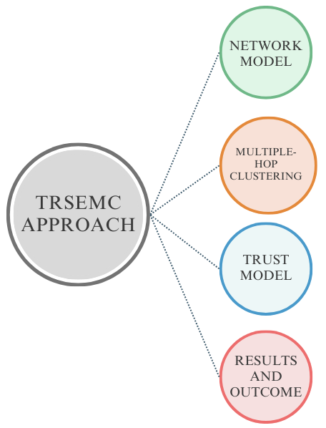
- TRSEMC Model Structure.

Network Model for VANETs.
In overall, a network made up of three different kinds of entities is referred to as a VANET. They consist of vehicles, permanent Road side Units (RSUs), and Trust Authorities (TAs). Vehicles and RSUs together might be referred to as VANET entities or nodes. The network's administration hub is called TA. Acting as the network's Certificate Authority (CA), it communicates with RSUs to provide registration and certification management for both Vehicles and RSUs. We take for granted that TA has free access to communication, computing, and storage resources. Furthermore, no opponent may potentially reach an agreement. RSUs are roadside devices used to regulate vehicles within a specific communication range. As a go-between, they communicate wirelessly with the automobiles and via wires with the TA. Vehicles are supplied with onboard units, or OBUs, which allow them to connect with other vehicles and RSUs via an open wireless channel. Constant monitoring conditions are enabled by a range of integrated sensors in autos. On a regular basis, observed data is sent by geocaching, which floods a specific region of the world, and local broadcasting, which is a single hop.

Multiple-hop Clustering Method:
Introduced and contrasted with previous one hop communication-based clustering approaches is a revolutionary multi-hop clustering technique. The primary goals of the suggested approach are to decrease the number of clusters in the network, expand the cluster head's coverage area, lower control overhead, and use less power. To improve the stability of the cluster for VANET with the lowest clustering cost, predictive model based efficient clustering is integrated. To increase vehicle mobility, the AODV protocol is enhanced. It is a reliable paradigm for topology-based networks that change quickly. The network's connection stability is improved by this protocol.
Throughout this part, we spoke about a novel model that improves VANET efficiency through an energy-efficient multi-hop clustering technique. The main idea behind the effort is to use internet connection to link the cars to the Gateway-RSU (roadside unit). It gives multi-hop neighbors a means of exchanging information and forming clusters. The connectivity, relative velocity, distance, and stability of the link amongst the nodes are the parameters that are employed in this section. When choosing a Master Cluster Head, the lowest mobility rate is one of the main requirements. Second, the cluster stability can be attributed to the election of the slave cluster leader. Node authorization, neighbor selection, MCH selection, SCH selection, as well as upkeep are the other important levels.

Trust Management
The RSU has implemented Vertical Trust Management (VTM) as a second verification method to identify Sybil nodes. V2I communications are intended to use the VTM mechanism. Vehicles that are linked to RSUs transmit their categorization results to them as a vote throughout this procedure. The ultimate say over each node's status is then made by the appropriate RSU. Such kind of trust model is separated into two sections and it is described below.
- Voting step: each car transmits its own output results to the RSU in the form of a list once the clustering method has been executed, identifying the cluster for every node.
- Process step: The RSU receives and stores the data that the vehicles have supplied initially. The RSU designates:
$\left\{\begin{aligned}0 if V_{i}=MN \\ 1 if V_{i}=NN\end{aligned}\right.$ 1
To determine the ultimate choice regarding its class, the RSU secondly obtains the vote of its neighbors for each node. As a result, the acquired data may be processed to create a table that shows each node's choice. Table III presents the outcome for n vehicles. The column denotes the vehicle class $V_{i}$ for each choice, while each line shows the local decision for each node. Following data processing, the RSU activates an algorithm to:
- Determine how many times each $V_{i}$ appears as a normal in each choice.
- Give every $V_{i}$ an appearance score S: $S=\frac{α}{β}*100$ Where, α represents the quantity of times $V_{i}$ has appeared as a regular vehicle, while β shows the total number of vehicles.
- List the acceptance level K that is used to differentiate between malicious and legitimate vehicles. Therefore, $V_{i}$ is recorded as a regular vehicle if its score S is greater than K; otherwise, it is regarded as a malevolent vehicle.
The aggregate judgment of all linked cars serves as the foundation for the VTM process. It may be applied in this manner as a verification method to get around any mistakes in the Vertical Trust. The result of the entire procedure is a list that includes every vehicle's categorization that was created by fusing VTM and HTM.
Algorithm 1: RSU Selection Process
input: Matrix calculation among the vehicles ${MV}_{nn}$of size
$$n×n$$
input: The threshold value $k$
output: Vehicle trust score
$$Array sum\left[n\right]of integer;$$
$$Array trust_{list\left[n\right]of}integer;$$
for $i←0$ to $n$do
Sum $\left[i\right]←0;$
for j$←0$ to $n$ do
if $MV\left[i,j\right]=1$ then
$sum\left[i\right]←sum\left[i\right]+MV\left[i,j\right];$
$sum\left[i\right]←\left(\frac{sum\left[i\right]}{n}\right)*100;$
if $sum \left[i\right]>=k$ then
Trust_ list $\left[i\right]=1;$
// $This vehicle is malicious$
Else
$trust_{list\left[i\right]}=0;$
// $This vehicle is normal$
return $trust_list$

Simulation Results.
We evaluated the performance of the SVCHT-UAV [49], FMMTC-UAV [50], and GRTMI-UAV [51] using the NS3 simulator and we evaluated the TRSEMC-UAV method that was recommended. The evaluation technique includes a variety of variables, such as Throughput (kbps), Delay (ms), Routing overhead (pkts), Accuracy (%) and Energy efficiency (joules) and as well the input parameters which are present in this simulation experimentation are given in table II.
- Input Parameters Table
Input Parameters | Values
Running Time | 250 ms
Coverage Distance | 2000m*2000m [53]
Number of Nodes | 500 Nodes
Node Radius | 100m
Initial Energy | 100 Joules [54]
Transmission Power | 0.500 Joules
Receiving Power | 0.050 Joules

Throughput.
The rate of speed at which data is effectively transmitted across a communication connection is known as throughput. In the “Fig.2”, the throughput performance of the TRSEMC-UAV is discussed and it is compared with SVCHT-UAV, FMMTC-UAV, and GRTMI-UAV methods.
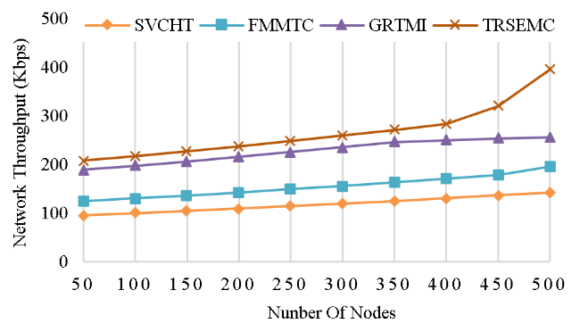
- Throughput Calculation.
The proposed TRSEMC achieved throughput of 396 kbps which outperforms SVCHT at 142 kbps, FMMTC at 196 kbps, and GRTMI at 256 kbps with a throughput of 396 kbps. This revel as that the proposed TRSEMC approach can handle more data transmission.

Network Delay
General reducing the delay is the primary task which is assigned for any network to obtain better performance. It is the difference between the located time and the transmission time so that by reducing the delay the efficiency of the network can get increased. In “Fig.3”, the delay performance of TRSEMC-UAV is discussed and it is compared with SVCHT-UAV, FMMTC-UAV, and GRTMI-UAV methods. In comparison to the existing technique of SVCHT at 124 ms, FMMTC at 102 ms, and GRTMI at 96 ms, the proposed TRSEMC approach confirmed that a reduced delay of 82 ms. In the Proposed TRSEMC technique, a smaller delay indicates faster data transmission.
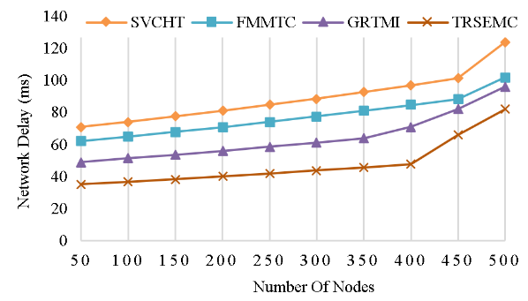
- Network Delay Calculation.

Routing overhead.
The additional data packets utilised in a network for routing information are referred to as "routing overhead”. In “Fig.4”, the routing overhead of TRSEMC-UAV is described and it is compared with SVCHT-UAV, FMMTC-UAV, and GRTMI-UAV methods.
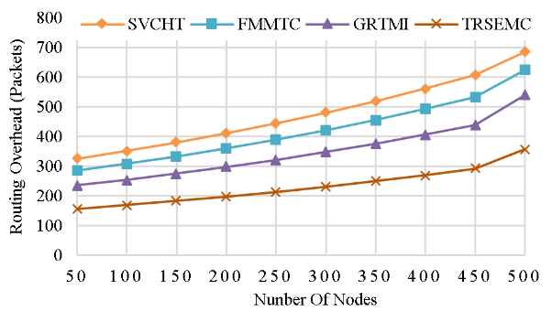
- Routing Overhead Calculation.
The Routing Overhead of 358 packets for the Proposed TRSEMC is less than that of the existing technique of 685 packets for SVCHT, 625 packets for FMMTC, and 541 packets for GRTMI. Hence the proposed method is effective with minimum routing overhead.

Accuracy Calculation
The ratio of correctly or precisely conveyed data from source to destination is known as accuracy. In “Fig.5”, the accuracy of TRSEMC-UAV is described and it is compared with SVCHT-UAV, FMMTC-UAV, and GRTMI-UAV methods.
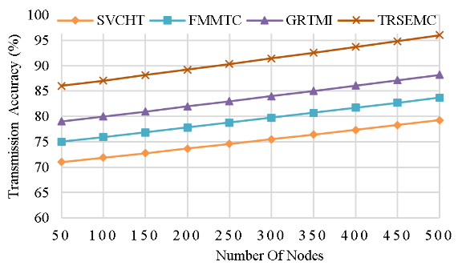
- Accuracy Calculation.
In comparison to the existing technique SVCHT at 79%, FMMTC at 84%, and GRTMI at 88%, the proposed TRSEMC obtained a greater accuracy of 96%. This reveals that the proposed TRSEMC approach is more successful in data transmission.

Energy Efficiency.
Energy efficiency is the quantification of the proportion of usable energy produced compared to the energy used during the process of data transmission, often measured in joules. In “Fig.6”, the efficiency of TRSEMC-UAV is described and it is compared with SVCHT-UAV, FMMTC-UAV, and GRTMI-UAV methods.
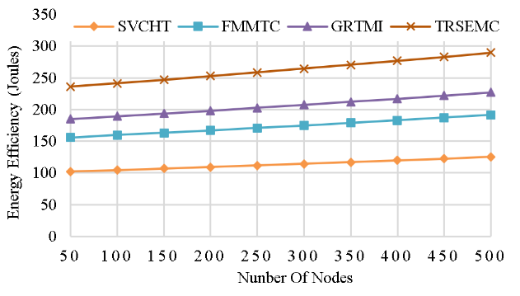
- Energy Efficiency Calculation.
The Proposed TRSEMC has minimum energy consumption per unit of data, about 290 joules, in contrast to the existing technique SVCHT at 125 joules, FMMTC at 191 joules, and GRTMI at 227 joules. This indicates that the Proposed TRSEMC performs effective data transmission and its final results are given in table III.
- Comparative performances of existing and proposed method.
Parameter | SVCHT | FMMTC | GRTMI
Throughput (kbps) | 142 | 196 | 256
Delay (ms) | 124 | 102 | 96
Routing overhead (pkts) | 685 | 625 | 541
Accuracy (%) | 79 | 84 | 88
Energy Efficiency (joules) | 125 | 191 | 227

Conclusion.
In this article several drawbacks are identified in the literature survey and to bridges that gap multi hop clustering model and vertical trust management is developed so that it is able to manage the frequent topological changes through effective CH selection process and cluster formation model. The main output matrices like data success rate and efficiency are maximized and that leads to reduce the routing overhead and delay of the vehicles in the proposed model. Through this clustering and trust management process the input rate of the data is increased and that results in the maximization of throughput. As a whole this proposed model is better than several earlier researches in wireless communication. In future work effective resource allocation is concentrated to improve the performance of the vehicles in the densely populated area.

References
- A. H. Abbas, N. F. Abdulsattar, H. S. Mansour, M. H. Mutar, M. I. Habelalmateen, L. Audah, N. A. M. Alduais, and A. Mohammed, "A New Hybrid Approach Cluster-Heads Election to reduce the number of clusters in VANETs," in 2022 5th International Conference on Engineering Technology and its Applications (IICETA), pp. 436-440, 2022. DOI: https://doi.org/10.1109/IICETA54559.2022.9888442.
- M. I. Habelalmateen, A. H. Abbas, L. Audah, and N. A. M. Alduais, "Dynamic multiagent method to avoid duplicated information at intersections in VANETs," Telkomnika (Telecommunication Computing Electronics and Control), vol. 18, no. 2, pp. 613-621, 2020. DOI: http://doi.org/10.12928/telkomnika.v18i2.13947.
- S. A. Rashid, M. I. Habelalmateen, A. J. Ahmed, A. H. Abbas, M. A. Jubair, M. H. Hassan, A. Abdulhadi, S. Hammed, and L. Audah, "Congestion Aware Genetic Q-learning Based RPL Routing Protocol for Vehicle Ad-Hoc Networks," in 2022 5th International Conference on Engineering Technology and its Applications (IICETA), pp. 464-469, 2022. doi: https://doi.org/10.1109/IICETA54559.2022.9888583.
- A. H. Abbas, A. J. Ahmed, S. A. Rashid, N. F. Abdulsattar, M. H. Hassan, M. A. Jubair, and M. I. Habelalmateen, "Predictive Hybrid Routing with Multi Objective Optimization Model for Opportunistic Routing for VANET," in 2022 5th International Conference on Engineering Technology and its Applications (IICETA), pp. 470-476, 2022. doi: https://doi.org/10.1109/IICETA54559.2022.9888274.
- A. H. Najim, A. H. Abbas, K. Al-sharhanee, and H. M. Hariz, "Reinforcement Learning-based Topology-Aware Routing Protocol with Priority Scheduling for Internet of Drones in Agriculture Application," International Journal of Intelligent Engineering and Systems, vol. 16, no. 5, pp. 395-405, 2023. doi: https://doi.org/10.22266/ijies2023.1031.34.
- A. H. Abbas, A. J. Ahmed, S. A. Rashid, M. A. Jubair, N. F. Abdulsattar, H. S. Mansour, and M. I. Habelalmateen, "Hybrid ANT Based Continuous Cuckoo Search Optimization Algorithm for Vehicle Adhoc Networks," in 2022 5th International Conference on Engineering Technology and its Applications (IICETA), pp. 447-452, May 31-June 1, 2022. https://doi.org/10.1109/IICETA54559.2022.9888404
- M. K. Hasan, M. M. Ahmed, N. F. Wani, A. H. Abbas, L. M. Alkwai, S. Islam, A. K. M. A. Habib, and R. Hassan, "Dynamic load modeling for bulk load-using synchrophasors with wide area measurement system for smart grid real-time load monitoring and optimization," Sustainable Energy Technologies and Assessments, vol. 57, p. 103190, 2023. doi: https://doi.org/10.1016/j.seta.2023.103190.
- A. H. Abbas, A. J. Ahmed, and S. A. Rashid, "A Cross-Layer Approach MAC/NET with Updated-GA (MNUG-CLA)-Based Routing Protocol for VANET Network," World Electric Vehicle Journal, vol. 13, no. 5, article no. 87, 2022. DOI: https://doi.org/10.3390/wevj13050087.
- H. S. Mansour, M. H. Mutar, I. A. Aziz, S. A. Mostafa, H. Mahdin, A. H. Abbas, M. H. Hassan, N. F. Abdulsattar, and M. A. Jubair, "Cross-Layer and Energy-Aware AODV Routing Protocol for Flying Ad-Hoc Networks," Sustainability, vol. 14, no. 15, article no. 8980, 2022. DOI: https://doi.org/10.3390/su14158980.
- M. A. Jubair, S. A. Mostafa, D. A. Zebari, H. M. Hariz, N. F. Abdulsattar, M. H. Hassan, A. H. Abbas, F. H. Abbas, A. Alasiry, and M. Turki-Hadj, "A QoS Aware Cluster Head Selection and Hybrid Cryptography Routing Protocol for Enhancing Efficiency and Security of VANETs," IEEE Access, vol. 10, pp. 124792-124804, 2022. doi: https://doi.org/10.1109/ACCESS.2022.3224466.
- M. I. Habelalmateen, A. J. Ahmed, A. H. Abbas, and S. A. Rashid, "TACRP: Traffic-Aware Clustering-Based Routing Protocol for Vehicular Ad-Hoc Networks," Designs, vol. 6, no. 5, article no. 89, 2022. DOI: https://doi.org/10.3390/designs6050089.
- N.F. Abdulsattar, F. Abedi, H.M.A. Ghanimi, S. Kumar, A.H. Abbas, A.S. Abosinnee, A. Alkhayyat, M.H. Hassan, and F.H. Abbas, "Botnet Detection Employing a Dilated Convolutional Autoencoder Classifier with the Aid of Hybrid Shark and Bear Smell Optimization Algorithm-Based Feature Selection in FANETs," Big Data and Cognitive Computing, vol. 6, no. 4, article no. 112, 2022. DOI: https://doi.org/10.3390/bdcc6040112.
- V. O. Nyangaresi, I. M. Al-Joboury, K. A. Al-sharhanee, A. H. Najim, A. H. Abbas, and H. M. Hariz, "A biometric and physically unclonable function–Based authentication protocol for payload exchanges in internet of drones," e-Prime - Advances in Electrical Engineering, Electronics and Energy, vol. 7, pp. 100471, 2024. DOI: https://doi.org/10.1016/j.prime.2024.100471
- N.F. Abdulsattar, A.H. Abbas, M.H. Mutar, M.H. Hassan, M.A. Jubair, and M.I. Habelalmateen, "An Investigation Study for Technologies, Challenges and Practices of IoT in Smart Cities," in 2022 5th International Conference on Engineering Technology and its Applications (IICETA), pp. 554-557, 2022. DOI: https://doi.org/10.1109/IICETA54559.2022.9888474.
- F. Abedi, S. R. M. Zeebaree, Z. S. Ageed, H. M. A. Ghanimi, A. Alkhayyat, M. A. M. Sadeeq, S. N. Mahmood, A. S. Abosinnee, Z. H. Kareem, A. H. Abbas, W. K. Al-Azzawi, M. M. Jaber, and M. Dauwed, "Severity Based Light-Weight Encryption Model for Secure Medical Information System," Computers, Materials & Continua, vol. 74, no. 3, pp. 5691-5704, 2023. DOI: https://doi.org/10.32604/cmc.2023.034435.
- A. H. Kadhim, A. M. Razaq, M. A. Jubair, N. F. Abdulsattar, A. H. Abbas, M. H. Hassan, A. Jamal Ahmed, S. AbdulJabbar Rashid, and M. I. Habelalmateen, "A Real-Time Low-Cost Remote Doctor Monitoring System," in 2022 5th International Conference on Engineering Technology and its Applications (IICETA), pp. 558-561, 2022. doi: https://doi.org/10.1109/IICETA54559.2022.9888536.
- F. Abedi, H. M. A. Ghanimi, A. D. Algarni, N. F. Soliman, W. El-Shafai, A. H. Abbas, Z. H. Kareem, H. M. Hariz, and A. Alkhayyat, "Computational Intelligence Driven Secure Unmanned Aerial Vehicle Image Classification in Smart City Environment," Computer Systems Science and Engineering, vol. 47, no. 3, pp. 3127-3144, 2023. DOI: https://doi.org/10.32604/csse.2023.038959.
- N. F. Abdulsattar, D. A. Mohammed, A. Alkhayyat, S. Z. Hamed, H. M. Hariz, A. S. Abosinnee, A. H. Abbas, M. H. Hassan, M. A. Jubair, F. H. Abbas, A. D. Algarni, N. F. Soliman, and W. El-Shafai, "Privacy-Preserving Mobility Model and Optimization-Based Advanced Cluster Head Selection (P2O-ACH) for Vehicular Ad Hoc Networks," Electronics, vol. 11, no. 24, p. 4163, 2022, DOI: https://doi.org/10.3390/electronics11244163.
- F. Abedi, H. M. A. Ghanimi, M. A. M. Sadeeq, A. Alkhayyat, Z. H. Kareem, S. N. Mahmood, A. H. Abbas, A. S. Abosinnee, W. K. Al-Azzawi, M. M. Jaber, and M. Dauwed, "Hybrid Deep Learning Enabled Load Prediction for Energy Storage Systems," Computers, Materials & Continua, vol. 75, no. 2, pp. 3359-3374, 2023. DOI: https://doi.org/10.32604/cmc.2023.034221.
- I. Ahmad, S. Hussain, S. N. Mahmood, H. Mostafa, A. Alkhayyat, M. Marey, A. H. Abbas, and Z. Abdulateef Rashed, "Co-Channel Interference Management for Heterogeneous Networks Using Deep Learning Approach," Information, vol. 14, no. 2, article no. 139, 2023. DOI: https://doi.org/10.3390/info14020139.
- A. M. Abdulkarem, F. Abedi, H. M. A. Ghanimi, S. Kumar, W. K. Al-Azzawi, A. H. Abbas, A. S. Abosinnee, I. M. Almaameri, and A. Alkhayyat, "Robust Automatic Modulation Classification Using Convolutional Deep Neural Network Based on Scalogram Information," Computers, vol. 11, no. 11, article no. 162, 2022. DOI: https://doi.org/10.3390/computers11110162.
- S. Alsubai, A. K. Dutta, A. H. Alkhayyat, M. M. Jaber, A. H. Abbas, and A. Kumar, "Hybrid deep learning with improved Salp swarm optimization based multi-class grape disease classification model," Computers and Electrical Engineering, vol. 108, p. 108733, 2023. DOI: https://doi.org/10.1016/j.compeleceng.2023.108733.
- I. S. Al-Hawary, E. Ali, S. M. H. Kamona, L. Hussain Saleh, A. S. Abdulwahid, D. N. Al-Saidi, M. S. Alhassan, F. A. Rasen, H. Abdullah Abbas, A. Alawadi, A. H. Abbas, and M. Sina, "Prediction of geomechanical bearing capacity using autoregressive deep neural network in carbon capture and storage systems," Heliyon, vol. 9, no. 11, pp. e21913, Nov. 2023. doi: https://doi.org/10.1016/j.heliyon.2023.e21913.
- M. R. M. Alsemawi, M. H. Mutar, E. H. Ahmed, H. O. Hanoosh, and A. H. Abbas, "Emotions recognition from human facial images based on fast learning network," Indonesian Journal of Electrical Engineering and Computer Science, vol. 30, no. 3, pp. 1478-1487, 2023. doi: http://doi.org/10.11591/ijeecs.v30.i3.pp1478-1487.
- J. Tang, A. K. Abbas, N. A. Koka, N. Sadoon, J. K. Abbas, R. A. Abdalhuseen, M. Abosaooda, N. M. Ahmed, and A. H. Abbas, "Optimization of thermal biofuel production from biomass using CaO-based catalyst through different algorithm-based machine learning approaches," Case Studies in Thermal Engineering, vol. 50, p. 103419, 2023. doi: https://doi.org/10.1016/j.csite.2023.103419.
- A. H. Alwan, A. A. Aziz, M. A. Jubair, A. H. Abbas, M. H. Hassan, S. Alheejawi, N. F. Abdulsattar, A. S. Mustafa, and M. I. Habelalmateen, "Monitoring the Impact of the Nodes Density on the MANETs’ Environment," in 2022 5th International Conference on Engineering Technology and its Applications (IICETA), pp. 546-549, 2022. doi: https://doi.org/10.1109/IICETA54559.2022.9888339.
- Mostafa, S.A., Mustapha, A., Ramli, A.A., Jubair, M.A., Hassan, M.H., Abbas, A.H. (2021). Comparative Analysis to the Performance of Three Mobile Ad-Hoc Network Routing Protocols in Time-Critical Events of Search and Rescue Missions. In: Cassenti, D., Scataglini, S., Rajulu, S., Wright, J. (eds) Advances in Simulation and Digital Human Modeling. AHFE 2020. Advances in Intelligent Systems and Computing, vol 1206. Springer, Cham. https://doi.org/10.1007/978-3-030-51064-0_16.
- M. H. Hassan, M. A. Jubair, A. H. Abbas, A. J. Ahmed, S. A. Rashid, M. H. Mutar, H. S. Mansour, A. Ali, and M. I. Habelalmateen, "AODV based Crow Search Algorithm for Improving the QoS of MANET," in 2022 5th International Conference on Engineering Technology and its Applications (IICETA), pp. 424-428, 2022. DOI: https://doi.org/10.1109/IICETA54559.2022.9888484.
- M. A. Jubair, M. H. Hassan, S. A. Mostafa, H. Mahdin, A. Mustapha, L. H. Audah, F. S. Shaqwi, and A. H. Abbas, "Competitive analysis of single and multi-path routing protocols in MANET," Indonesian Journal of Electrical Engineering and Computer Science, vol. 19, no. 1, pp. 293-300, 2020. http://doi.org/10.11591/ijeecs.v19.i1.pp293-300.
- S. A. Rashid, A. J. Ahmed, M. H. Hassan, A. H. Abbas, M. I. Habelalmateen, M. A. Jubair, L. Audah, and W. Al-Azzawi, "Ranking Based Routing Protocol for Residual Energy Estimation in Wireless Sensor Network Based IoT Network," in 2022 5th International Conference on Engineering Technology and its Applications (IICETA), pp. 453-459, 2022. https://doi.org/10.1109/IICETA54559.2022.9888349.
- A. J. Ahmed, A. H. Abbas, S. A. Rashid, M. A. Jubair, M. H. Hassan, A. Abdulhadi, N. F. Abdulsattar, and M. I. Habelalmateen, "Congestion Aware Q-Learning (CAQL) in RPL Protocol – WSN based IoT Networks," in 2022 5th International Conference on Engineering Technology and its Applications (IICETA), pp. 429-435, 2022. doi: https://doi.org/10.1109/IICETA54559.2022.9888322.
- A. H. Abbas, H. Mansour, and A. Al-Fatlawi, "Self-Adaptive Efficient Dynamic Multi-Hop Clustering (SA-EDMC) Approach for Improving VANET’s Performance," International Journal of Interactive Mobile Technologies (iJIM), vol. 16, no. 14, pp. 136-151, Jul. 2022. DOI: https://doi.org/10.3991/ijim.v16i14.31081.
- F. Abedi, H. M. A. Ghanimi, A. D. Algarni, N. F. Soliman, W. El-Shafai, A. H. Abbas, Z. H. Kareem, H. M. Hariz, and A. Alkhayyat, "Chimp Optimization Algorithm Based Feature Selection with Machine Learning for Medical Data Classification," Computer Systems Science and Engineering, vol. 47, no. 3, pp. 2791–2814, 2023. doi: https://doi.org/10.32604/csse.2023.038762.
- M. A. A. Albadr et al., "Online sequential extreme learning machine approach for breast cancer diagnosis," Neural Computing and Applications, vol. Volume, no. Issue, pp. Page, 2024. DOI: https://doi.org/10.1007/s00521-024-09617-x.
- M. S. Alshuhri, S. G. Al-Musawi, A. A. Al-Alwany, H. Uinarni, I. Rasulova, P. Rodrigues, A. T. Alkhafaji, A. M. Alshanberi, A. H. Alawadi, and A. H. Abbas, "Artificial intelligence in cancer diagnosis: Opportunities and challenges," Pathology - Research and Practice, vol. 253, pp. 154996, 2024. https://doi.org/10.1016/j.prp.2023.154996.
- A. Abdulbari, S. K. Abdul Rahim, F. Abedi, P. J. Soh, A. Hashim, R. Qays, S. Ahmad, and M. Y. Zeain, "Single-Layer Planar Monopole Antenna-Based Artificial Magnetic Conductor (AMC)," International Journal of Antennas and Propagation, vol. 2022, pp. 6724175, 2022. https://doi.org/10.1155/2022/6724175.
- A. H. Abbas, M. I. Habelalmateen, S. Jurdi, L. Audah, and N. A. M. Alduais, "GPS based location monitoring system with geo-fencing capabilities," AIP Conference Proceedings, vol. 2173, no. 1, p. 020014, Nov. 2019. DOI: https://doi.org/10.1063/1.513392.
- S. Saleem, A. H. Jabbar, M. H. Jameel, A. Rehman, Z. H. Kareem, A. H. Abbas, Z. Ghaffar, S. A. Razzaq, R. A. Pashameah, E. Alzahrani, E.-P. Ng, and S. M. Sapuan, "Enhancement in structural, morphological, and optical properties of copper oxide for optoelectronic device applications," Nanotechnology Reviews, vol. 11, no. 1, pp. 2827-2838, 2022.DOI: https://doi.org/10.1515/ntrev-2022-0473.
- G.G. Shayea, D.A. Mohammed, A.H. Abbas, and N.F. Abdulsattar, "Privacy-Aware Secure Routing through Elliptical Curve Cryptography with Optimal RSU Distribution in VANETs," Designs, vol. 6, no. 6, pp. 121, 2022. doi: https://doi.org/10.3390/designs6060121.
- M.H. Hassan, A.H. Abbas, M.H. Mutar, M.A. Jubair, S.A. Rashid, A.J. Ahmed, M.I. Habelalmateen, A. Mohammed, and L. Audah, "Investigative Study on Routing Protocols in Flying Ad Hoc Networks Environment," in 2022 5th International Conference on Engineering Technology and its Applications (IICETA), pp. 460-463, 2022. doi: https://doi.org/10.1109/IICETA54559.2022.9888600.
- X. Liu, H. Huang, F. Xiao, and Z. Ma, "A blockchain-based trust management with conditional privacy-preserving announcement scheme for VANETs," IEEE Internet of Things Journal, vol. 7, no. 5, 2019, pp. 4101-4112, doi: 10.1109/JIOT.2019.2957421.
- M. S. Nurfatih, M. Y. bin Idris, D. Stiawan, and E. A. Winanto, "Enhancing Trust Model of Information Vehicular Ad-Hoc Networks Through Blockchain Consensus Algorithm," in 2020 3rd International Conference on Information and Communications Technology (ICOIACT), November 2020, pp. 487-492, doi: 10.1109/ICOIACT50329.2020.9332128.
- D. Zhang, F. R. Yu, R. Yang, and L. Zhu, "Software-defined vehicular networks with trust management: A deep reinforcement learning approach," IEEE Transactions on Intelligent Transportation Systems, vol. 23, no. 2, 2020, pp. 1400-1414, doi: 10.1109/TITS.2020.3025684.
- R. J. Atwa, P. Flocchini, and A. Nayak, "Risk-based trust evaluation model for VANETs," in 2020 International Symposium on Networks, Computers and Communications (ISNCC), October 2020, pp. 1-6, doi: 978-1-7281-5628-6/20.
- B. Li, R. Liang, D. Zhu, W. Chen, and Q. Lin, "Blockchain-based trust management model for location privacy preserving in VANET," IEEE Transactions on Intelligent Transportation Systems, vol. 22, no. 6, 2020, pp. 3765-3775, doi: 10.1109/TITS.2020.3035869.
- J. Guo, X. Li, Z. Liu, J. Ma, C. Yang, J. Zhang, and D. Wu, "TROVE: A context-awareness trust model for VANETs using reinforcement learning," IEEE Internet of Things Journal, vol. 7, no. 7, 2020, pp. 6647-6662, doi: 10.1109/JIOT.2020.2975084.
- A. Haddaji, S. Ayed, and L. C. Fourati, "Blockchain-based multi-levels trust mechanism against sybil attacks for vehicular networks," in 2020 IEEE 14th International Conference on Big Data Science and Engineering (BigDataSE), December 2020, pp. 155-163,doi: 10.1109/BigDataSE50710.2020.00028.
- F. Li, Z. Guo, C. Zhang, W. Li, and Y. Wang, "ATM: an active-detection trust mechanism for VANETs based on blockchain," IEEE Transactions on Vehicular Technology, vol. 70, no. 5, 2021, pp. 4011-4021, doi: 10.1109/TVT.2021.3050007.
- B. Luo, X. Li, J. Weng, J. Guo, and J. Ma, "Blockchain enabled trust-based location privacy protection scheme in VANET," IEEE Transactions on Vehicular Technology, vol. 69, no. 2, 2019, pp. 2034-2048, doi: 10.1109/TVT.2019.2957744.
- Veena Suhas Bhende, Ashish Kumar Sinha and Aparna A. Junnarkar, “SVC-HT: Secure Vehicular Ad hoc Communications using Hybrid Trust”, International Conference on Intelligent Technologies (CONIT), 2022, 10.1109/CONIT55038.2022.9847836.
- Ida Mirzadeh, Mohammad Sayad Haghighi and Alireza Jolfaei, “Filtering Malicious Messages by Trust-Aware Cognitive Routing in Vehicular Ad Hoc Networks”, IEEE Transactions on Intelligent Transportation Systems, 2022, doi: 10.1109/TITS.2022.3191634
- Benaicha Mehdi, Samira Moussaoui and Guerroumi Mohamed, “A Geographic Routing Based on Road Traffic and Multi-hop Intersections in VANETs (GRBRT-MI)”, International Conference on Advanced Electrical Engineering (ICAEE), 2022, doi: 10.1109/ICAEE53772.2022.9962043
- A. J. Ahmed, S. A. Rashid, A. H. Abbas, N. F. Abdulsattar, H. S. Mansour, M. H. Hassan, M. I. Habelalmateen, and A. Hussain, "An Effectual Secure Cryptography Scheme for Multipath Routing in A Wsn-Based IoT Environment," in 2022 5th International Conference on Engineering Technology and its Applications (IICETA), pp. 441-446, 2022. doi: https://doi.org/10.1109/IICETA54559.2022.9888604.
- A. J. Ahmed, A. H. Abbas, and S. A. Rashid, "Multi level trust calculation with improved ant colony optimization for improving quality of service in wireless sensor network," IAES International Journal of Artificial Intelligence, vol. 12, no. 3, pp. 1224–1237, 2023. doi: https://doi.org/10.11591/ijai.v12.i3.pp1224-1237

