Improved VANETs Routing with Particle Swarm Optimization to Maximize Quality of Service

1st Hayder Shihab Ahmed Alsoufi
Audit Department Region Six
Federal Board of Supreme Audit
Al-Diwaniyah, Iraq
haiderddw@gmail.com
4th Rusul Lsmael Hadi
National University of Science and Technology
Dhi Qar, Iraq
rusul.l.hadi@nust.edu.iq.
2nd Hussein Muhi Hariz
Department of Computer Techniques Engineering
Mazaya University College
DhiQar, Iraq;
huhraiz22@gmail.com
5th F.H. Abbas
Medical Laboratories Techniques Department
Al-Mustaqbal University
Hillah, Iraq
fatimahashim@mustaqbal-college.edu.iq
3rd P. Tamil Selvi
Department of Department of Computer Science and Business Systems
Rajalakshmi Engineering College
Chennaie , India;
tamilselvi.p@rajalakshmi.edu.in
6th Mohammed I. Hashim
Department of Computer Technical Engineering
College of Technical Engineering
The Islamic University
Najaf, Iraq
moh.mtech89@gmail.com

Abstract—In this article an improved VANETs routing with particles swarm optimization to improve the quality-of-service parameters (IVRPSO) are developed. The core modules which are present in the article are RPL protocol-based routing and particles swarm optimization. Through these processes that routing of the high-speed vehicles are standardized and the quality of communication is improvised. The implementation of this network is done in NS3 software and the parameters which are concentrated to analyses the performance are data success rate, network throughput, routing overhead, data loss date and average delay. The simulation output states that from the execution of the varying number of vehicles the performance of the IVRPSO is better than the earlier works concerned with efficiency and data success rate.
Keywords—VANETs, ITS, V2V, V2I, RPL protocol and Particles Swarm Optimization.

Introduction
VANETs have been growing in a huge way which collects the attention of both academic and industrial sectors [1-4]. In an intelligent transportation system maximum of the application concentrates on vehicular communication and its future development [5-9]. The communication in the vehicular network is carried out among the roadside units and the vehicles and to reduce the future traffic incidence several concepts are developed in the earlier researches [10-14]. Vehicular network is the derivation of mobile communication and the nodes which are present in this technology equipped with on-board units OBUs [15-18]. The OBUs are used to provide exchange information from one vehicle to another in an effective manner [19-22]. Most of the times the vehicles communicate with stationery access points which are otherwise called as road side units (RSUs) [23-26].
Secondly efficient data monitoring according to the environment and conditions are completely taken care of the sensors and such technology is termed as vehicular sensor networks (VSN) [27-30]. This technology is used in most applications like pollution control, temperature control, and pressure control and vibration analysis [31-33]. Due to the characteristics of high speed vehicles the vehicle's transmission efficiency is reduced which affects the quality of the communication model [34-38]. To attain maximum efficiency it becomes essential to concentrate on routing and optimization to expand the vehicles standard [39-40]. For that purpose in the article improved the vehicular routing and optimization model is concentrated to improve the vehicles performance. The major contribution of the research described as follows.
This article is designed to offer effective routing in situations where cars are traveling at a fast pace and are present anywhere within the coverage region. Initially, better vehicular routing is created with the RPL protocol's objective functions present, which aid in normalizing high-speed cars and cut down on network latency. The second method is particle swarm optimization, which finds the best route between the source and the destination to lessen network-wide traffic congestion. This procedure results in significantly lower power usage and delays, which points to the highest possible level of service quality.

Related Works
In [41], introduced a Bio-inspired model to optimize communication in VANETs. Additionally, Software-Defined Networking is integrated into VANET sources to stabilize networking topologies. In [42], evaluated the performance of topological models namely Fisheye State and Dynamic Source Routing, in the context VANETs with V2V and V2I communication. In [43], introduced a hybrid model addressing limitations in VANETs and IoV during emergencies. The model overcomes VANET technical constraints, providing efficient communication and secure routing. In [44], introduced a prediction-based intelligent clustering to develop the performance of high speed vehicles. This aims to improve routing based on link stability and extend cluster coverage for enhanced VANET mobility and energy efficiency. In [45], explored the challenges and potential improvements in VANETs, a subset of MANETs with applications in road safety and QoS. This provides a review of data dissemination and its various types of VANETs.
In [46], introduced a spectrum-aware protocol for Cognitive Radio-enabled VANET, It utilizes a weighted graph approach with Next-hop Determination Factor to choose the stable transmission paths based on dynamic behaviors. In [47], introduced an onion based optimization routing model for the network with maximum mobility. This protocol employs effective location identification process with the presence of the relay models, where vehicles dynamically selects the specific location to provide security. In [48], introduces a new routing protocol, Central Lane-based Lifetime Routing, for cluster-based VANETs. This aims to enhance the quality of services in cluster-based VANETs by selecting CHs from the central lane of the road. In [49], explored vehicle communication in intelligent transport mainly to enhance the performance of the routing model to obtain better performance among the vehicles.
In [50], a novel geographic routing model is developed to perform multi hope intersection among the vehicles to achieve road safety and congestion free communication among the high speed vehicles. Through this model that traffic connectivity operations are performed in an effective manner from which it achieved maximum delivery ratio and the delay is reduced but the final results are not applicable for densely populated areas. In [51], urban vehicular communication is concentrated. Opportunistic routing model is developed mainly to maximize the data success rate and reduce the delay occurrences. The results are moderate and it still needs improvement in terms of efficiency and throughput. In [52], the joint optimization model is developed to reduce the delay and overhead. Secondly cluster based aerial devices are constructed to decrease the power utilization when it's travels at high speed. After analyzing the earlier models it is shown that there is a research gap present in terms of routing and achieving maximum quality of service. This earlier models are summarized in table I that includes its merits and demerits.
- Earlier Research Summary.
No | Methodology | Advantages | Disadvantages
[41] | Bioinspired Routing Protocol | High packet delivery ratio | Increase network complexity
[45] | Review of data dissemination | Provides road safety and quality of service (QoS) | High energy utilization
[46] | Spectrum-aware Mobility Pattern-based Reactive Routing Protocol | High packet delivery ratio | High delay
[47] | Onion-based Anonymous Routing Protocol | Provides anonymity for highly mobile VANETs | High computational overhead
[48] | Central Lane-based Lifetime Routing Protocol | Enhances quality of services | Limited applicability
[49] | Exploration of Routing Protocols | Explores performance of different routing protocols | Limited coverage
[50] | Geographic Routing Model for Multi-hop Intersection | Achieves road safety and congestion-free communication | High energy consumption
[51] | Opportunistic Routing Model | Improves delivery ratio and reduces delay | Low throughput and efficiency
[52] | Joint Optimization Model | Reduces delay and overhead, | High routing overhead

Proposed IVRPSO Model.
We provide a dependable VANET routing determination strategy for urban settings in this section. The plan aims to improve VANETs' networks by including wired networks that make advantage of RSUs' communications capabilities. Traffic laws, the surrounding environment, and road topology all have a big influence on moving cars. In order to represent shifting node patterns in terms of traffic and traffic forecast, these limitations will be taken into account. The workflow of the IVRPSO model is shown in “Fig.1”.
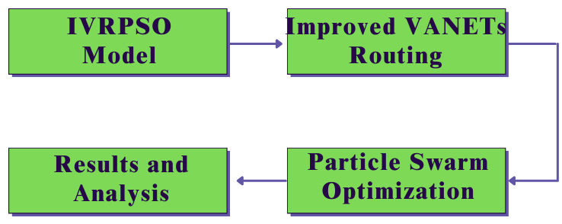
- IVRPSO model.

Improved VANETs Routing.
The Objective Function (OF) is a common feature of the RPL protocol. The OF is mostly used to create routing models, which include data on RPL parent selection and rank computation. There are specific rules in OF for calculating ranks, such as selecting the vehicle with a minimum rank value as a parent and the vehicle with a maximum rank level as a child. The parent vehicle's information is stored by the child vehicle in its parent routing table. MRHOF and objective function zero (OF0) are the two main objective functions. Equation 1 is mostly utilized to compute the hop count in order to determine the rank using OF0. The root relative distance is the primary parameter of OF0 that is utilized to calculate rank.
Rank = rank_parent + increase_rank 1
Where, from the “(1)”, the constant value is increase rank. Similar to this, with MRHOF, connection metrics like latency or expected transmission count (ETX) are utilized for rank updates. Below is an evaluation of the computed in “(2)”.
Rank = rank_parent + cost_path 2
Where the measurement of the connection metric is cost_path. Typically, throughout an RPL protocol communication process, a node forwards messages to either its neighbor router or its root. The hand-off procedure determines the network performance based on the delay. The path selection in our suggested architecture is based on the access point transmission count, that it is calculated with the presence of the whale based optimal path selection. Finding the path between the sender and the recipient that has the fewest intermediary hop nodes is the primary goal of the job. The RPL model is used for routing, which aids in message transmission to the intended recipient. Because of the reactive manner, the sender often uses the P2P communication paradigm to choose the best route to reach its target. This approach is similar to the multipath AODV routing process which is utilized here for the process of routing among the high speed vehicles. However in the earlier work, messages were distributed using the trickle algorithm to create a time-bound Destination Oriented Directed Acyclic Graph (DODAG) and were transmitted by carrying DAG (Directed Acyclic Graph) data packets. Here, we are improving this procedure and raising the network's overall performance by adding an objective functions utilizing learning automata. The MOAODV protocol was explained in the parts that follow, and the optimal route is determined by combining it with the whale optimization method. A learning automaton is employed in the goal function to improve the RPL protocol in order to further develop the network.

Particle Swarm Optimization.
PSO is a meta-heuristic approach which optimizes using a stochastic population. It draws inspiration from the social behaviors of schooling fish and flocking birds that travel together in search of food. It mimics the individual particle's physical motions inside the swarm, at this condition each particle is led by both its own and the swarm's optimal positions. To find the optimum answer for each iteration, it compares the starting solution with all of its nearby neighbors. Every swarm particle moves within individual and worldwide best.
PSO algorithms essentially consist of the subsequent steps.
1) Sv starts the swarm.
2) N particles make up a swarm, which displays N potential solutions inside the search space. In the VANET, particles stand in for cars.
3) Each particle has a unique position (the quality of the solution) and velocity (the ability to move toward potentially superior alternative solutions).
4) Every particle chooses its optimal location and then moves toward a new optimal position by using its velocity. Using the optimal positions of individuals and the entire swarm, the position may be adjusted to the global optimum.
5) Every particle changes its location and velocity at each iteration.
6) Every particle's fitness value is calculated and contrasted with the memory's fitness value. It serves as the global optimum if the current fitness value is higher.
7) After the final iteration, the process is terminated. The finest answer is regarded as the greatest available worldwide.
8) The packet is transmitted to the next forwarding node, which is a vehicle with the largest global optimal.
9) Until the packet reaches its destination, the procedure is repeated.

Simulation Results.
Using the NS2 simulator, we assessed how well the GRTM-UAV [49], SIGO-UAV [50], and RJED-UAV [51] protocols performed while assessing the suggested IVRPSO-UAV method. A number of indicators are included in the assessment approach, including throughput, data success rate, average delay, routing overhead, and data loss rate and as well the input parameters which are present in this simulation experimentation are given in table II.
- Input Parameters Table
Input Parameters | Values
Running Time | 200 ms
Coverage Distance | 1500m*1500m [53]
Number of Nodes | 500 Nodes [54]
Node Radius | 100m [55]
Initial Energy | 100 Joules [56]
Transmission Power | 0.500 Joules [57]
Receiving Power | 0.050 Joules [57]

Data success rate.
The percentage of data that is successfully sent without any errors is referred to as the data success ratio. The “Fig.2”, illustrates the data success rate calculation of the IVRPSO-UAV and it is compared with the GRTM-UAV, SIGO-UAV, and RJED-UAV. The performance of the proposed model is high and it is obtained with the presence of the effective routing and optimization method.
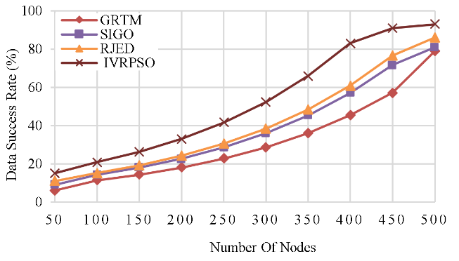
- Data Success Rate Calculation.
The proposed IVRPSO technique outperforms the existing technique of GRTM at 79%, SIGO at 81%, and RJED at 86%, with high Data Success Ratio of 93%. This reveals that the Proposed IVRPSO is more efficient.

Throughput
Throughput refers to the rate of speed at which data is successfully delivered through a medium; it is expressed as kilobits per second (kbps). The “Fig.3”, shows the throughput calculation of the IVRPSO-UAV and it is compared with the GRTM-UAV, SIGO-UAV, and RJED-UAV.
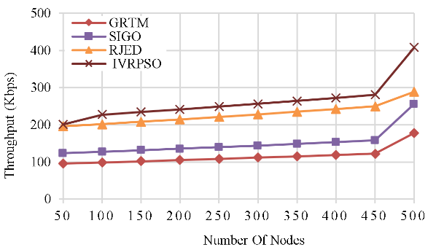
- Throughput Calculation.
The Proposed IVRPSO achieved highest Throughput of 408 kbps in comparison to the existing technique of GRTM at 178 kbps, SIGO at 256 kbps, and RJED at 289 kbps. These values show that the Proposed IVRPSO technique is capable of handling large amount of data.

Routing overhead.
Routing Overhead refers to the additional data packets used for transmitting routing information inside a network. The “Fig.4”, shows the routing overhead calculation of the IVRPSO-UAV and it is compared with the GRTM-UAV, SIGO-UAV, and RJED-UAV.
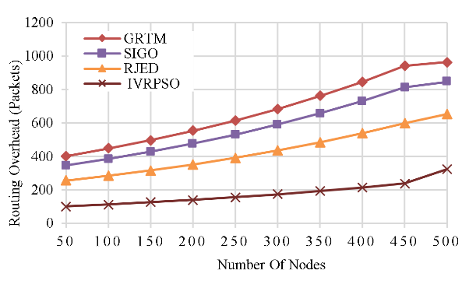
- Routing overhead calculation.
The Proposed IVRPSO shows a reduced Routing Overhead of 325 packets in comparison to the existing techniques of GRTM at 964 packets, SIGO at 847 packets, and RJED at 654 packets. This shows a more efficient routing algorithm.

Data loss rate
It refers to the ratio of packets which are failed to reach destination during the process of transmission. The “Fig.5”, illustrates the data loss rate calculation of the IVRPSO-UAV and it is compared with the GRTM-UAV, SIGO-UAV, and RJED-UAV and as well the performance of the proposed model results lower loss of data with the presence of whale optimization and RPL routing model.
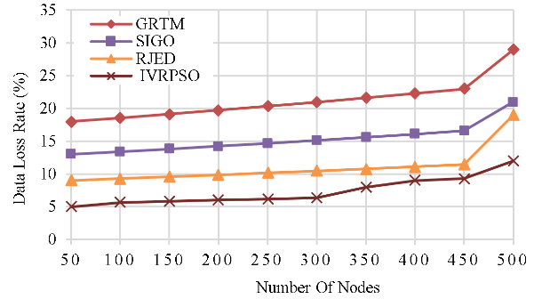
- Data Loss Rate Calculation.
The IVRPSO approach proposed shows reduced Data Loss Rate of 12% in comparison to the existing technique of GRTM at 29%, SIGO at 21%, and RJED at 19%. This signifies more dependability.

Average delay.
The average delay refers to the average time it takes for data packets to transit from the source to the destination. The “Fig.6”, shows the Average delay calculation of the IVRPSO-UAV and it is compared with the GRTM-UAV, SIGO-UAV, and RJED-UAV.
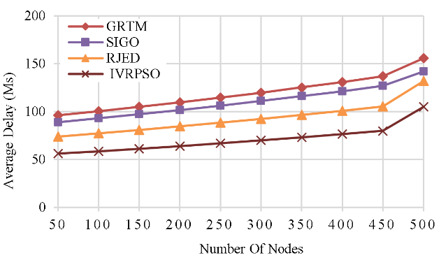
- Average delay calculation.
The Proposed IVRPSO approach has a reduced Average Delay of 105 ms in comparison to the existing technique of GRTM at 156 ms, SIGO at 142 ms, and RJED at 132 ms. The Proposed IVRPSO approach achieves faster data transmission and minimum delay and as well its final results are given in table III.

Conclusion.
In the article, an efficient routing and improved optimization model has developed to improve the quality of service of the devices which are present in the vehicular communication. This technology is mainly suitable for the urban environment where most of the vehicles travel at high speed with random mobility. The performance of the network is calculated using the software ns3 and from the final result it is proven that the proposed model attained better outcome in terms of data success rate and efficiency with the presence of swarm particles based optimization so that the data travelled in optimal path to reduce the delay and routing overhead. In future work, clustering is used to concentrate to enlarge coverage area of the network.

References
- A. H. Abbas, A. J. Ahmed, S. A. Rashid, M. A. Jubair, N. F. Abdulsattar, H. S. Mansour, and M. I. Habelalmateen, "Hybrid ANT Based Continuous Cuckoo Search Optimization Algorithm for Vehicle Adhoc Networks," in 2022 5th International Conference on Engineering Technology and its Applications (IICETA), pp. 447-452, May 31-June 1, 2022. https://doi.org/10.1109/IICETA54559.2022.9888404
- M. I. Habelalmateen, A. H. Abbas, L. Audah, and N. A. M. Alduais, "Dynamic multiagent method to avoid duplicated information at intersections in VANETs," Telkomnika (Telecommunication Computing Electronics and Control), vol. 18, no. 2, pp. 613-621, 2020. DOI: http://doi.org/10.12928/telkomnika.v18i2.13947.
- M. K. Hasan, M. M. Ahmed, N. F. Wani, A. H. Abbas, L. M. Alkwai, S. Islam, A. K. M. A. Habib, and R. Hassan, "Dynamic load modeling for bulk load-using synchrophasors with wide area measurement system for smart grid real-time load monitoring and optimization," Sustainable Energy Technologies and Assessments, vol. 57, p. 103190, 2023. doi: https://doi.org/10.1016/j.seta.2023.103190.
- A. H. Abbas, A. J. Ahmed, and S. A. Rashid, "A Cross-Layer Approach MAC/NET with Updated-GA (MNUG-CLA)-Based Routing Protocol for VANET Network," World Electric Vehicle Journal, vol. 13, no. 5, article no. 87, 2022. DOI: https://doi.org/10.3390/wevj13050087.
- H. S. Mansour, M. H. Mutar, I. A. Aziz, S. A. Mostafa, H. Mahdin, A. H. Abbas, M. H. Hassan, N. F. Abdulsattar, and M. A. Jubair, "Cross-Layer and Energy-Aware AODV Routing Protocol for Flying Ad-Hoc Networks," Sustainability, vol. 14, no. 15, article no. 8980, 2022. DOI: https://doi.org/10.3390/su14158980.
- M. A. Jubair, S. A. Mostafa, D. A. Zebari, H. M. Hariz, N. F. Abdulsattar, M. H. Hassan, A. H. Abbas, F. H. Abbas, A. Alasiry, and M. Turki-Hadj, "A QoS Aware Cluster Head Selection and Hybrid Cryptography Routing Protocol for Enhancing Efficiency and Security of VANETs," IEEE Access, vol. 10, pp. 124792-124804, 2022. doi: https://doi.org/10.1109/ACCESS.2022.3224466.
- M. I. Habelalmateen, A. J. Ahmed, A. H. Abbas, and S. A. Rashid, "TACRP: Traffic-Aware Clustering-Based Routing Protocol for Vehicular Ad-Hoc Networks," Designs, vol. 6, no. 5, article no. 89, 2022. DOI: https://doi.org/10.3390/designs6050089.
- S. A. Rashid, M. I. Habelalmateen, A. J. Ahmed, A. H. Abbas, M. A. Jubair, M. H. Hassan, A. Abdulhadi, S. Hammed, and L. Audah, "Congestion Aware Genetic Q-learning Based RPL Routing Protocol for Vehicle Ad-Hoc Networks," in 2022 5th International Conference on Engineering Technology and its Applications (IICETA), pp. 464-469, 2022. doi: https://doi.org/10.1109/IICETA54559.2022.9888583.
- A. H. Abbas, A. J. Ahmed, S. A. Rashid, N. F. Abdulsattar, M. H. Hassan, M. A. Jubair, and M. I. Habelalmateen, "Predictive Hybrid Routing with Multi Objective Optimization Model for Opportunistic Routing for VANET," in 2022 5th International Conference on Engineering Technology and its Applications (IICETA), pp. 470-476, 2022. doi: https://doi.org/10.1109/IICETA54559.2022.9888274.
- A. H. Najim, A. H. Abbas, K. Al-sharhanee, and H. M. Hariz, "Reinforcement Learning-based Topology-Aware Routing Protocol with Priority Scheduling for Internet of Drones in Agriculture Application," International Journal of Intelligent Engineering and Systems, vol. 16, no. 5, pp. 395-405, 2023. doi: https://doi.org/10.22266/ijies2023.1031.34.
- N.F. Abdulsattar, F. Abedi, H.M.A. Ghanimi, S. Kumar, A.H. Abbas, A.S. Abosinnee, A. Alkhayyat, M.H. Hassan, and F.H. Abbas, "Botnet Detection Employing a Dilated Convolutional Autoencoder Classifier with the Aid of Hybrid Shark and Bear Smell Optimization Algorithm-Based Feature Selection in FANETs," Big Data and Cognitive Computing, vol. 6, no. 4, article no. 112, 2022. DOI: https://doi.org/10.3390/bdcc6040112.
- V. O. Nyangaresi, I. M. Al-Joboury, K. A. Al-sharhanee, A. H. Najim, A. H. Abbas, and H. M. Hariz, "A biometric and physically unclonable function–Based authentication protocol for payload exchanges in internet of drones," e-Prime - Advances in Electrical Engineering, Electronics and Energy, vol. 7, pp. 100471, 2024. DOI: https://doi.org/10.1016/j.prime.2024.100471
- N.F. Abdulsattar, A.H. Abbas, M.H. Mutar, M.H. Hassan, M.A. Jubair, and M.I. Habelalmateen, "An Investigation Study for Technologies, Challenges and Practices of IoT in Smart Cities," in 2022 5th International Conference on Engineering Technology and its Applications (IICETA), pp. 554-557, 2022. DOI: https://doi.org/10.1109/IICETA54559.2022.9888474.
- F. Abedi, S. R. M. Zeebaree, Z. S. Ageed, H. M. A. Ghanimi, A. Alkhayyat, M. A. M. Sadeeq, S. N. Mahmood, A. S. Abosinnee, Z. H. Kareem, A. H. Abbas, W. K. Al-Azzawi, M. M. Jaber, and M. Dauwed, "Severity Based Light-Weight Encryption Model for Secure Medical Information System," Computers, Materials & Continua, vol. 74, no. 3, pp. 5691-5704, 2023. DOI: https://doi.org/10.32604/cmc.2023.034435.
- A. H. Kadhim, A. M. Razaq, M. A. Jubair, N. F. Abdulsattar, A. H. Abbas, M. H. Hassan, A. Jamal Ahmed, S. AbdulJabbar Rashid, and M. I. Habelalmateen, "A Real-Time Low-Cost Remote Doctor Monitoring System," in 2022 5th International Conference on Engineering Technology and its Applications (IICETA), pp. 558-561, 2022. doi: https://doi.org/10.1109/IICETA54559.2022.9888536.
- F. Abedi, H. M. A. Ghanimi, A. D. Algarni, N. F. Soliman, W. El-Shafai, A. H. Abbas, Z. H. Kareem, H. M. Hariz, and A. Alkhayyat, "Computational Intelligence Driven Secure Unmanned Aerial Vehicle Image Classification in Smart City Environment," Computer Systems Science and Engineering, vol. 47, no. 3, pp. 3127-3144, 2023. DOI: https://doi.org/10.32604/csse.2023.038959.
- N. F. Abdulsattar, D. A. Mohammed, A. Alkhayyat, S. Z. Hamed, H. M. Hariz, A. S. Abosinnee, A. H. Abbas, M. H. Hassan, M. A. Jubair, F. H. Abbas, A. D. Algarni, N. F. Soliman, and W. El-Shafai, "Privacy-Preserving Mobility Model and Optimization-Based Advanced Cluster Head Selection (P2O-ACH) for Vehicular Ad Hoc Networks," Electronics, vol. 11, no. 24, p. 4163, 2022, DOI: https://doi.org/10.3390/electronics11244163.
- F. Abedi, H. M. A. Ghanimi, M. A. M. Sadeeq, A. Alkhayyat, Z. H. Kareem, S. N. Mahmood, A. H. Abbas, A. S. Abosinnee, W. K. Al-Azzawi, M. M. Jaber, and M. Dauwed, "Hybrid Deep Learning Enabled Load Prediction for Energy Storage Systems," Computers, Materials & Continua, vol. 75, no. 2, pp. 3359-3374, 2023. DOI: https://doi.org/10.32604/cmc.2023.034221.
- I. Ahmad, S. Hussain, S. N. Mahmood, H. Mostafa, A. Alkhayyat, M. Marey, A. H. Abbas, and Z. Abdulateef Rashed, "Co-Channel Interference Management for Heterogeneous Networks Using Deep Learning Approach," Information, vol. 14, no. 2, article no. 139, 2023. DOI: https://doi.org/10.3390/info14020139.
- A. M. Abdulkarem, F. Abedi, H. M. A. Ghanimi, S. Kumar, W. K. Al-Azzawi, A. H. Abbas, A. S. Abosinnee, I. M. Almaameri, and A. Alkhayyat, "Robust Automatic Modulation Classification Using Convolutional Deep Neural Network Based on Scalogram Information," Computers, vol. 11, no. 11, article no. 162, 2022. DOI: https://doi.org/10.3390/computers11110162.
- S. Alsubai, A. K. Dutta, A. H. Alkhayyat, M. M. Jaber, A. H. Abbas, and A. Kumar, "Hybrid deep learning with improved Salp swarm optimization based multi-class grape disease classification model," Computers and Electrical Engineering, vol. 108, p. 108733, 2023. DOI: https://doi.org/10.1016/j.compeleceng.2023.108733.
- I. S. Al-Hawary, E. Ali, S. M. H. Kamona, L. Hussain Saleh, A. S. Abdulwahid, D. N. Al-Saidi, M. S. Alhassan, F. A. Rasen, H. Abdullah Abbas, A. Alawadi, A. H. Abbas, and M. Sina, "Prediction of geomechanical bearing capacity using autoregressive deep neural network in carbon capture and storage systems," Heliyon, vol. 9, no. 11, pp. e21913, Nov. 2023. doi: https://doi.org/10.1016/j.heliyon.2023.e21913.
- M. R. M. Alsemawi, M. H. Mutar, E. H. Ahmed, H. O. Hanoosh, and A. H. Abbas, "Emotions recognition from human facial images based on fast learning network," Indonesian Journal of Electrical Engineering and Computer Science, vol. 30, no. 3, pp. 1478-1487, 2023. doi: http://doi.org/10.11591/ijeecs.v30.i3.pp1478-1487.
- J. Tang, A. K. Abbas, N. A. Koka, N. Sadoon, J. K. Abbas, R. A. Abdalhuseen, M. Abosaooda, N. M. Ahmed, and A. H. Abbas, "Optimization of thermal biofuel production from biomass using CaO-based catalyst through different algorithm-based machine learning approaches," Case Studies in Thermal Engineering, vol. 50, p. 103419, 2023. doi: https://doi.org/10.1016/j.csite.2023.103419.
- A. H. Alwan, A. A. Aziz, M. A. Jubair, A. H. Abbas, M. H. Hassan, S. Alheejawi, N. F. Abdulsattar, A. S. Mustafa, and M. I. Habelalmateen, "Monitoring the Impact of the Nodes Density on the MANETs’ Environment," in 2022 5th International Conference on Engineering Technology and its Applications (IICETA), pp. 546-549, 2022. doi: https://doi.org/10.1109/IICETA54559.2022.9888339.
- Mostafa, S.A., Mustapha, A., Ramli, A.A., Jubair, M.A., Hassan, M.H., Abbas, A.H. (2021). Comparative Analysis to the Performance of Three Mobile Ad-Hoc Network Routing Protocols in Time-Critical Events of Search and Rescue Missions. In: Cassenti, D., Scataglini, S., Rajulu, S., Wright, J. (eds) Advances in Simulation and Digital Human Modeling. AHFE 2020. Advances in Intelligent Systems and Computing, vol 1206. Springer, Cham. https://doi.org/10.1007/978-3-030-51064-0_16.
- M. H. Hassan, M. A. Jubair, A. H. Abbas, A. J. Ahmed, S. A. Rashid, M. H. Mutar, H. S. Mansour, A. Ali, and M. I. Habelalmateen, "AODV based Crow Search Algorithm for Improving the QoS of MANET," in 2022 5th International Conference on Engineering Technology and its Applications (IICETA), pp. 424-428, 2022. DOI: https://doi.org/10.1109/IICETA54559.2022.9888484.
- A. H. Abbas, N. F. Abdulsattar, H. S. Mansour, M. H. Mutar, M. I. Habelalmateen, L. Audah, N. A. M. Alduais, and A. Mohammed, "A New Hybrid Approach Cluster-Heads Election to reduce the number of clusters in VANETs," in 2022 5th International Conference on Engineering Technology and its Applications (IICETA), pp. 436-440, 2022. DOI: https://doi.org/10.1109/IICETA54559.2022.9888442.
- M. A. Jubair, M. H. Hassan, S. A. Mostafa, H. Mahdin, A. Mustapha, L. H. Audah, F. S. Shaqwi, and A. H. Abbas, "Competitive analysis of single and multi-path routing protocols in MANET," Indonesian Journal of Electrical Engineering and Computer Science, vol. 19, no. 1, pp. 293-300, 2020. http://doi.org/10.11591/ijeecs.v19.i1.pp293-300.
- S. A. Rashid, A. J. Ahmed, M. H. Hassan, A. H. Abbas, M. I. Habelalmateen, M. A. Jubair, L. Audah, and W. Al-Azzawi, "Ranking Based Routing Protocol for Residual Energy Estimation in Wireless Sensor Network Based IoT Network," in 2022 5th International Conference on Engineering Technology and its Applications (IICETA), pp. 453-459, 2022. https://doi.org/10.1109/IICETA54559.2022.9888349.
- A. J. Ahmed, A. H. Abbas, S. A. Rashid, M. A. Jubair, M. H. Hassan, A. Abdulhadi, N. F. Abdulsattar, and M. I. Habelalmateen, "Congestion Aware Q-Learning (CAQL) in RPL Protocol – WSN based IoT Networks," in 2022 5th International Conference on Engineering Technology and its Applications (IICETA), pp. 429-435, 2022. doi: https://doi.org/10.1109/IICETA54559.2022.9888322.
- A. H. Abbas, H. Mansour, and A. Al-Fatlawi, "Self-Adaptive Efficient Dynamic Multi-Hop Clustering (SA-EDMC) Approach for Improving VANET’s Performance," International Journal of Interactive Mobile Technologies (iJIM), vol. 16, no. 14, pp. 136-151, Jul. 2022. DOI: https://doi.org/10.3991/ijim.v16i14.31081.
- F. Abedi, H. M. A. Ghanimi, A. D. Algarni, N. F. Soliman, W. El-Shafai, A. H. Abbas, Z. H. Kareem, H. M. Hariz, and A. Alkhayyat, "Chimp Optimization Algorithm Based Feature Selection with Machine Learning for Medical Data Classification," Computer Systems Science and Engineering, vol. 47, no. 3, pp. 2791–2814, 2023. doi: https://doi.org/10.32604/csse.2023.038762.
- M. A. A. Albadr et al., "Online sequential extreme learning machine approach for breast cancer diagnosis," Neural Computing and Applications, vol. Volume, no. Issue, pp. Page, 2024. DOI: https://doi.org/10.1007/s00521-024-09617-x.
- M. S. Alshuhri, S. G. Al-Musawi, A. A. Al-Alwany, H. Uinarni, I. Rasulova, P. Rodrigues, A. T. Alkhafaji, A. M. Alshanberi, A. H. Alawadi, and A. H. Abbas, "Artificial intelligence in cancer diagnosis: Opportunities and challenges," Pathology - Research and Practice, vol. 253, pp. 154996, 2024. https://doi.org/10.1016/j.prp.2023.154996.
- A. Abdulbari, S. K. Abdul Rahim, F. Abedi, P. J. Soh, A. Hashim, R. Qays, S. Ahmad, and M. Y. Zeain, "Single-Layer Planar Monopole Antenna-Based Artificial Magnetic Conductor (AMC)," International Journal of Antennas and Propagation, vol. 2022, pp. 6724175, 2022. https://doi.org/10.1155/2022/6724175.
- A. H. Abbas, M. I. Habelalmateen, S. Jurdi, L. Audah, and N. A. M. Alduais, "GPS based location monitoring system with geo-fencing capabilities," AIP Conference Proceedings, vol. 2173, no. 1, p. 020014, Nov. 2019. DOI: https://doi.org/10.1063/1.513392.
- S. Saleem, A. H. Jabbar, M. H. Jameel, A. Rehman, Z. H. Kareem, A. H. Abbas, Z. Ghaffar, S. A. Razzaq, R. A. Pashameah, E. Alzahrani, E.-P. Ng, and S. M. Sapuan, "Enhancement in structural, morphological, and optical properties of copper oxide for optoelectronic device applications," Nanotechnology Reviews, vol. 11, no. 1, pp. 2827-2838, 2022.DOI: https://doi.org/10.1515/ntrev-2022-0473.
- G.G. Shayea, D.A. Mohammed, A.H. Abbas, and N.F. Abdulsattar, "Privacy-Aware Secure Routing through Elliptical Curve Cryptography with Optimal RSU Distribution in VANETs," Designs, vol. 6, no. 6, pp. 121, 2022. doi: https://doi.org/10.3390/designs6060121.
- M.H. Hassan, A.H. Abbas, M.H. Mutar, M.A. Jubair, S.A. Rashid, A.J. Ahmed, M.I. Habelalmateen, A. Mohammed, and L. Audah, "Investigative Study on Routing Protocols in Flying Ad Hoc Networks Environment," in 2022 5th International Conference on Engineering Technology and its Applications (IICETA), pp. 460-463, 2022. doi: https://doi.org/10.1109/IICETA54559.2022.9888600.
- A. Gopalakrishnan, P.M. Bala, and T.A. Kumar, "An advanced bio-inspired shortest path routing algorithm for SDN controller over VANET," in 2020 International Conference on System, Computation, Automation and Networking (ICSCAN), IEEE, July 2020, pp. 1-5, doi: 978-1-721-6202-7.
- R.Z. Akbar, "Performance analysis fsr and dsr routing protocol in vanet with v2v and v2i models," in 2020 3rd International Seminar on Research of Information Technology and Intelligent Systems (ISRITI), IEEE, December 2020, pp. 158-163, doi: 10.1109/ISRITI51436.2020.9315367
- P. Soleimani, M.R.B. Marvasti, and P. Ghorbanzadeh, "A Hybrid Traffic Management Method Based on Combination of IOV and VANET Network in Urban Routing for Emergency Vehicles," in 2020 4th International Conference on Smart City, Internet of Things and Applications (SCIOT), IEEE, September 2020, pp. 58-65, doi: 978-1-7281-9611-4/20
- P. Soleimani, M.R.B. Marvasti, and P. Ghorbanzadeh, "A Hybrid Traffic Management Method Based on Combination of IOV and VANET Network in Urban Routing for Emergency Vehicles," in 2020 4th International Conference on Smart City, Internet of Things and Applications (SCIOT), IEEE, September 2020, pp. 58-65, doi: 10.12720/jcm.15.4.332-344
- S.A. Rashid, M.M. Hamdi, and S. Alani, "An overview on quality of service and data dissemination in VANETs," in 2020 International Congress on Human-Computer Interaction, Optimization and Robotic Applications (HORA), IEEE, June 2020, pp. 1-5, doi: 978-1-7281-9352-6/20
- S. Akter and N. Mansoor, "A spectrum aware mobility pattern based routing protocol for CR-VANETs," in 2020 IEEE Wireless Communications and Networking Conference (WCNC), IEEE, May 2020, pp. 1-6, doi:978-1-7281-3106-1/20
- M. S. Haghighi and Z. Aziminejad, "Highly Anonymous Mobility-Tolerant Location-based Onion Routing for VANETs," IEEE Internet of Things Journal, October 2019, pp. 1-1, DOI: 10.1109/JIOT.2019.2948315, doi: 10.1109/JIOT.2019.2948315.
- M.A. Islam, M. Hossen, and M.F. Hossen, "Central Lane-based Life Time Routing Protocol in Vehicular Ad Hoc Network," in 2020 2nd International Conference on Advanced Information and Communication Technology (ICAICT), IEEE, November 2020, pp. 359-363, doi: 10.1109/ICAICT51780.2020.9333500.
- A.M. Shaban, S. Kurnaz, and A.M. Shantaf, "Evaluation DSDV, AODV and OLSR routing protocols in real live by using SUMO with NS3 simulation in VANET," in 2020 International Congress on Human-Computer Interaction, Optimization and Robotic Applications (HORA), IEEE, June 2020, pp. 1-5, doi: 978-1-7281-9352-6/20
- Benaicha Mehdi, Samira Moussaoui and Guerroumi Mohamed, “A Geographic Routing Based on Road Traffic and Multi-hop Intersections in VANETs (GRBRT-MI)”, International Conference on Advanced Electrical Engineering (ICAEE), 2022, doi: 10.1109/ICAEE53772.2022.9962043
- Shuto Takahashi and Masami Yoshida, “Shadowing-Fading-based Intersection Geographic Opportunistic Routing Protocol for Urban VANETs”, International Conference on Advanced Communication Technology (ICACT), 2022, doi: 10.23919/ICACT53585.2022.9728799
- Somayeh Mokhtari and Nima Nouri, “Relaying Data With Joint Optimization of Energy and Delay in Cluster-Based UAV-Assisted VANETs”, IEEE Internet of Things Journal, vol. 9, no. 23, pp. 24541 – 24559, 2022, doi: 10.1109/JIOT.2022.3188563
- R. Q. Malik, K. N. Ramli, Z. H. Kareem, M. I. Habelalmatee, A. H. Abbas, and A. Alamoody, "An Overview on V2P Communication System: Architecture and Application," in 2020 3rd International Conference on Engineering Technology and its Applications (IICETA), pp. 174-178, 2020. doi: https://doi.org/10.1109/IICETA50496.2020.9318863.
- Y.S. Jghef, M.J.M. Jasim, H.M.A. Ghanimi, A.D. Algarni, N.F. Soliman, W. El-Shafai, S.R.M. Zeebaree, A. Alkhayyat, A.S. Abosinnee, N.F. Abdulsattar, A.H. Abbas, H.M. Hariz, and F.H. Abbas, "Bio-Inspired Dynamic Trust and Congestion-Aware Zone-Based Secured Internet of Drone Things (SIoDT)," Drones, vol. 6, no. 11, pp. 337, 2022. https://doi.org/10.3390/drones6110337.
- A. H. Najim, H. S. Mansour, and A. H. Abbas, "Characteristic analysis of queue theory in Wi-Fi applications using OPNET 14.5 modeler," Eastern-European Journal of Enterprise Technologies, vol. 2, no. 9-116, pp. 35–43, 2022. doi: http://doi.org/10.15587/1729-4061.2022.255520.
- A. J. Ahmed, S. A. Rashid, A. H. Abbas, N. F. Abdulsattar, H. S. Mansour, M. H. Hassan, M. I. Habelalmateen, and A. Hussain, "An Effectual Secure Cryptography Scheme for Multipath Routing in A Wsn-Based IoT Environment," in 2022 5th International Conference on Engineering Technology and its Applications (IICETA), pp. 441-446, 2022. doi: https://doi.org/10.1109/IICETA54559.2022.9888604.
- A. J. Ahmed, A. H. Abbas, and S. A. Rashid, "Multi level trust calculation with improved ant colony optimization for improving quality of service in wireless sensor network," IAES International Journal of Artificial Intelligence, vol. 12, no. 3, pp. 1224–1237, 2023. doi: https://doi.org/10.11591/ijai.v12.i3.pp1224-1237.

